Exp. No: 17 EYE DIAGRAM ANALYSIS OF OPTICAL COMMUNICATION LINK USING OPTISYSTEM

OBJECTIVES
1. Design and establish a fiber optic communication link using OptiSystem software.
2. Measure and evaluate the Bit Error Rate (BER) of the system for different fiber lengths.
3. Study the effect of fiber length on BER, Q-factor, attenuation, and dispersion.

SOFTWARE REQUIRED
- OptiSystem software

SIMULATION CIRCUIT
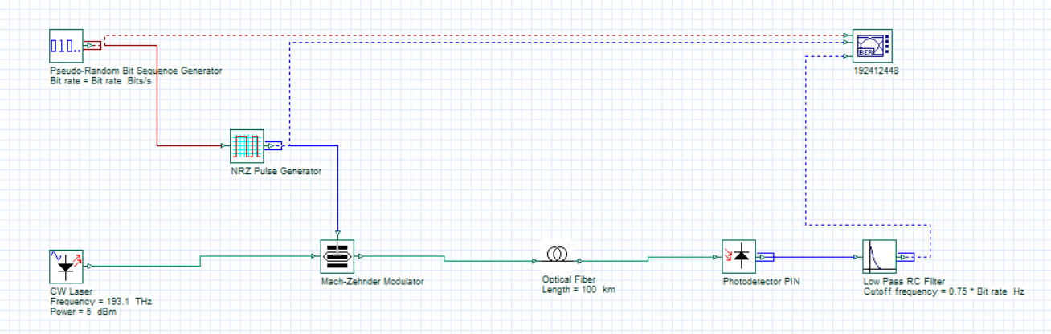

OUTPUT
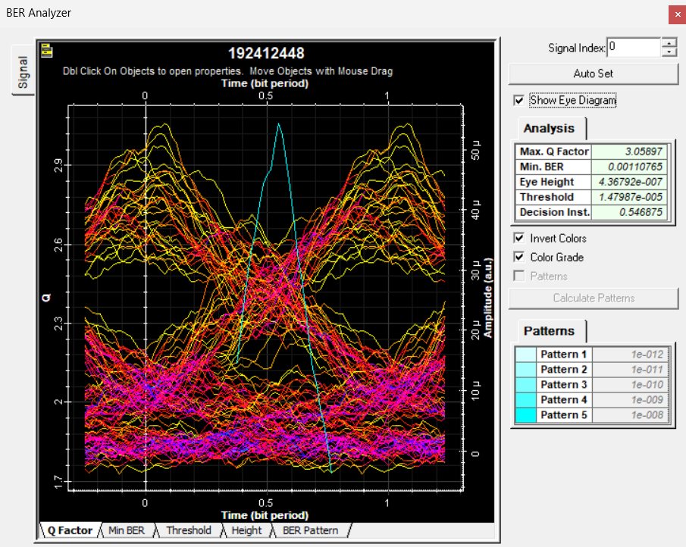
Eye diagram 1: Max. Q factor = 3.05897, Min. BER = 0.00110765 (nearly closed eye)
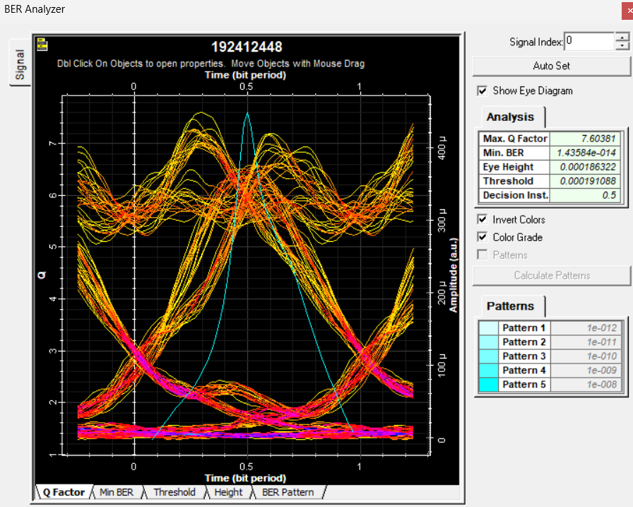
Eye diagram 2: Max. Q factor = 7.60381, Min. BER = 1.43584e-014 (open eye)
REFLECTION:
This experiment helped me understand how an optical communication link is built and how its quality is judged using the eye diagram. Using OptiSystem, I connected a pseudo-random bit sequence generator, NRZ pulse generator, CW laser, Mach-Zehnder modulator, optical fiber, PIN photodetector and low pass RC filter, and analyzed the received signal with the BER analyzer. I learned how fiber length, through attenuation and dispersion, closes the eye, lowers the Q factor and raises the bit error rate, which directly affects the reliability of the link.

CONCLUSION
The experiment demonstrates how the eye diagram and BER analyzer are used to evaluate an optical link. The eye diagram with a Q factor of 3.06 has a nearly closed eye and a BER of about 1.1 × 10⁻³, which is unacceptable for reliable communication, because attenuation and dispersion over the fiber distort the pulses and add to the noise. The eye diagram with a Q factor of 7.60 has a wide open eye and a BER of about 1.4 × 10⁻¹⁴, indicating error-free operation. As the fiber length increases, attenuation reduces the received power and dispersion broadens the pulses, so the Q factor and eye height fall while the BER rises. Fiber length must therefore be chosen within the system power and dispersion budget to keep the BER at an acceptable level.

