Exp-04 Measurement and Analysis of Dispersion Compensation in Optical Fiber using OptiSystem
CO Mapping: CO1 Bloom's Level: K4 WK Level: WK4, WK6
OBJECTIVES
- To demonstrate dispersion compensation using the Ideal Dispersion Compensation component in OptiSystem.
- To observe the broadening of a 12.5 ps optical Gaussian pulse after propagation through 10 km of single-mode fiber (SMF).
- To compensate the accumulated dispersion of 160 ps/nm and verify recovery of the original pulse shape.
SOFTWARE / HARDWARE REQUIRED
• OptiSystem Software
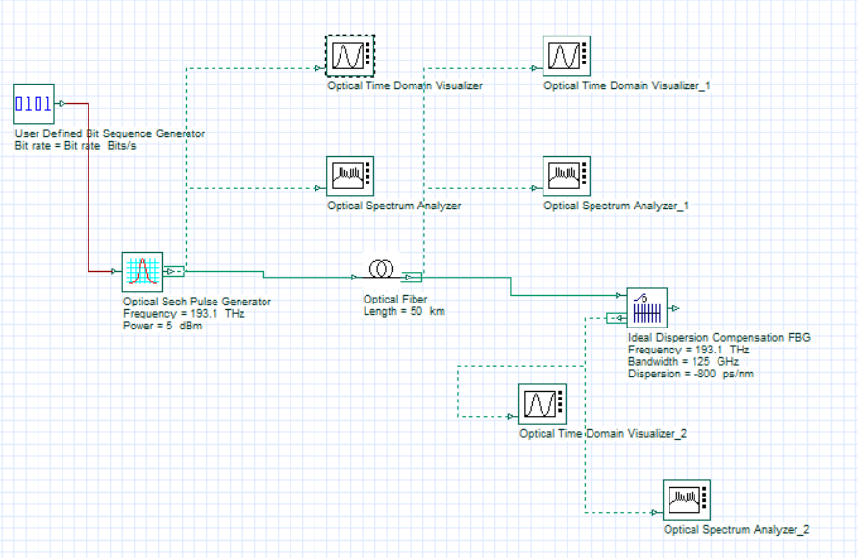
SIMULATION CIRCUIT

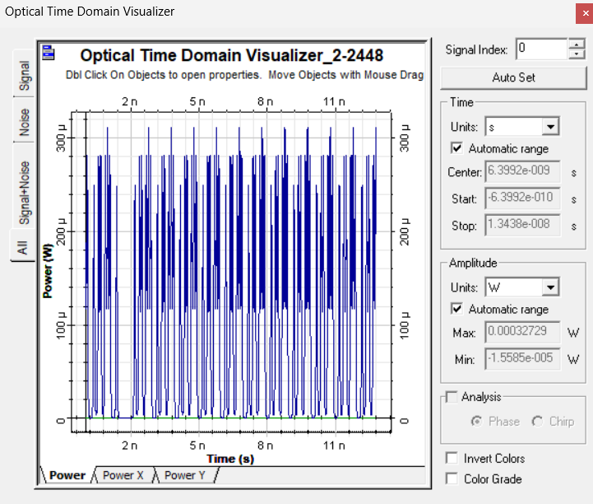
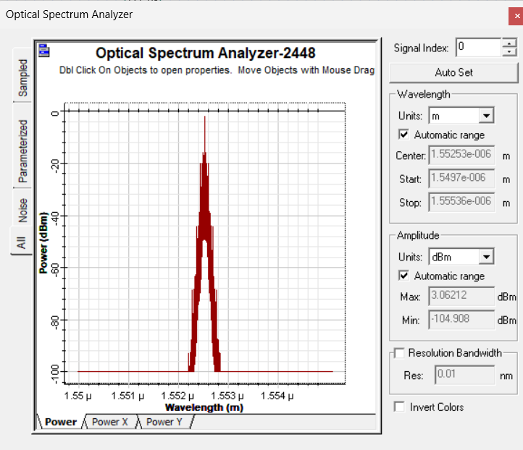
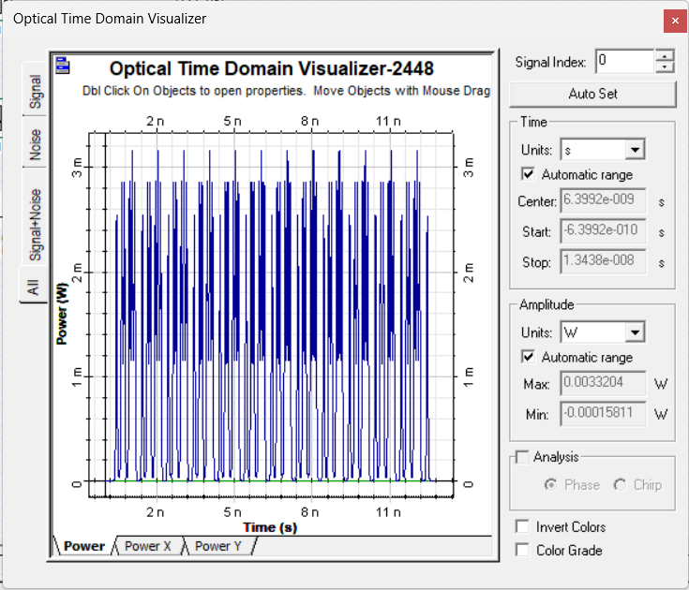
OUTPUT
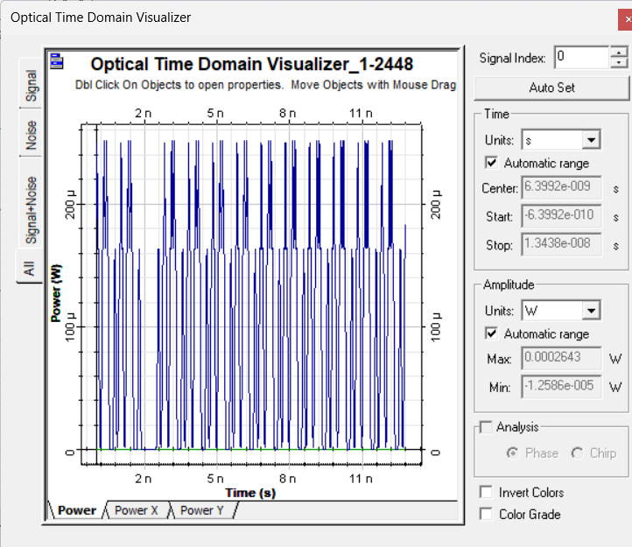
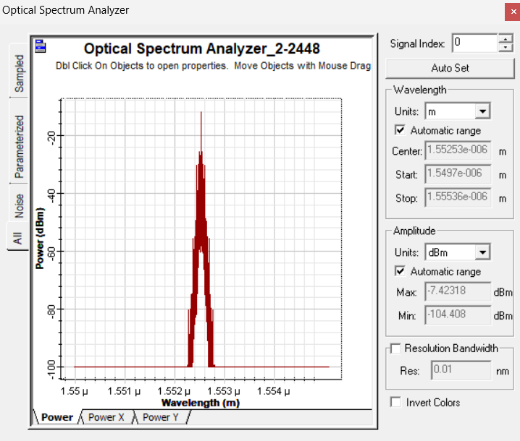
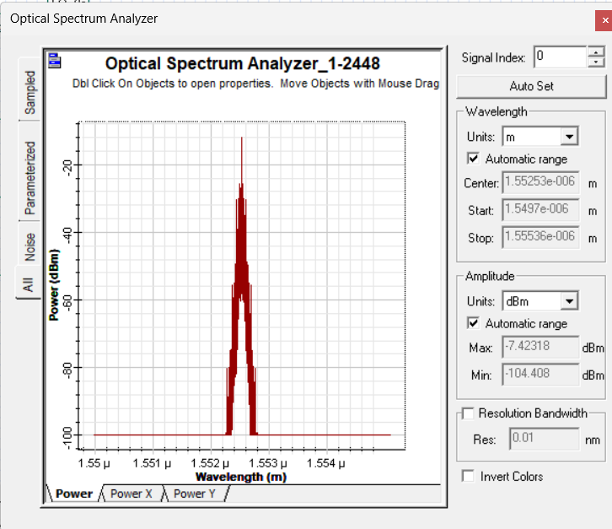
REFLECTION
This experiment helped me understand the concept of dispersion in optical fiber and its effect on signal transmission. Using OptiSystem, I analyzed how dispersion compensation reduces pulse spreading and improves the quality of the received signal. I learned that proper dispersion compensation is essential for achieving reliable, high-speed optical communication.
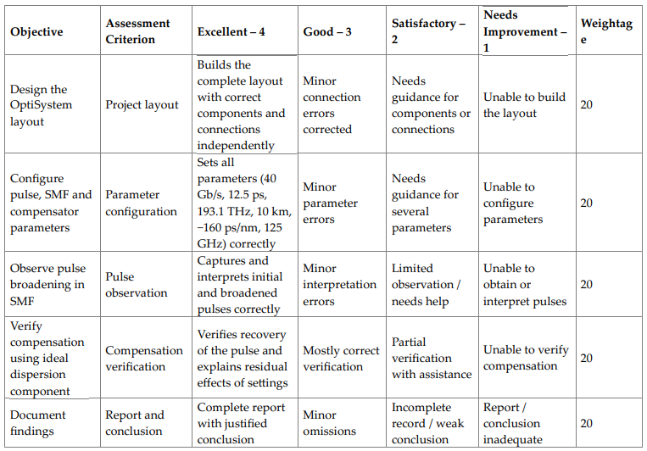

CONCLUSION
Dispersion compensation was successfully demonstrated using the Ideal Dispersion Compensation component in OptiSystem. A 12.5 ps Gaussian pulse broadened approximately four times after 10 km of SMF (accumulated dispersion 160 ps/nm), and se=ing the compensator dispersion to –160 ps/nm restored the pulse, achieving an exact compensation of the accumulated dispersion.

