ANALYSIS OF EDFA-BASED DENSE WDM LINK PERFORMANCE USING OPTISYSTEM
CO Mapping: CO1 Bloom's Level: K4 WK Level: WK4, WK6
OBJECTIVES
- To design a 4-channel Dense WDM link (100 GHz spacing, 193.1 THz, NRZ) in OptiSystem using a WDM Transmitter, WDM Mux 4x1 and WDM Demux 1x4.
- To study the effect of cascaded 50 km optical fiber spans with EDFA amplification (5 m erbium-doped length) on the transmitted signal power.
- To measure the received optical power using Optical Power Meters and the signal spectrum using the WDM Analyzer.
- To evaluate link performance at each receiver using BER Analyzers by observing the eye diagram, Q factor and minimum BER.
SOFTWARE / HARDWARE REQUIRED
• OptiSystem Software (Optiwave) on a Windows PC
SIMULATION CIRCUIT
The circuit consists of a 4-channel WDM Transmitter (193.1 THz, 100 GHz spacing, 5 dBm, NRZ), a WDM Mux 4x1, a Loop Control, two 50 km optical fiber spans each followed by an EDFA (5 m), a WDM Demux 1x4, four Optical Receivers (cutoff frequency = 0.75 × bit rate) with BER Analyzers, a WDM Analyzer (185–200 THz) and two Optical Power Meters.
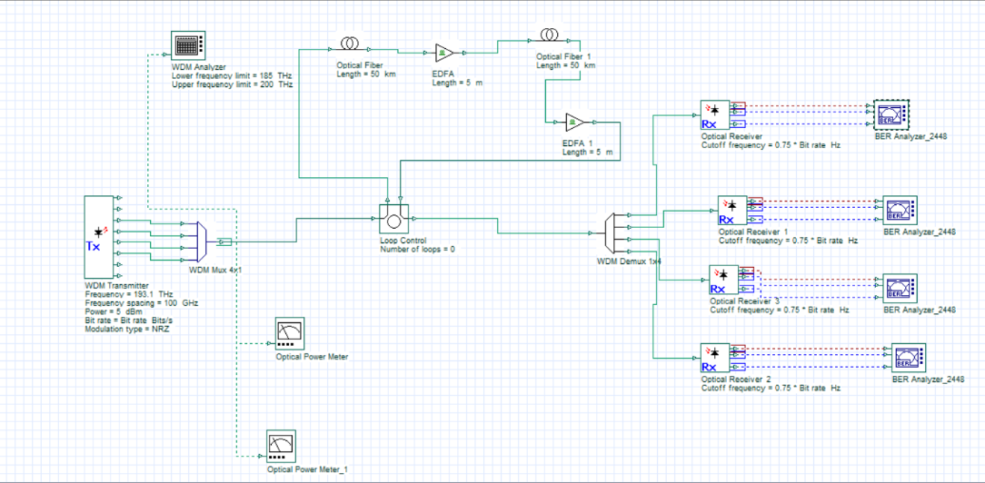
Fig. 1: OptiSystem layout of the EDFA-based 4-channel DWDM link
PROCEDURE
1. Open OptiSystem and create a new project; set the bit rate, sequence length and sample rate in Layout parameters.
2. Place the WDM Transmitter (4 channels, 193.1 THz, 100 GHz spacing, 5 dBm, NRZ) and connect it to the WDM Mux 4x1.
3. Connect the Mux output to the Loop Control, followed by Optical Fiber (50 km), EDFA (5 m), Optical Fiber 1 (50 km) and EDFA 1 (5 m).
4. Connect the amplified signal to the WDM Demux 1x4 and attach an Optical Receiver and BER Analyzer to each demux output.
5. Connect the WDM Analyzer and the Optical Power Meters at the required points of the link.
6. Run the simulation and record the power meter readings, eye diagrams, Q factor and minimum BER.
OUTPUT
Optical Power Meter readings (Total Power, Signal Index 0):
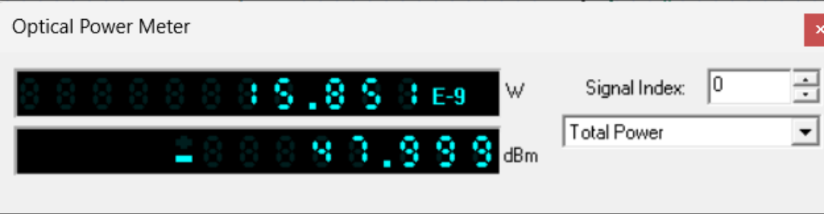
Fig. 2: Optical Power Meter – 15.851 nW (−47.999 dBm)
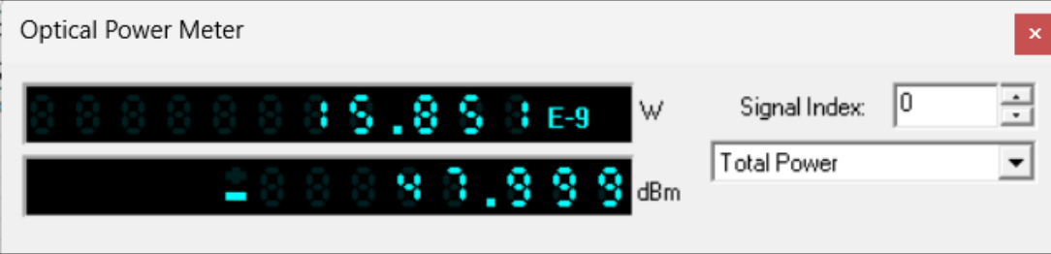
Fig. 3: Optical Power Meter_1 – 15.851 nW (−47.999 dBm)
BER Analyzer eye diagrams (BER Analyzer_2448):
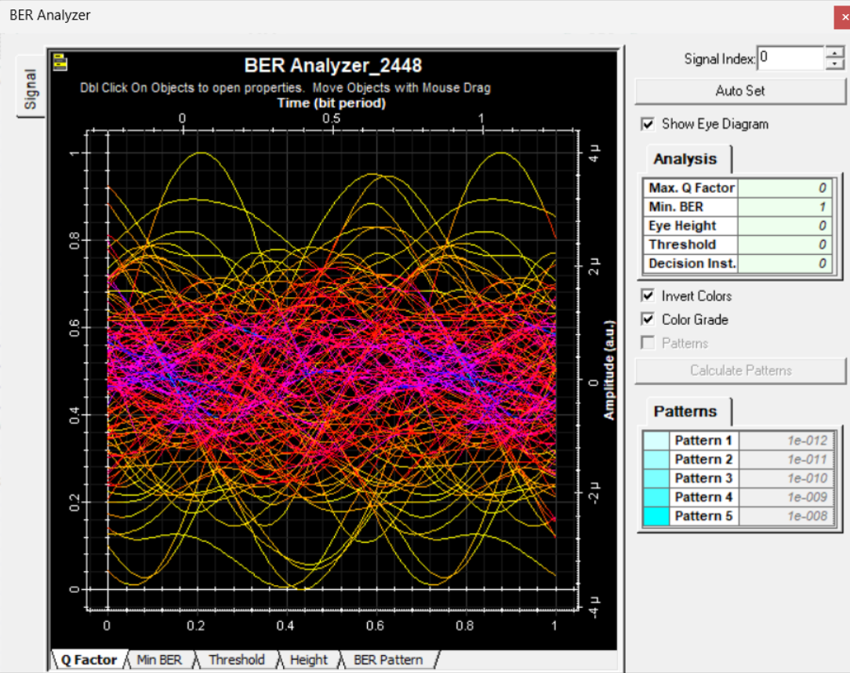
Fig. 4: BER Analyzer eye diagram (Max. Q Factor = 0, Min. BER = 1, Eye Height = 0)
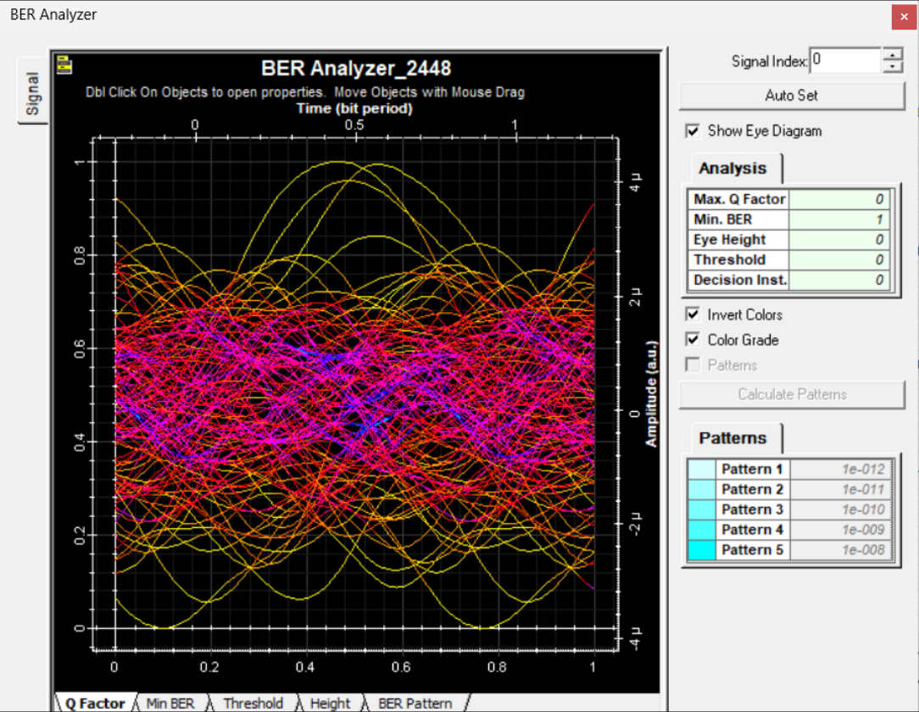
Fig. 5: BER Analyzer eye diagram (Max. Q Factor = 0, Min. BER = 1, Eye Height = 0)
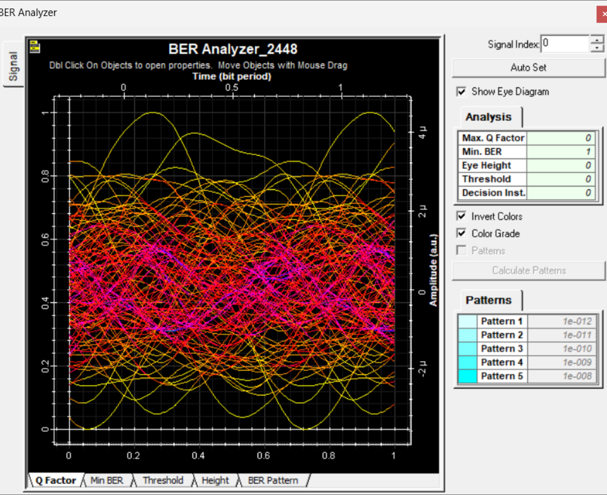
Fig. 6: BER Analyzer eye diagram (Max. Q Factor = 0, Min. BER = 1, Eye Height = 0)
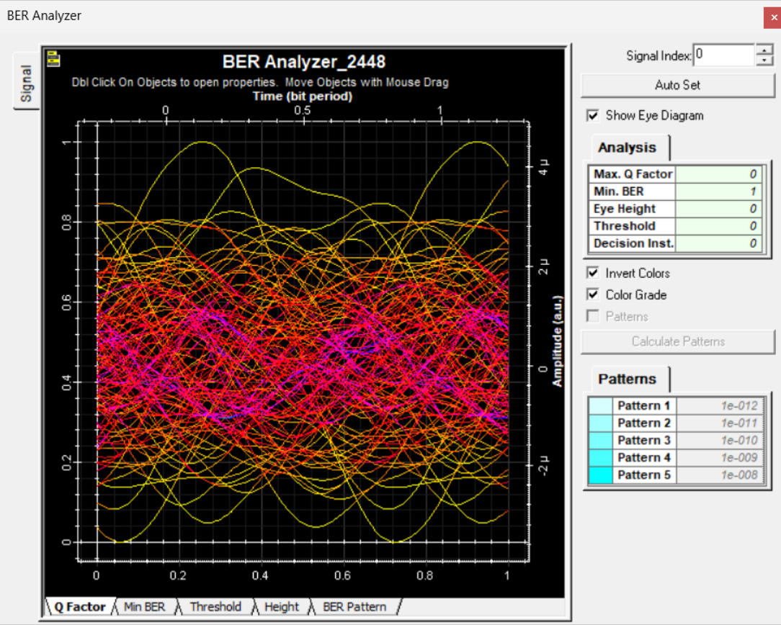
Fig. 7: BER Analyzer eye diagram (Max. Q Factor = 0, Min. BER = 1, Eye Height = 0)
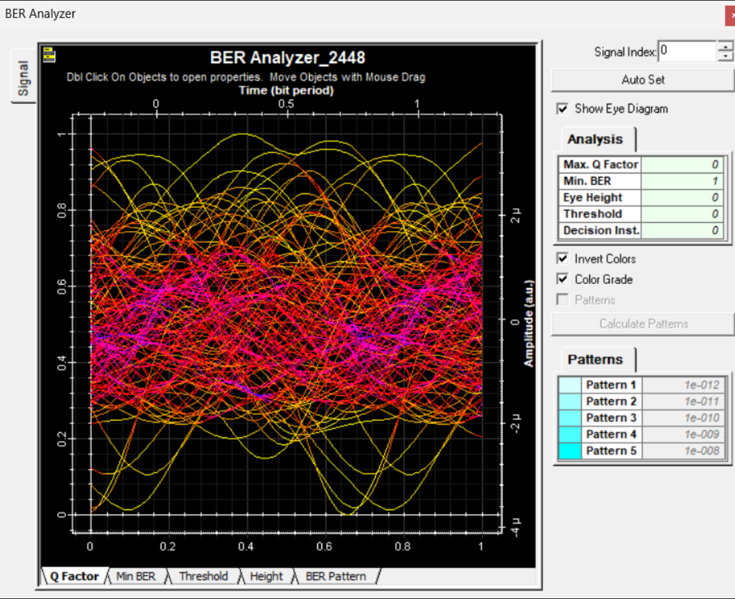
Fig. 8: BER Analyzer eye diagram (Max. Q Factor = 0, Min. BER = 1, Eye Height = 0)
OBSERVATIONS
Parameter | Observed value | Remarks
Total received power | 15.851 nW (−47.999 dBm) | Both power meters read the same
Max. Q Factor | 0 | No distinguishable eye
Min. BER | 1 | Link not error-free
Eye Height | 0 | Eye completely closed
Threshold / Decision Inst. | 0 / 0 | Not resolvable

REFLECTION
This experiment helped me understand how a dense WDM link is built and evaluated in OptiSystem, and how EDFAs are used to restore the power lost in 50 km fiber spans. The measured total power of about −48 dBm is far below the 5 dBm launched per channel, and every BER Analyzer shows a closed, noisy eye with Q factor 0 and BER 1. This shows that the link, as simulated here, did not deliver a usable signal. Probable causes are the very short 5 m EDFA length with insufficient pump power or gain, the Loop Control set to 0 loops, the accumulated fiber attenuation and dispersion over 100 km, and mux/demux insertion losses. Increasing the EDFA pump power/length, checking the loop setting and adding dispersion compensation would be the next steps to improve the result.
CONCLUSION
A 4-channel EDFA-based DWDM link was designed and analysed in OptiSystem. The power meters showed a received power of 15.851 nW (−47.999 dBm) and the BER Analyzers showed a closed eye with Q factor 0 and BER 1, indicating poor link performance for the chosen parameters. The experiment shows that amplifier gain, loop settings, loss and dispersion must be carefully tuned for reliable DWDM transmission.

