EXPERIMENT 20:

PERFORMANCE EVALUATION OF FREE-SPACE OPTICAL (FSO) LINK UNDER ATMOSPHERIC TURBULENCE USING OPTISYSTEM

OBJECTIVES :

To design and simulate a Free-Space Optical (FSO) communication link using OptiSystem software.

To study the transmission of optical signals through free space.

To analyse the effects of atmospheric turbulence on signal quality.

To evaluate the performance of the FSO link using BER and received optical power.

To understand how atmospheric conditions affect the reliability of optical communication.

SOFTWARE REQUIRED: Opti System.

CIRCUIT DIAGRAM:

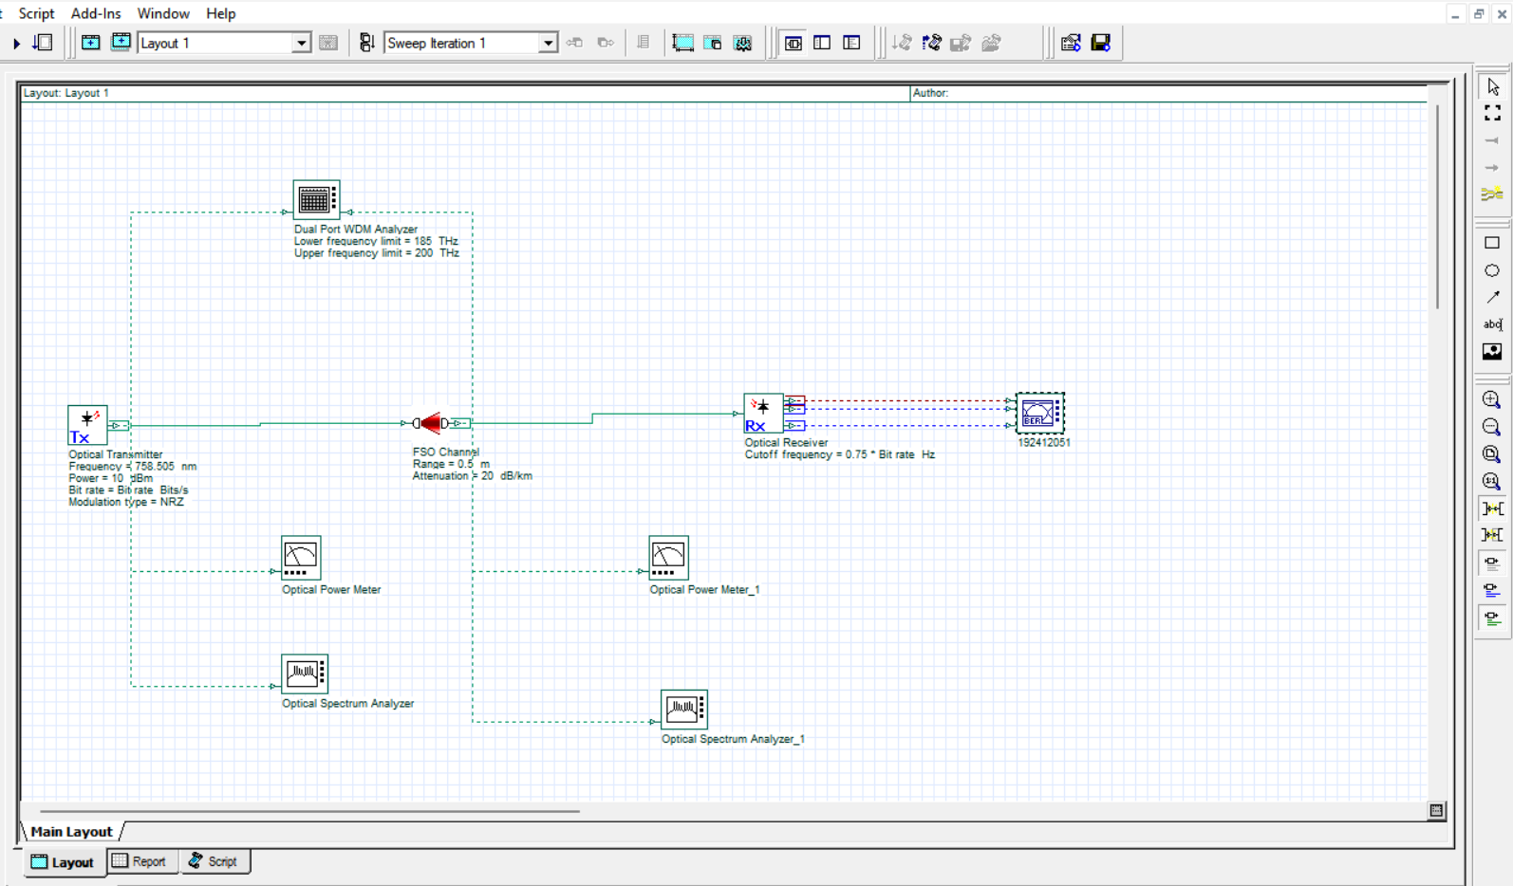

Output:

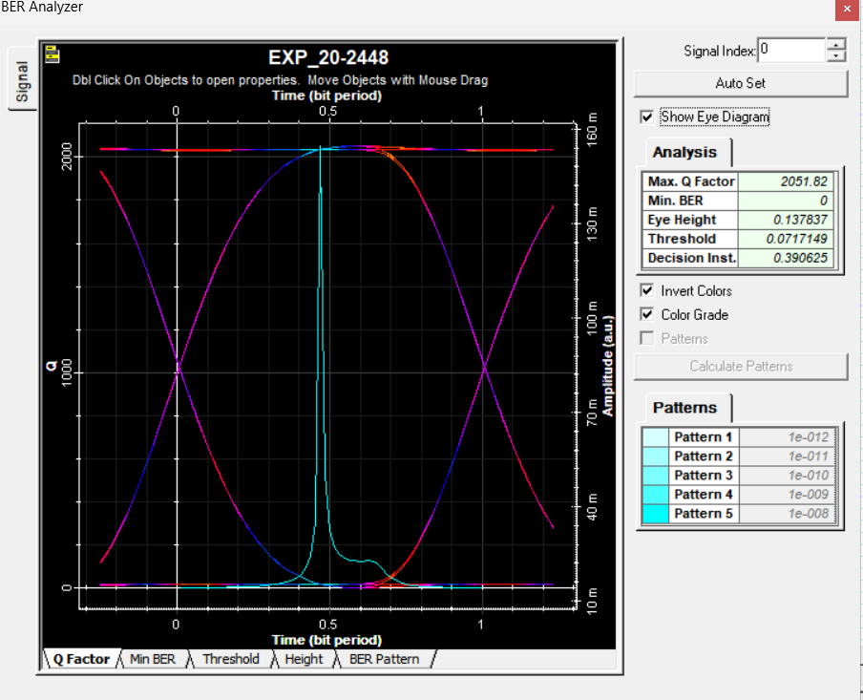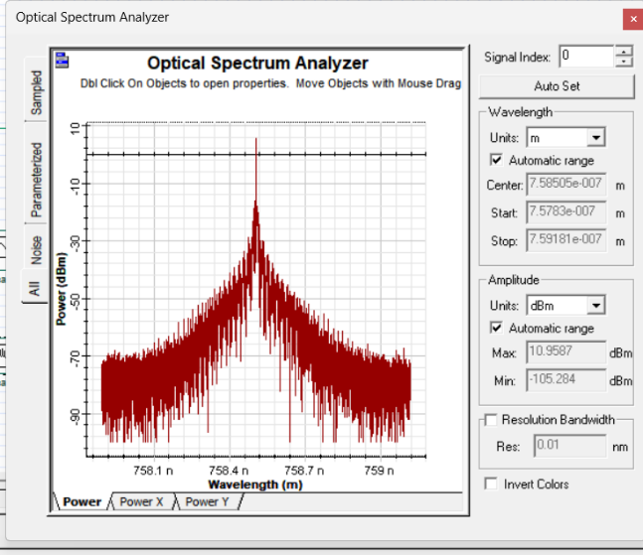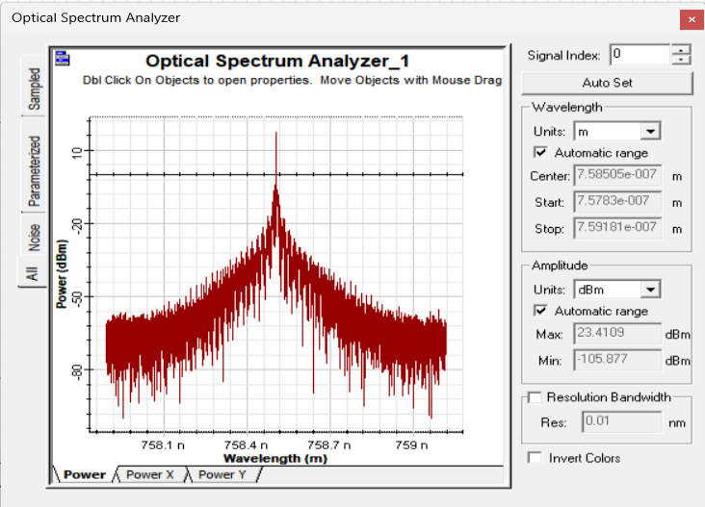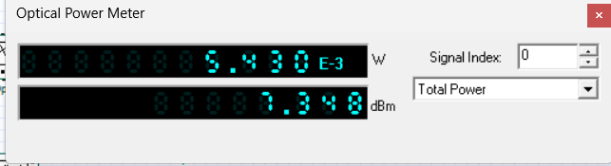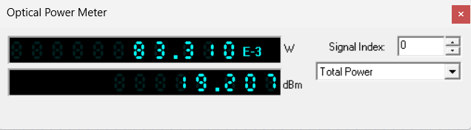

REFLECTION:
- Learned the basic working principle of Free-Space Optical communication.
- Understood the effect of atmospheric turbulence on optical signal transmission.
- Gained practical knowledge of designing and simulating an FSO link using OptiSystem.
- Learned to analyse system performance using BER and received power measurements.

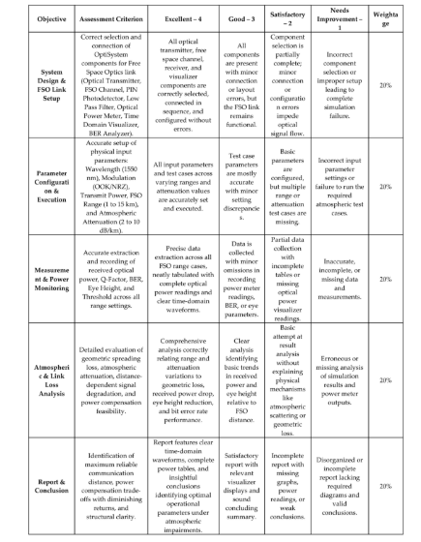
RUBRICS:

CONCLUSION

Thus, the performance of a Free-Space Optical (FSO) communication link under atmospheric turbulence was successfully evaluated using OptiSystem. The simulation helped to understand how atmospheric turbulence affects optical signal quality and transmission. The performance was analysed using received optical power and Bit Error Rate (BER). Hence, this experiment provided a better understanding of FSO communication and its reliability under different atmospheric conditions.

