Exp. No: 10 PHOTODIODE RESPONSE AND SENSITIVITY ANALYSIS USING OPTISYSTEM

OBJECTIVES
1. Design and simulate an optical receiver using PIN and APD photodetectors in OptiSystem.
2. Observe the photocurrent generated for a given received optical power and determine the responsivity of the detectors.
3. Determine the receiver sensitivity (minimum received power), bandwidth and the variation of SNR and BER with received power.
4. Compare the PIN and APD receivers and evaluate photodetector performance.
SOFTWARE REQUIRED
• OptiSystem software
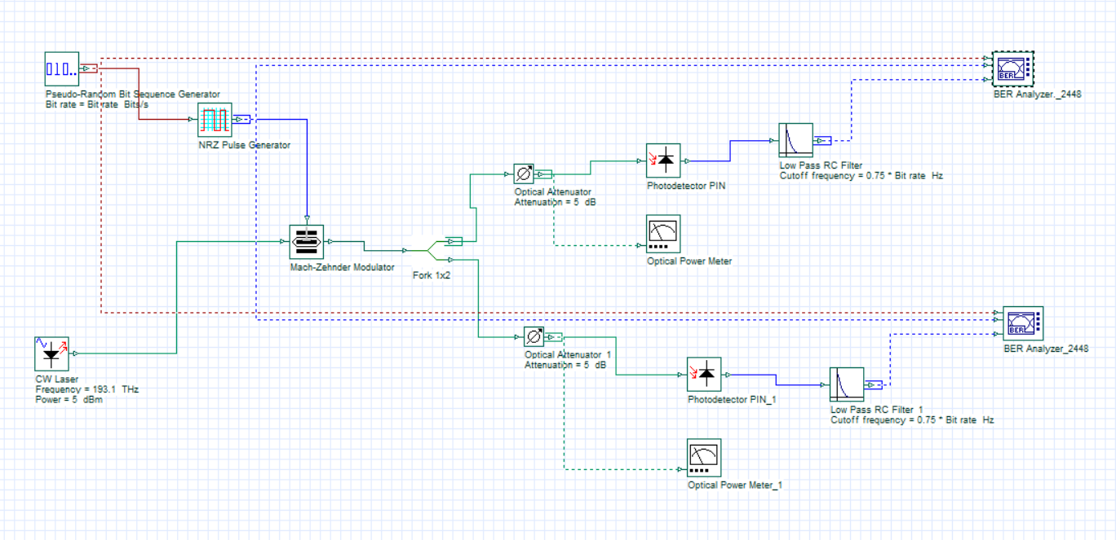
SIMULATION CIRCUIT

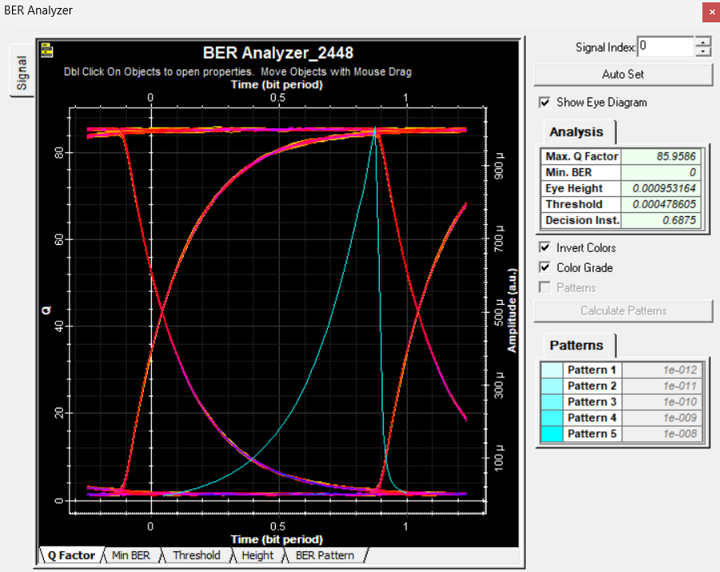
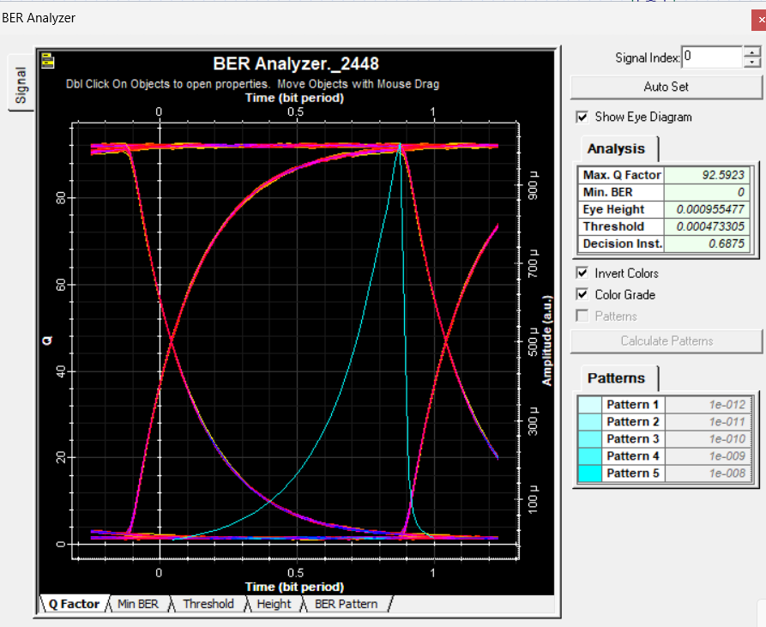
OUTPUT

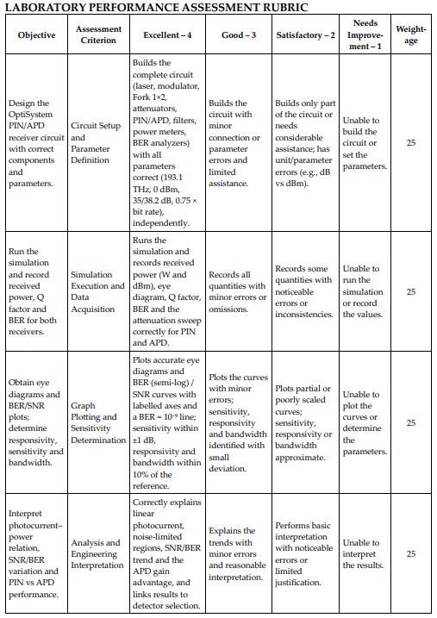
REFLECTION:
This experiment helped me understand the working of a photodiode and its role in converting optical signals into electrical signals at the receiver. Using OptiSystem, I analyzed photodiode response and sensitivity under different conditions. I learned how photodiode characteristics affect signal detection, receiver performance, and the reliability of optical communication systems.
CONCLUSION
The experiment demonstrates how photodetectors convert optical power into photocurrent and affect receiver performance. The PIN receiver operates effectively at −38.2 dBm, while the APD receiver achieves higher sensitivity, working at −41.4 dBm due to avalanche gain. As received power increases, SNR and Q factor improve, reducing BER. Receiver bandwidth is mainly determined by the low-pass filter. Overall, APDs provide better sensitivity, whereas PIN photodiodes offer simpler operation with lower noise, making detector selection dependent on the system power budget.

