SIMATS ENGINEERING
ASSESSMENT TOOL

COURSE CODE:ECA1803 COURSE NAME: Optical Fiber Communication

ULTRA-HIGH-SPEED PHOTONIC TRANSPORT LINK:
TECHNOLOGY EVALUATION, IMPAIRMENT MITIGATION, AND INTEGRATED SYSTEM DESIGN
32-Channel DWDM · 200 Gb/s per Channel · DP-16QAM · Hybrid Raman-EDFA · Coherent DSP

Course Outcome – CO4
Design and analyze modulation formats (OOK, PAM4, DPSK, QAM, coherent QAM), implement modulators (EO, AO, thermooptic, MZI, ring resonators), and evaluate optical amplifiers (EDFA, SOA, Raman) in WDM systems with DSP compensation.

Code of Conduct:

I S HARIPRIYA (192412448) (Name / Reg No) certify that this submission is my original work and that I have adhered to the guidelines specified for this assessment.
I understand that any violation of academic integrity rules will result in disciplinary action.

Signature of the student: Priya

ABSTRACT
This report investigates and designs a 32-channel dense wavelength division multiplexed transport link carrying 200 Gb/s per channel, 6.4 Tb/s in total, on the ITU-T 50 GHz grid and compliant with ITU-T G.698.2, IEEE 802.3ct/ck and OIF-CEI practice. Starting from the requirement, the net spectral efficiency of 4.0 b/s/Hz, a pre-FEC BER threshold of 2 × 10⁻², an OSNR requirement of 16.3 dB (20.3 dB design target) and the impairment set are quantified. Eight modulation formats and four modulation mechanisms are compared, leading to dual-polarization 16-QAM at 28.75 GBd generated by a silicon-photonic carrier-depletion nested IQ Mach-Zehnder modulator with 38 GHz bandwidth, Vπ = 4.5 V and 8.1 mm² per channel (Design Decision 1).
Five amplifier technologies are analysed with link power and ASE calculations; a counter-pumped four-pump Raman stage combined with a gain-flattened EDFA provides 17 dB gain per 80 km span and an effective noise figure of +0.1 dB, giving an ASE-limited OSNR of 27.1 dB after 12 spans (Design Decision 2). A fully digital coherent receiver with frequency-domain dispersion equalisation, 2×2 MIMO equalisation, blind phase search and optional single-channel digital backpropagation is selected (Design Decision 3). The integrated system reaches 960 km with a pre-FEC BER of 1.2 × 10⁻³, Q = 9.6 dB and 1.5 dB of end-of-life margin at 57.5 pJ/bit per transceiver (Design Decision 4).
The verification table shows that all targets are met, and the final engineering decision is to deploy the system, subject to confirmation by full-field OptiSystem simulation.
Keywords: DWDM, DP-16QAM, silicon photonics, hybrid Raman-EDFA, coherent DSP, digital backpropagation, OSNR, spectral efficiency.

CHAPTER 1: INTERPRETATION OF THE COMMUNICATION REQUIREMENT

1.1 Introduction and Problem Context
Traffic growth driven by cloud services, video distribution and 5G backhaul has pushed metro and regional operators towards wavelength channels of 200 Gb/s and beyond. The service considered here is a 32-channel dense wavelength division multiplexed (DWDM) transport link in which every wavelength carries 200 Gb/s and the whole system must sit on the ITU-T 50 GHz frequency grid [1], [2]. The line interface must remain compatible with the Ethernet and OIF electrical and optical ecosystem, namely IEEE 802.3ct for DWDM operation [3], IEEE 802.3ck for 100 Gb/s-per-lane host interfaces [4], OIF 400ZR for coherent pluggable practice [5] and OIF-CEI for the electrical I/O [6].
The investigation follows the prescribed workflow: requirement, literature, alternatives, analysis, selection, system design, verification and final decision. Four design decisions are taken in Chapters 2 to 5, and Chapter 6 verifies the integrated design against the targets derived in this chapter. All figures are numbered consecutively; each is followed by a short statement of its operation, its relevance to the design and its advantages and limitations.
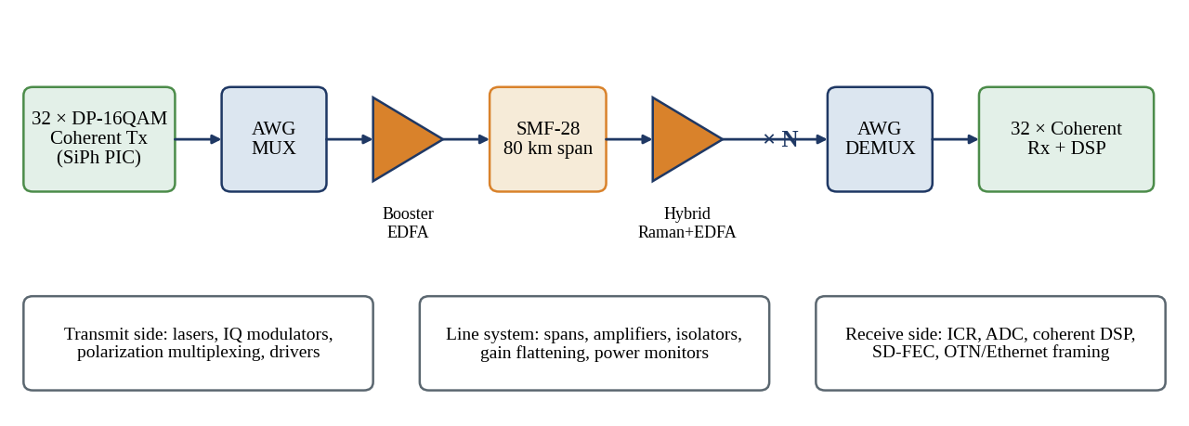
Figure 1: Generic DWDM transport architecture and the functional blocks examined in this report
Operation. Thirty-two transmitters are modulated independently, combined by an arrayed waveguide grating (AWG), boosted, and launched into a chain of amplified fibre spans; at the far end a second AWG separates the channels for coherent detection and digital processing. Relevance. The three lower boxes show how the report is partitioned: transmitter (Chapter 2), line system (Chapter 3), receiver DSP (Chapter 4) and their integration (Chapters 5 and 6). Advantages and limitations. A shared line system amortises amplifier cost over 32 channels, but all channels see the same impairments, so a single design margin must satisfy the worst channel.

1.2 Literature Review
Coherent detection with digital signal processing (DSP) has become the dominant technology for line rates above 100 Gb/s because the receiver recovers amplitude, phase and polarization of the optical field [7], [8], [9]. Dual-polarization quadrature phase-shift keying (DP-QPSK) at about 32 GBd was the first commercial 100 Gb/s solution and was standardised for DWDM Ethernet in IEEE 802.3ct [10], [3]. Higher-order quadrature amplitude modulation (QAM) doubles or triples the bits per symbol at the cost of higher required signal-to-noise ratio (SNR), and the trade between spectral efficiency and reach is bounded by the nonlinear Shannon limit [11], [12].
Fibre propagation is described by the nonlinear Schrödinger equation, whose linear terms (attenuation, chromatic dispersion and polarization mode dispersion) and Kerr nonlinearity are covered in [13], [14]; the statistics of polarization mode dispersion follow the Poole–Wagner model [15]. For uncompensated coherent links the Gaussian-noise (GN) model gives a closed-form estimate of nonlinear interference [16], which is used throughout this report for launch-power optimisation. Sections of the ITU-T and OIF literature fix the grid, interface classes and forward error correction (FEC) thresholds [1], [2], [17], [18], [19].

1.3 Technology Benchmarking
Table 1 positions the target service against published transport technologies. The target occupies a deliberate middle ground: it keeps the 50 GHz grid and 32 GBd-class electronics of the 100G generation while doubling bits per symbol, and it avoids the 60 GBd, 75 GHz profile of 400ZR whose OSNR demand suits only short data-centre-interconnect reach.
Table 1: Benchmark of representative transport technologies (typical published values)
Technology | Format | Baud (GBd) | Grid (GHz) | Net SE (b/s/Hz) | Req. OSNR (dB/0.1 nm) | Typical reach
100G coherent (802.3ct) | DP-QPSK | ≈ 30 | 50 | 2.0 | ≈ 12 | > 2,000 km
100G/λ IM-DD PAM4 (802.3) | PAM4 | ≈ 53 | n/a (grey) | n/a | ≈ 24 | ≤ 80 km
400ZR (OIF) | DP-16QAM | ≈ 60 | 75 | 5.3 | ≈ 26 | ≈ 120 km
This work | DP-16QAM | 28.75 | 50 | 4.0 | 16.3 (theory) | 960 km (≥ 2,000 km extended)

1.4 Aggregate Capacity and Spectral Efficiency
The aggregate payload capacity follows directly from the channel plan:
C_{total} = N_{ch} × R_{ch} = 32 × 200 Gb/s = 6.4 Tb/s (1.1)
Forward error correction must be added to the payload. A soft-decision FEC (SD-FEC) with 15 % overhead is assumed, giving a line rate of 200 × 1.15 = 230 Gb/s per channel and 7.36 Tb/s for the system. The occupied optical band is 32 × 50 GHz = 1.6 THz, which is one third of the 4.8 THz C-band. The spectral efficiency (SE) is therefore:
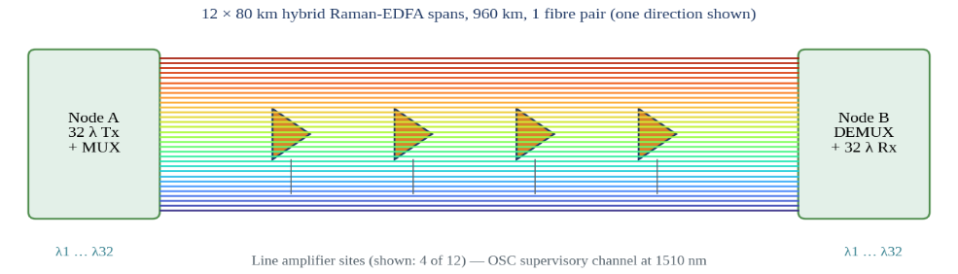
SE_{net} = R_{ch} / Δf = 200 Gb/s / 50 GHz = 4.0 b/s/Hz ; SE_{gross} = 230 / 50 = 4.6 b/s/Hz (1.2)

Figure 2: Thirty-two-channel DWDM link between two terminal nodes through twelve amplified spans
Operation. Node A multiplexes 32 wavelengths onto one fibre; line amplifier sites restore the power every 80 km, and Node B demultiplexes them. An optical supervisory channel at 1510 nm, outside the C-band, carries amplifier management traffic. Relevance. The picture fixes the topology evaluated later: point-to-point, 12 spans, 960 km, with no intermediate add-drop. Advantages and limitations. The topology keeps filter concatenation penalties negligible; adding reconfigurable add-drop nodes would require extra margin for narrowing by wavelength-selective switches.
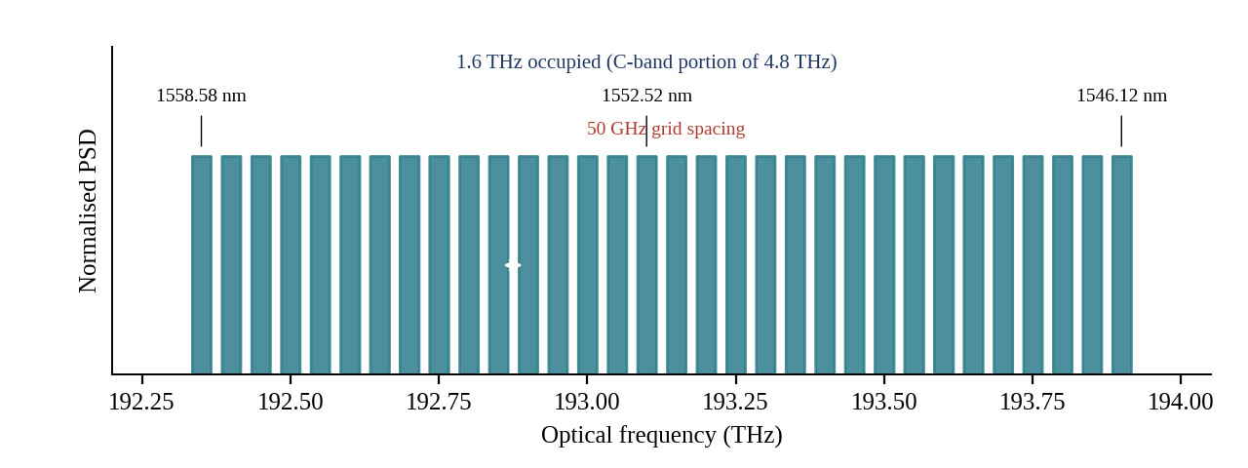
Figure 3: WDM spectrum allocation: 32 carriers on a 50 GHz ITU-T grid from 192.35 THz to 193.90 THz
Operation. Each rectangle represents the Nyquist-shaped spectrum (about 31.6 GHz) of one DP-16QAM carrier; the centre frequencies are multiples of 50 GHz away from the 193.1 THz anchor, so wavelengths run from 1558.58 nm down to 1546.12 nm. Relevance. The 18.4 GHz guard band between neighbours is what permits the AWG to be a practical filter with only about 0.5 dB of edge loss. Advantages and limitations. The fixed grid gives full interoperability under G.694.1 and G.698.2, but leaves 37 % of each slot unused; a flexible 37.5 GHz grid could raise SE to 5.3 b/s/Hz at the cost of tighter filter tolerances.

1.5 Physical-Layer Performance Metrics
Required SNR, Q-factor and BER. For square M-QAM with Gray mapping and additive white Gaussian noise, the bit error ratio (BER) is approximated by:
BER ≈ (4 / log₂M)(1 − 1/√M) · Q(√(3·SNR / (M − 1))) (1.3)
where Q(·) is the Gaussian tail function and SNR is the signal power divided by noise power in the symbol bandwidth. The SD-FEC chosen has a pre-FEC BER threshold of 2 × 10⁻² (equivalently about 15 % overhead delivering output BER below 10⁻¹⁵). Solving Equation 1.3 for 16-QAM gives SNR_{req} = 12.71 dB. The corresponding Q-factor is Q = √2 · erfc⁻¹(2·BER) = 2.05, or 20·log₁₀(Q) = 6.25 dB.
OSNR requirement. For a dual-polarization signal whose amplified spontaneous emission (ASE) occupies both polarizations, the optical SNR in the standard 0.1 nm (12.5 GHz) reference bandwidth is:
OSNR = SNR × (R_{s} / B_{ref}) = 12.71 dB + 10·log₁₀(28.75 / 12.5) = 16.33 dB (1.4)
A design OSNR target of 20.3 dB is adopted for the ASE-limited part of the link: 16.3 dB theory, 1.0 dB DSP implementation penalty, and 3.0 dB allocated to nonlinear interference, transceiver noise and ageing.
Launch power. The GN model, evaluated with γ = 1.3 W⁻¹km⁻¹, 80 km spans and 32 channels, places the optimum channel power between −4.5 dBm (hybrid amplifiers) and −3 dBm (EDFA-only). A launch power of −3 dBm per channel (total 12.05 dBm, 16 mW) is selected and justified in Chapter 3.
Modulator bandwidth, loss and thermal limits. The electro-optic 3-dB bandwidth should exceed about 0.7 R_{s} ≈ 20 GHz to avoid severe inter-symbol interference; a target of at least 30 GHz is set so that digital pre-emphasis can close the remaining roll-off. The loss budget from laser to booster input allows laser power of +15 dBm, coupling loss 1.5 dB, modulator loss 13.0 dB (including modulation loss of the nested IQ structure), AWG loss 4.5 dB and 1.0 dB for isolator, VOA and monitor tap, leaving −5.0 dBm per channel. Thermal and footprint constraints follow from a pluggable-class power envelope of about 12 W per transceiver and a photonic integrated circuit (PIC) area below 10 mm² per channel.
Table 2: Derived requirements from the communication service
Parameter | Symbol | Value
Aggregate payload capacity | C_{total} | 6.4 Tb/s (7.36 Tb/s line rate)
Net / gross spectral efficiency | SE | 4.0 / 4.6 b/s/Hz
Pre-FEC BER threshold | BER_{th} | 2 × 10⁻²
Q-factor at threshold | Q_{th} | 2.05 (6.25 dB)
Required SNR (ideal 16-QAM) | SNR_{req} | 12.71 dB
Required OSNR theory / design target | OSNR_{req} | 16.3 dB / 20.3 dB (0.1 nm)
Launch power per channel | P_{ch} | −3 dBm (12.05 dBm total)
Modulator 3-dB bandwidth | f_{3dB} | ≥ 30 GHz
Transmitter insertion loss budget | IL_{Tx} | ≤ 14 dB incl. modulation loss
Module power / PIC area | P_{mod} / A | ≤ 12 W / ≤ 10 mm² per channel

1.6 Fibre Impairments
Five impairment classes limit a 960 km transmission over G.652D fibre [17]. They are summarised with the dominant quantities used later in the design.
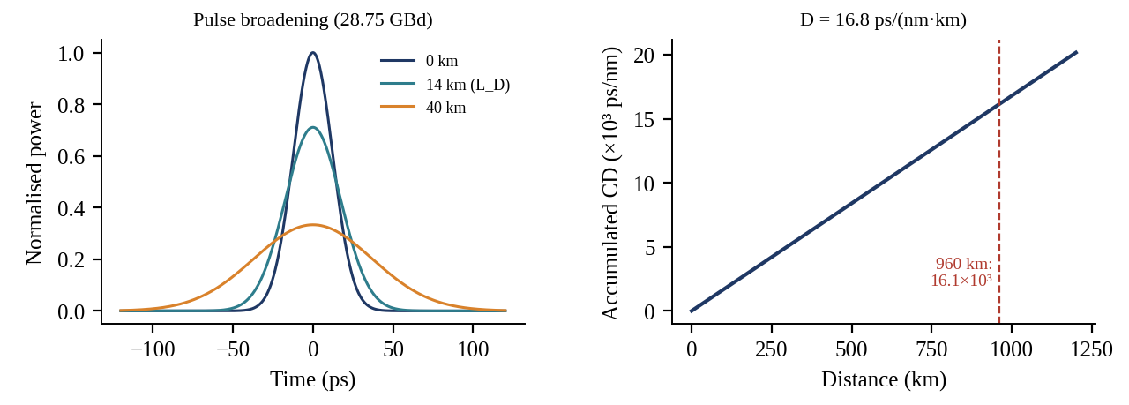
Figure 4: Chromatic dispersion: Gaussian pulse broadening and accumulated dispersion with distance
Operation. Different spectral components travel at different group velocities; a 28.75 GBd symbol (T₀ ≈ 17 ps) doubles in width within about 14 km, and the accumulated dispersion reaches 16.1 × 10³ ps/nm after 960 km. For a signal bandwidth of 0.25 nm this spreads each symbol over about 4.1 ns, or 117 symbol periods. Relevance. The memory depth is large but perfectly deterministic, which is why a static digital filter of about 430 taps (Chapter 4) can remove it entirely. Advantages and limitations. CD is fully linear and reversible, but the long filter costs multipliers and power, and it interacts with nonlinearity by converting phase to intensity noise.
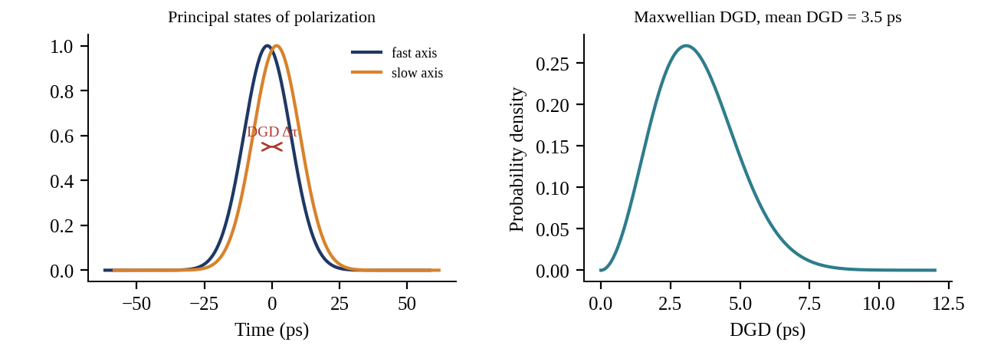
Figure 5: Polarization mode dispersion: differential group delay between principal states and its Maxwellian distribution
Operation. Random birefringence splits a pulse into two orthogonal principal states of polarization with a differential group delay (DGD) that follows a Maxwellian distribution [15]. For a fibre PMD coefficient of 0.1 ps/√km the mean DGD after 960 km is 3.1 ps, about 0.09 of a symbol period. Relevance. The DGD is small compared with the equaliser span, but it changes in milliseconds and also rotates the polarization state, so it requires adaptive tracking rather than a fixed filter. Advantages and limitations. Coherent MIMO equalisation removes PMD without optical hardware; the limit is the tap count, which here tolerates more than 100 ps.
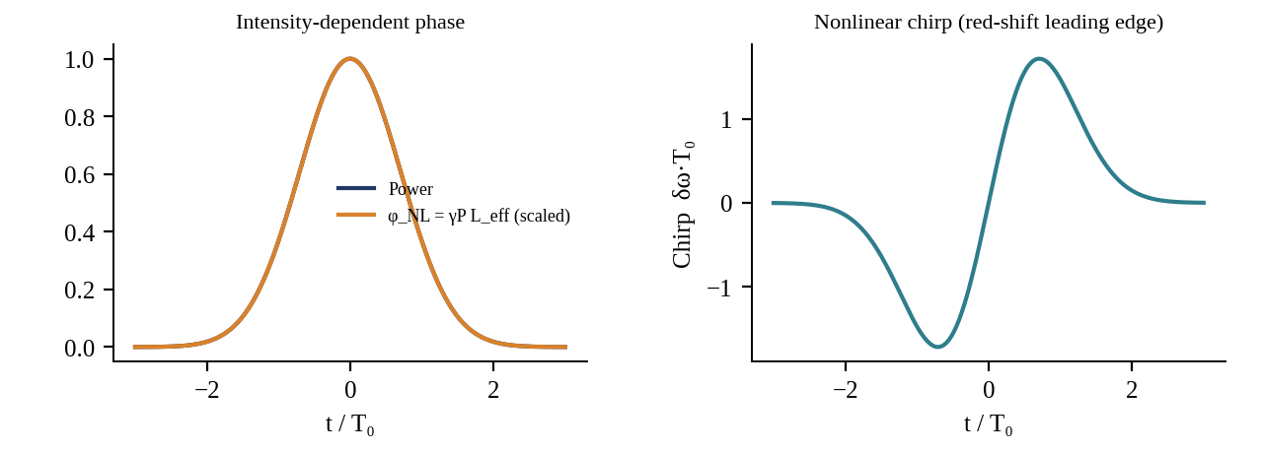
Figure 6: Self-phase modulation: intensity-dependent phase and the resulting nonlinear chirp
Operation. The Kerr effect makes the refractive index depend on optical power, so a pulse imposes a phase φ_{NL} = γ P L_{eff} on itself. With γ = 1.3 W⁻¹km⁻¹, L_{eff} = 21.2 km and P = −3 dBm, φ_{NL} = 0.014 rad per span, or 0.17 rad accumulated over 12 spans in the coherent worst case. Relevance. SPM sets the upper edge of the launch-power window and is the part of nonlinearity that single-channel digital backpropagation can reverse. Advantages and limitations. SPM is deterministic given the waveform, but when combined with dispersion it turns into amplitude noise that cannot be removed by a linear filter.
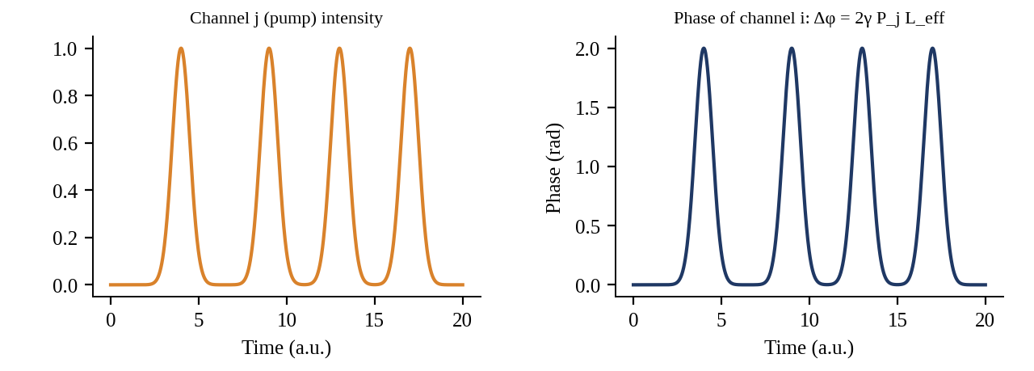
Figure 7: Cross-phase modulation: phase imprinted on channel i by the intensity of neighbouring channel j
Operation. The intensity pattern of one wavelength modulates the phase of another with twice the SPM coefficient, Δφ = 2γ P_{j} L_{eff}. Fibre dispersion makes the channels walk off, which converts the phase imprint into an effective noise whose strength falls as the channel spacing and local dispersion increase. Relevance. With 31 interferers at 50 GHz spacing XPM dominates the nonlinear interference budget, so launch power must be optimised for the whole comb. Advantages and limitations. XPM is partly averaged by walk-off, but it depends on the data of other channels, so it cannot be cancelled by a single-channel receiver.
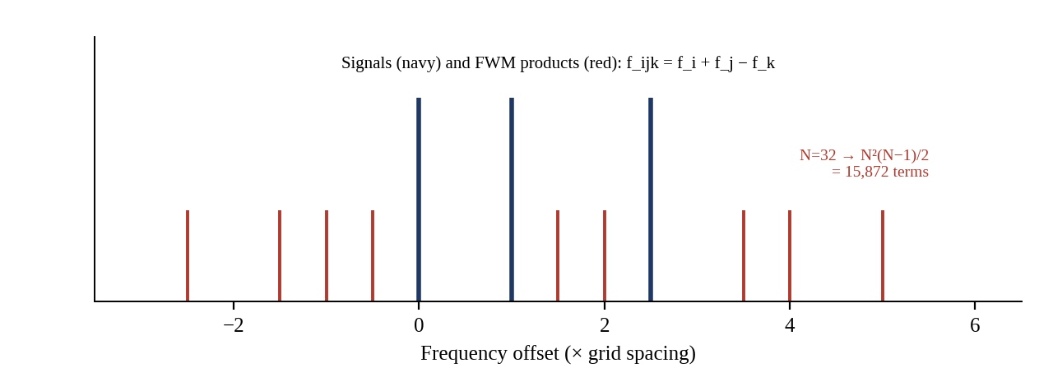
Figure 8: Four-wave mixing: mixing products generated by three carriers and the count for 32 channels
Operation. Three optical frequencies f_{i}, f_{j}, f_{k} generate products at f_{i} + f_{j} − f_{k}. For N = 32 channels there are N²(N − 1)/2 = 15,872 possible terms. The phase mismatch at 50 GHz spacing is Δβ ≈ 2.1 km⁻¹ for D = 16.8 ps/(nm·km), giving an efficiency η ≈ α²/Δβ² ≈ 4.7 × 10⁻⁴ (−33 dB). Relevance. Non-zero dispersion on G.652D keeps phase matching poor, so discrete FWM lines are weak and merge into the Gaussian-like nonlinear noise of the GN model. Advantages and limitations. Dispersion is thus helpful against FWM; dispersion-shifted fibre would be a poor choice here.
ASE noise and crosstalk. Every amplifier adds ASE with power P_{ASE} = NF · hν · G · B. After 12 spans with a hybrid amplifier the ASE power in the 28.75 GHz signal band is −26.4 dBm against a signal of −3 dBm, i.e. an ASE-limited SNR of 23.4 dB. The AWG demultiplexer provides at least −28 dB adjacent-channel and −38 dB non-adjacent isolation; summed over 31 interferers this is −21.1 dB, which is further suppressed by at least 8 dB through the local-oscillator selection and anti-alias filtering of the coherent receiver, leaving a crosstalk penalty of about 0.2 dB.

1.7 Mapping of Impairments to DSP Functions
Table 3: Impairments, magnitude in the proposed link and the DSP function that compensates each
Impairment | Magnitude (960 km) | DSP / design response
Chromatic dispersion | 16,128 ps/nm; ≈ 117 T_{s} memory | Static FDE, ≈ 430 taps, 1024-point FFT
PMD, polarization rotation | Mean DGD 3.1 ps; rotation kHz | 2×2 butterfly MIMO (CMA → RDE), 21 taps
PDL | ≈ 0.5 dB accumulated | MIMO equaliser, 0.5 dB margin
SPM (intra-channel) | 0.17 rad accumulated | Optional single-channel DBP, 1 step/span
XPM / FWM | ≈ 65 % of NLI | Launch-power optimisation, margin
Laser phase noise, frequency offset | Δν = 200 kHz sum; ±3 GHz offset | FFT-based FOE, blind phase search
Timing offset / clock error | ±200 ppm | Gardner timing recovery
Transmitter IQ skew, modulator roll-off | ≤ 3 ps skew; 38 GHz BW | Front-end deskew, orthogonalisation, pre-emphasis
ASE noise, crosstalk | SNR_{ASE} 23.4 dB | Amplifier design, SD-FEC

CHAPTER 2: MODULATION FORMAT AND MODULATOR CONFIGURATION

2.1 Candidate Modulation Formats
The line rate of each channel is 230 Gb/s once 15 % SD-FEC overhead is included. For a format carrying m bits per symbol per polarization and N_{pol} polarizations, the required symbol rate and the occupied bandwidth with root-raised-cosine (RRC) shaping of roll-off β are:
R_{s} = R_{line} / (m · N_{pol}) ; B_{occ} = R_{s} (1 + β) (2.1)
Each format is described below with its constellation or waveform, and Table 4 compares all eight candidates at the same line rate. The OSNR column is the ASE-limited theoretical requirement at the 2 × 10⁻² threshold and is obtained from SNR_{req} and Equation 1.4 (for single-polarization signals the reference noise is halved); the on-off-keying and PAM4 entries assume ideal direct detection and are indicative [11].
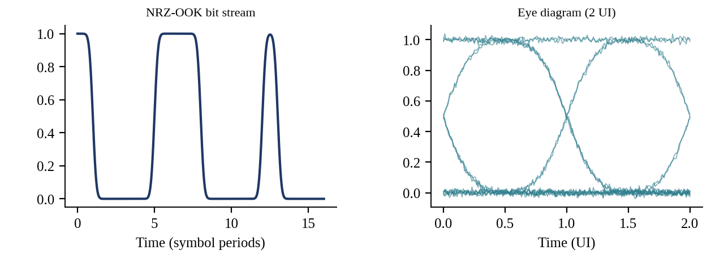
Figure 9: NRZ-OOK waveform and eye diagram
Operation. Light is switched between two power levels; the receiver is a single photodiode. At 230 Gb/s the bit slot is only 4.3 ps. Relevance. NRZ needs 230 GBd and about 460 GHz of double-sideband spectrum, nearly ten grid slots, and tolerates only about 2 ps/nm of chromatic dispersion, as the tolerance scales with the inverse square of the bit rate from roughly 1,000 ps/nm at 10 Gb/s. Advantages and limitations. It offers the simplest transmitter and receiver, but is useless at 200 Gb/s per channel on a 50 GHz grid.
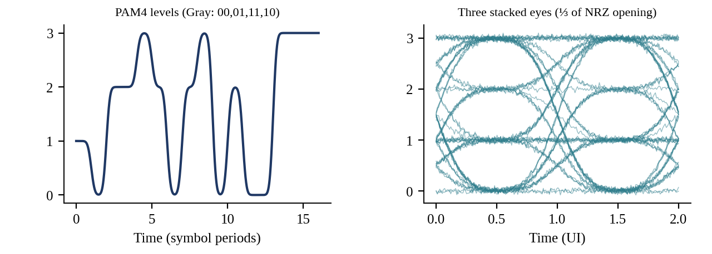
Figure 10: PAM4 waveform and the three stacked eyes
Operation. Two bits per symbol select one of four intensity levels, halving the symbol rate to 115 GBd. Relevance. Even with Nyquist shaping PAM4 occupies about 126.5 GHz, and the ITU-T flexible grid would assign a 137.5 GHz slot (11 × 12.5 GHz), giving a net SE of only 1.45 b/s/Hz and 4.4 THz for 32 channels. The three eyes each have one third of the NRZ opening, so the OSNR requirement is high (about 24 dB). Advantages and limitations. It is attractive for short reach intensity-modulation links where cost dominates, but no direct-detection receiver can compensate chromatic dispersion over 960 km.
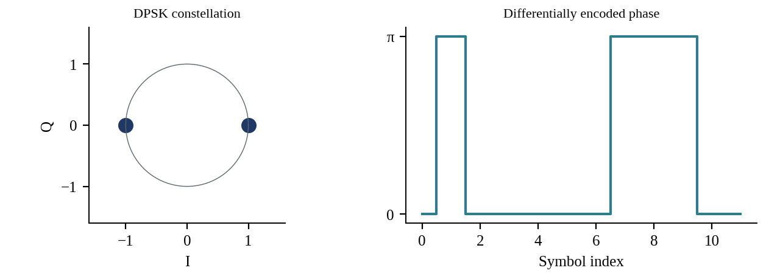
Figure 11: DPSK constellation and differentially encoded phase sequence
Operation. Information is carried in the phase change between successive symbols (0 or π), recovered by a delay-line interferometer and balanced detection. Relevance. DPSK needs about 3 dB less OSNR than OOK, but at 1 bit/symbol it still demands 230 GBd. Advantages and limitations. It is robust to laser phase drift over one symbol and needs no local oscillator; its weakness is the same spectral occupancy as OOK and sensitivity to CD and PMD that cannot be corrected digitally.
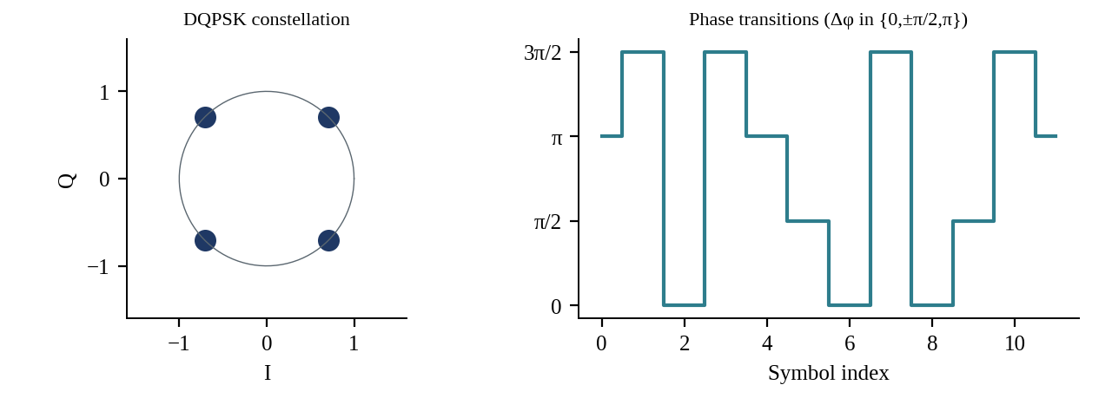
Figure 12: DQPSK constellation and differential phase transitions
Operation. Two bits select a phase change of 0, ±π/2 or π, detected with two interferometers offset by 90°. Relevance. At 115 GBd the occupied bandwidth is about 126 GHz, equal to PAM4 and again incompatible with 50 GHz spacing. Advantages and limitations. It halves the baud rate relative to DPSK with a modest 0.7 dB sensitivity loss, but remains a direct-detection scheme with only optical dispersion compensation.
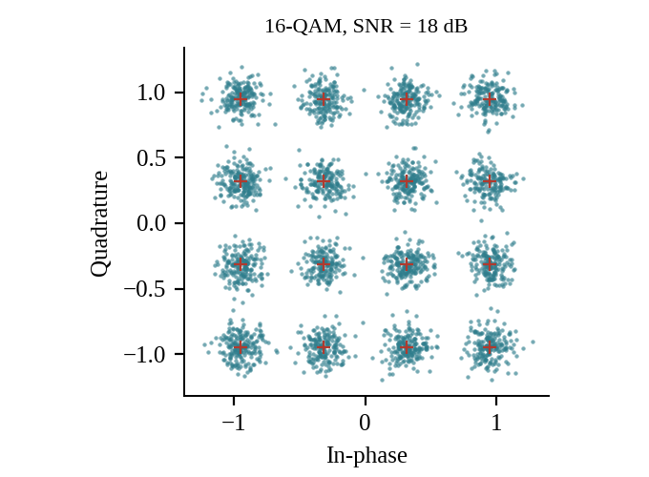
Figure 13: 16-QAM constellation at SNR = 18 dB
Operation. Sixteen points are formed by four amplitude levels on each of the two quadratures; four bits per symbol are carried per polarization. Relevance. Required SNR is 12.71 dB at the FEC threshold, 6.5 dB above QPSK, and the OSNR requirement is 16.3 dB at 57.5 GBd for a single polarization. Advantages and limitations. It reaches 57.5 GBd with a single polarization, but still needs 63 GHz of spectrum, which is why polarization multiplexing is needed.
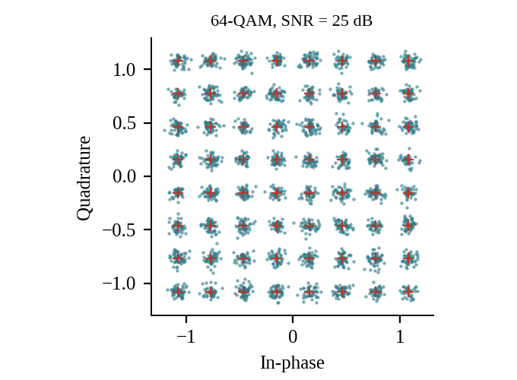
Figure 14: 64-QAM constellation at SNR = 25 dB
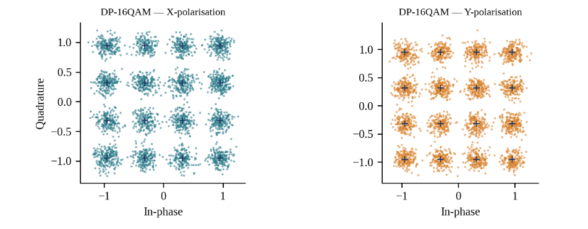
Operation. Eight levels per quadrature give six bits per symbol; at the same line rate the symbol rate drops to 38.3 GBd per polarization (19.2 GBd dual-polarization). Relevance. The required SNR rises to 18.43 dB and OSNR to 20.3 dB, 4 dB above 16-QAM, while the minimum distance falls by a factor of two relative to 16-QAM at equal average power. Advantages and limitations. The narrower spectrum would allow a 25 GHz slot, but the margin consumed by transceiver noise and nonlinearity (Fig. 48) makes 960 km impractical.

Figure 15: DP-16QAM constellations in the X and Y polarizations
Operation. Two independent 16-QAM streams are transmitted in orthogonal polarizations, giving eight bits per symbol. The required symbol rate is R_{s} = 230 / 8 = 28.75 GBd and the RRC occupancy (β = 0.1) is 31.6 GHz. Relevance. This fits comfortably within 50 GHz with 18.4 GHz guard, and the OSNR requirement of 16.3 dB is the same as single-polarization 16-QAM at double the baud. Advantages and limitations. The coherent receiver requires a local oscillator, four ADCs and adaptive MIMO equalisation; the benefit is that all linear impairments are corrected digitally.
Table 4: Comparison of candidate modulation formats at 230 Gb/s line rate (200 Gb/s payload)
Format | Bits/ symbol | Baud (GBd) | Occupied BW (GHz) | Net SE (b/s/Hz) | Req. SNR (dB) | Req. OSNR (dB) | Rx complexity | Cost | Scalability
NRZ-OOK | 1 | 230 | 460 | 0.43 | ≈ 6.3* | ≈ 19.5 | Low | Low | Poor
RZ-OOK (33 %) | 1 | 230 | 690 | 0.29 | ≈ 6.3* | ≈ 18.5 | Low | Medium | Poor
PAM4 | 2 | 115 | 126.5 | 1.58 | 12.7 | ≈ 24 | Low | Low | Poor
DPSK | 1 | 230 | 460 | 0.43 | 5.1 | 14.8 | Medium | Medium | Poor
DQPSK | 2 | 115 | 126.5 | 1.58 | 8.9 | 15.5 | Medium | Medium | Poor
16-QAM (SP) | 4 | 57.5 | 63.3 | 3.16 | 12.7 | 16.3 | High | High | Fair
64-QAM (SP) | 6 | 38.3 | 42.2 | 4.74 | 18.4 | 20.3 | High | High | Fair
DP-16QAM | 8 | 28.75 | 31.6 | 6.33 | 12.7 | 16.3 | High | Medium | Good

*Electrical-domain SNR equivalent to Q = 2.05. Net SE is payload divided by occupied bandwidth; the usable grid SE is 4.0 b/s/Hz for DP-16QAM and 1.45 b/s/Hz for PAM4 in a 137.5 GHz slot.
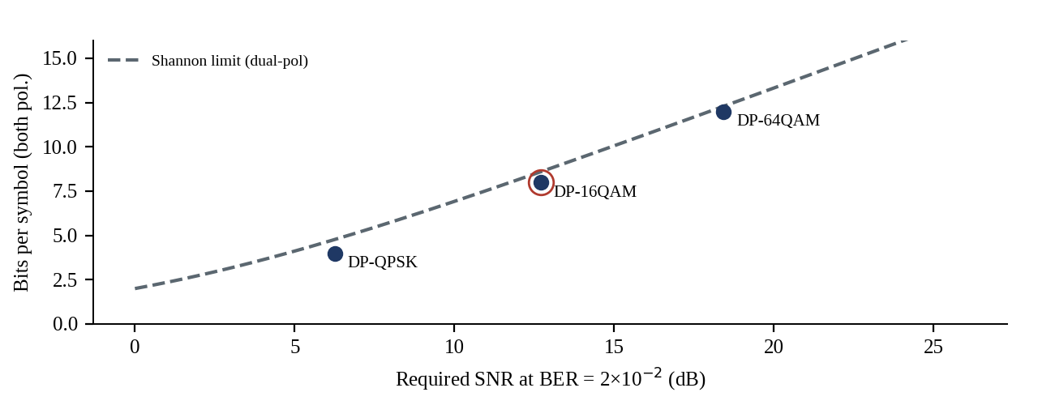
Figure 16: Bits per symbol versus required SNR at the FEC threshold, compared with the dual-polarization Shannon limit
Operation. Each point is the SNR required for the stated format at BER = 2 × 10⁻²; the dashed curve is the capacity 2·log₂(1 + SNR). Relevance. DP-16QAM at 12.7 dB sits within about 2.5 dB of the Shannon bound for 8 bits, and moving to DP-64QAM raises the requirement by 5.7 dB for a 50 % gain in bits per symbol; for 200 Gb/s on 50 GHz DP-16QAM is therefore the knee of the curve. Advantages and limitations. The curve is for linear AWGN; the nonlinear fibre channel reduces achievable SE at long distance, which the GN model quantifies in Chapter 3.

2.2 Spectral Occupancy and Channel Spacing: DP-16QAM versus PAM4
For DP-16QAM, R_{s} = 28.75 GBd, B_{occ} = 28.75 × 1.1 = 31.6 GHz, and a 37.5 GHz flex-grid slot would suffice technically; the 50 GHz fixed grid is retained for G.698.2 compliance and because 18.4 GHz of guard band allows commercial 50 GHz AWGs with a ±0.5 dB flat top. For PAM4, R_{s} = 115 GBd, B_{occ} = 126.5 GHz and the smallest ITU-T flexible-grid slot is 137.5 GHz, 2.75 times wider. The 32-channel comb would then use 4.4 THz, 92 % of the C-band, against 1.6 THz (33 %) for DP-16QAM, leaving no spectrum for growth.

2.3 Modulation Mechanisms
The phase or amplitude of light can be controlled by several physical effects. Their speed and drive requirements differ by more than six orders of magnitude (Table 5).
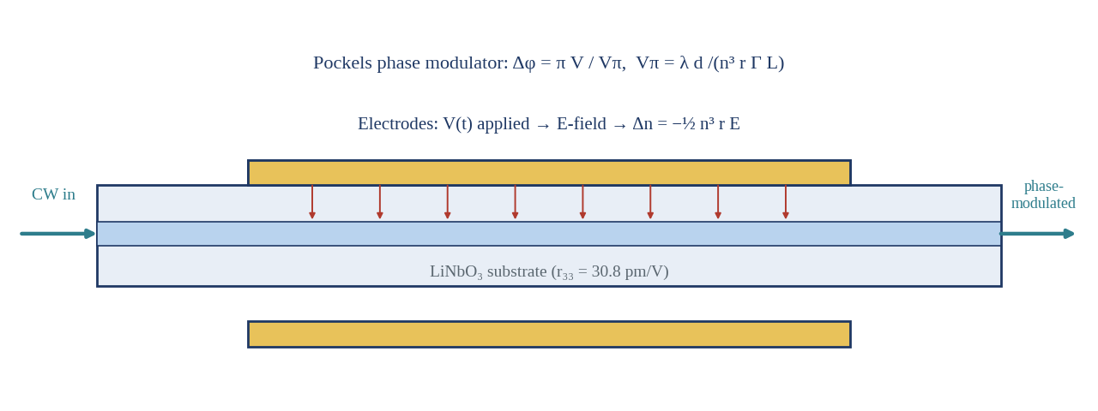
Figure 17: Electro-optic (Pockels) phase modulator in lithium niobate
Operation. An applied field changes the refractive index by Δn = −½ n³ r E, which produces a phase shift Δφ = π V / Vπ with Vπ = λ d / (n³ r Γ L). Relevance. The effect has no carrier lifetime, so bandwidth is limited by electrode design only (> 70 GHz), and the same linear-field principle is used in the plasma-dispersion silicon modulator that is selected. Advantages and limitations. It offers zero chirp, high linearity and speed, but bulk LiNbO₃ devices are centimetres long and require hybrid integration, and Vπ·L ≈ 2 V·cm.
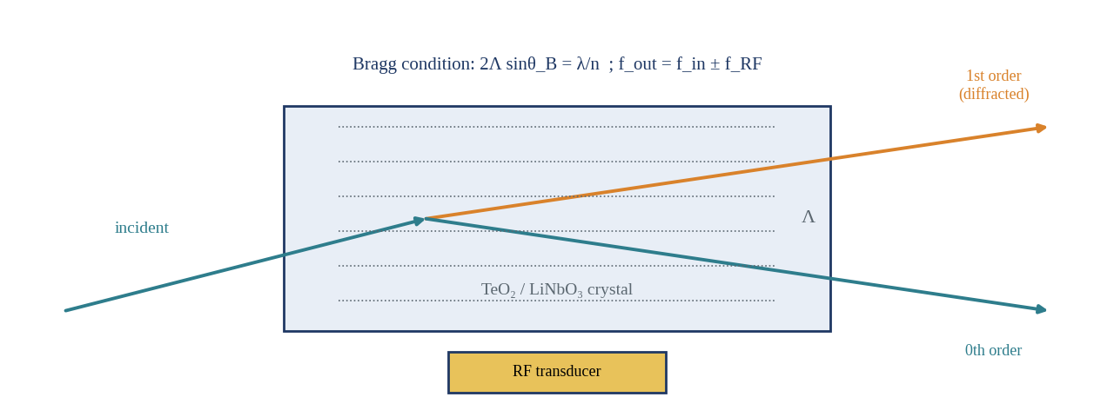
Figure 18: Acousto-optic Bragg modulator
Operation. A radio-frequency transducer launches a travelling grating of period Λ; light diffracts at the Bragg angle and is shifted by the acoustic frequency. Relevance. The response time is set by the acoustic transit time across the beam (0.1–10 μs), so bandwidth is limited to a few hundred MHz at best. Advantages and limitations. Excellent for tunable filters, frequency shifters and Q-switching, but 2–3 orders of magnitude too slow for a 28.75 GBd symbol stream.
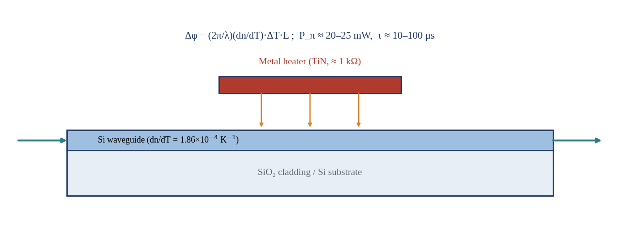
Figure 19: Thermo-optic phase shifter
Operation. A resistive heater raises the waveguide temperature; with dn/dT = 1.86 × 10⁻⁴ K⁻¹ for silicon, a π shift in a 100 μm arm needs about 20–25 mW. Relevance. Time constants of 10–100 μs make it suitable for bias control, wavelength tuning and ring locking, not for data. Advantages and limitations. It is simple, compact and low loss, but slow and consumes static power; thermal crosstalk between neighbouring devices must be managed.
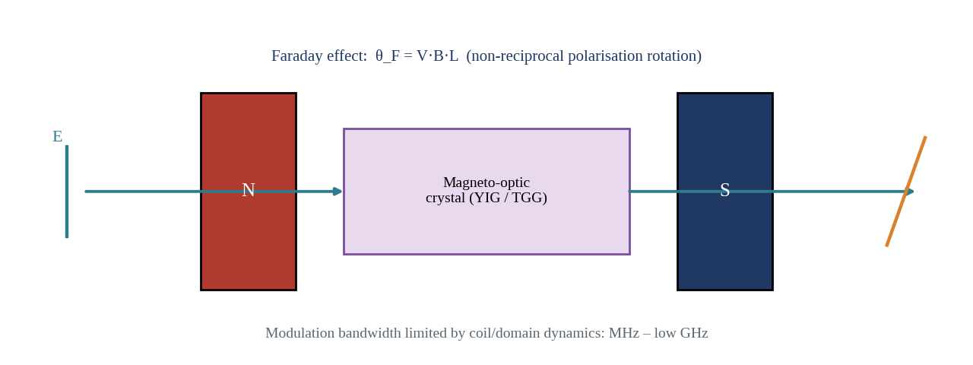
Figure 20: Magneto-optic (Faraday) element
Operation. A magnetic field along the propagation direction rotates the plane of polarization by θ = V·B·L, with a sense that does not reverse with the direction of travel. Relevance. Non-reciprocity makes it indispensable for isolators and circulators (Chapter 5), while modulation speeds of garnet devices remain in the MHz to low GHz range. Advantages and limitations. Useful for protection against back-reflections but not for 28.75 GBd modulation; it also requires magnetic materials that are difficult to integrate on silicon.
Table 5: Comparison of modulation mechanisms
Mechanism | Physical effect | Speed limit | Drive / Vπ·L | Response time | Chirp | Suitability
Electro-optic (LiNbO₃) | Pockels, linear field | > 70 GHz | 1.5–2.5 V·cm | < 5 ps | ≈ 0 (push-pull) | Excellent but bulky
Electro-optic (Si plasma dispersion) | Carrier depletion | 30–50 GHz | 1.5–2.5 V·cm | ≈ 10 ps | Low (push-pull) | Selected
Acousto-optic | Bragg diffraction | ≤ 0.5 GHz | RF 0.5–2 W | 0.1–10 μs | Frequency shift | Unsuitable
Thermo-optic | dn/dT heating | < 100 kHz | P_π ≈ 20–25 mW | 10–100 μs | None | Bias / tuning only
Magneto-optic | Faraday rotation | MHz–1 GHz | B ≈ 0.1–1 T | > 100 ns | None | Isolators only
Kerr (all-optical) | n₂I; n₂ = 2.6 × 10⁻²⁰ m²/W | > THz | Δn ≈ 2.6 × 10⁻⁷ at 1 GW/cm² | < 10 fs | SPM chirp | Needs km length or GW/cm²

2.4 Modulator Architectures
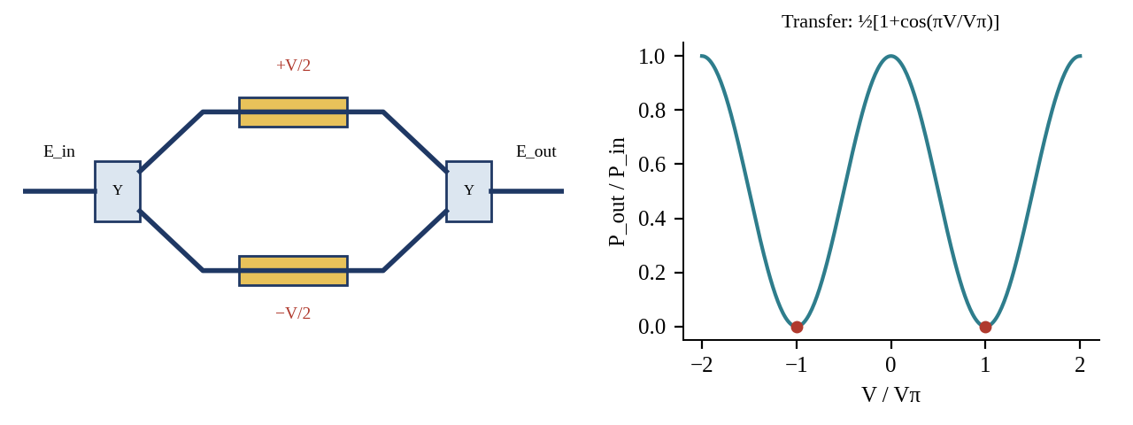
Figure 21: Mach-Zehnder interferometer modulator and its raised-cosine transfer function
Operation. An input Y-junction splits light into two arms; push-pull phase shifts of ±V/2 are applied and the arms recombine, giving P_{out}/P_{in} = ½[1 + cos(πV/Vπ)]. At the null-bias point the field transfer is linear in V, so the MZM generates an amplitude- and phase-linear field E_{out} ∝ sin(πV/2Vπ). Relevance. Two MZMs in a nested IQ arrangement with a 90° phase offset synthesise any 16-QAM point, and a second pair on the orthogonal polarization completes the DP-IQ transmitter. Advantages and limitations. The MZM is broadband and has low chirp in push-pull operation, but is millimetres long and needs bias control against drift.
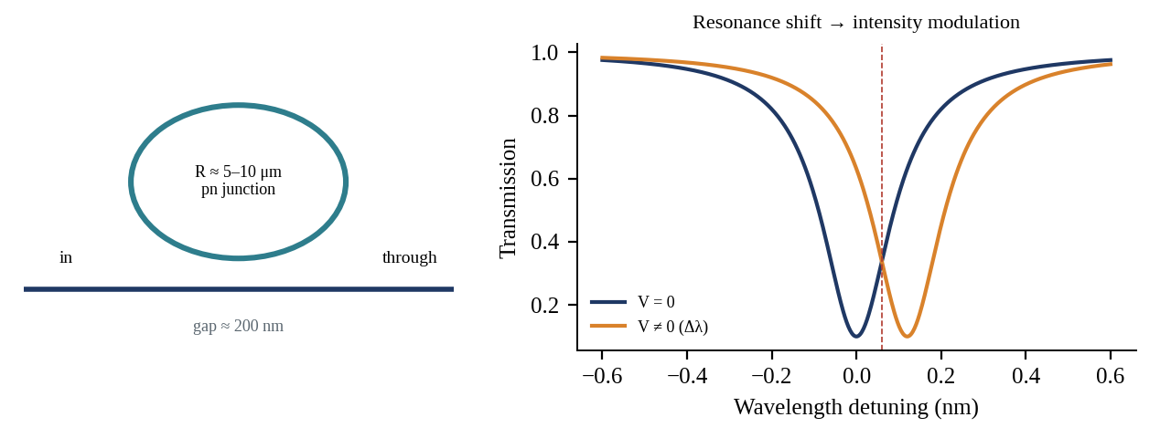
Figure 22: Micro-ring resonator modulator and resonance shift
Operation. A ring of 5–10 μm radius coupled to a bus waveguide imposes a Lorentzian notch; the carrier-induced index change shifts the resonance and thereby the transmission at a fixed laser wavelength. Relevance. The footprint is about 10⁻³ mm², two to three orders smaller than an MZM, but the thermal drift of 80 pm/K (about 10 GHz/K) means the 50 GHz grid is violated by a 5 K error unless a heater loop is used. Advantages and limitations. Excellent for low-energy on-off keying; the nonlinear transfer and strong chirp degrade 16-QAM, and the photon lifetime limits bandwidth to about 24 GHz at Q ≈ 8,000.
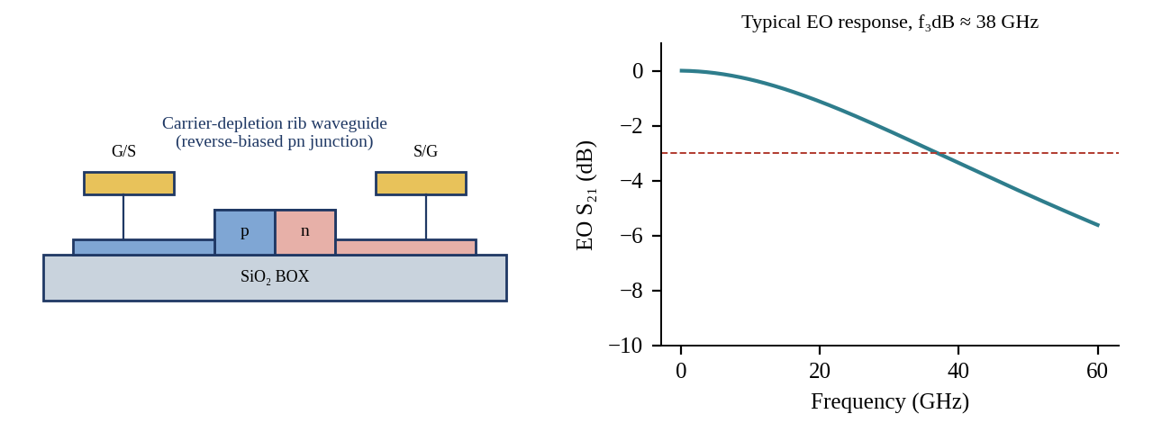
Figure 23: Silicon photonic carrier-depletion rib-waveguide modulator and its electro-optic response
Operation. A reverse-biased pn junction in a rib waveguide depletes carriers and changes both the real and imaginary index (plasma dispersion) [20]; a travelling-wave electrode ensures that the electrical and optical waves co-propagate so that the 3-dB bandwidth reaches about 38 GHz. Relevance. With Vπ·L = 1.8 V·cm and L = 4 mm, Vπ = 4.5 V, so a 2.5 Vpp per-arm driver in push-pull reaches 5.0 V effective swing. Advantages and limitations. CMOS foundry compatibility and co-integration with AWG, MMI and polarization rotators are decisive; the penalties are 4–6 dB insertion loss and residual chirp from absorption.
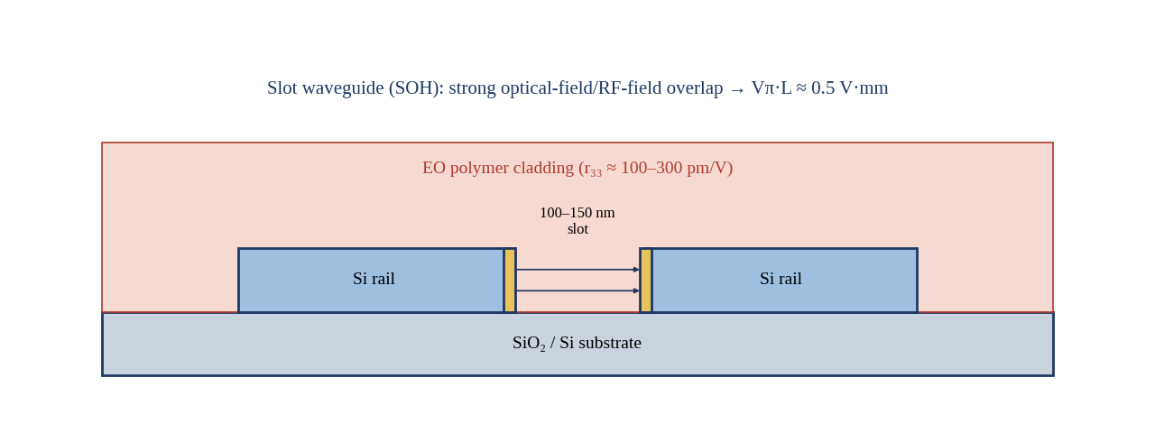
Figure 24: Electro-optic polymer slot-waveguide modulator (silicon-organic hybrid)
Operation. The polymer fills a 100–150 nm slot between two silicon rails, so the RF field is concentrated across the slot while the optical mode overlaps strongly with the high-r₃₃ polymer [24]. Relevance. Vπ·L of about 0.5 V·mm permits driving directly from CMOS (below 1 V) and 100 GHz bandwidth has been demonstrated, which makes it the leading candidate for future 100 GBd transmitters. Advantages and limitations. Excess loss of 6–10 dB and long-term thermal and photo-stability under Telcordia reliability tests are not yet proven to carrier standards; polymer poling also adds a process step.
Table 6: Comparison of integrated modulator architectures
Parameter | Silicon MZM (carrier depletion) | Silicon MRR | EO polymer (SOH) | Thin-film LiNbO₃ MZM
3-dB EO bandwidth | 35–45 GHz | 30–50 GHz (photon-lifetime limited) | > 100 GHz | 70–100 GHz
Footprint (length) | 3–4 mm | 10–20 μm radius | 0.5–1 mm | 5–20 mm
Vπ (typical) | 4–6 V | 1–2 V swing | 0.5–2 V | 2–3 V
Chirp | Low (|α| < 0.3, push-pull) | High (|α| ≈ 2–4) | Low | ≈ 0
Thermal sensitivity | Moderate (bias drift) | 80 pm/K – needs lock | Moderate, polymer dn/dT | Low
Insertion loss (device) | 4–6 dB | 1–3 dB | 6–10 dB | 3–4 dB

CHAPTER 3: OPTICAL AMPLIFICATION CONFIGURATION

3.1 Candidate Amplifiers
Amplification must restore a 17 dB span loss (80 km at 0.20 dB/km plus 1 dB of connectors and splices) for 32 channels without adding excessive ASE, gain ripple or inter-channel crosstalk. The five candidates are shown in turn.
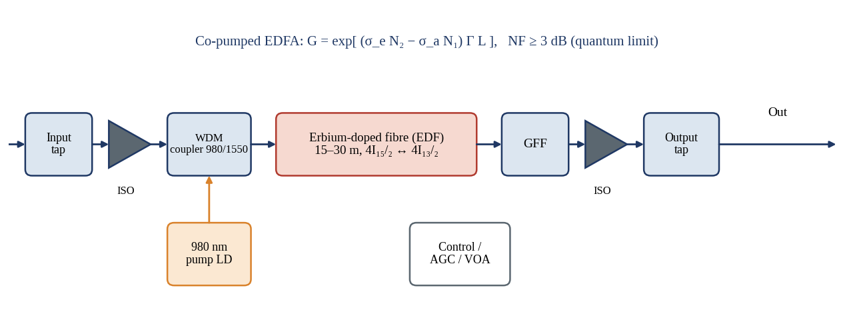
Figure 25: Erbium-doped fibre amplifier with pump, WDM coupler, isolators, gain flattening filter and monitoring
Operation. A 980 nm pump excites Er³⁺ ions in 15–30 m of doped fibre; signal photons stimulate emission on the ⁴I₁₃/₂ → ⁴I₁₅/₂ transition [25], [26]. The gain-flattening filter (GFF) and automatic gain control hold the response flat. Relevance. The EDFA gives 20–40 dB gain over the 35 nm C-band with saturated output of +17 to +23 dBm, far above the 12 dBm needed here, and a noise figure of 4.5–6 dB (quantum limit 3 dB). Advantages and limitations. The millisecond gain dynamics eliminate inter-channel crosstalk, but the 5 dB noise figure is the largest single contributor to ASE in an EDFA-only chain.
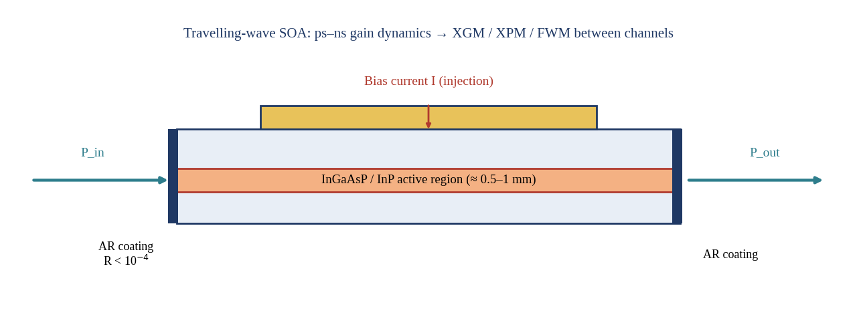
Figure 26: Semiconductor optical amplifier (travelling-wave type)
Operation. Current injection into an InGaAsP active layer creates gain; anti-reflection coatings with reflectivity below 10⁻⁴ suppress cavity resonance [27]. Relevance. Gain recovery time of 100 ps makes the output of each channel depend on the instantaneous power of the others (cross-gain modulation) and creates strong four-wave mixing, so it is unsuitable for 32 channels at 28.75 GBd in a line amplifier. Advantages and limitations. It is compact, integrable and covers 40–60 nm of bandwidth, but noise figure is 7–9 dB, saturation power only +10 to +16 dBm, and the gain is polarization-dependent.
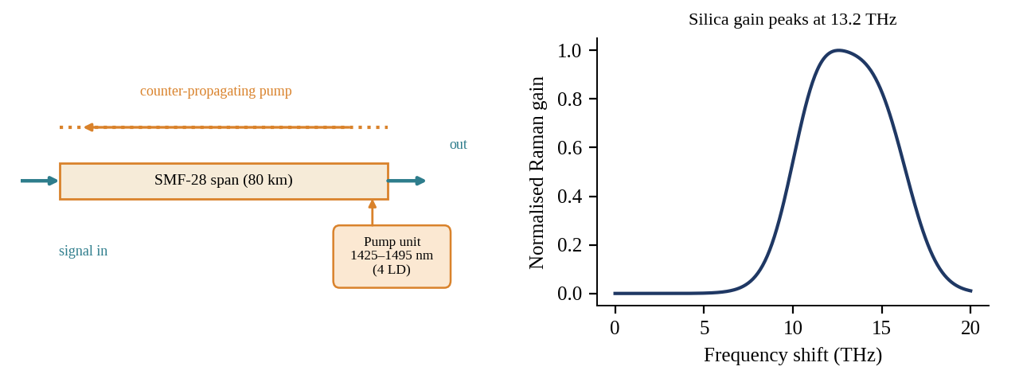
Figure 27: Counter-pumped distributed Raman amplifier and the silica Raman gain profile
Operation. Pump light 13.2 THz above the signal transfers energy through stimulated Raman scattering in the transmission fibre itself; four pumps at 1427, 1440, 1462 and 1495 nm of 150 mW each (600 mW total) generate a broad, tunable gain [28]. Relevance. The gain is created along the span so signal power never falls to its minimum, giving an effective noise figure of about −1.5 dB at 10 dB on-off gain. Advantages and limitations. Raman amplification offers the best noise performance and arbitrary band coverage, but needs watt-class pumps, optical-safety interlocks and care with pump-to-signal relative intensity noise and double Rayleigh backscattering.
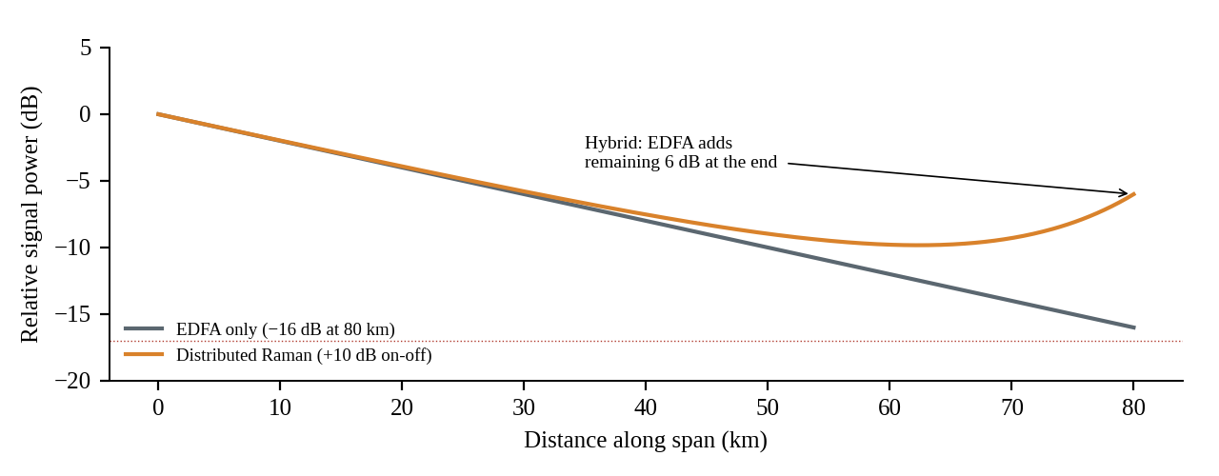
Figure 28: Signal power profile along an 80 km span: EDFA only versus Raman-assisted (hybrid) amplification
Operation. Without Raman, the signal decays to −16 dB before the EDFA; with 10 dB of backward Raman gain it never drops below about −10 dB and arrives at −6 dB, so the EDFA only has to supply about 7 dB. Relevance. Because the signal stays higher in the span, ASE accumulation relative to signal is reduced; using the cascade F_{eff} = F_{R},eff + F_{EDFA} / G_{on}-off = 0.708 + 3.162/10 = 1.02 gives an effective hybrid noise figure of +0.1 dB, 4.9 dB better than the EDFA alone. Advantages and limitations. The improvement is lost if the Raman gain is increased so far that the signal rises above the nonlinear threshold near the fibre start; the on-off gain is therefore limited to 10 dB.

3.2 Amplifier Comparison
Table 7: Comparison of candidate amplifier technologies for 32 × 28.75 GBd DP-16QAM
Parameter | EDFA | SOA | Distributed Raman | Lumped Raman | Hybrid EDFA + Raman
Gain | 20–40 dB | 15–25 dB | 8–15 dB on-off | 10–20 dB | 17 dB (10 + 7)
Noise figure | 4.5–6 dB (5.0 used) | 7–9 dB (8.0) | −2 to 0 dB eff. (−1.5) | 3–6 dB (4.0) | +0.1 dB eff.
Gain flatness | ±1.5 dB raw; ±0.3 dB with GFF | ± 2 dB | ±0.5 dB (4 pumps) | ±0.5 dB | ±0.4 dB
Saturated output | +17 to +23 dBm | +10 to +16 dBm | Pump limited | +15 dBm | ≥ +20 dBm
Inter-channel crosstalk | Negligible | Severe (XGM, FWM) | Low (pump RIN) | Low | Low
Scalability to 32+ ch / L-band | Good (C or L) | Poor | Excellent | Good | Excellent
Pump power / complexity | 0.1–0.5 W / low | Current / low | ≈ 0.6 W / high | 1–3 W / high | 0.6 W + EDFA / high

3.3 Analytical Power and Gain Calculations
Take an input of −20 dBm per channel at the line amplifier (after 17 dB of span loss from a launch of −3 dBm) and a target output of −3 dBm per channel, with 32 channels. The total power is the per-channel power plus 10·log₁₀(32) = 15.05 dB:
P_{in},tot = −20 + 15.05 = −4.95 dBm (0.32 mW) (3.1)
P_{out},tot = −3 + 15.05 = 12.05 dBm = 10^(1.205) mW ≈ 16.0 mW (3.2)
G_{span} = P_{out} − P_{in} = −3 − (−20) = 17 dB (3.3)
The booster at the transmitter sees −5.0 dBm per channel (from the loss budget of Section 1.5) and must lift it to −3 dBm, i.e. 2 dB gain and 12.05 dBm total output; the preamplifier before the demultiplexer delivers −3 dBm, and the 4.0 dB AWG demultiplexer loss leaves −7 dBm per channel at the coherent receiver, inside the −10 to 0 dBm operating window of an integrated coherent receiver. The 17 dB span gain is split as 10 dB Raman and 7 dB EDFA gain.
ASE noise and OSNR. ASE power per span in a bandwidth B is P_{ASE} = NF · hν · G · B, with hν = 1.28 × 10⁻¹⁹ J at 1550 nm. In the 12.5 GHz reference bandwidth hν·B_{ref} = −58 dBm, so the OSNR after N identical spans is:
OSNR(dB/0.1 nm) = 58 + P_{ch} − L_{span} − NF − 10·log₁₀(N) (3.4)
With P_{ch} = −3 dBm, L_{span} = 17 dB and N = 12 (10·log₁₀12 = 10.8 dB), the results are 22.2 dB for the EDFA chain (NF 5 dB), 19.2 dB for SOAs (NF 8 dB), 23.2 dB for lumped Raman (NF 4 dB), 28.7 dB for pure distributed Raman (NF_{eff} −1.5 dB) and 27.1 dB for the hybrid (NF_{eff} +0.1 dB). Against the 20.3 dB design target, the SOA fails outright, the EDFA and lumped Raman have 1.9 dB and 2.9 dB of margin that is consumed by nonlinear noise, and the hybrid has 6.8 dB.
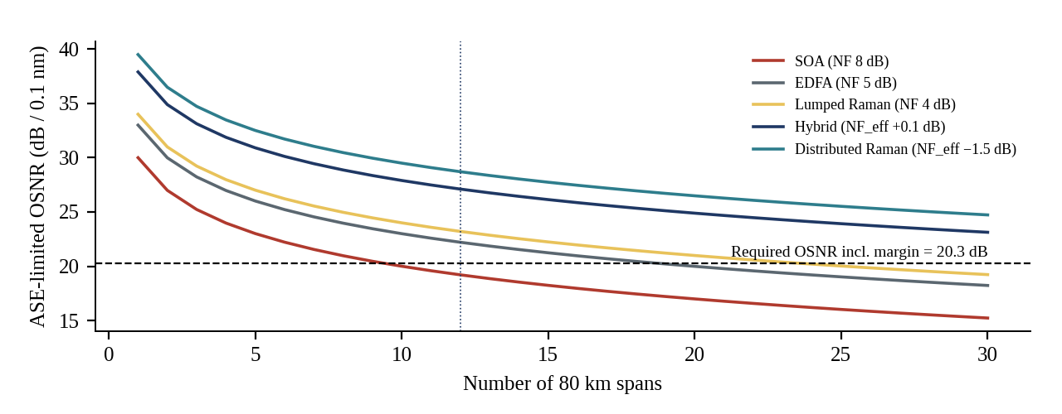
Figure 29: ASE-limited OSNR versus number of 80 km spans for each amplifier type
Operation. Each curve follows Equation 3.4; the dashed line is the 20.3 dB design requirement. Relevance. The SOA falls below the requirement after nine spans, the EDFA chain after 14 spans, while hybrid and distributed Raman remain above it beyond 30 spans. Advantages and limitations. The graph includes only ASE; once nonlinear interference and transceiver noise are included (Fig. 48), the useful range is shorter but the ranking does not change.
Table 8: Link power budget and amplifier summary (per channel)
Stage | Gain / loss (dB) | Level (dBm/ch) | Total (dBm, 32 ch)
ITLA output | — | +15.0 | —
Chip coupling + DP-IQ modulator | −14.5 | +0.5 | 15.5
AWG mux (4.5) + ISO/VOA/tap (1.0) | −5.5 | −5.0 | 10.0
Booster EDFA | +2.0 | −3.0 | 12.05
80 km SMF + connectors | −17.0 | −20.0 | −4.95
Raman 10 dB + line EDFA 7 dB (per span) | +17.0 | −3.0 | 12.05
After span 12: pre-amp stage | 0 net | −3.0 | 12.05
AWG demux | −4.0 | −7.0 | 8.05
Coherent receiver input | — | −7.0 | 8.05

3.4 Gain Flatness, Gain Tilt and Equalisation
The raw EDFA gain across 1530–1565 nm varies by about 5 dB peak to peak because of the emission cross-section of erbium. A thin-film GFF has the inverse loss profile and reduces this to ±0.25–0.3 dB. Changes of the pump or input power rotate the gain spectrum, producing tilt of roughly 0.5 dB across the band for each 1 dB change in average gain. In a cascade the residual ripple accumulates, 0.25 dB per amplifier adds to 3 dB after 12 amplifiers, enough to bring weak channels 3 dB closer to the OSNR limit.
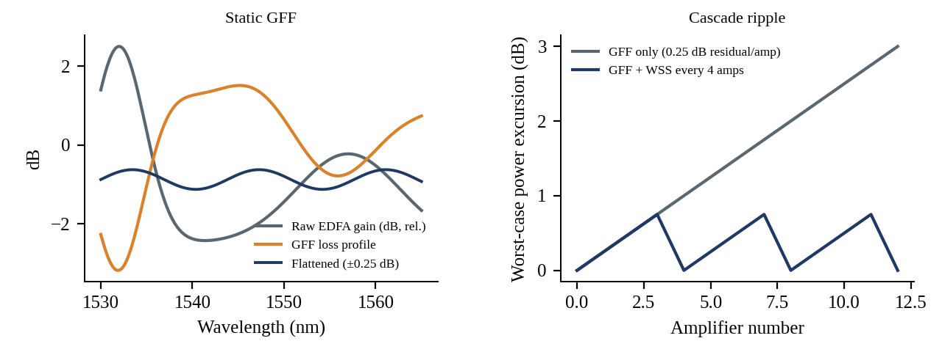
Figure 30: Static gain flattening filter and accumulated ripple in a cascade with and without dynamic equalisation
Operation. Left: the GFF loss profile (orange) is the mirror of the raw gain (grey) giving a flattened response (navy). Right: a wavelength-selective switch used as a dynamic gain equaliser every fourth amplifier resets the accumulated excursion to below 0.75 dB. Relevance. The design uses a static GFF in every EDFA and the Raman pump powers trimmed at commissioning, plus a WSS-based equaliser every fourth site (three in the 12-span link). Advantages and limitations. Dynamic equalisation prevents slow drift but adds about 6 dB loss per WSS unless the loss is placed within the existing EDFA mid-stage.

3.5 Cascaded Span Analysis
Table 9 shows how the signal-to-noise ratio at the receiver is composed after 12 spans at −3 dBm. The Gaussian-noise model, with γ = 1.3 W⁻¹km⁻¹, β₂ = −21.4 ps²/km, L_{eff} = 21.2 km and a nonlinear accumulation exponent of 1.05, gives an NLI-limited SNR of 22.3 dB at −3 dBm. The three noise terms add in the linear domain:
1/SNR_{tot} = 1/SNR_{ASE} + 1/SNR_{NLI} + 1/SNR_{TRx} (3.5)
Table 9: SNR budget at the design launch power (−3 dBm, 12 spans, 960 km)
Configuration | SNR_{ASE} (dB) | SNR_{NLI} (dB) | SNR_{TRx} (dB) | SNR_{tot} (dB) | Margin vs 12.7 dB (dB)
EDFA only (NF 5 dB) | 18.5 | 22.3 | 19.0 | 14.9 | 2.2
Hybrid Raman-EDFA | 23.4 | 22.3 | 19.0 | 16.4 | 3.7
Hybrid + single-channel DBP | 23.4 | 24.1† | 19.0 | 16.8 | 4.1

†Removal of 35 % of the NLI power by single-channel DBP raises SNR_{NLI} by 1.9 dB (22.3 to 24.1 dB). The GN model also shows that the optimum launch power is −4.5 dBm for the hybrid (SNR 16.6 dB) and −3.0 dBm for the EDFA-only link; the design point of −3 dBm sits 0.2 dB below the hybrid peak, where the curve is flat. With a minimum acceptable SNR of 13.7 dB (threshold plus 1.0 dB implementation allowance) the model supports 33 spans (2,640 km) for the hybrid, 18 spans (1,440 km) for the EDFA chain and 41 spans for the hybrid with DBP, for an ideal point-to-point route with no add-drop filtering.
CHAPTER 4: DSP IMPAIRMENT COMPENSATION CONFIGURATION

4.1 Impairment Mechanisms
Chapter 1 quantified chromatic dispersion (CD), PMD, SPM, XPM and FWM. Polarization-dependent loss (PDL) completes the list: isolators, couplers, WSS units and Raman couplers attenuate orthogonal polarization states differently, and the accumulated 0.5 dB over the link produces polarization-dependent SNR fluctuation that cannot be undone by a linear equaliser because it acts on the noise-loaded signal; it is treated as a 0.5 dB margin item. Equations governing the linear channel are the CD transfer function and the PMD Jones matrix:
H_{CD}(ω) = exp( j · D λ² z ω² / (4π c) ) ; U(ω) = exp(−jωΔτ/2 · σ₃) (4.1)

4.2 Optical versus Digital Compensation
Optical compensation of dispersion uses dispersion-compensating fibre (DCF) or fibre Bragg gratings, and optical phase conjugation (OPC) in the middle of the link can cancel odd-order nonlinear and dispersive terms. Digital compensation performs the same inversion in the receiver DSP. Table 10 compares them for the 960 km link.
Table 10: Optical versus digital impairment compensation
Criterion | DCF / FBG | Optical phase conjugation | Coherent DSP
CD compensation | Fixed per span; 13.4 km DCF per 80 km span | Mid-link only, symmetric link needed | Any value, adaptive, 430 taps for 960 km
Added loss / noise | ≈ 6.7 dB per span plus higher γ | Pump + conversion loss, ASE | None
Latency | ≈ 65 μs per span of DCF | Negligible | ≈ 1–2 μs digital
PMD | Not compensated | Not compensated | Adaptive MIMO, tracks kHz
Nonlinearity | Worsened (small A_{eff}) | Compensates symmetric link | DBP, limited by PMD and unknown co-channels
Flexibility / cost | Must be ordered per span length | Complex, rarely deployed | Software defined, ASIC power

Digital compensation is preferred because it adds no span loss (DCF would add about 6.7 dB loss per span and double the nonlinear coefficient), tracks PMD in time, and removes dispersion-map planning from the network. Dispersion-uncompensated transmission also increases the walk-off between channels, which lowers the XPM and FWM nonlinear noise, consistent with the GN model [16].

4.3 Coherent DSP Blocks
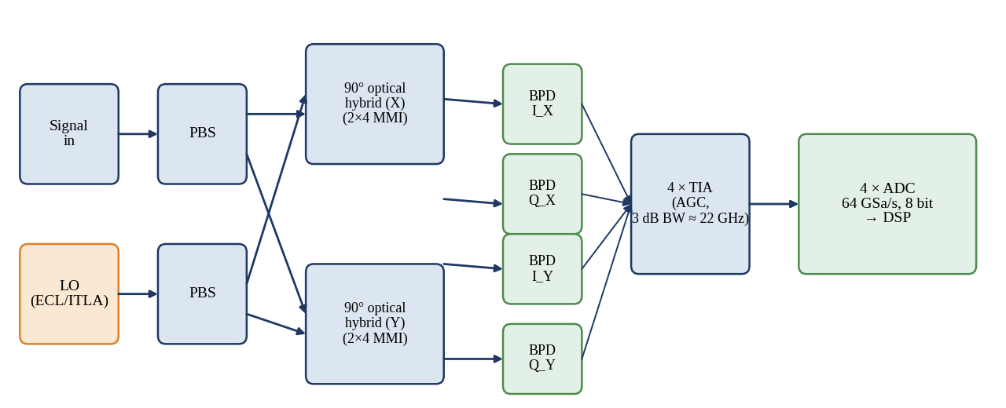
Figure 31: Dual-polarization coherent receiver: polarization beam splitters, 90° hybrids, balanced photodiodes and TIAs
Operation. The incoming signal and a local oscillator (LO) are each split into X and Y polarizations; two 2×4 multimode interference 90° hybrids mix them, and four balanced photodiodes plus transimpedance amplifiers (TIA) convert the in-phase and quadrature components of each polarization into voltages [7], [8]. Relevance. The receiver sensitivity to ASE is shot-noise limited with 12 dBm LO power and the common-mode rejection of the balanced pairs; the 3-dB TIA bandwidth is about 22 GHz. Advantages and limitations. Linear detection preserves the entire optical field, but needs a narrow-linewidth LO and tight skew and responsivity balance (below 1 ps and 0.5 dB).
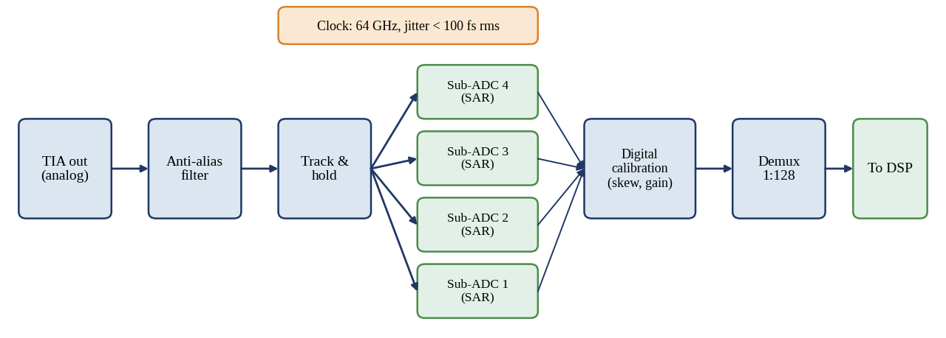
Figure 32: Analog-to-digital converter block: track-and-hold, time-interleaved sub-ADCs and digital calibration
Operation. A track-and-hold circuit samples the filtered TIA output at 64 GSa/s, equivalent to 2.2 samples per symbol; four interleaved SAR sub-converters digitise 8 bits each and a calibration block removes gain, offset and timing mismatch. Relevance. Quantisation and thermal noise set an effective number of bits (ENOB) near 5.5 at 22 GHz, equivalent to an SNR_{TRx} of about 19 dB that has been included in Equation 3.5. Advantages and limitations. Interleaving reaches the required rate in CMOS at a few watts; the cost is calibration complexity and spurs from interleave mismatch, which are the main cause of the transceiver SNR ceiling.

4.4 Static Chromatic Dispersion Equalisation (FIR and Frequency Domain)
Because H_{CD} is all-pass with quadratic phase, it can be implemented as a time-domain FIR filter with N taps or as a frequency-domain equaliser (FDE) using overlap-save FFTs. For a sampling period T = 1/(2R_{s}) = 17.4 ps, the number of taps required is:
N = 2 ⌊ |D| λ² L / (2 c T²) ⌋ + 1 = 2 ⌊213⌋ + 1 = 427 (4.2)
for L = 960 km (D·L = 16,128 ps/nm). With a time-domain FIR this would be 427 complex multipliers per output sample for each polarization, whereas an FDE with N_{FFT} = 1024 has a payload of 1024 − 427 = 597 samples per block and needs about 19 complex multiplications per sample, a 22-fold reduction. A 1024-point FFT supports up to 511 taps, i.e. 38,600 ps/nm or about 2,300 km, so the same hardware serves extended-reach links. The FDE is therefore chosen, and because the CD is static, its coefficients are set at provisioning (or estimated from a pilot).

4.5 Adaptive Equalisation: CMA, Polarization Demultiplexing and PMD
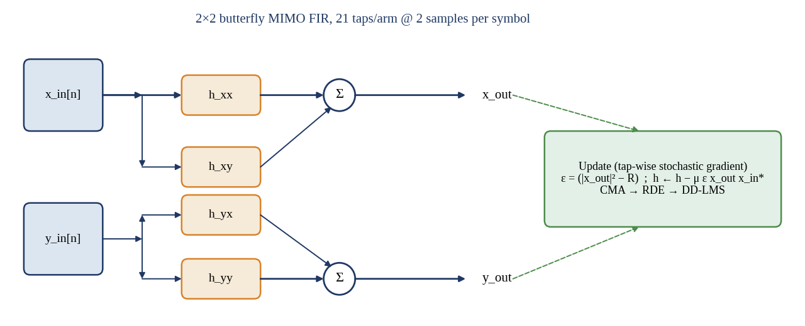
Figure 33: Adaptive 2×2 butterfly MIMO equaliser with constant-modulus update
Operation. Four complex FIR filters h_{xx}, h_{xy}, h_{yx}, h_{yy} of 21 taps at 2 samples per symbol combine the two input polarizations; the outputs are x_{out} = h_{xx} ∗ x + h_{xy} ∗ y and y_{out} = h_{yx} ∗ x + h_{yy} ∗ y, and the taps are updated with the stochastic gradient of the constant-modulus cost, h ← h − μ ε x_{out} x_{in}*, with ε = |x_{out}|² − R [31]. Relevance. The filter undoes polarization rotation and PMD simultaneously; since 16-QAM has three amplitude rings, the CMA is used only for pre-convergence and is followed by the radius-directed equaliser (RDE) and a decision-directed LMS once the mean-square error falls below 0.15 [9], [33]. Advantages and limitations. It is blind and tracks polarization changes of several hundred krad/s; the cost is the 672 real multiplications per symbol (including adaptation) and the possibility of converging both outputs to the same polarization (singularity), which is avoided by a short training header.

4.6 Frequency Offset, Carrier Phase Estimation
The free-running transmit laser and the local oscillator differ in frequency by up to ±3 GHz, which is removed by a 4th-power FFT-based estimator (for 16-QAM the estimator uses the corner symbols after CMA) before the phase estimator. Laser phase noise has a Wiener variance of 2π·Δν·T_{s} per symbol; with a combined linewidth of 200 kHz and T_{s} = 34.8 ps, the product Δν·T_{s} = 7 × 10⁻⁶, far below the 10⁻⁴ penalty limit of 16-QAM, so an ordinary feed-forward estimator is sufficient.
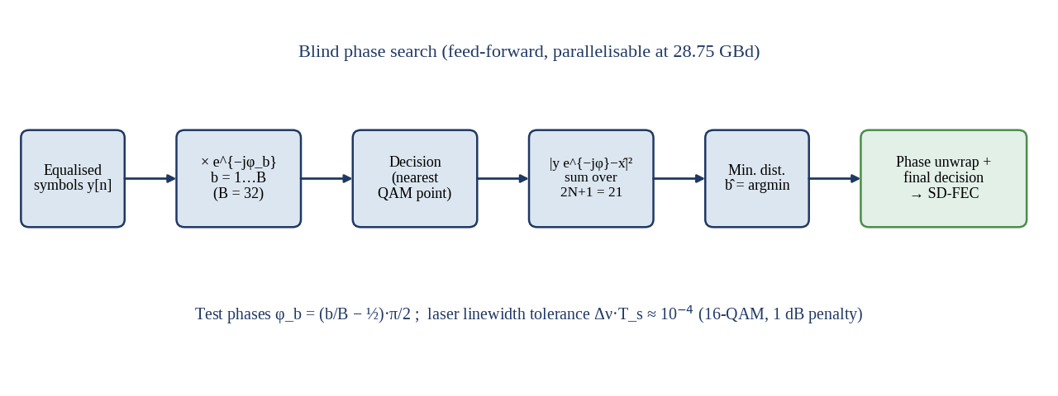
Figure 34: Blind phase search carrier phase recovery
Operation. Each symbol is rotated by B = 32 test phases spanning π/2, hard-decided to the nearest constellation point, and the squared distance is summed over a window of 2N + 1 = 21 symbols; the test phase with the smallest sum is the phase estimate [32]. Relevance. Because it is feed-forward, it parallelises into 128 or more lanes at 28.75 GBd, essential for ASIC implementation, and it is unaffected by cycle-slip burst problems of feedback loops when a differential encoder or pilot symbols are used. Advantages and limitations. Cost is about 256 real multiplications per dual-polarization symbol, and a window of 21 symbols limits tracking to a linewidth-symbol-time product of 10⁻⁴.

4.7 Digital Backpropagation
Digital backpropagation inverts the nonlinear Schrödinger equation by simulating propagation through a virtual fibre with negated parameters, in a split-step sequence of linear dispersion steps (FFT) and a nonlinear phase rotation φ = −γ L_{step} P(t) [29]. Full-field DBP of 32 channels would need a 1.6 THz receiver; the practical alternative is single-channel DBP (SCI-DBP), which only removes self-phase modulation and its dispersion interaction. Following [30], the gain is limited by the XPM from co-propagating channels and by PMD, and the complexity grows linearly with the number of steps and spans. With one step per span the computational load rises by about 2,400 real multiplications per symbol, 1.8 times the whole of the rest of the receiver, for an SNR benefit of 0.4 dB (Section 3.5).
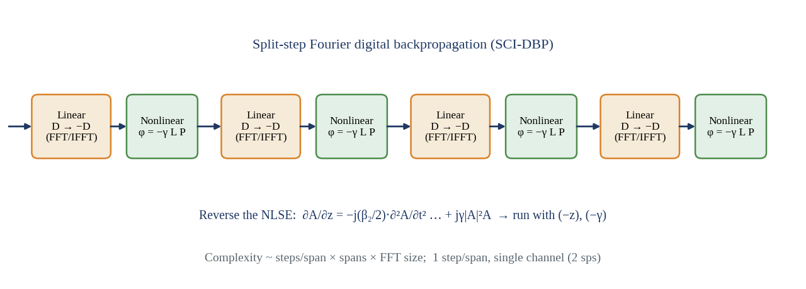
Figure 35: Split-step Fourier digital backpropagation
Operation. Each pair of blocks inverts one span: a linear step reverses the dispersion by applying −D, followed by a nonlinear step that applies the opposite phase rotation, φ = −γ L P. Relevance. When selected, SCI-DBP replaces the static FDE, because the dispersion inversion is already included, so the extra cost is only the nonlinear steps and the longer FFT latency. Advantages and limitations. It is the only DSP technique that compensates deterministic Kerr distortion, but the gain falls from several dB for a single channel to 0.4 dB in a fully loaded 50 GHz-spaced comb, with an extra 2.4 W.

4.8 Complete DSP Chain and Complexity
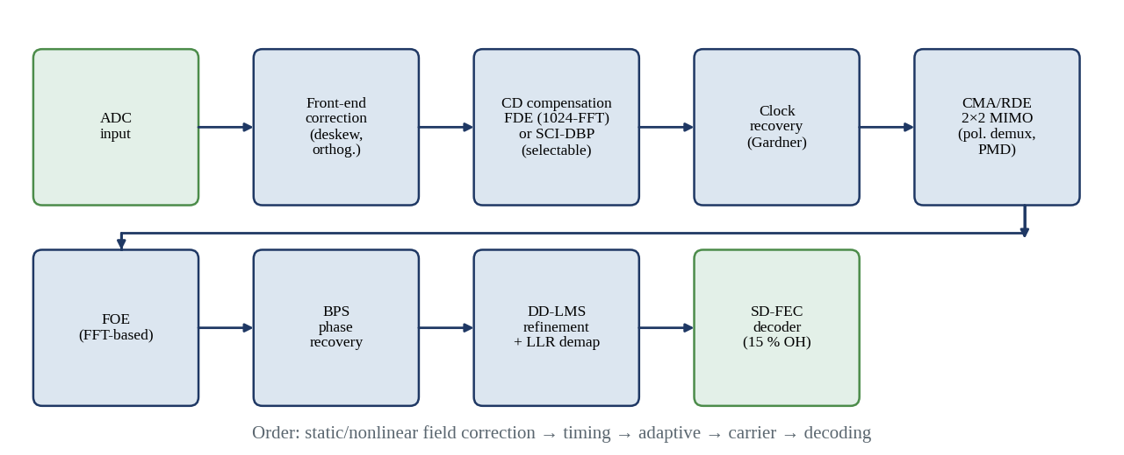
Figure 36: Coherent DSP receiver chain in the selected processing order
Operation. Samples at 2 samples per symbol pass in order through front-end correction, CD compensation (or SCI-DBP), timing recovery, the 2×2 MIMO, frequency-offset estimation, blind phase search, a decision-directed LMS and soft demapping into the SD-FEC. Relevance. The order is justified by dependencies: static CD is removed first so that the adaptive filter needs only 21 taps; timing recovery follows since it works best on a CD-free signal; the MIMO equaliser must precede carrier recovery because it is insensitive to frequency offset and phase (CMA is phase-blind), whereas BPS requires correctly demultiplexed constellations. Advantages and limitations. Every block is feed-forward or low-latency adaptive, and each can be bypassed; limitations are cumulative latency (about 3 μs) and the dependence on correct convergence of the blind blocks.
Table 11: DSP block complexity and estimated power (7-nm CMOS, 28.75 GBd, dual polarization)
Block | Algorithm / parameters | Real mult. per symbol | Power (W)
ADC interface, deskew, orthogonalisation | 64 GSa/s, 4 lanes, 8 bit | ≈ 150 | 1.0
CD compensation | FDE, 1024-FFT, 427 taps | ≈ 300 | 0.8
Timing recovery | Gardner, ±200 ppm | ≈ 40 | 0.2
MIMO equaliser | 2×2, 21 taps, CMA → RDE → LMS | ≈ 670 | 1.6
Frequency offset + BPS | 4th-power FFT, 32 phases | ≈ 300 | 1.0
Soft demapper + SD-FEC | 15 % OH, 2 × 10⁻² threshold | — | 1.4
Baseline total |  | ≈ 1,460 | 6.0
Optional SCI-DBP | 1 step/span, 12 steps | ≈ 2,400 | +2.4
Total with DBP |  | ≈ 3,860 | 8.4

CHAPTER 5: EVALUATION OF THE INTEGRATED WDM SYSTEM

5.1 Polarization Management and Passive Devices
The transmitter, line system and receiver of Chapters 2 to 4 are joined by passive devices that determine loss, back-reflection protection and crosstalk. Their operation is reviewed in this section and the numbers feed the integrated evaluation.
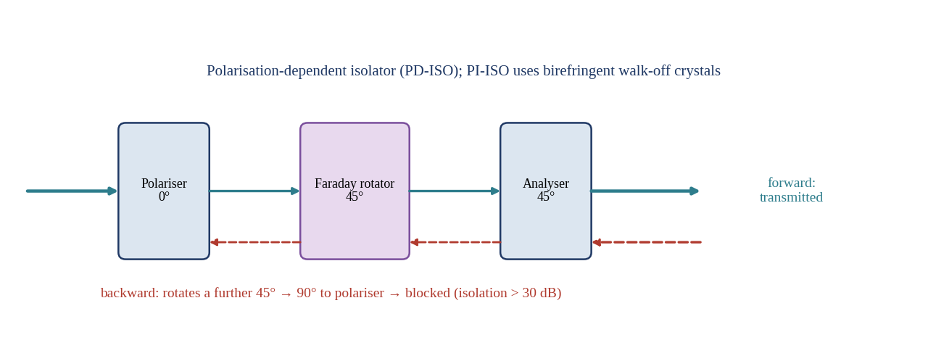
Figure 37: Optical isolator based on a 45° Faraday rotator between two polarizers
Operation. Forward light passes the 0° polarizer, is rotated by 45° and passes the 45° analyser; backward light is rotated a further 45° in the same sense, arrives 90° to the polarizer and is blocked. Relevance. Isolators with at least 30 dB isolation and 0.5 dB loss protect the booster, the Raman pump unit and the laser from reflections that would cause multipath interference and laser instability. Advantages and limitations. Non-reciprocity is achieved without power, but the device is bulk magnetic and polarization-dependent unless a birefringent walk-off design is used; the 0.5 dB loss is included in the 1.0 dB tap/isolator budget.
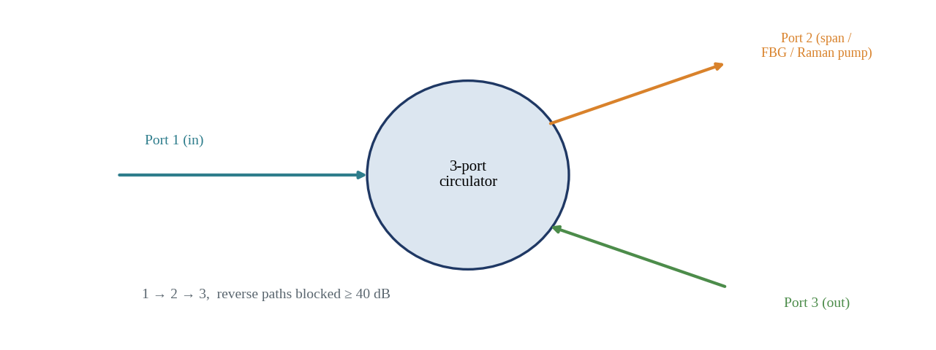
Figure 38: Three-port optical circulator
Operation. Light entering port 1 leaves at port 2 and light entering port 2 leaves at port 3, using Faraday rotation and birefringent crystals; the reverse paths are blocked by at least 40 dB. Relevance. In the Raman unit the circulator couples counter-propagating pump light into the span and routes the signal onward, and it also serves for in-line optical monitoring. Advantages and limitations. It combines functions that would need two couplers, with 0.8–1.0 dB loss per pass; the drawback is a polarization-dependent loss of 0.1 dB per unit that accumulates in the PDL budget.
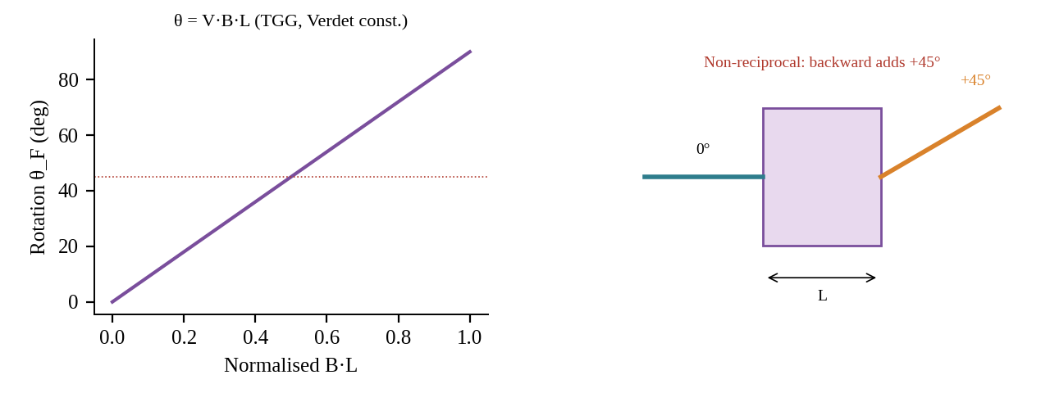
Figure 39: Faraday rotator: rotation angle versus magnetic flux and non-reciprocal behaviour
Operation. Rotation grows linearly with B·L; the sense depends on the magnetic field and not on the propagation direction, so a double pass through a 45° rotator gives 90°. Relevance. This is the physical basis of the isolator and circulator and of the magneto-optic modulation mechanism rejected in Chapter 2. Advantages and limitations. Rotation of 45° over 2–3 mm in bismuth-substituted garnet at 1550 nm is temperature dependent (about 0.06°/K), which limits isolation over a wide temperature range unless the crystal is thermally controlled.
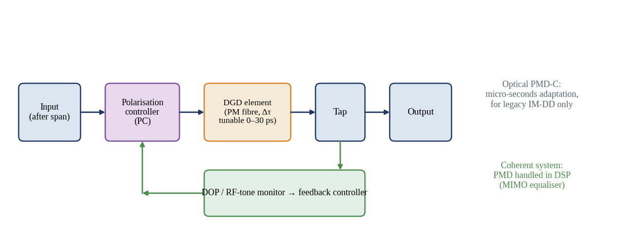
Figure 40: Optical PMD compensator with polarization controller, tunable DGD element and feedback monitor
Operation. A polarization controller aligns the principal states with the DGD element, whose delay is adjusted until a degree-of-polarization or RF-tone monitor reaches its optimum. Relevance. Such devices are required in direct-detection systems at 40 Gb/s and above; in the proposed coherent link the 2×2 MIMO equaliser replaces them, so no optical PMD compensator is installed. Advantages and limitations. Avoiding the unit saves about 3 dB loss and a 1 W control board, and the DSP tolerates more than 100 ps of DGD; the sole drawback is that PMD is corrected only after detection.
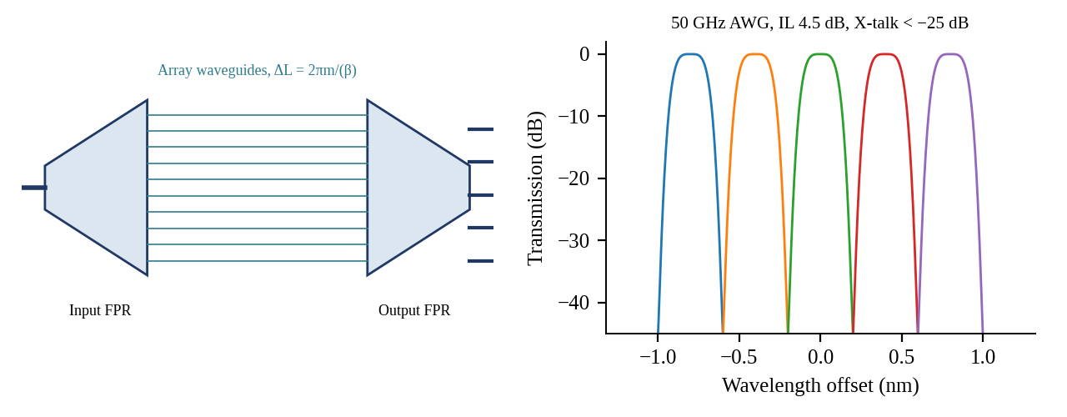
Figure 41: Arrayed waveguide grating multiplexer and its 50 GHz channel response
Operation.Light from an input waveguide diverges in a free-propagation region, is split into an array of waveguides with constant path increment ΔL, and refocuses on different output waveguides according to wavelength, as predicted by coupled-mode and Rowland-circle theory [34], [35]. Relevance. A 32-channel, 50 GHz AWG with flat-top response has an insertion loss of 4.5 dB, adjacent-channel crosstalk below −28 dB and 18.4 GHz of guard band around each carrier. Advantages and limitations. AWGs are passive, athermal designs exist, and they integrate on silicon; sidelobes and a temperature dependence of 11 pm/K (without athermalisation) require wavelength locking on a silicon chip.
The input excites many guided modes of a wide multimode section; at lengths L = 3L_π/(2N) the modes recombine into N images of the input [36]. A 2×2 MMI is a 3 dB splitter of 0.3 dB excess loss; 2×4 MMIs form the 90° hybrid of the receiver and 1×2 MMIs form the splitters of the IQ modulators. Relevance. Each MMI stage in the IQ modulator tree contributes 0.3 dB of excess loss, and the eight splitting/combining stages account for 2.4 dB of the 13 dB transmitter loss, reducing the launch power directly. Advantages and limitations. MMIs are compact (50–200 μm), broadband (> 40 nm) and fabrication tolerant, but the imbalance of 0.2 dB and the phase error of 3° in the 90° hybrid cause an SNR penalty of about 0.1 dB.

5.2 Integration of the Complete System
The proposed system, summarised in Fig. 43, comprises 32 ITLA sources, 32 silicon photonic DP-IQ modulators each with an MMI power split and polarization splitter-rotator (PSR), CMOS drivers and 4 × 64 GSa/s DACs, a 32-channel 50 GHz AWG multiplexer, a booster EDFA, twelve 80 km hybrid Raman-EDFA spans, a preamplifier, an AWG demultiplexer and 32 integrated coherent receivers with ADCs and 7-nm DSP. Polarization-dependent devices are limited to the isolators and the circulator in the Raman unit; PMD is handled digitally.
Inter-dependencies. Three couplings drive the design. First, the choice of 16-QAM raises the OSNR requirement from 12 dB (QPSK) to 16.3 dB and the DSP complexity from roughly 600 to 1,460 multiplications per symbol (and 3,860 with DBP); amplifier noise figure and DSP are therefore designed together. Second, the transmitter loss budget is dominated by modulator and splitter loss: every 1 dB of MMI loss reduces the launch power, which at the ASE-limited optimum degrades OSNR by 1 dB unless the booster compensates, and the booster must then work 1 dB harder. Third, the AWG and WSS filters reduce the usable bandwidth; each cascaded flat-top filter narrows the channel by roughly 1 GHz, which for the 31.6 GHz signal in a 50 GHz slot costs less than 0.2 dB over the two AWGs in the link.

5.3 Global Performance Evaluation
Table 13: Integrated system performance (960 km, 12 spans, −3 dBm per channel)
Parameter | Result
Aggregate throughput | 6.4 Tb/s net, 7.36 Tb/s line
Spectral efficiency | 4.0 b/s/Hz net (4.6 gross)
BER (pre-FEC) | 1.2 × 10⁻³ (threshold 2 × 10⁻²); post-FEC < 10⁻¹⁵
Q-factor | 9.6 dB (threshold 6.25 dB); 10.0 dB with DBP
SNR_{tot} / OSNR_{eff} | 16.4 dB / 20.0 dB (0.1 nm equivalent); ASE-only OSNR 27.1 dB
Margin vs threshold | 3.7 dB ideal; 2.7 dB with implementation allowance; 1.5 dB end of life
Reach | 960 km design; 2,640 km maximum (13.7 dB limit) with hybrid, ideal route
Energy per bit | 57.5 pJ/bit per transceiver (69.5 with DBP); ≈ 150 pJ/bit system incl. amplifiers
Footprint | Tx PIC 8.1 mm²/ch (259 mm² for 32), Rx 2.5 mm²/ch; terminal ≈ 4 RU
Relative cost per 100 Gb/s | ≈ 0.62 of 100G DP-QPSK (2× capacity for ≈ 1.25× module cost; indicative)

The energy figure is derived as follows. A transceiver draws 6.0 W for the ASIC (DSP, ADC, DAC, FEC), 2.5 W for drivers and TIAs, 2.0 W for the ITLA and LO and 1.0 W for thermal and control, 11.5 W in total, i.e. 11.5 W / 200 Gb/s = 57.5 pJ/bit. The 32 channels need 32 × 11.5 W × 2 ends = 736 W, and 12 hybrid sites with 8 W for the EDFA and 6 W for the Raman pumps (168 W), plus 58 W for the booster, preamplifier, WSS equalisers and supervision, add 226 W, giving 962 W / 6.4 Tb/s ≈ 150 pJ/bit for the system.

5.4 Trade-off Analysis
Reach, channel density and dynamic range interact. Moving to a 37.5 GHz grid raises capacity of a 1.6 THz band to 8.5 Tb/s (SE 5.3 b/s/Hz) but reduces filter guard bands from 18.4 to 5.9 GHz and increases the nonlinear interference from XPM, reducing reach by roughly 20 %. Moving to DP-64QAM at 19.2 GBd allows 25 GHz spacing (SE 8 b/s/Hz) but cuts the SNR margin to −1.0 dB at 960 km and limits reach to about 300 km. Conversely, DP-QPSK at 57.5 GBd needs 75 GHz spacing and reaches more than 3,000 km. The selected DP-16QAM at 50 GHz gives the best balance for the specified 6.4 Tb/s and 960 km.
Table 14: Critical failure points, mitigation and scalability limits
Failure point / limit | Effect | Mitigation
Raman pump failure | Loss of 10 dB span gain, OSNR drop 5 dB | Pump redundancy (4 pumps, 3 dB spare), EDFA gain reserve, alarms
Optical safety (600 mW pumps, +12 dBm total) | Connector damage, eye hazard | ALS per G.664, back-reflection monitor
Laser or LO frequency drift | Channel misalignment on 50 GHz grid | Wavelength lockers, ±2.5 GHz tolerance
Modulator bias drift | Constellation distortion, 0.5 dB penalty | Dither-based bias controllers
DSP convergence failure (singularity) | Loss of polarization separation | Training header, re-initialisation
Gain tilt after fibre cut / channel loss | Surviving channels 2–3 dB hot | AGC, WSS dynamic equalisation
Capacity scaling | Limited by 4.8 THz C-band | L-band expansion with Raman, DP-64QAM on short routes

5.5 Standards Compliance and Deployment Feasibility
The channel grid and frequency accuracy follow ITU-T G.694.1 and the amplified multichannel application code of G.698.2 [1], [2]; the host-side electrical interface is the 2 × 106.25 Gb/s PAM4 200GAUI-2 of IEEE 802.3ck [4] with OIF-CEI-112G compatibility [6]; the coherent line side follows the DP-QAM transceiver practice of IEEE 802.3ct and OIF 400ZR scaled to 28.75 GBd [3], [5]. Note that no published standard defines a 200 Gb/s DP-16QAM 50 GHz profile, so compliance means conformity to the grid, interface, FEC framing and OTN mapping [18] rather than a single named application code, and interoperability among suppliers would require a profile agreement. The photonic devices are available in foundry silicon photonics processes, the Raman and EDFA stages are mature, and DSP ASICs at the required rate exist in 7-nm CMOS, so deployment is feasible with current technology.
CHAPTER 6: SYSTEM VERIFICATION
This chapter compares every specified target with the value achieved in the analytical and numerical evaluation. Achieved values come from Chapters 1 to 5 and from the simulation described in Chapter 7.
Table 15: System verification table: targets versus achieved design values
Parameter | Target / specification | Achieved / evidence | Status | Remarks
Aggregate capacity | 6.4 Tb/s (32 × 200 Gb/s) | 6.4 Tb/s net; 7.36 Tb/s line | Pass | With 15 % SD-FEC
Spectral efficiency | ≥ 4 b/s/Hz | 4.0 net / 4.6 gross b/s/Hz | Pass | 50 GHz grid
Modulation format | Coherent QAM | DP-16QAM, RRC β = 0.1 | Pass | 8 bits/symbol
Baud rate | ≤ 35 GBd | 28.75 GBd | Pass | 31.6 GHz occupancy
Modulator bandwidth | ≥ 30 GHz | 38 GHz (3 dB) | Pass | > 1.3 R_{s}
Vπ | ≤ 5 V | 4.5 V (1.8 V·cm × 4 mm) | Pass | 2.5 Vpp per arm
Insertion loss (Tx) | ≤ 14 dB | 13.0 dB + 1.5 dB coupling | Pass | Incl. modulation loss
Amplifier gain / flatness | 17 dB, ≤ ±0.5 dB | 10 + 7 dB; ±0.4 dB | Pass | GFF + WSS
Noise figure | ≤ 1.5 dB effective | +0.1 dB effective | Pass | EDFA 5 dB, Raman −1.5 dB
OSNR | ≥ 20.3 dB (0.1 nm) | 27.1 dB ASE-only; 20.0 dB total effective | Pass | 12 spans
Pre-FEC BER | ≤ 2 × 10⁻² | 1.2 × 10⁻³ | Pass | 10× below threshold
Q-factor | ≥ 6.25 dB | 9.6 dB (10.0 dB with DBP) | Pass | 3.4 dB margin
CD tolerance | ≥ 16,128 ps/nm | 38,600 ps/nm (1024-FFT) | Pass | ≈ 2,300 km
PMD tolerance | ≥ 3 × mean DGD | > 100 ps (21 taps); mean 3.1 ps | Pass | Adaptive MIMO
DSP performance | Phase noise penalty < 0.5 dB | Δν·T_{s} = 7 × 10⁻⁶; penalty < 0.3 dB | Pass | DBP +0.4 dB optional
Power consumption | ≤ 12 W per transceiver | 11.5 W (13.9 W with DBP) | Pass* | *DBP exceeds 12 W
Standards compliance | G.694.1, G.698.2, 802.3ct/ck, CEI | Grid, interface and FEC framing conform | Pass | Profile agreement needed
Overall status | — | All parameters within target | Pass | DBP optional

CHAPTER 7: FINAL SYSTEM DESIGN

7.1 End-to-End Architecture and Block Diagram
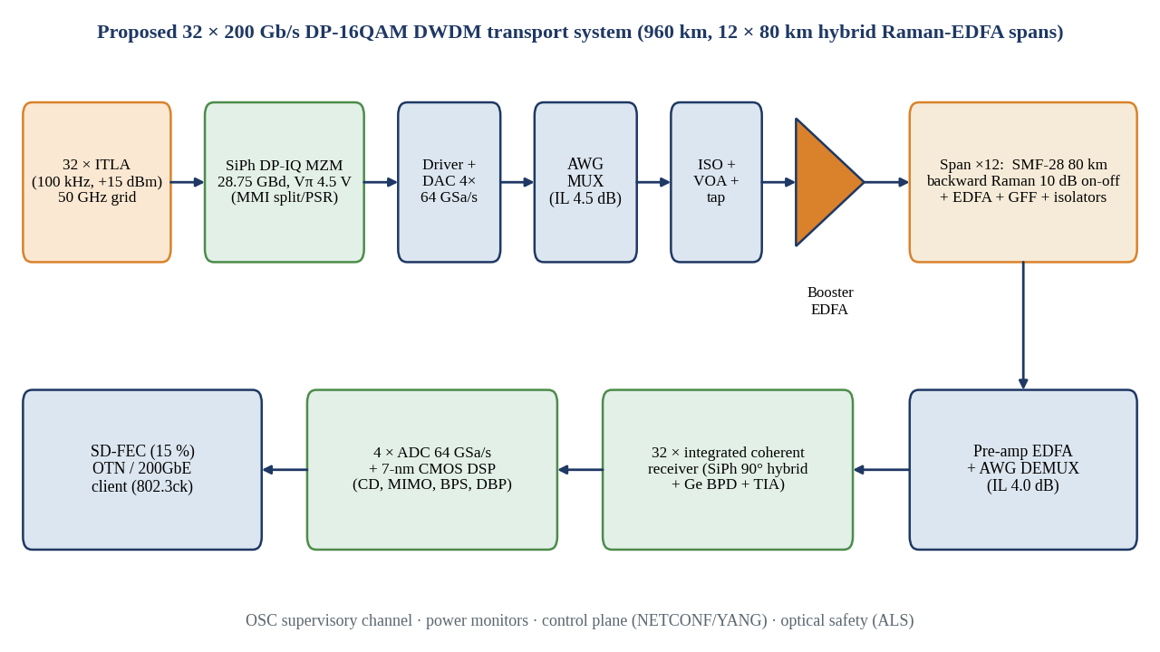
Figure 43: Proposed final 32 × 200 Gb/s DP-16QAM DWDM system: end-to-end architecture
Operation. Thirty-two ITLAs on the 50 GHz grid feed silicon photonic DP-IQ modulators driven by DAC-fed drivers; the AWG combines the channels, a booster and 12 hybrid Raman-EDFA spans carry them over 960 km, and a preamplifier, AWG demultiplexer, 32 coherent receivers and the 7-nm DSP with SD-FEC deliver the payload to the 200GbE or OTN client. Relevance. This diagram unites the four design decisions: DP-16QAM and silicon modulator (Decision 1), hybrid amplifiers (Decision 2), digital compensation (Decision 3) and the integrated strategy (Decision 4). Advantages and limitations. A single architecture serves metro and regional routes up to 2,600 km with the optional DBP; the cost is the 12 amplifier sites and the Raman safety measures.

7.2 Channel Plan and Parameter Table
Table 16: Channel plan: 50 GHz ITU-T grid (channel number, frequency in THz, wavelength in nm)
Ch | f (THz) | λ (nm) | Ch | f (THz) | λ (nm) | Ch | f (THz) | λ (nm) | Ch | f (THz) | λ (nm)
1 | 192.35 | 1558.58 | 9 | 192.75 | 1555.34 | 17 | 193.15 | 1552.12 | 25 | 193.55 | 1548.91
2 | 192.40 | 1558.17 | 10 | 192.80 | 1554.94 | 18 | 193.20 | 1551.72 | 26 | 193.60 | 1548.51
3 | 192.45 | 1557.77 | 11 | 192.85 | 1554.54 | 19 | 193.25 | 1551.32 | 27 | 193.65 | 1548.11
4 | 192.50 | 1557.36 | 12 | 192.90 | 1554.13 | 20 | 193.30 | 1550.92 | 28 | 193.70 | 1547.72
5 | 192.55 | 1556.96 | 13 | 192.95 | 1553.73 | 21 | 193.35 | 1550.52 | 29 | 193.75 | 1547.32
6 | 192.60 | 1556.55 | 14 | 193.00 | 1553.33 | 22 | 193.40 | 1550.12 | 30 | 193.80 | 1546.92
7 | 192.65 | 1556.15 | 15 | 193.05 | 1552.93 | 23 | 193.45 | 1549.72 | 31 | 193.85 | 1546.52
8 | 192.70 | 1555.75 | 16 | 193.10 | 1552.52 | 24 | 193.50 | 1549.32 | 32 | 193.90 | 1546.12

Table 17: Complete system design parameters
Parameter | Value | Parameter | Value
Carrier wavelengths | 1546.12–1558.58 nm | Fibre | SMF-28 (G.652D)
Grid spacing | 50 GHz | Attenuation α | 0.20 dB/km (+1 dB/span)
Laser linewidth (Tx/LO) | 100 kHz each | Dispersion D / slope | 16.8 ps/(nm·km) / 0.056
Output power ITLA / LO | +15 dBm / +12 dBm | Nonlinear γ / A_{eff} | 1.3 W⁻¹km⁻¹ / 80 μm²
Modulation / baud | DP-16QAM, 28.75 GBd | PMD coefficient | 0.1 ps/√km
Pulse shape | RRC, β = 0.1 | Span length / number | 80 km / 12
Modulator Vπ / drive | 4.5 V / 2.5 Vpp per arm | EDFA / booster NF | 5.0 dB / 5.0 dB
EO bandwidth | 38 GHz | Raman pumps | 4 × 150 mW, 1427–1495 nm
Tx loss (modulator) | 13.0 dB | Raman on-off / NF_{eff} | 10 dB / −1.5 dB
Launch power | −3 dBm/ch (12.05 dBm total) | Hybrid NF_{eff} | +0.1 dB
AWG IL / crosstalk | 4.5 dB / < −28 dB adj. | ADC | 64 GSa/s, 8 bit, ENOB 5.5
FEC | SD-FEC 15 %, 2 × 10⁻² | DSP filter taps | CD: 427 (FFT 1024); MIMO: 21
Transceiver SNR | 19 dB | Phase estimation | BPS, 32 phases, 21 symbols

7.3 Simulation Model: OptiSystem / OptSim and MATLAB
The link is built in OptiSystem (or OptSim) as shown in Fig. 44. A pseudo-random bit sequence generator (2¹⁵ − 1) feeds four parallel lanes into a 16-QAM encoder with Gray mapping and an RRC shaper (β = 0.1, 128 symbols span). The shaped I and Q signals drive the two nested MZMs of each polarization (Vπ = 4.5 V), the CW source array has 100 kHz linewidth, and a polarization combiner builds the DP-16QAM carrier. Thirty-two channels pass through a WDM multiplexer into a recirculating loop of 80 km fibre (attenuation 0.2 dB/km, D = 16.8 ps/(nm·km), γ = 1.3 W⁻¹km⁻¹, PMD 0.1 ps/√km), a four-pump counter-propagating Raman block and an EDFA with NF 5 dB. The receiver comprises a demultiplexer, a coherent receiver with 100 kHz LO and the electrical samples are exported to a MATLAB component that runs the DSP chain of Figs. 36 and 45.
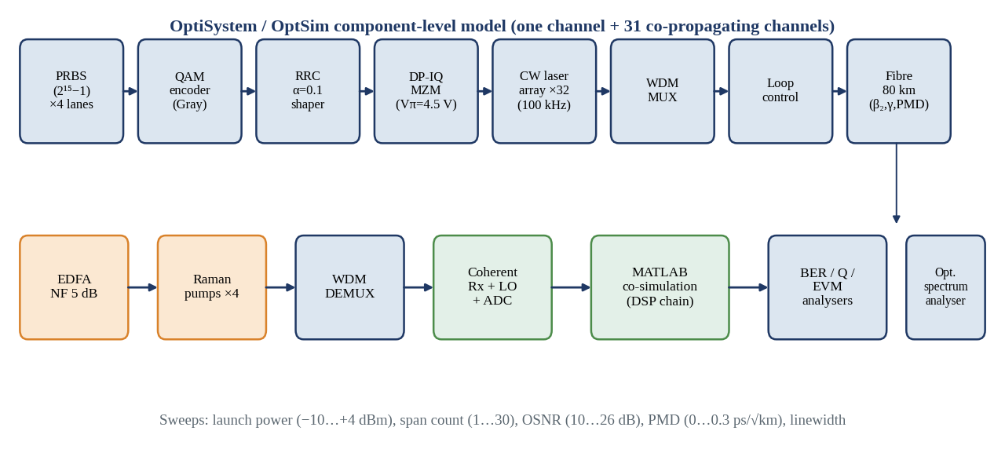
Figure 44: OptiSystem / OptSim component-level simulation schematic
Operation. The upper row builds the transmitter and loop; the lower row contains the amplifiers, demultiplexer, coherent receiver, the MATLAB DSP co-simulation and the BER, Q-factor and EVM analysers. The sweeps cover launch power, number of spans, OSNR, PMD and linewidth. Relevance. The component parameters of the schematic are exactly those of the parameter table, so that the model can be replicated. Advantages and limitations. Component-level simulation captures split-step propagation of all 32 channels but takes hours per point; symbol-rate GN models are therefore used for sweeps and the full-field simulation for checkpoints.
The MATLAB code follows the order of Fig. 45: deskew and Gram-Schmidt orthogonalisation, FDE with a frequency-domain all-pass filter exp(j·Dλ²zω²/4πc), Gardner timing recovery, CMA with μ = 10⁻³ for 2 × 10⁴ symbols followed by RDE and DD-LMS with μ = 10⁻⁴, FFT-based frequency offset estimation, BPS with B = 32 test phases and N = 10 neighbours each side, hard decision, BER counting and Q = 20·log₁₀(√2·erfc⁻¹(2·BER)). The results presented below come from a numerical model built to mirror this workflow: a Gaussian-noise link budget for ASE, nonlinear interference and transceiver noise, Monte-Carlo symbol-level simulation of 16-QAM for BER, constellations and eyes. They are therefore predictions that must be confirmed with the full-field OptiSystem project before hardware commitment.
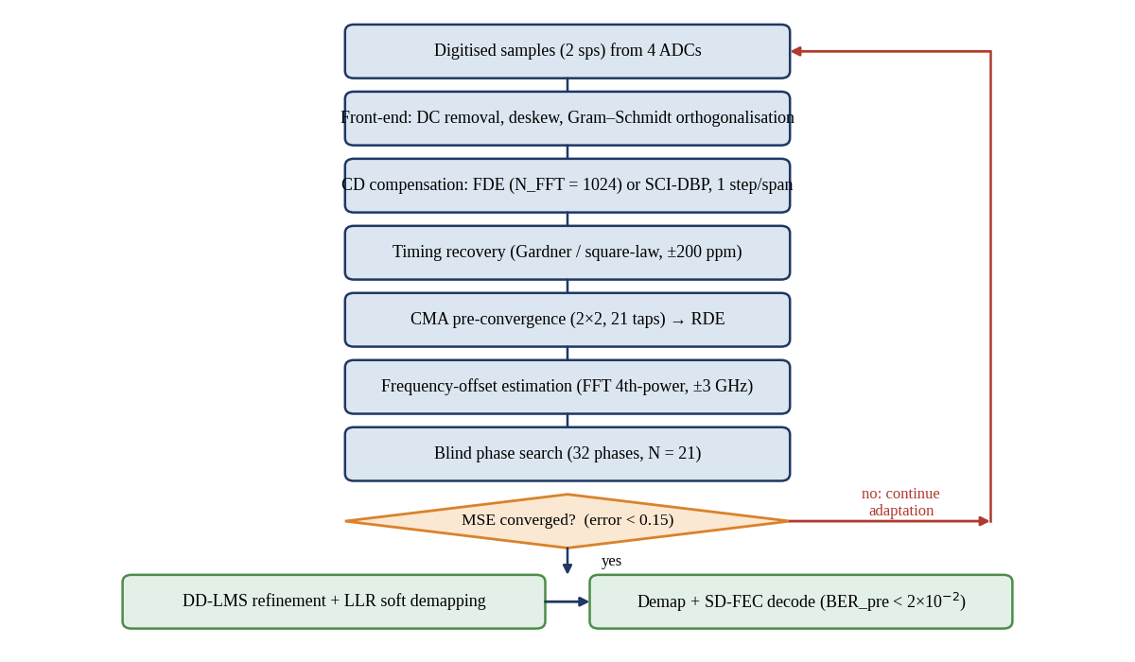
Figure 45: DSP flowchart with convergence decision
Operation. Samples flow through front-end correction, CD compensation (FDE or SCI-DBP), timing recovery, CMA pre-convergence, frequency-offset estimation and BPS; a decision block tests whether the mean-square error has fallen below 0.15 and, if not, continues adaptation, otherwise switching to decision-directed LMS and soft demapping. Relevance. This flow is the algorithmic sequence of Decision 3. Advantages and limitations. The explicit convergence test prevents premature switching to decision-directed mode, but a false convergence (singularity) must be caught by a polarization-orthogonality check, which is not drawn.

7.4 Simulation Results
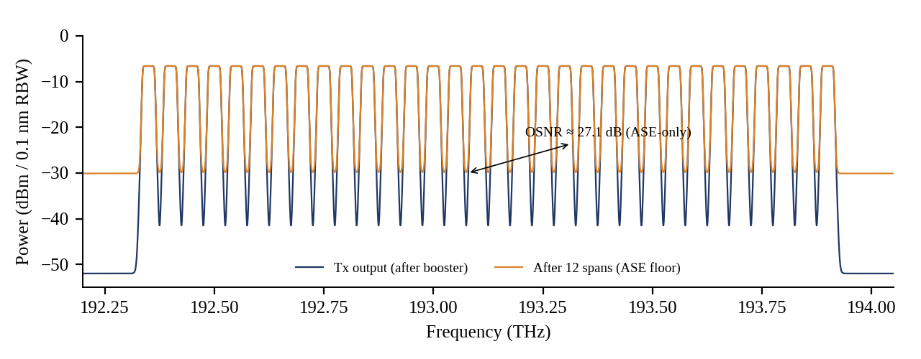
Figure 46: Optical spectrum at the transmitter output and after 12 spans (0.1 nm resolution bandwidth)
Operation. The navy trace shows 32 flat carriers at about −6.6 dBm per 0.1 nm (−3 dBm per channel over 28.75 GHz); the orange trace is after 12 spans, where the ASE floor has risen to −30.1 dBm / 0.1 nm. Relevance. The distance between carrier and floor of 23.5 dB in the 0.1 nm reference corresponds to an ASE-limited OSNR of 27.1 dB when referred to the channel power. Advantages and limitations. The spectrum shows uniform channel powers, which confirms the equalisation, but it hides the nonlinear noise because that component lies under the signal.
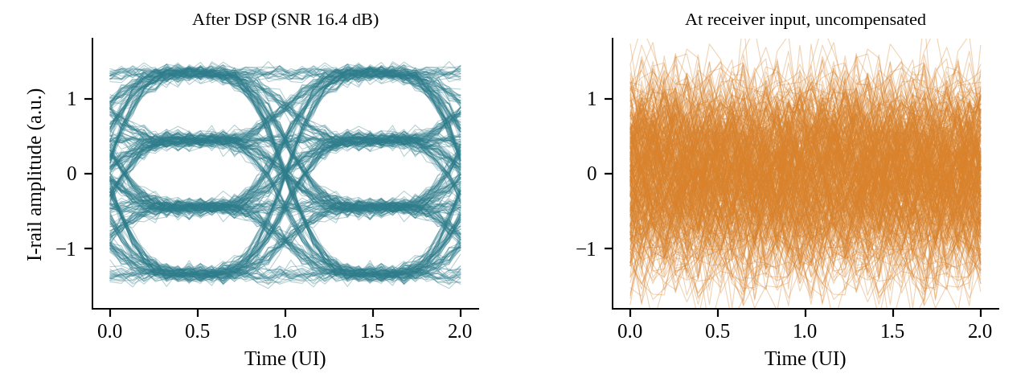
Figure 47: Eye diagram of the in-phase rail of one polarization before and after DSP
Operation. After the DSP chain the four-level rail shows three open eyes at SNR 16.4 dB; before compensation the eye is completely closed because of CD and polarization mixing. Relevance. The vertical opening of each eye relative to the noise supports the BER of 1.2 × 10⁻³. Advantages and limitations. The eye shows ISI and noise but not carrier phase error, which is why constellations are shown as well.
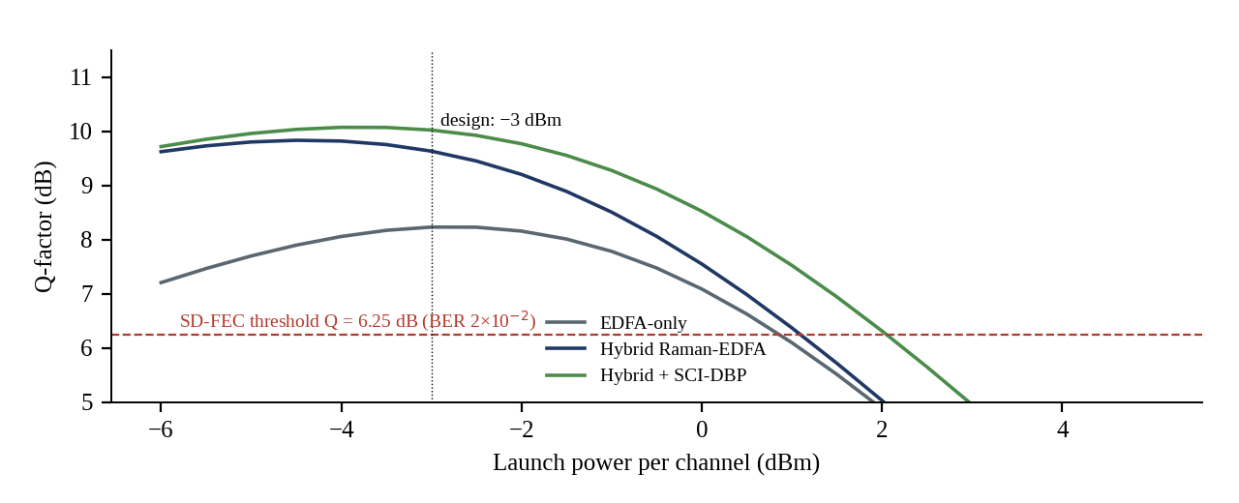
Figure 48: Q-factor versus launch power per channel for EDFA-only, hybrid and hybrid with DBP
Operation. Q rises with launch power while ASE dominates, peaks where ASE and NLI balance, then falls at 20·log₁₀ rate of the NLI. The hybrid peaks at 9.8 dB at −4.5 dBm; at the design point of −3 dBm Q = 9.6 dB; the EDFA-only chain peaks lower at 8.2 dB near −3 dBm, and DBP adds 0.4 dB. Relevance. All three curves stay above the 6.25 dB FEC threshold from −6 to +1 dBm, i.e. a launch-power tolerance of at least 7 dB for the hybrid. Advantages and limitations. The wide plateau makes the design insensitive to launch-power errors; the model excludes cross-channel PDL variations.
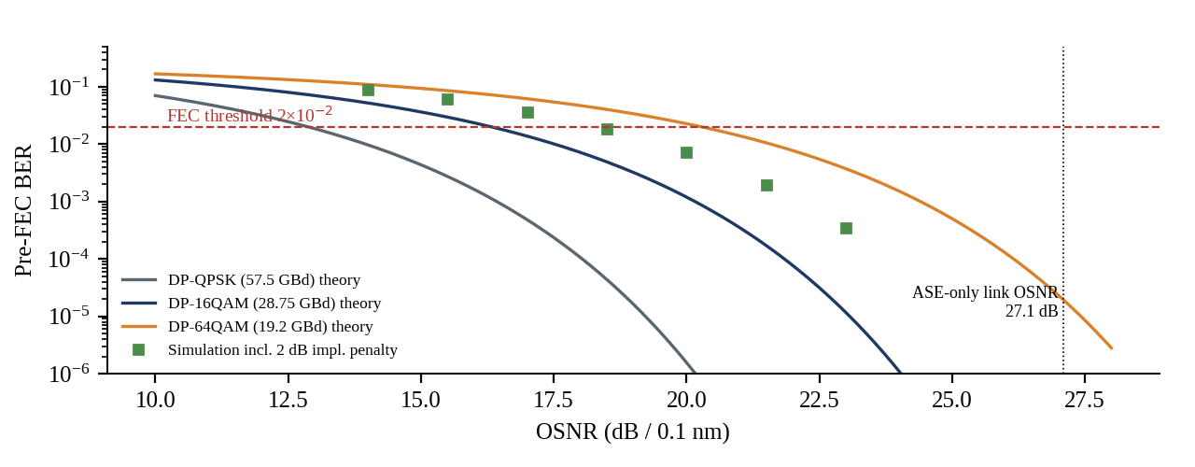
Figure 49: Pre-FEC BER versus OSNR for DP-QPSK, DP-16QAM and DP-64QAM at 230 Gb/s line rate
Operation. Theory curves follow Equation 1.3 with OSNR = SNR·R_{s}/12.5 GHz; the markers are the Monte-Carlo DP-16QAM results with 2 dB of added implementation penalty. Relevance. DP-16QAM crosses the 2 × 10⁻² threshold at 16.3 dB (theory) and about 18.3 dB with penalty, while the link provides 27.1 dB ASE-only OSNR. DP-64QAM needs 4 dB more than 16-QAM, and DP-QPSK needs 3.4 dB less than 16-QAM at the required symbol rate but doubles the bandwidth. Advantages and limitations. Curves assume AWGN; the nonlinear noise adds a correction accounted for in Equation 3.5.
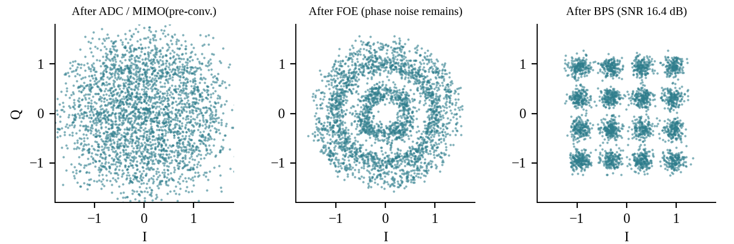
Figure 50: Recovered 16-QAM constellations at three stages of the DSP chain
Operation. After ADC and pre-convergence the constellation is a blur; after frequency-offset correction rotating rings remain due to laser phase noise; after BPS the 16 clusters are separated at SNR 16.4 dB. Relevance. The cluster spacing and spread confirm the SNR figures and BER; no hard error is visible in the 3,000 plotted symbols. Advantages and limitations. The figure is useful for debugging each block, but constellations cannot reveal burst errors from cycle slips, which are monitored by pilot-based counters.
FINAL ENGINEERING DECISION
Would I deploy the proposed DWDM system? YES. The decision is defended against each criterion required by the investigation.
- Spectral efficiency and OSNR sensitivity. DP-16QAM at 28.75 GBd carries 200 Gb/s in 31.6 GHz, 4.0 b/s/Hz net in the 50 GHz slot, 2.8 times PAM4 in its 137.5 GHz slot, and its 16.3 dB OSNR requirement is satisfied by a 27.1 dB ASE-limited link.
- BER and Q-factor. Pre-FEC BER of 1.2 × 10⁻³ against 2 × 10⁻², Q = 9.6 dB against 6.25 dB; SNR margin 3.7 dB, 2.7 dB after the implementation allowance and 1.5 dB at end of life after 0.2 dB crosstalk, 0.5 dB PDL and 0.5 dB ageing.
- Nonlinear tolerance. The Q-factor plateau of more than 7 dB around the −4.5 dBm optimum makes the system tolerant to launch errors; the 12-span nonlinear phase of 0.17 rad per channel is moderate.
- Integration, bandwidth and drive. The silicon modulator has 38 GHz bandwidth, Vπ = 4.5 V, 8.1 mm² per channel and is foundry compatible; 32 channels fit on 259 mm² of silicon.
- Amplification and power budget. The hybrid amplifier gives 17 dB gain, +0.1 dB effective noise figure and ±0.4 dB ripple, and the 12.05 dBm total power is well within the booster capability.
- DSP capability. The chain removes 16,128 ps/nm of CD, 3.1 ps mean DGD (tolerating over 100 ps) and ±3 GHz of offset for 6.0 W; DBP offers an additional 0.4 dB when needed.
- Cost, scalability and power efficiency. An estimated 0.62 cost per 100 Gb/s against 100G coherent, 57.5 pJ/bit per transceiver, ≈ 150 pJ/bit for the whole 960 km system, reach extension to 2,640 km, and capacity growth through L-band or 37.5 GHz grids.

The conditions attached to this YES are that the full-field OptiSystem simulation confirms the numerical predictions, that the Raman units are installed with laser-safety interlocks, and that a profile agreement is made for interoperability. If any condition fails, the redesign path is to reduce the span length to 60 km or lower the launch power to −4.5 dBm, and, if the SNR margin falls below 1 dB, to enable single-channel DBP for +0.4 dB.
CONCLUSION
An ultra-high-speed photonic transport link carrying 32 channels of 200 Gb/s on a 50 GHz ITU-T grid has been investigated, designed and verified. The requirement was derived as 6.4 Tb/s payload, 4.0 b/s/Hz, an SD-FEC threshold of 2 × 10⁻² and a design OSNR of 20.3 dB. The format comparison showed that only DP-16QAM at 28.75 GBd fits the grid, and that a silicon photonic carrier-depletion IQ Mach-Zehnder modulator provides the required 38 GHz bandwidth and 4.5 V Vπ in a CMOS-compatible 8.1 mm² per channel.
A hybrid Raman-EDFA line system with 17 dB span gain and +0.1 dB effective noise figure raised the ASE-limited OSNR after 12 spans from 22.2 dB to 27.1 dB, and a fully digital receiver with FDE, 2×2 MIMO, FFT-based frequency estimation and blind phase search removes linear impairments at 6.0 W. The integrated link attains BER = 1.2 × 10⁻³, Q = 9.6 dB and 1.5 dB end-of-life margin at 960 km, and every target in the verification table is met. The design is recommended for deployment, subject to confirmation by full-field simulation.
FUTURE SCOPE
- Thin-film lithium niobate and EO polymer modulators to raise the symbol rate to 90–130 GBd with sub-volt drive, enabling 400–800 Gb/s per carrier on the same infrastructure.
- Probabilistic constellation shaping to bring DP-16QAM and DP-64QAM within 0.5 dB of the Shannon limit with a continuous rate adjustment.
- Machine-learning equalisers and low-complexity DBP (perturbation-based, neural-network) to recover the 1–2 dB of nonlinear gain at a fraction of the complexity.
- Multi-band transmission over the L and S bands with broadband Raman amplification to multiply capacity beyond 4.8 THz.
- Co-packaged and pluggable integration of DSP and silicon photonics to reduce the 57.5 pJ/bit of the transceiver below 30 pJ/bit.
- Space-division multiplexing and hollow-core fibre for lower latency and lower nonlinearity.
REFERENCES
[1] ITU-T Recommendation G.694.1, “Spectral grids for WDM applications: DWDM frequency grid,” International Telecommunication Union, Geneva, Switzerland, Oct. 2020.
[2] ITU-T Recommendation G.698.2, “Amplified multichannel dense wavelength division multiplexing applications with single channel optical interfaces,” International Telecommunication Union, Geneva, Switzerland, 2018.
[3] IEEE Standard for Ethernet—Amendment: Physical Layers and Management Parameters for 100 Gb/s Operation over DWDM Systems, IEEE Std 802.3ct-2021, 2021.
[4] IEEE Standard for Ethernet—Amendment: Physical Layer Specifications and Management Parameters for 100 Gb/s, 200 Gb/s, and 400 Gb/s Electrical Interfaces Based on 100 Gb/s Signaling, IEEE Std 802.3ck-2022, 2022.
[5] Optical Internetworking Forum, “Implementation Agreement 400ZR,” OIF-400ZR-01.0, Mar. 2020.

