EXP N0:16 FIBER-OPTIC LINK DESIGN, LINK BUDGET AND BER ANALYSIS USING OPTISYSTEM
OBJECTIVES
- To design a point-to-point optical fiber link in OptiSystem using a CW Laser, Mach-Zehnder Modulator, 50 km single-mode fiber, PIN photodetector and low-pass RC filter.
- To measure the optical power at the transmitter, modulator output and fiber output using Optical Power Meters and to prepare the link power budget.
- To observe the optical spectrum before and after fiber propagation using Optical Spectrum Analyzers.
- To evaluate the link performance using a BER Analyzer by observing the eye diagram, Q factor and minimum BER.
SOFTWARE REQUIRED
• OptiSystem Software
SIMULATION CIRCUIT
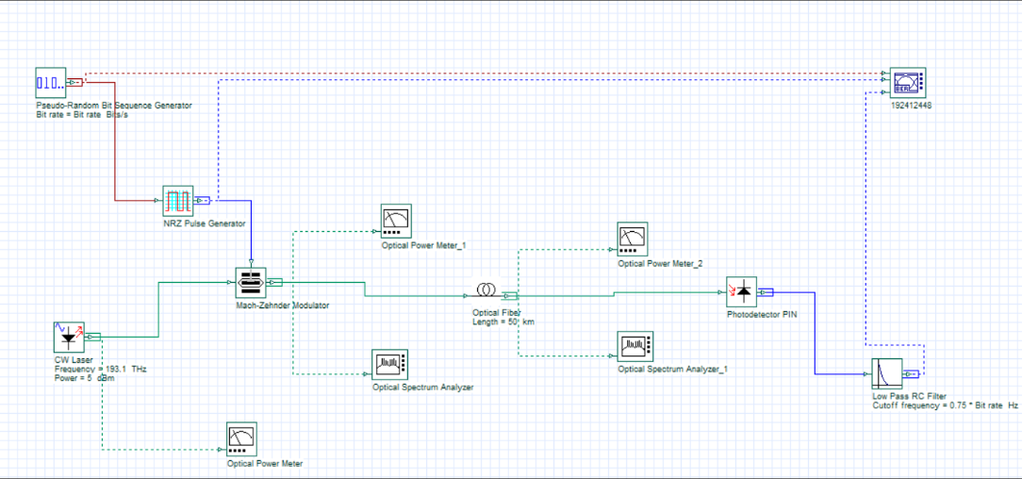
Fig. 1: OptiSystem layout of the fiber-optic link
OUTPUT
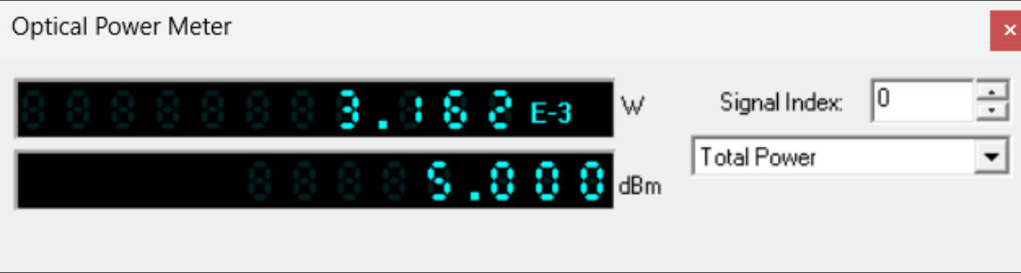
Fig. 2: Optical Power Meter at laser output – 3.162 mW (5.000 dBm)
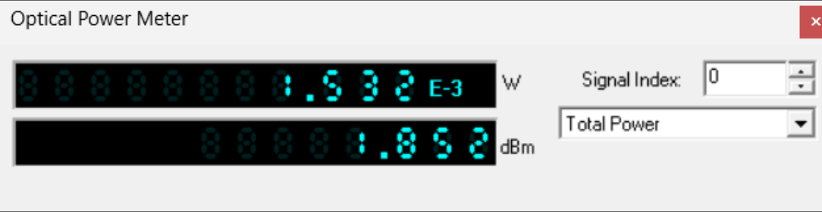
Fig. 3: Optical Power Meter_1 at modulator output – 1.532 mW (1.852 dBm)
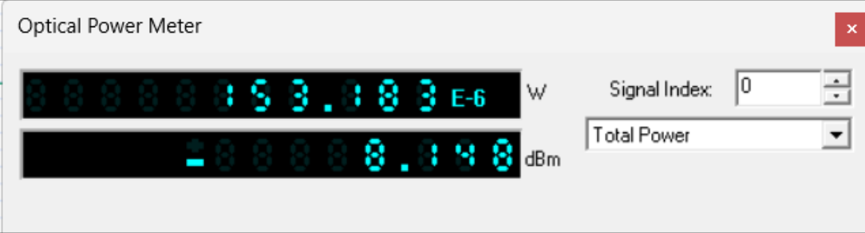
Fig. 4: Optical Power Meter_2 at fiber output – 153.183 µW (−8.148 dBm)
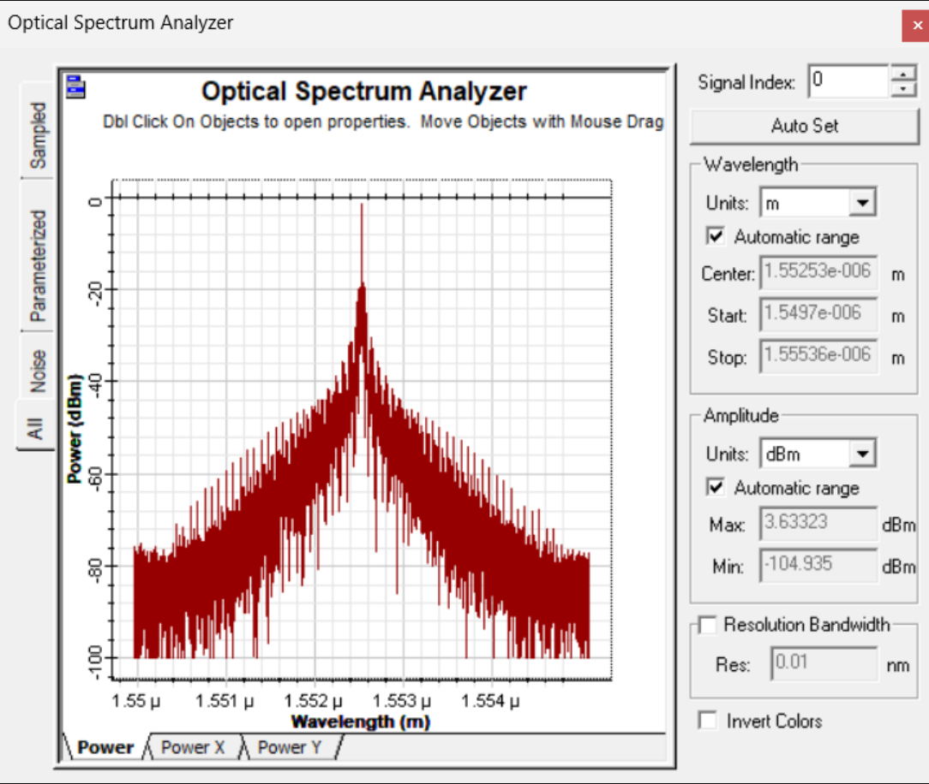
Fig. 5: Optical Spectrum Analyzer (modulator output) – peak 3.633 dBm
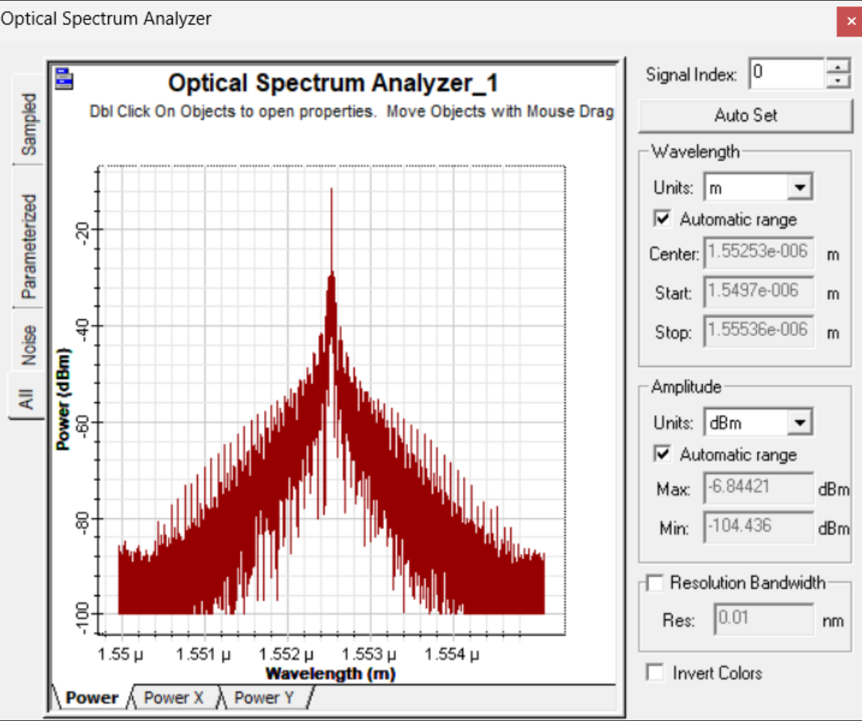
Fig. 6: Optical Spectrum Analyzer_1 (fiber output) – peak −6.844 dBm
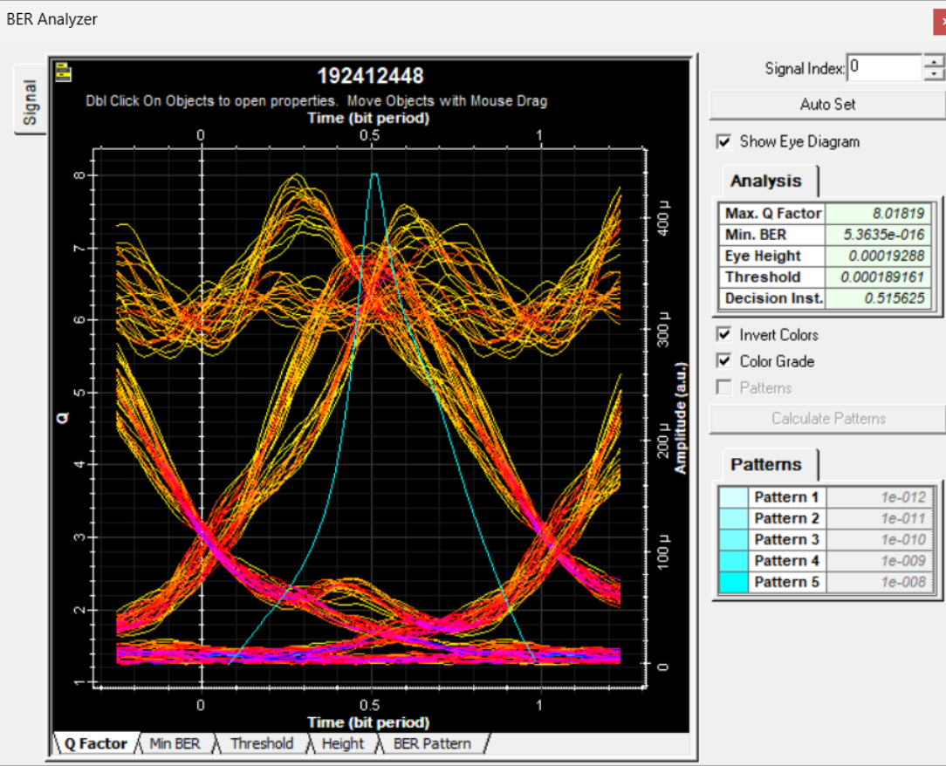
Fig. 7: BER Analyzer eye diagram (Q factor = 8.01819, Min. BER = 5.3635e-016)

REFLECTION
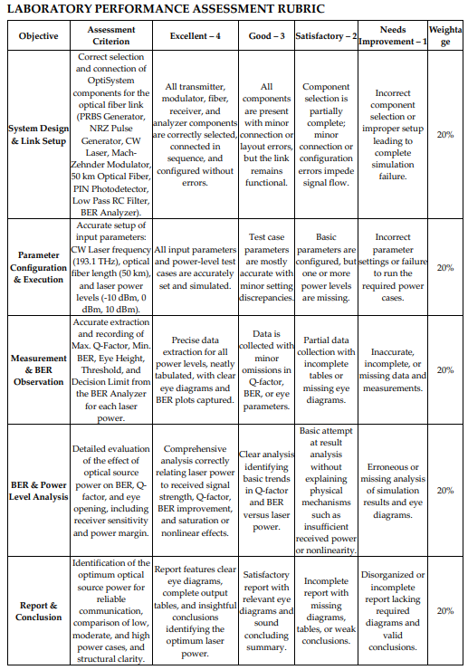
This experiment helped me understand how a complete optical link is built in OptiSystem and how the power budget is calculated from power meter readings at each stage. The 5 dBm laser power reduced to 1.852 dBm after the Mach-Zehnder Modulator and to −8.148 dBm after 50 km of fiber, giving a total loss of 13.148 dB. The spectra show the same shape before and after the fiber with a lower peak level after propagation. The BER Analyzer gave a Q factor of 8.01819 and a minimum BER of 5.3635e-016, with a clearly open eye, so the link performs well without any amplifier. I also learned that the Q factor and BER can be read directly from the eye diagram to judge link quality.

CONCLUSION
A 50 km fiber-optic link was designed and analysed in OptiSystem. The power budget showed a total loss of 13.148 dB, with a received power of −8.148 dBm. The BER analysis gave a Q factor of 8.01819 and a BER of 5.3635e-016, which is well below the 1e-9 requirement, so the link provides reliable error-free transmission for the chosen parameters.

