Exp. No: 9 ANALYSES OF PHOTODETECTOR NOISE AND SNR USING MATLAB/SCILAB
OBJECTIVES
1. Analyze the key noise sources in an optical photodetector, namely shot noise, dark current noise and thermal (receiver) noise.
2. Compute the individual and total noise current variances (σ²) across a range of input optical powers.
3. Evaluate the Signal-to-Noise Ratio (SNR) and observe its scaling in the thermalnoise-limited and shot-noise-limited regimes.
4. Calculate the Minimum Detectable Optical Power (Pmin) at SNR = 1 (0 dB).
5. Simulate and visualize photodetector noise and SNR curves using MATLAB.
SOFTWARE REQUIRED
• MATLAB (or GNU Octave / Scilab)
MATLAB Program:
clc; clear; close all
q=1.6e-19; k=1.38e-23; h=6.626e-34; c=3e8;
eta=0.85; lam=1550e-9; Id=5e-9;
T=300; RL=50; Fn=2; B=1e9;
Pdbm=-60:0.1:0;
P=10.^((Pdbm-30)/10);
R=eta*q*lam/(h*c);
Ip=R*P;
shot=2*q.*Ip*B;
dark=2*q*Id*B;
thermal=4*k*T*B*Fn/RL;
total=shot+dark+thermal;
SNR=10*log10(Ip.^2./total);
figure(1)
loglog(P,shot,P,total,'LineWidth',1.5)
grid on
xlabel('Power (W)')
ylabel('Noise Variance')
title('Noise Analysis')
legend('Shot Noise','Total Noise')
figure(2)
plot(Pdbm,SNR,'LineWidth',1.5)
grid on
xlabel('Power (dBm)')
ylabel('SNR (dB)')
title('SNR Analysis')
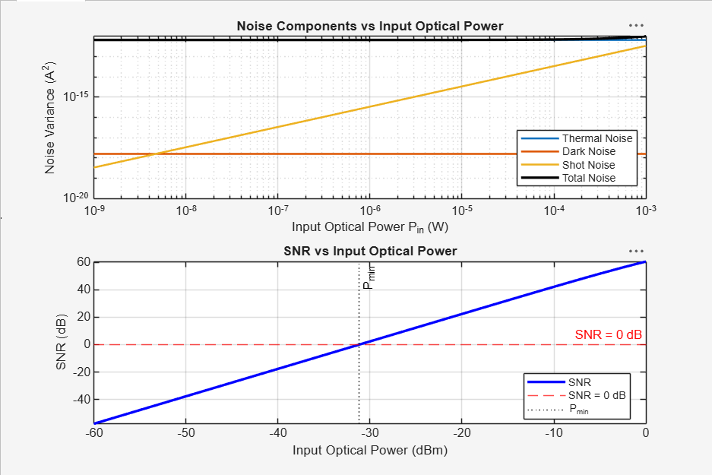
OUTPUT

REFLECTION
This experiment helped in understanding the effect of noise on photodetector performance and the relationship between signal-to-noise ratio (SNR) and input optical power. MATLAB was used to analyze shot noise, dark noise, thermal noise, and SNR characteristics. The plotted graphs showed that thermal noise dominates at low power levels, while SNR improves significantly as optical power increases. The experiment provided practical knowledge of photodetector noise analysis and optical receiver performance evaluation.

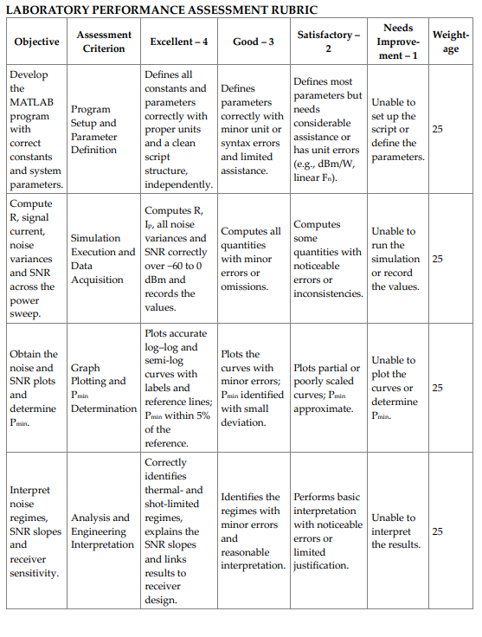
CONCLUSION
The study shows how input optical power affects noise and SNR in a PIN photodetector receiver. Performance depends on the power level:
• Low power: thermal noise dominates, giving negative SNR and no reliable detection (below Pmin ≈ −31.16 dBm).
• Moderate power: the signal rises above the thermal noise and the SNR increases at 20 dB/decade.
• High power: SNR becomes large and shot noise grows linearly, approaching the thermal level near +2.9 dBm.
These results help in estimating the receiver sensitivity and in designing low-noise optical receivers

