Exp-14 ANALYSIS OF EDFA-BASED DENSE WDM LINK PERFORMANCE USING OPTISYSTEM

OBJECTIVES
- To design a 4-channel Dense WDM link (100 GHz spacing, 193.1 THz, NRZ) in OptiSystem using a WDM Transmitter, WDM Mux 4x1 and WDM Demux 1x4.
- To study the effect of cascaded 50 km optical fiber spans with EDFA amplification (5 m erbium-doped length) on the transmitted signal power.
- To measure the received optical power using Optical Power Meters and the signal spectrum using the WDM Analyzer.
- To evaluate link performance at each receiver using BER Analyzers by observing the eye diagram, Q factor and minimum BER.
SOFTWARE / HARDWARE REQUIRED
• OptiSystem Software (Optiwave) on a Windows PC
SIMULATION CIRCUIT
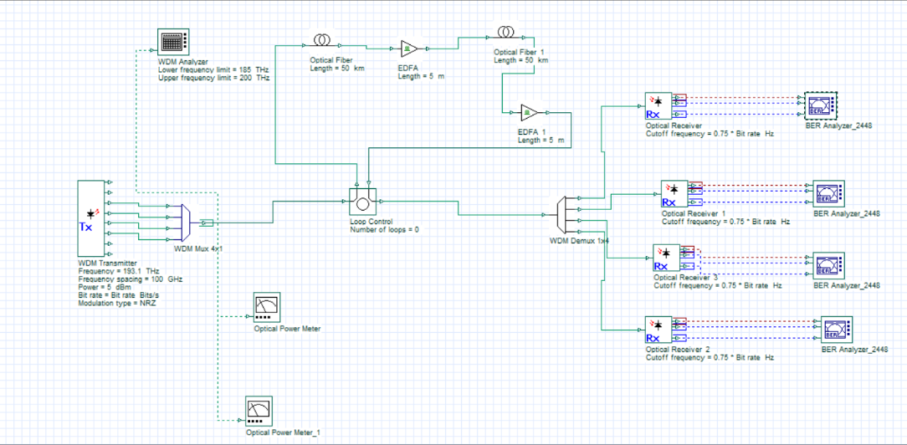
Fig. 1: OptiSystem layout of the EDFA-based 4-channel DWDM link

OUTPUT
Optical Power Meter readings (Total Power, Signal Index 0):
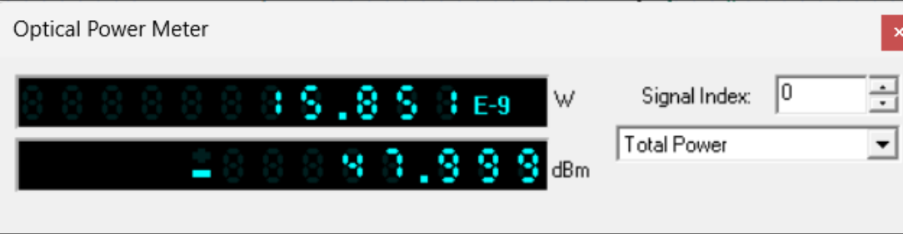
Fig. 2: Optical Power Meter – 15.851 nW (−47.999 dBm)
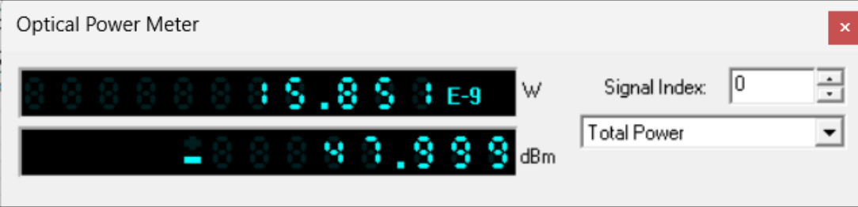
Fig. 3: Optical Power Meter_1 – 15.851 nW (−47.999 dBm)
BER Analyzer eye diagrams (BER Analyzer_2448):
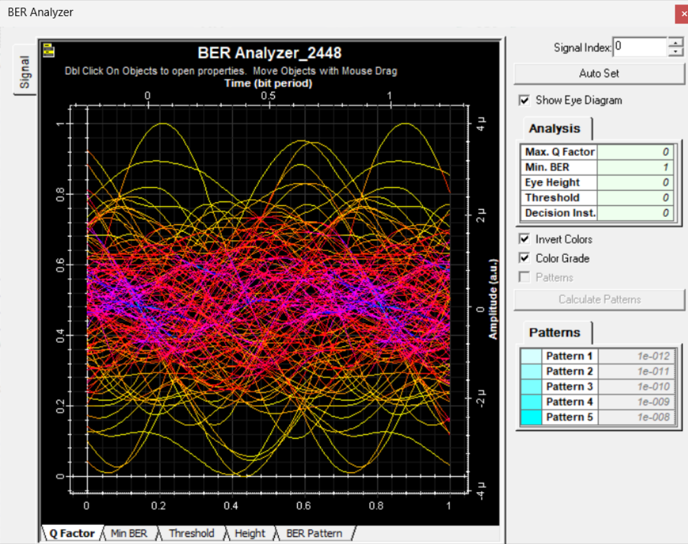
Fig. 4: BER Analyzer eye diagram (Max. Q Factor = 0, Min. BER = 1, Eye Height = 0)
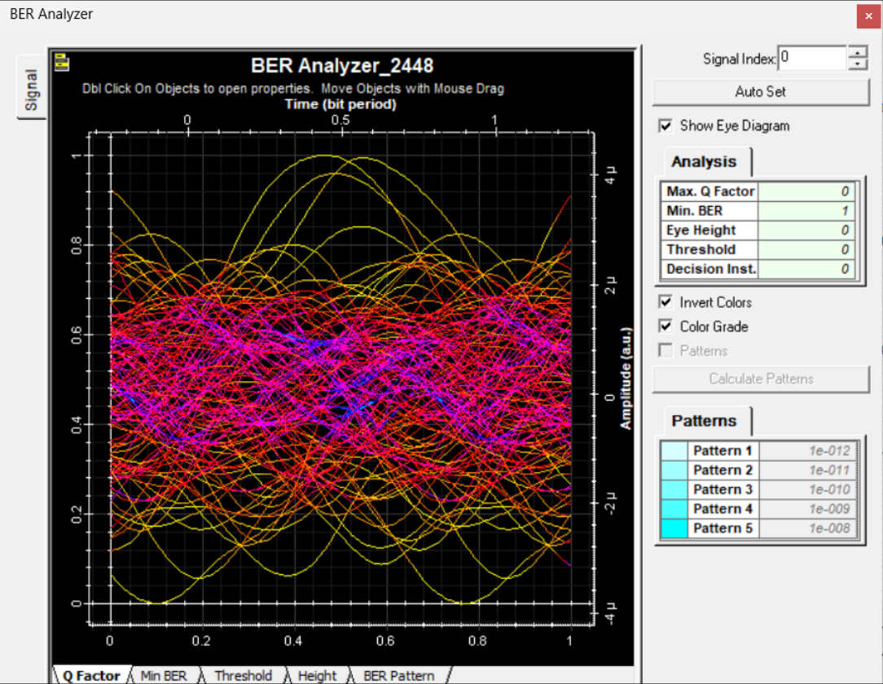
Fig. 5: BER Analyzer eye diagram (Max. Q Factor = 0, Min. BER = 1, Eye Height = 0)
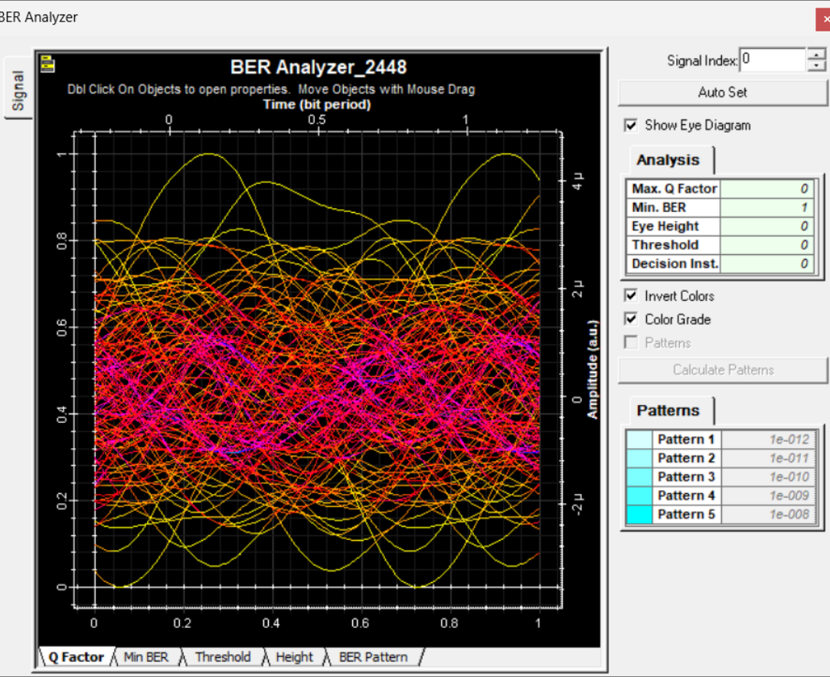
Fig. 6: BER Analyzer eye diagram (Max. Q Factor = 0, Min. BER = 1, Eye Height = 0)
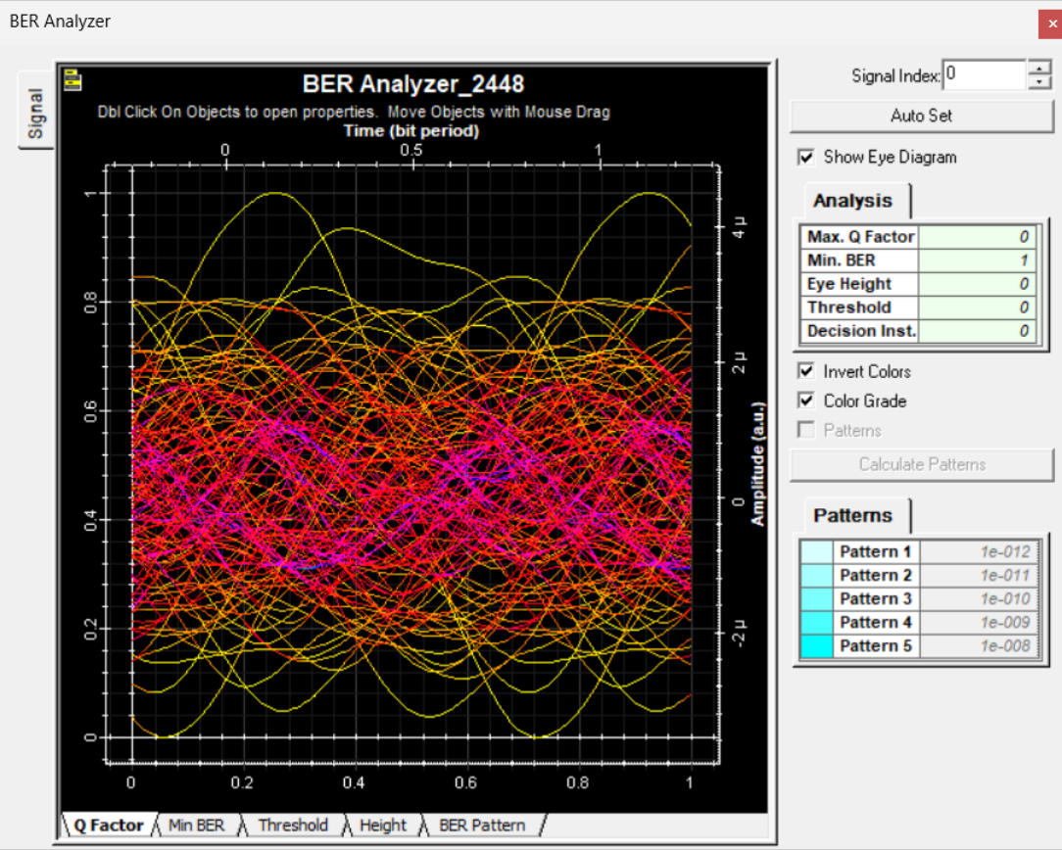
Fig. 7: BER Analyzer eye diagram (Max. Q Factor = 0, Min. BER = 1, Eye Height = 0)
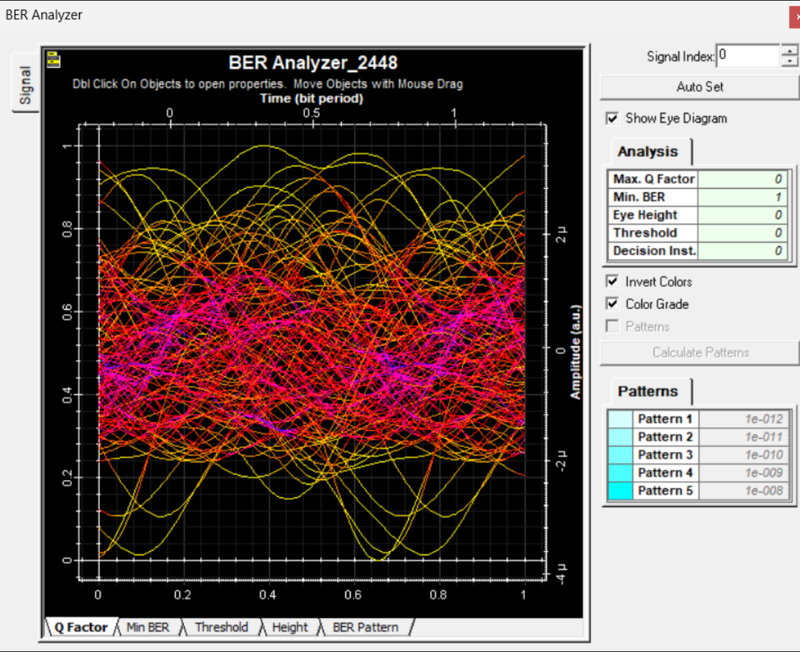
Fig. 8: BER Analyzer eye diagram (Max. Q Factor = 0, Min. BER = 1, Eye Height = 0)

REFLECTION
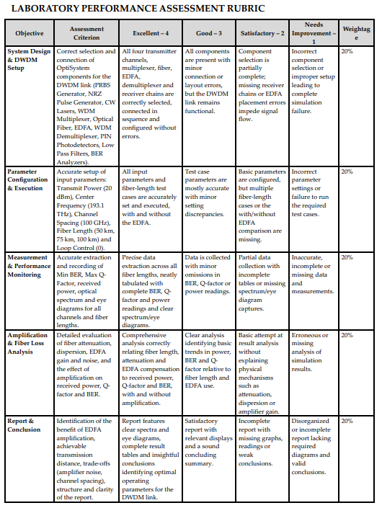
This experiment helped me understand how a dense WDM link is built and evaluated in OptiSystem, and how EDFAs are used to restore the power lost in 50 km fiber spans. The measured total power of about −48 dBm is far below the 5 dBm launched per channel, and every BER Analyzer shows a closed, noisy eye with Q factor 0 and BER 1. This shows that the link, as simulated here, did not deliver a usable signal. Probable causes are the very short 5 m EDFA length with insufficient pump power or gain, the Loop Control set to 0 loops, the accumulated fiber attenuation and dispersion over 100 km, and mux/demux insertion losses. Increasing the EDFA pump power/length, checking the loop setting and adding dispersion compensation would be the next steps to improve the result.

CONCLUSION
A 4-channel EDFA-based DWDM link was designed and analysed in OptiSystem. The power meters showed a received power of 15.851 nW (−47.999 dBm) and the BER Analyzers showed a closed eye with Q factor 0 and BER 1, indicating poor link performance for the chosen parameters. The experiment shows that amplifier gain, loop settings, loss and dispersion must be carefully tuned for reliable DWDM transmission.

