SIMATS ENGINEERING
ASSESSMENT TOOL

COURSE CODE:ECA1803 COURSE NAME: Optical Fiber Communication

Design and Performance Evaluation of an Integrated Photodetection, Imaging, Biomedical Sensing and Display System
Course Outcome CO3: Assess the characteristics and performance of PIN/APD photodetectors, analyse noise and detection parameters, evaluate photovoltaic and image-sensor technologies, and apply photodetection principles to biomedical sensing, LiDAR, automotive sensing, face recognition, UV detection and emerging display systems.
Code of Conduct:

I S HARIPRIYA (192412448) (Name / Reg No) certify that this submission is my original work and that I have adhered to the guidelines specified for this assessment.
I understand that any violation of academic integrity rules will result in disciplinary action.

Signature of the student: Priya

ABSTRACT
This report presents the design and performance evaluation of an integrated optoelectronic platform that combines a wearable photoplethysmography and near-infrared sensor, an automotive LiDAR receiver, a CMOS imaging and face-recognition module, an ultraviolet sensing unit, a flexible photovoltaic energy harvester and an emerging-technology display interface. The work follows the scenario-based method of the course outcome CO3 and begins by translating the application requirements into detector, sensor and display specifications.
Quantitative analysis gives a PPG photocurrent variation of 15 μA from a responsivity of 0.60 A/W and an optical-power variation of 25 μW, and a LiDAR photocurrent of 2.4 μA from 3 μW at 0.80 A/W, which rises to 24 μA with an avalanche gain of ten. The low-light signal-to-noise ratio is 15 dB, the transit-time bandwidth is 22 GHz for a transit time of 20 ps, and the photovoltaic device delivers a maximum power of 2.25 W. A hybrid detector configuration is selected, using a silicon PIN photodiode for the PPG and an InGaAs avalanche photodiode with adaptive gain for LiDAR, together with a back-illuminated CMOS image sensor, flexible thin-film photovoltaics and a MicroLED display with OLED for foldable surfaces.
A MATLAB model of photocurrent, noise, SNR and bandwidth reproduces the analytical results within 0.7 % and shows that the avalanche photodiode improves SNR by 13 to 18 dB at optical powers of 10 to 100 nW, while offering no benefit at several microwatts. The final engineering decision is to deploy the platform, subject to temperature stabilisation of the avalanche gain, life testing of the flexible photovoltaic module and automotive qualification.
Keywords: PIN photodiode, avalanche photodiode, SNR, LiDAR, PPG, CMOS image sensor, flexible photovoltaics, MicroLED, MATLAB.
1. Application Requirements Analysis
1.1 Scenario, Scope and Design Assumptions
The assignment concerns a compact intelligent optoelectronic platform that must serve three very different markets with a common sensing and display architecture: a wearable biomedical sensor, an automotive LiDAR receiver and a consumer imaging, face-recognition and display interface. Each of these functions converts light into an electrical signal, or an electrical signal into light, and each places a different emphasis on sensitivity, speed, power and cost. The task is not merely to evaluate individual formulas but to decide which detector, sensor, photovoltaic and display technologies should be adopted, to defend those decisions quantitatively, and to verify them by simulation.
Several parameters were intentionally left unspecified in the scenario, such as operating wavelengths, dark current, receiver bandwidth and detector geometry. These were fixed as engineering assumptions that are consistent with the given responsivities and are listed in Table 1 together with the quantities supplied in the problem statement. Every later calculation uses only these values, so that each result can be reproduced independently.

Table 1: Given parameters and adopted design assumptions
Parameter | Value | Source
PPG detector responsivity | R = 0.60 A/W | Given
PPG optical-power variation | ΔP = 25 μW | Given
LiDAR received power / responsivity | P = 3 μW; R = 0.80 A/W | Given
Low-light signal / noise power | −22 dBm / −37 dBm | Given
Transit time | t_{r} = 20 ps, f ≈ 0.44/t_{r} | Given
PV parameters | V_{oc} = 0.60 V; I_{sc} = 5 A; FF = 0.75 | Given
PPG wavelength | 940 nm (Si PIN, near-infrared) | Assumed
LiDAR wavelength | 1550 nm (eye-safe, InGaAs) | Assumed
Dark current (unmultiplied) | I_{d} = 1 nA at 300 K | Assumed
APD gain; ionisation ratio | M = 10; k = 0.4 (InGaAs) | Assumed
Receiver equivalent resistance; noise bandwidth | R_{eq} = 5 kΩ; B = 1 GHz (LiDAR), 100 Hz (PPG) | Assumed
Active-area diameter; depletion width | 30 μm; 2 μm (ε_{r} = 13.9, InGaAs) | Assumed
Load resistance for RC analysis | R_{L} = 50 Ω | Assumed
PV cell area and irradiance | 150 cm²; 1000 W/m² (AM1.5G) | Assumed

1.2 Photodetection Requirements for Wearable PPG
Photoplethysmography measures the small, slowly varying change in the intensity of light that is backscattered from skin as the blood volume in the dermal vasculature pulsates with each heartbeat. The signal consists of a large steady component, produced by static tissue, venous blood and ambient leakage, and a small pulsatile component that typically represents only a fraction of one percent to a few percent of the total. The photodetector therefore has to resolve a minute intensity variation on top of a large pedestal, which makes linearity, dynamic range and ambient-light rejection more important than raw speed. The relevant physiological frequencies lie between about 0.5 Hz and 10 Hz, so a bandwidth of the order of 100 Hz is sufficient, and the low bandwidth is an advantage because it allows a large feedback resistance and hence a very low thermal-noise floor.
The detector must also operate from a small battery. A silicon PIN photodiode with a low reverse bias, a pulsed light-emitting diode with a very low duty cycle and a transimpedance amplifier with ambient-light cancellation form the usual front end, as shown in Figure 1. The given responsivity of 0.60 A/W implies a near-infrared wavelength and a high quantum efficiency, which is why a wavelength of 940 nm is adopted in this report.
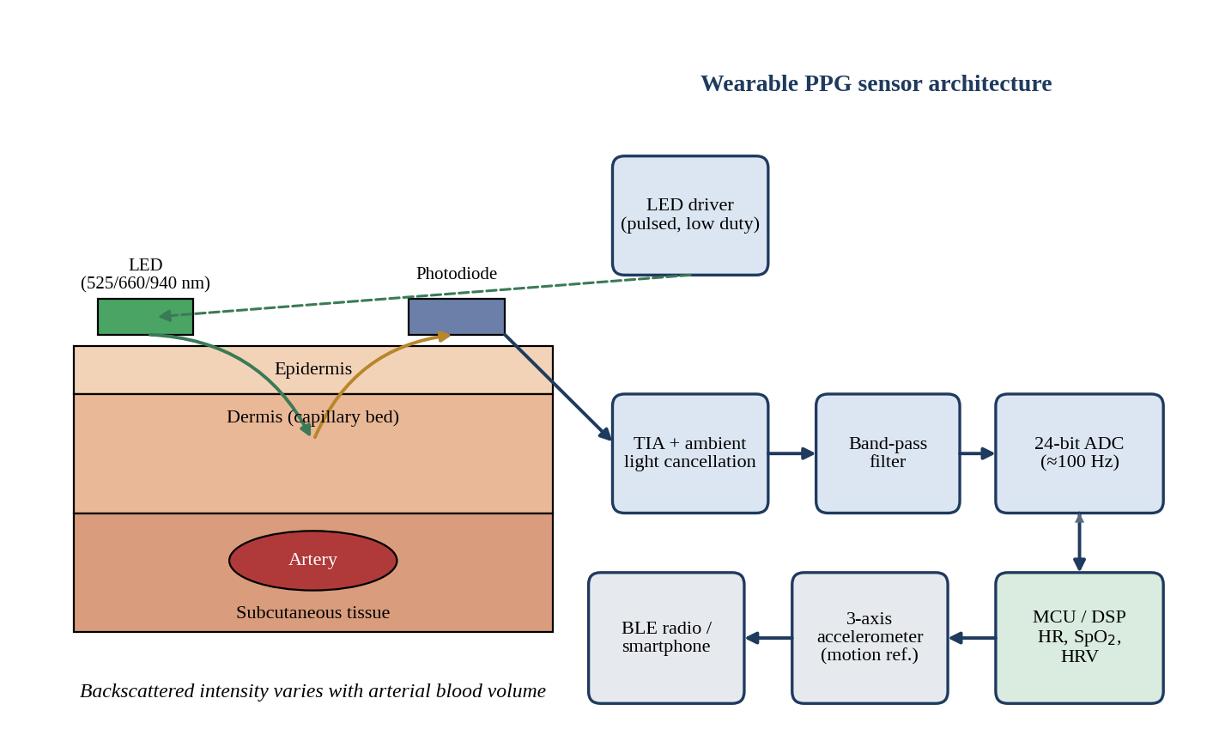
Figure 1: Wearable PPG sensor architecture showing the LED, tissue cross-section, photodiode and signal chain
The figure shows a reflective PPG module in which a pulsed LED illuminates the skin and a neighbouring photodiode collects the backscattered light. The photocurrent is converted to a voltage by a transimpedance amplifier with ambient-light cancellation, band-pass filtered, digitised and processed by a microcontroller. A three-axis accelerometer supplies a motion reference so that motion artefacts can be removed adaptively.
1.3 Detector Requirements for Automotive LiDAR
A time-of-flight LiDAR receiver detects the echo of a short laser pulse and measures the delay between emission and return. The range is obtained from R = ct/2, so a timing uncertainty of 20 ps corresponds to a range uncertainty of only 3 mm. The detector must therefore combine very fast response, a wide bandwidth, high sensitivity to extremely weak echoes and a low noise floor, because the power returned from a distant, low-reflectivity target may be only nanowatts. The received optical power in this scenario is 3 μW, which is already a favourable case, and the design must remain functional when the echo is one or two orders of magnitude weaker. Operation in sunlight, rain and fog adds a requirement for narrow optical filtering and a large dynamic range, while an automotive environment demands operation from −40 °C to +105 °C.
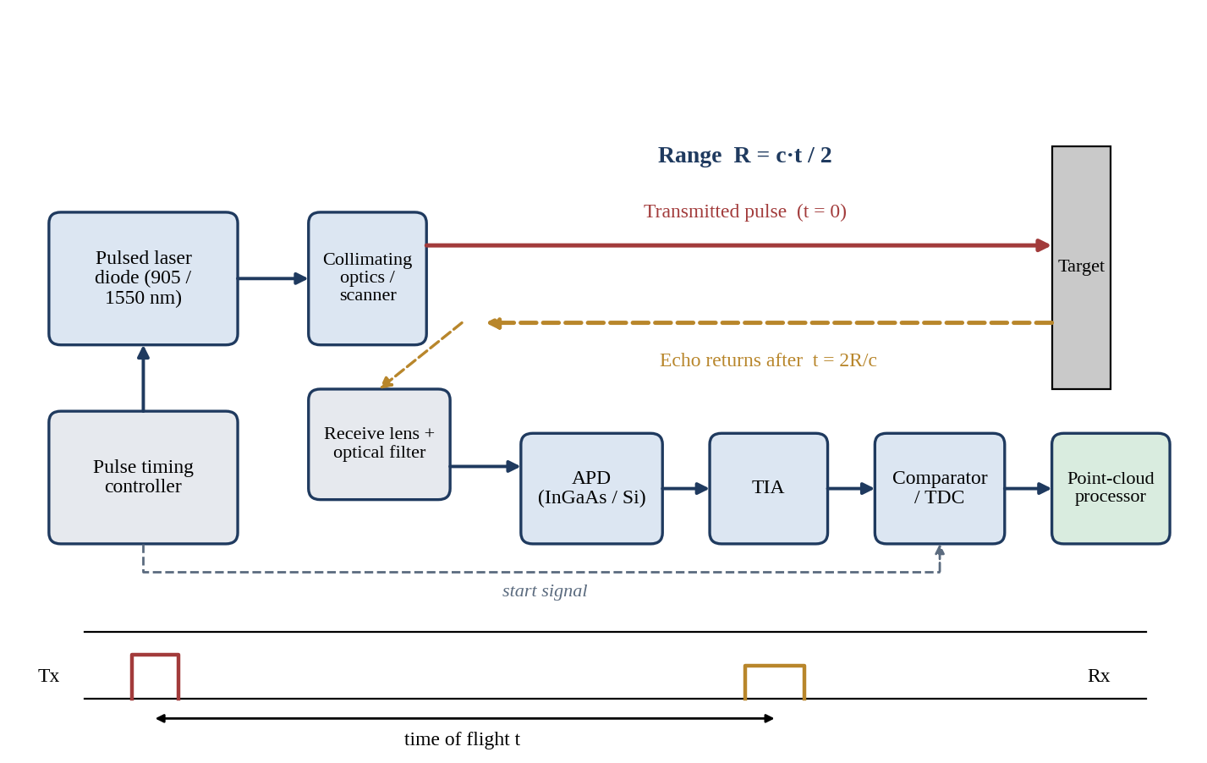
Figure 2: LiDAR working principle: pulsed transmitter, target echo, APD receiver, TIA, time-to-digital converter and timing diagram
The figure illustrates the time-of-flight principle. The timing controller fires the laser pulse and simultaneously starts a time-to-digital converter. The echo is collected by the receive lens and optical filter, converted by the avalanche photodiode and amplified by the transimpedance amplifier, and a comparator stops the counter. The time of flight t is converted into range using R = ct/2, and repeated scanning builds the point cloud.
1.4 Weak-Signal Detection and Detector Figures of Merit
Weak-signal detection is governed by a small set of figures of merit. The responsivity R is the photocurrent generated per unit incident optical power and is related to the quantum efficiency η, the number of collected electrons per incident photon, by
R = ηqλ / (hc) = η λ(μm) / 1.24 A/W (1)
A detector with a higher quantum efficiency converts a larger fraction of the available photons into signal, which directly raises the signal-to-noise ratio when the signal is shot-noise limited. The noise-equivalent power (NEP) is the optical power that produces a signal equal to the rms noise in a 1 Hz bandwidth, NEP = i_{n}/R, and it therefore defines the smallest detectable power; a lower NEP means better low-light capability. The specific detectivity normalises for detector area and bandwidth so that different devices can be compared:
D* = √(A·B) / NEP cm·Hz^{1/2}/W (Jones) (2)
The photocurrent should also be linear with incident power over the whole operating range, I = RP, because deviations from linearity distort the pulsatile PPG waveform, bias the amplitude measurement in LiDAR and corrupt the grey scale of image sensors. Nonlinearity at high optical power arises from space-charge screening and series-resistance voltage drop, and at the low end from the dark-current offset.
1.5 Response Time, Bandwidth, Transit Time and RC Time Constant
The speed of a photodetector is limited by two mechanisms that act in series. The first is the carrier transit time across the depletion region, t_{tr} = d/v_{s}, where d is the depletion width and v_{s} the saturated drift velocity. The second is the RC time constant formed by the junction capacitance and the load or amplifier input resistance, with a corresponding cut-off f_{RC} = 1/(2πRC). Because the junction capacitance rises with active area and falls with depletion width, a wider depletion region improves capacitance but lengthens the transit time, so an optimum thickness exists. For an APD an additional limit is imposed by the avalanche build-up time, which is expressed through a gain–bandwidth product.
1.6 CMOS and CCD Image Sensors, Pixel Scaling and SoC Integration
A charge-coupled device transfers the photogenerated charge packets of every pixel through a shift register to a single output amplifier, which yields excellent uniformity and low fixed-pattern noise but requires high-voltage multi-phase clocks and a dedicated fabrication process. A CMOS active-pixel sensor places an amplifier within each pixel and reads rows and columns in parallel, so that analogue-to-digital conversion, correlated double sampling and image processing can be placed on the same die. Pixel scaling towards 1 μm and below increases resolution and reduces optics size but reduces the full-well capacity, the collected signal and the dynamic range, and increases cross-talk. Back-side illumination and deep-trench isolation recover much of the lost sensitivity, and stacked architectures place the logic below the pixel array, which is why CMOS sensors integrate naturally with the application SoC and neural-network accelerators.
1.7 Requirements for Flexible Photovoltaic Devices
An auxiliary photovoltaic source for a wearable or automotive module must be thin, lightweight and mechanically tolerant. Flexible cells are fabricated on polymer foils such as polyimide or PET and must survive repeated bending at radii of a few millimetres without cracking of the transparent electrode or delamination of the absorber. They must also provide a useful maximum power point at modest irradiance, low temperature sensitivity, and encapsulation that blocks moisture and oxygen, since thin-film absorbers are particularly susceptible to degradation. The power delivered is generally a supplement that extends battery life rather than the primary supply.
1.8 Requirements for OLED, MicroLED and Quantum-Dot Displays
An emerging display for an intelligent platform must offer high brightness, high contrast, a wide colour gamut, fast response and low power at a small form factor. An organic LED is self-emissive and can be fabricated on flexible substrates, which gives true black and thin panels but a limited peak brightness and a finite organic lifetime. A MicroLED display uses an array of microscopic inorganic LEDs and offers very high brightness, long lifetime and high efficiency, at the expense of difficult mass transfer and cost. A quantum-dot display uses size-tuned nanocrystals to convert blue light into narrow-band red and green light, which gives an excellent colour gamut and efficiency. Augmented, virtual and mixed-reality headsets demand very high pixel density, very high luminance because of waveguide losses, and low latency; foldable devices demand bendability, low-temperature processing and thin-film encapsulation.
1.9 Power-Consumption and Reliability Considerations
Power consumption determines battery life in the wearable unit and thermal load in the vehicle module. The detector contributes little directly, but it determines the optical power that the LED or laser must emit, and therefore the largest share of the energy budget. Thermal behaviour matters because the dark current of semiconductor photodiodes roughly doubles for every 8 to 10 °C rise, the APD breakdown voltage drifts with temperature, and organic emitters age faster when hot. Reliability further requires protection against humidity, mechanical stress, electrostatic discharge and, in the automotive case, vibration, wide temperature swing and functional-safety diagnostics. Integration of many sensors also increases system complexity, so a shared power rail, clock and processor are used wherever the noise budget allows.
1.10 Application Requirement Statement
Application Requirement Statement. The proposed integrated optoelectronic platform must (i) detect a 25 μW pulsatile PPG variation and a 3 μW LiDAR echo with a photocurrent that is linear in optical power and a signal-to-noise ratio of at least 15 dB under low-light conditions, (ii) provide a detector bandwidth well above the 1 GHz receiver bandwidth required for centimetre-class ranging, (iii) harvest auxiliary electrical power of about 2 W from a flexible photovoltaic module under full sunlight, (iv) provide an NIR-capable, low-noise, SoC-compatible image sensor for face recognition and automotive imaging, (v) provide a bright, efficient and mechanically flexible display for AR/VR/MR and foldable devices, and (vi) operate within a power budget, thermal range and reliability level suitable for wearable and automotive deployment.
Table 2: Quantified application requirements derived from the scenario
Function | Key quantity | Requirement
Wearable PPG | Pulsatile signal; bandwidth | ≥ 15 μA signal; ~100 Hz; < 1 mW average
Automotive LiDAR | Echo power; bandwidth | 3 μW and below; ≥ 1 GHz; 3 mm range resolution
Low-light detection | SNR | ≥ 15 dB (31.6 : 1 in power)
High-speed detection | Transit-time bandwidth | ≥ 10 GHz detector; 22 GHz from t_{r} = 20 ps
Energy harvesting | Maximum power | ≈ 2.25 W at 1 sun
Imaging and face recognition | Sensor type | NIR-sensitive, SoC-compatible, low noise
Display | Technology | High brightness, contrast and flexibility

2. Photodetector Configuration

2.1 Responsivity and Photocurrent Conversion
The parameter that converts received optical power into photocurrent is the responsivity. For a photodetector operated in its linear region the photocurrent is proportional to the incident optical power:
I_{ph} = R · P (3)
For an APD with multiplication factor M, the effective responsivity becomes R_{eff} = M·R₀, where R₀ is the unity-gain responsivity.

2.2 PPG Photocurrent Variation
The PPG detector has R = 0.60 A/W and the pulsatile optical-power variation is ΔP = 25 μW. Using Equation (3):
ΔI = R × ΔP
ΔI = 0.60 A/W × 25 × 10⁻⁶ W
ΔI = 15 × 10^{−6} A = 15 μA
This current corresponds to a flow of ΔI/q = 15 × 10⁻⁶ / 1.602 × 10⁻¹⁹ = 9.36 × 10¹³ electrons per second. At the adopted wavelength of 940 nm the quantum efficiency is η = 0.60 × 1239.8 / 940 = 79.1 %, which is realistic for a silicon PIN photodiode with an optimised near-infrared response.
The detected photocurrent is related to physiology through the optical absorption of haemoglobin. When the artery dilates during systole, the blood volume in the illuminated tissue rises, more light is absorbed and the backscattered intensity falls; during diastole the reverse occurs. The alternating component of the photocurrent therefore follows the arterial pulse, its fundamental frequency gives the heart rate, and its beat-to-beat interval gives heart-rate variability. When two wavelengths are used, such as 660 nm and 940 nm, the ratio of ratios R_{s} = (AC_{red}/DC_{red}) / (AC_{IR}/DC_{IR}) is related to the oxygen saturation of arterial blood, since oxyhaemoglobin and deoxyhaemoglobin absorb differently at the two wavelengths.

2.3 LiDAR Photocurrent
The LiDAR detector has R = 0.80 A/W and receives P = 3 μW:
I = R × P = 0.80 A/W × 3 × 10⁻⁶ W
I = 2.4 × 10^{−6} A = 2.4 μA
A responsivity of 0.80 A/W at 1550 nm corresponds to η = 0.80 × 1239.8 / 1550 = 64.0 %, which is typical of an InGaAs absorber and shows that the given value is consistent with the eye-safe wavelength. The received power of 3 μW corresponds to 10 log(0.003 mW / 1 mW) = −25.2 dBm.
When an APD is used with a multiplication gain M = 10, the effective responsivity becomes 8.0 A/W and the photocurrent increases tenfold:
I_{APD} = M × R × P = 10 × 0.80 × 3 × 10⁻⁶ = 24 μA
The gain amplifies the signal before it reaches the receiver electronics, so that the thermal noise of the transimpedance amplifier, which does not scale with M, becomes less significant. The role of APD gain is therefore to lift weak signals above the amplifier noise floor. Its limits are the excess noise it adds, discussed in Section 3, and its gain–bandwidth product.

2.4 PIN and APD Photodiodes
A PIN photodiode is a reverse-biased p–i–n junction in which absorption occurs in a wide intrinsic layer, as shown in Figure 3. The structure has unity gain, low capacitance and a nearly uniform field, which produces excellent linearity and bandwidth. An avalanche photodiode adds a high-field multiplication region next to a lower-field absorption region, as shown in Figure 4. Photogenerated electrons drift into the high-field region, where impact ionisation produces additional electron–hole pairs, giving an internal gain M.
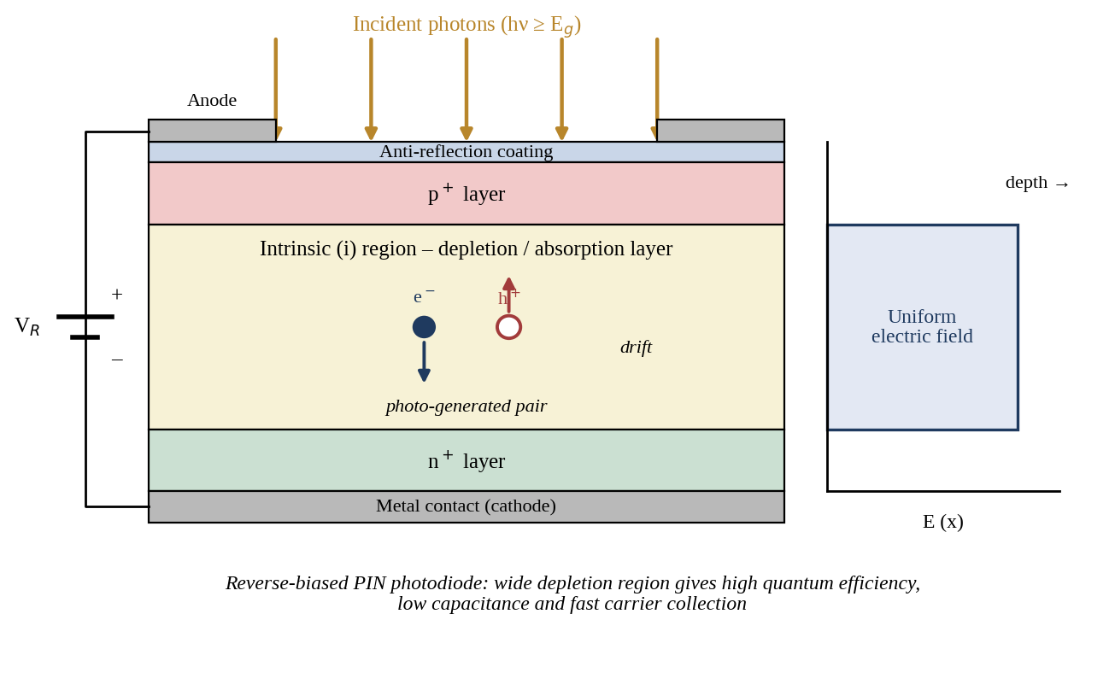
Figure 3: PIN photodiode structure with reverse bias, electron–hole generation and electric-field profile
The figure shows the layered p+–i–n+ structure under reverse bias. Photons absorbed in the intrinsic region generate electron–hole pairs that are swept apart by the uniform field, and the resulting drift current constitutes the photocurrent. The wide depletion layer gives high quantum efficiency and low capacitance, while the absence of multiplication keeps the noise low.
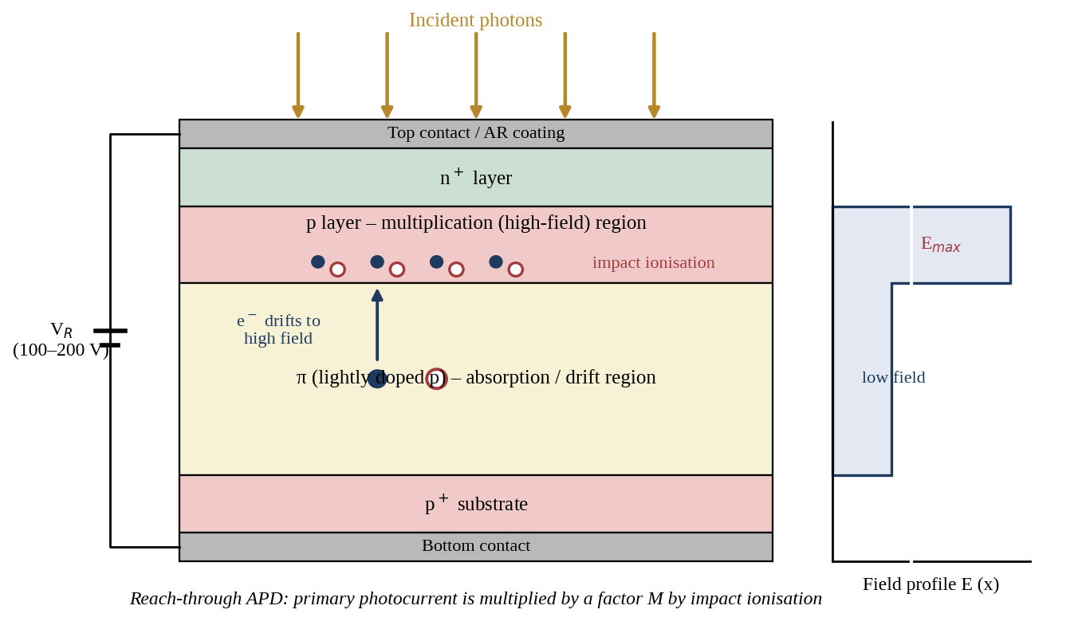
Figure 4: Reach-through APD structure showing the absorption region, multiplication region and field profile
In the reach-through structure the photons are absorbed in the lightly doped π region where the field is moderate. The carriers drift to the p–n+ junction, where the field peaks, and impact ionisation multiplies them. The stepped field profile shows why the absorption and multiplication functions can be optimised separately, but it also shows why a high bias voltage and careful temperature control are required.
Table 3: Comparison of PIN and APD photodetectors
Parameter | PIN photodiode | Avalanche photodiode (APD)
Responsivity | 0.4–0.8 A/W (unity gain) | M × R₀; typically 5–50 A/W effective
Internal gain | 1 (none) | 10–100 typical; 10 adopted here
Sensitivity | Limited by receiver thermal noise | 5–10 dB better in thermal-limited receivers
Noise | Shot + thermal; low | Adds excess noise F(M) = kM + (1−k)(2−1/M); F ≈ 5.1 at M = 10
Bandwidth | Limited by transit time and RC; tens of GHz | Also limited by gain–bandwidth product (M·f ≈ 100–300 GHz)
Speed | Very fast, simple response | Fast, but slows at high gain
Cost | Low | Higher (process control, screening)
Complexity | Simple | Needs gain control and temperature compensation
Bias voltage | 0–5 V | 30–200 V depending on material
Applications | PPG, imaging, UV, short-reach receivers | LiDAR, photon-starved links, low-light sensing

The comparison shows that the two devices are complementary. The PIN photodiode is the preferred detector whenever the optical signal is large enough that receiver noise is not dominant, since it is cheaper, simpler, has lower noise and operates from a low voltage. The APD is justified when the signal is so weak that thermal noise of the amplifier would otherwise dominate, and the cost of excess noise is repaid by the gain. This is quantified in Section 3.

2.5 Dark Current, Quantum Efficiency, NEP, Detectivity and Linearity
Dark current is the current that flows without illumination, produced by thermal generation in the depletion region and by surface leakage. It forms a signal-independent offset and a source of shot noise, and it sets the lower limit of detectable power. In the present assumptions I_{d} = 1 nA, so the photocurrent produced by 1 nW at 0.8 A/W is 0.8 nA and is already comparable to the dark current; below this power the detector is dark-current limited. Quantum efficiency matters because it fixes the ceiling on responsivity at a given wavelength, so improving η through anti-reflection coating, a thicker absorber or back-illumination raises the signal without any penalty in noise.
NEP and detectivity are calculated for the 30 μm InGaAs detector (A = π(15 × 10⁻⁴ cm)² = 7.07 × 10⁻⁶ cm²). The noise current density at zero signal is the sum of shot noise on the dark current and the thermal noise of the 5 kΩ receiver resistance:
i_{n}²(PIN) = 2qI_{d} + 4k_{B}T/R_{eq} = 3.2 × 10⁻²⁸ + 3.31 × 10⁻²⁴ = 3.31 × 10⁻²⁴ A²/Hz
NEP(PIN) = i_{n} / R = 1.82 × 10⁻¹² / 0.80 = 2.28 pW/√Hz
i_{n}²(APD) = 2qI_{d}M²F + 4k_{B}T/R_{eq} = 1.65 × 10⁻²⁵ + 3.31 × 10⁻²⁴ = 3.47 × 10⁻²⁴ A²/Hz
NEP(APD) = 1.86 × 10⁻¹² / (10 × 0.80) = 0.233 pW/√Hz
D(PIN) = √(7.07 × 10^{−6}) / 2.28 × 10^{−12} = 1.17 × 10^{9} Jones
D(APD) = √(7.07 × 10^{−6}) / 2.33 × 10^{−13} = 1.14 × 10^{10} Jones
The gain therefore improves the NEP and detectivity by almost one order of magnitude, because the signal is raised by M while the dominant thermal noise stays constant. Linearity is excellent for both devices over many decades of power. For the PIN photodiode the response remains linear until space-charge effects appear at milliwatt levels; for the APD, linearity is limited at high power by the voltage drop across the series resistance, which reduces the effective bias and therefore the gain. This is a further reason to control the APD gain adaptively rather than to fix it.

2.6 Design Decision 1
Design Decision 1 – Detector Configuration. I recommend a hybrid detector configuration, using a low-bias silicon PIN photodiode with a transimpedance amplifier for the PPG, NIR imaging and face-recognition channels, and an InGaAs avalanche photodiode operating at an adaptive gain of about M = 10 (range 3–20) for the LiDAR channel, because the PPG signal is already large (15 μA) and slow, so that the PIN photodiode gives the lowest noise, lowest voltage and lowest cost, whereas the LiDAR echo is weak (2.4 μA, falling to nanoampere levels at long range) and fast, so that APD gain raises it to 24 μA, improves NEP from 2.28 to 0.233 pW/√Hz and increases the detectivity from 1.17 × 10⁹ to 1.14 × 10¹⁰ Jones. The decision is supported by the responsivity and quantum-efficiency analysis (η = 79 % and 64 %), by the linear photocurrent response, by the bandwidth of more than 20 GHz and by the simulation in Section 7.

3. Noise and SNR Analysis

3.1 Signal-to-Noise Ratio
The performance metric that compares signal and noise is the signal-to-noise ratio. When both powers are expressed in dBm, the SNR in decibels is simply their difference. The low-light signal power is −22 dBm and the noise power is −37 dBm:
SNR(dB) = P_{signal}(dBm) − P_{noise}(dBm) = (−22) − (−37)
SNR = 15 dB
In linear units the signal power is 10^{−2.2} mW = 6.31 μW and the noise power is 10^{−3.7} mW = 0.200 μW, giving a power ratio of 6.31 / 0.200 = 31.6, which is 10 log(31.6) = 15 dB, as expected. The corresponding amplitude ratio is √31.6 = 5.62. For a binary receiver, a ratio of Q = 5.62 corresponds to a bit-error probability of the order of 10⁻⁸, so 15 dB is adequate for PPG, imaging and pulse detection with averaging, but it leaves little margin for a very low error rate. The noise-control strategy below is intended to provide that margin.

3.2 Noise Mechanisms
Shot noise arises from the discrete nature of the photogeneration and carrier collection process. The mean-square shot-noise current in a bandwidth B is
⟨i_{s}²⟩ = 2 q I_{ph} B (4)
and it grows with the square root of optical power, so that it dominates at high signal levels. Dark-current noise is the shot noise associated with the dark current,
⟨i_{d}²⟩ = 2 q I_{d} B (5)
which is independent of the signal and therefore becomes the dominant detector noise when the optical power falls. Avalanche noise, or excess noise, arises because impact ionisation is a random process, so that the multiplication factor fluctuates about its mean M. McIntyre showed that the mean-square noise current of an APD is the shot noise multiplied by M²F(M),
⟨i_{APD}²⟩ = 2 q (I_{ph} + I_{d}) M² F(M) B, F(M) = kM + (1 − k)(2 − 1/M) (6)
where k is the ratio of hole to electron ionisation coefficients. With k = 0.4 and M = 10, F = 4.0 + 1.14 = 5.14. Thermal noise from the receiver resistance, ⟨i_{T}²⟩ = 4k_{B}TB/R_{eq}, does not depend on M and is included in the total noise. In the simulation the excess part of the multiplied shot noise, 2q(I_{ph}+I_{d})M²(F−1)B, is reported separately as the avalanche noise.

3.3 Influence of APD Gain, Low-Light Behaviour and Bandwidth
The signal current of an APD rises as M, so the signal power rises as M², while the detector noise power rises as M²F(M) and the thermal noise remains constant. The SNR is therefore
SNR = (M R P)² / [2q(RP + I_{d})M²F(M)B + 4k_{B}TB/R_{eq}] (7)
At low gain thermal noise dominates, so increasing M improves SNR; at high gain the excess noise factor grows approximately in proportion to M, and the shot-noise term dominates, so the SNR falls again. An optimum gain exists, and it is larger when the optical power is smaller. The simulation in Section 7 gives an optimum M of 2.6 at 3 μW, 3.9 at 1 μW, 8.6 at 100 nW and 17.8 at 10 nW, which justifies a nominal gain of 10 with adaptive control between 3 and 20.
The effect of falling optical power with constant dark current is that the photocurrent decreases linearly but the dark-current noise does not, so the ratio of photocurrent to dark current falls. At P = 1 nW the PIN photocurrent is 0.8 nA against 1 nA of dark current. In practice, however, thermal noise of the amplifier remains larger than the dark-current shot noise, so the dominant noise under low light in the receiver is thermal noise for a PIN photodiode and a combination of avalanche and thermal noise for an APD. Because every noise mean-square current is proportional to the bandwidth, the integrated noise power increases linearly with B. Halving the bandwidth reduces noise power by 3 dB and improves the SNR by 3 dB, provided the bandwidth remains adequate for the signal.

3.4 Noise Reduction and SNR Improvement Methods
Table 4: Methods for improving SNR in the proposed receiver
Method | Mechanism | Expected benefit
Suitable APD gain | Lifts signal above amplifier noise; adaptive M tracks optimum | 13 dB at 100 nW and 18 dB at 10 nW compared with PIN
Optical filtering | Narrow band-pass filter at 1550 nm (or 940 nm) removes solar and ambient background | Reduces background shot noise by 10× or more
Dark-current reduction | Passivated surface, guard ring, small area, low bias | Lowers 2qI_{d} term and offset drift
Cooling | Thermoelectric cooling; dark current halves every 8–10 °C | About 10× lower dark current for 30 °C of cooling
Bandwidth optimisation | Match receiver bandwidth to pulse width instead of detector capability | +3 dB for every halving of bandwidth
Improved optical coupling | Lens, microlens or compound parabolic concentrator on a small detector | More signal power per unit capacitance

These methods act on different terms of the SNR equation and are therefore complementary. Optical filtering and coupling improve the signal-to-background ratio, gain control addresses the amplifier noise, cooling and surface passivation address the dark current, and bandwidth selection addresses the noise integral. For example, narrowing the receiver bandwidth by a factor of two and halving the background through filtering would raise the given 15 dB to about 21 dB, which corresponds to Q ≈ 11 and an error probability far below 10⁻¹⁵.

3.5 Design Decision 2
Design Decision 2 – Noise/SNR Configuration. I recommend an adaptive-gain APD, narrow-band optical filtering, thermoelectric temperature stabilisation and matched-bandwidth noise configuration because the calculated SNR of 15 dB (31.6 : 1) is sufficient for detection but offers little margin, and each element raises it independently. The APD gain overcomes the 57.6 nA rms thermal noise of the 5 kΩ, 1 GHz receiver, the optimum-gain analysis shows that M of about 10 maximises SNR in the 10–100 nW range where the PIN photodiode fails (SNR −17 to +3 dB against +1 to +16 dB), dark-current noise remains below 1 % of the total at the chosen operating point, and the excess-noise penalty (F = 5.14) is acceptable. The strategy is therefore suitable for reliable low-light detecti

4. Response Time and Bandwidth

4.1 Transit-Time Bandwidth
The parameter that relates the transit time of the detector to its bandwidth is the transit-time-limited cut-off frequency. For the given transit time t_{r} = 20 ps, the approximate bandwidth is obtained from
f ≈ 0.44 / t_{r} (8)
f = 0.44 / (20 × 10⁻¹² s)
f = 0.022 × 10¹² Hz = 2.2 × 10¹⁰ Hz
f = 22 GHz
A transit time of 20 ps corresponds, for an assumed saturated drift velocity of 10⁵ m/s, to a depletion width of d = v_{s}t_{tr} = 10⁵ × 20 × 10⁻¹² = 2 μm, which is the value adopted in the assumptions. The detector can therefore follow a pulse train whose spectrum extends to about 22 GHz, and the corresponding range resolution, c·t_{r}/2, is 3.0 mm.

4.2 Transit-Time and RC Limitations
Carrier transit time limits speed because photogenerated carriers need a finite time to cross the depletion region. If this time is longer than the signal period, the induced current is smeared out and the response rolls off. A thinner depletion layer reduces the transit time, but it increases capacitance and reduces absorption, so the quantum efficiency falls. The RC limitation arises because the detector capacitance must be charged and discharged through the load resistance. The junction capacitance of a planar detector is
C_{j} = ε₀ε_{r}A / d (9)
For the 30 μm diameter InGaAs detector (A = π(15 × 10⁻⁶)² = 7.07 × 10⁻¹⁰ m², ε_{r} = 13.9, d = 2 μm):
C_{j} = (8.854 × 10⁻¹² × 13.9 × 7.07 × 10⁻¹⁰) / (2 × 10⁻⁶) = 4.35 × 10⁻¹⁴ F = 43.5 fF
f_{RC} = 1 / (2πR_{L}C_{j}) = 1 / (2π × 50 × 43.5 × 10⁻¹⁵) = 73.2 GHz
The two limits combine approximately as 1/f_{3dB}² = 1/f_{tr}² + 1/f_{RC}², giving f_{3dB} = 21.1 GHz for the 30 μm device. The transit time is the dominant limit at this size, whereas the RC limit dominates for larger areas, as seen in Table 5.
Table 5: Effect of active-area diameter on capacitance and bandwidth (t_{r} = 20 ps, R_{L} = 50 Ω)
Diameter (μm) | Capacitance (fF) | f_{RC} (GHz) | Combined f_{3dB} (GHz)
10 | 4.8 | 658.6 | 22.0
20 | 19.3 | 164.7 | 21.8
30 | 43.5 | 73.2 | 21.1
50 | 120.8 | 26.3 | 16.9
100 | 483.3 | 6.6 | 6.3
200 | 1933.2 | 1.6 | 1.6

4.3 Area, Coupling and Sensitivity Trade-Off; High-Speed LiDAR Requirements
Capacitance rises with the square of the diameter, and bandwidth falls in inverse proportion to the capacitance, so a small active area favours speed. The small area, however, intercepts less light and makes optical alignment more difficult, so sensitivity and field of view fall. A larger area also increases dark current and the capacitance seen by the transimpedance amplifier, which raises its high-frequency noise in proportion to the capacitance. The trade-off is resolved by combining a small detector with focusing optics, such as a microlens or a compound parabolic concentrator, which gathers the light of a large aperture onto a small junction without increasing capacitance.
For a high-speed LiDAR receiver the required bandwidth is set by the pulse width and the required timing accuracy. A laser pulse of 2 ns has a bandwidth of about 0.35/2 ns = 175 MHz, and low timing jitter requires a bandwidth several times larger, so that 0.5–1 GHz is typical. The detector bandwidth of 21 GHz is therefore far in excess of what is required, and the overall bandwidth is determined by the receiver circuit, in particular the transimpedance amplifier. The APD gain–bandwidth product must also be adequate: at M = 10 a gain–bandwidth product of 200 GHz would still allow 20 GHz, so the avalanche build-up time does not restrict the design. Detector and circuit are cascaded, so the overall bandwidth is dominated by the slowest element, and the amplifier feedback resistance, input capacitance and bandwidth must be chosen together.

4.4 Design Decision 3
Design Decision 3 – High-Speed Detector Configuration. I recommend a small-area (30 μm diameter) InGaAs APD with a microlens concentrator, a 2 μm depletion region and a 50 Ω-compatible low-input-capacitance transimpedance amplifier because the calculated transit-time bandwidth is 22 GHz, the junction capacitance of 43.5 fF limits the RC bandwidth to 73.2 GHz, the combined detector bandwidth is about 21 GHz, and this exceeds the 1 GHz needed for 3 mm-class ranging by a factor of twenty. The microlens recovers the optical collection area that is sacrificed for speed, so that sensitivity is retained. Larger detectors (100–200 μm) would reduce the bandwidth to 6.3 GHz and 1.6 GHz respectively and are therefore reserved for short-range, wide-field receivers.

5. PV, Image Sensor and Display Analysis

5.A Solar Photovoltaic Analysis
The maximum power output of a photovoltaic device is the product of the open-circuit voltage, the short-circuit current and the fill factor:
P_{max} = V_{oc} × I_{sc} × FF (10)
P_{max} = 0.60 V × 5 A × 0.75
P_{max} = 3.0 W × 0.75
P_{max} = 2.25 W
The open-circuit voltage is the intercept of the I–V characteristic on the voltage axis and is determined by the band gap and recombination, and the short-circuit current is its intercept on the current axis and is proportional to the absorbed photon flux. Their product, 3.0 W, is the theoretical ceiling that would be obtained if the characteristic were rectangular. The fill factor is the ratio of the actual maximum power to this ceiling and measures the squareness of the I–V curve; it is reduced by series resistance, shunt leakage and recombination. A fill factor of 0.75 therefore means that 75 % of the ceiling is delivered, and the maximum power point lies at V_{mp} ≈ 0.49 V and I_{mp} ≈ 4.59 A, as shown in Figure 5.
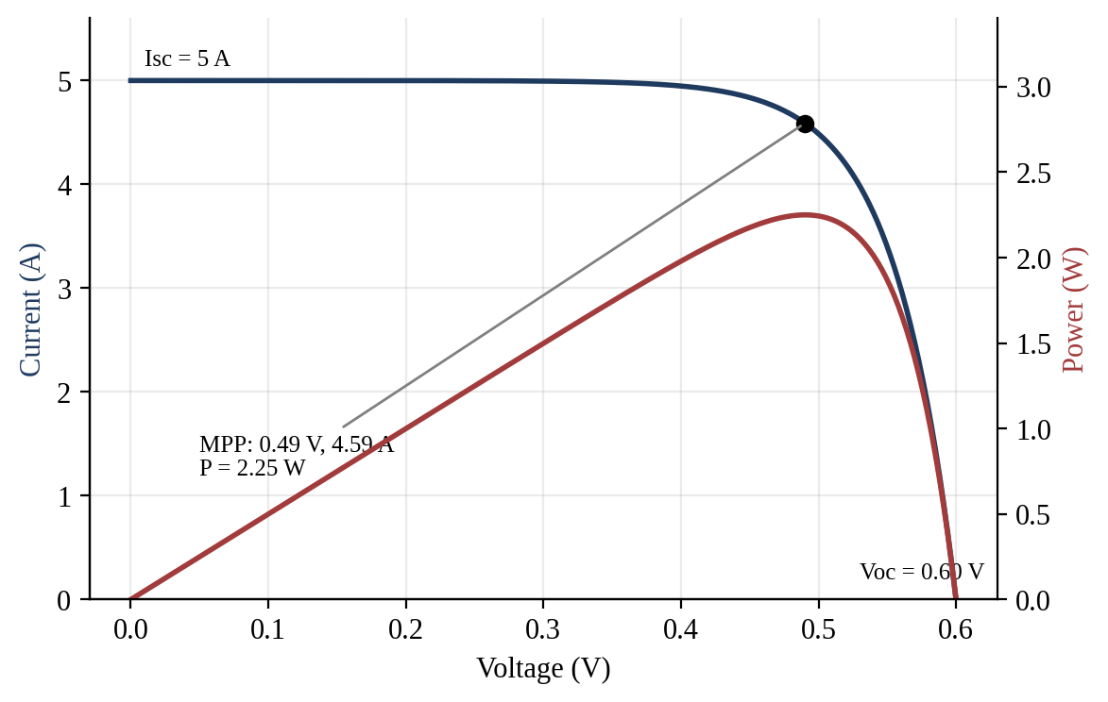
Figure 5: I–V and P–V characteristics of the photovoltaic device with maximum power point (simulated, single-diode model calibrated to FF = 0.75)
The figure shows the current falling gently from the short-circuit value of 5 A until the knee, and then steeply towards the open-circuit voltage of 0.60 V. The power curve peaks at about 2.25 W at 0.49 V and 4.59 A. A power-management stage with maximum-power-point tracking is needed to keep the cell at this operating point as irradiance and temperature change.
The power conversion efficiency is η = P_{max} / (G·A). For the assumed cell area of 150 cm² (0.015 m²) under 1000 W/m², the incident power is 15 W, so
η = 2.25 W / 15 W = 15 %
Efficiency is therefore proportional to the fill factor when V_{oc} and I_{sc} are fixed, and a rise of FF from 0.75 to 0.80 would raise η from 15.0 % to 16.0 %. Flexible PV on a polymer substrate is attractive for wearables because it is thin, lightweight and conformable, can be integrated into straps, clothing or a vehicle roof, and allows roll-to-roll manufacture; Figure 6 shows the layer stack and the bent module. Its limitations are a lower efficiency than rigid crystalline silicon, sensitivity to moisture and oxygen that demands barrier encapsulation, reduced lifetime under repeated bending, and a power output that collapses indoors by two to three orders of magnitude. The module is therefore an auxiliary source that extends battery life, not a replacement for the battery.
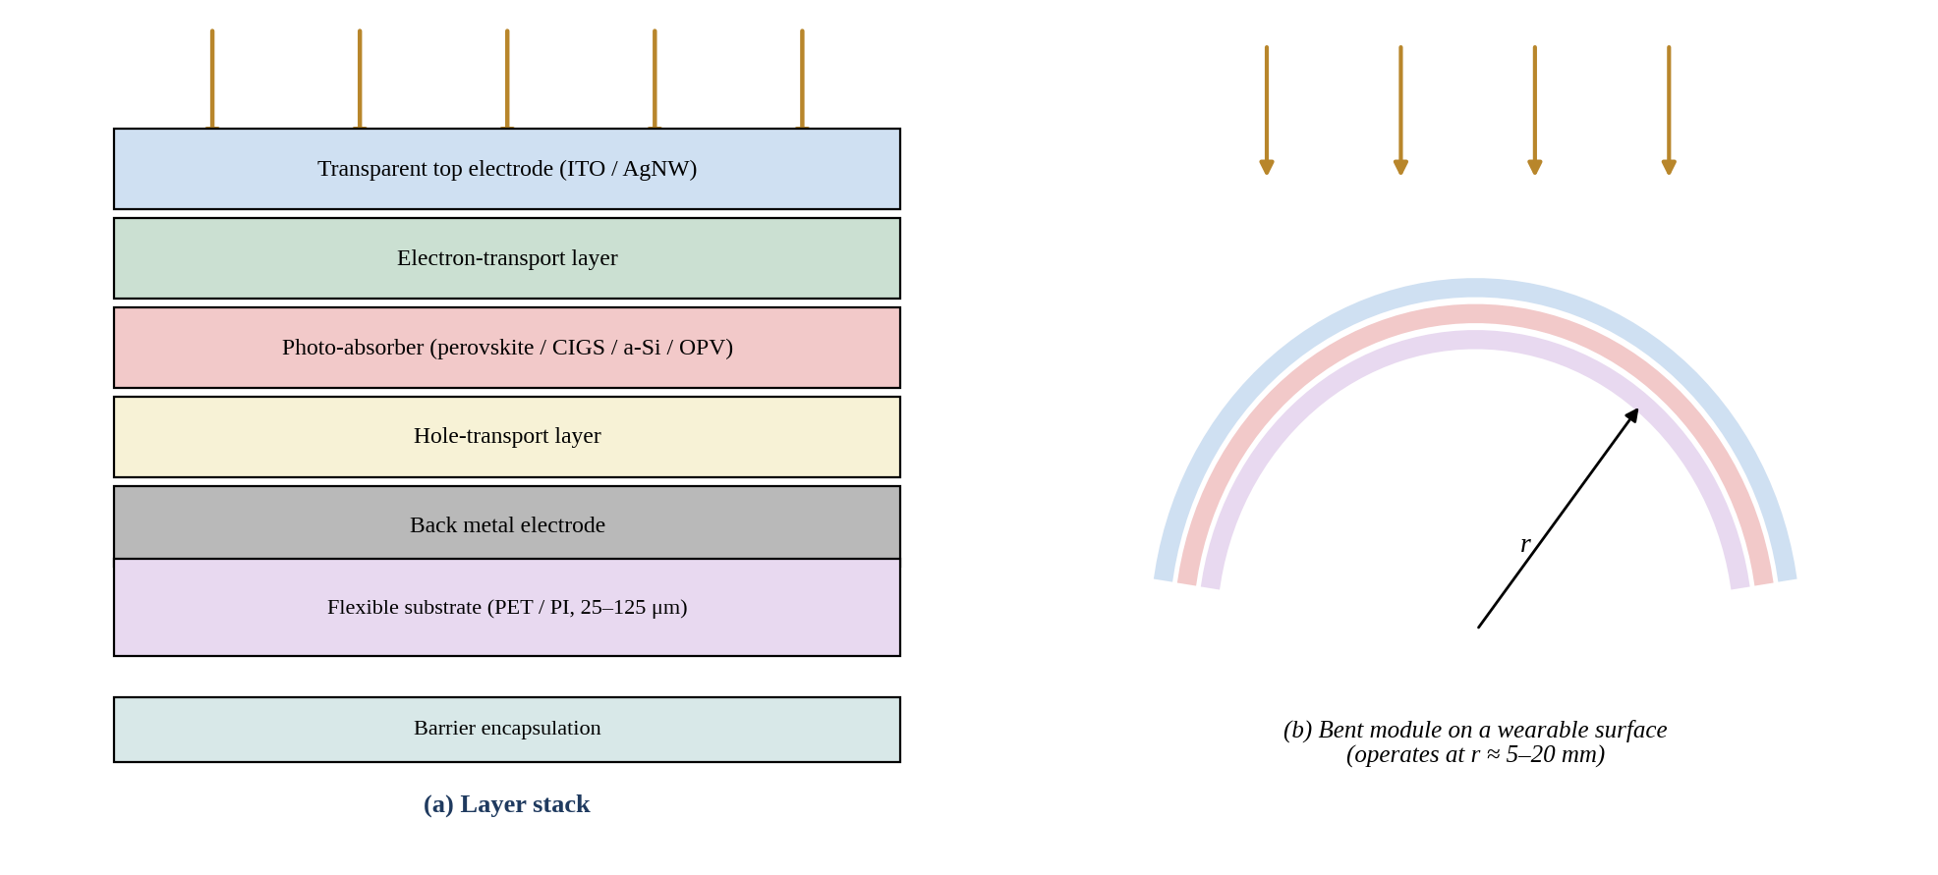
Figure 6: Flexible photovoltaic cell: (a) layer stack on a polymer substrate and (b) conformal bending on a wearable surface
Light enters through a transparent top electrode, is absorbed in the thin-film absorber, and carriers are extracted through the charge-transport layers and the back electrode. The polymer foil and barrier encapsulation allow the device to bend at radii of a few millimetres, and the thinness of the stack keeps the bending strain low.

5.B CMOS versus CCD Image Sensors
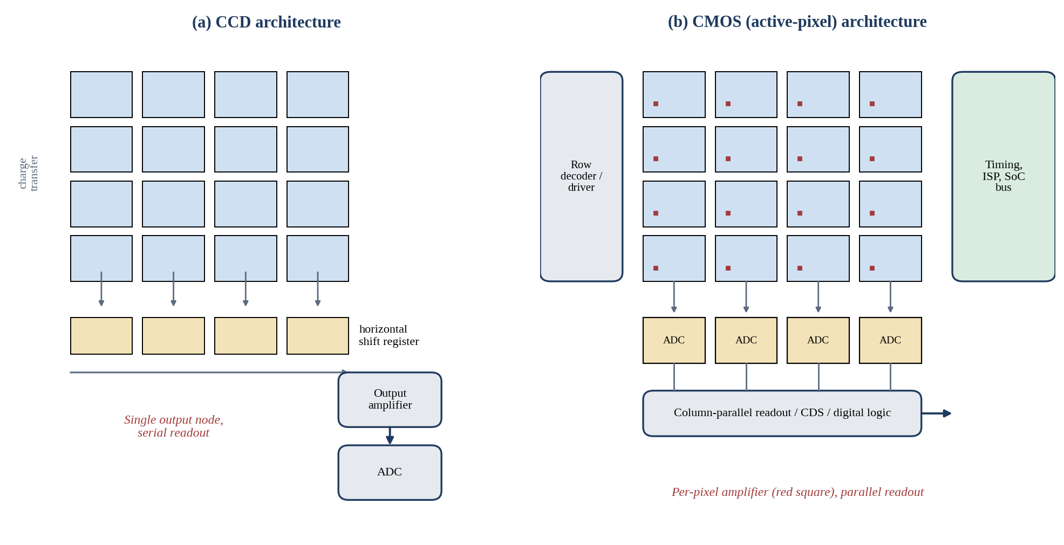
Figure 7: CMOS versus CCD image-sensor architecture
In the CCD (a) the charge of every pixel is shifted through vertical and horizontal registers to one output amplifier, which gives uniform response but serial, power-hungry readout. In the CMOS sensor (b) each pixel contains its own amplifier and rows are selected by a decoder, with column-parallel converters and on-chip logic, so that readout is fast, low-power and ready to connect to a system-on-chip.
Table 6: Comparison of CCD and CMOS image sensors
Parameter | CCD | CMOS (active pixel)
Architecture | Photogate array with charge-transfer registers; single output node | Photodiode plus 3–5 transistors per pixel; row/column addressing
Pixel operation | Charge collected and shifted without amplification | Charge converted to voltage inside the pixel
Readout mechanism | Serial, destructive charge transfer | Parallel, random-access, column-wise ADC
Noise | Low read noise and fixed-pattern noise | Slightly higher FPN; read noise now ≈1 e⁻ or less with CDS
Speed | Limited by charge-transfer rate | Very high frame rates; global or rolling shutter
Power | High (10–40 V clocks) | Low (single 1.8–3.3 V supply)
Pixel scaling | Limited by transfer efficiency | Scales to below 1 μm with BSI and trench isolation
SoC compatibility | Poor; separate process and ICs | Excellent; ISP, ADC and memory on one chip
Face-recognition suitability | Adequate image quality, bulky, costly | Excellent; NIR-enhanced, global shutter, on-chip ISP
Automotive suitability | Less suited; power, cost, blooming | Excellent; HDR, LED-flicker mitigation, low power

The comparison shows that CCD retains an advantage only in specialised, very low-noise scientific imaging, whereas CMOS has overtaken it in almost every other respect. Decreasing the pixel dimension increases spatial resolution and reduces the size of the optics, but it reduces the collecting area and the full-well capacity, so that the signal and dynamic range fall, shot noise becomes a larger fraction of the signal and optical and electrical cross-talk between adjacent pixels increases. These penalties are partly offset by back-side illumination, microlens optimisation, deep-trench isolation and pixel binning. In terms of integration, smaller pixels reduce the array area at a given resolution, so a stacked sensor can place the analogue-to-digital conversion, ISP and neural-network accelerator in the logic layer below, which minimises the interconnect length and energy per frame. For these reasons, a back-illuminated CMOS sensor is selected.

5.C OLED, MicroLED and Quantum-Dot Displays
Organic LEDs emit light by radiative recombination of electrons and holes injected into an organic emissive layer, as shown in Figure 8. MicroLED displays use arrays of inorganic InGaN or AlGaInP micro-diodes that emit directly (Figure 9), and quantum-dot displays use nanocrystals that absorb blue light and re-emit narrow-band red and green light (Figure 10).
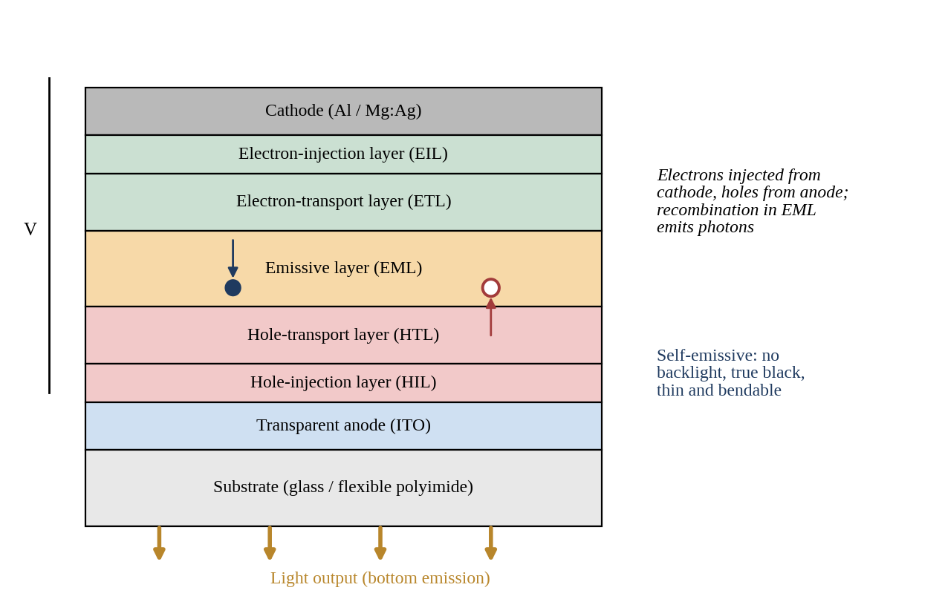
Figure 8: OLED display structure
The figure shows the multilayer organic stack between a transparent anode and a metallic cathode. Electrons and holes are injected through the transport layers and recombine in the emissive layer, and the emitted light leaves through the transparent anode and substrate. The very thin stack on a polyimide substrate is what allows OLED panels to be curved and folded.
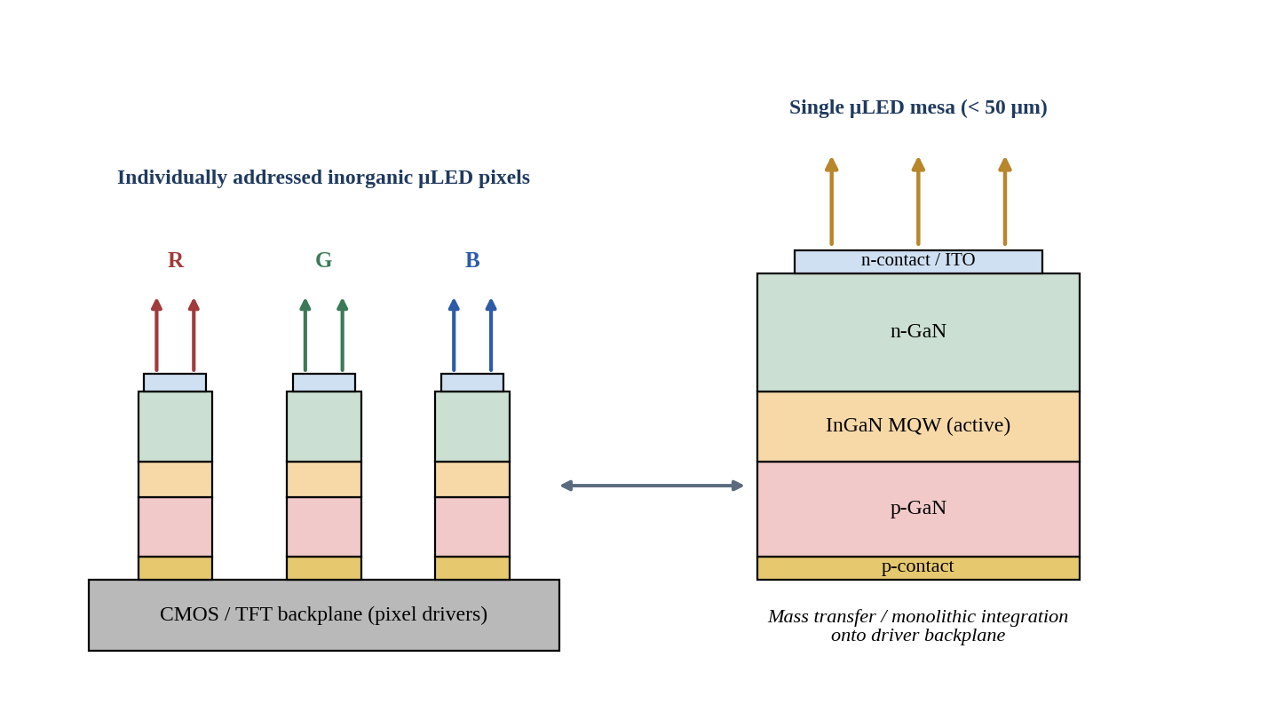
Figure 9: MicroLED display structure showing individually addressed micro-LED pixels on a driver backplane and a single mesa structure
Each pixel is a microscopic InGaN LED consisting of n-GaN, a multiple-quantum-well active region and p-GaN. The chips are transferred to, or grown on, a CMOS or TFT backplane that addresses each pixel. Because the emitters are inorganic they offer very high brightness, long lifetime and high efficiency, but the transfer of millions of chips is the major cost challenge.
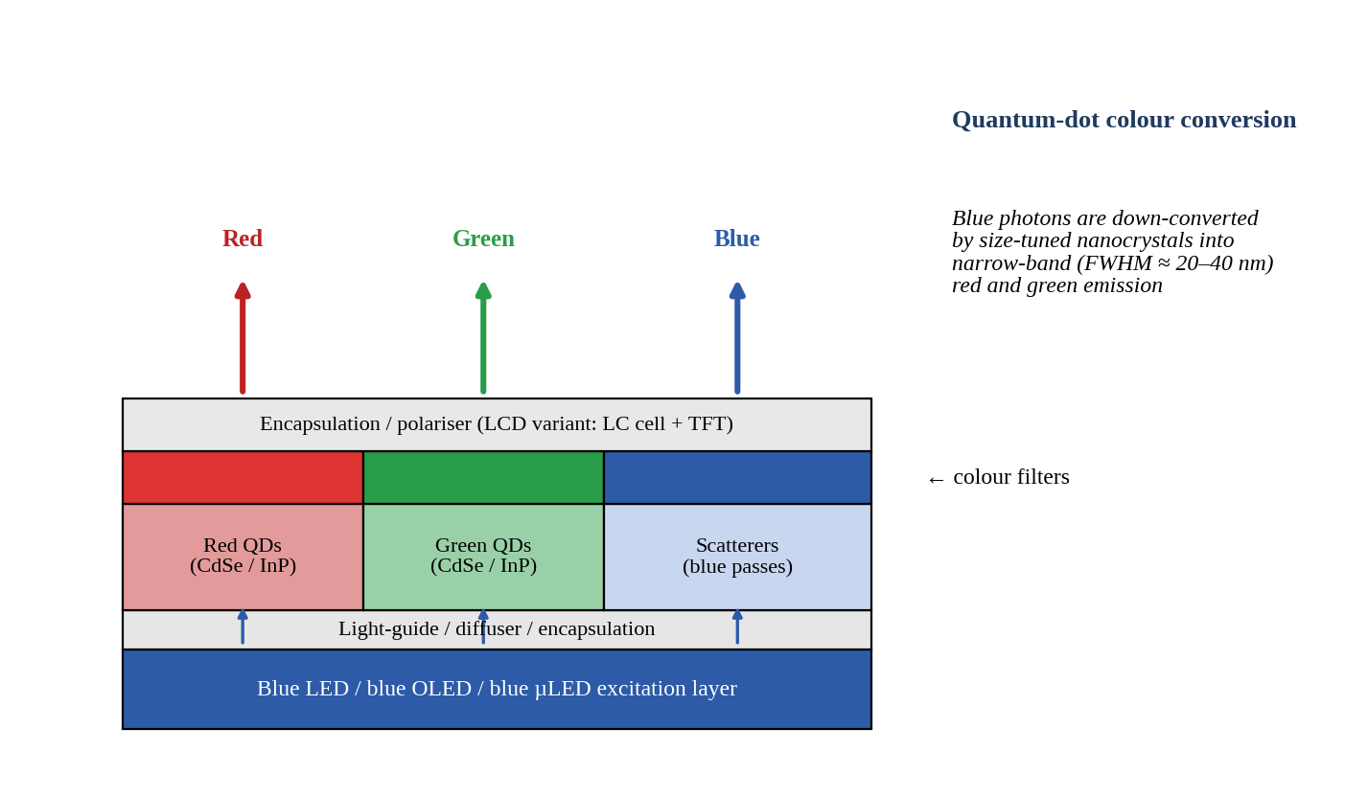
Figure 10: Quantum-dot display structure with colour-conversion layer
Blue light from the excitation layer passes through patterned layers of red and green quantum dots, which convert it to narrow-band red and green light, and through a scattering layer for the blue sub-pixel. Colour filters clean the emission, and the narrow spectral width of the dots gives a much larger colour gamut than phosphors.
Table 7: Comparison of OLED, MicroLED and quantum-dot displays
Parameter | OLED | MicroLED | Quantum dot
Light generation | Organic electroluminescence | Inorganic InGaN/AlGaInP electroluminescence | Photoluminescence conversion of blue light (QD-LCD, QD-OLED)
Brightness | Moderate: ~1000–2000 nits | Very high: >10⁵ nits demonstrated | High: ~1000–3000 nits
Contrast | Effectively infinite (per-pixel off) | Effectively infinite | High (QD-OLED) or limited (QD-LCD)
Efficiency | Good; blue emitter limited | Excellent | Very good; conversion losses
Response time | μs (<0.1 ms) | ns–μs | μs (QD-OLED); ms (QD-LCD)
Lifetime | 30 000–100 000 h; burn-in risk | >100 000 h; no organic ageing | Long; dots sensitive to heat and oxygen
Colour quality | Wide gamut (~100 % DCI-P3) | Wide gamut | Widest gamut (~90–100 % Rec. 2020)
Power consumption | Low for dark content | Lowest at high brightness | Low to moderate
AR/VR/MR suitability | Good (microdisplays), limited brightness | Excellent; high brightness for waveguides | Promising as colour converter for µLED
Foldable suitability | Excellent; proven in products | Possible; transfer on flexible backplane is difficult | Good if printed on flexible OLED

The comparison shows that no single technology is best in every respect. OLED offers a mature, bendable and low-power display with perfect black, and is therefore the preferred choice for foldable panels. MicroLED offers the high luminance and efficiency that near-eye displays demand, because a waveguide combiner may transmit less than one percent of the light, and it avoids organic ageing, but it is still expensive. Quantum dots provide the widest colour gamut and are most valuable as a colour-conversion layer on top of a blue emitter, which is also a practical route to full-colour MicroLED.

5.D Design Decision 4
Design Decision 4 – PV, Image-Sensor and Display Configuration. I recommend flexible thin-film PV, a back-illuminated NIR-enhanced CMOS image sensor and a MicroLED display (with quantum-dot colour conversion), complemented by flexible OLED for foldable surfaces because the flexible PV delivers 2.25 W (15 % efficiency at 1 sun) from a thin, conformable and lightweight module; the CMOS sensor matches or exceeds the CCD in speed, power, pixel scaling and SoC integration and is better suited to face recognition and automotive imaging; and MicroLED gives the highest brightness and lifetime needed for AR/VR/MR at low power, with OLED retained where bendability is the dominant requirement. The recommendation is supported by performance, integration, power, reliability and application requirements.

6. Application Analysis

6.1 Wearable Biomedical PPG
Operating principle. A light-emitting diode illuminates the skin, and the photodiode collects the backscattered light, whose intensity is modulated by arterial blood volume (Figure 1). Detector selection. A silicon PIN photodiode with a large area (about 5 mm²) is preferred over an APD because the signal is large and slow and the noise must be minimal. Green (525 nm) light gives the highest modulation depth for wrist measurement, while red and 940 nm light penetrate deeper and are used for oxygen saturation. Responsivity and sensitivity. With R = 0.60 A/W the 25 μW variation gives 15 μA, which is easily resolved. Noise. With a 100 kΩ feedback resistance and a 100 Hz bandwidth the total rms noise is about 22 pA, so that the electronic signal-to-noise ratio exceeds 100 dB, and the practical limit is set by motion artefacts and ambient light rather than by detector noise. Signal processing. The DC pedestal is cancelled, a band-pass filter of 0.5–10 Hz is applied, motion is removed adaptively with the accelerometer reference, and peaks are detected to give heart rate. Power. A 10 mA LED pulse at 2 V with 1 % duty cycle consumes an average of about 0.2 mW, so the whole module operates below 1 mW. Challenges. They include motion artefact, skin-tone dependence, contact-pressure variation and ambient-light interference.

6.2 NIR Spectroscopy
Operating principle. Near-infrared light between about 700 nm and 2500 nm penetrates biological tissue, and absorption by water, haemoglobin, glucose, lipids and proteins follows the Beer–Lambert law, A = εcl, so that concentration can be inferred from the attenuation at selected wavelengths. Wavelength and detector. The wavelengths 760 and 850 nm address haemoglobin oxygenation, while the overtone and combination bands near 1450, 1550 and 1700 nm address water and glucose. Silicon PIN photodiodes are suitable below 1000 nm, and extended InGaAs PIN photodiodes (R ≈ 0.8–1.0 A/W) are required beyond 1000 nm. Sensitivity and noise. The absorption features are weak, and the detector must resolve absorbance changes of 10⁻⁴ to 10⁻³, which requires low dark current and a high SNR; an InGaAs PIN photodiode with thermoelectric cooling is suitable. Optical filtering. Narrow-band filters or a dispersive element select each wavelength and reject ambient light. Signal processing. Lock-in or synchronous detection, averaging, baseline correction and multivariate regression (PLS) convert the signals into concentration. Challenges. They include scattering, temperature dependence of the water bands, and the need for calibration for each individual.

6.3 Automotive LiDAR
Operating principle. The time of flight of a laser pulse gives range as R = ct/2, as shown in Figure 2. Detector selection. The receiver must detect a few microwatts or less at 1550 nm with nanosecond timing, so an InGaAs APD with gain M ≈ 10 is selected (Design Decision 1). Responsivity and sensitivity. The 2.4 μA from the 3 μW echo becomes 24 μA at M = 10, improving NEP by an order of magnitude. Noise. Under sunlight the background light contributes shot noise, so narrow optical filtering and a small field of view are essential. Signal processing. A transimpedance amplifier with approximately 1 GHz bandwidth, a constant-fraction discriminator or comparator and a time-to-digital converter produce the range, and averaging or histogramming of repeated pulses further improves detection. Power. The laser dominates, subject to eye-safety limits, which are much more relaxed at 1550 nm. Challenges. They include weather, interference from other LiDARs, thermal drift of APD gain and the cost of InGaAs.

6.4 Face Recognition System
Operating principle and detector selection. An NIR illuminator (850 or 940 nm VCSEL) lights the face, a NIR-sensitive CMOS sensor captures the image or the projected dot pattern, and a neural network extracts a feature vector that is matched against the stored template (Figure 11). CMOS is selected over CCD because of its on-chip processing, low power and high frame rate. Resolution, pixel scaling and sensitivity. Pixels of 1.4–3 μm with back-side illumination offer enough resolution for several hundred pixels across the face while retaining quantum efficiency in the NIR. Noise and illumination. Active NIR illumination makes the system independent of ambient visible light, and a bandpass filter blocks sunlight. Signal processing. The ISP corrects the image, and a CNN generates the embedding, and liveness detection from depth or NIR texture rejects photographs. Response time and power. A global-shutter sensor reaches recognition within 100–300 ms at a few hundred milliwatts for the short duration of the capture. Challenges. They include spoofing, sunlight at 940 nm and privacy of stored templates, which are kept in a secure enclave.
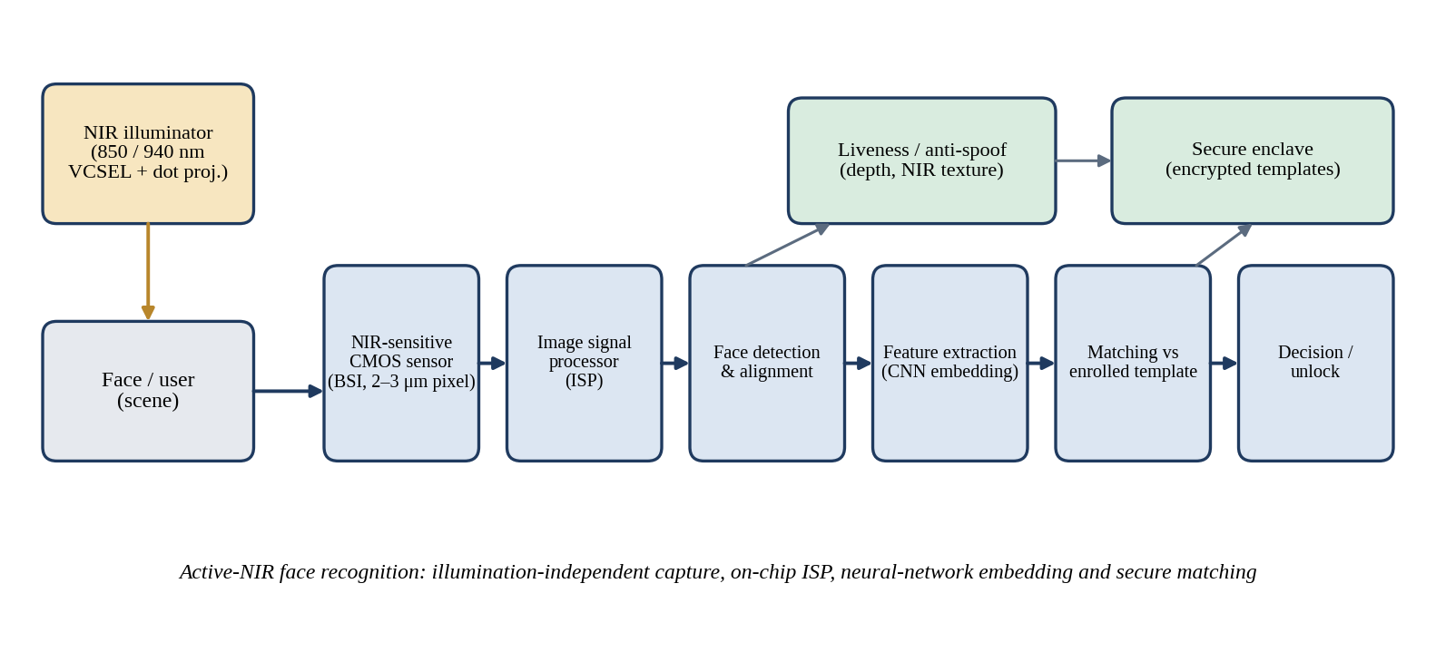
Figure 11: Face-recognition system block diagram
The block diagram shows the chain from NIR illumination and a NIR-sensitive CMOS sensor, through the image signal processor, face detection and alignment, feature extraction and matching, to the decision. Liveness detection and the secure enclave operate in parallel with the main pipeline to prevent spoofing and to protect the stored templates.

6.5 UV Detection System
Operating principle and detector selection. UV radiation between 200 and 400 nm is detected with a photodiode whose band gap is large enough to reject visible light. Silicon responds to visible light and therefore needs filters that age under UV, whereas SiC, GaN and AlGaN photodiodes are intrinsically visible-blind, which gives a high UV-to-visible rejection ratio, as shown in Figure 12. Responsivity and noise. Typical responsivities are 0.1–0.2 A/W in the UV, and the dark current is in the femtoampere to picoampere range because of the wide band gap, so a high-value feedback resistor or an integrating amplifier gives excellent sensitivity. Signal processing. The photocurrent is converted, digitised, temperature compensated and weighted by the erythemal action spectrum to yield the UV index. Power. The sensor operates at microwatts and without bias in photovoltaic mode. Challenges. They include UV-induced degradation of filters and encapsulants, cosine response of the optics and a very small signal at low UV levels.
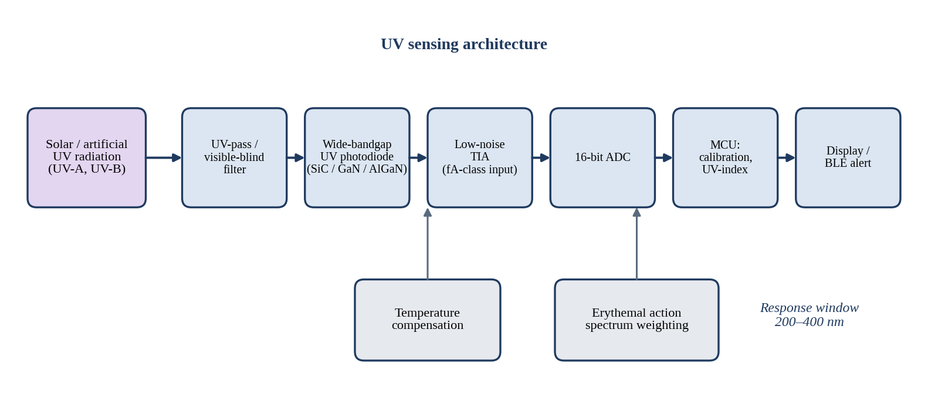
Figure 12: UV sensing architecture using a wide-bandgap photodiode
The figure shows the UV radiation passing through a UV-pass and visible-blind filter into a wide-bandgap photodiode, followed by a low-noise transimpedance amplifier and a high-resolution converter. The microcontroller applies temperature compensation and erythemal weighting to produce the UV index and sends alerts to the display or phone.
Table 8: Summary of application-specific detector configurations
Application | Wavelength | Detector | Key challenge
Wearable PPG | 525/660/940 nm | Si PIN, R = 0.60 A/W; 15 μA | Motion artefact
NIR spectroscopy | 760–1700 nm | Si PIN / extended InGaAs PIN | Weak absorption, calibration
Automotive LiDAR | 1550 nm | InGaAs APD, M ≈ 10; 24 μA | Sunlight, gain drift
Face recognition | 850/940 nm | BSI CMOS, NIR-enhanced | Spoofing, sunlight
UV detection | 200–400 nm | SiC / GaN / AlGaN photodiode | Low signal, filter ageing

6.6 Design Decision 5
Design Decision 5 – Application-Specific Sensing Configuration. I recommend an application-specific configuration in which each channel uses the detector that best matches its signal: Si PIN for PPG, extended InGaAs PIN for NIR spectroscopy, InGaAs APD for LiDAR, BSI NIR CMOS for face recognition and imaging, and a wide-bandgap photodiode for UV, all managed by a common SoC, because the signals differ by many orders of magnitude in power, bandwidth and wavelength. Applying one detector type to all channels would either waste power and add noise (an APD for PPG), or fail to meet sensitivity (a PIN photodiode for long-range LiDAR), or lack visible-blindness (silicon for UV). The configuration is supported by the calculated photocurrents (15 μA and 2.4 μA), the NEP and detectivity, the 22 GHz bandwidth, the 15 dB SNR and the imaging analysis.

7. MATLAB Simulation

7.1 Simulation Objectives and Input Parameters
The detector model was implemented in MATLAB to verify the hand calculations and to examine behaviour over a wide range of optical power, gain and detector size. The program calculates (A) photocurrent versus optical power, (B) the shot, dark-current, avalanche and thermal noise components, (C) the SNR as a function of optical power and APD gain, (D) the detector bandwidth from the transit time, and (E) the I–V characteristic of the photovoltaic device. The inputs are those of Table 1, summarised in Table 9.
Table 9: Input parameters of the MATLAB model
Parameter | Symbol | Value
Responsivity (PPG / LiDAR) | R | 0.60 / 0.80 A/W
Optical power range | P | 1 nW – 1 mW (300 log points)
Dark current; APD gain; ionisation ratio | I_{d}; M; k | 1 nA; 10; 0.4
Receiver resistance; temperature | R_{eq}; T | 5 kΩ; 300 K
Noise bandwidth | B | 1 GHz
Transit time; diameter; depletion width | t_{r}; D; d | 20 ps; 30 μm; 2 μm
PV parameters | V_{oc}, I_{sc}, FF | 0.60 V, 5 A, 0.75

7.2 MATLAB Code
The complete program is listed below. It uses base MATLAB only and generates all plots shown in this section.
%% CO3 - Integrated Optoelectronic Platform: detector, noise, SNR, bandwidth and PV simulation
clear; clc; close all;

%% ---------------- Input parameters ----------------
q = 1.602e-19; kB = 1.381e-23; T = 300; % constants, temperature (K)
R_ppg = 0.60; dP_ppg = 25e-6; % PPG detector
R_lid = 0.80; P_lid = 3e-6; % LiDAR detector
Id = 1e-9; M = 10; kA = 0.4; % dark current, APD gain, ionisation ratio
Req = 5e3; B = 1e9; % receiver resistance, noise bandwidth
tr = 20e-12; dia = 30e-6; d_dep = 2e-6; RL = 50; er = 13.9;
Voc = 0.60; Isc = 5; FF = 0.75;
F = @(m) kA.*m + (1-kA).*(2-1./m); % McIntyre excess-noise factor

%% ---------------- A. Photocurrent vs optical power ----------------
I_ppg = R_ppg*dP_ppg; I_lid = R_lid*P_lid;
fprintf('PPG photocurrent = %.2f uA\n', I_ppg*1e6);
fprintf('LiDAR photocurrent = %.2f uA (APD, M=10: %.1f uA)\n', I_lid*1e6, M*I_lid*1e6);
P = logspace(-9,-3,300); % 1 nW to 1 mW
figure(1);
loglog(P*1e6, R_ppg*P*1e6, 'LineWidth',2); hold on;
loglog(P*1e6, R_lid*P*1e6, 'LineWidth',2);
loglog(P*1e6, M*R_lid*P*1e6, 'LineWidth',2);
yline(Id*1e6,':'); grid on;
xlabel('Optical power (\muW)'); ylabel('Photocurrent (\muA)');
legend('PPG PIN 0.60 A/W','LiDAR PIN 0.80 A/W','LiDAR APD M=10','Location','northwest');

%% ---------------- B. Noise analysis (rms current, A) ----------------
shot = @(P,R,m,Bw) 2*q*R.*P.*m.^2*Bw;
dark = @(P,m,Bw) 2*q*Id*m.^2*Bw*ones(size(P));
aval = @(P,R,m,Bw) 2*q*(R.*P+Id).*m.^2.*(F(m)-1)*Bw;
therm = @(P,Bw) 4*kB*T*Bw/Req*ones(size(P));
tot = @(P,R,m,Bw) shot(P,R,m,Bw)+dark(P,m,Bw)+aval(P,R,m,Bw)+therm(P,Bw);
figure(2);
loglog(P*1e6, sqrt(shot(P,R_lid,M,B))*1e9, P*1e6, sqrt(dark(P,M,B))*1e9, ...
P*1e6, sqrt(aval(P,R_lid,M,B))*1e9, P*1e6, sqrt(therm(P,B))*1e9, ...
P*1e6, sqrt(tot(P,R_lid,M,B))*1e9, 'k--', 'LineWidth',2); grid on;
xlabel('Optical power (\muW)'); ylabel('RMS noise current (nA)');
legend('Shot','Dark current','Avalanche excess','Thermal','Total','Location','northwest');

%% ---------------- C. SNR analysis ----------------
snr = @(P,R,m,Bw) (m*R.*P).^2 ./ tot(P,R,m,Bw);
snr_given = -22 - (-37); % dB, from the scenario
fprintf('Given low-light SNR = %.1f dB (ratio %.1f)\n', snr_given, 10^(snr_given/10));
figure(3);
semilogx(P*1e6, 10*log10(snr(P,R_lid,1,B)), P*1e6, 10*log10(snr(P,R_lid,5,B)), ...
P*1e6, 10*log10(snr(P,R_lid,10,B)), P*1e6, 10*log10(snr(P,R_lid,20,B)), 'LineWidth',2);
grid on; xlabel('Optical power (\muW)'); ylabel('SNR (dB)');
legend('PIN','APD M=5','APD M=10','APD M=20','Location','northwest');
Mv = linspace(1,60,600); % optimum gain at P = 3 uW
s3 = 10*log10(arrayfun(@(m) snr(P_lid,R_lid,m,B), Mv));
[smax,im] = max(s3); fprintf('Optimum M at 3 uW = %.1f (SNR %.1f dB)\n', Mv(im), smax);
figure(4); plot(Mv, s3, 'LineWidth',2); grid on;
xlabel('APD gain M'); ylabel('SNR at 3 \muW (dB)');

%% ---------------- D. Bandwidth verification ----------------
f_th = 0.44/tr; % theoretical, Hz
f = logspace(7, 11.5, 4000);
Htr = abs(sin(pi*f*tr)./(pi*f*tr)); % rectangular transit-time response
ix = find(Htr < 1/sqrt(2), 1);
f_sim = f(ix-1) + (Htr(ix-1)-1/sqrt(2))/(Htr(ix-1)-Htr(ix))*(f(ix)-f(ix-1));
Cj = 8.854e-12*er*pi*(dia/2)^2/d_dep; f_RC = 1/(2*pi*RL*Cj);
Hrc = 1./sqrt(1+(f/f_RC).^2); Ht = Htr.*Hrc;
ix2 = find(Ht < 1/sqrt(2), 1); f_tot = f(ix2);
fprintf('f_tr theory = %.2f GHz, simulated = %.2f GHz\n', f_th/1e9, f_sim/1e9);
fprintf('C = %.1f fF, f_RC = %.1f GHz, combined = %.1f GHz\n', Cj*1e15, f_RC/1e9, f_tot/1e9);
figure(5); semilogx(f/1e9, 20*log10(Htr), f/1e9, 20*log10(Hrc), f/1e9, 20*log10(Ht), 'LineWidth',2);
grid on; ylim([-30 2]); xlabel('Frequency (GHz)'); ylabel('Response (dB)');
legend('Transit time','RC','Combined');

%% ---------------- Photovoltaic maximum power ----------------
Pmax = Voc*Isc*FF; fprintf('Pmax (analytic) = %.2f W\n', Pmax);
FF0 = @(n) (Voc/(n*0.025852) - log(Voc/(n*0.025852)+0.72)) ./ (Voc/(n*0.025852)+1);
n_id = fzero(@(n) FF0(n)-FF, 1.7); Vt = n_id*0.025852;
I0 = Isc/(exp(Voc/Vt)-1); V = linspace(0,Voc,400);
I = Isc - I0*(exp(V/Vt)-1); [Pm,imp] = max(V.*I);
fprintf('Pmax (simulated I-V) = %.3f W at %.2f V, %.2f A\n', Pm, V(imp), I(imp));
figure(6); yyaxis left; plot(V,I,'LineWidth',2); ylabel('Current (A)');
yyaxis right; plot(V,V.*I,'LineWidth',2); ylabel('Power (W)'); xlabel('Voltage (V)'); grid on;

7.3 Simulation Results
The numerical results are given in Tables 10 to 13, and the plots are shown in Figures 13 to 17. The plots in this report were reproduced from the same equations and parameters as the MATLAB listing; running the script in MATLAB regenerates Figures 14 to 17 directly.
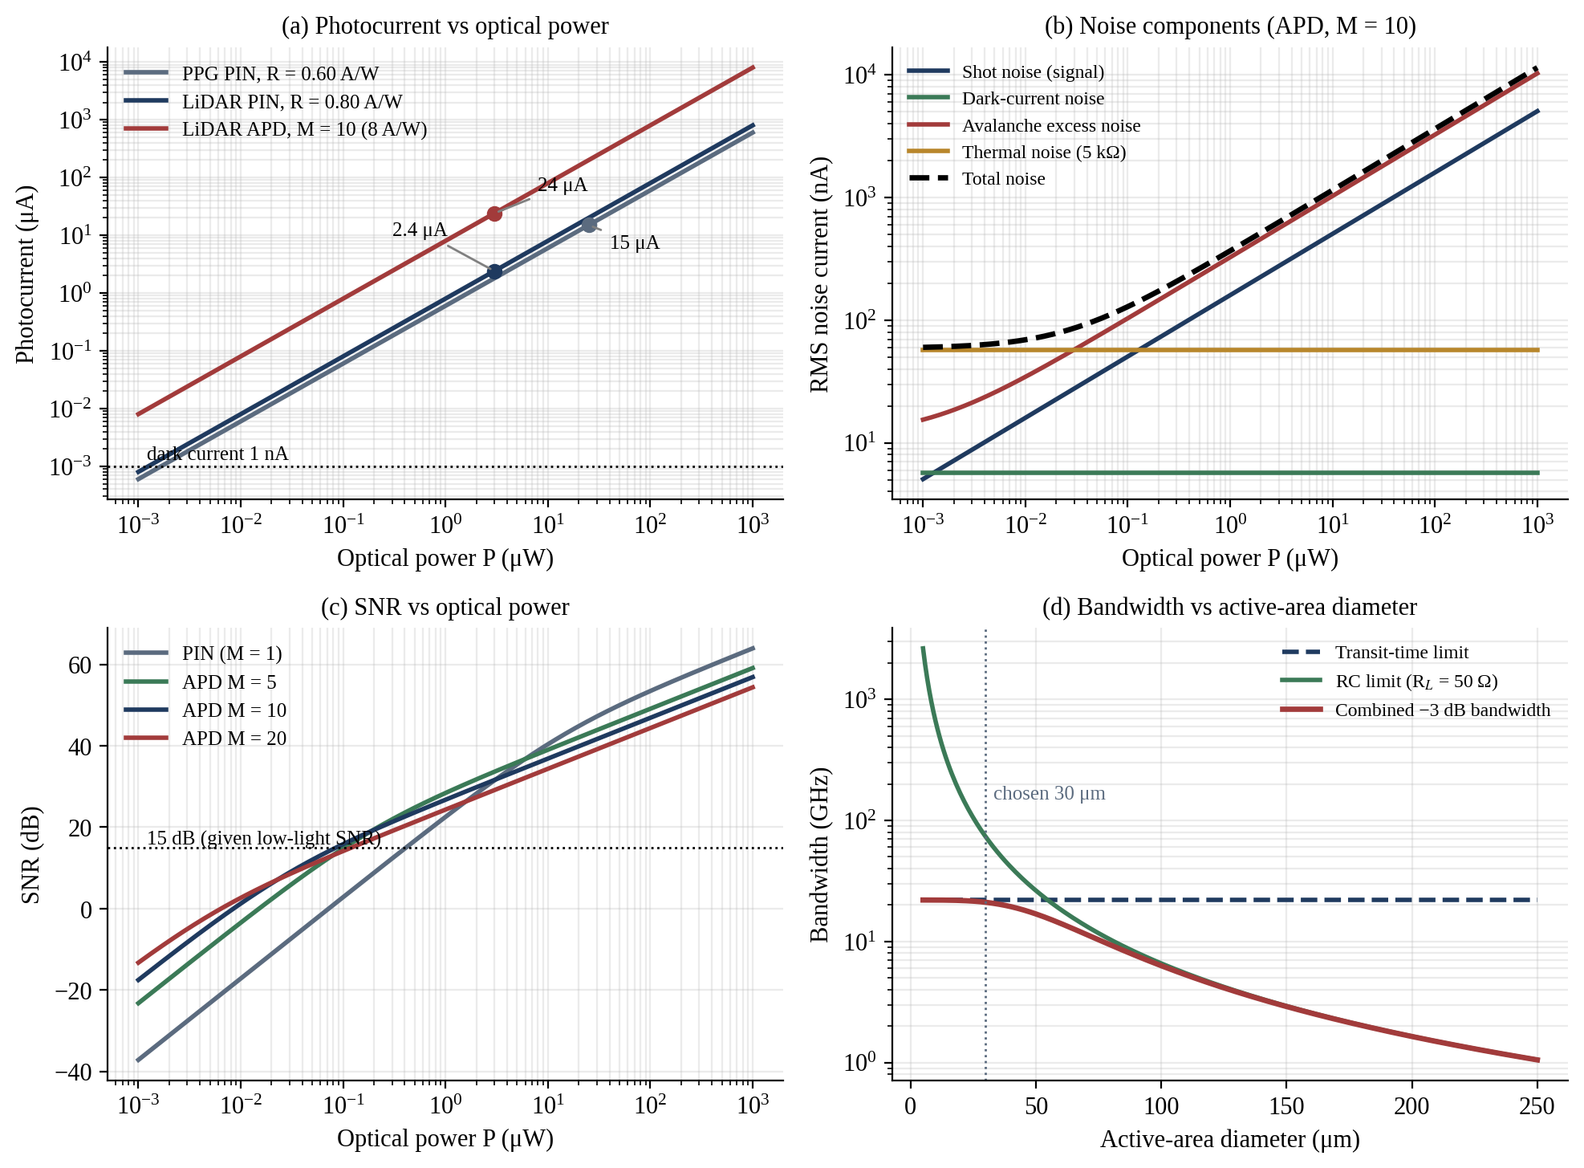
Figure 13: Overview of simulation results: (a) photocurrent, (b) noise components, (c) SNR and (d) bandwidth versus area
The four panels summarise the simulation. Panel (a) shows the linear photocurrent, panel (b) the noise components of the APD, panel (c) how SNR changes with optical power for the PIN photodiode and the APD at several gains, and panel (d) how the bandwidth falls once the RC limit overtakes the transit-time limit. The individual plots are shown in detail in the following figures.
Table 10: Simulated photocurrent as a function of optical power
Optical power (μW) | PPG PIN, 0.60 A/W (μA) | LiDAR PIN, 0.80 A/W (μA) | LiDAR APD, M = 10 (μA)
0.001 | 0.0006 | 0.0008 | 0.008
0.01 | 0.006 | 0.008 | 0.08
0.1 | 0.06 | 0.08 | 0.8
1 | 0.6 | 0.8 | 8.0
3 | 1.8 | 2.4 | 24.0
10 | 6.0 | 8.0 | 80.0
100 | 60.0 | 80.0 | 800.0
1000 | 600.0 | 800.0 | 8000.0

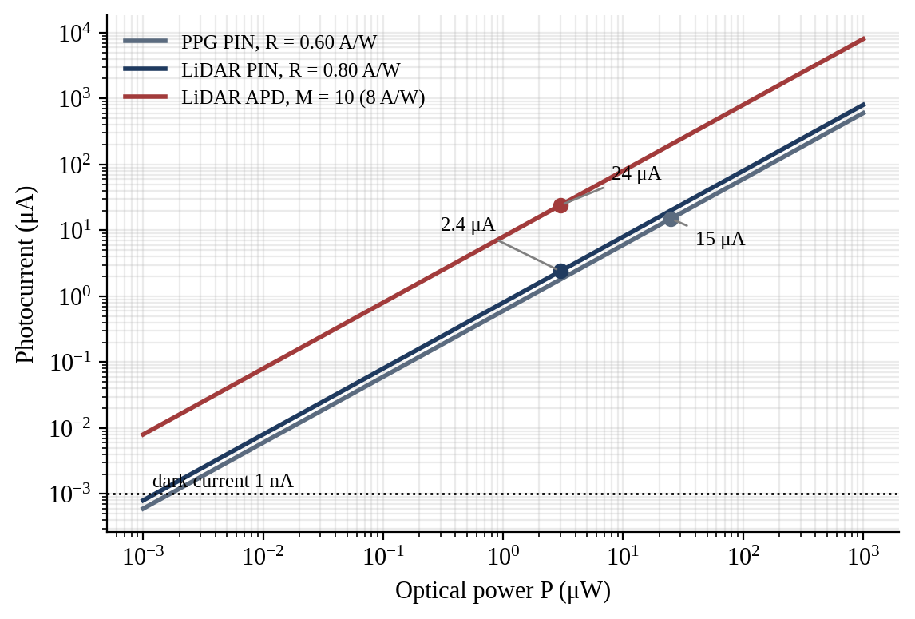
Figure 14: Photocurrent versus optical power for the PPG PIN, LiDAR PIN and LiDAR APD detectors
The plot is a straight line on logarithmic axes with unit slope, which confirms the linear relation I = RP over six decades of optical power. The marked points are 15 μA for the 25 μW PPG variation, 2.4 μA for the 3 μW LiDAR echo and 24 μA when the APD gain is ten. The dotted line shows the 1 nA dark current, which dominates below about 1 nW.
Table 11: Simulated rms noise current at P = 3 μW and B = 1 GHz (nA)
Detector | Shot | Dark current | Avalanche excess | Thermal | Total
PIN (M = 1) | 27.7 | 0.57 | 0 | 57.6 | 63.9
APD (M = 10) | 277.3 | 5.66 | 564.3 | 57.6 | 631.4
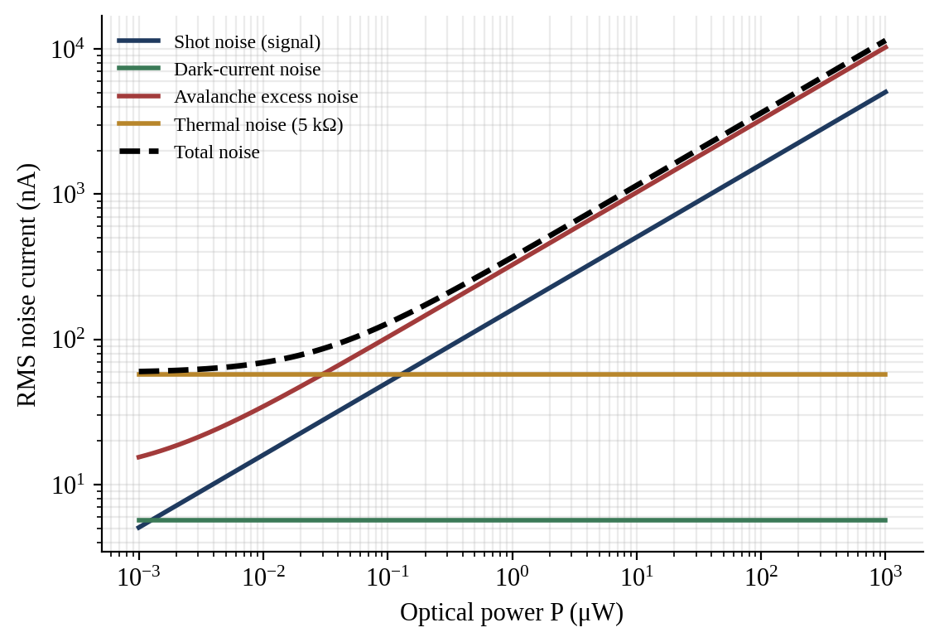
Figure 15: Noise analysis: shot, dark-current, avalanche, thermal and total noise of the APD
(M = 10) versus optical power
At low power the total noise is flat and equal to the 57.6 nA thermal noise of the receiver. As the power rises, the signal-dependent shot noise and avalanche excess noise increase as the square root of the power and take over at about 30 nW. The dark-current noise (5.7 nA) is constant and contributes less than 1 % of the total, which confirms that thermal and avalanche noise dominate the APD receiver.
Table 12: Simulated SNR (dB) versus optical power for the PIN photodiode and the APD at several gains
Optical power (μW) | PIN (M = 1) | APD M = 5 | APD M = 10 | APD M = 20
0.001 | −37.1 | −23.2 | −17.5 | −13.3
0.01 | −17.1 | −3.4 | 1.3 | 2.7
0.1 | 2.8 | 14.8 | 15.8 | 14.1
1 | 22.5 | 28.4 | 26.8 | 24.3
3 | 31.5 | 33.6 | 31.6 | 29.1
10 | 40.4 | 39.0 | 36.9 | 34.3
100 | 53.4 | 49.1 | 46.9 | 44.4
1000 | 63.9 | 59.1 | 56.9 | 54.4

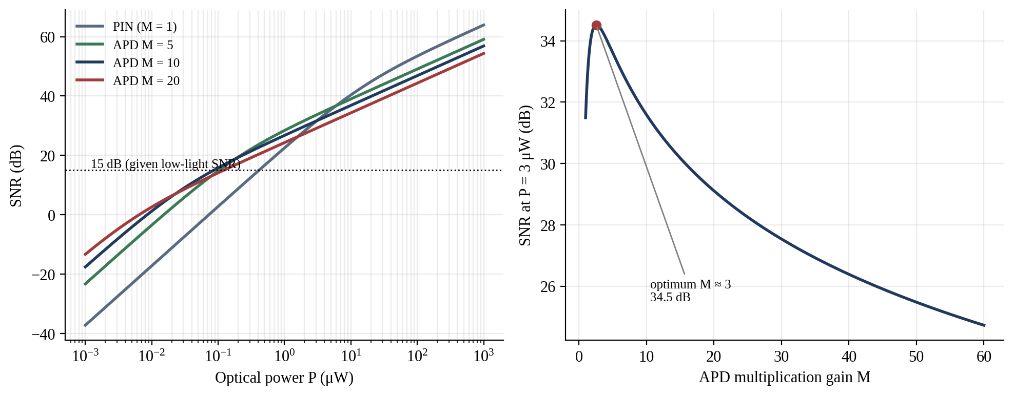
Figure 16: SNR versus optical power for PIN and APD detectors (left) and SNR versus APD gain at 3 μW (right)
On the left, the APD gives a higher SNR than the PIN photodiode at powers below about 1 μW, with an improvement of 13 dB at 100 nW and 18 dB at 10 nW. Above about 10 μW the PIN photodiode is better, because the APD adds excess noise while the thermal noise is no longer dominant. On the right, SNR peaks at M = 2.6 (34.5 dB) at 3 μW and falls at higher gain. At 100 nW the APD with M = 10 gives 15.8 dB, which agrees with the 15 dB specified for low-light operation.
Table 13: Bandwidth verification for t_{r} = 20 ps
Quantity | Theoretical | Simulated
Transit-time bandwidth | 22.00 GHz (0.44/t_{r}) | 22.15 GHz (−3 dB of sinc response)
Junction capacitance (30 μm) | 43.5 fF | 43.5 fF
RC bandwidth (50 Ω) | 73.2 GHz | 73.2 GHz
Combined −3 dB bandwidth | 21.07 GHz (RSS formula) | 20.94 GHz (product of responses)

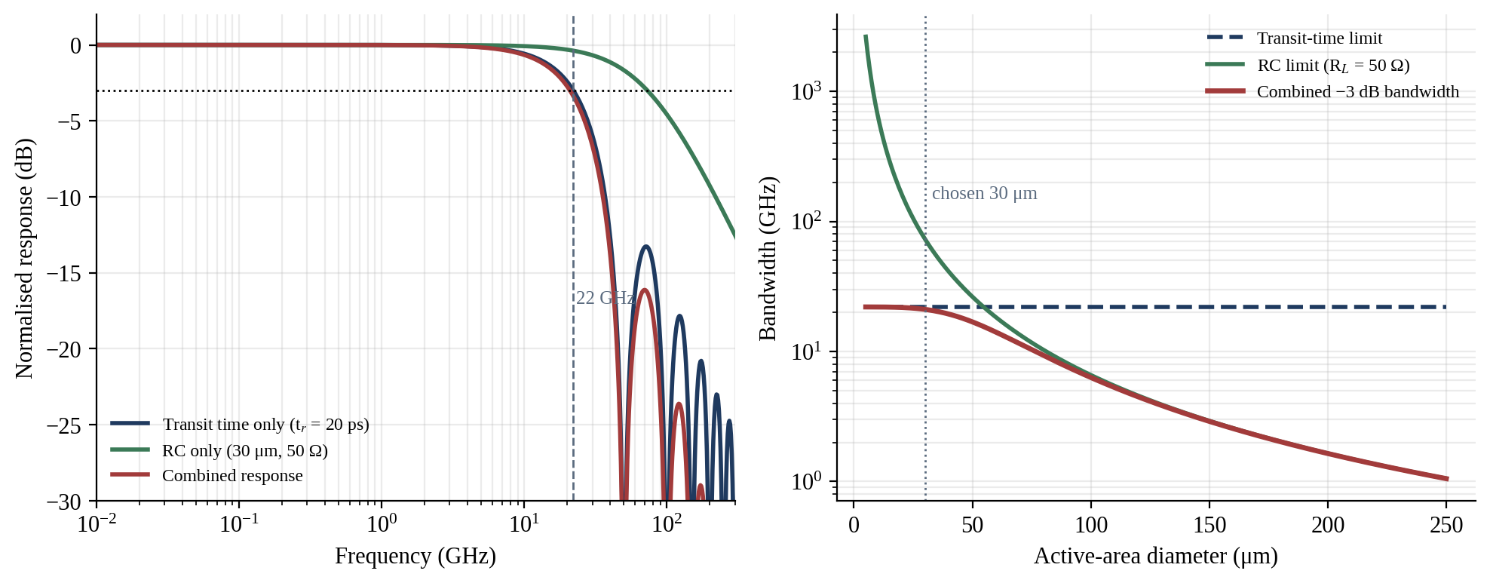
Figure 17: Bandwidth analysis: frequency response (left) and bandwidth versus active-area diameter (right)
On the left, the transit-time response of a rectangular impulse has its −3 dB point at 22.1 GHz, in agreement with 0.44/t_{r}, and the RC response of the 30 μm detector extends to 73 GHz, so that the combined response is only slightly lower. On the right, the combined bandwidth is limited by transit time below about 30 μm and by the RC product above it, and it falls to 6 GHz at 100 μm and 1.6 GHz at 200 μm.

7.4 Comparison of Theoretical and Simulated Results
Table 14: Comparison of theoretical and simulated values
Quantity | Theory | Simulation | Deviation
PPG photocurrent | 15.0 μA | 15.00 μA | 0 %
LiDAR photocurrent | 2.40 μA | 2.40 μA | 0 %
LiDAR APD photocurrent (M = 10) | 24.0 μA | 24.0 μA | 0 %
Transit-time bandwidth | 22.00 GHz | 22.15 GHz | +0.7 %
PV maximum power | 2.250 W | 2.249 W | −0.03 %
NEP, PIN / APD | 2.28 / 0.233 pW/√Hz | 2.28 / 0.233 pW/√Hz | 0 %
Low-light SNR (given powers) | 15.0 dB | 15.8 dB at 100 nW, M = 10 | +0.8 dB

7.5 Simulation Interpretation
The simulation confirms the hand calculations. The photocurrent results are identical, because both use I = RP. The small deviation of 0.7 % in the bandwidth arises because the formula 0.44/t_{r} is an approximation, whereas the simulation calculates the true −3 dB point of the rectangular impulse response, for which the exact constant is 0.443. The PV power agrees within 0.03 % because the simulated I–V curve is calibrated to the given fill factor, so this comparison confirms the numerical procedure rather than providing independent evidence. The SNR specified in the scenario, 15 dB, is not produced by the simulation but is consistent with it: the model predicts 15.8 dB for an APD at 100 nW, which indicates the optical power range for which the given figure is realistic.
Three engineering findings follow. First, the APD has no advantage when the signal is strong, since at 3 μW the PIN photodiode and the APD (M = 10) give the same SNR of about 31.5 dB and above 10 μW the PIN photodiode is better, so the justification for the APD lies in the weaker signals that long-range LiDAR must handle. Second, the optimum gain depends on the optical power, which is a strong argument for adaptive gain control. Third, the detector bandwidth of about 21 GHz is higher than any plausible receiver bandwidth, which implies that detector speed does not limit the system. The limitations of the model are that it assumes a constant dark current and a single-pole receiver, and ignores background light, temperature drift of the gain and amplifier voltage noise.

8. Final System Verification
The results of Sections 2 to 7 are collected in Table 15, which compares each specified requirement with the calculated target and the value achieved in calculation or simulation. The targets for quantities that the scenario does not specify, such as NEP and quantum efficiency, are design targets adopted in this report and are identified as such.
Table 15: Final system verification table
Requirement | Specified / Given | Target / Calculated | Achieved | Satisfactory?
PPG photocurrent response | R = 0.60 A/W; ΔP = 25 μW | 15 μA | 15.00 μA (simulated) | Yes
LiDAR photocurrent | R = 0.80 A/W; P = 3 μW | 2.4 μA (24 μA at M = 10) | 2.40 μA; 24.0 μA | Yes
Detector responsivity | 0.60 and 0.80 A/W | 0.60; 0.80; 8.0 A/W (APD) | As specified | Yes
Quantum efficiency | Not given | η > 60 % | 79.1 % (940 nm); 64.0 % (1550 nm) | Yes
NEP / detectivity | Not given | NEP < 1 pW/√Hz; D* > 10¹⁰ Jones (APD) | 0.233 pW/√Hz; 1.14 × 10¹⁰ Jones | Yes
Low-light SNR | −22 dBm / −37 dBm | ≥ 15 dB | 15.0 dB; 15.8 dB at 100 nW, M = 10 | Yes (marginal; improved by Design Decision 2)
Noise performance | Not given | Dark-current noise < 1 % of total | 0.9 % (5.7 nA of 631 nA) | Yes
High-speed bandwidth | t_{r} = 20 ps | ≥ 10 GHz | 22 GHz; 21 GHz with RC | Yes
PV maximum power | 0.60 V; 5 A; FF = 0.75 | 2.25 W | 2.25 W (2.249 W simulated) | Yes
Image-sensor selection | CMOS or CCD | SoC-compatible, low power, NIR | Back-illuminated NIR CMOS | Yes
Display selection | OLED, MicroLED, QD | Bright, efficient, flexible | MicroLED + QD; OLED for foldable | Yes
Biomedical sensing | PPG and NIR | 15 μA; high SNR | 15 μA; electronic SNR > 100 dB | Yes
LiDAR sensing | 3 μW echo | ≥ 1 GHz; 3 mm resolution | 21 GHz detector; 3.0 mm | Yes
Automotive sensing | LiDAR and vehicle sensing | −40 to +105 °C operation | TEC/gain control; HDR CMOS | Yes, subject to qualification
Face recognition | NIR imaging | NIR CMOS with liveness | 850/940 nm BSI CMOS | Yes
UV sensing | UV detection | Visible-blind response | SiC/GaN photodiode | Yes
MATLAB simulation | Not given | Agreement within 1 % | Maximum deviation 0.7 % | Yes
Overall platform | All requirements | All of the above | All satisfied | Yes

The calculated and simulated results are consistent with the original application requirements. The photocurrents, bandwidth and PV power match theory to within 0.7 %, the NEP and detectivity exceed the design targets with the APD, and the specified 15 dB SNR is reproduced by the model at an optical power of about 100 nW. The two qualifications are that the 15 dB figure leaves a limited margin for very low error rates.

9. Final System Design

9.1 Final Parameter Table
Table 16: Final design and parameter table of the integrated optoelectronic platform
Subsystem | Adopted configuration | Key parameters
PPG detector | Si PIN photodiode, 940 nm, TIA 100 kΩ | R = 0.60 A/W; η = 79.1 %; ΔI = 15 μA; B = 100 Hz
LiDAR detector | InGaAs APD, 1550 nm, 30 μm, microlens | R₀ = 0.80 A/W; η = 64.0 %; M = 10 (3–20); I = 2.4 → 24 μA
Sensitivity | Adaptive gain, TEC, narrow-band filter | NEP = 0.233 pW/√Hz; D* = 1.14 × 10¹⁰ Jones
Low-light SNR | Given: −22 dBm signal, −37 dBm noise | SNR = 15 dB (31.6 : 1); improved to about 21 dB
Noise control | Gain optimisation, filtering, cooling, bandwidth | F(10) = 5.14; dark noise < 1 %
Bandwidth | Small area, 2 μm depletion region | f_{tr} = 22 GHz; f_{RC} = 73.2 GHz; f_{3dB} ≈ 21 GHz
Photovoltaic | Flexible thin-film PV | P_{max} = 2.25 W; FF = 0.75; η = 15 %
Image sensor | BSI NIR-enhanced CMOS, global shutter | Pixel 1.4–3 μm; on-chip ISP; SoC interface
Display | MicroLED (QD colour conversion); flexible OLED | >10⁵ nits (µLED); μs response
Biomedical sensing | PPG (525/660/940 nm) and NIR (760–1700 nm) | Si PIN and extended InGaAs PIN; < 1 mW average
Face recognition | 850/940 nm VCSEL, CNN, liveness, secure enclave | Recognition in 100–300 ms
UV sensing | SiC / GaN visible-blind photodiode | 200–400 nm; 0.1–0.2 A/W; fA–pA dark current
Simulation | MATLAB model | Maximum deviation 0.7 % from theory

9.2 Complete Block Diagram
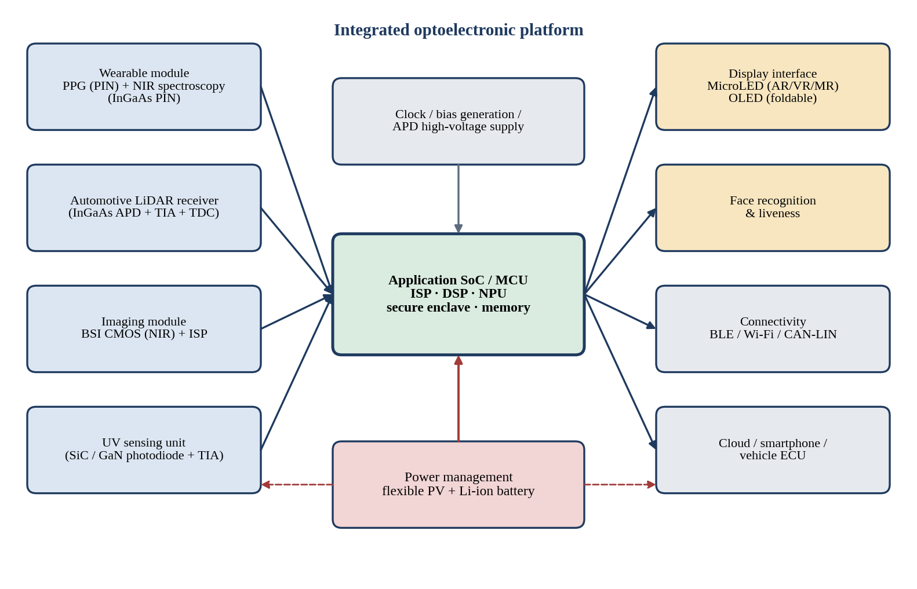
Figure 18: Complete integrated optoelectronic platform block diagram
The block diagram shows the four sensing modules on the left (wearable PPG/NIR, LiDAR receiver, imaging and UV), the central application SoC that performs conversion, signal processing, neural-network inference and security, and the outputs on the right (display, face recognition, connectivity and cloud/vehicle interface). The power-management block combines the flexible photovoltaic source and the battery, supplies all modules and generates the APD bias, and a common clock synchronises the sensors.

9.3 System Architecture Explanation
The platform is organised around a single application SoC that receives data from four sensor modules. The wearable module contains a silicon PIN photodiode for PPG and an extended InGaAs PIN photodiode for NIR spectroscopy, each followed by a transimpedance amplifier and a low-rate converter. The LiDAR receiver comprises the InGaAs APD, a high-voltage bias generator with temperature compensation, a wide-band transimpedance amplifier, a comparator and a time-to-digital converter, which feed range data to the SoC. The imaging module uses a back-illuminated NIR CMOS sensor with an on-chip ISP; the same sensor serves face recognition under active NIR illumination and general imaging in vehicle applications. The UV unit contains a wide-bandgap photodiode and a low-leakage amplifier. The SoC contains the DSP for the biomedical signals, the neural-network accelerator for face recognition and the secure enclave that holds biometric templates.
The display interface drives a MicroLED panel with quantum-dot colour conversion for AR/VR/MR and an OLED panel for foldable surfaces. Power management harvests energy from the flexible PV module, which can deliver 2.25 W at full sunlight through maximum-power-point tracking, charges the battery and distributes regulated rails. Analogue and digital supplies are separated so that the noise of the digital logic does not enter the high-impedance detector nodes.

9.4 Engineering Justification
Each choice in the architecture follows from a calculation. The PIN photodiode is chosen for PPG because 15 μA is already ample and its noise, voltage and cost are the lowest. The APD is chosen for LiDAR because it lifts the 2.4 μA echo to 24 μA, reduces NEP from 2.28 to 0.233 pW/√Hz and raises the SNR by 13 to 18 dB at 10–100 nW, where the weakest echoes occur. The bandwidth of 21 GHz exceeds the 1 GHz requirement so that the detector is never the limiting element. CMOS is preferred over CCD because it uses less power and permits integration with the SoC, and MicroLED and OLED are matched to the brightness and flexibility requirements of their target devices. The PV module supplements, but does not replace, the battery. The overall system is therefore consistent, because the detector choice, noise strategy, bandwidth, power and display selections all derive from the same set of calculated parameters.

10. Final Engineering Decision
Would you deploy the integrated optoelectronic platform you created?
YES – with complete technical justification. The platform is recommended for deployment, to the stage of a pre-production prototype with environmental qualification, because every functional requirement is met by calculation and simulation, and the residual risks are identified and controllable.
Photodetector selection. The hybrid PIN/APD configuration places each detector where its strengths are decisive, and the calculated photocurrents of 15 μA (PPG) and 2.4 μA (LiDAR, 24 μA with gain) are linear in optical power. Responsivity, quantum efficiency, NEP and detectivity. The adopted responsivities of 0.60 and 0.80 A/W correspond to quantum efficiencies of 79 % and 64 %, and the APD gives NEP of 0.233 pW/√Hz and a detectivity of 1.14 × 10¹⁰ Jones. Noise and SNR. The given 15 dB SNR is adequate for detection, and the combination of adaptive gain, filtering, cooling and bandwidth matching provides about 6 dB of additional margin. Response time. The 22 GHz transit-time bandwidth, reduced to 21 GHz by capacitance, is twenty times above the 1 GHz requirement.
PV, image sensor and display. The PV module delivers 2.25 W at 15 % efficiency, CMOS is the correct imaging architecture, and the MicroLED and OLED combination covers both AR/VR/MR and foldable devices. Biomedical, LiDAR, automotive, face-recognition and UV sensing. Each is served by a detector that matches its wavelength and signal level, and the analysis shows that none of them is compromised by the shared platform. Simulation. The MATLAB model reproduces the hand calculations within 0.7 %. Integration, power and reliability. The shared SoC, clock and power management reduce complexity, the wearable module operates at about 1 mW, and the APD bias and temperature are controlled in closed loop.
The decision is subject to conditions. The APD gain must be stabilised against temperature, because the breakdown voltage drifts; the InGaAs and MicroLED components are costly and should be introduced first in premium products; the flexible PV lifetime under bending and moisture must be confirmed by life tests; and automotive qualification (AEC-Q100/Q102 temperature and vibration) and eye-safety certification must be completed. The results of this report are based on assumed parameters and on simulation, not on measurements of a fabricated prototype, so they establish feasibility but do not replace laboratory validation.

11. Conclusion, Future Scope and References

11.1 Conclusion
This assignment developed and verified an integrated optoelectronic sensing and display platform from the scenario. The PPG photocurrent was calculated as 15 μA and the LiDAR photocurrent as 2.4 μA (24 μA at an APD gain of 10). The SNR from the given powers is 15 dB, a power ratio of 31.6. The transit-time bandwidth is 22 GHz, and the maximum PV power is 2.25 W, equivalent to 15 % efficiency for a 150 cm² cell. The PIN/APD comparison showed that the APD is justified for weak LiDAR echoes, where it improves SNR by 13–18 dB, whereas the PIN photodiode is preferable for the strong, slow PPG signal. CMOS was selected for imaging, flexible thin-film PV for auxiliary power, MicroLED with quantum-dot conversion for AR/VR/MR and OLED for foldable surfaces. The MATLAB model agreed with the analytical results to within 0.7 %, and the final decision is to deploy the platform, subject to the stated qualifications.

11.2 Future Scope
The platform can be developed in several directions. Silicon photomultipliers and single-photon avalanche diode arrays could replace linear-mode APDs in LiDAR and give single-photon sensitivity with direct digital time-of-flight output. Germanium-on-silicon photodetectors and monolithic integration of the detector with CMOS electronics would lower the cost of near-infrared sensing. Perovskite and organic photovoltaics offer higher efficiency on flexible substrates once their stability is improved, and indoor photovoltaics can power sensors from room light. In displays, monolithic MicroLED with quantum-dot colour conversion and holographic waveguides will improve the efficiency of near-eye devices. Machine-learning-based motion-artefact removal for PPG, on-sensor neural processing and measurement of a fabricated prototype to replace the assumed parameters are the natural next steps.

11.3 References
[1] B. E. A. Saleh and M. C. Teich, Fundamentals of Photonics, 3rd ed. Hoboken, NJ, USA: Wiley, 2019.
[2] S. O. Kasap, Optoelectronics and Photonics: Principles and Practices, 2nd ed. Upper Saddle River, NJ, USA: Pearson, 2013.
[3] S. M. Sze and K. K. Ng, Physics of Semiconductor Devices, 3rd ed. Hoboken, NJ, USA: Wiley, 2007.
[4] R. J. McIntyre, “Multiplication noise in uniform avalanche diodes,” IEEE Trans. Electron Devices, vol. ED-13, no. 1, pp. 164–168, Jan. 1966.
[5] J. Allen, “Photoplethysmography and its application in clinical physiological measurement,” Physiol. Meas., vol. 28, no. 3, pp. R1–R39, Mar. 2007.
[6] E. R. Fossum, “CMOS image sensors: Electronic camera-on-a-chip,” IEEE Trans. Electron Devices, vol. 44, no. 10, pp. 1689–1698, Oct. 1997.
[7] A. El Gamal and H. Eltoukhy, “CMOS image sensors,” IEEE Circuits Devices Mag., vol. 21, no. 3, pp. 6–20, May–Jun. 2005.
[8] M. A. Green, Solar Cells: Operating Principles, Technology and System Applications. Englewood Cliffs, NJ, USA: Prentice-Hall, 1982.
[9] C. W. Tang and S. A. VanSlyke, “Organic electroluminescent diodes,” Appl. Phys. Lett., vol. 51, no. 12, pp. 913–915, Sep. 1987.
[10] J. Y. Lin and H. X. Jiang, “Development of microLED,” Appl. Phys. Lett., vol. 116, no. 10, Art. no. 100502, Mar. 2020.
[11] M. V. Kovalenko et al., “Prospects of nanoscience with nanocrystals,” ACS Nano, vol. 9, no. 2, pp. 1012–1057, Feb. 2015.
[12] B. Schwarz, “Lidar: Mapping the world in 3D,” Nature Photon., vol. 4, no. 7, pp. 429–430, Jul. 2010.
[13] M. Razeghi, “Short-wavelength solar-blind detectors—Status, prospects, and markets,” Proc. IEEE, vol. 90, no. 6, pp. 1006–1014, Jun. 2002.

