EXPERIMENT 18

OPTICAL SPECTRUM AND OSNR ANALYSIS USING OPTISYSTEM

OBJECTIVES :

1. Design an optical communication system using OptiSystem.

2. Study how source power affects optical spectral intensity.

3. Analyze how fiber length affects attenuation, dispersion, and nonlinear effects.

4. Study the combined effect of source power and fiber length.

SOFTWARE REQUIRED: Opti System.

CIRCUIT DIAGRAM:

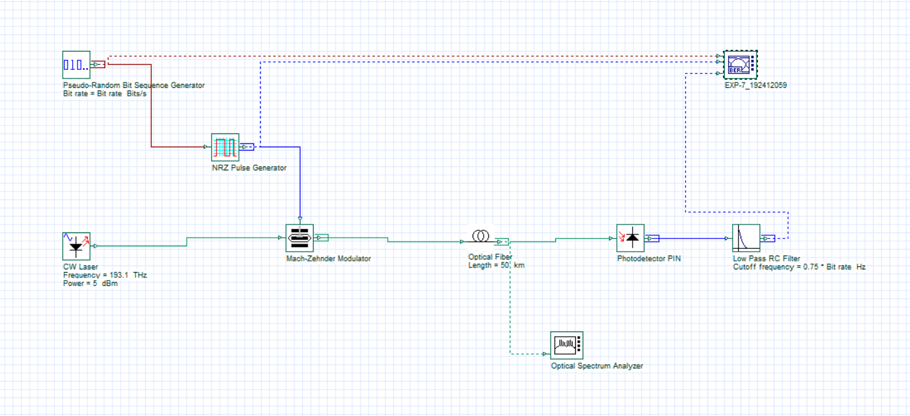

OUTPUTS:

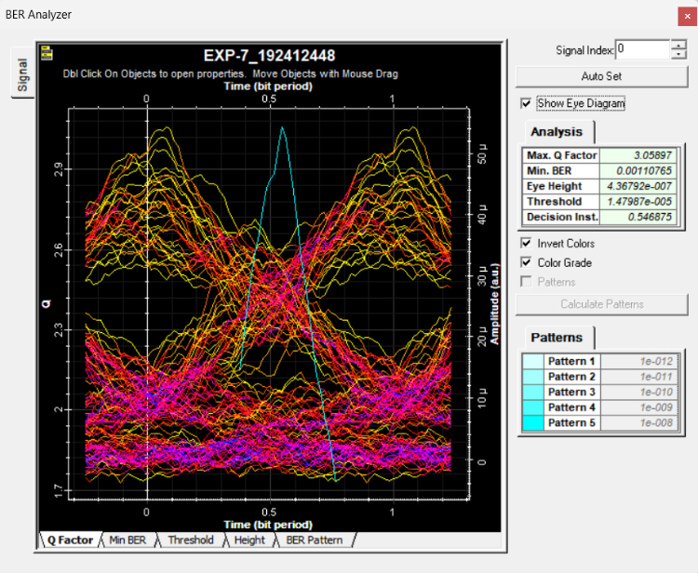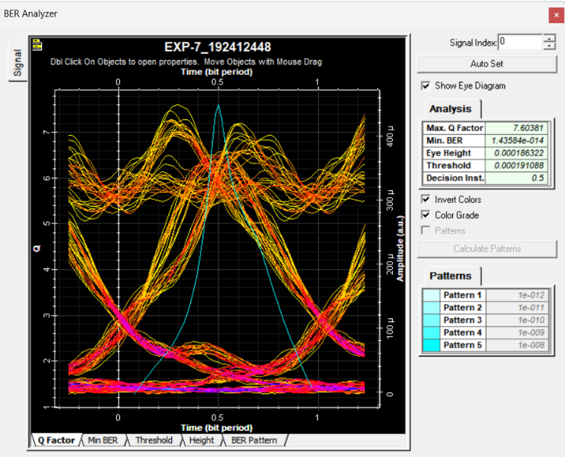 | 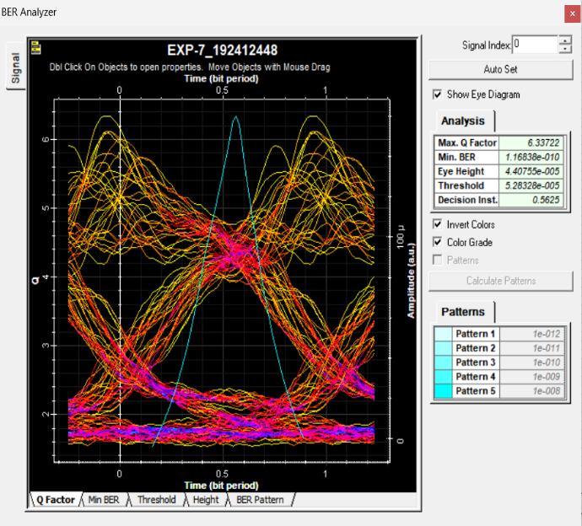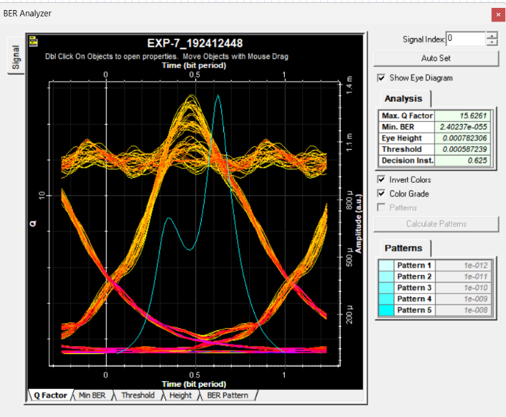

REFLECTION:
- Learned to design an optical communication system using OptiSystem.
- Understood how to observe and analyse the optical spectrum.
- Gained knowledge about OSNR and its importance.
- Understood how noise affects optical signal quality.

RUBRICS:
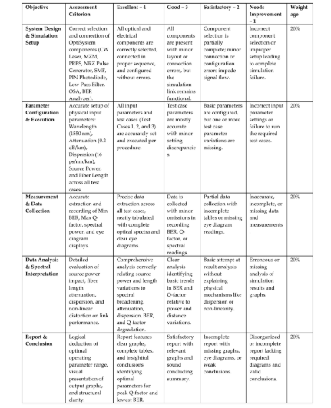

CONCLUSION
Thus, the optical spectrum and OSNR analysis were successfully performed using OptiSystem. The optical spectrum was observed, and OSNR was analysed to understand the signal quality and noise performance of the optical communication system.

