SIMATS ENGINEERING
ASSESSMENT TOOL

COURSE CODE:ECA1803 COURSE NAME: Optical Fiber Communication

DWDM Metro Link Commissioning: From Field Measurements to a Standards-Based Upgrade Decision
Course Outcome – CO5 : System performance and optimize optical link, measurement and WDM design using OTDR evidence, eye-diagram and BER diagnostics, quantum detection limits, ITU-T G.694.1 channel planning and energy-efficient photonic technologies

Code of Conduct:

I S HARIPRIYA (192412448) (Name / Reg No) certify that this submission is my original work and that I have adhered to the guidelines specified for this assessment.
I understand that any violation of academic integrity rules will result in disciplinary action.

Signature of the student: Priya

ABSTRACT
This report investigates the commissioning of a 60 km ITU-T G.652.D metro link carrying eight 10 Gb/s NRZ channels on the 100 GHz ITU-T G.694.1 grid, in which Channel 3 has insufficient margin and Channel 5 has a partially closed eye, and develops a standards-based upgrade to 1.6 Tb/s on the same fibre pair. The as-built loss is 22.52 dB, which is 1.27 dB above the 21.25 dB design, giving a received power of −21.52 dBm. After a dispersion penalty of 1.00 dB and extinction-ratio penalties of 1.10 dB and 3.22 dB, the system margins are +0.38 dB for Channel 3 and −1.75 dB for Channel 5, against the 3 dB requirement. The OSNR of 47 dB and PMD of 0.775 ps show that the link is power-limited, not noise- or PMD-limited.
OTDR interpretation identifies a 0.62 dB mechanical splice at 31.50 km (−34 dB), a 1.20 dB LC/UPC connector at 59.900 km (−22 dB) and a second connector 9 m away (−40 dB). A 100 ns pulse (dynamic range 27 dB against 22.52 dB required, EDZ 5 m) is selected, supplemented by a 10 ns far-end trace to measure the second connector, and the location uncertainty is ±43 m and ±82 m. The BER values are 1.5×10⁻¹⁴ and 1.3×10⁻⁶; the total jitter gives eye widths of 0.651 UI and 0.390 UI, and the extinction ratio predicts Q = 4.66 for Channel 5 against 4.7 measured, identifying a channel-specific transmitter fault. The direct-detection receiver is 20.6 dB from the quantum limit of 26.9 photons per bit.
Of the 16 × 100G, 8 × 200G and 4 × 400G options, the four-channel silicon-photonic 400G solution on 75 GHz slots (300 GHz, 5.33 b/s/Hz, 37.5 pJ/bit, 21 dB OSNR margin) is selected, and a repair-verify-upgrade workflow is defined. The repaired link reaches a 3.65 dB margin at +3 dBm launch power, and the final decision is to deploy the system subject to post-repair verification.
Keywords: DWDM, link budget, OTDR, dead zone, eye diagram, BER, quantum limit, ITU-T G.694.1, DP-QPSK, DP-16QAM, silicon photonics, energy per bit.

CHAPTER 1
INTERPRETATION OF PERFORMANCE REQUIREMENTS
  - Engineering Problem and Working Approach
A metro operator has commissioned a 60 km ITU-T G.652.D single-mode link between two data centres. The link carries eight 10 Gb/s non-return-to-zero (NRZ) channels on the 100 GHz ITU-T G.694.1 grid and is amplified only by a transmit booster erbium-doped fibre amplifier (EDFA) delivering +1 dBm per channel at the line output. Acceptance testing exposed three symptoms: (i) Channel 3 works but the power-meter results suggest that even this channel has less than the required 3 dB receiver margin; (ii) Channel 5 shows a partially closed eye and a high bit-error ratio (BER); and (iii) the operator now wants to raise the capacity of the same fibre pair to 1.6 Tb/s without re-laying fibre, in a spectrally and energy-efficient manner.
The work in this report follows the sequence REQUIREMENT → MEASUREMENT → ANALYSIS → ROOT-CAUSE IDENTIFICATION → REPAIR AND UPGRADE → VERIFICATION → DEPLOYMENT DECISION. This first chapter works backward from the symptoms: it identifies which instrument validates which quantity, which loss, penalty and noise components must be budgeted, how the eye diagram links to Q-factor and BER, what limits OTDR measurements, which standards and hardware choices constrain the repair and the upgrade, and finally condenses all of this into a Performance Requirement Statement.
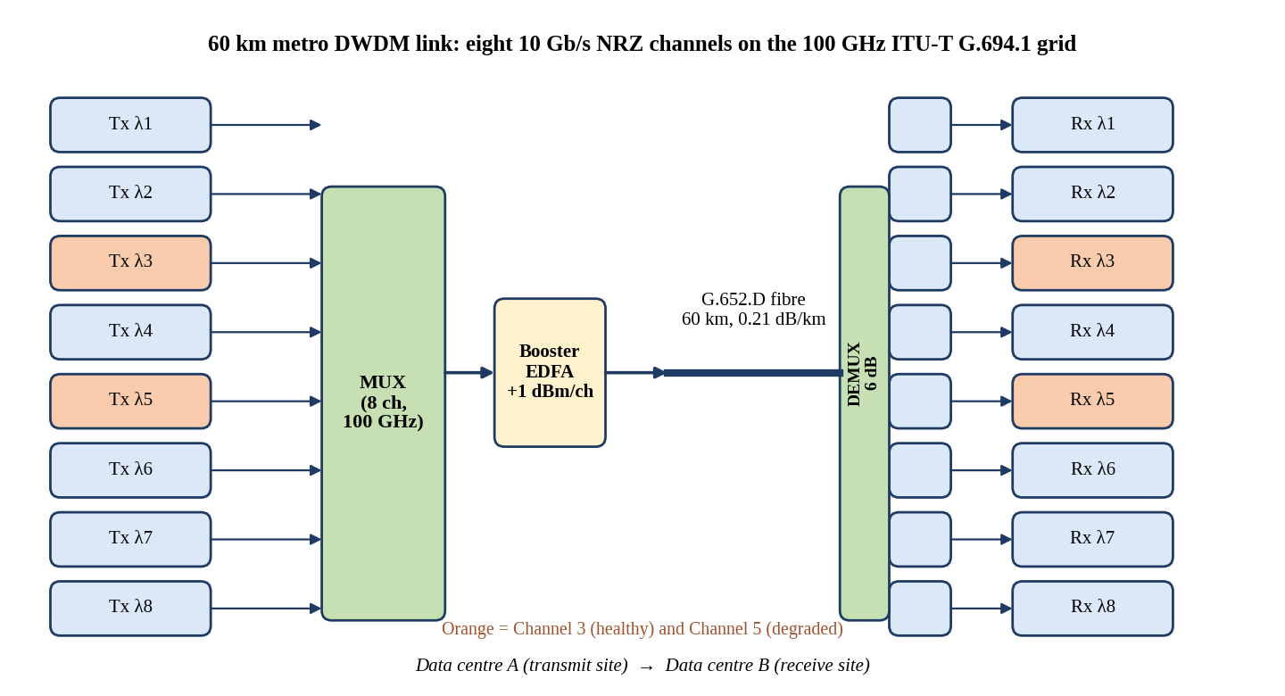
Figure 1: Architecture of the eight-channel 10 Gb/s DWDM metro link (Channel 3 and Channel 5 highlighted).
Explanation of the figure. The figure shows eight transmitters (λ1–λ8) combined by a 100 GHz DWDM multiplexer, boosted by a single EDFA, carried over 60 km of G.652.D fibre and separated by a demultiplexer that feeds eight receivers. There is no in-line or pre-amplifier, so the only gain element is the booster at the transmit end.
Relation to the case study. Channel 3 (healthy) and Channel 5 (degraded) share every passive element: the multiplexer, booster, fibre, and demultiplexer. Any impairment that appears on both channels must therefore be shared (fibre, connectors, splices, demultiplexer), whereas an impairment that appears on Channel 5 only must be channel-specific (its transmitter or its own patch cord).
Practical significance. The architecture explains why the budget is purely power-limited at the receiver: the 6 dB demultiplexer loss sits after all gain, so every additional dB of excess loss translates directly into a dB of lost receiver margin, and the only remedies are lower loss, higher launch power or a better receiver.
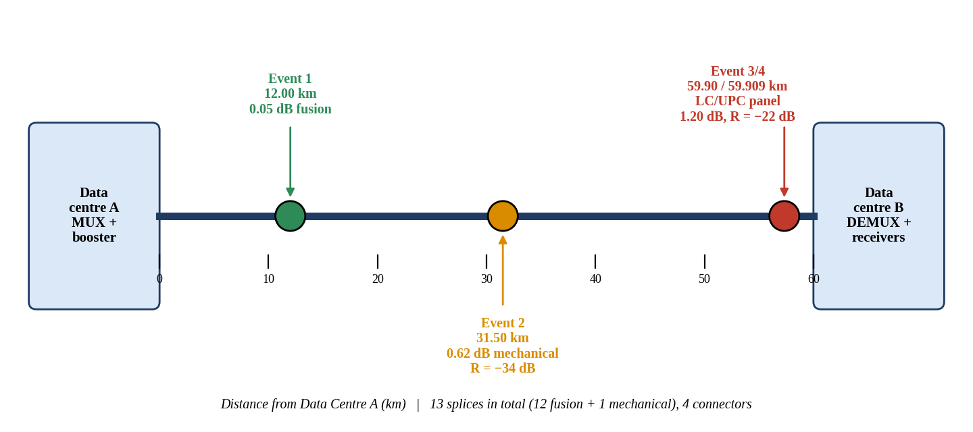
Figure 2: Metro optical fibre link with the four OTDR events located along the 60 km route.
Explanation of the figure. The route diagram places the OTDR events on the physical link: a 0.05 dB fusion splice at 12.00 km, a 0.62 dB mechanical splice at 31.50 km, and a poor LC/UPC patch-panel connector at 59.900 km followed by a second patch-cord connector 9 m later at 59.909 km.
Relation to the case study. These four events are the physical explanation for the 1.27 dB excess loss between the design value (21.25 dB) and the as-built value (22.52 dB). Events 2 and 3 are the dominant contributors, and events 3 and 4 sit at the receive-site patch panel where access is easy.
Practical significance. Fault localisation by OTDR converts a vague 'low margin' complaint into a short, ranked repair list: one patch-panel intervention at Data Centre B and one splice-closure intervention near 31.5 km.

1.2 Measurement Instruments and the Quantity Each One Validates
A complete commissioning dossier for a DWDM link needs five instrument families. Each one measures a different physical quantity, and no single instrument can substitute for another. Table 1 summarises what each instrument validates on this particular 60 km link.
Table 1: Measurement instruments and the quantity validated on this link
Instrument | Quantity measured | What it validates on this link | Acceptance criterion
Optical power meter + stabilised source | End-to-end insertion loss (dB) and received power (dBm) at 1550 nm | Total link loss (22.52 dB as-built vs 21.25 dB design); received power per channel vs −24 dBm sensitivity | Loss ≤ 21.25 dB; effective received power ≥ −21 dBm
Optical spectrum analyser (OSA) | Per-channel power, wavelength, OSNR at 0.1 nm resolution, channel flatness | Launch power (+1 dBm), grid alignment, EDFA noise (OSNR 47 dB) | OSNR ≥ 20 dB; channels on G.694.1 grid
OTDR | Loss and reflectance of every event versus distance (backscatter trace) | Location and nature of the mechanical splice, bad connector and 9 m patch cord | Splice ≤ 0.1 dB, connector ≤ 0.5 dB, reflectance ≤ −45 dB
BER tester (BERT) | Bit-error ratio, Q-factor, error-free seconds | Channel 3 BER 1.5×10⁻¹⁴ and Channel 5 BER 1.3×10⁻⁶ vs 10⁻¹² target | BER ≤ 10⁻¹², Q ≥ 7.03
Eye-diagram analyser | Eye height, eye width, extinction ratio, jitter (DJ, RJ), mask margin | Channel 5 vertical and horizontal eye closure; ER 4.5 dB vs ≥ 8.2 dB | ER ≥ 8.2 dB, eye width ≥ 0.5 UI
PMD / dispersion analyser | Differential group delay (DGD) in ps, chromatic dispersion in ps/nm | PMD 0.77 ps vs 10 ps tolerance; accumulated dispersion 1020 ps/nm | DGD ≤ 10 % of bit period

1.2.1 Optical power meter
The optical power meter is a calibrated photodiode head that reads absolute power in dBm. Used with a stabilised 1550 nm source, it measures the insertion loss of the complete link by the reference-then-measure method: the power through a single reference cord (P_ref) is recorded first, and the link is then inserted, giving IL = P_ref − P_link. This is the only instrument that includes the connector at each end and the demultiplexer in a single, traceable number, and it is the standard by which the as-built loss of 22.52 dB is compared with the 21.25 dB design loss. Its limitation is that it gives one number for the whole link and cannot say where the loss occurs.
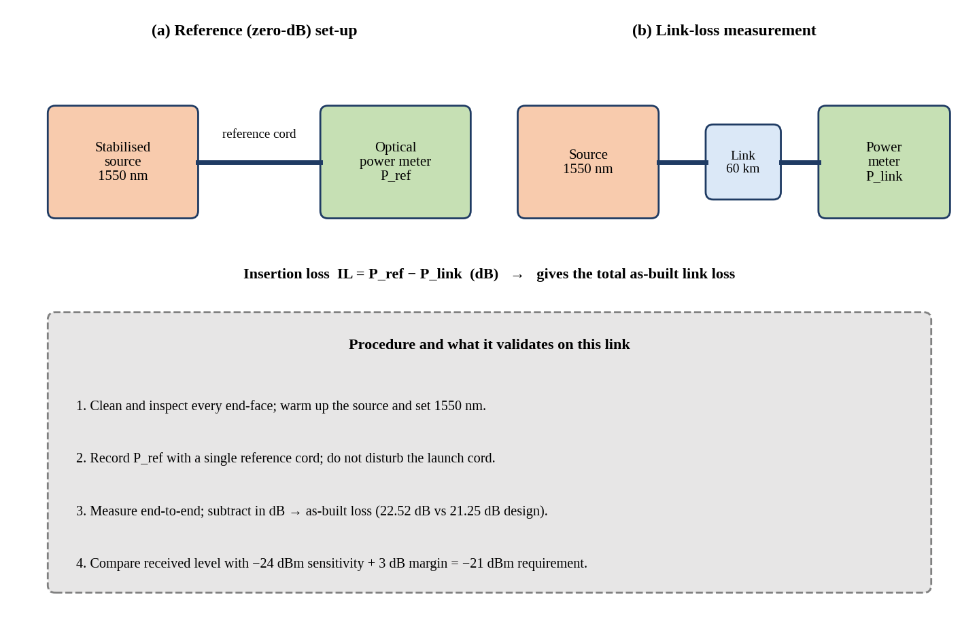
Figure 3: Optical power-meter set-up: reference (zero-dB) measurement and link-loss measurement.
Explanation of the figure. Panel (a) records the reference power P_ref with a single cord between source and meter. Panel (b) inserts the 60 km link in the same optical path, and the difference in dB is the insertion loss. The box lists the four-step procedure and the acceptance comparison.
Relation to the case study. For this link the meter result of 22.52 dB (equivalently a received level of −21.52 dBm per channel at +1 dBm launch) is the first clue that the margin is below 3 dB: the requirement is an effective level of −24 dBm + 3 dB = −21 dBm after penalties, and the raw level is already 0.52 dB below it.
Practical significance. Practically, connector cleanliness and reference-cord quality dominate the uncertainty of this measurement. Cleaning and inspecting every end-face, warming up the source and fixing the wavelength at 1550 nm reduce the uncertainty to about ±0.1 dB, which is small compared with the 1.27 dB excess loss being diagnosed.

1.2.2 Optical spectrum analyser (OSA)
The OSA is a grating-based or interferometric spectrometer that displays power against wavelength. In a DWDM link it measures the launched power per channel, the centre wavelength relative to the G.694.1 grid, channel-to-channel power flatness and, most importantly, the optical signal-to-noise ratio (OSNR), defined in a 0.1 nm (12.5 GHz) reference bandwidth. Because the amplified spontaneous emission (ASE) of the booster is visible between channels, the OSA separates noise-limited impairments from power-limited impairments.
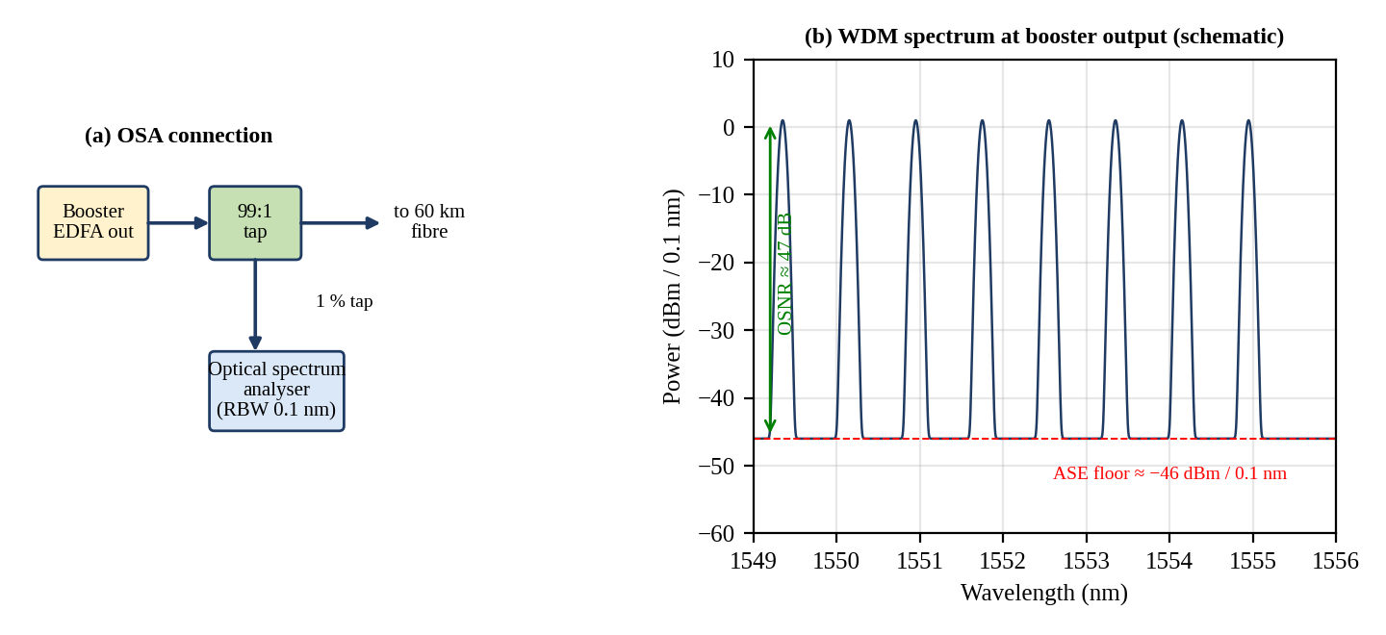
Figure 4: Optical spectrum analyser set-up (1 % monitor tap) and schematic WDM spectrum with OSNR indicated.
Explanation of the figure. The OSA is connected through a 99:1 tap after the booster so that it observes the live signal without interrupting traffic. Panel (b) shows eight equal channels on about 0.8 nm (100 GHz) spacing at +1 dBm, standing about 47 dB above the ASE floor of roughly −46 dBm in the 0.1 nm resolution bandwidth.
Relation to the case study. The case data give an input power of −6 dBm per channel and an EDFA noise figure of 5 dB, so OSNR = 58 + (−6) − 5 = 47 dB, far above the 20 dB requirement. The OSA therefore tells us that noise is not the cause of Channel 5's problem; a power and extinction-ratio problem is.
Practical significance. In practice, the OSA is also used to check that no channel has drifted off its G.694.1 frequency and that gain tilt has not left Channel 3 or Channel 5 several dB below the average. A flat spectrum with Channel 5 at the same power as its neighbours proves that the Channel 5 fault lies in the modulation (extinction ratio), not in launched average power.

1.2.3 OTDR
The optical time-domain reflectometer injects a short high-power pulse and records the returned backscatter and Fresnel reflections as a function of time, which is converted to distance. It is the only instrument that locates events along the route, measuring each event's loss (dB) and reflectance (dB). Its role here is to identify and rank the mechanical splice, the poor connector and the 9 m patch cord; its limitations (dynamic range, event dead zone, attenuation dead zone) are treated in Section 1.4.

1.2.4 BER tester
The bit-error-ratio tester sends a pseudo-random bit sequence (for example PRBS-31) through the channel and compares the received sequence with the expected one, counting errors. It validates the end-to-end quality against the 10⁻¹² requirement, which means that on a 10 Gb/s channel about one error is expected every 100 s. Statistically, demonstrating BER < 10⁻¹² at 95 % confidence requires about 3×10¹² error-free bits, i.e., 300 s; the BERT can also sweep a decision threshold to estimate Q-factor quickly for very low BER values.

1.2.5 Eye-diagram analyser
A sampling oscilloscope or real-time scope with clock recovery overlays many bit periods on a two-unit-interval window to form an eye. It measures eye height (vertical opening), eye width (horizontal opening), extinction ratio ER = P₁/P₀, rise and fall times, and the two jitter components: deterministic jitter (DJ, bounded, peak-to-peak) and random jitter (RJ, Gaussian, rms). It is the instrument that distinguishes a vertical (noise/ER) problem from a horizontal (timing) problem.

1.2.6 PMD and chromatic-dispersion analyser
A PMD analyser (interferometric, Jones-matrix eigenanalysis or fixed-analyser method) measures the mean differential group delay (DGD) in picoseconds, while a chromatic-dispersion analyser (phase-shift method) measures the accumulated dispersion in ps/nm. On this link the expected values are PMD = 0.1 ps/√km × √60 km = 0.775 ps and dispersion D·L = 17 × 60 = 1020 ps/nm. They validate that dispersion penalty and PMD stay within the budget at 10 Gb/s, and they confirm that the coherent receivers of the upgrade will see conditions that their digital signal processing easily compensates.

1.3 Loss, Penalty and Noise Components in a Practical Budget
A practical link budget is not simply 'fibre length × attenuation'. Every dB that reaches the receiver must be accounted for and every penalty that reduces its usable sensitivity must be added. The following components are included in this report.

1.3.1 Optical loss mechanisms
Fibre loss is the sum of intrinsic and extrinsic mechanisms. The intrinsic part is Rayleigh scattering (dominant at 1550 nm, scaling as λ⁻⁴), infrared absorption and residual OH absorption, giving typically 0.19–0.21 dB/km. The extrinsic part comprises macrobending and microbending, which are wavelength-dependent and become severe near 1625 nm, as well as cabling and installation stress. The case study specifies 0.21 dB/km at 1550 nm, so the 60 km span contributes 12.60 dB.

1.3.2 Connector loss
A connector joins two fibres through a mechanical interface, and its loss comes from intrinsic and extrinsic effects. Intrinsic factors are core-diameter and mode-field mismatch and core eccentricity. Extrinsic factors are lateral offset, angular misalignment, end-face gap, surface contamination and scratches. If a small air gap remains between the two end-faces, each glass–air interface reflects a Fresnel fraction r = [(n − 1)/(n + 1)]² = [(1.4682 − 1)/(1.4682 + 1)]² = 0.036. This corresponds to a return loss of 14.4 dB and a transmission loss of 10 log(1 − 0.036) = 0.159 dB per interface, i.e., about 0.32 dB for a two-interface air gap, even for perfectly aligned fibres. Physical-contact (PC/UPC) polishing eliminates the gap and reduces reflectance to −50 dB or better; angled physical contact (APC) at 8° reduces reflectance to −60 dB or better. The design allowance of 0.5 dB per connector is a conservative maximum, with well-made connectors achieving 0.1–0.3 dB.

1.3.3 Splice loss
Splice loss is dominated by core misalignment and mode-field mismatch. For Gaussian modes with mode-field radius w, a lateral offset d produces a loss of approximately 4.343 (d/w)² dB; with w ≈ 5.2 µm (mode-field diameter ≈ 10.4 µm at 1550 nm) an offset of 1 µm gives 0.16 dB, whereas 0.5 µm gives only 0.04 dB. A fusion splice makes a continuous glass joint with self-alignment by surface tension and typically yields 0.02–0.1 dB and no measurable reflectance. A mechanical splice depends on a V-groove, an index-matching gel and a clamp; its loss is typically 0.1–0.75 dB and it reflects at −30 to −45 dB. The design allowance is 0.05 dB per splice for 13 splices (0.65 dB).

1.3.4 Dispersion penalties
Chromatic dispersion broadens pulses by Δτ = D · L · σλ because the source emits a finite spectral width σλ. When the broadening becomes a significant fraction of the bit period, adjacent bits interfere (intersymbol interference) and the receiver needs more power to maintain the same BER. The case study gives δ = 5 log[1 + 2π(B·D·L·σλ)²], which is evaluated for 10 Gb/s in Chapter 2. PMD adds a statistical broadening with mean DGD = k_PMD√L, which must be below 10 % of the bit period.

1.3.5 OSNR degradation
Each EDFA adds ASE noise with noise figure NF. In a 0.1 nm reference bandwidth, OSNR = 58 + P_in − NF (dB), where P_in is the per-channel input power to the amplifier in dBm. The constant 58 dBm equals −10 log(hν · 12.5 GHz) at 1550 nm. OSNR degrades with every cascaded amplifier and with low amplifier input power, so a booster-only link is almost always power-limited rather than noise-limited.

1.3.6 Receiver sensitivity and system margin
Receiver sensitivity is the minimum average power at which the receiver achieves the target BER (here −24 dBm for BER 10⁻¹², valid only for ER ≥ 8.2 dB). System margin is the difference between the effective received power (after all penalties) and the sensitivity: Margin = P_rx − δ_disp − δ_ER − P_sens. The margin of at least 3 dB is held in reserve for ageing of the laser and fibre, repair splices, temperature variation and measurement uncertainty; it must exist on top of every penalty.

1.4 OTDR Dynamic Range, Event Dead Zone and Attenuation Dead Zone
OTDR measurements are bounded by three performance parameters. Dynamic range (DR) is the one-way difference, in dB, between the backscatter level at the near end and the RMS noise floor; to measure the whole link with useful accuracy the DR must exceed the one-way trace loss plus a margin of about 6 dB, so that the far-end events lie above the noise. Event dead zone (EDZ) is the minimum distance after a reflective event at which a second reflective event can still be detected as separate; it is set by the pulse width and the receiver recovery time. Attenuation dead zone (ADZ) is the minimum distance after a reflective event at which the loss of a following event can be measured, i.e., after which the backscatter trace has recovered to within 0.5 dB of the extrapolated line. The ADZ is always larger than the EDZ.
A longer pulse carries more energy, so DR increases with pulse width, but both dead zones also increase. A short pulse resolves close events but cannot reach the far end of a 60 km link. For this link the case data are: 10 ns (DR 20 dB, EDZ 1 m, ADZ 4 m); 100 ns (DR 27 dB, EDZ 5 m, ADZ 15 m); 1 µs (DR 33 dB, EDZ 40 m, ADZ 100 m). The trade-off is quantified in Chapter 3, where the one-way trace loss of 16.52 dB gives a required dynamic range of 22.52 dB.
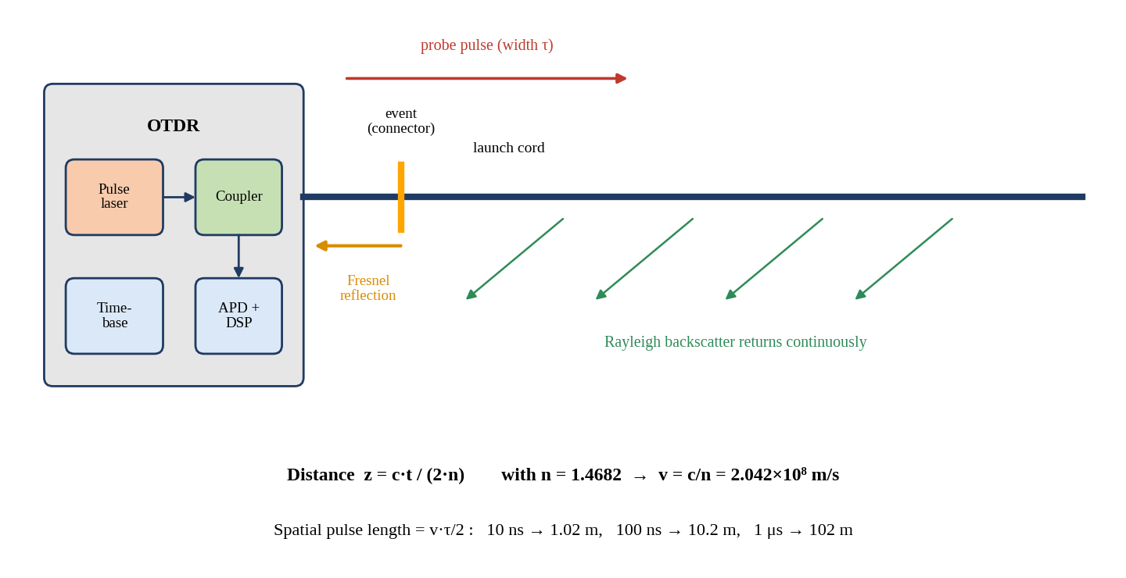
Figure 5: OTDR working principle: probe pulse, Rayleigh backscatter and Fresnel reflection.
Explanation of the figure. The OTDR pulse laser sends a short pulse through a coupler into the fibre. Rayleigh scattering returns a continuous weak signal whose level falls with distance at twice the fibre attenuation, while connectors and breaks return a strong Fresnel reflection. The time of arrival t gives distance z = c·t/(2n), and the pulse width τ sets the spatial pulse length vτ/2.
Relation to the case study. With n = 1.4682 the pulse velocity is v = c/n = 2.042×10⁸ m/s, so the spatial pulse lengths are 1.02 m (10 ns), 10.2 m (100 ns) and 102 m (1 µs). Because events 3 and 4 are only 9 m apart, the pulse width must be chosen so that the spatial pulse length and dead zones are comparable with or smaller than this separation.
Practical significance. This principle is why the OTDR can find a fault without access to the far end, but also why it cannot measure the connector loss of the second patch-cord connector under a long pulse: the strong reflection from the first connector saturates the detector for a time proportional to the pulse width.
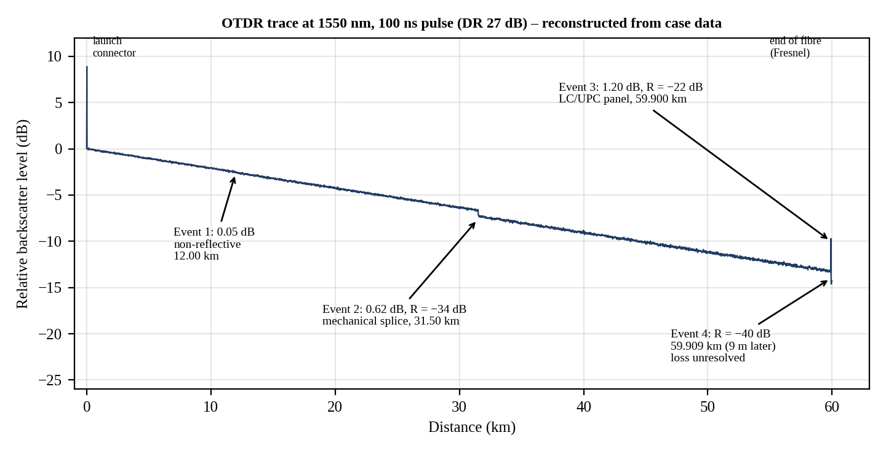
Figure 6: Reconstructed OTDR trace at 1550 nm (100 ns pulse) showing events 1–4.
Explanation of the figure. The sloping line is the Rayleigh backscatter with slope 0.21 dB/km. The 0.05 dB step at 12.00 km is the non-reflective fusion splice. At 31.50 km a 0.62 dB step with a small reflection spike (−34 dB) marks the mechanical splice. Near 59.9 km a 1.20 dB step and a large spike (−22 dB) mark the poor connector, followed 9 m later by a second reflection (−40 dB). The final spike at 60 km is the end-of-fibre Fresnel reflection.
Relation to the case study. The trace turns the numerical case data into a visual diagnosis. The two largest steps (0.62 dB and 1.20 dB) are far above the allowances of 0.05 dB (fusion) and 0.5 dB (connector), and they sum with the connector and splice excess to the 1.27 dB of excess link loss.
Practical significance. Practically, technicians read three things from such a trace: the step height (loss), the spike height (reflectance) and the distance. Reflectance values above −45 dB for UPC or above −60 dB for APC indicate contamination, a gap or damage, and reflections of −22 dB are strong enough to disturb laser stability and raise the receiver noise floor.

1.5 Splice and Connector Technologies
The repair and the later upgrade both depend on the choice of splice type and connector family. This section introduces the relevant constructions; the quantitative comparison for this link follows in Chapter 3.

1.5.1 Fusion splice versus mechanical splice
A fusion splice melts the two cleaved fibre ends with an electric arc, aligning the cores using profile alignment or local-injection-and-detection systems, and the result is a single continuous glass fibre. A mechanical splice aligns the fibre ends in a V-groove or capillary and uses an index-matching gel to suppress Fresnel reflection. Mechanical splices are quick and need no power supply, but the residual gap and angular error lead to higher loss and measurable reflectance, and the gel can age.
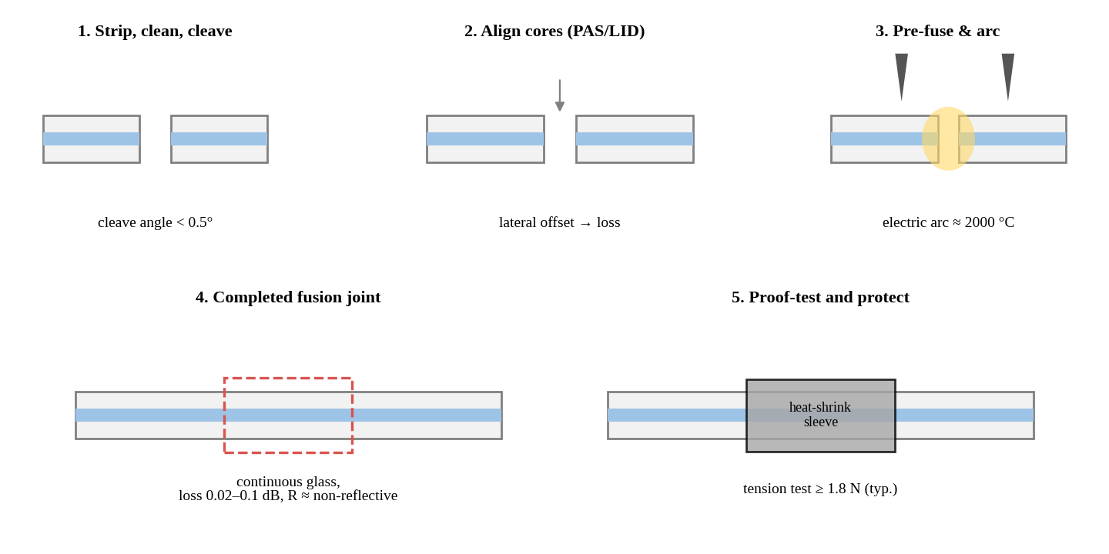
Figure 7: Fusion splice process: cleave, align, arc fusion, protect.
Explanation of the figure. The figure shows five stages: the coating is stripped and the fibre cleaved with an angle below 0.5°; the cores are aligned (profile alignment, PAS, or local-injection-and-detection, LID); an arc of roughly 2000 °C fuses the glass; the completed joint is continuous; and a heat-shrink sleeve protects it after a proof test.
Relation to the case study. The 12 fusion splices of the link have 0.05 dB each (event 1 is one of them, 0.05 dB and non-reflective, as expected). Repairing event 2 by fusion splicing would bring it from 0.62 dB to the same 0.05 dB design value, recovering 0.57 dB.
Practical significance. Fusion splicing is the permanent, low-reflectance method of choice for long-haul and DWDM routes; its limitation is the need for a splicing machine, power, a clean environment, and a closure with enough slack fibre.
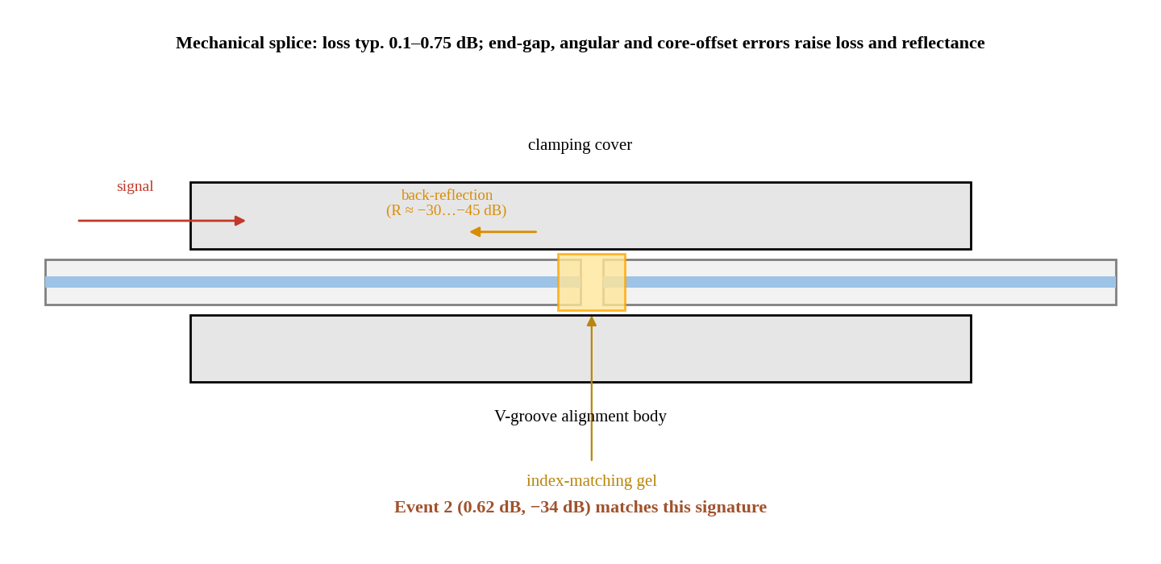
Figure 8: Mechanical splice: V-groove alignment with index-matching gel.
Explanation of the figure. Two cleaved fibres are inserted from opposite ends into a V-groove and held by a clamping cover. The index-matching gel fills the small gap and reduces, but does not eliminate, back-reflection. Gap, angular error and lateral offset determine loss and reflectance.
Relation to the case study. Event 2 (0.62 dB loss and −34 dB reflectance at 31.50 km) matches the signature of such a splice: higher loss than the 0.05 dB design allowance and a measurable reflection that a fusion splice would not show. It is the 13th splice of the link.
Practical significance. Mechanical splices are valid as temporary restoration or in the access network, but in a DWDM trunk with a booster amplifier the extra loss and reflectance, as well as long-term gel drift, make them a liability, so event 2 should be re-made as a fusion splice.

1.5.2 SC, LC, MPO and CS connectors
Four connector families are relevant to the patch panel and to the upgraded transceivers. They differ in ferrule size, fibre count and density, and these properties determine how well they fit a given faceplate.
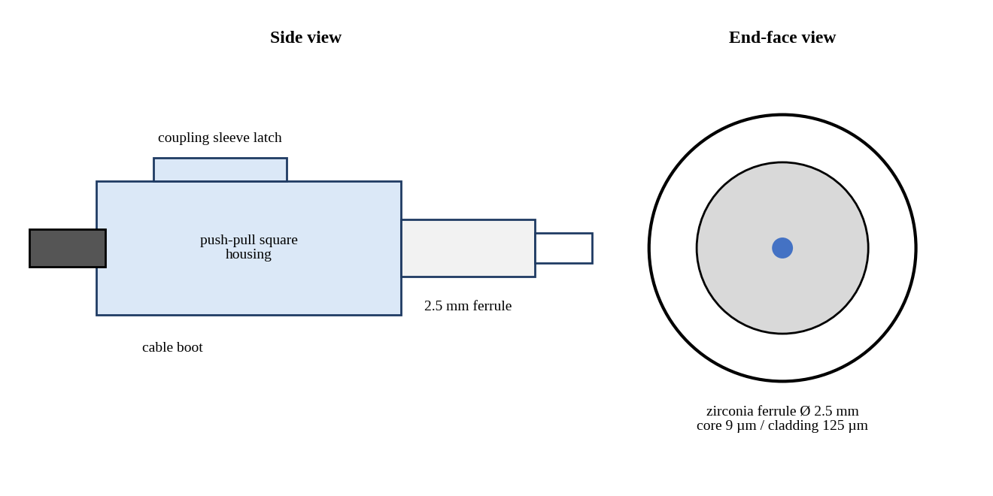
Figure 9: SC connector: 2.5 mm ferrule with push-pull square housing.
Explanation of the figure. The SC connector uses a 2.5 mm zirconia ferrule in a push-pull body. The square housing latches without rotation and can be ganged into duplex clips. The end-face view shows a 125 µm cladding and 9 µm single-mode core in the centre of the ferrule.
Relation to the case study. SC connectors appear on older passive panels and some DWDM multiplexers. They would be compatible with the existing link but occupy about twice the area of LC and are rarely used on pluggable transceivers.
Practical significance. Practically, SC is robust and tolerant of handling, and many legacy ODFs use it; replacing the damaged patch cord with SC would be possible but would not match the LC interfaces on SFP+ and coherent pluggables.
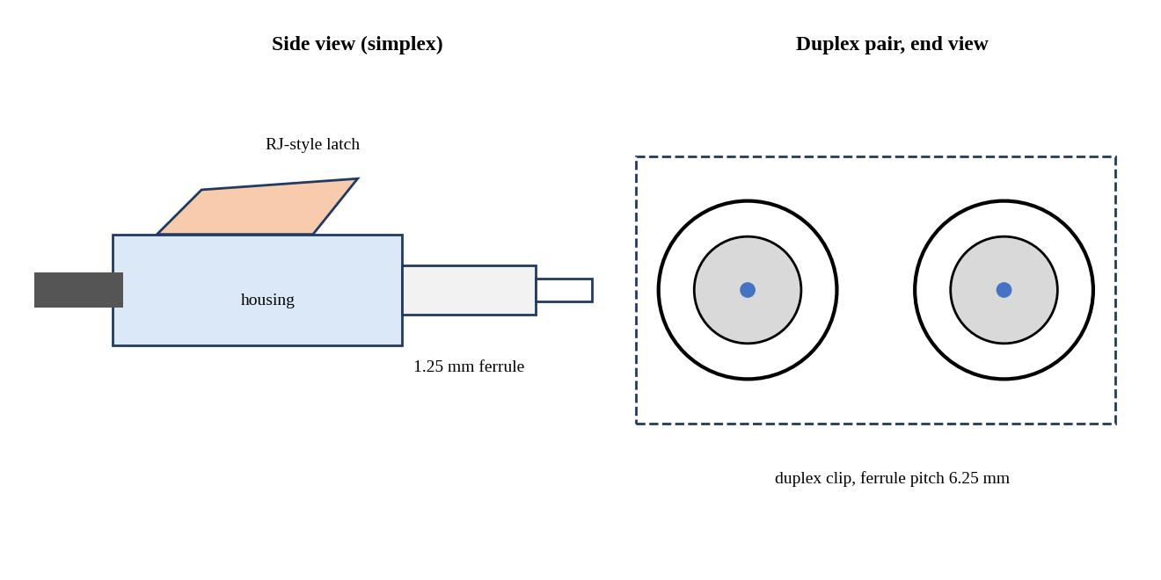
Figure 10: LC connector: 1.25 mm ferrule with latch, shown as a duplex pair.
Explanation of the figure. The LC connector halves the ferrule diameter to 1.25 mm and uses an RJ-style latch. Duplex clips hold two LC connectors with 6.25 mm pitch, forming the transmit and receive pair.
Relation to the case study. Event 3 is an LC/UPC patch-panel connector, and the SFP+ modules of the existing link and the coherent pluggables of the upgrade all use LC interfaces, so LC is the connector family that keeps the repair and the upgrade compatible.
Practical significance. LC offers high density, low insertion loss (0.1–0.3 dB typical for good grades) and standard availability, which is why it dominates data-centre patching. Its small ferrule makes contamination more critical, so end-face inspection per IEC 61300-3-35 is mandatory before mating.
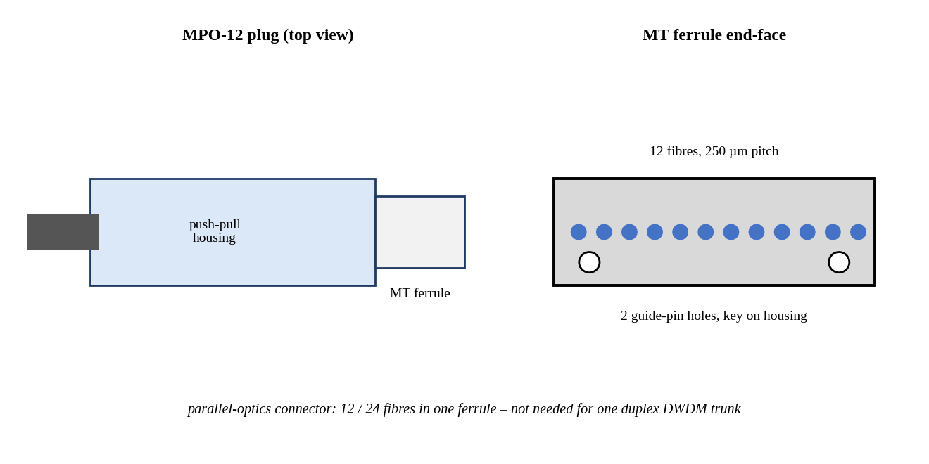
Figure 11: MPO connector: 12-fibre MT ferrule with guide pins.
Explanation of the figure. The MPO uses a rectangular MT ferrule holding 12 (or 24) fibres on a 250 µm pitch, aligned by two guide pins, in a push-pull housing. The end-face view shows the 12-fibre row and the two guide-pin holes.
Relation to the case study. MPO is designed for parallel optics (for example 40G/100G SR4, or breakout cabling). The case study uses a single duplex fibre pair for a serial DWDM signal, so MPO would waste ten fibres and add contamination risk.
Practical significance. MPO becomes relevant only if the upgrade used parallel-fibre transceivers; it is not appropriate for this wavelength-multiplexed single-pair trunk.
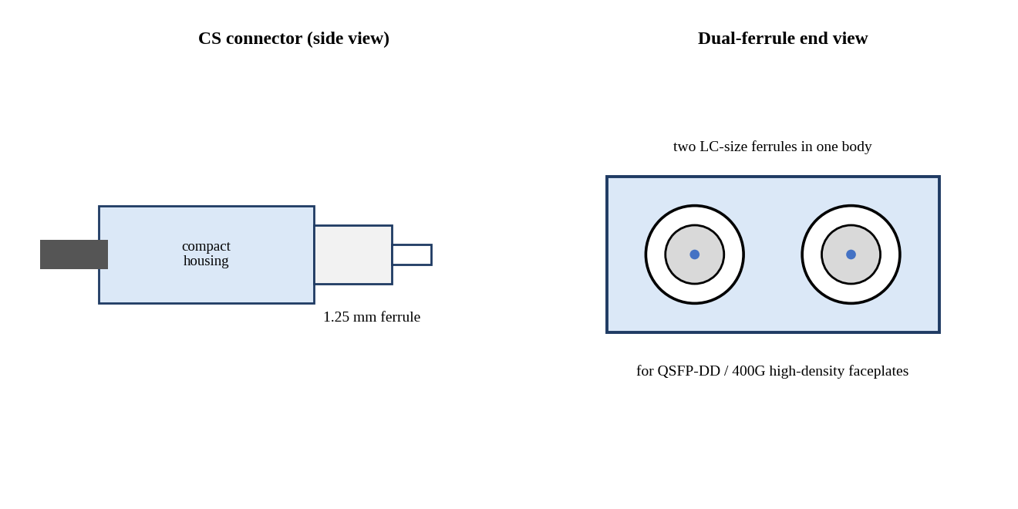
Figure 12: CS connector: dual 1.25 mm ferrules in a compact housing.
Explanation of the figure. The CS connector places two 1.25 mm ferrules in a single compact housing, giving more duplex ports per rack unit than LC. It is aimed at very-high-density faceplates such as QSFP-DD and OSFP breakout applications.
Relation to the case study. The CS family is a candidate for dense 400G faceplates, but the case needs only four duplex pairs on the upgraded trunk, so its density benefit is not needed, and its limited installed base would make the repair and sparing more complicated.
Practical significance. CS is an emerging option for high-density 400G breakout; for the 60 km repair, LC remains the practical choice because of availability, ecosystem and compatibility with the existing patch panel.

1.6 Interpretation of the Eye Diagram, Q-Factor and BER
The eye diagram is a time-domain summary of the received signal. Four observations in the case study must be related to the Q-factor and to the BER target of 10⁻¹², which requires Q ≥ 7.03.
- Reduced eye opening. A reduced vertical opening means that the separation between the mean levels of '1' and '0' is small compared with the noise standard deviations. Since Q = (μ₁ − μ₀)/(σ₁ + σ₀), any shrinkage of the eye height or growth of noise lowers Q and raises BER.
- Low extinction ratio. ER = P₁/P₀ is the ratio of the optical power in a '1' to that in a '0'. For a fixed average power the optical modulation amplitude is OMA = 2P_avg(r − 1)/(r + 1), with r = 10^(ER/10). A low ER therefore places the '0' level close to the '1' level, collapsing the eye vertically and costing power penalty 10 log[(r + 1)/(r − 1)] dB. Channel 5 has ER = 4.5 dB (r = 2.82), well below the receiver's 8.2 dB validity limit.
- High jitter. Timing variations of the crossings narrow the horizontal opening. Deterministic jitter (DJ) is bounded and arises from intersymbol interference, duty-cycle distortion and dispersion; random jitter (RJ) is Gaussian and unbounded, so at BER 10⁻¹² total jitter is TJ = DJ + 14.07·RJ and the eye width is 1 UI − TJ. Channel 5 has DJ = 0.30 UI and RJ = 0.022 UI.
- Increased BER. BER = ½ erfc(Q/√2), so BER depends exponentially on Q: Q = 7.6 yields 1.5×10⁻¹⁴, whereas Q = 4.7 yields 1.3×10⁻⁶, which is some 10⁶ times more errors than the target allows.
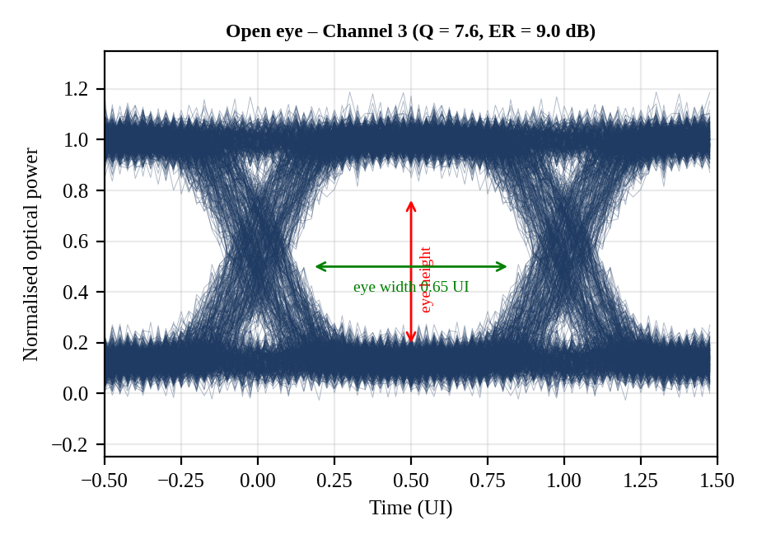
Figure 13: Eye diagram of Channel 3 (open eye: Q = 7.6, ER = 9.0 dB, DJ = 0.18 UI).
Explanation of the figure. The simulated eye shows two well-separated rails at the '1' and '0' levels and a wide, clean central opening. The annotated eye width is 0.65 UI (1 − 0.349) and the eye height is large compared with the noise on each rail.
Relation to the case study. This is the reference condition of the shared fibre: ER 9.0 dB satisfies the 8.2 dB limit, and Q = 7.6 exceeds 7.03 by only 0.57, which corresponds to only about 0.34 dB of optical margin — consistent with the power-meter finding that Channel 3's margin is far below 3 dB.
Practical significance. An open eye at the receiver proves that the transmitter modulation and the receiver bandwidth are acceptable; the remaining task for Channel 3 is only to restore power margin.
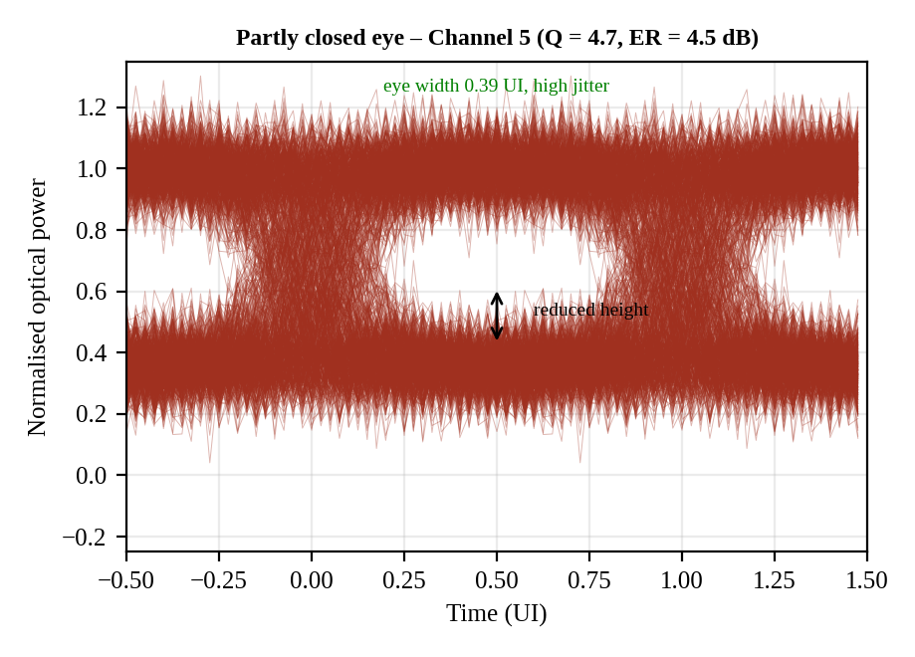
Figure 14: Eye diagram of Channel 5 (partially closed eye: Q = 4.7, ER = 4.5 dB, DJ = 0.30 UI).
Explanation of the figure. The rails at the '1' and '0' levels sit close together, and the noise bands on each rail occupy much of the vertical opening. The wide crossing region reflects the large jitter, and the eye width is only 0.39 UI (1 − 0.610).
Relation to the case study. Since Channel 5 and Channel 3 share the same fibre, connectors and demultiplexer, the difference between the two eyes points to a channel-specific cause. The low ER (4.5 dB versus 9.0 dB) explains the vertical closure, while the larger DJ and RJ closes the eye horizontally.
Practical significance. Practically, an eye like this will show a BER around 10⁻⁶, which would be corrected only by forward error correction. Instead of increasing power, the correct action is to restore the transmitter's ER by adjusting the bias and modulation or by replacing the transmitter.
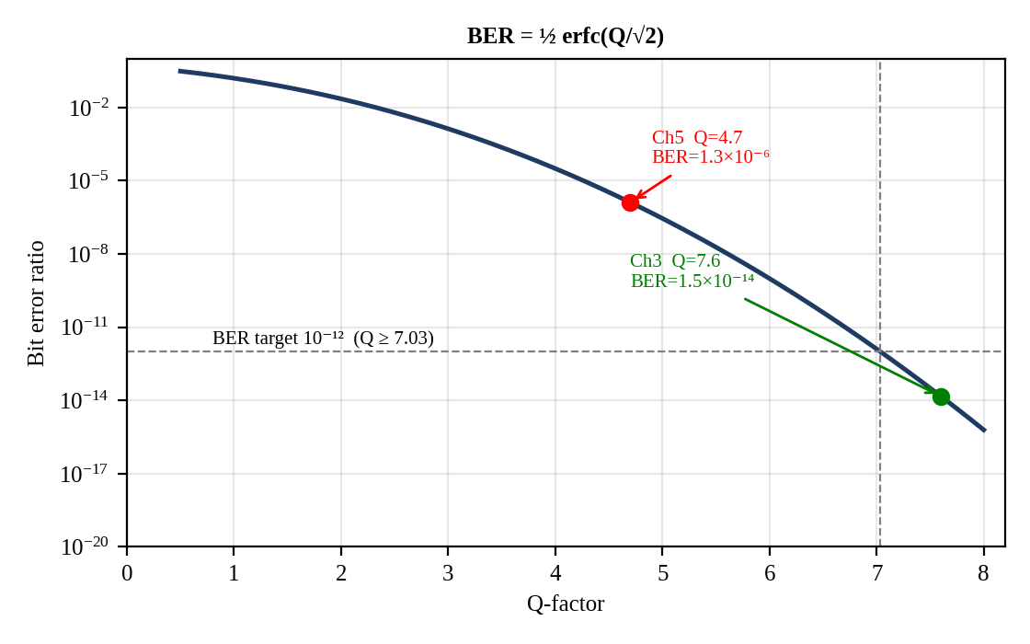
Figure 15: BER versus Q-factor curve, BER = ½ erfc(Q/√2), with Channel 3, Channel 5 and the 10⁻¹² target.
Explanation of the figure. The semilog curve falls steeply with Q. The dashed lines mark the 10⁻¹² target at Q = 7.03. Channel 3 (Q = 7.6) lies just to the right of the target and Channel 5 (Q = 4.7) lies far to the left on the 10⁻⁶ region.
Relation to the case study. The curve shows that a Q difference of only 2.9 corresponds to eight decades of BER. Channel 3 passes the BER target by only 0.57 in Q, while Channel 5 fails by 2.33 in Q.
Practical significance. Because BER falls so quickly with Q, small improvements in OMA (ER correction, repaired loss, higher launch) give very large BER improvements, which is why the recovery plan can be verified by Q ≥ 7.03.

1.7 Applicable Standards

1.7.1 ITU-T G.652.D
ITU-T G.652 specifies the standard single-mode fibre, and the sub-category D (low water peak) is the one used for metropolitan and long-haul DWDM. Its key attributes are: mode-field diameter of 8.6–9.5 µm at 1310 nm; cable cut-off wavelength ≤ 1260 nm; zero-dispersion wavelength between 1300 and 1324 nm; chromatic dispersion of about 17 ps/(nm·km) at 1550 nm; a maximum attenuation coefficient of 0.30 dB/km at 1550 nm (typical installed value 0.19–0.22 dB/km), and a link-design PMD coefficient of ≤ 0.20 ps/√km. The fibre can be used from 1260 to 1625 nm, including the full C-band (1530–1565 nm). The case-study values (0.21 dB/km, D = 17 ps/(nm·km), PMD coefficient 0.1 ps/√km) are consistent with this recommendation, and since the fibre is G.652.D the chromatic dispersion that coherent receivers must compensate is the usual 17 ps/(nm·km).

1.7.2 ITU-T G.694.1
ITU-T G.694.1 defines the DWDM frequency grid. The anchor frequency is 193.1 THz, and the fixed grid is defined for channel spacings of 12.5, 25, 50 and 100 GHz (and integer multiples). The nominal frequency of channel n on the 50 GHz grid is f = 193.1 THz + n × 0.05 THz. The recommendation also defines a flexible grid (flex-grid) with a central-frequency granularity of 6.25 GHz, f = 193.1 THz + n × 0.00625 THz, and slot widths that are multiples of 12.5 GHz (m × 12.5 GHz). A flexible grid lets super-channels of different baud rates and modulation formats occupy exactly the spectrum they need, and Option Q and Option R of this case depend on it.

1.8 Practical Constraints
- No fibre re-laying. The upgrade must use the existing fibre pair. All gain must come from higher capacity per wavelength (coherent modulation) rather than from additional fibre.
- Margin requirements. The design margin of ≥ 3 dB must be satisfied for every channel after all penalties; a 'pass' that leaves 0.38 dB is not acceptable.
- Spectral limitations. The C-band offers about 4.8 THz (96 channels of 50 GHz). Delivering 1.6 Tb/s with 10 Gb/s channels on 100 GHz spacing would need 160 channels and 16 THz, which is impossible; the spectral efficiency must rise from 0.1 to several b/s/Hz.
- Energy limitations. The legacy 10G SFP+ consumes 3.5 W per 10 Gb/s, i.e., 350 pJ/bit. The upgrade must minimise energy per bit (pJ/bit) and absolute power at each terminal.
- Existing optics. The multiplexer and demultiplexer are fixed 100 GHz devices and the only amplifier is the booster; any upgrade that needs a different grid has to replace or bypass these passive units, and the connector family (LC) must be preserved.

1.9 Performance Requirement Statement
The repaired and upgraded 60 km ITU-T G.652.D DWDM link between the two data centres, using the existing fibre pair and no re-laying, shall satisfy all of the following requirements simultaneously:
(1) Passive loss. Total as-built optical loss shall not exceed the design value of 21.25 dB (12.60 dB fibre + 2.00 dB connectors + 0.65 dB splices + 6.00 dB demultiplexer). No OTDR event shall exceed its allowance: fusion splice ≤ 0.05–0.1 dB and non-reflective; connector ≤ 0.5 dB with reflectance ≤ −45 dB (UPC).
(2) Receiver margin. After the dispersion penalty (≈ 1.0 dB) and the extinction-ratio penalty, every channel shall reach an effective received power at least 3 dB above the −24 dBm sensitivity, i.e. ≥ −21 dBm.
(3) Signal quality. Every channel shall have ER ≥ 8.2 dB, Q ≥ 7.03 (BER ≤ 10⁻¹²), and eye width ≥ 0.5 UI (TJ ≤ 0.5 UI at BER 10⁻¹²).
(4) Noise and PMD. OSNR shall be at least 20 dB (0.1 nm) for the legacy signals and at least the format-specific requirement plus 3 dB for the upgrade; mean PMD shall not exceed 10 % of the bit period.
(5) Capacity, spectrum and energy. The same fibre pair shall carry 1.6 Tb/s on the ITU-T G.694.1 grid with the highest feasible payload spectral efficiency and the lowest energy per bit (pJ/bit), and with an OSNR margin ≥ 3 dB on the repaired link.
(6) Evidence. Each of the above shall be demonstrated by measurement (power meter, OSA, OTDR, BERT/eye, PMD) after repair and again after upgrade, before the system is placed in service.
CHAPTER 2
LINK BUDGET, DISPERSION AND OSNR ANALYSIS
2.1 Input Data and Method
The analysis works backward from receiver sensitivity and the 3 dB margin requirement. The numerical inputs are those of the case study; the as-built values replace the design allowances wherever the OTDR and the power meter have measured a real value. Table 2 lists the inputs and indicates whether each is a design allowance or a measured quantity.
Table 2: Input data for the link-budget analysis
Parameter | Value | Source / status
Fibre length L | 60 km | Case data
Fibre attenuation α | 0.21 dB/km at 1550 nm | Case data (G.652.D)
Launch power per channel | +1 dBm at line output | Case data
Demultiplexer loss | 6.0 dB | Case data
Connectors (design) | 4 × 0.5 dB | Design allowance
Splices (design) | 13 × 0.05 dB | Design allowance
Connectors (as-built) | Event 3: 1.20 dB; three connectors at 0.5 dB (incl. event 4) | Measured (OTDR / power meter)
Splices (as-built) | 12 fusion × 0.05 dB (incl. event 1); event 2 = 0.62 dB | Measured (OTDR)
Receiver sensitivity | −24 dBm at BER 10⁻¹² (valid for ER ≥ 8.2 dB) | Case data
Required margin | ≥ 3 dB | Requirement
Dispersion D; source rms width σλ | 17 ps/(nm·km); 0.03 nm | Case data
PMD coefficient | 0.1 ps/√km | Case data
EDFA noise figure; input power | 5 dB; −6 dBm per channel | Case data
Required OSNR | 20 dB (0.1 nm) | Case data
Extinction ratio | Channel 3: 9.0 dB; Channel 5: 4.5 dB | Measured (eye analyser)

2.2 Fibre, Connector and Splice Loss

Calculation 2.1 – Fibre loss
Formula | L_fibre = α × L
Substitution | L_fibre = 0.21 dB/km × 60 km
Calculation | 0.21 × 60 = 12.6
Units | dB/km × km = dB
Final answer | L_fibre = 12.60 dB

The fibre contributes 59.3 % of the design loss of 21.25 dB, and it cannot be changed without re-laying fibre. The 12.60 dB is therefore a fixed quantity of the budget, and all improvement must come from the 8.65 dB of discrete components (demultiplexer, connectors and splices) or from launch power.

Calculation 2.2 – Connector loss (design and as-built)
Formula | L_conn = Σ (individual connector losses)
Substitution | Design: 4 × 0.5 dB. As-built: 1.20 dB (event 3) + 3 × 0.5 dB (including event 4)
Calculation | Design: 4 × 0.5 = 2.00. As-built: 1.20 + 1.50 = 2.70
Units | dB
Final answer | L_conn,design = 2.00 dB; L_conn,as-built = 2.70 dB (excess +0.70 dB)

The connector excess of 0.70 dB is attributable solely to event 3: the patch-panel LC/UPC connector measured 1.20 dB against a 0.5 dB allowance. The other three connectors, including the second connector of the patch cord (event 4), are at the 0.5 dB allowance according to the power-meter result, so event 3 alone consumes 55 % of the total excess loss.

Calculation 2.3 – Splice loss (design and as-built)
Formula | L_splice = Σ (individual splice losses)
Substitution | Design: 13 × 0.05 dB. As-built: 12 × 0.05 dB (fusion, incl. event 1) + 0.62 dB (event 2, mechanical)
Calculation | Design: 13 × 0.05 = 0.65. As-built: 0.60 + 0.62 = 1.22
Units | dB
Final answer | L_splice,design = 0.65 dB; L_splice,as-built = 1.22 dB (excess +0.57 dB)

The mechanical splice at 31.50 km is 12.4 times higher than the 0.05 dB allowance and accounts for the remaining 45 % of the excess. The remaining twelve fusion splices behave as designed.

2.3 Total Link Loss: Design versus As-Built

Calculation 2.4 – Total link loss
Formula | L_total = L_fibre + L_conn + L_splice + L_demux
Substitution | Design: 12.60 + 2.00 + 0.65 + 6.00. As-built: 12.60 + 2.70 + 1.22 + 6.00
Calculation | Design: 21.25. As-built: 22.52. Excess: 22.52 − 21.25 = 1.27
Units | dB
Final answer | Design loss = 21.25 dB; as-built loss = 22.52 dB; excess = 1.27 dB (+5.98 %)

Table 3: Design versus as-built loss budget
Component | Design (dB) | As-built (dB) | Excess (dB) | Share of excess
Fibre (60 km × 0.21 dB/km) | 12.60 | 12.60 | 0.00 | 0 %
Connectors | 2.00 | 2.70 | +0.70 | 55 %
Splices | 0.65 | 1.22 | +0.57 | 45 %
Demultiplexer | 6.00 | 6.00 | 0.00 | 0 %
Total | 21.25 | 22.52 | +1.27 | 100 %

The loss budget shows that 12.60 dB (fibre) and 6.00 dB (demultiplexer), i.e., 82.6 % of the as-built loss, are fixed by the installed plant. The whole 1.27 dB excess comes from two events, namely event 3 (0.70 dB above allowance) and event 2 (0.57 dB above allowance), both of which can be corrected by field work.

2.4 Received Power per Channel

Calculation 2.5 – Received power
Formula | P_rx = P_launch − L_total
Substitution | Design: P_rx = +1 dBm − 21.25 dB. As-built: P_rx = +1 dBm − 22.52 dB
Calculation | Design: 1 − 21.25 = −20.25. As-built: 1 − 22.52 = −21.52
Units | dBm − dB = dBm
Final answer | P_rx,design = −20.25 dBm; P_rx,as-built = −21.52 dBm

Before any penalty is applied the raw margin to the −24 dBm sensitivity is −21.52 − (−24) = 2.48 dB as-built (design: 3.75 dB). The as-built link already misses the 3 dB requirement by 0.52 dB, even for an ideal transmitter and negligible dispersion; this confirms the power-meter finding that the margin is below 3 dB 'even for Channel 3'.

2.5 EDFA Noise and OSNR
An erbium-doped fibre amplifier amplifies the optical signal by stimulated emission from Er³⁺ ions pumped at 980 nm or 1480 nm, and it adds amplified spontaneous emission (ASE), whose power is described by the noise figure NF. For a booster whose input carries a per-channel power P_in the OSNR in the 0.1 nm reference bandwidth is OSNR = 58 + P_in − NF. The constant is obtained from OSNR = P_in/(NF · hν · Δν) with Δν = 12.5 GHz: hνΔν = 1.28×10⁻¹⁹ J × 12.5×10⁹ Hz = 1.60×10⁻⁹ W = −58 dBm.
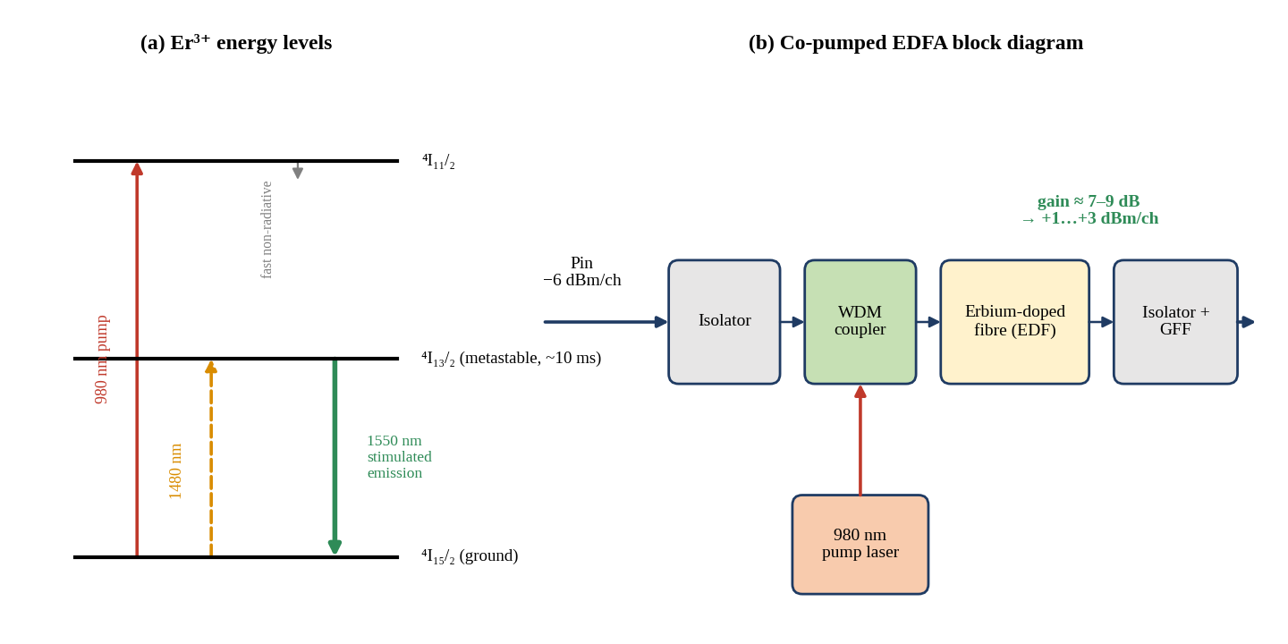
Figure 16: EDFA working principle: Er³⁺ energy levels and co-pumped amplifier block diagram.
Explanation of the figure. Panel (a) shows how pump photons at 980 nm raise Er³⁺ ions from the ground state ⁴I₁₅/₂ to ⁴I₁₁/₂, from which they relax quickly to the metastable level ⁴I₁₃/₂ (lifetime about 10 ms). Signal photons near 1550 nm stimulate the transition back to the ground state, producing gain. Panel (b) shows the isolator, WDM pump coupler, erbium-doped fibre and output isolator with gain-flattening filter.
Relation to the case study. The booster raises the −6 dBm per channel input to +1 dBm per channel at the line output, so its gain is about 7 dB. The amplifier noise figure of 5 dB sets the OSNR at 47 dB. Raising the output to +3 dBm per channel needs a gain of 9 dB, which is within the capability of a typical booster and does not change the input-referred OSNR.
Practical significance. Because the EDFA is a saturated gain medium shared by all eight channels, total output power (+10.0 dBm at +1 dBm per channel, +12.0 dBm at +3 dBm per channel) is the quantity that is limited by the pump. The gain-flattening filter keeps Channel 3 and Channel 5 within about 1 dB of each other.

Calculation 2.6 – OSNR at the receiver
Formula | OSNR = 58 + P_in − NF
Substitution | OSNR = 58 + (−6 dBm) − 5 dB
Calculation | 58 − 6 − 5 = 47
Units | dBm − dB gives dB (0.1 nm reference bandwidth)
Final answer | OSNR = 47 dB; margin over the 20 dB requirement = 27 dB

The OSNR of 47 dB is 27 dB (a factor of 500) above the 20 dB requirement. Because the booster is the only amplifier and the loss after it (fibre, connectors, demultiplexer) attenuates signal and ASE equally, the OSNR measured at the receiver is the same as the OSNR leaving the booster. The 10 Gb/s NRZ link is therefore power-limited and penalty-limited, not noise-limited: improving OSNR would give no benefit, whereas each dB of recovered loss or reduced penalty directly increases margin.

2.6 Chromatic Dispersion Penalty
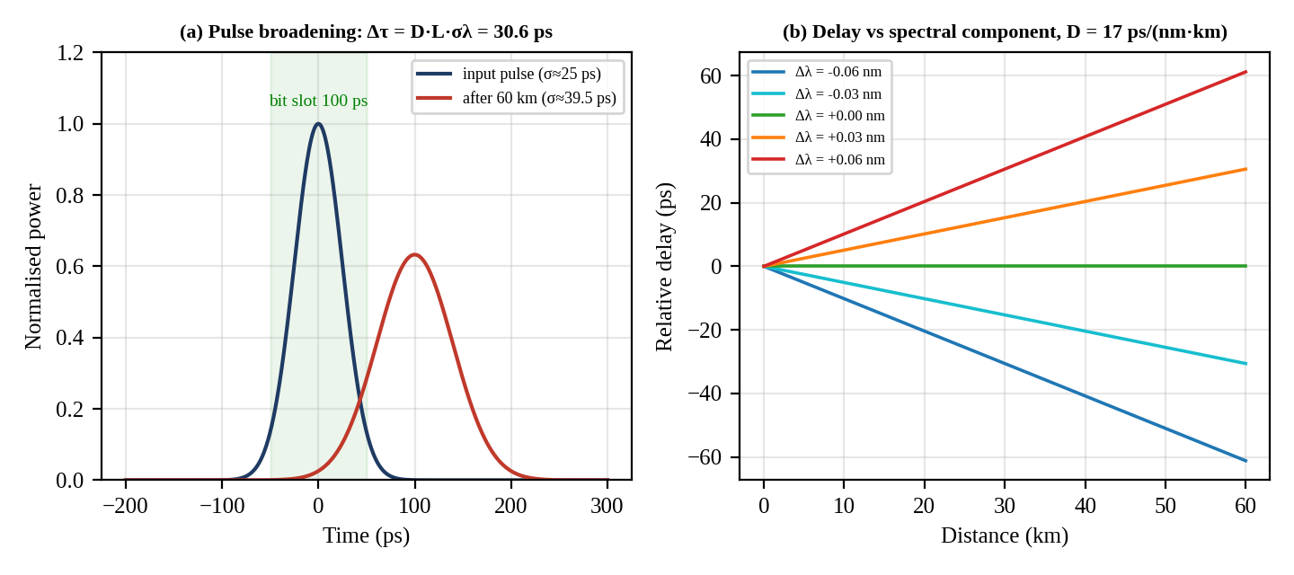
Figure 17: Dispersion in optical fibre: pulse broadening and wavelength-dependent delay.
Explanation of the figure. Panel (a) compares a 25 ps rms input pulse with the pulse after 60 km. The source has a finite spectral width, and each spectral component travels at a different speed, so the pulse broadens by Δτ = D·L·σλ = 17 × 60 × 0.03 = 30.6 ps and its rms width grows from 25 ps to √(25² + 30.6²) = 39.5 ps. Panel (b) shows the relative delay of different spectral components, growing linearly with distance at 17 ps/(nm·km) per nm of offset.
Relation to the case study. The 30.6 ps broadening corresponds to 0.306 of the 100 ps bit period, so a visible fraction of each bit spills into its neighbours. This is the origin of the dispersion penalty that must be subtracted from the received power.
Practical significance. Practically, the penalty can be reduced by using a source with narrower spectrum (an externally modulated DFB laser has σλ well below 0.03 nm), by dispersion compensation, or by moving to coherent detection, where the accumulated 1020 ps/nm is compensated in digital signal processing.

Calculation 2.7 – Dispersion penalty
Formula | δ = 5 log₁₀[1 + 2π (B·D·L·σλ)²]
Substitution | B = 10×10⁹ b/s; D·L = 17 ps/(nm·km) × 60 km = 1020 ps/nm; σλ = 0.03 nm → D·L·σλ = 30.6 ps = 30.6×10⁻¹² s
Calculation | B·D·L·σλ = 10×10⁹ × 30.6×10⁻¹² = 0.306; (0.306)² = 0.0936; 2π × 0.0936 = 0.5883; 1 + 0.5883 = 1.5883; log₁₀(1.5883) = 0.2009; δ = 5 × 0.2009 = 1.0047
Units | B·D·L·σλ is dimensionless; δ in dB
Final answer | δ = 1.00 dB (1.0047 dB)

A 1 dB dispersion penalty is generally the accepted maximum for direct-detection systems (the usual design limit is 1–2 dB), so the link is at the limit of acceptable dispersion for this source. It cannot be neglected: it removes about 20 % of the available power and must be included in the margin calculation. Reducing the source rms width to 0.02 nm would reduce the penalty to 0.50 dB, and to 0.01 nm to 0.14 dB, but the present transmitters are not changed in this plan, so the full 1.00 dB is kept as a conservative assumption.

2.7 Polarisation-Mode Dispersion
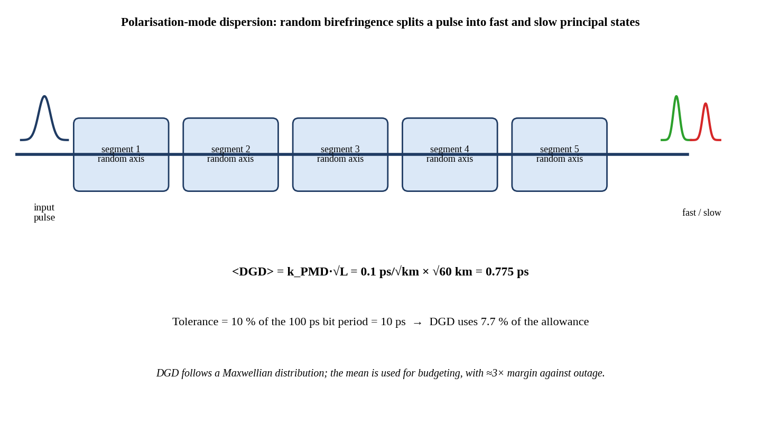
Figure 18: Polarisation-mode dispersion (PMD): random birefringence and differential group delay.
Explanation of the figure. Random birefringent segments along the fibre couple energy between two orthogonal principal polarisation states that travel at slightly different group velocities. The result is a fast and a slow component of the pulse separated by the differential group delay (DGD). The mean DGD grows with the square root of length because the segments are random.
Relation to the case study. With a PMD coefficient of 0.1 ps/√km the mean DGD of the 60 km link is 0.775 ps, which is less than 1 % of the 100 ps bit period; the link is thus completely free of PMD limits for 10 Gb/s NRZ.
Practical significance. PMD becomes critical at higher baud rates and over long distances; for the coherent upgrade at 32 GBd (bit period 31.25 ps, tolerance 3.1 ps) the DGD is still only 2.5 % of the symbol period and the DSP equaliser can compensate far larger values.

Calculation 2.8 – PMD check
Formula | DGD_mean = k_PMD × √L; tolerance = 0.10 × T_bit
Substitution | DGD = 0.1 ps/√km × √60 km; T_bit = 1/10 Gb/s = 100 ps
Calculation | √60 = 7.746; DGD = 0.1 × 7.746 = 0.775 ps; tolerance = 0.10 × 100 = 10 ps; ratio = 0.775/10 = 0.0775
Units | ps/√km × √km = ps
Final answer | DGD = 0.775 ps ≤ 10 ps allowed (7.7 % of the tolerance, 0.78 % of the bit period) → PASS

2.8 Extinction-Ratio Penalty, Effective Received Power and System Margin
The receiver sensitivity of −24 dBm is guaranteed only when ER ≥ 8.2 dB. When the extinction ratio is finite, the '0' level carries power that adds no signal, and for a fixed average power the optical modulation amplitude is reduced by a factor (r − 1)/(r + 1). The extinction-ratio power penalty is PP_ER = 10 log₁₀[(r + 1)/(r − 1)], with r = 10^(ER/10).

Calculation 2.9 – Extinction-ratio penalty (Channel 3 and Channel 5)
Formula | r = 10^(ER/10); PP_ER = 10 log₁₀[(r + 1)/(r − 1)]
Substitution | Channel 3: ER = 9.0 dB → r = 10^0.9. Channel 5: ER = 4.5 dB → r = 10^0.45
Calculation | Ch3: r = 7.943; (8.943)/(6.943) = 1.2881; PP = 10 log(1.2881) = 1.10. Ch5: r = 2.818; (3.818)/(1.818) = 2.1002; PP = 10 log(2.1002) = 3.22
Units | dB
Final answer | PP_ER(Ch3) = 1.10 dB; PP_ER(Ch5) = 3.22 dB (difference 2.12 dB)

Calculation 2.10 – Effective received power and system margin
Formula | P_eff = P_rx − δ − PP_ER; Margin = P_eff − P_sens; P_sens = −24 dBm
Substitution | Ch3: P_eff = −21.52 − 1.00 − 1.10. Ch5: P_eff = −21.52 − 1.00 − 3.22
Calculation | Ch3: P_eff = −23.62 dBm; Margin = −23.62 + 24.00 = 0.38. Ch5: P_eff = −25.75 dBm; Margin = −25.75 + 24.00 = −1.75 (computed with unrounded intermediate values)
Units | dBm − dB = dBm; dBm − dBm = dB
Final answer | Channel 3: P_eff = −23.62 dBm, margin = +0.38 dB (< 3 dB, shortfall 2.62 dB). Channel 5: P_eff = −25.75 dBm, margin = −1.75 dB (shortfall 4.75 dB)

Both channels fail the 3 dB margin requirement. Channel 3 retains only 0.38 dB and Channel 5 is below sensitivity by 1.75 dB. The Q-factor measurements corroborate this: Channel 3 has a Q margin of 10 log(7.6/7.03) = 0.34 dB, which is almost exactly its 0.38 dB power margin, so the budget and the BER tester independently tell the same story.
Sensitivity of the conclusion to the ER treatment. The vendor sensitivity is specified for ER ≥ 8.2 dB, which itself contains a penalty of 10 log[(6.607 + 1)/(6.607 − 1)] = 1.32 dB. If the sensitivity of −24 dBm is assumed to already contain this 1.32 dB, then only the incremental penalty relative to the reference applies: Channel 3 (ER 9.0 dB) takes no extra penalty and Channel 5 takes 3.22 − 1.32 = 1.90 dB. Table 4 compares the two treatments. The conservative absolute treatment is adopted as the primary result because it is consistent with the measured Q of Channel 3, but the conclusion is the same under both treatments: neither channel meets 3 dB.
Table 4: Received-power and margin analysis under two treatments of the ER penalty
Quantity | Design (Ch3) | As-built Ch3 | As-built Ch5 | Requirement
Received power P_rx (dBm) | −20.25 | −21.52 | −21.52 | —
Dispersion penalty (dB) | 1.00 | 1.00 | 1.00 | —
ER penalty, absolute (dB) | 1.10 | 1.10 | 3.22 | —
Effective power (dBm), absolute | −22.35 | −23.62 | −25.75 | ≥ −21.00
Margin (dB), absolute | 1.65 | 0.38 | −1.75 | ≥ 3.00
ER penalty, incremental to 8.2 dB (dB) | 0.00 | 0.00 | 1.90 | —
Effective power (dBm), incremental | −21.25 | −22.52 | −24.42 | ≥ −21.00
Margin (dB), incremental | 2.75 | 1.48 | −0.42 | ≥ 3.00

An important result in the design column is that even the ideal as-designed link, with 21.25 dB of loss and +1 dBm launch, delivers only 1.65 dB of margin (absolute treatment) after dispersion and ER penalties. The loss repair alone therefore cannot reach 3 dB; a launch-power increase (or a penalty reduction) is also necessary. This is the central quantitative finding of the budget.

2.9 Corrective Scenarios to Reach the 3 dB Margin
The required margin gain for Channel 3 is 3.00 − 0.38 = 2.62 dB. The available levers are the repair of event 3 (0.70 dB), the repair of event 2 (0.57 dB), and the booster launch power. Table 5 evaluates the combinations for a Channel 3-quality transmitter (ER 9.0 dB); after the Channel 5 transmitter is restored to ER ≥ 9 dB, Channel 5 follows the same numbers.
Table 5: Corrective scenarios and resulting margin (absolute ER treatment)
Scenario | Loss (dB) | Launch (dBm) | P_rx (dBm) | P_eff (dBm) | Margin (dB)
S0 As-built | 22.52 | +1 | −21.52 | −23.62 | 0.38 FAIL
S1 Launch +2 dB only | 22.52 | +3 | −19.52 | −21.62 | 2.38 FAIL
S2 Repair event 3 only | 21.82 | +1 | −20.82 | −22.92 | 1.08 FAIL
S3 Repair events 2 and 3 | 21.25 | +1 | −20.25 | −22.35 | 1.65 FAIL
S4 Repair event 3 + launch +2 dB | 21.82 | +3 | −18.82 | −20.92 | 3.08 marginal
S5 Repair events 2 and 3 + launch +2 dB | 21.25 | +3 | −18.25 | −20.35 | 3.65 PASS

Scenario S5 is selected. It repairs both events, restores the budget to the design loss of 21.25 dB, and raises the launch power by 2 dB to +3 dBm per channel, producing a margin of 3.65 dB. Scenario S4 passes the 3 dB test by only 0.08 dB, which would leave no allowance for connector ageing; Scenarios S1 to S3 all fail. A launch of +3 dBm per channel is acceptable: with 8 channels the total power is +12 dBm (16 mW), the effective length of the fibre is L_eff = (1 − e^(−αL))/α = 19.5 km (α = 0.0484 km⁻¹), and the nonlinear phase for all channels combined is φ_NL = γ P_total L_eff = 1.3 W⁻¹km⁻¹ × 0.016 W × 19.5 km = 0.41 rad, well below the 1 rad guideline, while the per-channel power is below typical stimulated-Brillouin-scattering thresholds. The OSNR is unaffected (47 dB).

2.10 Analysis of the Budget Components
- Power budget. The as-built link has 22.52 dB of loss, 1.27 dB (6 %) above design; this takes the raw margin from 3.75 dB to 2.48 dB. Fibre (56 %) and demultiplexer (27 %) dominate the loss, but only the excess can be fixed.
- Dispersion impact. The 1.00 dB penalty is the second-largest common deduction after the demultiplexer, and it equals 79 % of the 1.27 dB excess loss. It limits the link to roughly its current length with the present source.
- System margin. The as-built margins of 0.38 dB (Channel 3) and −1.75 dB (Channel 5) fall short of 3 dB by 2.62 dB and 4.75 dB respectively. After repair, launch correction and ER restoration, both channels reach 3.65 dB.
- OSNR adequacy. 47 dB against 20 dB gives 27 dB of headroom; noise is not the limiting mechanism, so no pre-amplifier or additional amplifier is required.

2.11 Design Decision 1
DESIGN DECISION 1 – SELECT THE PROPOSED LINK-BUDGET CONFIGURATION
The as-built link does not meet the margin requirement: the as-built loss is 22.52 dB (+1.27 dB), P_rx = −21.52 dBm, and after the dispersion penalty (1.00 dB) and ER penalty the margin is +0.38 dB for Channel 3 and −1.75 dB for Channel 5, against the required 3 dB. OSNR = 47 dB is 27 dB above the requirement, so noise is not the limiting component.
I recommend correcting the excess passive loss first — event 3/4 at the patch panel (−0.70 dB) and then the mechanical splice, event 2 (−0.57 dB), to restore the 21.25 dB design loss — and combining this with a +2 dB booster-power increase to +3 dBm per channel (total +12 dBm), and with restoration of Channel 5's extinction ratio to ≥ 8.2 dB, because the excess loss is the only component shared by all eight channels, is entirely correctable in the field, and the penalties (1.00 dB dispersion, 1.10 dB ER at ER 9 dB) are fixed by the transmitters; repair alone leaves only 1.65 dB of margin and launch power alone gives only 2.38 dB, but the combination gives 3.65 dB (0.65 dB above the requirement), with the nonlinear phase of 0.41 rad and an unchanged OSNR of 47 dB.
CHAPTER 3
OTDR ANALYSIS AND FAULT LOCALIZATION
3.1 Event Table and Physical Interpretation
The OTDR trace of the link (Figure 6) contains four events. Their loss, reflectance and distance allow each to be assigned a physical cause. The decisive indicators are the loss relative to the allowance (0.05 dB for a fusion splice, 0.5 dB for a connector) and the reflectance: a fusion splice has no measurable reflection, a mechanical splice reflects at −30 to −45 dB, and a good UPC connector reflects at −50 dB or better (APC −60 dB or better).
Table 6: OTDR events and their diagnosis
Event | Position (km) | Loss (dB) | Reflectance | Diagnosis | Action
1 | 12.00 | 0.05 | Non-reflective | Normal fusion splice, within 0.05 dB allowance | None; record as baseline
2 | 31.50 | 0.62 | −34 dB | Mechanical splice: loss 12× allowance and a clear reflection | Re-make as fusion splice (priority 2)
3 | 59.900 | 1.20 | −22 dB | LC/UPC patch-panel connector, 2.4× allowance, very strong reflection: contamination, damage or air gap | Inspect, clean; replace patch cord (priority 1)
4 | 59.909 | not resolved | −40 dB | Second connector of a patch cord 9 m from event 3; reflectance 10 dB worse than a good UPC (−50 dB) | Clean / replace with event 3; measure from far end

3.2 Selection of Pulse Width and Test Arrangement
The required dynamic range of the OTDR is the one-way trace loss plus 6 dB. The one-way trace loss is the loss that the OTDR traverses between the launch connector and the end of the fibre. The demultiplexer lies beyond the measured fibre, so it is excluded; the as-built trace loss is the fibre (12.60 dB), the connectors (2.70 dB) and the splices (1.22 dB).

Calculation 3.1 – Required OTDR dynamic range
Formula | DR_required = L_trace(one-way) + 6 dB; L_trace = L_fibre + L_conn + L_splice
Substitution | L_trace = 12.60 + 2.70 + 1.22; DR_required = L_trace + 6
Calculation | L_trace = 16.52 dB; DR_required = 16.52 + 6 = 22.52
Units | dB
Final answer | DR_required = 22.52 dB

Table 7: Pulse-width evaluation for the 60 km link
Pulse width | Spatial pulse length | DR (dB) | EDZ (m) | ADZ (m) | DR ≥ 22.52 dB? | Events 3/4 separate? (9 m) | Loss of event 4 measurable?
10 ns | 1.02 m | 20 | 1 | 4 | No (−2.52 dB) | Yes (EDZ 1 < 9 m) | Yes (ADZ 4 < 9 m)
100 ns | 10.2 m | 27 | 5 | 15 | Yes (+4.48 dB) | Yes (EDZ 5 < 9 m) | No (ADZ 15 > 9 m)
1 µs | 102 m | 33 | 40 | 100 | Yes (+10.48 dB) | No (EDZ 40 > 9 m) | No (ADZ 100 > 9 m)

Only the 100 ns and 1 µs pulses supply the required 22.52 dB of dynamic range, and of these only 100 ns has an event dead zone (5 m) smaller than the 9 m separation of events 3 and 4. The 1 µs pulse would merge events 3 and 4 into one broad reflection; the 10 ns pulse resolves them but its dynamic range of 20 dB is 2.52 dB below the requirement, so the far end of the trace is lost in noise. The 100 ns pulse is therefore the correct pulse for the end-to-end trace: it has 4.48 dB of dynamic-range headroom, its EDZ of 5 m separates events 3 and 4 as distinct reflective events, and the 10.2 m spatial pulse length is comparable to the 9 m patch cord. However, its ADZ of 15 m is larger than the 9 m cord, so the loss of the second connector (event 4) cannot be measured with the 100 ns trace: the backscatter does not recover between event 3 and event 4.
Test arrangement. The following arrangement gives a valid measurement of every event and is adopted in this report: (a) a launch cord (about 500 m, longer than the 100 ns attenuation dead zone) and a tail cord of equal length at the far end so that the first and last connectors are both characterised; (b) a 100 ns, 1550 nm end-to-end trace from Data Centre A, averaged for about 2 minutes, to document the full route, events 1 and 2, and the reflectance of events 3 and 4; (c) a bidirectional measurement, repeating the trace from Data Centre B and averaging the A→B and B→A losses of each event (cancelling the backscatter-coefficient mismatch that makes splice loss appear as a 'gain' in one direction); and (d) a 10 ns trace taken from Data Centre B, where events 3 and 4 appear only about 0.1 km (about 0.6 km with a 500 m launch cord) from the OTDR. There the dynamic range (20 dB) is not a limitation, the ADZ of 4 m is smaller than 9 m, and the loss of the second connector becomes measurable. The power meter finally closes the loop: the OTDR localises, the power meter gives the true end-to-end insertion loss.

3.3 Spatial Pulse Length and Event Separation

Calculation 3.2 – Spatial pulse length
Formula | SPL = v·τ/2 = c·τ/(2n)
Substitution | c = 2.998×10⁸ m/s; n = 1.4682 → v = c/n = 2.998×10⁸/1.4682 = 2.042×10⁸ m/s
Calculation | 10 ns: 2.042×10⁸ × 10×10⁻⁹/2 = 1.02 m. 100 ns: 2.042×10⁸ × 100×10⁻⁹/2 = 10.2 m. 1 µs: 2.042×10⁸ × 1×10⁻⁶/2 = 102 m
Units | (m/s) × s = m
Final answer | SPL = 1.02 m (10 ns); 10.2 m (100 ns); 102 m (1 µs)

Calculation 3.3 – Separation of events 3 and 4
Formula | Δz = z₄ − z₃; Δt = 2·Δz·n/c
Substitution | Δz = 59.909 km − 59.900 km = 9 m; Δt = 2 × 9 × 1.4682/2.998×10⁸
Calculation | Δz = 0.009 km = 9.0 m; Δt = 26.43/2.998×10⁸ = 88.2×10⁻⁹ s
Units | m; s
Final answer | Separation = 9 m; round-trip delay difference = 88.2 ns

The 88.2 ns round-trip separation is shorter than the 100 ns pulse width, so with 100 ns the two reflections overlap partially, yet the detector can still distinguish two peaks because the EDZ (5 m) is shorter than the 9 m spacing. With a 1 µs pulse (SPL 102 m ≫ 9 m) the two events merge into one. This confirms that events 3 and 4 appear as two separate reflective events at 10 ns and 100 ns, but as one event at 1 µs, and that the loss of event 4 can be read only with a pulse whose ADZ (4 m at 10 ns) is below 9 m.

3.4 Round-Trip Delay and Location Uncertainty

Calculation 3.4 – Round-trip delay of each event
Formula | t_rt = 2·z·n/c
Substitution | n = 1.4682; c = 2.998×10⁸ m/s; z = 12 000 m, 31 500 m, 59 900 m, 59 909 m
Calculation | Event 1: 2 × 12 000 × 1.4682/2.998×10⁸ = 117.5 µs. Event 2: = 308.5 µs. Event 3: = 586.7 µs. Event 4: = 586.8 µs
Units | m / (m/s) = s
Final answer | t_rt = 117.5 µs, 308.5 µs, 586.7 µs and 586.8 µs

Calculation 3.5 – Location uncertainty from a ±0.002 group-index error
Formula | ΔZ = z·(Δn/n)
Substitution | Δn/n = 0.002/1.4682 = 1.362×10⁻³ (0.136 %)
Calculation | Event 1: 12 000 × 1.362×10⁻³ = 16.3 m. Event 2: 31 500 × 1.362×10⁻³ = 42.9 m. Event 3: 59 900 × 1.362×10⁻³ = 81.6 m. Event 4: 59 909 × 1.362×10⁻³ = 81.6 m
Units | m
Final answer | ±16.3 m (event 1), ±42.9 m (event 2), ±81.6 m (events 3 and 4)

Table 8: Round-trip delay and location uncertainty of the events
Event | Distance (km) | Round-trip delay (µs) | Uncertainty from Δn = ±0.002 (m) | Search window for the repair crew
1 | 12.00 | 117.5 | ±16.3 | 11.984 – 12.016 km
2 | 31.50 | 308.5 | ±42.9 | 31.457 – 31.543 km
3 | 59.900 | 586.7 | ±81.6 | Patch panel (known location)
4 | 59.909 | 586.8 | ±81.6 (9 m separation uncertain by only ±0.012 m) | Patch cord, 9 m from event 3

The ±0.136 % uncertainty means that the optical distance is accurate to ±82 m at the far end. This does not matter for events 3 and 4, which are at a known patch panel, but it is critical for event 2: the splice closure at 31.50 km must be found within ±43 m. In addition, optical fibre length is longer than the sheath length because of helical stranding and slack loops (typically 1–3 %), so the cable-length marking and the installation records must be used to convert the OTDR distance into a physical location; a short, confirmatory 10 ns trace taken from the nearest manhole would narrow the search. Because the group-index error is common to events 3 and 4, the relative uncertainty of the 9 m separation is only 9 × 1.362×10⁻³ = 0.012 m, so the identification of events 3 and 4 as two connectors of a 9 m patch cord is reliable.
3.5 Analysis of Events 2, 3 and 4
Event 2 (0.62 dB, −34 dB, 31.50 km): mechanical splice. The loss is 12.4 times the 0.05 dB allowance and the reflectance of −34 dB is characteristic of a V-groove/index-gel joint with a residual gap or angular error. A fusion splice would show no reflection and would have a typical loss of 0.02–0.1 dB. It is the 13th splice of the link and is the only one that is mechanical. It contributes 0.57 dB of excess loss and, with a −34 dB reflection, adds an echo that returns to the transmitter after 308.5 µs, i.e. about 3×10⁶ bit periods later, where it appears as low-level noise.
Event 3 (1.20 dB, −22 dB, 59.900 km): defective LC/UPC connector. A reflectance of −22 dB is 28 dB worse than the −50 dB expected from a good UPC and corresponds to a reflected fraction of 0.63 % of the incident power (a bare glass–air interface reflects 3.6 %). This indicates a contaminated, scratched or chipped end-face, a residual air gap from a dirty or worn ferrule, or a poor polish. The 1.20 dB loss is 0.70 dB above allowance and is the largest single contributor to the excess loss.
Event 4 (−40 dB, 59.909 km): second connector of the 9 m patch cord. Its reflectance of −40 dB is 10 dB worse than the −50 dB of a good UPC, so it is not clean either, although it is less severe than event 3. Its loss cannot be resolved with the 100 ns pulse (ADZ 15 m > 9 m), but the power-meter result of 0.5 dB at the allowance level is available, with the 10 ns far-end trace to confirm it. Because event 3 and event 4 are both reflective and only 9 m apart, they form a short cavity that can produce multipath interference (an etalon) at the receiver; the two connectors must therefore be repaired together.
3.6 Fusion Splice versus Mechanical Splice
Table 9: Comparison of fusion and mechanical splicing for this link
Criterion | Fusion splice | Mechanical splice
Typical loss | 0.02–0.1 dB (design 0.05 dB) | 0.1–0.75 dB (event 2: 0.62 dB)
Reflectance | Non-reflective (< −65 dB) | −30 to −45 dB (event 2: −34 dB)
Long-term stability | Continuous glass, very stable | Gel and clamp can age, loss changes with temperature
Installation time and equipment | 5–10 min per splice, needs splicer and power | 1–3 min, hand tool only
Cost per joint | Low consumables, high equipment cost | Higher cost per joint, low equipment cost
Suitability for DWDM trunk with booster | Preferred: low loss and no reflections | Only for temporary restoration
Effect on this link | Would reduce event 2 from 0.62 dB to 0.05 dB (−0.57 dB) | Leaves 0.57 dB of excess loss and an echo

3.7 UPC versus APC Connectors
The two polishes differ in the geometry of the end-face. In a UPC connector the ferrule face is polished flat to a slightly domed surface so that the cores touch; light that is reflected goes straight back along the fibre, so the reflectance is limited by the quality of the contact, typically −50 dB or better. In an APC connector the face is polished at 8° from perpendicular; the reflected light strikes the cladding at an angle that exceeds the acceptance angle and is lost, giving −60 dB or better even if a small gap exists. The price is slightly higher insertion loss for the same alignment quality (typically 0.2–0.3 dB) and incompatibility: a UPC connector must never be mated with an APC connector.
Table 10: UPC versus APC connectors
Criterion | LC/UPC (existing) | LC/APC
End-face | Flat/slightly domed, 0° angle | 8° angled
Reflectance | ≤ −50 dB (typical −55 dB) | ≤ −60 dB (typical −65 dB)
Insertion loss | 0.1–0.3 dB (premium grade) | 0.2–0.3 dB
Colour code | Blue | Green
Compatibility | Matches existing SFP+, mux/demux and coherent pluggable ports | Requires APC ports on both sides
Suitability here | Selected for the patch-panel repair, since the equipment ports are UPC | Preferred for new trunk paths where all ports are APC

3.8 SC versus LC versus MPO versus CS
Table 11: Comparison of SC, LC, MPO and CS connectors for the patch-panel repair
Criterion | SC | LC | MPO | CS
Ferrule | 2.5 mm, 1 fibre | 1.25 mm, 1 fibre | MT, 12 or 24 fibres | Two 1.25 mm ferrules
Relative density | Low | High (2× SC) | Very high per port | Very high (more than LC duplex)
Typical insertion loss (SM) | 0.1–0.3 dB | 0.1–0.3 dB | 0.35 dB (elite 0.25 dB) | 0.2–0.3 dB
Reflectance options | UPC, APC | UPC, APC | UPC, APC (angled MT) | UPC, APC
Use | Passive panels, legacy | SFP+/QSFP/coherent pluggables, data-centre patching | Parallel optics (SR4, breakouts) | High-density 400G faceplates
Fit to this repair | Possible but not matching the equipment | Best: matches the existing and upgraded ports | Unsuitable: single fibre pair | Not needed at 4 duplex ports

The patch-panel connector is therefore replaced with a factory-terminated, interferometer-tested LC/UPC patch cord (insertion loss ≤ 0.3 dB, reflectance ≤ −50 dB). The reasons are: the connector family and polish must match the LC/UPC ports of the equipment on both sides; the connector failure is due to contamination or damage and not to the family; a UPC-to-APC mismatch would damage end-faces; and a field-terminated connector would again risk the 0.5–1.2 dB loss seen at event 3. For the Si-photonic upgrade, the 400G pluggables also use duplex LC, so the repaired patch panel is compatible with it. Replacing UPC by APC across the whole trunk would reduce reflectance to −60 dB, but it would require every port to be APC and is not warranted when the UPC value can be met by cleaning and replacement.

3.9 Repair Strategy, Priorities and Verification
Table 12: Ranking of repair priorities
Priority | Event | Excess loss (dB) | Reflectance | Justification
1 | Events 3 and 4 (patch panel, 59.900/59.909 km) | 0.70 | −22 dB and −40 dB | Largest excess loss and strongest reflection; accessible indoors, no excavation, 30 min work; no splicing; two connectors 9 m apart form a reflective cavity; repair gives margin +0.70 dB
2 | Event 2 (mechanical splice, 31.50 km) | 0.57 | −34 dB | Needs closure access within ±43 m, a fusion splicer, and a short outage; repair gives +0.57 dB and removes an echo and ageing risk
3 | Event 1 (fusion splice, 12.00 km) | 0.00 | None | Within allowance; no action; keep as the baseline reference

3.9.1 Repair sequence
- Step 1 – Inspect and clean. Inspect the end-faces of events 3 and 4 with a video microscope (IEC 61300-3-35 grade) and clean them with a one-click cleaner and lint-free wipe. Re-test with the power meter; contamination alone may recover a part of the 0.70 dB.
- Step 2 – Replace. If loss or reflectance remains above 0.5 dB or −45 dB, replace the 9 m LC/UPC patch cord (and the panel adapter if damaged) with a new factory-terminated cord.
- Step 3 – Re-splice event 2. At the closure near 31.50 km, open the mechanical splice, re-cleave both fibres, and fusion-splice with a core-aligned splicer. Accept at ≤ 0.05 dB and proof-test.
- Step 4 – Coordinate outages. Perform steps 1–2 and step 3 in a single maintenance window, or in two windows with step 1–2 first, because it carries the larger margin gain.

3.9.2 Verification strategy
- OTDR. Repeat the 100 ns end-to-end trace from both ends and the 10 ns trace from Data Centre B. Accept: event 2 ≤ 0.1 dB and non-reflective; event 3 ≤ 0.5 dB and ≤ −45 dB (target −50 dB); event 4 ≤ 0.5 dB and ≤ −45 dB; no new event; fibre attenuation 0.21 dB/km ± 0.01.
- Power meter. Measure end-to-end insertion loss; accept ≤ 21.25 dB, i.e. a recovery of 1.27 dB.
- OSA. Confirm +3 dBm per channel, flat spectrum and OSNR ≥ 40 dB after the booster is adjusted.
- BERT and eye. Run a 24 h PRBS-31 test on all eight channels; accept BER ≤ 10⁻¹² and Q ≥ 7.03; check Channel 5's eye after the transmitter correction (Chapter 4).

3.10 Design Decision 2
DESIGN DECISION 2 – SELECT THE PROPOSED OTDR FAULT-LOCALIZATION CONFIGURATION
I recommend giving the highest repair priority to events 3 and 4 at the Data Centre B patch panel (clean, inspect and replace the 9 m LC/UPC patch cord with a factory-terminated, interferometer-tested LC/UPC cord), then re-making the mechanical splice at event 2 (31.50 km ± 43 m) as a fusion splice, and verifying with a 100 ns, 1550 nm bidirectional end-to-end OTDR trace plus a 10 ns trace from the far end with launch and tail cords, followed by an end-to-end power-meter measurement, because event 3 combines the largest excess loss (1.20 dB, 0.70 dB above allowance) with the highest reflectance (−22 dB, 28 dB worse than a good UPC) and can be repaired in minutes at an accessible location; event 4 (−40 dB) shares the same 9 m cavity; and event 2 (0.62 dB, −34 dB) contributes 0.57 dB and requires excavation and splicing.
OTDR settings are justified by the numbers: the required dynamic range is 22.52 dB, which excludes 10 ns (DR 20 dB), and the 1 µs pulse (EDZ 40 m) would merge the 9 m event pair; the 100 ns pulse (DR 27 dB, EDZ 5 m, SPL 10.2 m) separates events 3 and 4 but its ADZ of 15 m exceeds 9 m, so the 10 ns far-end trace (ADZ 4 m) is added to measure the loss of the second connector. The ±0.002 group-index uncertainty of ±81.6 m at 59.9 km and ±42.9 m at 31.5 km defines the search windows, while the 9 m separation is uncertain by only ±0.012 m.
CHAPTER 4
EYE DIAGRAM, BER AND QUANTUM LIMIT ANALYSIS
4.1 Bit-Error Ratio from the Measured Q-Factors
For NRZ with Gaussian noise and an optimum decision threshold, the bit-error ratio is related to the Q-factor by BER = ½ erfc(Q/√2). The target of 10⁻¹² corresponds to Q = 7.034, which is rounded to 7.03 in the case study. The measured Q values of the two channels are Q = 7.6 (System A, Channel 3) and Q = 4.7 (System B, Channel 5).

Calculation 4.1 – BER of Channel 3 (Q = 7.6)
Formula | BER = ½ erfc(Q/√2)
Substitution | BER = ½ erfc(7.6/√2) = ½ erfc(5.374)
Calculation | erfc(5.374) = 2.96×10⁻¹⁴ → BER = ½ × 2.96×10⁻¹⁴
Units | Dimensionless
Final answer | BER(Channel 3) = 1.5×10⁻¹⁴ (< 10⁻¹² target, PASS)

Calculation 4.2 – BER of Channel 5 (Q = 4.7)
Formula | BER = ½ erfc(Q/√2)
Substitution | BER = ½ erfc(4.7/√2) = ½ erfc(3.323)
Calculation | erfc(3.323) = 2.60×10⁻⁶ → BER = ½ × 2.60×10⁻⁶
Units | Dimensionless
Final answer | BER(Channel 5) = 1.3×10⁻⁶ (about 1.3×10⁶ times above the 10⁻¹² target, FAIL)

Channel 3 satisfies the BER target by a factor of 68 (1.5×10⁻¹⁴ against 10⁻¹²), but only 0.57 in Q (a 0.34 dB optical margin). Channel 5, at 1.3×10⁻⁶, would produce about 13 000 errors per second at 10 Gb/s; the error-free interval required for service cannot be reached without a fix. Raising Channel 5's Q from 4.7 to 7.03 requires a factor of 7.034/4.7 = 1.497 in Q, i.e. 1.75 dB of optical OMA improvement.

4.2 Total Jitter and Eye Width
Jitter in an NRZ eye consists of bounded deterministic jitter (DJ, peak-to-peak) and unbounded Gaussian random jitter (RJ, rms). At BER 10⁻¹² the Gaussian tail extends to ±7.03σ, so the peak-to-peak random jitter is 2 × 7.03 σ = 14.07 σ, and the total jitter is TJ = DJ + 14.07·RJ. The horizontal eye opening, i.e. the eye width, is 1 UI − TJ.

Calculation 4.3 – Total jitter and eye width of Channel 3 (System A)
Formula | TJ = DJ + 14.07·RJ; Eye width = 1 UI − TJ
Substitution | TJ = 0.18 UI + 14.07 × 0.012 UI
Calculation | 14.07 × 0.012 = 0.1688; TJ = 0.18 + 0.1688 = 0.3488; Eye width = 1 − 0.3488 = 0.6512
Units | UI (unit interval = 100 ps at 10 Gb/s)
Final answer | TJ = 0.349 UI (34.9 ps); eye width = 0.651 UI (65.1 ps)

Calculation 4.4 – Total jitter and eye width of Channel 5 (System B)
Formula | TJ = DJ + 14.07·RJ; Eye width = 1 UI − TJ
Substitution | TJ = 0.30 UI + 14.07 × 0.022 UI
Calculation | 14.07 × 0.022 = 0.3095; TJ = 0.30 + 0.3095 = 0.6095; Eye width = 1 − 0.6095 = 0.3905
Units | UI (100 ps at 10 Gb/s)
Final answer | TJ = 0.610 UI (61.0 ps); eye width = 0.390 UI (39.0 ps)

Table 13: Eye, jitter and Q comparison of Channel 3 and Channel 5
Parameter | Channel 3 (System A) | Channel 5 (System B) | Requirement
Q-factor | 7.6 | 4.7 | ≥ 7.03
BER | 1.5×10⁻¹⁴ | 1.3×10⁻⁶ | ≤ 10⁻¹²
Extinction ratio (dB) | 9.0 | 4.5 | ≥ 8.2
ER penalty (dB) | 1.10 | 3.22 | —
Deterministic jitter DJ (UI pk-pk) | 0.18 | 0.30 | —
Random jitter RJ (UI rms) | 0.012 | 0.022 | —
Random-jitter term 14.07 RJ (UI) | 0.169 | 0.310 | —
Total jitter TJ (UI) | 0.349 | 0.610 | ≤ 0.5
Eye width (UI) | 0.651 | 0.390 | ≥ 0.5 (design criterion)
Timing margin about the sampling point (UI, each side) | 0.326 | 0.195 | —

4.3 Vertical and Horizontal Eye Closure
Vertical (amplitude) closure. The vertical opening is governed by the optical modulation amplitude and by the noise on the two rails. With a fixed average power, the OMA is proportional to (r − 1)/(r + 1) = 0.776 for Channel 3 and 0.476 for Channel 5. Channel 5 therefore has only 61 % of the signal separation of Channel 3, i.e., a 2.12 dB loss of OMA, and the noise margin (the distance between the rails, measured in σ) collapses from 7.6 to 4.7 σ. This is the dominant, vertical cause of the BER increase.
Horizontal (timing) closure. The horizontal opening of Channel 5 falls from 0.651 UI to 0.390 UI because DJ rises from 0.18 to 0.30 UI and the RJ term from 0.169 to 0.310 UI. The timing margin around the optimum sampling point is ±0.195 UI (±19.5 ps) for Channel 5, compared with ±0.326 UI (±32.6 ps) for Channel 3. Part of the extra jitter is a direct consequence of the vertical closure, since a smaller slope-to-noise ratio at the crossing converts amplitude noise to timing jitter, and part comes from the low-ER transmitter (bias and duty-cycle distortion in the laser driver).
Interaction. The two closures are coupled: reduced vertical opening moves the decision threshold closer to noise, and increased jitter means that the receiver samples where the eye is smaller. The Q-factor reported by the BERT already includes the effect of both, so its fall from 7.6 to 4.7 is the combined outcome of the 2.12 dB amplitude loss and the extra timing spread.

4.4 Is the Extinction Ratio the Root Cause?
Channel 3 and Channel 5 share the same fibre, the same connectors, the same demultiplexer, the same booster and the same received power per channel, since the OSA shows equal channel powers. Any shared impairment, such as the 1.27 dB excess loss, the dispersion penalty and the PMD, would therefore affect both channels equally; the observed Q difference must have a channel-specific cause. The ER penalty test makes this quantitative. In a receiver where the noise is dominated by thermal noise, which is the same on both channels, Q is proportional to the OMA, so Q₅/Q₃ = [(r₅ − 1)/(r₅ + 1)]/[(r₃ − 1)/(r₃ + 1)].

Calculation 4.5 – Test of the ER explanation of the Q difference
Formula | Q₅(predicted) = Q₃ × [(r₅ − 1)/(r₅ + 1)] / [(r₃ − 1)/(r₃ + 1)]
Substitution | r₃ = 10^0.9 = 7.943; r₅ = 10^0.45 = 2.818. (r₃ − 1)/(r₃ + 1) = 0.7764; (r₅ − 1)/(r₅ + 1) = 0.4762
Calculation | Ratio = 0.4762/0.7764 = 0.6134; Q₅(predicted) = 7.6 × 0.6134 = 4.66. In dB: 10 log(0.7764/0.4762) = 2.12 dB, compared with the observed 10 log(7.6/4.7) = 2.09 dB
Units | Dimensionless; dB
Final answer | Predicted Q₅ = 4.66 against measured 4.7 (difference 0.9 %): the extinction ratio explains essentially the entire Q difference

The agreement is within 1 %, which means that the Q difference between the channels is fully accounted for by the 4.5 dB versus 9.0 dB extinction ratio, and that the cause is channel-specific (the Channel 5 transmitter), not shared (the fibre). The higher jitter of Channel 5 is a secondary symptom of the same transmitter: a laser biased too close to threshold shows a larger turn-on delay, pattern-dependent jitter and a lower modulation depth. The shared impairments (excess loss and dispersion) reduce both channels equally, which is why Channel 3 also has a reduced margin, but they do not explain the eye closure of Channel 5.

4.5 Quantum Limit of Direct Detection
An ideal direct-detection receiver (no thermal noise, unity quantum efficiency, infinite extinction ratio) makes an error only when a transmitted '1' produces zero detected photons (Poisson probability e^(−N) for a mean of N photons in the '1' bit) and a '0' is always correct. With equiprobable bits BER = ½ exp(−N). The photon energy at 1550 nm is hν = hc/λ = 6.626×10⁻³⁴ × 2.998×10⁸/1550×10⁻⁹ = 1.282×10⁻¹⁹ J.

Calculation 4.6 – Photon number and sensitivity of the ideal direct-detection receiver
Formula | BER = ½ exp(−N) → N = ln[1/(2·BER)]; P_sens = N·hν·B
Substitution | N = ln[1/(2 × 10⁻¹²)] = ln(5×10¹¹); hν = 1.282×10⁻¹⁹ J; B = 10 Gb/s
Calculation | N = 1.609 + 25.328 = 26.94 photons per 1-bit; P_sens = 26.94 × 1.282×10⁻¹⁹ × 10×10⁹ = 3.45×10⁻⁸ W = 34.5 nW = −44.62 dBm
Units | J × (1/s) = W; dBm = 10 log(P/1 mW)
Final answer | N = 26.9 photons/bit; P_sens(quantum limit) = −44.6 dBm; gap to −24 dBm = −24 − (−44.62) = 20.6 dB

The practical receiver sensitivity of −24 dBm corresponds to 10^(−24/10) × 10⁻³ W/(1.282×10⁻¹⁹ J × 10×10⁹ s⁻¹) = 3106 photons per bit, which is 115 times (20.6 dB) more than the 26.9 photons of the quantum limit. If the sensitivity is expressed as the average power of a 50 % mark density (photons occur in only half of the bits), the quantum-limit value is −47.6 dBm and the gap is 23.6 dB. The 20.6 dB gap is typical of a PIN receiver whose sensitivity is limited by thermal noise in the amplifier, not by photon statistics. The shortfall is the price paid for simplicity and for the lack of a pre-amplifier; it is not a defect of the link.

4.6 Homodyne and Heterodyne PSK Compared with Direct Detection
Coherent detection mixes the signal with a strong local oscillator (LO), so the detected photocurrent is proportional to the product of the signal and LO fields. This produces gain without electronic noise, and the shot noise of the LO dominates the noise (shot-noise-limited operation). For phase-shift keying the quantum-limit BER expressions are BER = ½ erfc(√(2N)) for homodyne and BER = ½ erfc(√N) for heterodyne, where N is the mean number of photons per bit. Setting BER = 10⁻¹² gives erfc argument x = 4.974 (Q/√2 with Q = 7.034, x² = 24.74).

Calculation 4.7 – Photon number and sensitivity of homodyne and heterodyne PSK
Formula | Homodyne: √(2N) = x → N = x²/2. Heterodyne: √N = x → N = x². P_sens = N·hν·B
Substitution | x = 4.974, x² = 24.74; hν·B = 1.282×10⁻¹⁹ × 10×10⁹ = 1.282×10⁻⁹ W
Calculation | Homodyne: N = 12.37; P = 12.37 × 1.282×10⁻⁹ = 1.585×10⁻⁸ W = −48.00 dBm. Heterodyne: N = 24.74; P = 24.74 × 1.282×10⁻⁹ = 3.171×10⁻⁸ W = −44.99 dBm
Units | W; dBm
Final answer | Homodyne PSK: 12.4 photons/bit, −48.0 dBm (gap 24.0 dB below −24 dBm). Heterodyne PSK: 24.7 photons/bit, −45.0 dBm (gap 21.0 dB)

Table 14: Quantum-limit comparison at BER = 10⁻¹² and 10 Gb/s
Detection scheme | Photons per bit N | Sensitivity (dBm) | Gap to −24 dBm receiver (dB)
Direct detection (OOK) | 26.9 | −44.6 | 20.6
Heterodyne PSK | 24.7 | −45.0 | 21.0
Homodyne PSK | 12.4 | −48.0 | 24.0
Practical receiver (this link) | 3106 | −24.0 | 0

Homodyne PSK needs 2.18 times fewer photons than direct detection (3.38 dB advantage), whereas heterodyne PSK needs 24.7 photons, only 0.37 dB better than direct detection. A heterodyne system has a 3 dB penalty with respect to homodyne because of image-frequency noise. Each of these remains tens of dB beyond the practical −24 dBm sensitivity, i.e. a practical receiver is limited by thermal and receiver noise, whereas the coherent receiver of the upgrade moves toward shot-noise-limited behaviour.

4.7 Shot, Thermal, Receiver and Quantum Noise
- Shot noise. Arises from the discreteness of photoelectrons; its variance is σ²_shot = 2q(I_p + I_d)Δf and scales with the optical power. It is the fundamental limit in coherent detection with a strong LO, where it is proportional to the LO power and becomes much larger than the thermal noise.
- Thermal noise. Johnson noise of the load resistance, σ²_th = 4kTΔf/R_L, is independent of the signal power. In a PIN receiver at 10 Gb/s it dominates the shot noise by a large factor and sets the −24 dBm sensitivity; this is the origin of the 20.6 dB gap.
- Receiver noise. The total receiver noise combines the thermal noise, the amplifier (TIA) noise and, for APD receivers, the multiplication excess noise. A low-noise TIA reduces the gap, but an optical pre-amplifier or a coherent LO gain is needed to approach the quantum limit.
- Quantum noise. The Poisson statistics of photons (photon counting) set the ideal limit N = 26.9 photons per 1-bit, with the ideal receiver detecting zero photons for a '1' with probability e^(−N). It is a fundamental floor that no receiver can pass.

4.8 Implications of the Quantum Limit for the Coherent Upgrade
The upgrade options use coherent detection with a strong LO and digital signal processing, so the receiver noise is dominated by LO shot noise, and the thermal noise of the TIA is negligible. The signal-to-noise ratio per symbol is then limited by the photon rate rather than by the electronics: SNR_shot ≈ η P_s/(hν R_s). With the repaired received power of −20.25 dBm per channel (+1 dBm launch) and a symbol rate of 32 GBd, the photon flux is 9.4 µW/(1.282×10⁻¹⁹ J) = 7.4×10¹³ photons/s, i.e., 2300 photons per symbol (33.6 dB). The SNR required for DP-QPSK at a typical SD-FEC pre-FEC BER of 2×10⁻² is about 6 dB, and for DP-16QAM about 13 dB, so the photon-counting limit leaves at least 20 dB of headroom, and neither format is limited by quantum noise. The coherent upgrade is therefore limited by ASE noise (the OSNR requirement of 12.5, 19.5 or 26 dB), by implementation penalties and by nonlinearity, and not by shot noise. This conclusion justifies the use of OSNR margin, not received-power sensitivity, as the quantity to be verified after the upgrade.

4.9 Root-Cause Identification for Channel 5
ROOT-CAUSE SUMMARY
Shared causes (affect Channel 3 and Channel 5 equally): excess passive loss of 1.27 dB (events 2 and 3), dispersion penalty of 1.00 dB, and the receiver's thermal-noise limit (gap of 20.6 dB from the quantum limit). These explain why Channel 3 has only 0.38 dB of margin.
Channel-specific cause (Channel 5 only): transmitter extinction ratio of 4.5 dB against ≥ 8.2 dB, which costs 3.22 dB (2.12 dB more than Channel 3), reduces OMA to 61 % of Channel 3's, and predicts Q = 4.66 (measured 4.7). The additional DJ (0.30 UI) and RJ (0.022 UI) close the eye horizontally to 0.390 UI, typical of a poorly biased or degraded laser driver. The root cause is the Channel 5 transmitter, not the fibre.

4.10 Design Decision 3
DESIGN DECISION 3 – SELECT THE PROPOSED EYE / BER PERFORMANCE CONFIGURATION
Channel 5 is not acceptable (Q = 4.7, BER = 1.3×10⁻⁶, ER = 4.5 dB, eye width 0.390 UI). Channel 3 is acceptable on BER (Q = 7.6, BER = 1.5×10⁻¹⁴, eye width 0.651 UI) but has only a 0.34 dB Q margin and 0.38 dB power margin.
I recommend replacing or re-biasing the Channel 5 transmitter (and its driver) to restore ER ≥ 9 dB and DJ/RJ at Channel 3 levels, because the ER penalty test predicts Q = 4.66 from Channel 3's Q = 7.6, matching the measured 4.7 within 1 %, and the fibre is shared with the healthy Channel 3. Recovery shall be confirmed by: ER ≥ 8.2 dB (target 9 dB); Q ≥ 7.03 (BER ≤ 10⁻¹²), expected ≈ 7.6 at the as-built power and higher after the 3.27 dB of margin gain from the repairs; TJ ≤ 0.5 UI (eye width ≥ 0.5 UI, expected 0.651 UI); and a 24 h BER test with no errors. The quantum-limit gap of 20.6 dB confirms that the receiver, not the photon statistics, limits the direct-detection link, and the 2300 photons per symbol of the coherent receiver show that the upgrade has ≥ 20 dB of shot-noise headroom.
CHAPTER 5
INTEGRATED WDM UPGRADE STRATEGY
5.1 Upgrade Options and Requirements
The operator wants 1.6 Tb/s on the same fibre pair. Three standards-based coherent options are compared with the legacy 10 Gb/s DWDM SFP+ solution; the table below lists their parameters. All three options deliver exactly 1.6 Tb/s (16 × 100G, 8 × 200G, 4 × 400G), so the comparison is on spectrum, OSNR margin, energy and complexity.
Table 15: Upgrade options and legacy reference (case-study data)
Option | Format | Channels | Slot / spacing | Power per module | Required OSNR (0.1 nm)
P | 100G DP-QPSK, 32 GBd | 16 | Fixed 50 GHz | 22 W | 12.5 dB
Q | 200G DP-16QAM, 32 GBd, roll-off 0.1 | 8 | Flex-grid, 12.5 GHz slots (Nyquist) | 20 W | 19.5 dB
R | 400G Si-photonic pluggable | 4 | Fixed 75 GHz | 15 W | 26 dB
Legacy | 10G DWDM SFP+ NRZ | 8 (160 needed for 1.6T) | 100 GHz | 3.5 W | 20 dB (link design)

5.2 Application of the ITU-T G.694.1 Grid
The grid has its anchor at 193.1 THz. For the 50 GHz fixed grid, the nominal frequency of channel n is f_n = 193.1 THz + n × 0.05 THz, and the wavelength follows from λ = c/f. For the flexible grid, the central frequency is f = 193.1 THz + n × 0.00625 THz, and the slot width is m × 12.5 GHz.
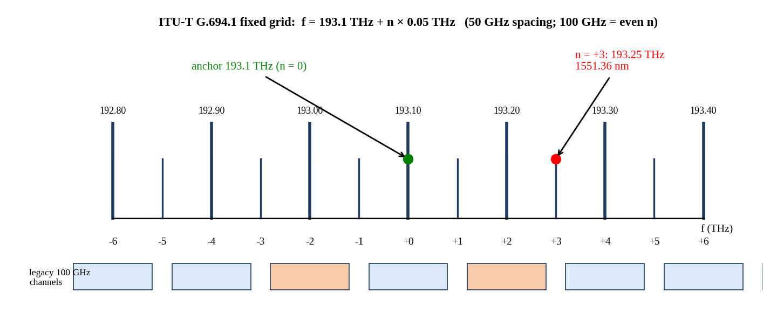
Figure 19: ITU-T G.694.1 grid representation: 193.1 THz anchor, 50 GHz and 100 GHz channels, and channel n = +3.
Explanation of the figure. The axis shows the fixed grid with 50 GHz spacing (thin ticks) and the 100 GHz subset (thick ticks at even n), anchored at 193.1 THz (n = 0). Channel n = +3 sits at 193.25 THz. The boxes below the axis show the eight legacy 10 Gb/s channels on the 100 GHz grid, of which Channel 3 and Channel 5 are shaded.
Relation to the case study. The upgrade must be positioned on the same grid as the legacy system so that it can be lit beside it; the grid arithmetic fixes where each Option P, Q or R channel is, and which wavelengths the booster, multiplexer and OSA must cover.
Practical significance. Because the frequency, and not the wavelength, is the invariant of the standard, equipment from different vendors interoperate by quoting frequency; the wavelength is derived from λ = c/f.

Calculation 5.1 – Frequency and wavelength of channel n = +3 (50 GHz grid)
Formula | f = 193.1 THz + n × 0.05 THz; λ = c/f
Substitution | f = 193.1 + 3 × 0.05 THz; λ = 2.998×10⁸ m/s ÷ (193.25×10¹² Hz)
Calculation | f = 193.1 + 0.15 = 193.25 THz; λ = 2.998×10⁸/1.9325×10¹⁴ = 1.55136×10⁻⁶ m
Units | THz; m → nm
Final answer | f(n = +3) = 193.25 THz; λ(n = +3) = 1551.36 nm

The result lies in the C-band, 0.8 nm below the 1552.56 nm of the 193.1 THz anchor (the wavelength falls as the frequency increases). With the 50 GHz grid, a spacing of 50 GHz corresponds to about 0.40 nm at 1550 nm; with the 12.5 GHz slot of the flexible grid, 0.10 nm.

5.3 Coherent Transceiver Architectures
Options P and Q use dual-polarisation (DP) coherent transmission, in which the transmitter modulates the optical carrier in amplitude and phase on two orthogonal polarisations, and the receiver recovers the full optical field with a local oscillator, 90° hybrids, balanced photodiodes and analogue-to-digital converters. The digital signal processor then compensates for chromatic dispersion, polarisation rotation and PMD, recovers the clock and carrier phase, and decodes the forward-error-correction (FEC) code.
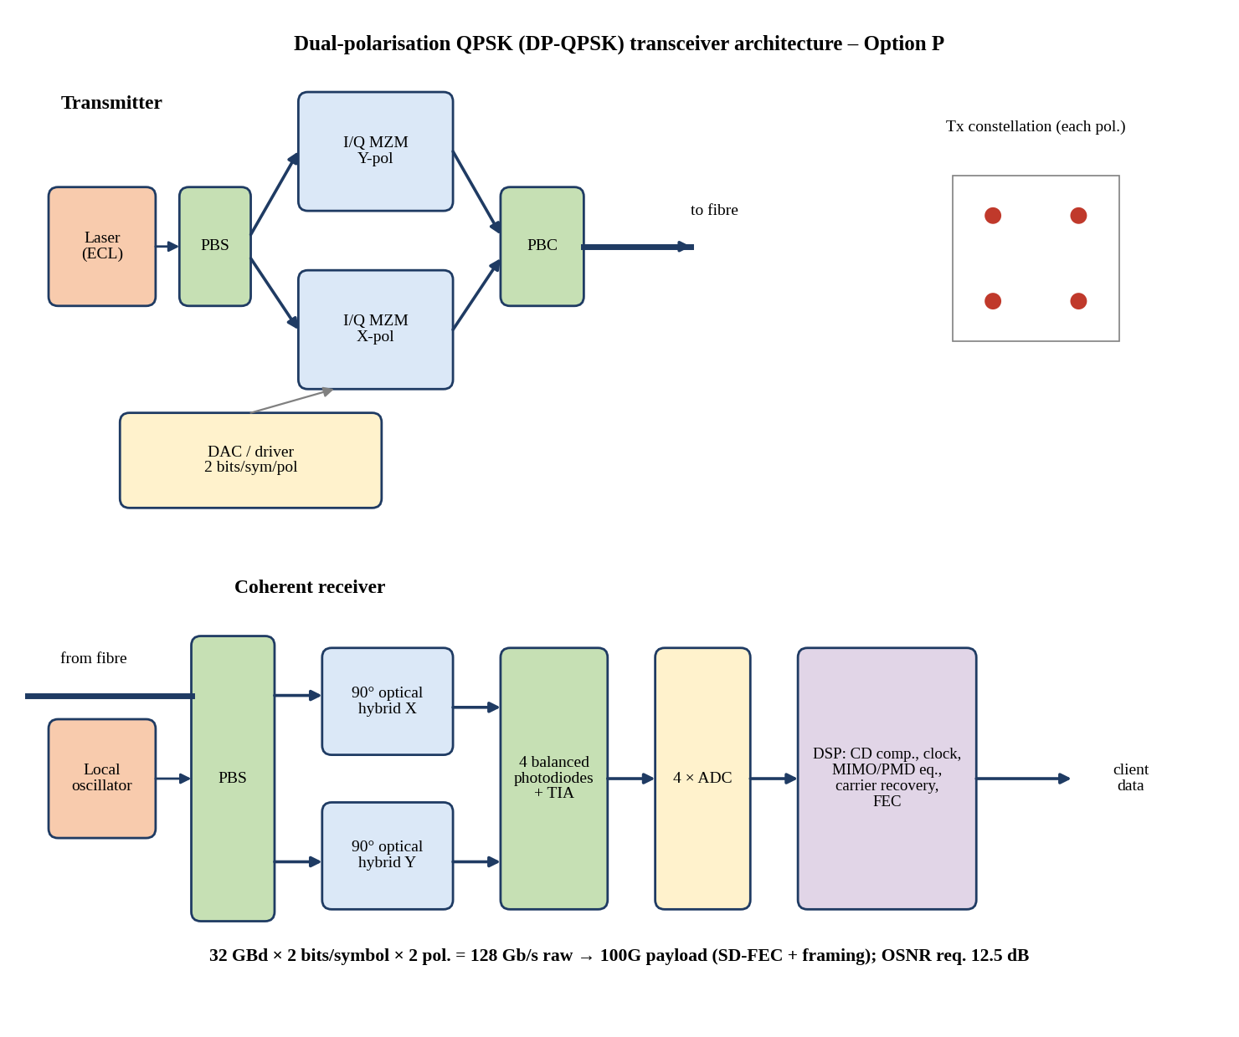
Figure 20: DP-QPSK transceiver architecture (Option P) with QPSK constellation.
Explanation of the figure. The ECL laser is split into two polarisations; each polarisation passes through an I/Q Mach–Zehnder modulator driven by DAC outputs, and the two are recombined by a polarisation beam combiner. The receiver mixes the incoming signal with a local oscillator in two 90° hybrids (one per polarisation), detects the four quadratures with balanced photodiodes and TIAs, digitises them, and processes them in the DSP. The inset shows four constellation points per polarisation (2 bits/symbol).
Relation to the case study. At 32 GBd with 2 bits/symbol/polarisation and 2 polarisations the raw line rate is 128 Gb/s, which carries a 100G payload plus SD-FEC overhead and framing. The required OSNR of 12.5 dB is the lowest of the three options because QPSK needs only about 6 dB SNR per symbol, so it is very robust at 60 km.
Practical significance. DP-QPSK is the workhorse of 100G long-haul links; its strength is margin, its weakness is the 50 GHz slot per 100 Gb/s, which gives a spectral efficiency of only 2 b/s/Hz and requires 16 transceivers per 1.6 Tb/s.
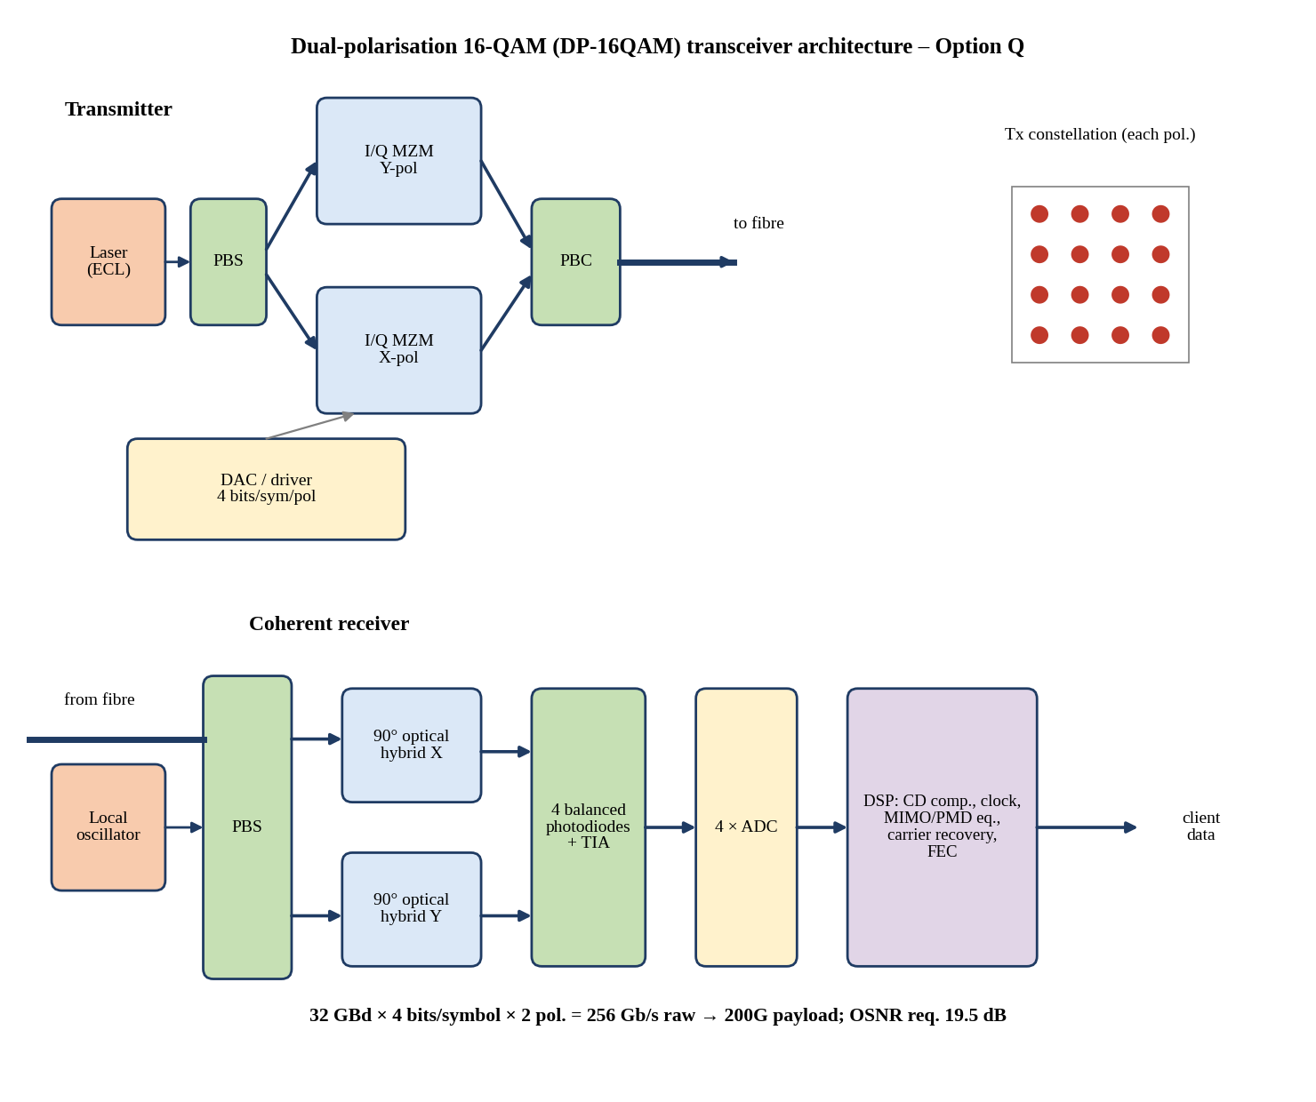
Figure 21: DP-16QAM transceiver architecture (Option Q) with 16-QAM constellation.
Explanation of the figure. The architecture is the same as in Figure 20, but the DACs generate four-level drive signals, so each polarisation carries 4 bits per symbol (16 constellation points). At 32 GBd the raw rate is 256 Gb/s for a 200G payload, and with a Nyquist roll-off of 0.1 the occupied bandwidth is only 35.2 GHz.
Relation to the case study. The required OSNR of 19.5 dB is 7 dB higher than for QPSK because the constellation points are closer together (SNR per symbol of about 13 dB against 6 dB). The repaired link provides 47 dB, so it has 27.5 dB of margin, which is ample.
Practical significance. The advantage is a doubling of bits per symbol: 8 transceivers carry the full 1.6 Tb/s and the spectrum shrinks from 800 GHz to 300 GHz. It requires digital pulse shaping (Nyquist), a flex-grid filter and tighter DAC/ADC linearity.
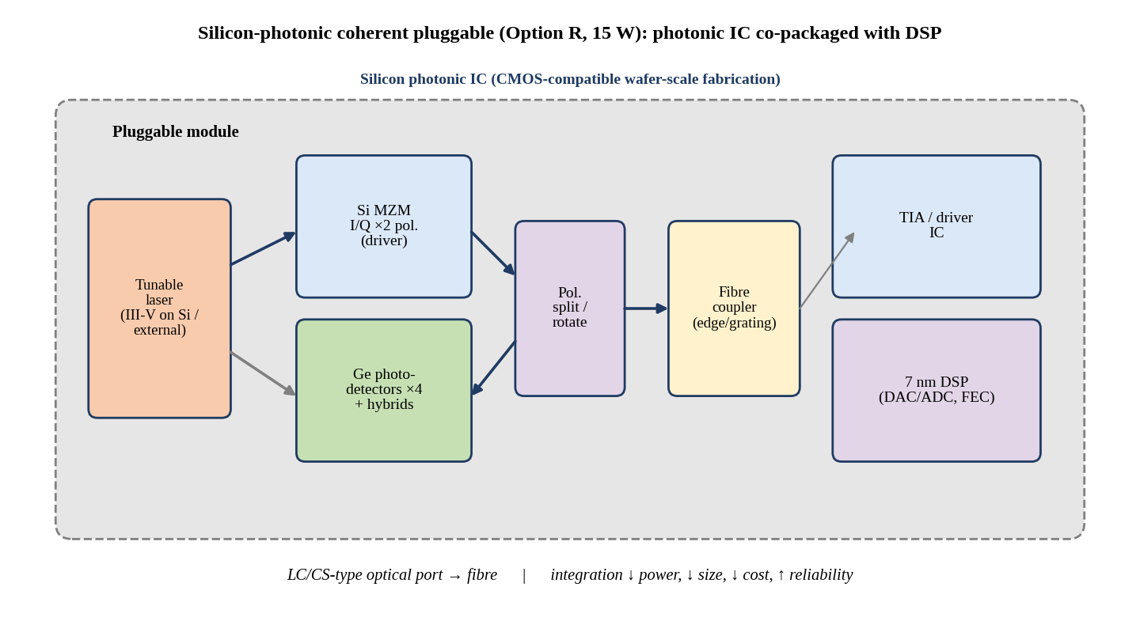
Figure 22: Silicon-photonic coherent transceiver (Option R): photonic IC co-packaged with a DSP.
Explanation of the figure. A tunable laser feeds a silicon photonic integrated circuit that contains the I/Q Mach–Zehnder modulators, the polarisation splitters and rotators, the 90° hybrids and germanium photodetectors. The photonic IC is co-packaged with the TIA/driver chip and a 7 nm DSP inside a pluggable module.
Relation to the case study. The integration replaces discrete lithium-niobate modulators and free-space optics, reducing the module power to 15 W for 400 Gb/s, i.e., 37.5 pJ/bit, compared with 220 pJ/bit for Option P and 100 pJ/bit for Option Q. Four modules cover the full 1.6 Tb/s.
Practical significance. Silicon photonics uses CMOS wafer-scale fabrication, which lowers cost, size and power, and increases reliability and sparing efficiency. Its limitation is the lower modulator bandwidth and the need for a separate laser, which is handled by hybrid integration.

5.4 Occupied Spectrum and Spectral Efficiency
For Option Q the Nyquist-shaped signal occupies B = R_s(1 + β) = 32 GBd × (1 + 0.1) = 35.2 GHz. The flexible grid allocates integer multiples of the 12.5 GHz slot, so the number of slots is m = ⌈35.2/12.5⌉ = ⌈2.816⌉ = 3, i.e., 37.5 GHz per channel, and 8 channels use 24 slots = 300 GHz.

Calculation 5.2 – Slots, occupied spectrum and spectral efficiency of Option Q
Formula | B_occ = R_s(1 + β); m = ⌈B_occ/12.5 GHz⌉; slot width = 12.5 GHz × m; SE = payload rate / slot width
Substitution | R_s = 32 GBd, β = 0.1 → B_occ = 32 × 1.1; m = ⌈35.2/12.5⌉
Calculation | B_occ = 35.2 GHz; m = 3 (2.816 rounded up); slot = 37.5 GHz; total = 8 × 37.5 = 300 GHz; SE = 200 Gb/s ÷ 37.5 GHz = 5.33 b/s/Hz
Units | GHz; b/s/Hz
Final answer | 3 slots (37.5 GHz) per channel; 24 slots = 300 GHz in total; payload SE = 5.33 b/s/Hz (5.68 b/s/Hz on the 35.2 GHz signal bandwidth)

Table 16: Occupied spectrum and payload spectral efficiency
Option | Channels | Slot per channel | Occupied spectrum | Payload per channel | Payload SE (b/s/Hz)
Legacy 10G SFP+ | 8 (160 for 1.6T) | 100 GHz | 800 GHz (16 THz for 1.6T) | 10 Gb/s | 0.10
P: 16 × 100G DP-QPSK | 16 | 50 GHz | 800 GHz | 100 Gb/s | 2.00
Q: 8 × 200G DP-16QAM | 8 | 37.5 GHz (3 slots) | 300 GHz | 200 Gb/s | 5.33
R: 4 × 400G Si-Ph | 4 | 75 GHz (6 slots) | 300 GHz | 400 Gb/s | 5.33

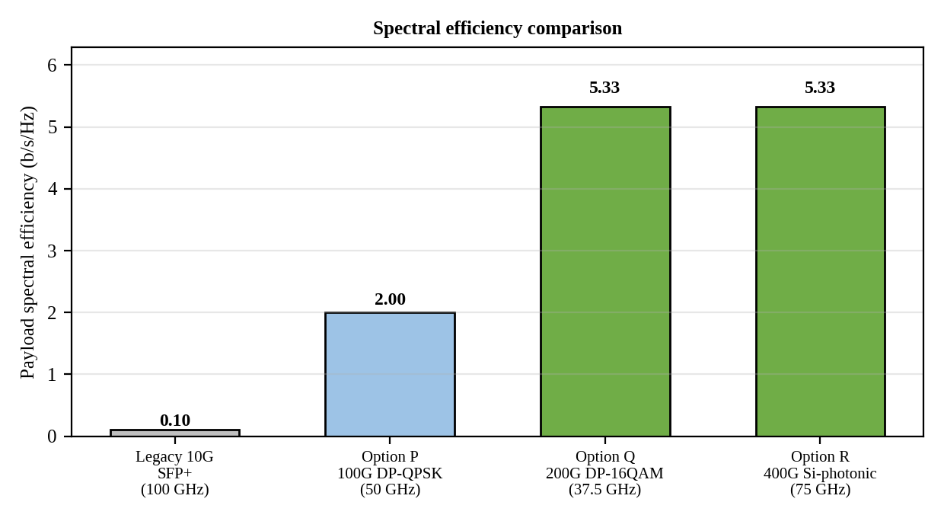
Figure 23: Spectral-efficiency comparison of the legacy system and Options P, Q and R.
Explanation of the figure. Bars show the payload spectral efficiency, defined as payload bit rate divided by occupied spectrum: 0.10 b/s/Hz for the legacy 100 GHz 10G system, 2.00 for Option P, and 5.33 for both Option Q and Option R.
Relation to the case study. The 1.6 Tb/s target needs 16 THz with the legacy 10G technology, which is more than three times the 4.8 THz of the entire C-band, so it is impossible; Options Q and R need only 300 GHz (6 % of the C-band), leaving room for the legacy channels during migration and for growth.
Practical significance. Spectral efficiency determines how many times the fibre pair can be 'reused' for more capacity without re-laying fibre; the 2.67-fold advantage of Q and R over P translates directly into future capacity.

5.5 OSNR Margin for the Repaired Link
The OSNR at the receiver of the repaired link is 47 dB (0.1 nm), as obtained in Chapter 2, since the booster is the only amplifier and the loss after it acts equally on signal and noise. The OSNR margin is the difference between this value and the OSNR required by each option.

Calculation 5.3 – OSNR margin
Formula | OSNR margin = OSNR_link − OSNR_required
Substitution | OSNR_link = 58 + (−6) − 5 = 47 dB. P: 47 − 12.5. Q: 47 − 19.5. R: 47 − 26
Calculation | P: 34.5 dB; Q: 27.5 dB; R: 21.0 dB
Units | dB
Final answer | OSNR margin: Option P = 34.5 dB, Option Q = 27.5 dB, Option R = 21.0 dB (all ≫ 3 dB)

All three options exceed the 3 dB requirement with a large margin, and the margin of even the most demanding option (R) is 21 dB, equal to a factor of 126 in noise power. The OSNR therefore does not discriminate between the options; it only confirms that all of them are feasible on a 60 km booster-only link. The limiting practical factors are the implementation penalties (a few dB), the nonlinear interaction of 12 channels during the migration, and the reception of enough power at the coherent receiver.

5.6 Module Power and Energy per Bit

Calculation 5.4 – Module power and energy per bit
Formula | P_total = N_modules × P_module; E_bit = P_module / R_bit (pJ/bit = W / Gb/s × 1000)
Substitution | P: 22 W ÷ 100 Gb/s; Q: 20 W ÷ 200 Gb/s; R: 15 W ÷ 400 Gb/s; Legacy: 3.5 W ÷ 10 Gb/s
Calculation | P: 22/100×10⁹ = 220 pJ/bit; total 16 × 22 = 352 W. Q: 100 pJ/bit; total 8 × 20 = 160 W. R: 37.5 pJ/bit; total 4 × 15 = 60 W. Legacy: 350 pJ/bit; total for 1.6 Tb/s = 160 × 3.5 = 560 W
Units | W; pJ/bit = 10⁻¹² J/bit
Final answer | E_bit = 220 pJ/bit (P), 100 pJ/bit (Q), 37.5 pJ/bit (R), 350 pJ/bit (legacy); power per terminal 352 W, 160 W, 60 W, 560 W respectively

Table 17: Comparison of the upgrade options (all deliver 1.6 Tb/s)
Parameter | Legacy 10G (scaled) | Option P | Option Q | Option R | Best
Modules per terminal | 160 | 16 | 8 | 4 | R
Occupied spectrum (GHz) | 16 000 | 800 | 300 | 300 | Q = R
Payload SE (b/s/Hz) | 0.10 | 2.00 | 5.33 | 5.33 | Q = R
Required OSNR (dB) | 20 | 12.5 | 19.5 | 26 | P
OSNR margin at 47 dB (dB) | 27 | 34.5 | 27.5 | 21.0 | P
Power per module (W) | 3.5 | 22 | 20 | 15 | R
Power per terminal (W) | 560 | 352 | 160 | 60 | R
Energy per bit (pJ/bit) | 350 | 220 | 100 | 37.5 | R
Energy relative to R | 9.3× | 5.9× | 2.7× | 1.0× | R

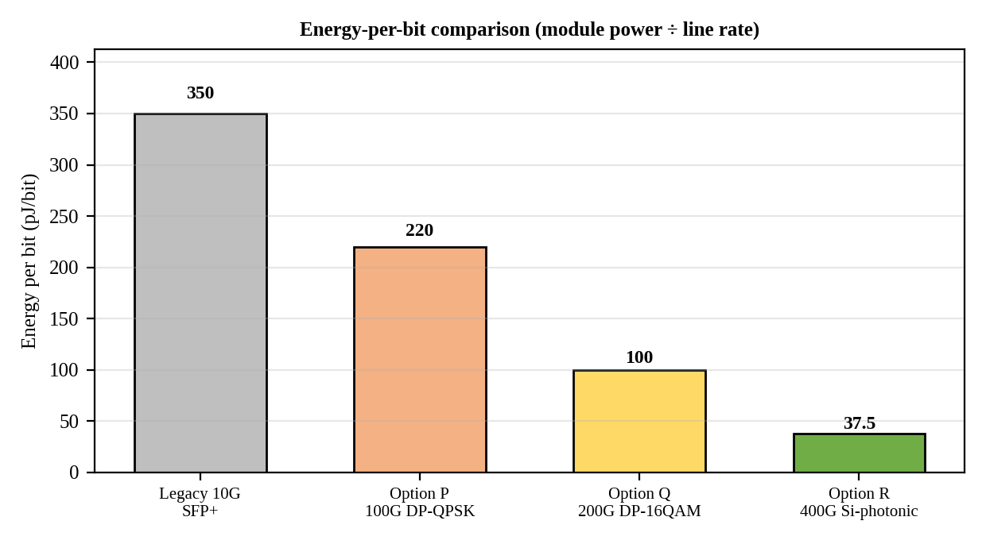
Figure 24: Energy-per-bit comparison of the legacy 10G solution and Options P, Q and R.
Explanation of the figure. The bars give the energy per bit as module power divided by line rate: 350 pJ/bit (legacy SFP+), 220 pJ/bit (P), 100 pJ/bit (Q) and 37.5 pJ/bit (R).
Relation to the case study. Option R consumes 83 % less energy per bit than Option P, 62.5 % less than Option Q and 89 % less than the legacy technology scaled to 1.6 Tb/s. At one terminal the difference between R (60 W) and P (352 W) is 292 W; with both terminals running continuously, Option R uses 120 W × 8760 h = 1051 kWh per year against 6167 kWh for Option P.
Practical significance. Energy per bit is a lasting cost, because it is paid every hour of operation and also doubles through cooling in the data-centre. Photonic integration is the main reason why the per-bit energy falls with higher line rate.

5.7 Flex-Grid versus Fixed-Grid, Silicon Photonics and Energy Efficiency

5.7.1 Advantages of the flexible grid
- Each channel occupies exactly the slots it needs (3 slots for a 35.2 GHz Nyquist signal), so no spectrum is wasted in a rigid 50 GHz or 100 GHz window; Option Q needs 37.5 GHz instead of 50 GHz.
- Mixed baud rates and formats can coexist (75 GHz for 400G, 37.5 GHz for 200G, 100 GHz for legacy), which makes a hitless migration from 10G to coherent possible.
- Channels can be re-sized in service as the format changes; the grid is future-proof for 600G–800G channels.
- Disadvantage: requires flex-grid capable multiplexers (WSS or filters), more complex guard-band planning and spectrum management.

5.7.2 Advantages of the fixed grid
- Simple, universally interoperable: 50 GHz and 100 GHz components are low cost and mature, and passive multiplexers need no control plane.
- Easy planning, fixed wavelength assignments and simple troubleshooting with an OSA.
- Disadvantage: spectral waste (Option P uses 50 GHz for 100 Gb/s, SE of only 2 b/s/Hz) and inability to exploit Nyquist shaping.

5.7.3 Silicon-photonics benefits
Monolithic integration of modulators, detectors and passives on a CMOS-compatible silicon wafer reduces chip count and interconnect losses, the module size (pluggable form factor), and cost. The power is saved in three ways: shorter and lower-capacitance electrical interconnects reduce driver power; the high-gain Ge detectors and integrated hybrids improve receiver efficiency; and the co-packaged 7 nm DSP uses less energy per operation. For this link the integration delivers 400 Gb/s at 15 W, giving the lowest pJ/bit by a factor of 2.7 over Option Q.

5.7.4 Energy efficiency
Energy efficiency is the key differentiator between options that otherwise meet capacity, OSNR and spectrum requirements. Option R is not only cheapest to run, it also has fewer modules (4 against 8 or 16), each of which carries a transceiver pair, a patch cord and an optical port; thus the number of connectors to be cleaned and the number of devices to fail is lower.

5.8 Sequence of Repair, Verification and Upgrade
The order of the work is repair → verify → upgrade, and it is justified as follows.
- Repair first because the faults (events 2, 3, 4 and the Channel 5 transmitter) affect the live 10G service now, and because a coherent channel placed on a link with a −22 dB reflection and a mechanical splice would inherit the same excess loss and echo, which will reduce the OSNR margin and mix with the DSP's equalisation.
- Verify second because the upgrade needs a clean baseline: an OTDR trace with no event above allowance, a loss of ≤ 21.25 dB, and a clean 24 h BER. The post-repair measurements become the reference against which the post-upgrade measurements are compared, so that any new degradation can be attributed correctly.
- Upgrade third, lighting the 400G channels in a free part of the C-band beside the legacy channels (193.65–193.95 THz), moving the traffic, and then retiring the legacy channels. This is hitless and has a back-out path.

5.9 Ranking of the Options
The ranking uses four criteria with weights: spectrum (30 %), energy (30 %), OSNR margin (20 %) and complexity/module count (20 %). A rank score of 3 is best and 1 is worst for each criterion.
Table 18: Weighted ranking of Options P, Q and R
Criterion | Weight | Option P | Option Q | Option R
Spectrum / SE | 30 % | 1 (2.00) | 3 (5.33) | 3 (5.33)
Energy per bit | 30 % | 1 (220 pJ/bit) | 2 (100 pJ/bit) | 3 (37.5 pJ/bit)
OSNR margin | 20 % | 3 (34.5 dB) | 2 (27.5 dB) | 1 (21.0 dB)
Complexity / module count | 20 % | 1 (16) | 2 (8) | 3 (4)
Weighted score | 100 % | 1.4 | 2.3 | 2.6
Rank |  | 3rd | 2nd | 1st

Option R ranks first with a score of 2.6, Option Q second (2.3) and Option P third (1.4). Option R is chosen even though it has the lowest OSNR margin, because 21 dB of margin is 7 times the 3 dB requirement and the margin is not a limiting factor. The ranking is robust: if the weight of the OSNR margin was raised to 50 % (with 20 % each for spectrum and energy and 10 % for complexity), the scores would be P = 2.0, Q = 2.2 and R = 2.0, so Option Q would take first place, which shows that Option Q is the natural fallback if the OSNR margin of a particular implementation turned out to be smaller than expected.

5.10 Measurements to Repeat after the Upgrade
- OSA: per-channel power, centre frequency against the G.694.1 flex-grid plan (±1.5 GHz), and OSNR ≥ 26 dB + 3 dB for each 400G channel (expected 47 dB).
- OTDR: repeat the 100 ns bidirectional trace and the 10 ns far-end trace to confirm that no new event appears (e.g., from the new patch cords) and that events 2 and 3 remain within allowance.
- Power meter: end-to-end loss ≤ 21.25 dB and per-channel received power at each coherent receiver inside the vendor window.
- Coherent receiver telemetry: pre-FEC BER (expected well below the 2×10⁻² SD-FEC threshold), post-FEC error-free operation, OSNR estimate, DGD and accumulated chromatic dispersion (expected 0.775 ps and 1020 ps/nm), polarisation-dependent loss.
- BER/throughput soak: 24 h Ethernet/OTN test at full 1.6 Tb/s, with no uncorrected errors.
CHAPTER 6
FINAL SYSTEM VERIFICATION
6.1 Verification Table
The table below consolidates the results of Chapters 2 to 5 against the original requirement. 'As-built' values are the commissioning measurements and calculations; 'after repair' values are the calculated values for the corrective package of Design Decisions 1–4 (repair of events 2, 3 and 4, +2 dB launch power, restoration of the Channel 5 extinction ratio, and Option R upgrade). Values marked 'predicted' must be confirmed by the post-repair measurements listed in Section 6.3.
Table 19: Final verification of the repaired and upgraded 60 km link
Requirement | Specified / target | Calculated value (as-built → after repair) | Status | Remarks
Total optical link loss | ≤ 21.25 dB (design) | 22.52 dB → 21.25 dB | PASS (after repair); as-built FAIL | Excess 1.27 dB = event 3 (0.70 dB) + event 2 (0.57 dB); fibre 12.60 dB and demux 6.00 dB unchanged
Received optical power | ≥ −24 dBm + 3 dB, i.e. effective ≥ −21 dBm | P_rx −21.52 → −18.25 dBm; effective Ch3 −23.62 → −20.35 dBm; Ch5 −25.75 → −20.35 dBm | PASS (after repair); as-built FAIL | Launch +1 → +3 dBm per channel (total +12 dBm); Ch5 effective power assumes ER restored to 9 dB
Dispersion penalty | ≤ 1–2 dB | 1.00 dB (B·D·L·σλ = 0.306) | PASS | At the limit of acceptability for σλ = 0.03 nm; narrower source gives 0.50 dB at 0.02 nm
PMD | ≤ 10 ps (10 % of 100 ps) | 0.775 ps | PASS | 0.78 % of the bit period; 2.5 % of the 31.25 ps symbol period at 32 GBd
OSNR (0.1 nm) | ≥ 20 dB (legacy); ≥ 26 dB + 3 dB (Option R) | 47 dB | PASS | Margin 27 dB (legacy); 21 dB (Option R); noise is not limiting
System margin | ≥ 3 dB | Ch3 0.38 dB → 3.65 dB; Ch5 −1.75 dB → 3.65 dB | PASS (after repair); as-built FAIL | Only the combination of repair + launch + ER restoration reaches 3 dB (S5); S1–S3 fail, S4 gives 3.08 dB
OTDR results | No event above allowance (fusion ≤ 0.05–0.1 dB; connector ≤ 0.5 dB, ≤ −45 dB) | E1 0.05 dB OK; E2 0.62 dB, −34 dB; E3 1.20 dB, −22 dB; E4 −40 dB → expected E2 ≤ 0.05 dB non-reflective; E3/E4 ≤ 0.5 dB, ≤ −50 dB | PASS (predicted) | To be confirmed by post-repair 100 ns bidirectional + 10 ns far-end traces
Eye opening | Eye width ≥ 0.5 UI (TJ ≤ 0.5 UI) | Ch3 0.651 UI; Ch5 0.390 UI → 0.651 UI | PASS (Ch5 predicted) | Ch5 TJ 0.610 → 0.349 UI after transmitter restoration
Q-factor and ER | Q ≥ 7.03; ER ≥ 8.2 dB | Ch3 Q 7.6, ER 9.0 dB; Ch5 Q 4.7, ER 4.5 dB → ER 9.0 dB, Q ≥ 7.6 | PASS (Ch5 predicted) | ER predicts Q₅ = 4.66 vs measured 4.7; Q rises further with +3.27 dB of power
BER | ≤ 10⁻¹² | Ch3 1.5×10⁻¹⁴; Ch5 1.3×10⁻⁶ → ≤ 1.5×10⁻¹⁴ | PASS (Ch5 predicted) | Confirm by 24 h PRBS-31 test on all channels
Quantum-limit gap | Informational (receiver quality) | Direct: 26.9 photons/bit, −44.6 dBm, gap 20.6 dB; homodyne PSK −48.0 dBm (24.0 dB); heterodyne −45.0 dBm (21.0 dB) | INFO | Coherent receiver at 2300 photons/symbol leaves ≥ 20 dB shot-noise headroom
Spectral efficiency | 1.6 Tb/s in the minimum spectrum | Option R: 300 GHz, 5.33 b/s/Hz (P: 2.00; Q: 5.33; legacy 0.10) | PASS | 6 % of C-band; room for growth
Energy per bit | Minimum pJ/bit | Option R 37.5 pJ/bit (Q 100; P 220; legacy 350) | PASS | 60 W per terminal; 89 % below scaled legacy
Upgrade decision | 1.6 Tb/s reliably without re-laying fibre | Option R selected, Option Q fallback; repair → verify → upgrade | PASS | All budget, OSNR, spectrum and energy criteria met

6.2 Explanation of Deviations and Consistency with the Requirement
- Loss deviation (+1.27 dB). The as-built loss exceeds the design by 5.98 %, which is entirely explained by the mechanical splice (event 2, +0.57 dB) and the defective LC/UPC connector (event 3, +0.70 dB). The sum matches the OTDR events exactly, so there is no unexplained loss; the fibre attenuation follows 0.21 dB/km.
- Margin deviation. The measured margin of Channel 3 (0.38 dB) is consistent with its Q margin of 0.34 dB, and the as-built margin shortfall of 2.62 dB equals the sum of the 1.27 dB excess loss and the 1.35 dB that the penalties consume beyond the design allowance. The 2 dB launch increase is chosen to cover that remaining 1.35 dB.
- Channel 5 deviation. The ER deficit explains the Q gap within 1 % (predicted 4.66 versus measured 4.7); the remaining jitter excess belongs to the same transmitter. The fibre-related quantities are identical on both channels.
- Dispersion. At 1.00 dB the penalty sits at the usual limit; it is consistent with the formula and is not changed by the repair. It disappears with coherent detection, since the DSP compensates 1020 ps/nm.
- Quantum-limit gap (20.6 dB). This is not a deviation from a requirement. It reflects thermal-noise-limited PIN reception; it is the reason why the legacy link is so sensitive to loss, and why the coherent upgrade, which has shot-noise headroom of at least 20 dB, removes this sensitivity.
- Predicted values. The after-repair values for OTDR events, Channel 5's eye and BER are engineering predictions based on the allowance values and on the ER scaling; they are not measurements and must be confirmed before acceptance.
Taken together, the calculated values and the measurement interpretations are consistent with the original communication requirement: every as-built deviation can be traced to a specific physical cause, the corrective actions are sufficient in total (3.65 dB margin against 3.00 dB) but not individually (S1–S3), and the upgrade meets the 1.6 Tb/s, spectrum and energy objectives.

6.3 Post-Repair Acceptance Measurements
Table 20: Acceptance tests and pass criteria
Test | Set-up | Pass criterion
End-to-end loss | Stabilised source and power meter, reference method, 1550 nm | ≤ 21.25 dB
OTDR (A→B and B→A) | 100 ns, 1550 nm, 500 m launch/tail cords, 2 min averaging | Event 2 ≤ 0.1 dB, no reflection; E3, E4 ≤ 0.5 dB and ≤ −45 dB; no new events
OTDR far-end short trace | 10 ns from Data Centre B | Loss of E4 measured ≤ 0.5 dB
OSA | 1 % tap after the booster | +3 dBm ± 0.5 dB per channel; OSNR ≥ 40 dB
BERT and eye | PRBS-31, 24 h, all eight channels | BER ≤ 10⁻¹², Q ≥ 7.03, ER ≥ 8.2 dB, eye width ≥ 0.5 UI
PMD and CD | PMD analyser and CD analyser | DGD ≤ 1 ps; CD 1020 ± 30 ps/nm

CHAPTER 7
FINAL SYSTEM DESIGN

7.1 Integrated Diagnostic, Repair and Upgrade Workflow
The final design integrates the six workflows into a single closed-loop process. Figure 25 shows the overall flowchart, and the tables that follow define each workflow in detail, with the instrument, the setting and the acceptance criterion at each step.
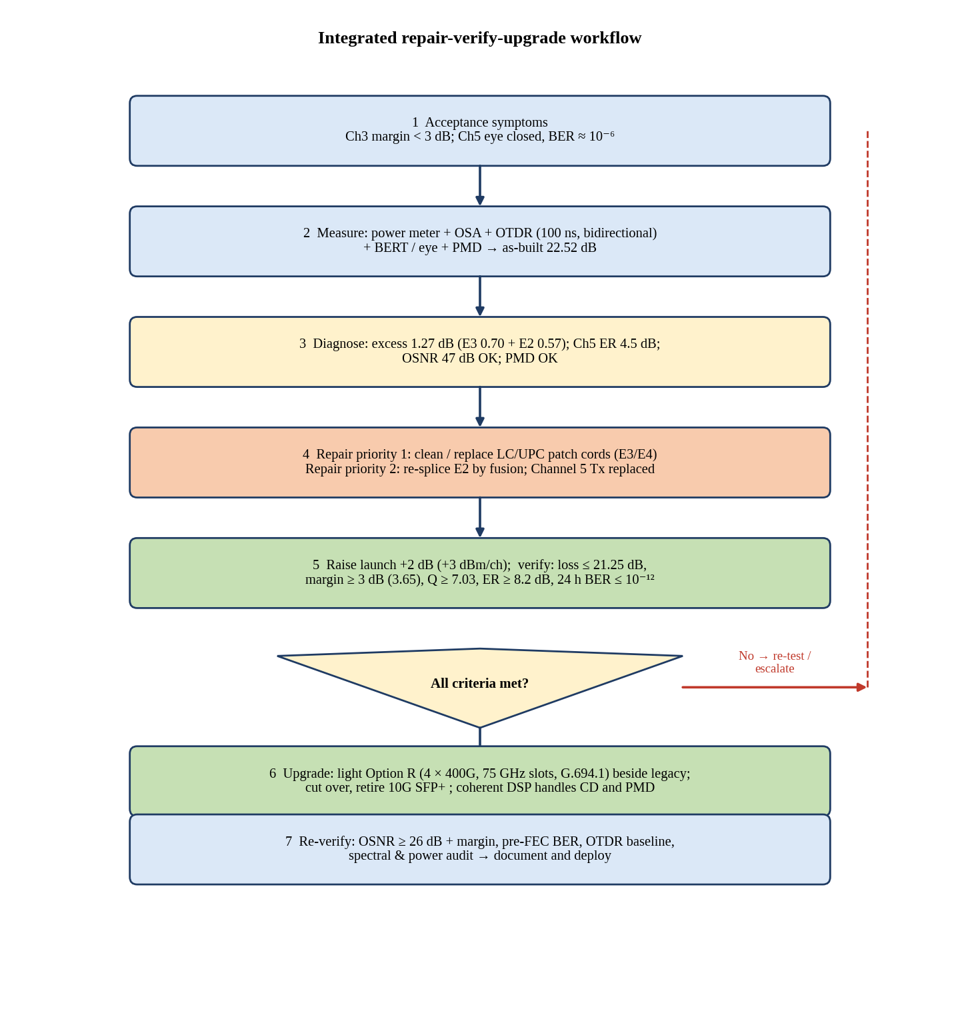
Figure 25: Integrated repair–verify–upgrade workflow flowchart.
Explanation of the figure. The flowchart starts from the acceptance symptoms and runs through measurement, diagnosis, repair, verification and upgrade, with a decision diamond that returns to re-test if any criterion fails. Steps 4 and 5 contain the corrective package, and step 6 the migration to the coherent channels.
Relation to the case study. Each box corresponds to a result of this report: step 3 uses the 1.27 dB excess loss (event 3 = 0.70 dB, event 2 = 0.57 dB), the 47 dB OSNR and the ER of 4.5 dB; step 5 uses the 3.65 dB margin; step 6 uses Design Decision 4.
Practical significance. The decision diamond is the hold point of the plan: no coherent channel is lit until loss ≤ 21.25 dB, margin ≥ 3 dB, Q ≥ 7.03 and the OTDR trace are all within limits, so that the upgrade cannot inherit unresolved faults.

7.1.1 Diagnostic and measurement workflow
Table 21: Diagnostic and measurement workflow
Step | Action | Instrument and setting | Output
D1 | Record symptoms: margin < 3 dB, Ch5 eye closed, BER high | BERT, eye analyser, power meter | Q: 7.6 and 4.7; ER 9.0 and 4.5 dB
D2 | Measure end-to-end loss and received power | Source + power meter, reference method, 1550 nm | 22.52 dB; −21.52 dBm
D3 | Measure launch power, OSNR and flatness | OSA, 0.1 nm RBW, 1 % tap | +1 dBm per channel; OSNR 47 dB
D4 | Measure PMD and dispersion | PMD/CD analyser | 0.775 ps; 1020 ps/nm
D5 | Identify shared and channel-specific causes | Compare Ch3 and Ch5 | Shared: excess loss; Ch5: ER

7.1.2 Fault-localization workflow
Table 22: Fault-localization workflow
Step | Action | Instrument and setting | Output
F1 | Attach launch and tail cords; clean and inspect | Video microscope, one-click cleaner | Known start and end connectors
F2 | End-to-end trace A→B | OTDR, 100 ns, 1550 nm (DR 27 dB ≥ 22.52 dB) | Events 1–4, distances
F3 | Reverse trace B→A and average the losses | OTDR, 100 ns | True splice losses
F4 | Far-end short trace for the 9 m patch cord | OTDR, 10 ns (ADZ 4 m) from Data Centre B | Loss of event 4
F5 | Convert distance to location with uncertainty | Δn = ±0.002 → ±43 m (E2), ±82 m (E3/E4) | Search window for crew

7.1.3 Repair workflow
Table 23: Repair workflow
Step | Action | Tool and criterion | Gain
R1 | Clean/inspect/replace the 9 m LC/UPC patch cord (events 3 and 4) | Interferometer: IL ≤ 0.3 dB, RL ≥ 50 dB | +0.70 dB
R2 | Re-make event 2 as a fusion splice at the closure | Core-aligned splicer, loss ≤ 0.05 dB, proof test | +0.57 dB
R3 | Re-bias or replace the Channel 5 transmitter | ER ≥ 9 dB, DJ ≤ 0.18 UI, RJ ≤ 0.012 UI | ER penalty 3.22 → 1.10 dB
R4 | Raise booster output by +2 dB | +3 dBm per channel, total +12 dBm; check OSA | +2.00 dB

7.1.4 Verification workflow
Table 24: Verification workflow
Step | Action | Instrument and setting | Pass criterion
V1 | Repeat OTDR (A→B, B→A, 10 ns far-end) | As F2–F4 | No event above allowance
V2 | Repeat end-to-end loss | Power meter | ≤ 21.25 dB
V3 | Measure effective power and margin | P_rx − 1.00 dB − 1.10 dB | ≥ −21 dBm; margin ≥ 3 dB (3.65 dB)
V4 | 24 h BER and eye on eight channels | BERT, PRBS-31 | BER ≤ 10⁻¹², Q ≥ 7.03, eye ≥ 0.5 UI
V5 | Archive baseline traces and spectra | OTDR/OSA files | Reference for the upgrade

7.1.5 Upgrade workflow
Table 25: Upgrade workflow
Step | Action | Instrument and setting | Pass criterion
U1 | Install flex-grid MUX/colourless splitter and four LC/UPC 400G ports at 193.65–193.95 THz | Grid plan from G.694.1 | Passbands 75 GHz each
U2 | Light one 400G channel, measure OSNR and pre-FEC BER | OSA, module telemetry | OSNR ≥ 29 dB, pre-FEC < 2×10⁻²
U3 | Light the other three; check flatness and nonlinear effects | OSA, 12-channel total power | Flatness ≤ 1 dB; margin retained
U4 | Migrate traffic from the 10G channels and retire the legacy transceivers | Cut-over window | Zero errors during cut-over
U5 | Final soak test and baseline | 24 h, 1.6 Tb/s | Error-free after FEC

7.2 Final Architecture
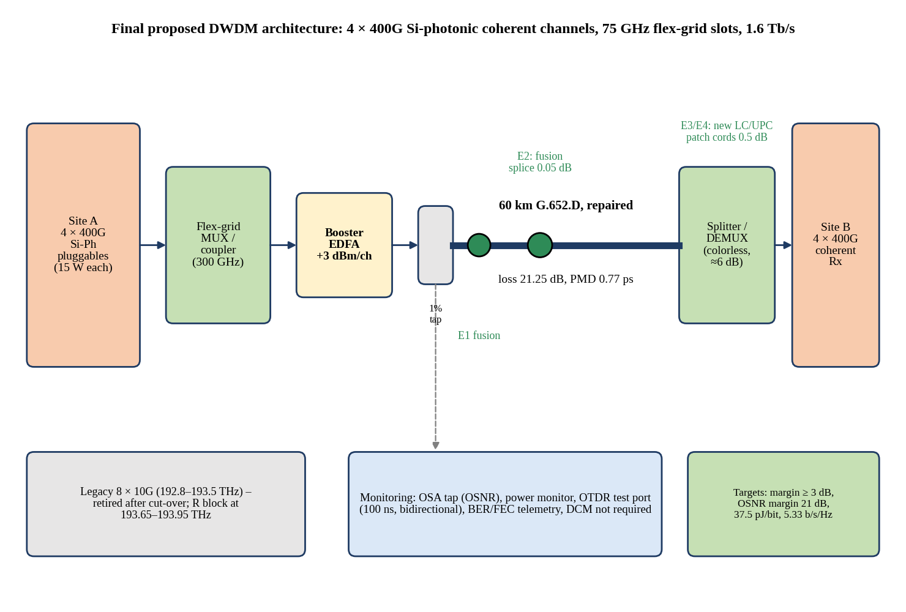
Figure 26: Final proposed DWDM architecture: 4 × 400G silicon-photonic coherent channels on 75 GHz slots over the repaired 60 km link.
Explanation of the figure. Four 400G silicon-photonic coherent pluggables at Site A feed a flex-grid multiplexer, the booster EDFA (+3 dBm per channel), and the repaired 60 km G.652.D fibre, in which event 2 is a fusion splice and the patch-panel connectors at events 3/4 are new LC/UPC cords. At Site B, a colourless splitter/demultiplexer of about 6 dB loss feeds four coherent receivers. The monitoring block provides the OSA tap, power monitor, OTDR test port and BER/FEC telemetry, and the legacy channels are retired after cut-over.
Relation to the case study. The diagram combines every correction of the report: the 21.25 dB repaired loss, the 3.65 dB margin, the 47 dB OSNR, the 0.775 ps PMD, the G.694.1 plan with 300 GHz of spectrum at 5.33 b/s/Hz and the 37.5 pJ/bit energy.
Practical significance. The design needs no new fibre, no in-line amplifier and no dispersion-compensating module, which keeps the number of passive and active elements, the failure points and the maintenance effort minimal.

7.3 Final Parameter Table
Table 26: Final parameter and decision table
Parameter | Adopted value | Decision / basis
Fibre and length | 60 km ITU-T G.652.D, 0.21 dB/km | No re-laying; fibre loss 12.60 dB
Total link loss | 21.25 dB (after repair) | Events 2 and 3 repaired
Launch power | +3 dBm per channel (total +12 dBm for 8) | DD1: +2 dB; φ_NL = 0.41 rad
Received power | −18.25 dBm; effective −20.35 dBm | Dispersion 1.00 dB + ER 1.10 dB
System margin | 3.65 dB | ≥ 3 dB (S5)
OSNR | 47 dB (0.1 nm) | 27 dB above legacy requirement
PMD | 0.775 ps | ≪ 10 ps
OTDR test | 100 ns bidirectional + 10 ns far-end, launch/tail cords | DD2
Repair priority | 1: events 3/4; 2: event 2; Ch5 Tx in parallel | DD2, DD3
Connector type | LC/UPC, IL ≤ 0.3 dB, RL ≥ 50 dB | Matches equipment ports
Channel 5 target | ER ≥ 9 dB, Q ≥ 7.6, eye ≥ 0.65 UI | DD3
Upgrade option | R: 4 × 400G Si-photonic, 75 GHz slots | DD4; fallback Q
Spectrum / SE | 300 GHz / 5.33 b/s/Hz | 6 % of C-band
Energy | 37.5 pJ/bit, 60 W per terminal | 89 % below scaled legacy

7.4 Final Channel Plan
The legacy 8 × 10G channels are assumed, for illustration, on 100 GHz spacing from 192.8 to 193.5 THz (Channel 3 at 193.0 THz and Channel 5 at 193.2 THz). The four 400G channels are placed above them in a contiguous 300 GHz block from 193.650 to 193.950 THz, separated from the last legacy channel by a 100 GHz guard band. The centre frequencies are of the form 193.1 THz + n × 0.00625 THz, with slot width m = 6 (75 GHz). After cut-over the legacy channels are removed and the block can be moved to the centre of the band if desired.
Table 27: Final G.694.1 channel plan
Channel | Service | Centre frequency (THz) | Wavelength (nm) | Slot (GHz) | Grid index n
Legacy Ch1–Ch8 | 8 × 10G NRZ | 192.8 to 193.5 (step 0.1) | 1554.98 to 1549.35 | 100 | Fixed grid
R1 | 400G coherent | 193.6875 | 1547.85 | 75 (6 × 12.5) | +94 (flex)
R2 | 400G | 193.7625 | 1547.26 | 75 | +106
R3 | 400G | 193.8375 | 1546.66 | 75 | +118
R4 | 400G | 193.9125 | 1546.06 | 75 | +130

7.5 Final Energy Assessment
Table 28: Energy assessment of the final design (1.6 Tb/s, both terminals continuously on)
Solution | Energy (pJ/bit) | Power per terminal (W) | Link power, both ends (W) | Annual energy (kWh)
Legacy 10G scaled to 1.6 Tb/s | 350 | 560 | 1120 | 9811
Option P | 220 | 352 | 704 | 6167
Option Q | 100 | 160 | 320 | 2803
Option R (selected) | 37.5 | 60 | 120 | 1051
Existing 8 × 10G (80 Gb/s only) | 350 | 28 | 56 | 491

The selected design provides 20 times the capacity of the existing 80 Gb/s system for 2.1 times its power (120 W against 56 W for the link), and uses 8760 kWh less per year than the legacy technology scaled to the same capacity. The power is that of the modules only; the cooling overhead would multiply it by the facility's PUE.

7.6 Final Reliability Assessment
Table 29: Reliability assessment of the final design
Factor | Assessment | Mitigation
Passive link | All events at or below allowance; fusion splices only; no reflective event worse than −45 dB | Baseline OTDR archive; annual OTDR and connector inspection
Power margin | 3.65 dB against 3.00 dB required; 0.65 dB spare | Monitor received power; alarm at −1 dB drift
OSNR and noise | 47 dB against 26 dB (R) = 21 dB margin | OSA check at every maintenance
Nonlinear effects | φ_NL = 0.41 rad for 8 channels; 12 channels during migration ≈ 0.6 rad | Reduce per-channel launch to module optimum after the cut-over
Number of active modules | R: 4 per terminal (vs 8 legacy, 16 P, 8 Q) | Fewer failure points; one cold spare per terminal
Impact of one module failure | R: 25 % of capacity (400G); Q: 12.5 %; P: 6.25 % | 1:N spare and fast replacement of pluggables; service-level agreements
Fibre route | Single fibre pair, no protection path | Residual risk; a second route is recommended if the SLA demands 99.99 %
Safety | +12 dBm total launch | Eye-safety procedures (IEC 60825-2), capped connectors, never inspect live fibres

7.7 Final Deployment Strategy
Table 30: Phased deployment plan
Phase | Activity | Hold-point criterion | Service impact
0 | Baseline measurements and spares preparation | Complete D1–D5, F1–F5 | None
1 | Clean/replace patch cord at events 3/4; replace Ch5 transmitter | IL ≤ 0.3 dB, RL ≥ 50 dB; ER ≥ 9 dB | Short outage per channel
2 | Re-splice event 2 by fusion; raise launch to +3 dBm | Event 2 ≤ 0.05 dB; margin ≥ 3 dB | One maintenance window
3 | 24 h verification and baseline archive | BER ≤ 10⁻¹², Q ≥ 7.03; loss ≤ 21.25 dB | None
4 | Install flex-grid MUX/splitter, light R1–R4 beside the legacy | OSNR ≥ 29 dB; pre-FEC BER < 2×10⁻² | None (parallel)
5 | Cut-over, retire legacy transceivers, final soak test | 24 h error-free at 1.6 Tb/s | Cut-over window

FINAL ENGINEERING DECISION
- Link budget and margin. As-built loss of 22.52 dB (+1.27 dB) gave margins of 0.38 dB (Ch3) and −1.75 dB (Ch5). Repair of events 2 and 3 restores 21.25 dB; the +2 dB launch lifts the effective power to −20.35 dBm and the margin to 3.65 dB, above the 3 dB requirement. No single action suffices (S1–S3 fail), and the combination does.
- Dominant excess loss. Event 3 (0.70 dB above allowance, 55 %) and event 2 (0.57 dB, 45 %) account for the whole excess; both are located (±82 m, ±43 m) and repairable.
- OSNR. 47 dB against 20 dB (legacy) and 26 dB (Option R): margin 27 dB and 21 dB. Noise is not a limit.
- BER and eye. Ch3: Q = 7.6, BER 1.5×10⁻¹⁴, eye 0.651 UI. Ch5: Q = 4.7, BER 1.3×10⁻⁶, eye 0.390 UI, with the extinction ratio of 4.5 dB explaining the Q difference within 1 % (predicted 4.66). Restoring ER ≥ 9 dB returns Channel 5 to the Channel 3 condition.
- OTDR diagnosis. The 100 ns pulse is the only one that provides the 22.52 dB dynamic range and separates the 9 m event pair (EDZ 5 m); the 10 ns far-end trace measures event 4's loss (ADZ 4 m). Events 3/4 take priority 1 and event 2 priority 2.
- PMD and dispersion. PMD is 0.775 ps (0.78 % of the bit period) and the dispersion penalty is 1.00 dB; coherent DSP removes both for the upgrade.
- Quantum limit. The direct-detection receiver is 20.6 dB from the 26.9 photons/bit limit (−44.6 dBm), whereas the coherent receiver has 2300 photons per symbol and ≥ 20 dB of shot-noise headroom.
- Spectral and energy efficiency. Option R carries 1.6 Tb/s in 300 GHz (5.33 b/s/Hz, 2.67 times Option P) at 37.5 pJ/bit (83 % less than P, 62.5 % less than Q, 89 % less than legacy).
- Upgrade feasibility. The G.694.1 plan (193.650–193.950 THz in four 75 GHz slots) coexists with the legacy channels and allows hitless cut-over. No fibre is re-laid.
- Reliability. Four modules per terminal, fusion splices only, 0.65 dB spare margin and 21 dB OSNR margin. The residual risks are the single fibre pair without protection, the 25 % capacity loss per module failure, and the dependence on predicted post-repair values; they are managed by a spare module, fibre-route protection if required by the SLA, and the hold-point tests.
Conclusion. The design should be deployed after the repair is verified. If any hold-point fails (for example if event 3 remains above 0.5 dB or the post-repair margin is below 3 dB), the fallback is Option Q on the same plan, or a replacement of the demultiplexer by a lower-loss unit, which would recover margin directly dB for dB.

REFERENCES
- ITU-T Recommendation G.652, Characteristics of a single-mode optical fibre and cable, 2016.
- ITU-T Recommendation G.694.1, Spectral grids for WDM applications: DWDM frequency grid, 2020.
- G. P. Agrawal, Fiber-Optic Communication Systems, 4th ed., Wiley, 2010.
- G. Keiser, Optical Fiber Communications, 5th ed., McGraw-Hill, 2015.
- IEC 61300-3-35, Fibre optic interconnecting devices and passive components – Examinations and measurements – Fibre optic connector endface visual and automated inspection.
- IEC 61746-1, Calibration of optical time-domain reflectometers (OTDR).
- Case study brief, ECA18 CO5 Case Study Based Assignment: DWDM Metro Link Commissioning.

