9. Simulation and Performance Evaluation of OFDMA Resource-Block Allocation for Multi-User Communication.

OBJECTIVES
- To represent a set of orthogonal OFDMA resource blocks and multiple users in MATLAB.
- To allocate resource blocks using traffic-demand and channel-quality-based allocation rules.
- To compare user throughput, resource utilization and fairness under different allocation
- strategies.
- To explain how orthogonal resource allocation limits inter-user interference in multi-user
- communication.

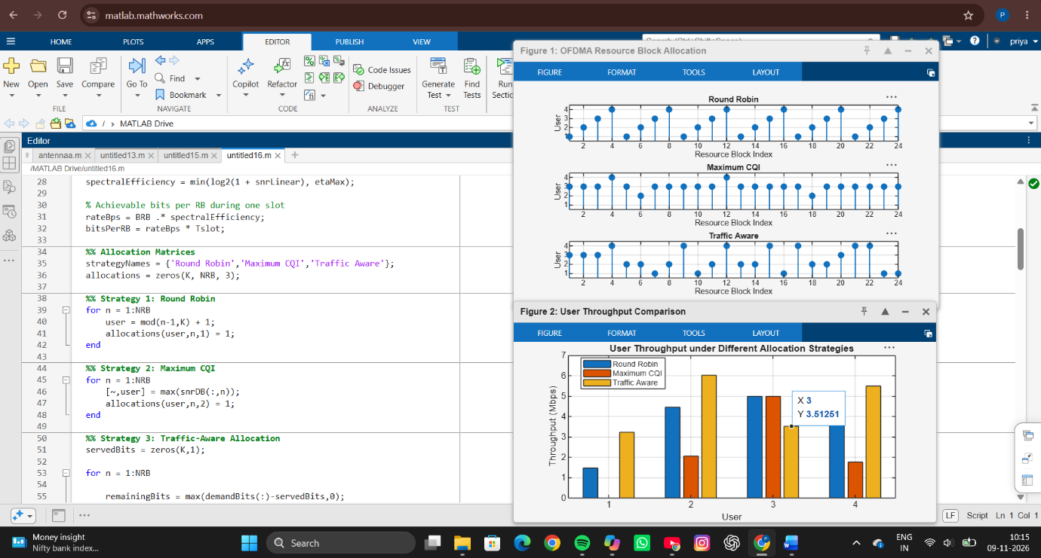
SIMULATION OUTPUT

RESULT
The OFDMA resource block allocation strategies were successfully implemented and analyzed using MATLAB. Three scheduling techniques, namely Round Robin, Maximum CQI, and Traffic-Aware allocation, were compared based on throughput, fairness, and resource utilization. The Maximum CQI method achieved the highest overall throughput by allocating resource blocks to users with the best channel conditions. The Round Robin method distributed resources equally among users and provided balanced access to the network. The Traffic-Aware scheme considered both channel quality and traffic demand, resulting in a better trade-off between throughput and fairness. Resource block allocation maps and throughput comparison graphs clearly illustrated the performance differences among the scheduling techniques.
REFLECTION
This experiment provided a practical understanding of OFDMA resource allocation in modern wireless communication systems. It demonstrated how different scheduling algorithms influence network performance, user throughput, and fairness. The Maximum CQI method maximizes spectral efficiency but may reduce fairness among users, whereas Round Robin ensures equal resource distribution at the cost of lower throughput. The Traffic-Aware approach effectively balances user demand and channel quality, making it suitable for realistic network scenarios. Overall, the experiment enhanced knowledge of LTE/5G resource management and highlighted the importance of scheduler design in improving network efficiency and user experience.

