Experiment Number: 1
Simulation and Comparative Analysis of FDMA, TDMA and CDMA:
Resource Allocation, User Capacity and Mobile-Generation Context

OBJECTIVES:
Objective 1: To estimate and compare the illustrative number of users supported by FDMA,TDMA and CDMA using the specified system parameters.
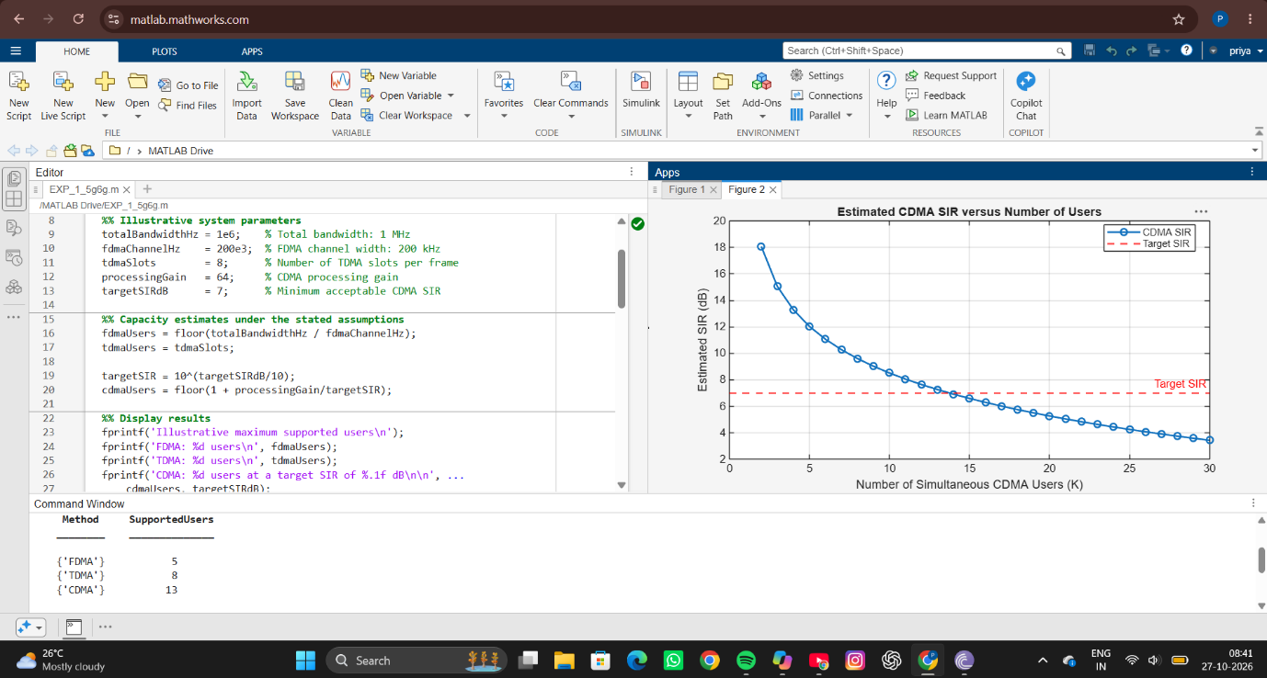
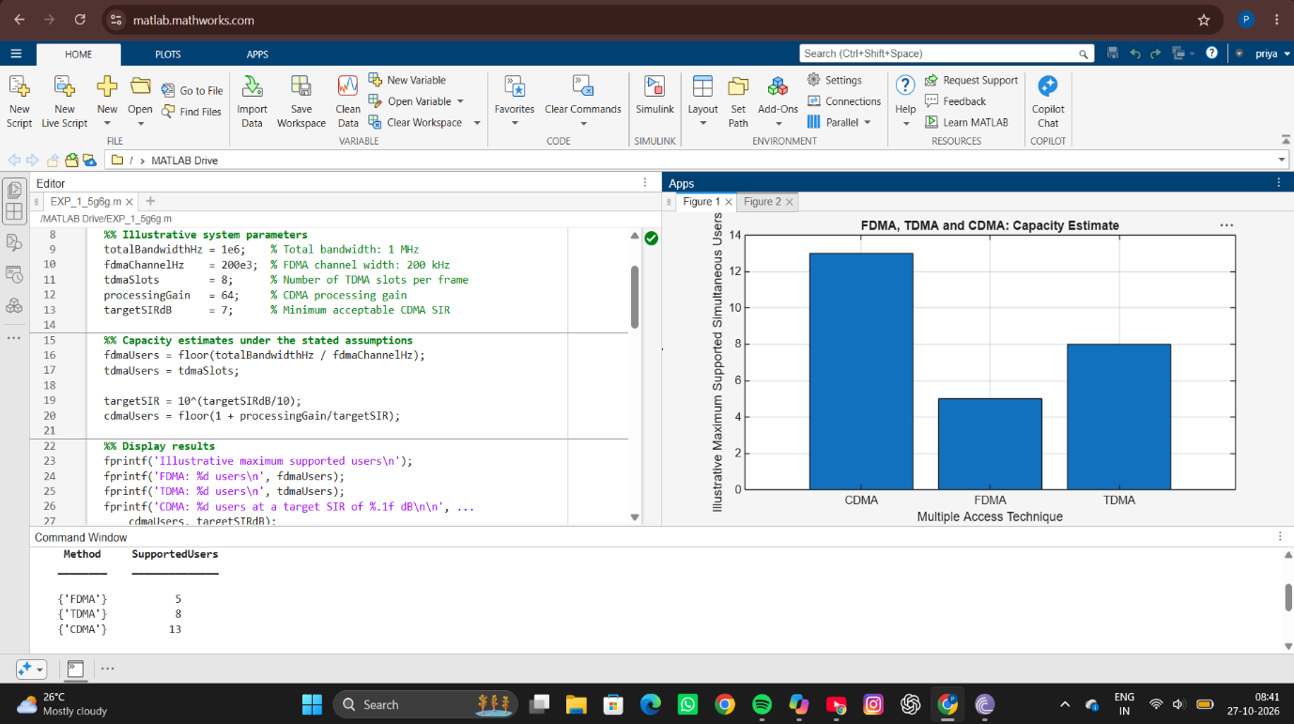
Simulation Otput:

Objective 2: CDMA SIR analysis:
To analyze how the estimated CDMA signal-to-interference ratio changes as the number ofsimultaneous users increases.
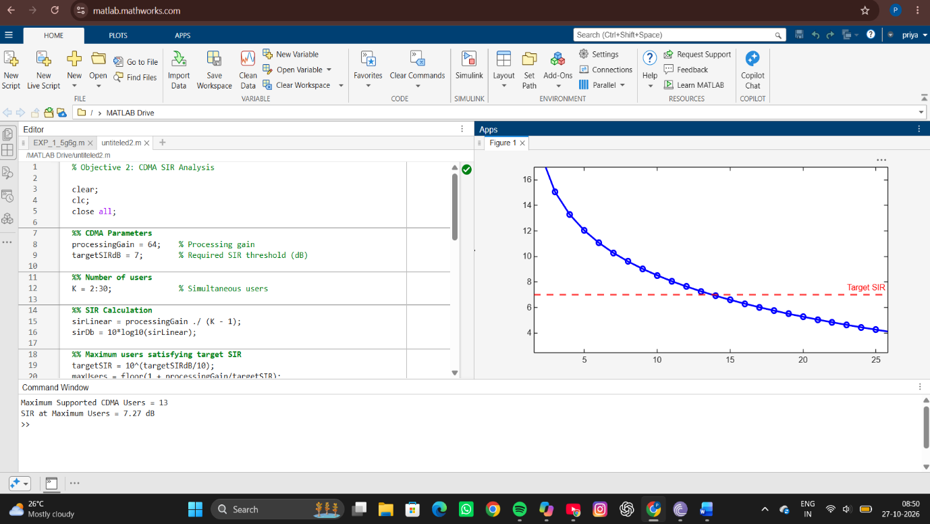
Simulation Output:

Objective 3: Mobile-generation comparison:
To relate representative multiple-access techniques to the evolution of mobile communication systems from 1G to 5G.
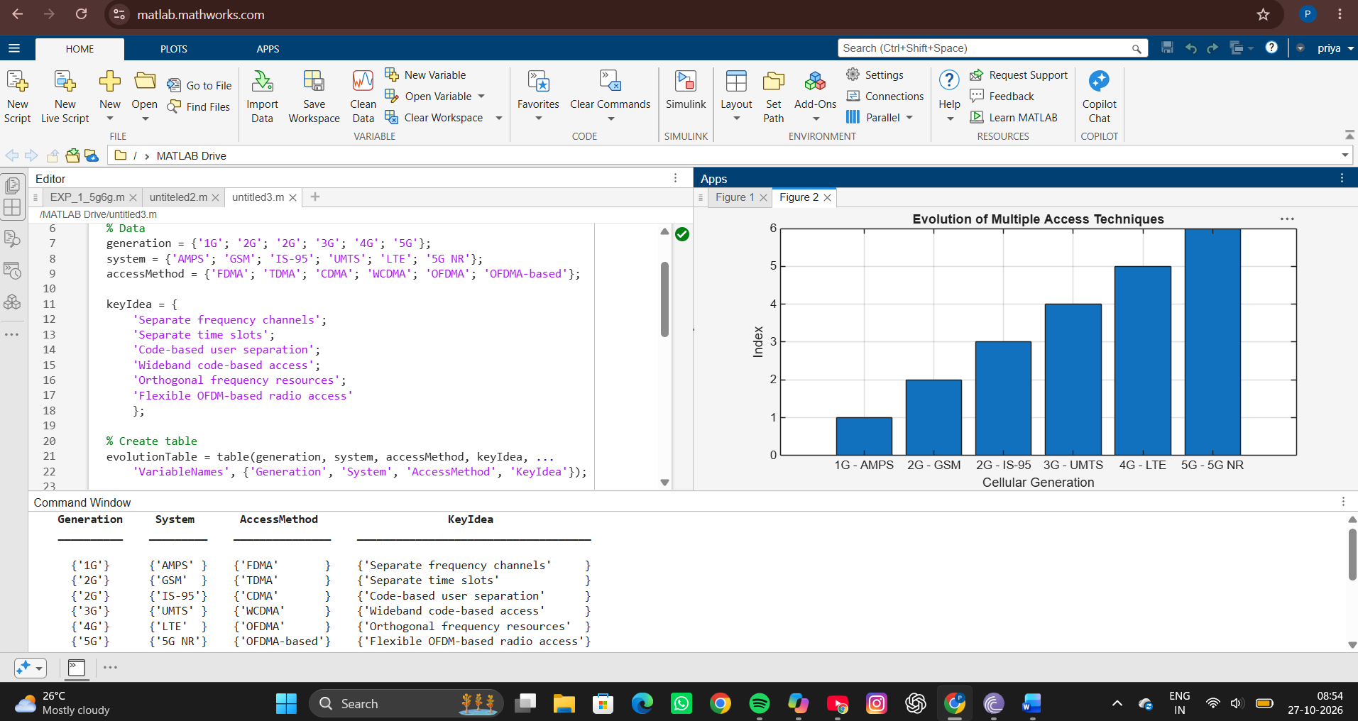
Simulation Output:
Objective 4: Resource-allocation diagrams:
To visualize how FDMA, TDMA and CDMA assign frequency, time and code resources to multiple users.
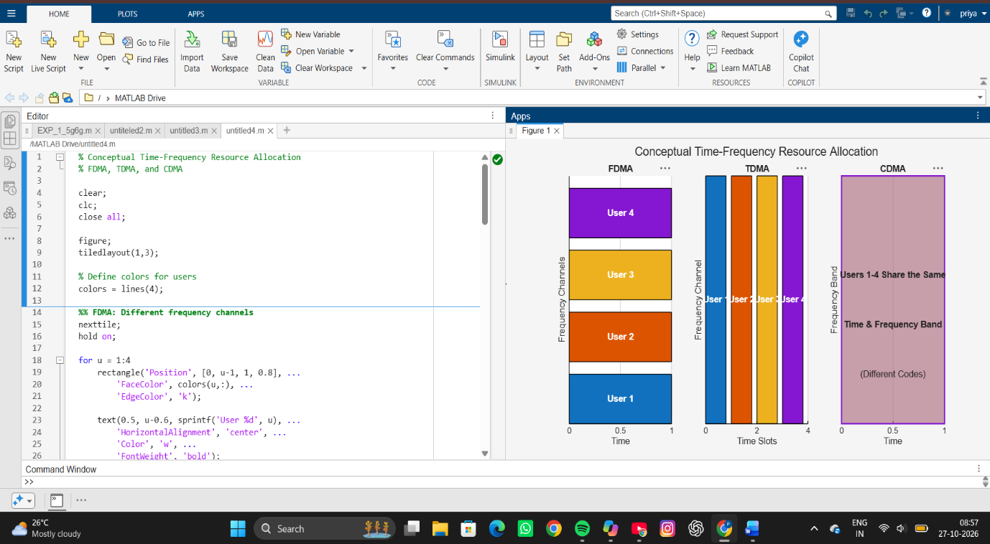
Simulation output:

RESULT
The MATLAB simulations were successfully executed to compare FDMA, TDMA, and CDMA multiple-access techniques. FDMA supported 5 users, TDMA supported 8 users, and CDMA supported the highest capacity with 13 users at a target SIR of 7 dB. The CDMA SIR graph showed that the signal-to-interference ratio decreases as the number of simultaneous users increases, reaching approximately 7.27 dB at 13 users. The evolution table illustrated the progression from FDMA and TDMA to CDMA, WCDMA, and OFDMA-based technologies. The resource-allocation diagrams clearly showed how FDMA separates users by frequency, TDMA by time slots, and CDMA by spreading codes.
REFLECTION
This experiment helped in understanding the working principles and performance of different multiple-access techniques used in cellular communication systems. The results demonstrated that CDMA can support more users and achieve better spectrum utilization than FDMA and TDMA. The SIR analysis highlighted the impact of increasing user interference on CDMA performance, while the evolution study showed how access technologies have advanced to meet growing network demands. Overall, the experiment provided valuable insight into resource allocation, user capacity, and the development of modern wireless communication systems.

