Experiment: 7
Analysis of 5G NR Frame Structure and Subcarrier Spacing

OBJECTIVES
Objective – 1: Generate / Inspect a Simplified 5G NR Resource Grid
Procedure
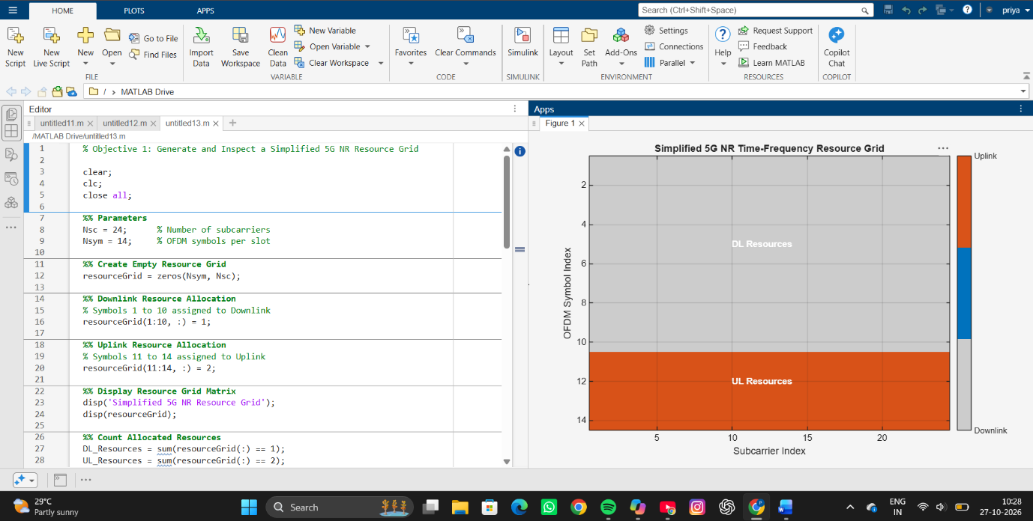
Simulation Output:
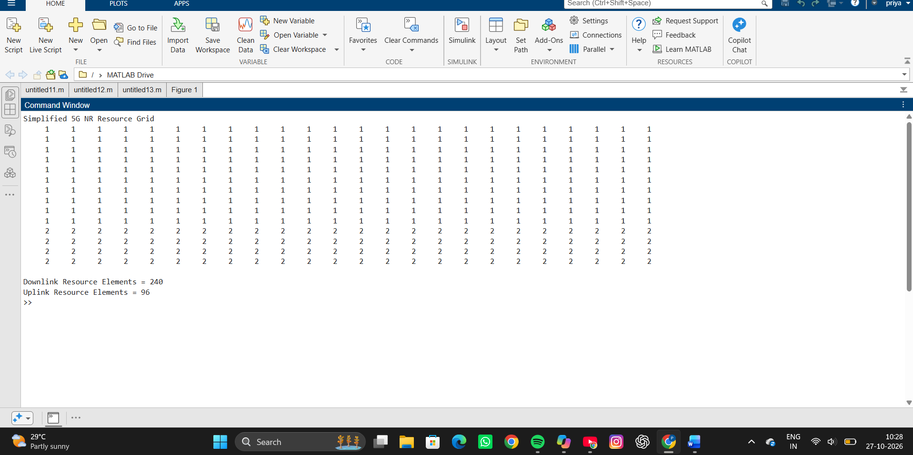

Objective – 2: Compare SCS and Slot Duration Procedure
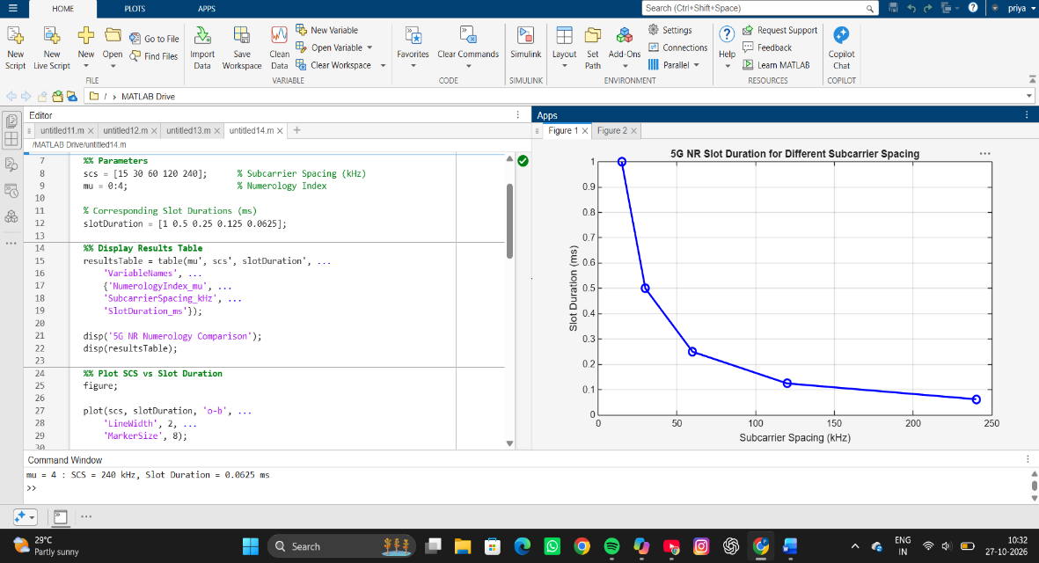
Simulation Output:
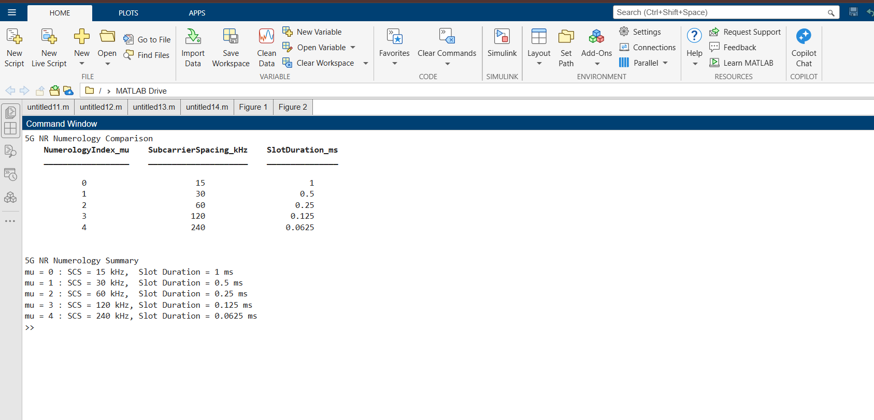
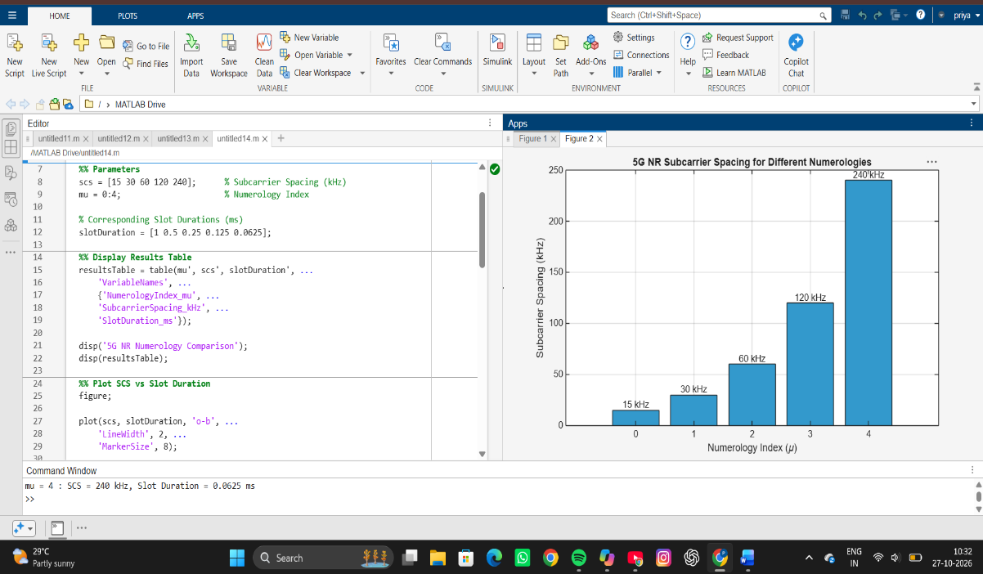
Objective – 3: Identify Basic DL and UL Resource Assignments
Procedure
Simulation Output:
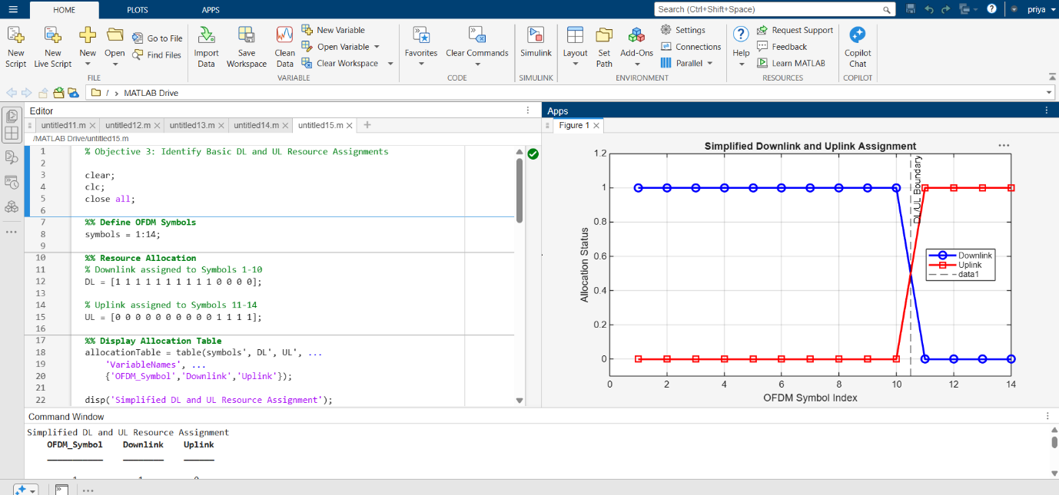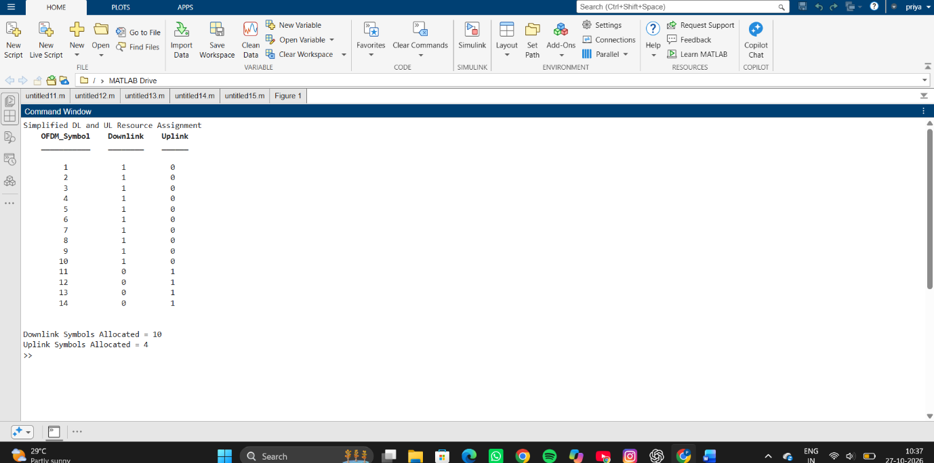

Objective – 4: Relate Resources to gNodeB, RAN and RRC
The gNodeB is the principal 5G NR radio access node. It participates in radio-resource
management and scheduling and provides the radio interface between the UE and the 5G
core. RRC is a control-plane protocol responsible for radio-resource configuration and
connection-related control. The simplified grid therefore represents the radio resources that
are scheduled and configured within the RAN; the exact allocation in a live network depends
on traffic, channel conditions, QoS and scheduling decisions.
RESULT
The experiment successfully demonstrated fundamental 5G NR concepts through three objectives. First, a simplified 5G NR resource grid was generated, showing the allocation of downlink and uplink resources across time and frequency domains using OFDM symbols and subcarriers. Second, the relationship between subcarrier spacing (SCS) and slot duration was analyzed, revealing that slot duration decreases as SCS increases, with values ranging from 1 ms for 15 kHz SCS to 0.0625 ms for 240 kHz SCS. Third, basic downlink (DL) and uplink (UL) resource assignments were illustrated within a 14-symbol slot, where symbols 1–10 were allocated to downlink transmission and symbols 11–14 to uplink transmission. The generated plots and resource-grid visualizations clearly represented the structure and flexibility of 5G NR resource allocation.
REFLECTION
This experiment provided a practical understanding of the 5G NR physical layer and resource management concepts. The resource-grid visualization highlighted how time-frequency resources are organized, while the numerology analysis demonstrated how different subcarrier spacings enable flexible support for diverse applications and latency requirements. The simplified DL and UL allocation model illustrated how resources can be assigned for different transmission directions within a slot. Overall, the experiment emphasized the flexibility, scalability, and efficiency of 5G NR, showing how configurable numerologies and resource allocation mechanisms help support enhanced mobile broadband, massive machine-type communications, and ultra-reliable low-latency communication services.

