11. Simulation and Performance Evaluation of OFDM and FBMC Wireless Waveforms
OBJECTIVES
- To generate a basic Orthogonal Frequency Division Multiplexing (OFDM) signal and a Filter
- Bank Multicarrier (FBMC) signal in MATLAB.
- To compare their spectral characteristics by plotting and analyzing their power spectral
- density (PSD).
- To examine and compare the Peak-to-Average Power Ratio (PAPR) of both waveforms
- under identical modulation conditions.
- To relate the empirical results to next-generation multi-carrier waveform design constraints
- (GFDM, FBMC, UFMC) defined in the wireless syllabus.
SAMPLE OUTPUT
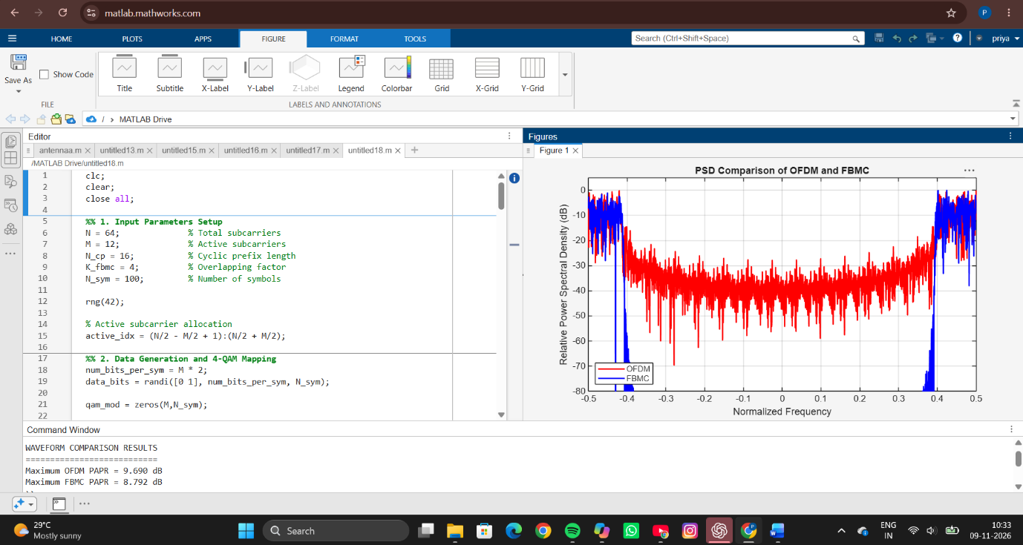
RESULT
The OFDM and FBMC waveforms were successfully generated and analyzed using MATLAB. The Peak-to-Average Power Ratio (PAPR) and Power Spectral Density (PSD) characteristics of both systems were evaluated. The results showed that OFDM produced higher out-of-band emissions due to its rectangular pulse shaping, whereas FBMC exhibited better spectral containment because of the PHYDYAS prototype filtering. The PSD plot demonstrated that FBMC significantly reduced sidelobe levels and spectral leakage compared to OFDM. The calculated PAPR values indicated that both waveforms experience peak power variations, with FBMC generally providing improved spectral efficiency and better frequency localization.
REFLECTION
This experiment provided a practical understanding of multicarrier waveform technologies used in modern wireless communication systems. By implementing OFDM and FBMC, the differences in spectral behavior and power characteristics became evident. FBMC offered superior spectral containment and reduced interference between adjacent channels, making it suitable for future communication systems with stringent spectrum requirements. OFDM, however, remains simpler to implement and is widely adopted in current standards. Overall, the experiment enhanced knowledge of waveform design, spectral efficiency, and the trade-offs involved in selecting suitable transmission techniques for next-generation wireless networks.

