Experiment Number: 3
MATLAB Analysis of Spectrum Bands, Propagation Loss and Cellular Interference
OBJECTIVES
- Calculate or simulate path loss at representative sub-1 GHz, mid-band and mmWave
- frequencies.
- Compare estimated received signal strength as frequency and distance change.
- Examine how cell separation or frequency reuse changes a simplified interference ratio.
- Relate the results to coverage and spectrum-use considerations across mobile generations,
- while stating model limitations.
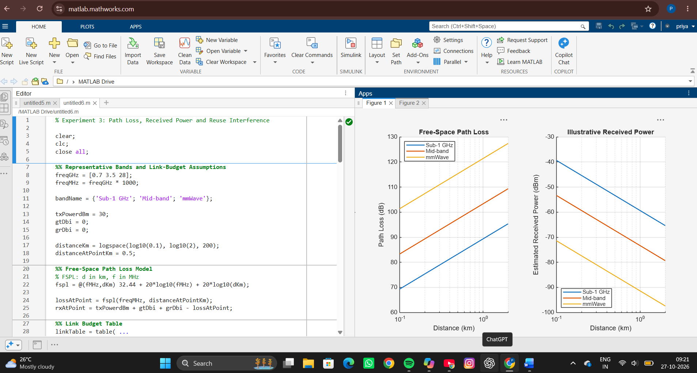
SIMULATION OUTPUT
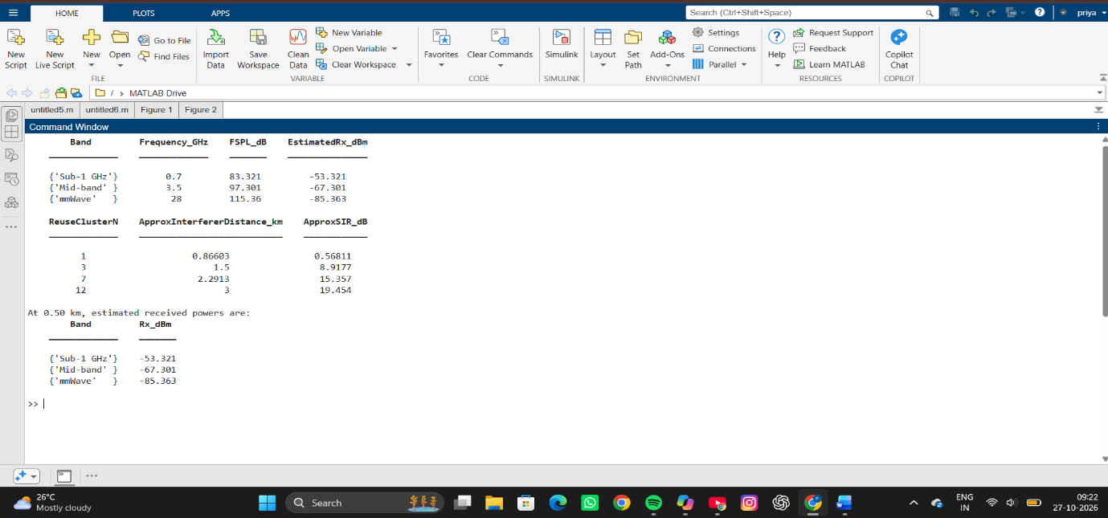
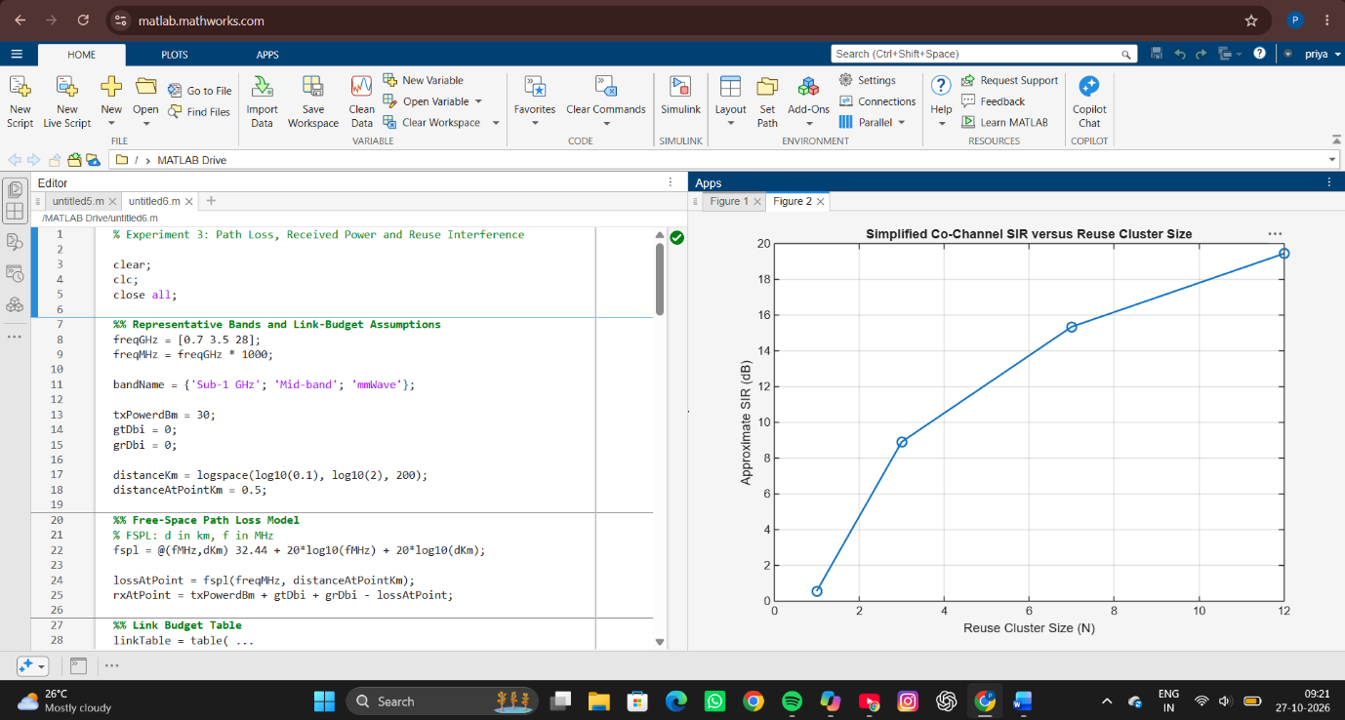
RESULT
The MATLAB simulation successfully evaluated path loss, received power, and co-channel reuse interference for different frequency bands. The results showed that path loss increases with both frequency and distance, while the received power decreases accordingly. Among the three bands, 700 MHz (Sub-1 GHz) provided the lowest path loss and highest received power, whereas 28 GHz (mmWave) experienced the highest path loss and lowest received power. The frequency reuse analysis demonstrated that increasing the reuse cluster size (N) increases the distance between co-channel cells, resulting in a higher Signal-to-Interference Ratio (SIR) and reduced interference. The generated graphs clearly illustrated the variation of path loss, received power, and SIR with distance and reuse cluster size.
REFLECTION
This experiment provided insight into the impact of propagation characteristics and frequency reuse on cellular network performance. The results highlighted that lower-frequency bands offer better coverage due to reduced path loss, while higher-frequency bands require denser deployments because of greater attenuation. The frequency reuse analysis demonstrated the trade-off between capacity and interference, showing that larger reuse cluster sizes improve signal quality but reduce spectral efficiency. Overall, the experiment enhanced the understanding of radio propagation, link-budget analysis, and interference management in wireless communication systems.

