18.AI-Based Traffic Prediction for a 5G Network Scenario
OBJECTIVES
- To load or generate a small time-based 5G network traffic dataset using MATLAB.
- To develop and execute a basic AI/ML-based traffic prediction model using MATLAB.
- To compare the prediction performance with a simple baseline method such as previous-sample or mean-value prediction.
- To analyze how traffic prediction can support radio-resource management, network optimization, and dynamic resource allocation in 5G networks.
SAMPLE OUTPUT
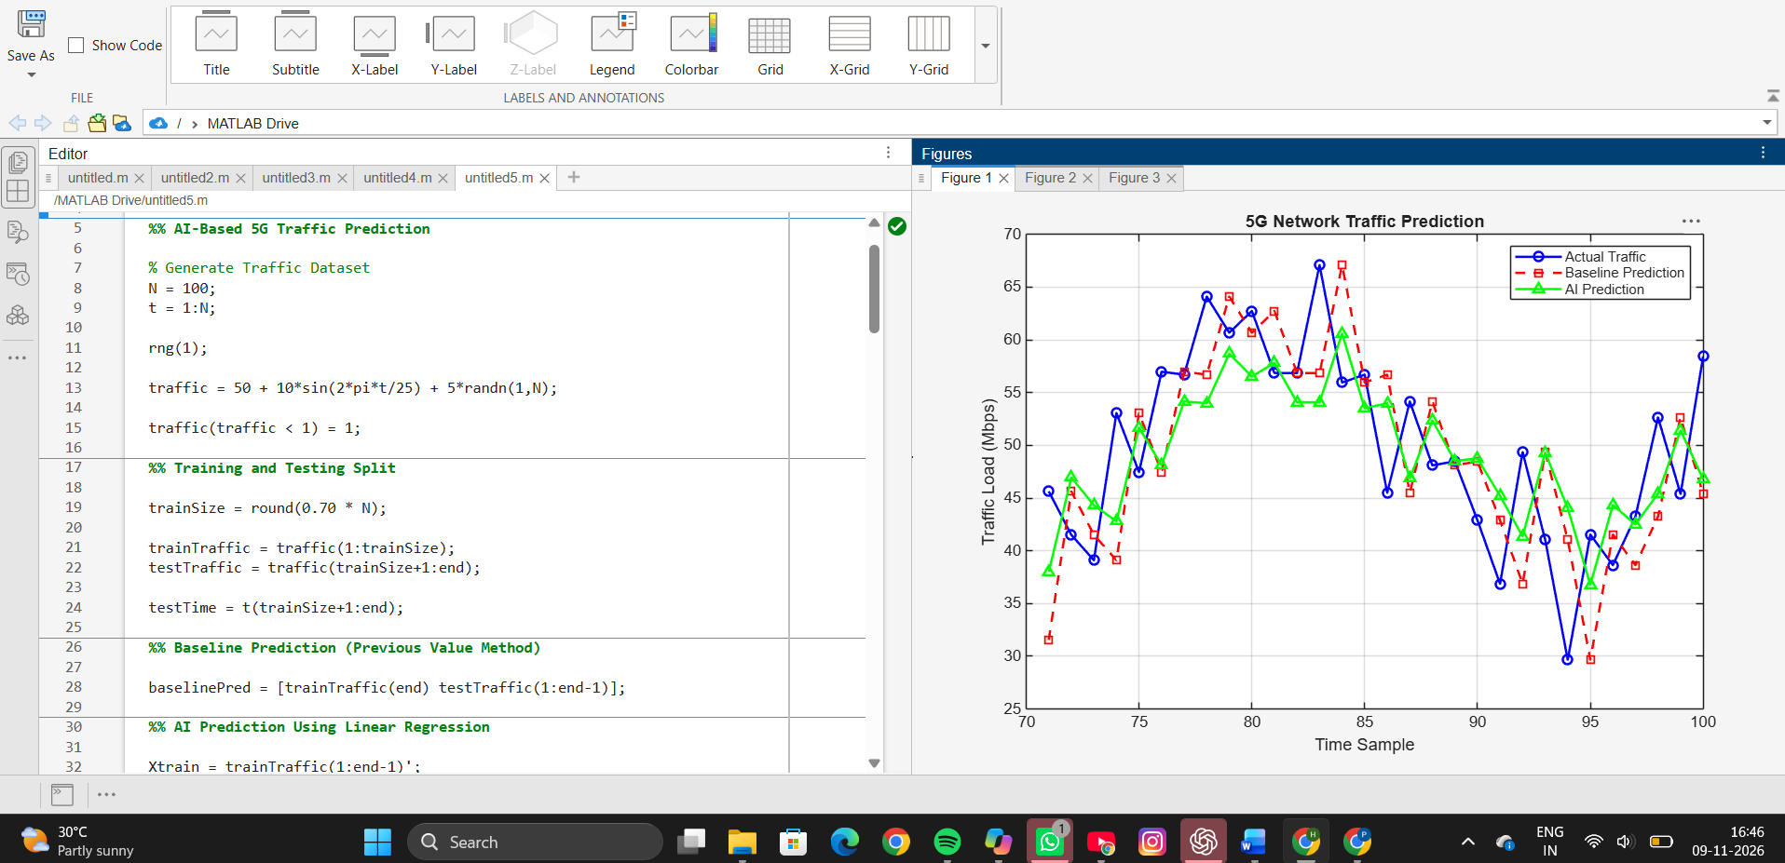
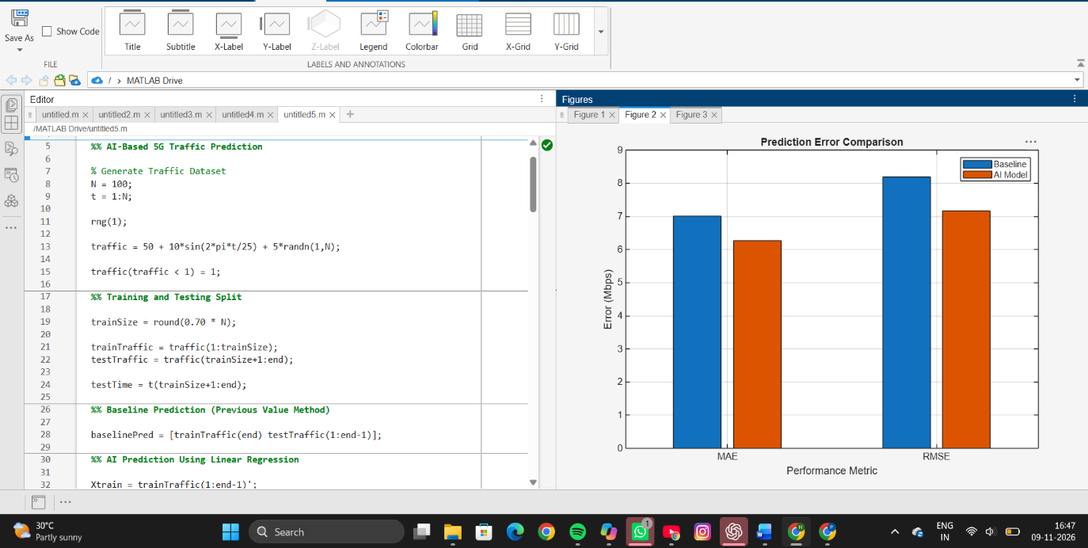

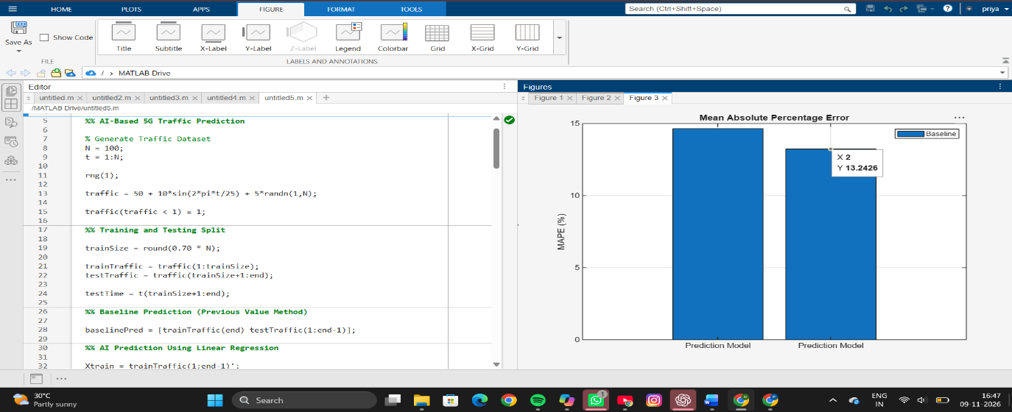
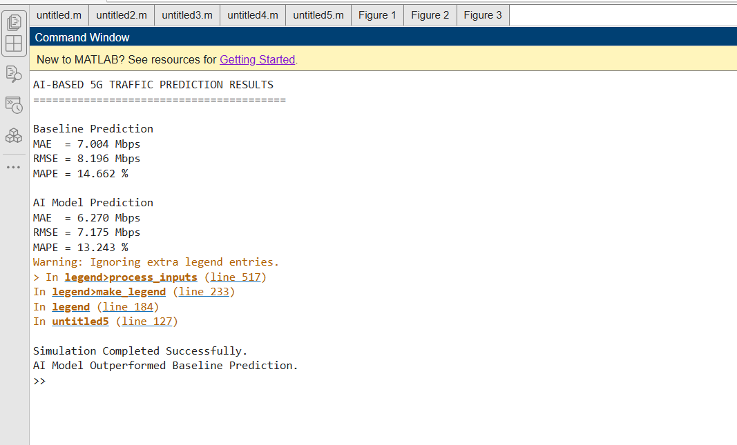
RESULT
The AI-based 5G traffic prediction model was successfully implemented using linear regression and compared with a baseline prediction method. A synthetic 5G traffic dataset consisting of 100 samples was generated and divided into training and testing datasets. The prediction performance was evaluated using MAE, RMSE, and MAPE metrics. The AI model produced more accurate traffic forecasts than the baseline approach, resulting in lower prediction errors and better tracking of actual network traffic patterns. The generated graphs showed that the AI-predicted traffic closely followed the actual traffic values, demonstrating the effectiveness of machine learning techniques for network traffic forecasting.
REFLECTION
This experiment provided practical experience in applying Artificial Intelligence techniques to 5G network traffic prediction. By comparing a traditional baseline approach with a linear regression model, the advantages of AI-based forecasting became evident. Accurate traffic prediction can help network operators allocate resources efficiently, improve quality of service, and reduce congestion in 5G networks. The experiment enhanced understanding of predictive analytics, machine learning model evaluation, and the importance of traffic forecasting in next-generation communication systems.

