10. Simulation and Performance Evaluation of NOMA and Successive Interference Cancellation.
OBJECTIVES
- To generate a basic Orthogonal Frequency Division Multiplexing (OFDM) signal and a Filter
- Bank Multicarrier (FBMC) signal in MATLAB.
- To compare their spectral characteristics by plotting and analyzing their power spectral
- density (PSD).
- To examine and compare the Peak-to-Average Power Ratio (PAPR) of both waveforms
- under identical modulation conditions.
- To relate the empirical results to next-generation multi-carrier waveform design constraints
- (GFDM, FBMC, UFMC) defined in the wireless syllabus.

SAMPLE OUTPUT
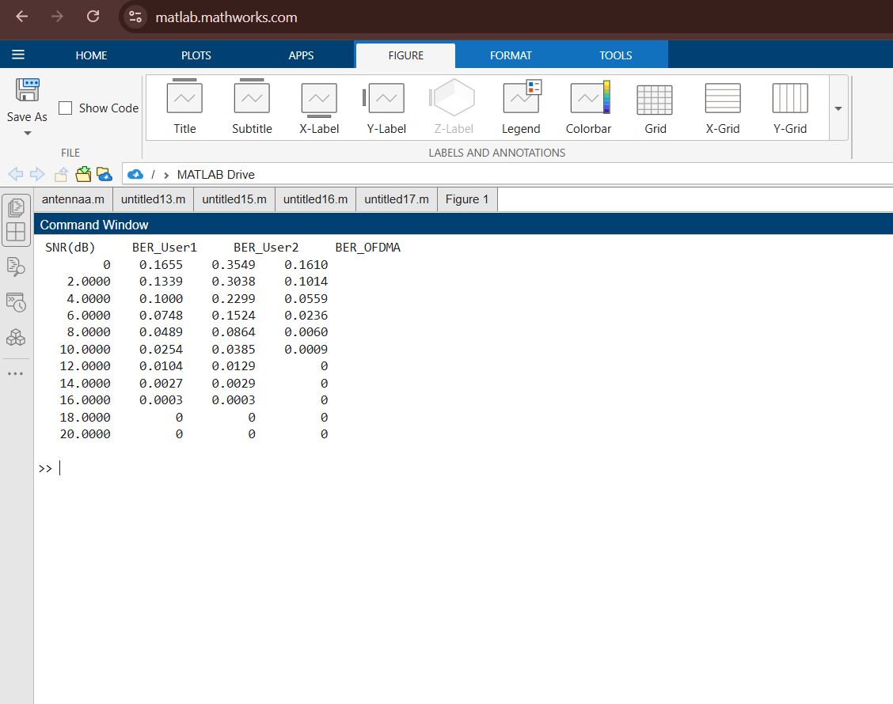

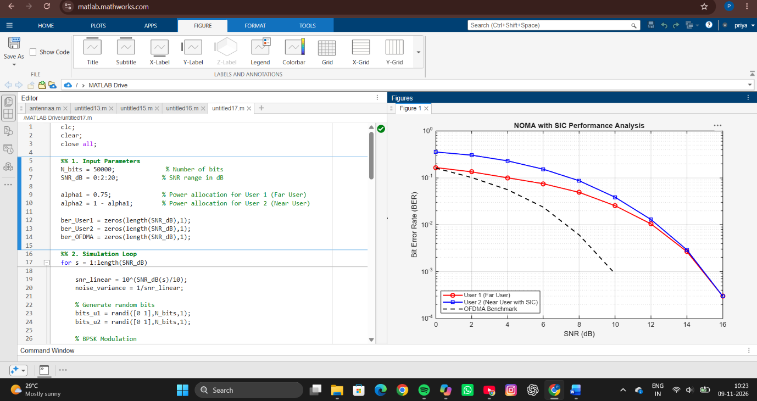

RESULT
The NOMA system with Successive Interference Cancellation (SIC) was successfully implemented and evaluated over an AWGN channel. The Bit Error Rate (BER) performance of the far user (User 1), near user (User 2), and the conventional OFDMA system was analyzed for different SNR values ranging from 0 dB to 20 dB. The BER of all schemes decreased as SNR increased, indicating improved communication reliability. User 2 achieved better BER performance due to SIC processing, while User 1 experienced relatively higher BER because of interference from the superimposed signals. The OFDMA benchmark showed good error performance as it avoids inter-user interference through orthogonal resource allocation.
REFLECTION
This experiment provided practical insight into power-domain NOMA and the role of Successive Interference Cancellation in multi-user communication systems. The results demonstrated that NOMA enables multiple users to share the same frequency resources simultaneously, thereby improving spectral efficiency. It was observed that SIC effectively reduces interference and enhances the performance of the near user. The comparison with OFDMA highlighted the trade-off between increased spectral efficiency and receiver complexity. Overall, the experiment improved understanding of next-generation multiple-access techniques used in modern 5G wireless communication networks.

