Experiment: 5
Simulation and Throughput Analysis of LTE-Advanced Carrier Aggregation

OBJECTIVES
• To model an LTE-Advanced link using one component carrier.
• To extend the model to use multiple aggregated component carriers.
• To compare estimated throughput for different carrier bandwidths.
• To explain how carrier aggregation increases available transmission bandwidth.

Objective – 1: Model One Component Carrier
Define a single LTE-Advanced component carrier and estimate its throughput for a selected bandwidth and spectral efficiency.

Simulation Outputs:
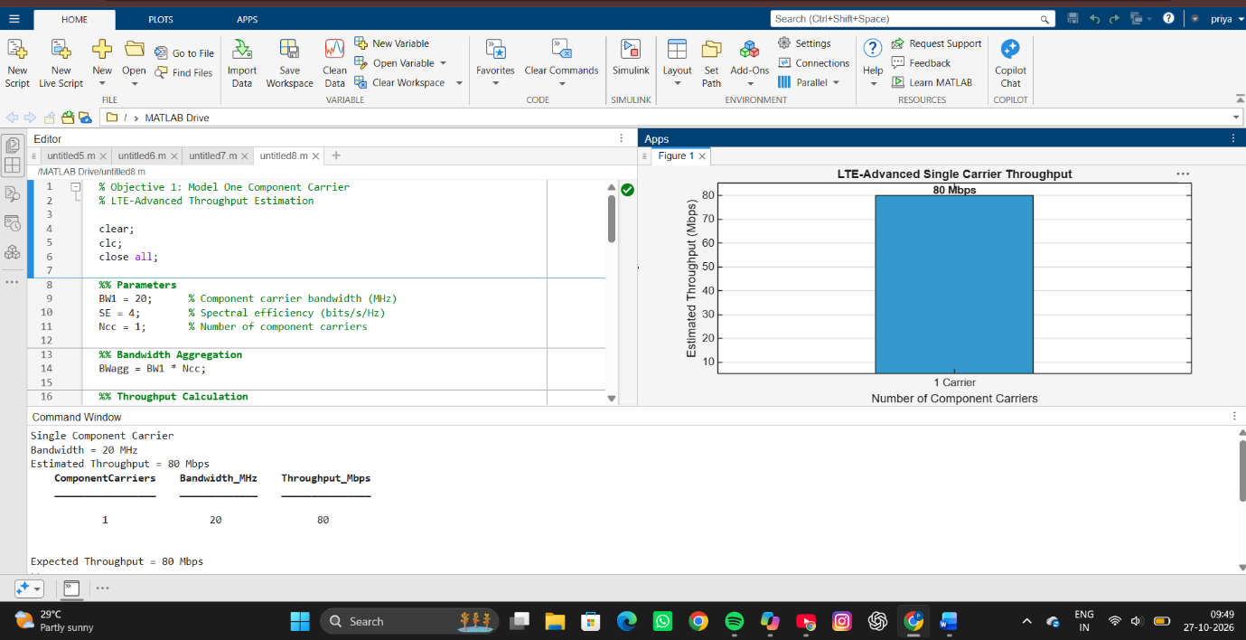

Objective – 2: Extend to Multiple Aggregated Component Carriers
Aggregate multiple component carriers and determine the resulting total bandwidth and estimated throughput.
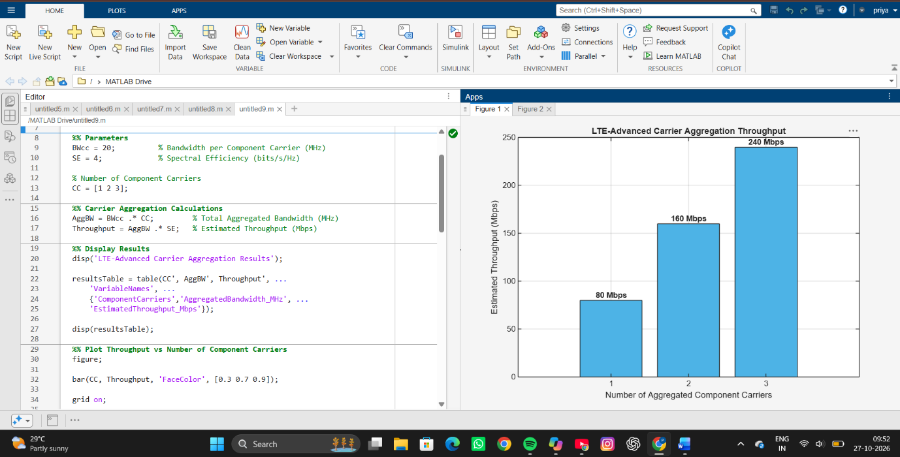
Simulation Outputs:

Objective – 3: Compare Estimated Throughput for Different Carrier Bandwidths
Procedure
Simulation Outputs:
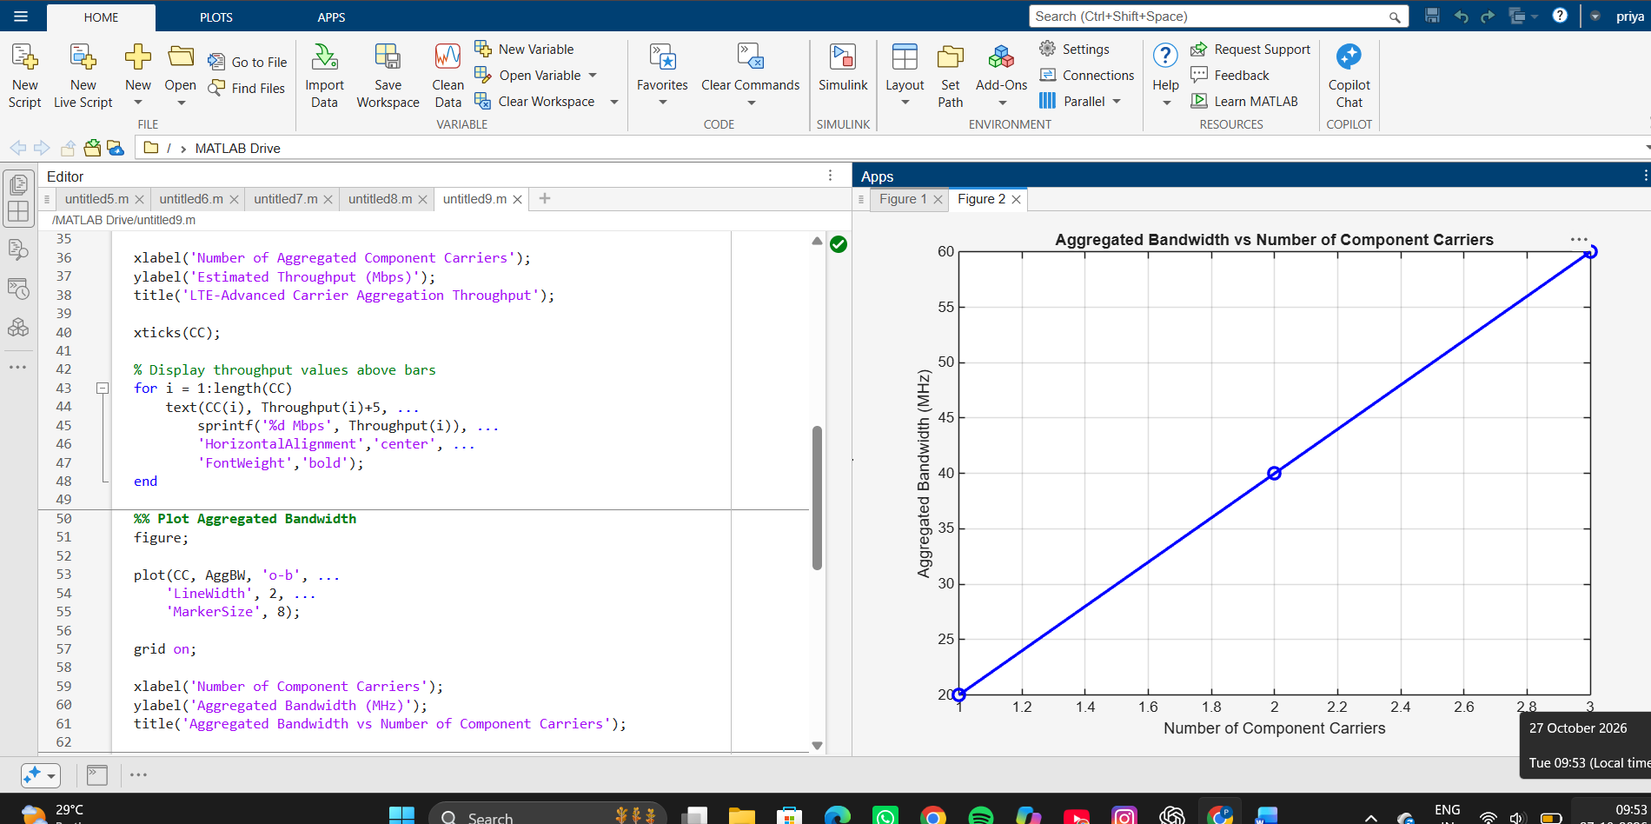

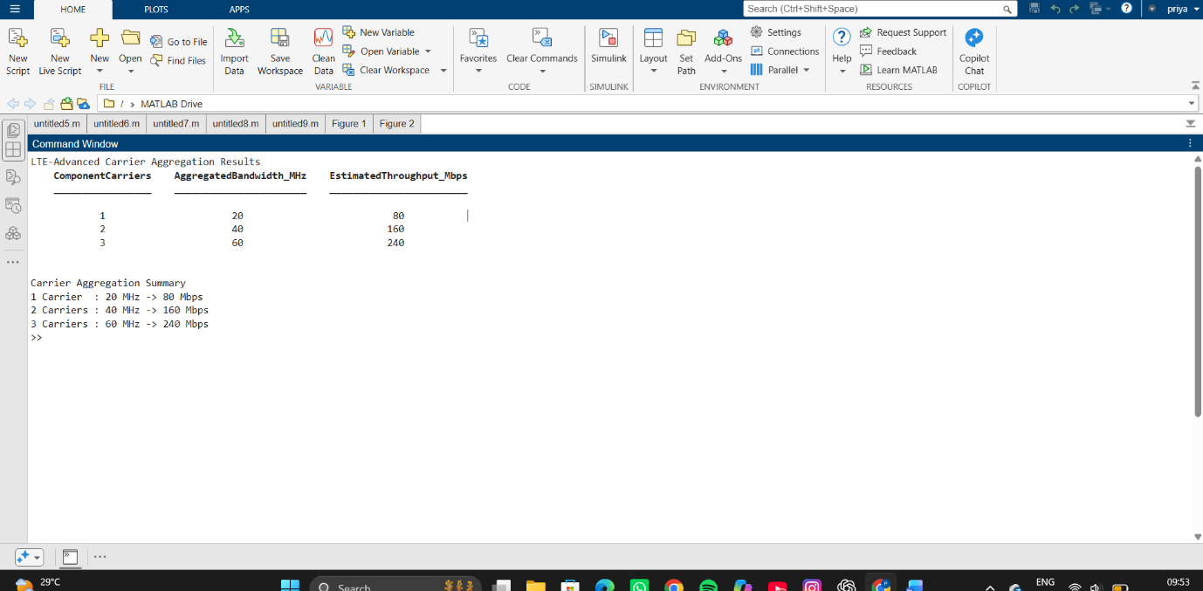
Objective – 4: Explain the Effect of Carrier Aggregation

The total available bandwidth is obtained by combining the component carriers. Under the
simplified constant spectral-efficiency model, throughput increases approximately in
proportion to the aggregated bandwidth. In a practical LTE-Advanced system, the actual
throughput is also influenced by modulation, coding, channel quality, control overhead,
scheduling and radio conditions.
RESULT
1. The LTE-Advanced link was successfully modeled using a single component carrier.
2. Multiple component carriers were aggregated and the resulting bandwidth and estimated
throughput were calculated.
3. Throughput was compared for different carrier bandwidths.
4. The simulation demonstrated that carrier aggregation increases available transmission
bandwidth and can increase achievable throughput.
REFLECTION
This experiment demonstrated the benefits of carrier aggregation in LTE-Advanced networks. The results showed that aggregating multiple component carriers increases the total available bandwidth, which directly improves the estimated throughput. As the number of component carriers increased from 1 to 3, the throughput increased proportionally from 80 Mbps to 240 Mbps. This highlights how carrier aggregation enhances spectrum utilization and enables higher data rates to meet growing user demands. Overall, the experiment provided a clear understanding of how LTE-Advanced improves network capacity and performance through the aggregation of multiple frequency carriers.

