17:Simulation of V2V and V2I Latency and Packet Delivery

OBJECTIVES
- To model a simple Vehicle-to-Vehicle (V2V) or Vehicle-to-Infrastructure (V2I) communication scenario using MATLAB.
- To estimate communication latency and packet delivery ratio (PDR) under different vehicle distances and traffic/channel conditions.
- To compare the communication performance of at least two V2X scenario settings.
- To analyze the relationship between distance, latency, packet delivery, and V2X safety requirements.
SAMPLE OUTPUT
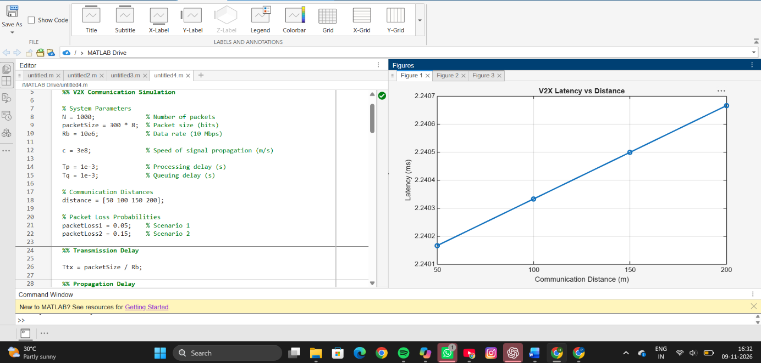
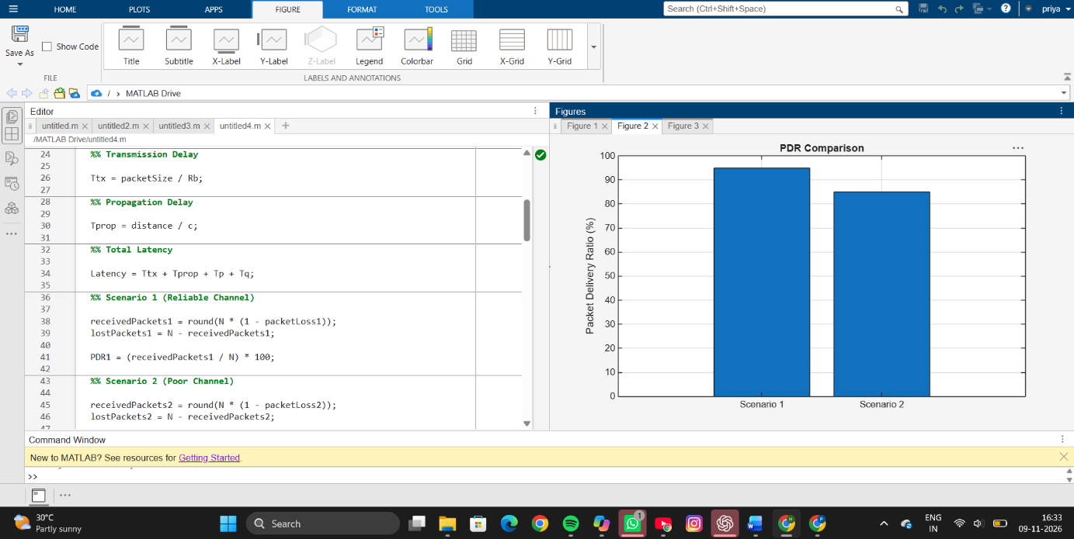

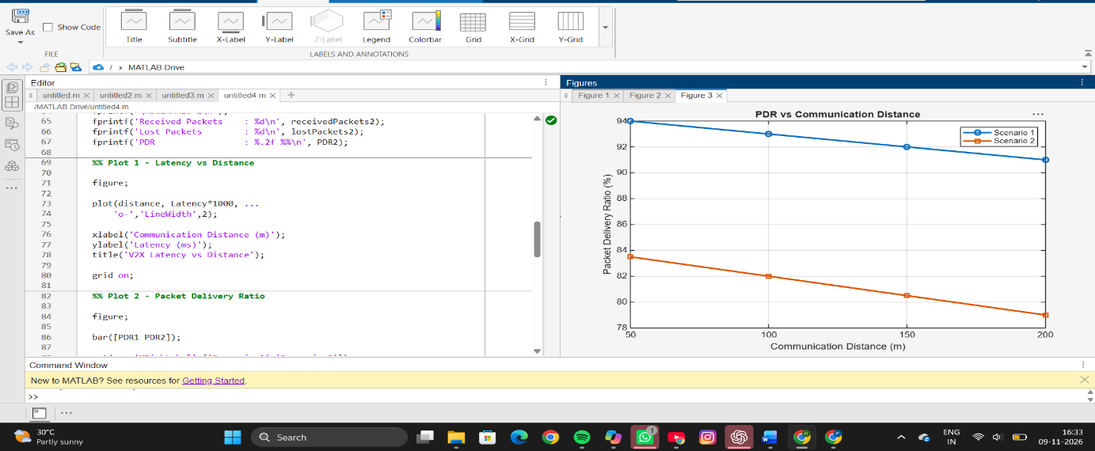
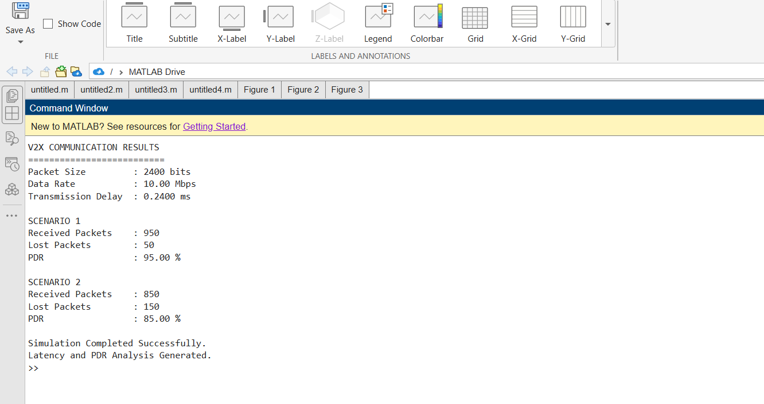
RESULT
The V2X communication system was successfully simulated for two different channel conditions. The transmission delay for a 2400-bit packet at a data rate of 10 Mbps was calculated, and the overall latency was evaluated for communication distances ranging from 50 m to 200 m. In Scenario 1, with a packet loss probability of 5%, the Packet Delivery Ratio (PDR) was approximately 95%, while in Scenario 2, with a packet loss probability of 15%, the PDR decreased to 85%. The latency increased slightly with communication distance due to propagation delay, and the generated plots clearly illustrated the variation of latency and packet delivery performance under different channel conditions.
REFLECTION
This experiment provided practical knowledge of Vehicle-to-Everything (V2X) communication performance analysis. The simulation demonstrated how packet loss and communication distance affect network reliability and latency. It was observed that higher packet loss probabilities significantly reduce packet delivery ratio, while increased distance contributes to greater propagation delay. Overall, the experiment improved understanding of wireless communication metrics such as latency, packet delivery ratio, and channel reliability in V2X networks.

