Experiment Number: 4
Hardware Measurement of Wireless Coverage and Channel Interference Using Raspberry Pi and ESP32

OBJECTIVES
- Measure received Wi-Fi signal strength at selected locations using a Raspberry Pi or
- ESP32.
- Record how distance or an obstruction changes measured signal strength.
- Compare observed nearby-network channel counts and/or packet delivery on selected Wi-Fi channels.
- Relate the observations to cellular coverage and interference concepts while stating why
- Wi-Fi is only a teaching proxy.

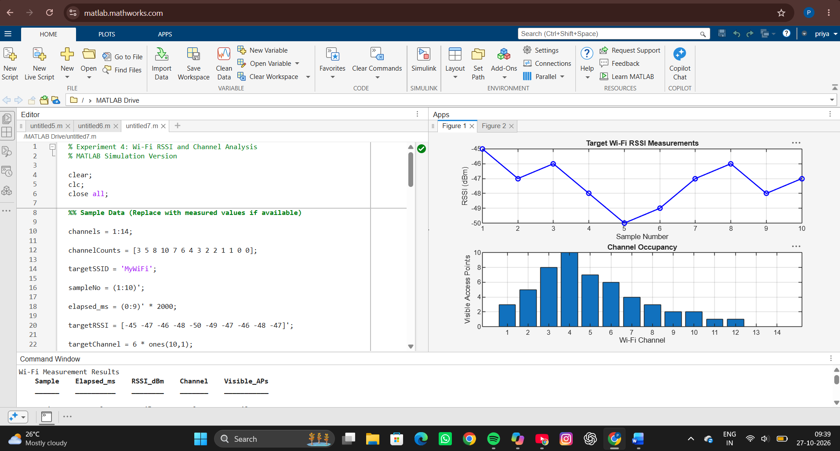
SIMULATION OUTPUT
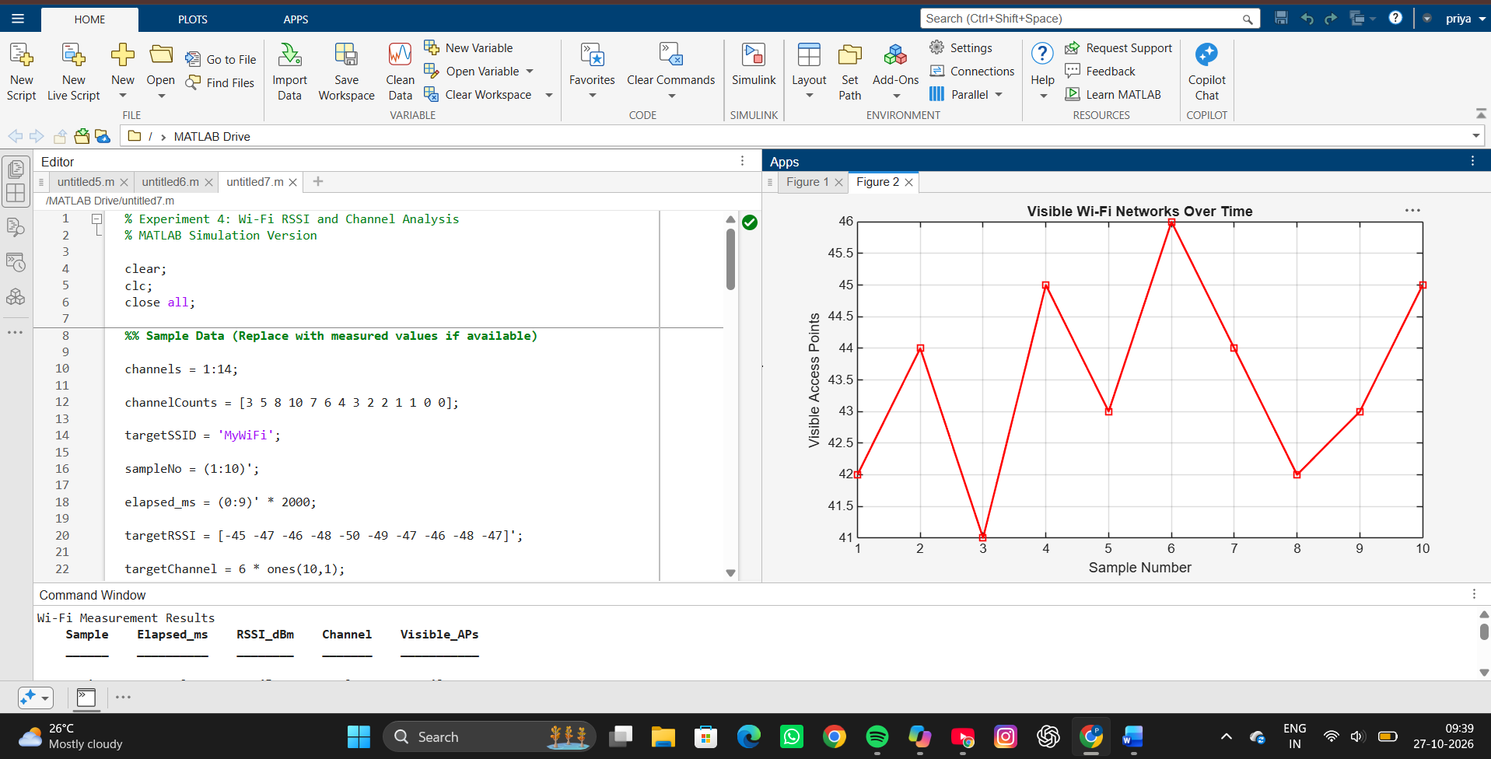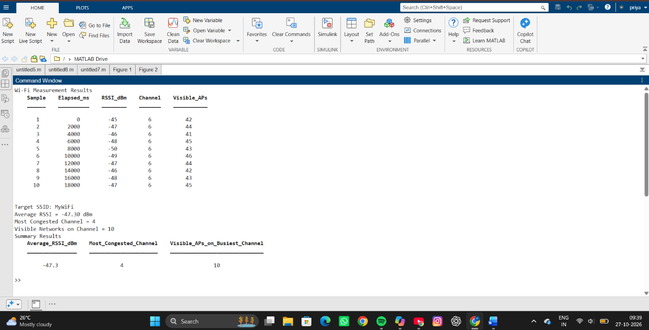
RESULT
- Displays RSSI measurements for the target Wi-Fi network.
- Identifies the most congested Wi-Fi channel.
- Shows visible access points over time.
- Plots:
  - RSSI vs Sample Number
  - Channel Occupancy
  - Visible Networks Over Time

REFLECTION
The simulation demonstrates how Wi-Fi signal strength and channel occupancy can be analyzed to assess wireless network performance. Stronger RSSI values indicate better signal quality, while higher channel occupancy suggests greater interference potential. The experiment helps identify congested channels and evaluate network conditions for improved Wi-Fi deployment and troubleshooting.

