14: Simulation of Edge and Cloud Processing for an IoT Application
OBJECTIVES
- To understand the concepts of edge computing and cloud computing in IoT
applications.
- To simulate IoT data processing at the edge device and at a remote cloud server using
MATLAB.
- To compare edge and cloud processing in terms of latency, network bandwidth
utilization, response time, and energy consumption.
- To analyze the effect of network delay and the volume of sensor data on overall
system performance.
- To evaluate the suitability of edge and cloud processing for real-time IoT
applications.
- To generate comparative plots and identify the advantages and limitations of both
processing approaches.
SAMPLE OUTPUT
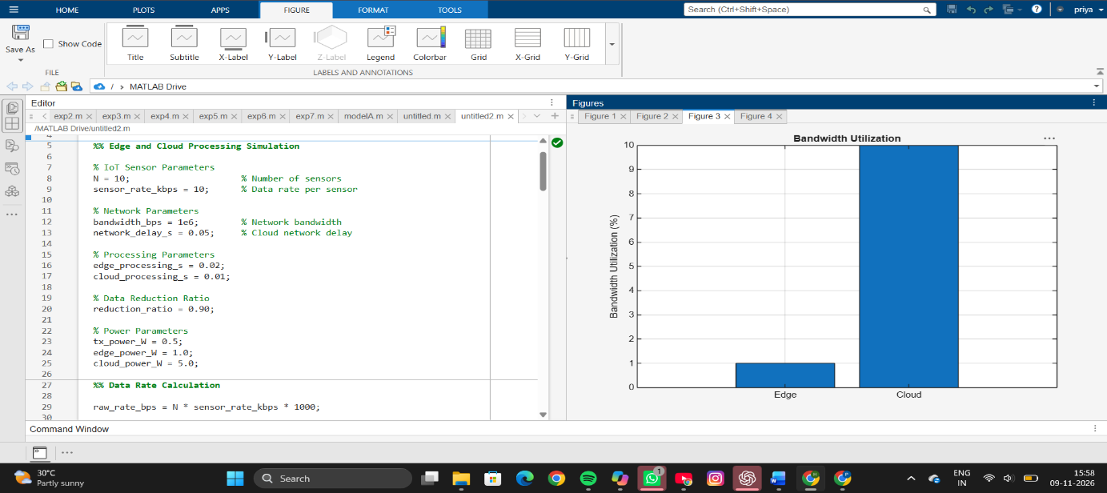
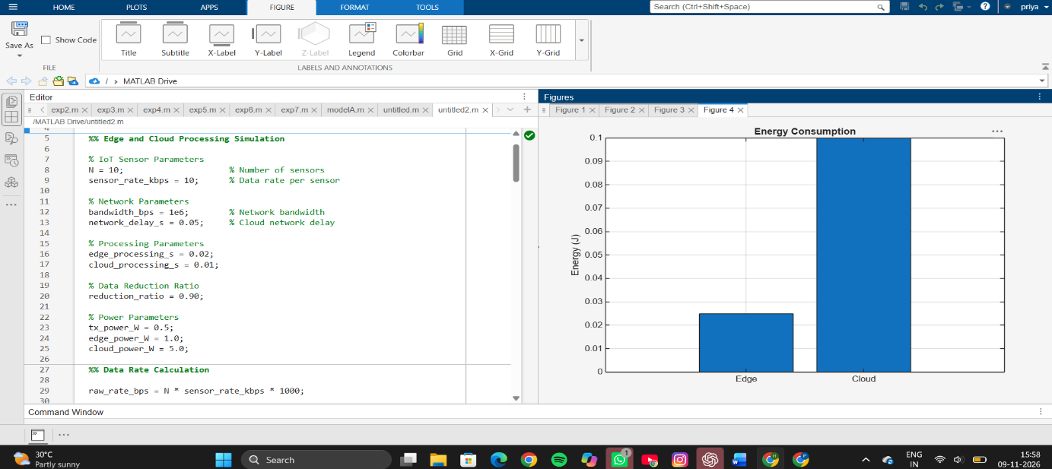
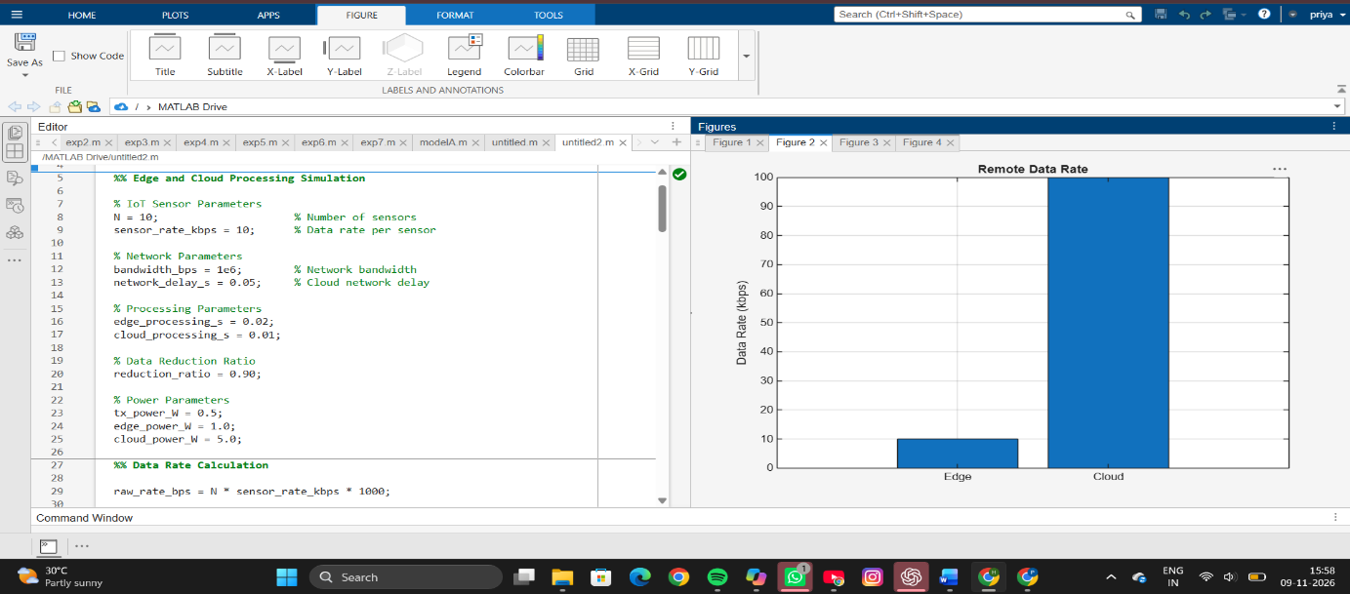
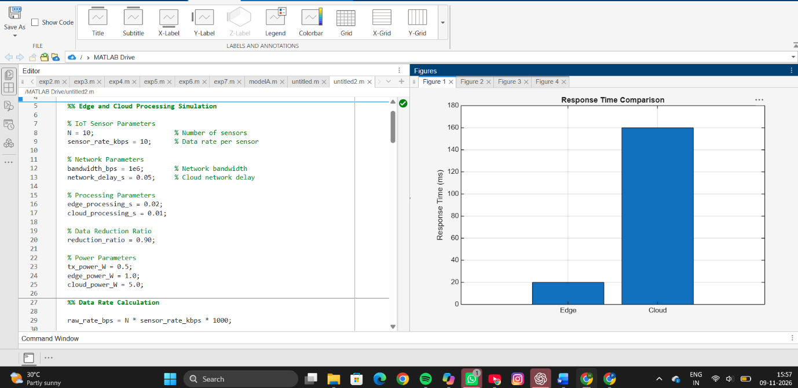
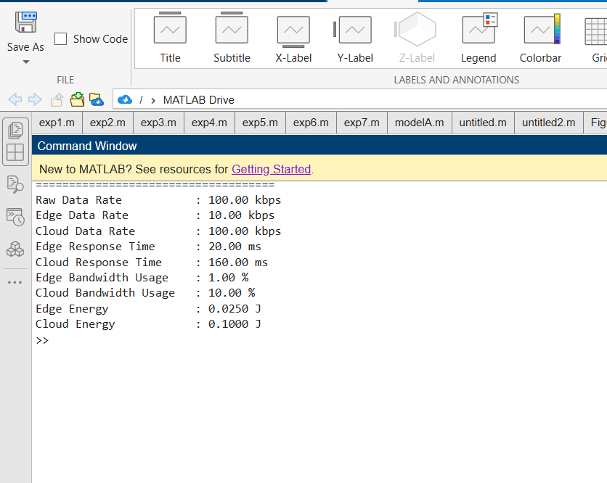
RESULT
The Edge and Cloud Processing simulation was carried out successfully for an IoT network consisting of 10 sensors. The total generated data rate was 100 kbps. Through edge processing, the transmitted data was reduced to 10 kbps due to local filtering, while cloud processing transmitted the entire 100 kbps. The edge architecture achieved a response time of approximately 20 ms, whereas cloud processing experienced a higher delay of about 160 ms because of network and transmission overheads. Edge processing also utilized only 1% of the available bandwidth compared to 10% in cloud processing and consumed less energy per processing batch.
REFLECTION
This experiment demonstrated the performance benefits of edge computing over traditional cloud computing for IoT applications. By processing data closer to the data source, edge computing significantly reduced latency, bandwidth usage, and energy consumption. The results emphasized the importance of edge processing in real-time applications such as smart healthcare, industrial automation, and intelligent transportation systems. Overall, the experiment provided a clear understanding of how edge computing improves efficiency and responsiveness in modern IoT environments.

