15. Design and Simulation of an IoT-Based Smart Agriculture System
OBJECTIVES
- To understand the architecture and working principles of an iot-based smart agriculture System.
- To simulate the collection of soil moisture, temperature, and humidity data using
Matlab.
- To design an automatic irrigation control algorithm based on soil moisture threshold
Values.
- To calculate the number of sensor data packets, total transmitted data, and
Communication time.
- To estimate water pump energy consumption based on its operating duration and power Rating.
- To generate and analyze graphs representing environmental parameters and irrigation
Pump status.
- To evaluate how iot technology can improve water management and agricultural
Monitoring.
SAMPLE OUTPUT
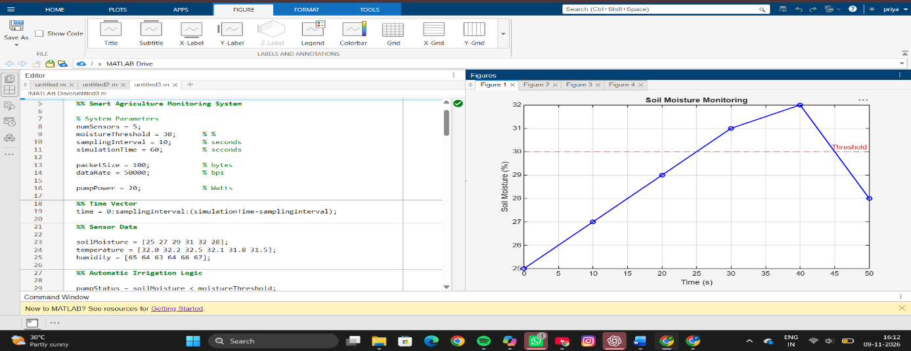
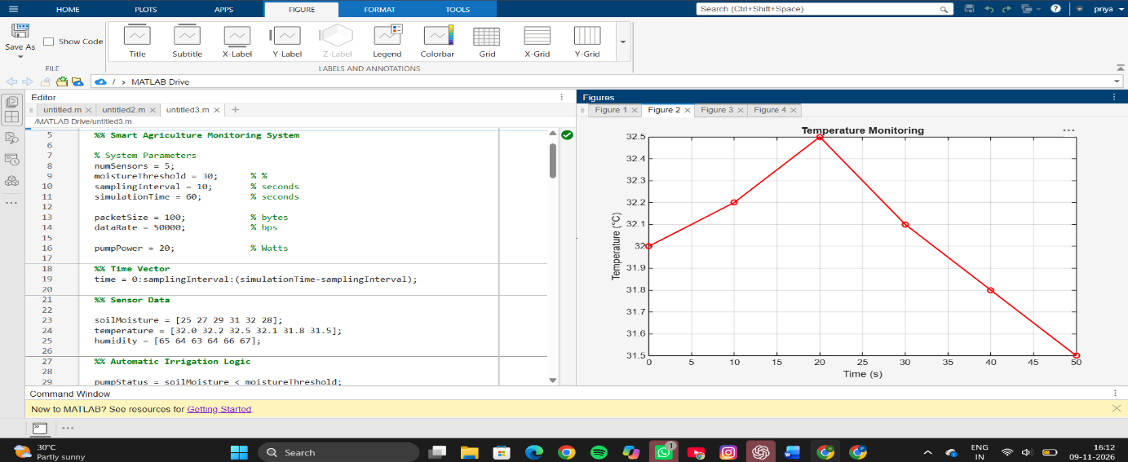

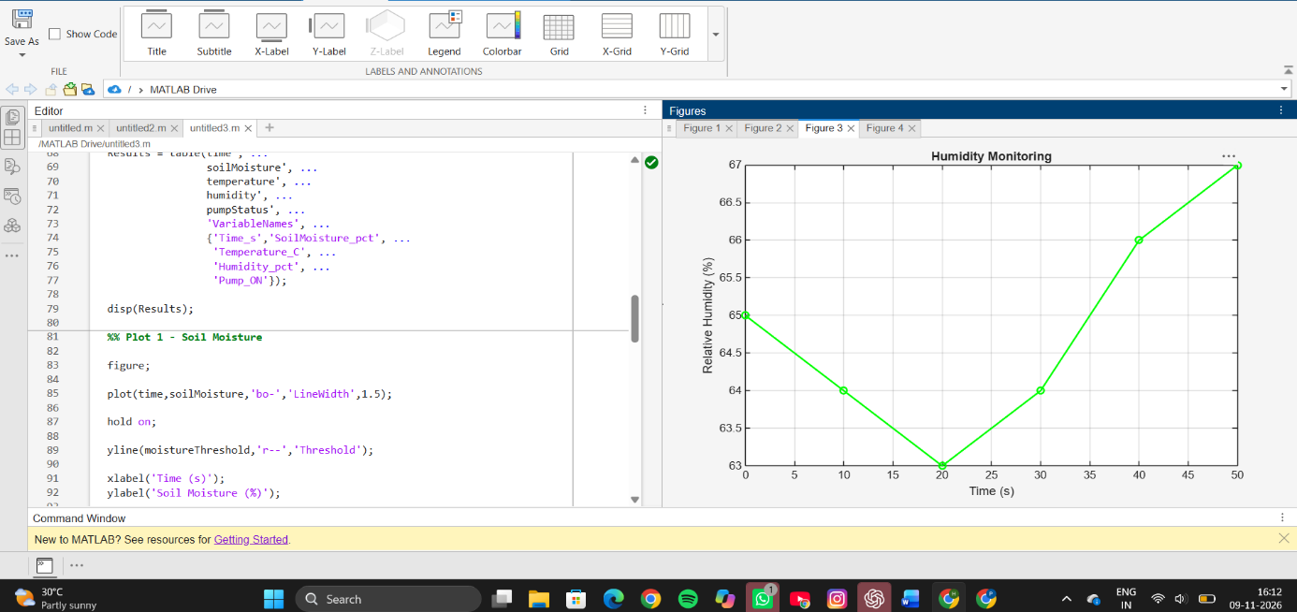
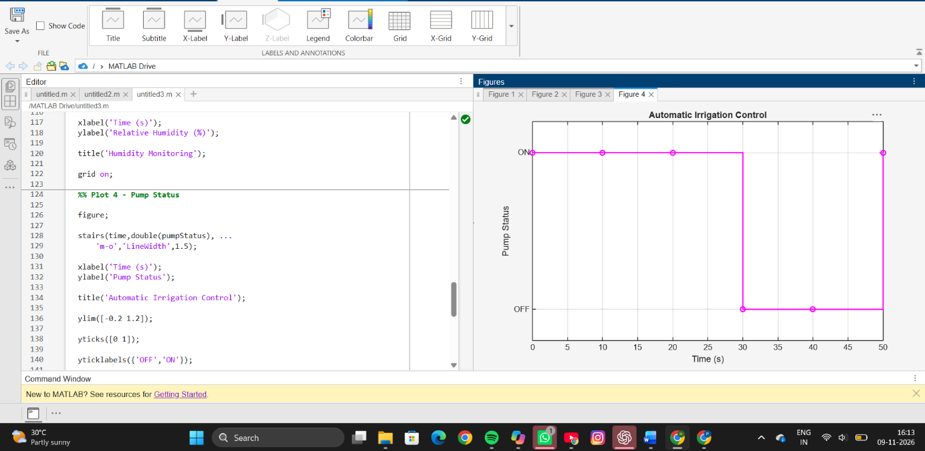
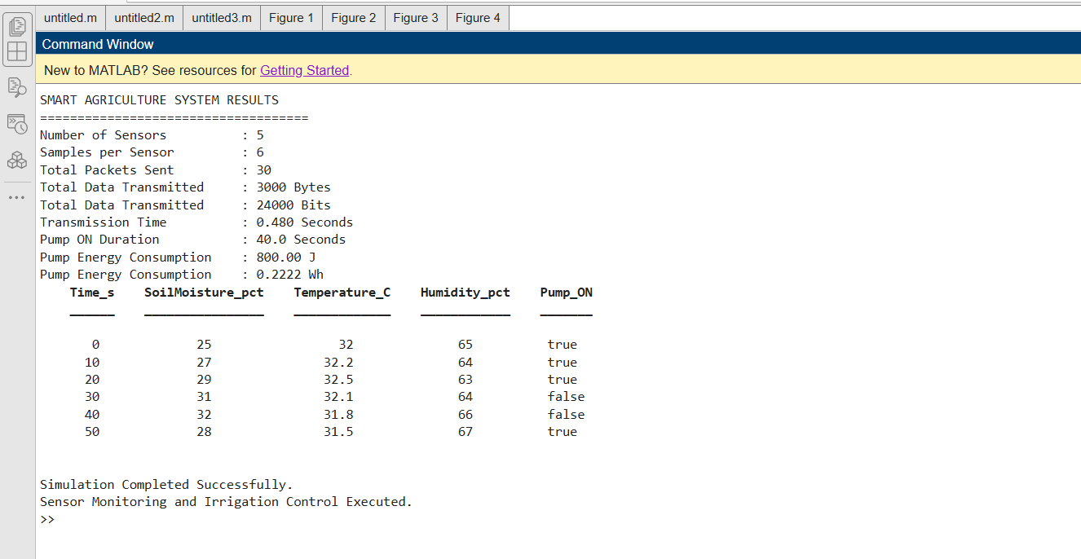

RESULT
The Smart Agriculture Monitoring System was successfully simulated using MATLAB. Soil moisture, temperature, and humidity values were continuously monitored over the simulation period. The irrigation pump was automatically activated whenever the soil moisture dropped below the threshold value of 30%. Out of the six monitoring intervals, the pump remained ON during the periods when the soil moisture values were 25%, 27%, 29%, and 28%. A total of 30 sensor data packets were transmitted, generating communication traffic and corresponding transmission time. The system also calculated the energy consumed by the irrigation pump during operation. Graphical outputs were generated for soil moisture, temperature, humidity, and pump status monitoring.
REFLECTION
This experiment provided a practical understanding of IoT-based smart agriculture systems. The automatic irrigation mechanism demonstrated how sensor data can be used to make real-time control decisions without human intervention. The simulation highlighted the importance of soil moisture monitoring in optimizing water usage and improving agricultural efficiency. It also showed how communication parameters such as packet transmission and energy consumption can be evaluated in IoT applications. Overall, the experiment enhanced understanding of smart farming technologies, sensor networks, automated control systems, and resource-efficient agriculture.

