13. Comparative Analysis of NB-IoT and LTE-M for an IoT Sensor Application

OBJECTIVES
- To study the operating principles and key characteristics of Narrowband Internet of Things (NB-IoT) and LTE for Machines (LTE-M).
- To compare NB-IoT and LTE-M in terms of data rate, latency, coverage, energy consumption, and packet delivery ratio.
- To simulate an IoT sensor application that periodically transmits temperature, humidity, or environmental sensor readings.
- To evaluate the impact of packet size, transmission interval, signal quality, and
retransmissions on network performance.
- To analyze the suitability of NB-IoT and LTE-M for different IoT applications.
- To plot and interpret the performance metrics of both technologies using MATLAB.2.

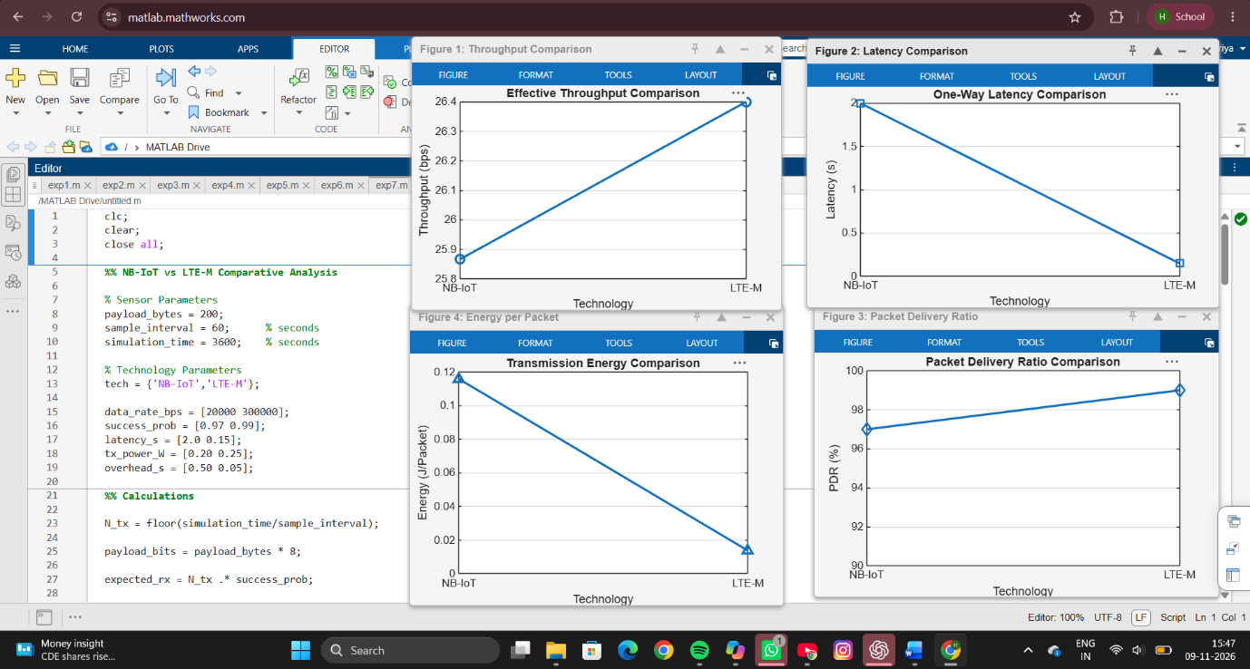
SAMPLE OUTPUT

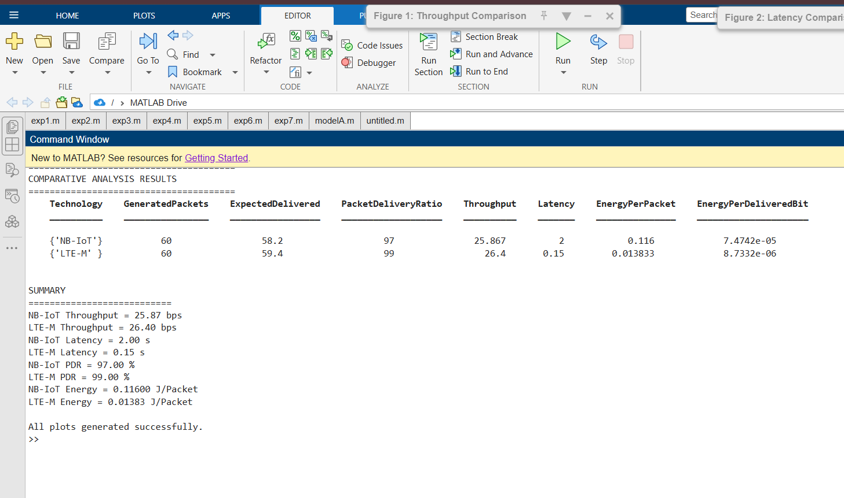
RESULT
The comparative analysis between NB-IoT and LTE-M was successfully performed using MATLAB. The results show that LTE-M achieved a higher throughput of approximately 26.4 bps compared to 25.9 bps for NB-IoT due to its higher data rate and packet delivery probability. LTE-M also exhibited significantly lower latency (0.15 s) than NB-IoT (2.0 s), making it more suitable for delay-sensitive IoT applications. The packet delivery ratio of LTE-M was slightly higher at 99%, while NB-IoT achieved 97%. In terms of energy consumption, LTE-M required approximately 0.014 J per packet, whereas NB-IoT consumed about 0.116 J per packet, indicating better energy efficiency for LTE-M under the given simulation conditions.
REFLECTION
This experiment provided valuable insight into the performance characteristics of two major cellular IoT technologies, NB-IoT and LTE-M. The analysis demonstrated that LTE-M offers better throughput, lower latency, higher reliability, and lower energy consumption, making it suitable for applications requiring mobility support and real-time communication. On the other hand, NB-IoT remains a practical solution for low-data-rate and delay-tolerant applications due to its simple network requirements and extended coverage capabilities. Overall, the experiment enhanced understanding of IoT communication technologies and highlighted the trade-offs involved when selecting an appropriate wireless technology for specific application requirements.

