Experiment Number: 2
MATLAB Simulation of Cellular Coverage, Cell Splitting and Handoff in a Multi-Cell Network
OBJECTIVES:
1. Model adjacent hexagonal cell coverage and identify cell centers and boundaries.
2. Estimate the number of cells required to cover a fixed service area for different cell radii.
3. Compare estimated users served under an explicit per-cell capacity assumption.
4. Simulate a mobile moving across a cell boundary and identify the serving-cell transition.
SIMULATION OUTPUTS:
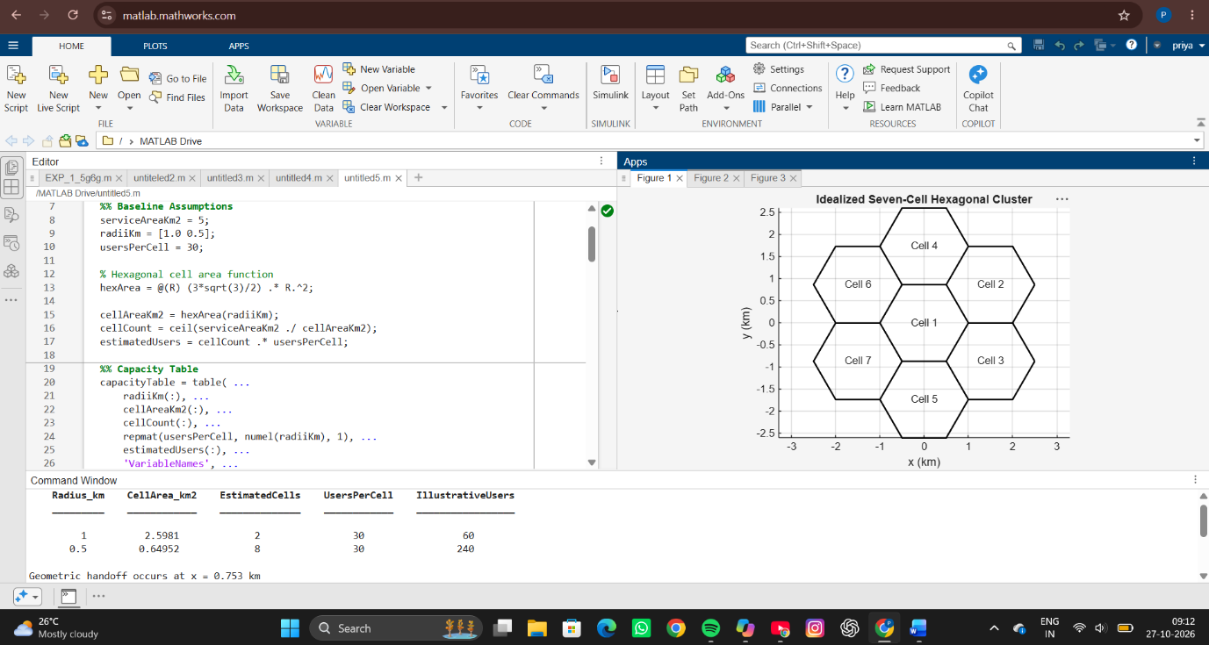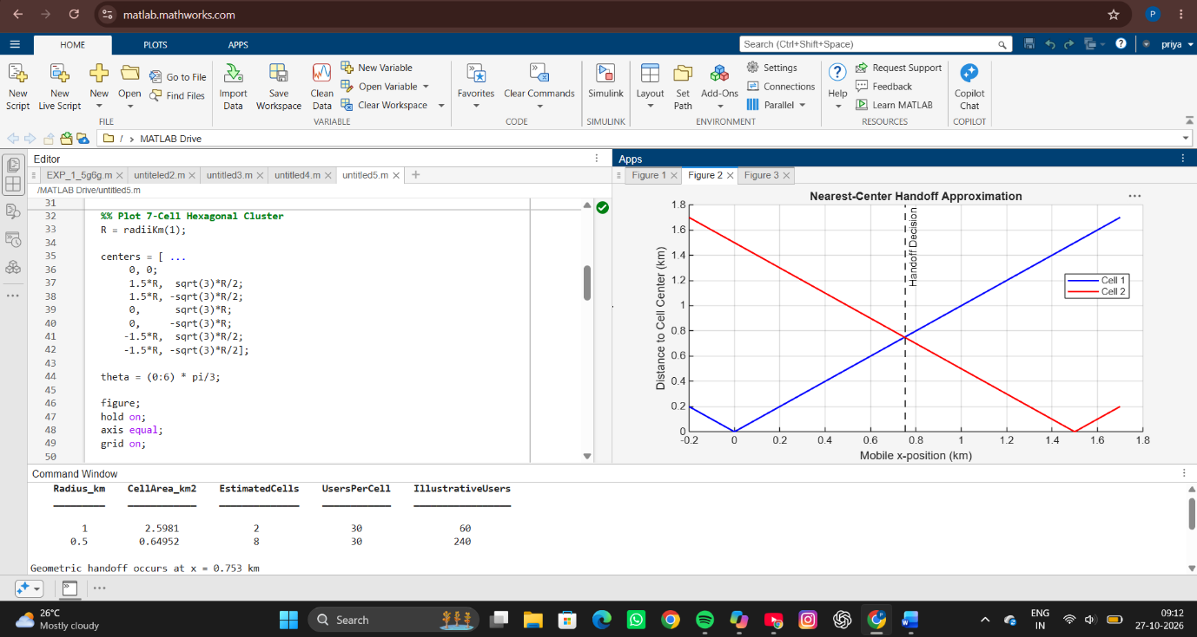
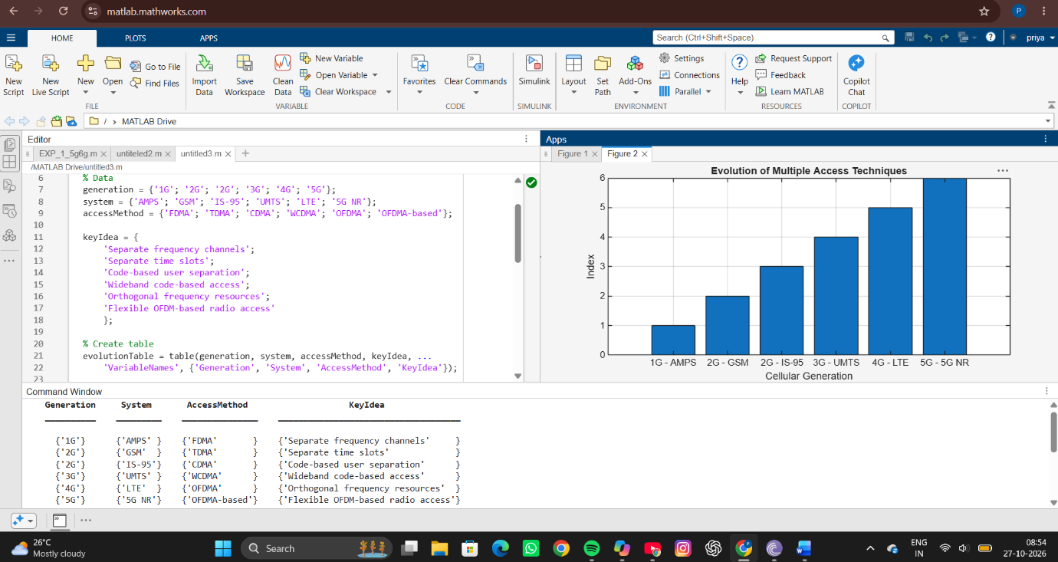
RESULT
The simulation of the hexagonal cellular system was successfully performed. For a service area of 5 km², a cell radius of 1 km required approximately 2 cells and supported 60 users, while a radius of 0.5 km required approximately 8 cells and supported 240 users. The seven-cell hexagonal cluster was generated to represent a typical cellular layout. The handoff analysis showed that as a mobile user moved between two adjacent cells, the serving cell changed when the neighboring cell became closer than the current serving cell. The distance and serving-cell graphs clearly illustrated the handoff process and identified the geometric handoff point.
REFLECTION
This experiment provided an understanding of cellular coverage planning and handoff mechanisms in mobile communication systems. The results showed that reducing cell size increases the number of cells and significantly improves the overall network capacity through cell splitting. The hexagonal model demonstrated efficient coverage with minimal overlap, while the handoff simulation illustrated how mobile users maintain continuous connectivity when moving between cells. Overall, the experiment highlighted the importance of cell planning and handoff management in achieving better capacity and seamless communication in cellular networks.

