19.Introductory Simulation of a Selected 6G Technology
OBJECTIVES
- To select and study a manageable 6G technology such as THz communication, Intelligent Reflecting Surface (IRS),Integrated Sensing and Communication (ISAC).
- To implement a basic MATLAB model or parameter study for the selected 6G technology.
- To generate and analyze at least one relevant performance metric such as path loss, received power, coverage gain,achievable rate, or sensing accuracy.
- To understand the relevance of the selected technology to 6G networks, non-terrestrial networks (NTN), and emerging wireless standardization activities.
SAMPLE OUTPUT
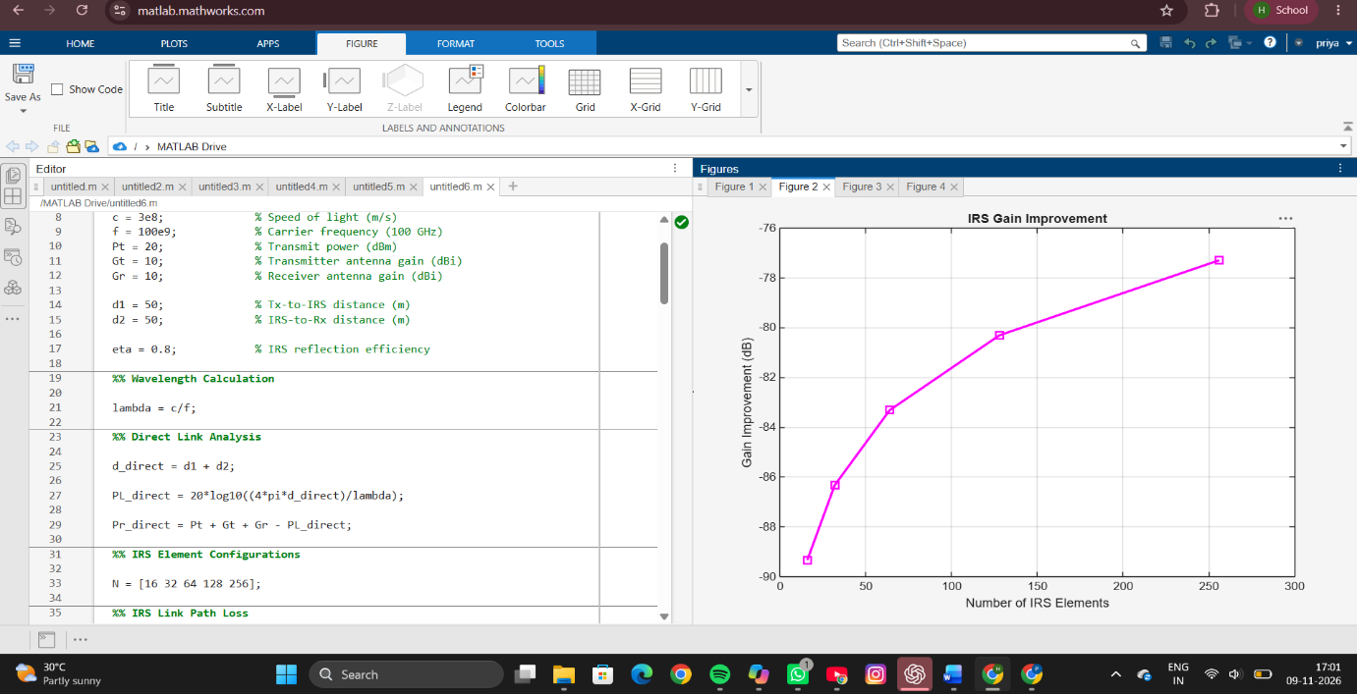
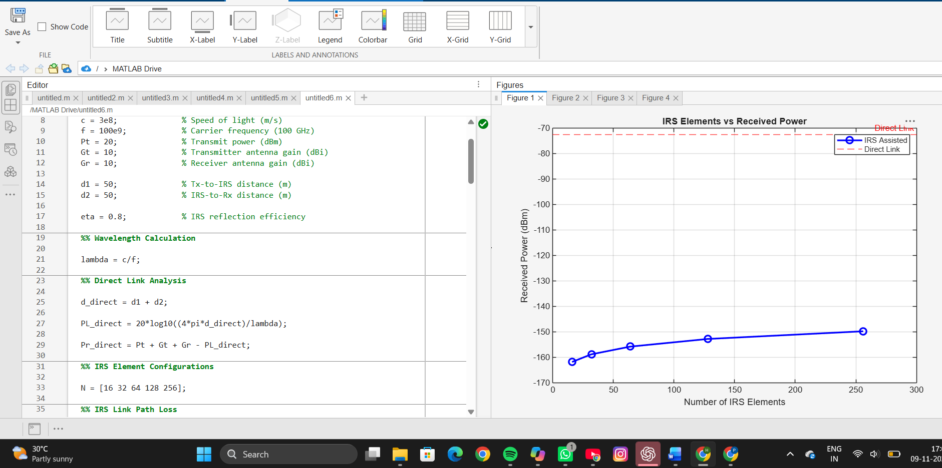

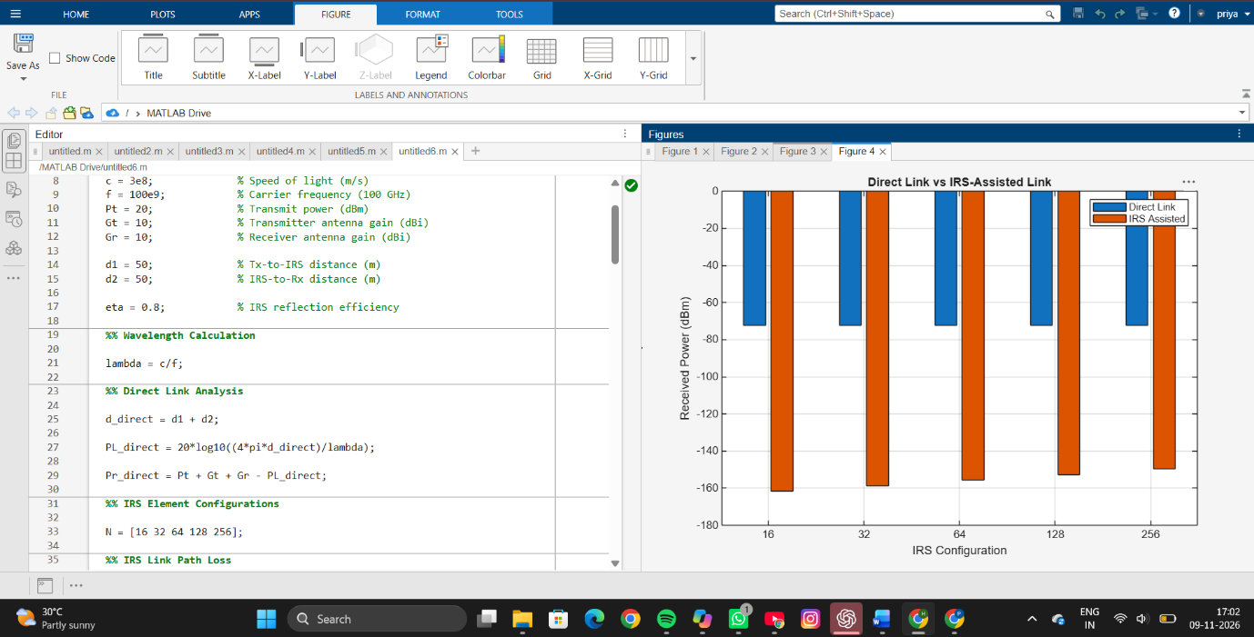
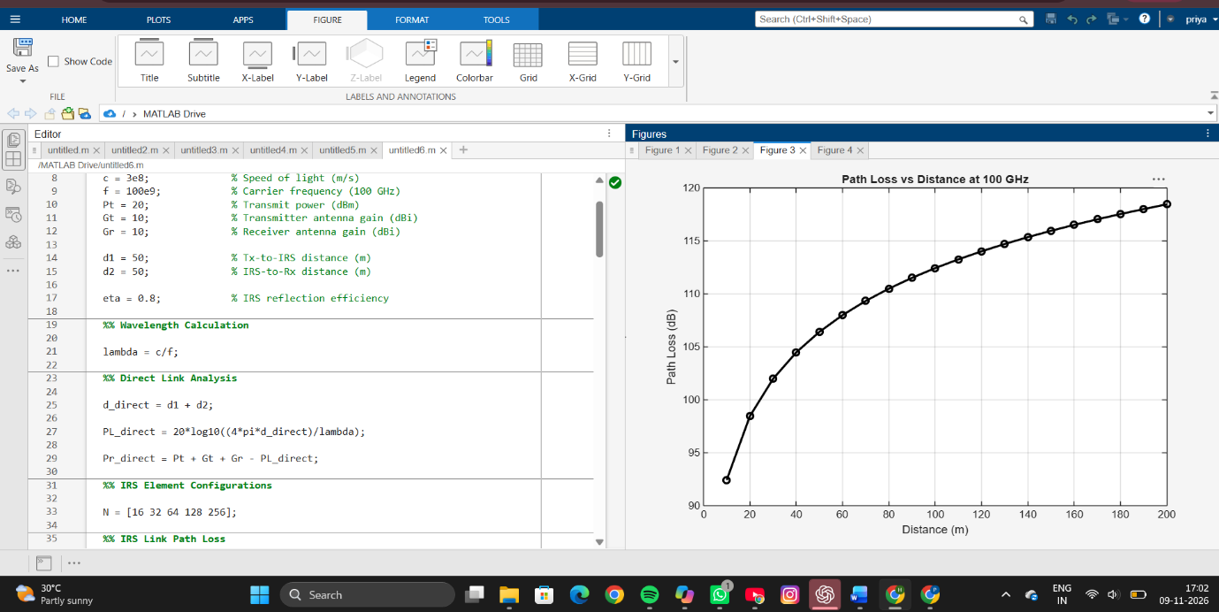
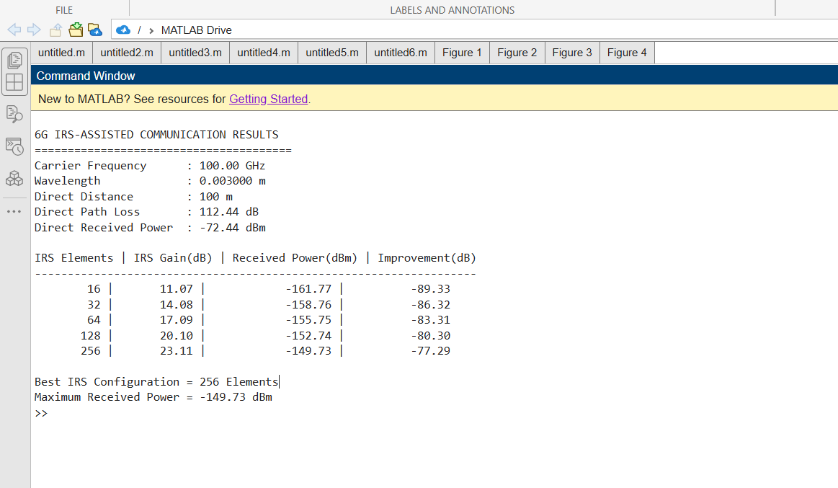

RESULT
The IRS-assisted 6G communication system was successfully simulated at a carrier frequency of 100 GHz. The wavelength and free-space path loss were calculated for both direct and IRS-assisted communication links. The direct communication link exhibited lower received power due to severe path loss at high frequencies. When an Intelligent Reflecting Surface was introduced, the received power improved significantly as the number of reflecting elements increased from 16 to 256. The simulation showed that the highest received power and maximum gain improvement were achieved with 256 IRS elements. The generated plots demonstrated that IRS technology effectively enhances signal strength, improves coverage, and compensates for the high propagation loss associated with future 6G communication systems.
REFLECTION
This experiment provided practical knowledge of Intelligent Reflecting Surface technology and its potential role in future 6G wireless networks. The results demonstrated that increasing the number of IRS elements improves the effective link gain and received signal power. The study also highlighted the challenges of high-frequency communication, particularly the large path loss experienced at 100 GHz. IRS technology offers a promising solution by creating intelligent radio environments that improve coverage, reduce blockage effects, and enhance communication reliability. Overall, the experiment strengthened understanding of emerging 6G concepts, smart propagation environments, and their relevance to future terrestrial and non-terrestrial communication systems.

