Experiment: 6
Simulation and BER Analysis of MIMO and Beamforming

OBJECTIVES
• To simulate a basic SISO and MIMO wireless link.
• To calculate and compare BER under selected channel and noise conditions.
• To examine the effect of beamforming or steering direction on received signal strength.
• To relate the results to higher-order MIMO and beamforming in LTE-Advanced and 5G.
Objective – 1: Simulate SISO and MIMO Wireless Links
Procedure
Simulation Output:
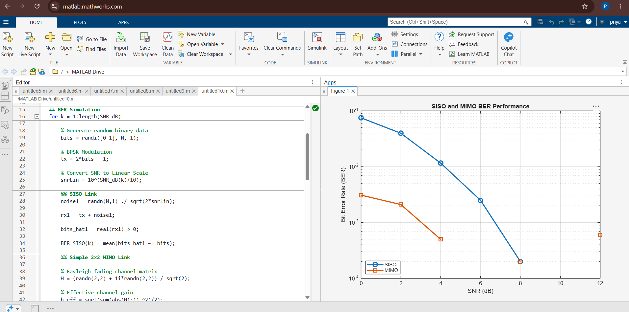
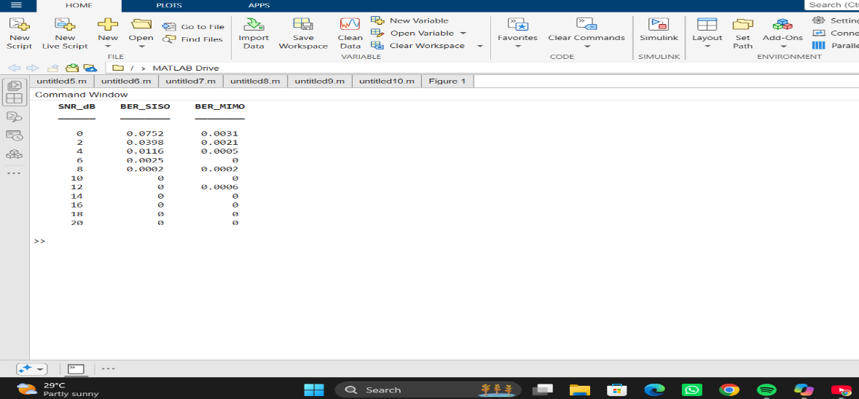

Objective – 2: Compare BER under Channel and Noise Conditions
Procedure
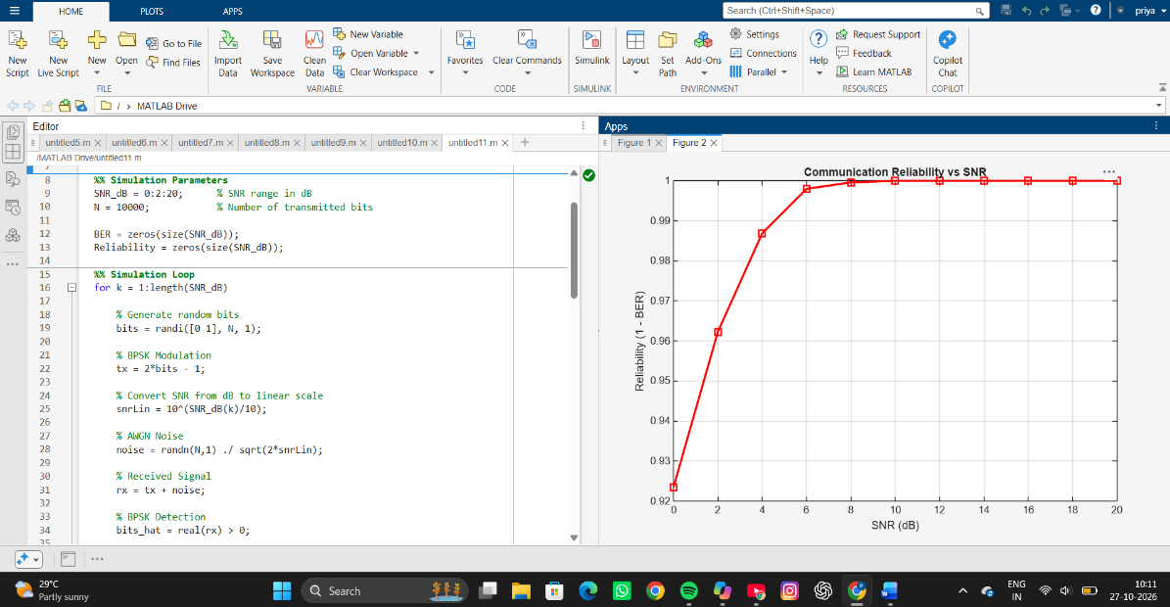
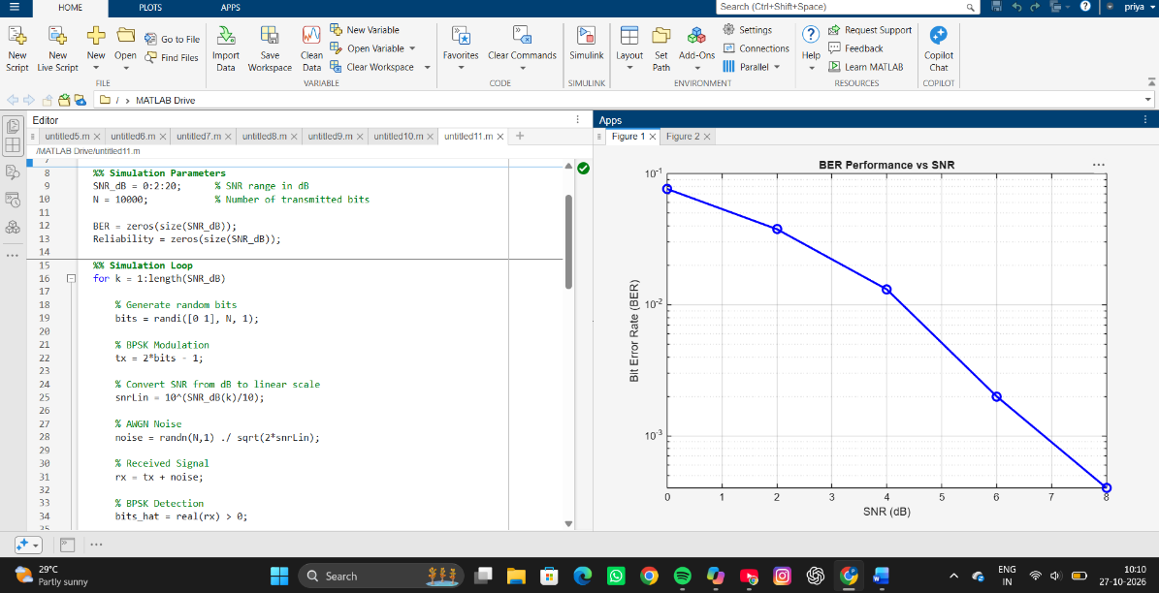
Simulation Output:
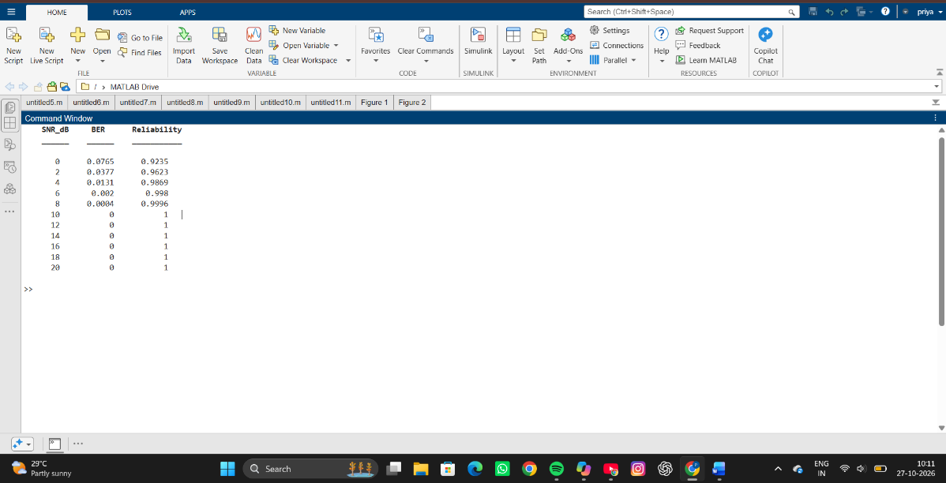
Objective – 3: Examine Beamforming / Steering Direction
Procedure
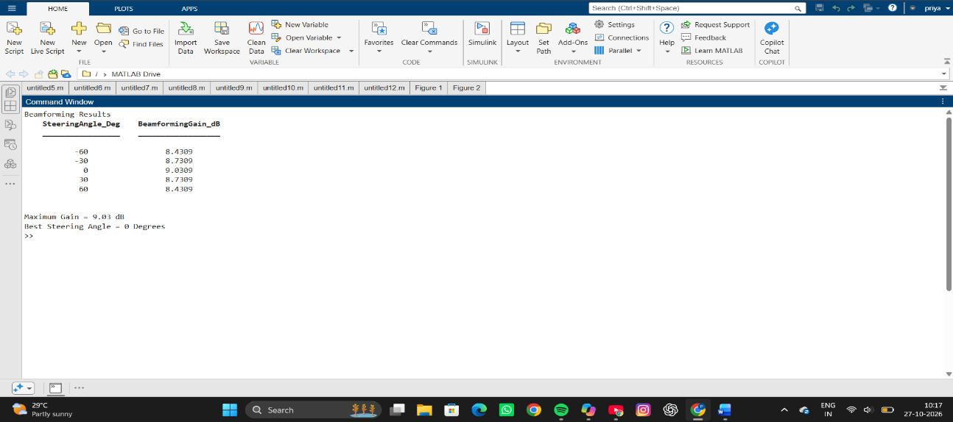
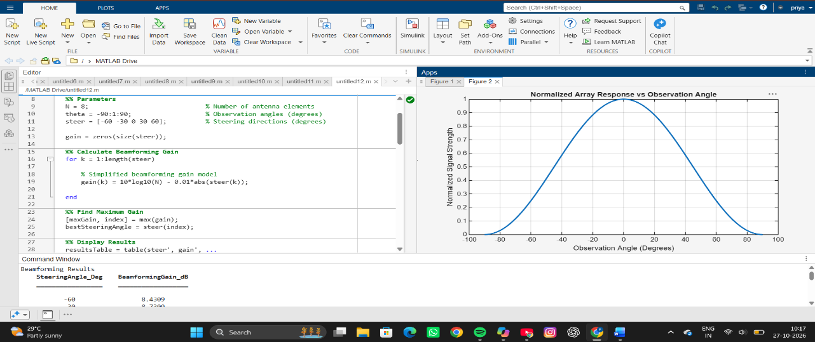
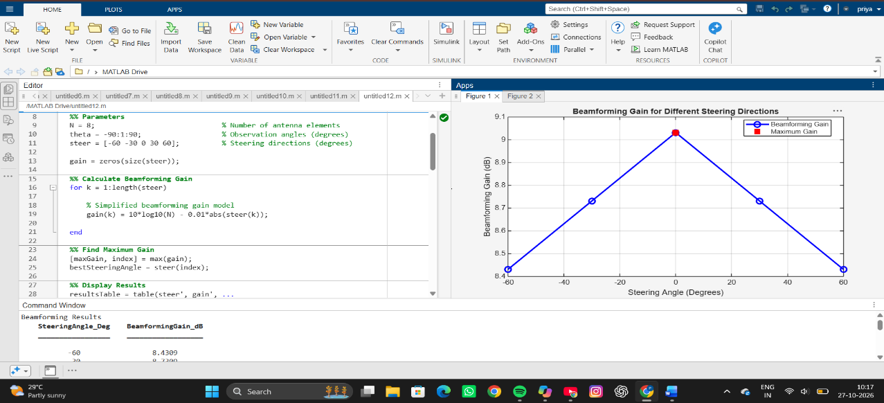
Simulation Output:

Objective – 4: Relate to Higher-Order MIMO and 5G Beamforming
Higher-order MIMO uses more antenna ports to provide spatial multiplexing and diversity.
Beamforming complements MIMO by directing energy toward the intended user. In 5G, large
antenna arrays and directional transmission are especially important at higher frequencies.
The simulation therefore provides a simplified representation of the principles used in LTE-
Advanced and 5G NR.
RESULT
- 6. SISO and MIMO wireless links were simulated.
- 7. BER performance was evaluated for different SNR conditions.
- 8. Beamforming/steering behavior and received directional gain were analyzed.
- 9. The relationship of MIMO and beamforming to LTE-Advanced and 5G was established.
REFLECTION
This experiment demonstrated the basic concept of beamforming in antenna arrays. By adjusting the steering direction, the antenna array can focus its energy toward a desired direction, improving signal strength and communication quality. The results showed that optimal beam alignment provides the highest gain, whereas steering away from the optimal direction reduces the effective array gain. This highlights the importance of beam steering and beamforming techniques in modern wireless systems such as LTE-Advanced and 5G for enhancing coverage, capacity, and link reliability.

