**GRADED ASSIGNMENT ON DOCKER**

Q1) Pull any image from the docker hub, create its container, and execute it showing the output.

Docker is a software platform to create, test and deploy applications in an isolated environment. Docker uses container to pack up an application with all of the parts it needs including, libraries and dependencies. It allows applications to use the kernel and other resources of the host operating system this will boost the performance and reduce the size of the application. Docker Hub is a centralized repository service that allows you to store container images and share them with your team. You can use Pull and Push command to upload and download images to and from the Docker Hub.

**Docker version command**

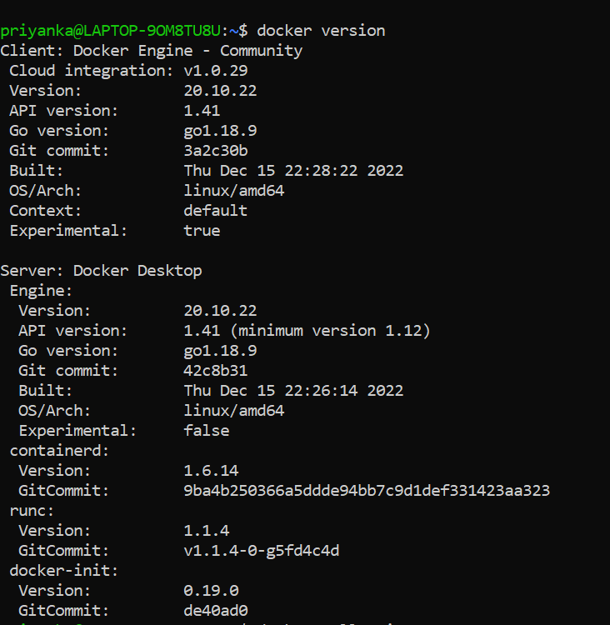

**Step1:**

We can pull the image from the Docker hub using the docker pull image name. Let us download the image called nginx from the Docker hub. Once the nginx image is downloaded, we get the following output.

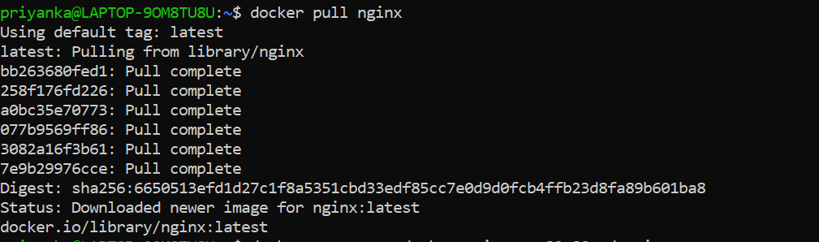

**Step2:**

Now create a new nginx container from the downloaded image and expose it on port 80 using the following command.

docker run --name docker-nginx -p 80:80 -d nginx



**Step3:**

We can also verify the nginx container with the below command. docker ps we will get the following output.

It will show the container-id.



**Step4:**

We can connect to the running container with the following command.



Now we are connected to the running container.

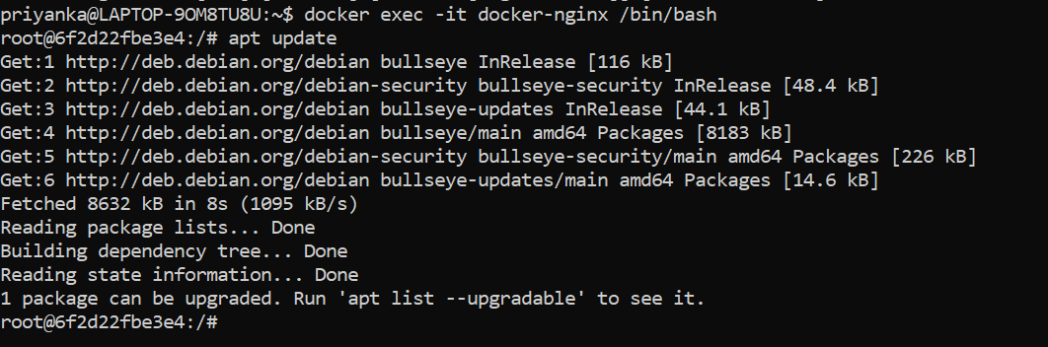

Q2) Create the basic java application, generate its image with necessary files, and execute it with docker. Creating the basic java application.

**Step 1:**

Create a directory, it is used to store the files.

**Step 2:**

Go to the directory that you have created.

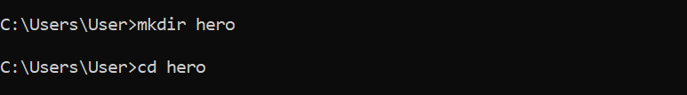



**Step 3:**

Create a java file, save it as sample.java

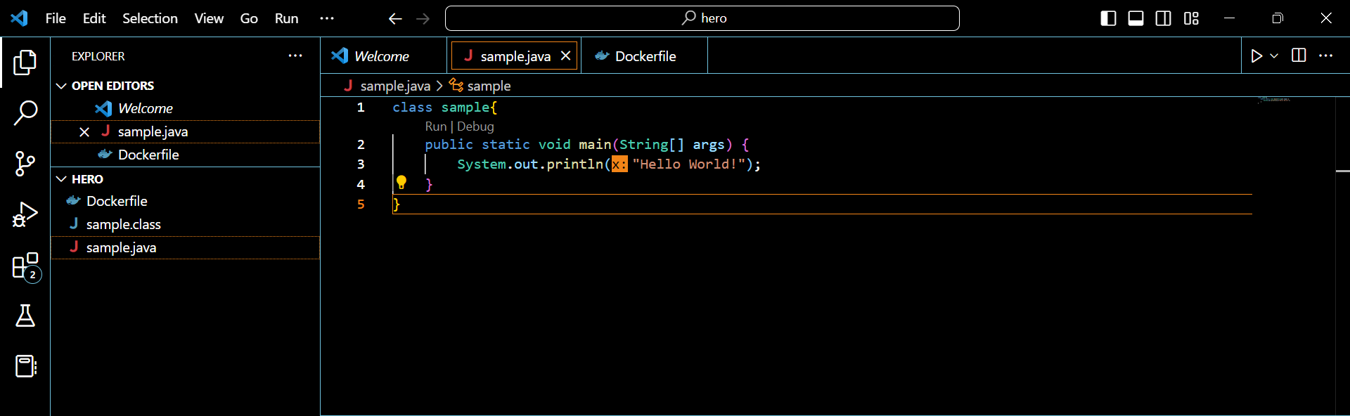

**Step 4:**

Create a docker file.

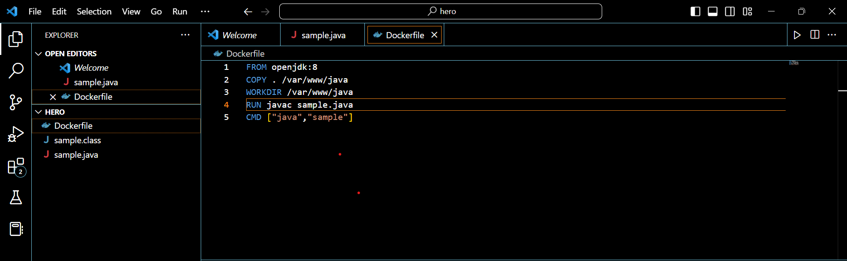

**Step 5:**

Now create an image by following below command. We must login as root in order to create a image. In the following command ,java-app is name of the image. We can have any name for our docker image.

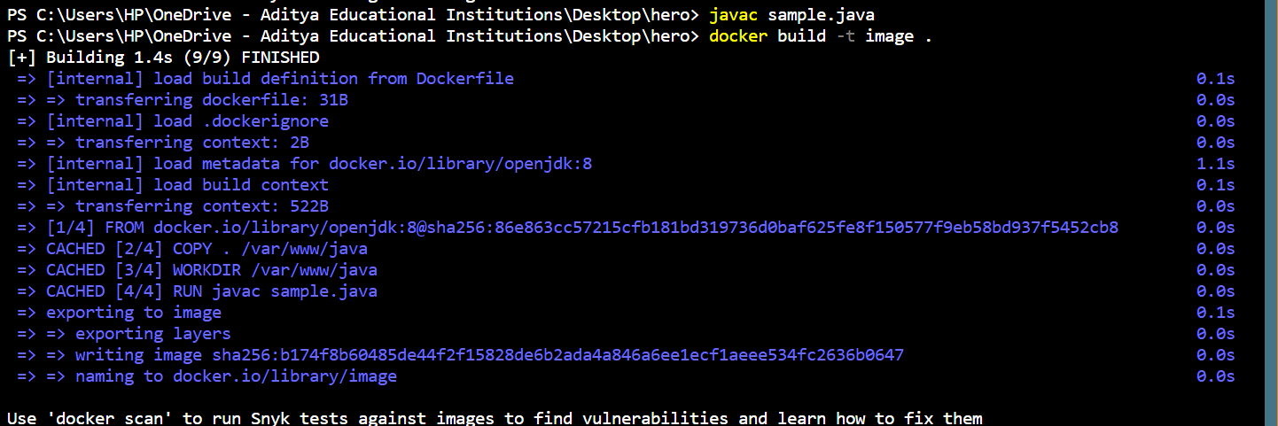

**Step 6:**

After successfully building the image, now we can run the image by using docker run command.

