**Yemen civil war: A case of an unending war and suffering**

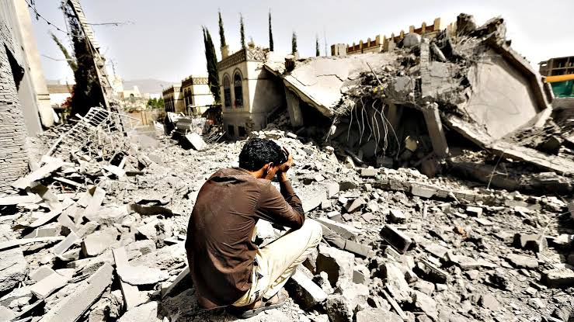

Yemen has been engulfed in a horrendous civil war since the past five years which has led to a massive humanitarian crisis in the country. Millions have been displaced and hundreds of thousands have lost their lives, but the war is still ravaging the cut try incessantly. However, the political developments of the past few decades in the country had been pointing out all the time to something disastrous yet to come.

In 1978, Ali Abdullah Saleh took the office for the President of Yemen. However, in his reign corruption was rampant and most high level offices were taken by Saleh's relatives. It was also during his time in the office as President that North and South Yemen unified into one state in 1990. But the southern separatists displayed hostility towards the North whom they blamed for discriminating against the South and taking its resources by force. The separatist movement only expanded with time.

Moreover, in the late 1990s, Zaydi Shia Muslim minority also formed a group known as the Houthi group whose rebels became neighbourly with the Shia ruled Iran. For many years, the Houthi forces constantly demonstrated force under Saleh's Yemen.

In 2011, livid Yemeni citizens protested against Saleh's incompetent government and also demanded his resignation. Saleh did not give his resignation although he gave economic concessions which he thought could buy out the pro-democracy protestors. The protestors were victims of violence by security forces but eventually, Saleh had to transfer powers to the then Vice President, Abdrabbuh Mansour Hadi who was to oversee a democratic transition in the country.

But Hadi's government was weak and ridiculed with corruption. And to make things worse for Hadi, the Houthi forces had started their fight with rebellions which aimed at snatching territories from the government. They even received support from ordinary citizens including Sunni Yemenis.

The Houthis successfully took over the capital city of Yemen, Sanaa in early 2015. Saleh and his loyal forces allied with the Houthis to regain power, but couldn't do so. Although they managed to drive away the government from key cities which further led to Hadi moving out of the country.

Saudi Arabia, then formed a coalition force comprising of other Sunni ruled Arabic nations as they were concerned about the uprising of the Houthis and believed that they were being supported by Iran. Thus, began the monstrous war between the Houthis and the Saudi led forces, which were on the other hand supported by the US and UK.

The Houthis attempted to conquer more land, whereas the coalition forces aimed at restoring Hadi's internationally recognised government. But the government could only be temporarily established in the southern part of Yemen, Aden.

Many political analysts and experts stated that the war was to extinguish shortly in the future, but little did they know that Yemen would witness a war which for many Yemenis would be 'never ending'.

Air strikes were common from both the sides with heavy casualties being observed.

Even the alliance between Saleh and the Houthis came to an abrupt end in 2017 when Saleh was ultimately killed. In 2018, the coalition forces tried to take over the Red Sea city of Hodeidah, the port of which plays an imperative role in the supply line for most Yemenis. However, it failed.

The Stockholm agreement which was brokered by the U.N to ensure ceasefire between the Houthis and the coalition forces, also couldn't hold up the truce.

Further in 2019, an attack on the eastern oil fields of Saudia Arabia which disrupted nearly half of the theocratic nation's oil supply only exacerbated the entire situation. The Houthis were quick to claim responsibility for the attack. However, the kingdom of Saudi believed it was committed by their bitter rival Iran whom they had previously accused of supplying weapons to the Houthis to constantly wage war on the forces. However, Iran denied such allegations.

Soon after, Saudi's key ally UAE also withdrew its forces from Yemen after facing backlash from the international community. UAE presently backs the Southern Transitional Council (STC) which was formed in 2017 with an aim to establish an independent South Yemen state. The STC has supported southern separatists for rebelling against Hadi's government.

Saudi Arabia has constantly tried to broker a deal between the STC and the recognised government. But in April this year, the STC declared a self rule in Aden which has severely altered relations between the groups involved in this civil war.

Today, Yemen's geographic landscape is entirely stitched by territories of the Houthis, STC, Anti-Houthi forces and the Yemeni government indicating the scale of conflicts within conflicts that have drowned the Yemenis. The United Nations has been constantly asking for donations and funding for their operations in Yemen.

What was thought of as a short termed conflict has escalated into a full blown warfare which has led to the world's worst humanitarian crisis. As per U.N, air strikes by Saudi led forces alone killed around 7,700 people till March 2020. But various American reports suggest that the casualties in the civil war might be even more than 1,00,000. More than 3.65 million people have been displaced and hundreds of thousands of children malnourished and exposed to diseases such as cholera, etc. With no adequate health facilities, the future of Yemenis is bleak and still hangs into uncertainty. The human cost of this war is overlooked by other nation states for whom this war is a fight to display strength and power over their rivals.

This war appropriately resonates with the final scene of David Lean's masterpiece *The Bridge on the River Kwai* (1957), where the army doctor (played by James Donald) throws out the word 'Madness' at each step after witnessing war and what it can drive humans to do.

The Yemen civil war will go down as another fine example of how war doesn't produce any victors but only paves way for human suffering. A lesson still unlearnt by us.