QualityGrid Automations — Workflow Reference
Four n8n workflows work together as one pipeline. Here's how they chain:
- v4.0A (Start Run) — runs Playwright tests, sends each result to v4.0B
- v4.0B (Receive Results) — LLM judges Pass / Fail / Needs Review, writes to the Google Sheet, and calls the Jira Dedup workflow on a confirmed Fail
- v4.0C (Manual Review Resolution) — fires when a human resolves a "Needs Review" row in the Sheet, and also calls the Jira Dedup workflow
- Jira Dedup (shared by v4.0B and v4.0C) — checks if a bug already exists for this test case, then comments on it or creates a new one
The reason there are four workflows instead of one giant one: each has a different trigger and a different job. Splitting them means the Jira dedup logic is written once and reused by both the automated path (v4.0B) and the human-review path (v4.0C), instead of copy-pasted twice.

1. v4.0A — Start Run
Job: Pull ready test cases from the sheet, run them in the browser, hand off each result
Trigger: Manual (a teammate clicks "Execute workflow"). A Google Sheets trigger is present too, but runs are manually kicked off by design — so a bad browser session or tunnel restart doesn't silently keep firing

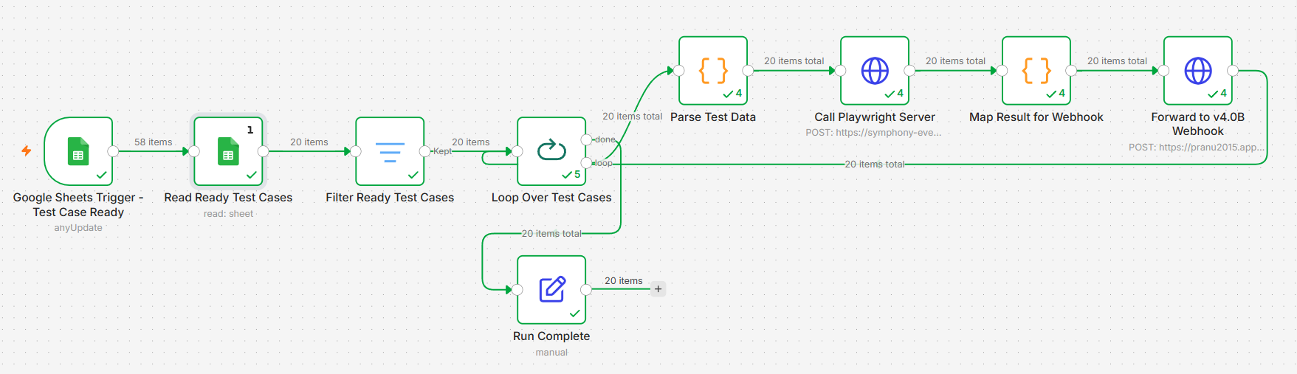

Node | Why it's there | What it does
Google Sheets Trigger – Test Case Ready | Watches for new test cases being added | Polls 02_Generated_Test_Cases for changes (present for future automation; today's runs are manual)
Read Ready Test Cases | Need the actual test case data | Reads all rows from 02_Generated_Test_Cases filtered to the Login module
Filter Ready Test Cases | Only run tests that are actually ready | Keeps rows where Status = Draft
Loop Over Test Cases | Playwright can't run 20 browsers at once reliably | Batches test cases (5 at a time) instead of firing everything simultaneously
Parse Test Data | Sheet data is a human-readable string, Playwright needs structured input | Converts "Key: Value, Key: Value" text into a proper object
Call Playwright Server | This is where the actual browser test happens | POSTs each test case to the local Playwright service (via Cloudflare tunnel), gets back Pass/Fail evidence and a screenshot path
Map Result for Webhook | v4.0B expects a specific shape | Packages the Playwright result together with the original test case metadata (Story ID, Unique Test Case Key, duration)
Forward to v4.0B Webhook | Hands the result off for AI judgment | POSTs to v4.0B's webhook, one at a time, and waits for it to fully finish before sending the next
Run Complete | Confirms the batch finished | Sets a completion message and timestamp

2. v4.0B — Receive Results
Job: Take a raw test result, get an AI verdict on it, write it to the sheet, and raise a bug if it failed
Trigger: Webhook, called by v4.0A. Always-on / published

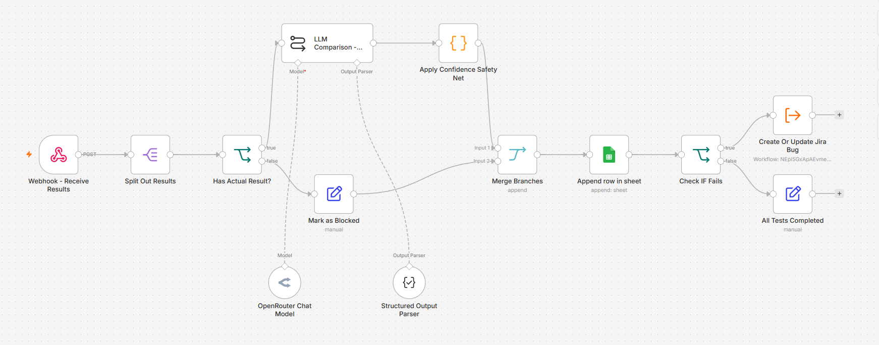

Node | Why it's there | What it does
Webhook – Receive Results | Entry point for every test result | Receives the POST from v4.0A; deliberately waits for the whole workflow to finish before responding, so v4.0A never moves on before this one is actually done
Split Out Results | Results arrive wrapped in an array | Unwraps body.results into a single item to work with
Has Actual Result? | A crashed test shouldn't get judged like a real one | Checks if Playwright actually returned an Actual Result; routes crashed/empty results away from the LLM entirely
LLM Comparison | This is the AI verdict step | Sends Expected Result vs. Actual Result to the LLM, which returns Pass / Fail / Needs Review, a confidence score, and its reasoning
Mark as Blocked | Handles the "no result" case from above | Marks the row as Blocked instead of guessing, so it's flagged for a human to look at
Apply Confidence Safety Net | Don't trust a low-confidence AI verdict | If confidence is below 70%, the verdict is downgraded to Needs Review regardless of what the AI said
Merge Branches | Two paths (judged / blocked) need to become one again | Recombines both branches before writing to the sheet
Append row in sheet | This is the system of record | Writes the final result — status, confidence, screenshot path, duration — to 03_Execution_Results
Check IF Fails | Only real failures should hit Jira | Routes to bug creation only when Execution Status is exactly Fail — Pass, Needs Review, and Blocked don't spam Jira
Create Or Update Jira Bug | Reuses shared logic instead of duplicating it | Calls the Jira Dedup workflow
All Tests Completed | Final acknowledgment | Confirms the result was fully processed

3. v4.0C — Manual Review Resolution

Job: When a human resolves a "Needs Review" test case as a Fail, send it through the exact same Jira logic as an automated failure

Trigger: Webhook, called directly by the Google Apps Script attached to the sheet — fires only when someone picks "Fail" in the Manual Verdict dropdown on a row still marked Needs Review

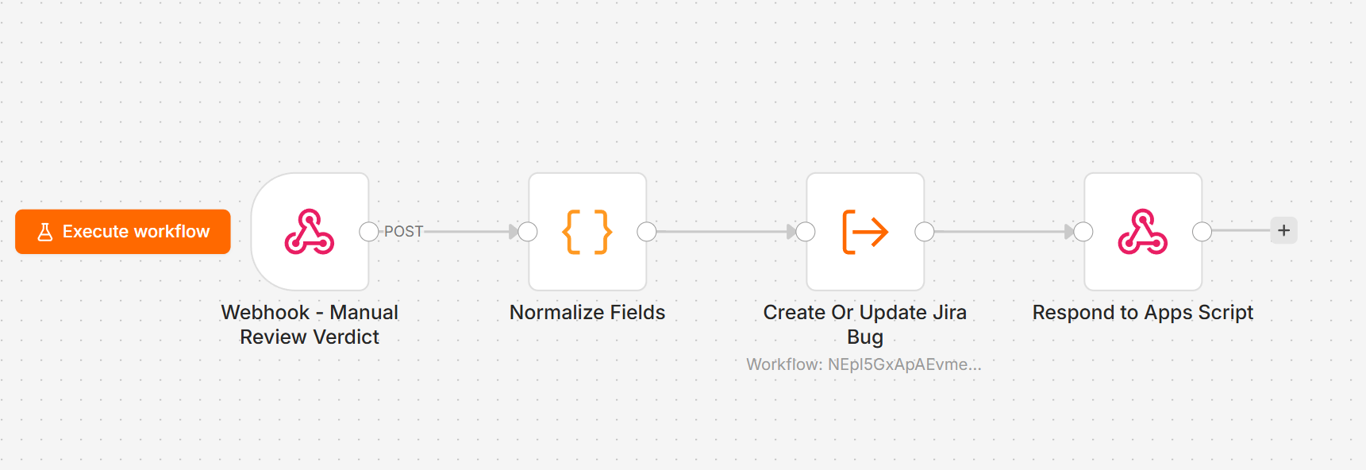

Node | Why it's there | What it does
Webhook – Manual Review Verdict | Entry point for human decisions | Receives the POST from Apps Script when a reviewer marks a row Fail
Normalize Fields | Jira Dedup workflow expects one consistent shape | Reshapes the Apps Script payload to match what v4.0B also sends, and tags Source: Manual Review so it's traceable later
Create Or Update Jira Bug | Same rule as v4.0B: don't duplicate logic | Calls the same shared Jira Dedup workflow
Respond to Apps Script | Apps Script is waiting on a response | Sends confirmation back so the reviewer's browser doesn't hang

Why this exists as its own workflow instead of folding into v4.0B: it has a completely different trigger (a spreadsheet edit, not a test run) and a different source of truth (a human's judgment, not the LLM's). Keeping it separate means a manual review never has to fake being an automated test result.

4. Jira Dedup — Create Or Update Jira Bug
Job: Given a failing test case, decide: comment on an existing open bug, or create a new one. Shared by both v4.0B and v4.0C
Trigger: Called by another workflow (not directly by anything external)

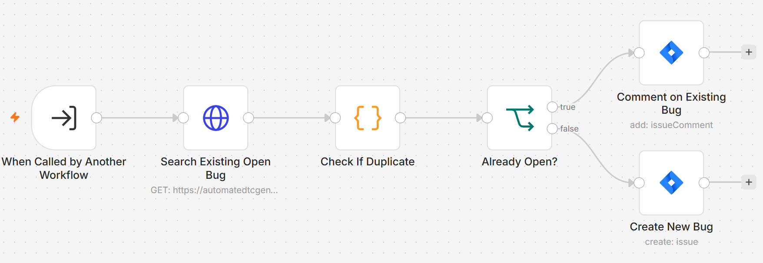

Node | Why it's there | What it does
When Called by Another Workflow | Defines the contract | Declares the inputs this sub-workflow needs (Test Case ID, Story ID, Unique Test Case Key, results, Source, etc.)
Search Existing Open Bug | Prevents duplicate tickets | Searches Jira for an open bug already labeled with this exact test case's key
Check If Duplicate | Turns the search result into a decision | Sets a flag: does a matching open bug already exist?
Already Open? | Routes based on that flag | Branches to "comment" or "create new"
Comment on Existing Bug | Keeps history instead of noise | Adds today's failure details as a comment on the already-open ticket
Create New Bug | Only when truly new | Creates a fresh Jira bug, labeled with the Unique Test Case Key so future runs can find and dedupe against it

Why deduplication matters: without it, running the same 20 test cases twice would create 20 duplicate tickets every single run. The label-based search means a bug for TC011 gets one ticket that accumulates comments over time, not a new ticket every time it fails again.

2-Minute Loom Script
Aim for ~280 spoken words. Suggested flow, screen-recording the n8n canvas as you talk:

1. Hook (15s)
"This is QualityGrid — an automated QA pipeline that runs real browser tests, gets an AI verdict on each one, and only escalates to a human when the AI isn't confident. It's four connected workflows."

2. v4.0A (25s)
"This one starts the run. It pulls test cases marked ready from a Google Sheet, batches them, and runs each one through Playwright — real browser automation, checking UI, login flows, security inputs like XSS and SQL injection, accessibility. Each result gets forwarded to the next workflow."

3. v4.0B (35s)
"This is the core of the system. It takes the raw result and asks an LLM: does the actual outcome match what we expected? The AI returns a verdict plus a confidence score — and here's the important part — if that confidence is low, we don't trust the AI's answer. It gets downgraded to 'Needs Review' automatically. Everything gets logged to the sheet, and confirmed failures automatically raise a Jira bug."

4. Jira Dedup (30s)
"Before creating a bug, it checks if one's already open for that exact test case. If it is, it just adds a comment instead of creating a duplicate. Run the same 20 tests every day and you get one ticket per real bug, not twenty duplicates."

5. v4.0C (25s)
"And this is the human-in-the-loop piece — when a test gets flagged 'Needs Review,' a reviewer just picks Pass or Fail in a dropdown on the sheet. If they say Fail, it runs through the exact same Jira logic, so a human's judgment gets treated with the same rigor as the AI's."

6. Close (10s)
"AI proposes the verdict. A person still gets the final say."

