Program Execution:

As mentioned, I must only focus on the task given to me, I have added functionality to transfer money from one account to another in a very simple way. Below execution tested and implemented with Gradle.

1. we must create some accounts using endpoint (http://localhost:8080/v1/accounts)
2. We need to verify if account is created using getAccount endpoint by providing input accountId.
3. To transfer Money, I have added one endpoint which will take fromAccount, toAccount and amount to transfer.
4. Added test classes for controller and service class
5. Please note some modification with annotation has been made as per requirement to execute and test.

Please see below set by step process with unit Testing:

1. Server started:

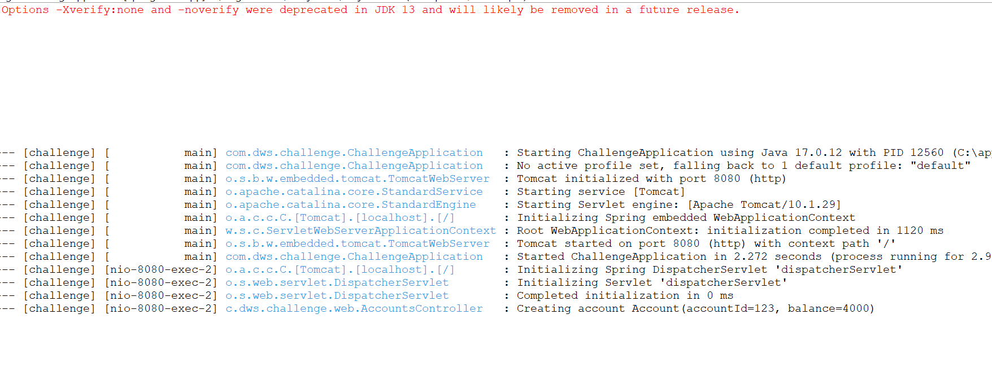

1. Created account id 123 with balance 4000: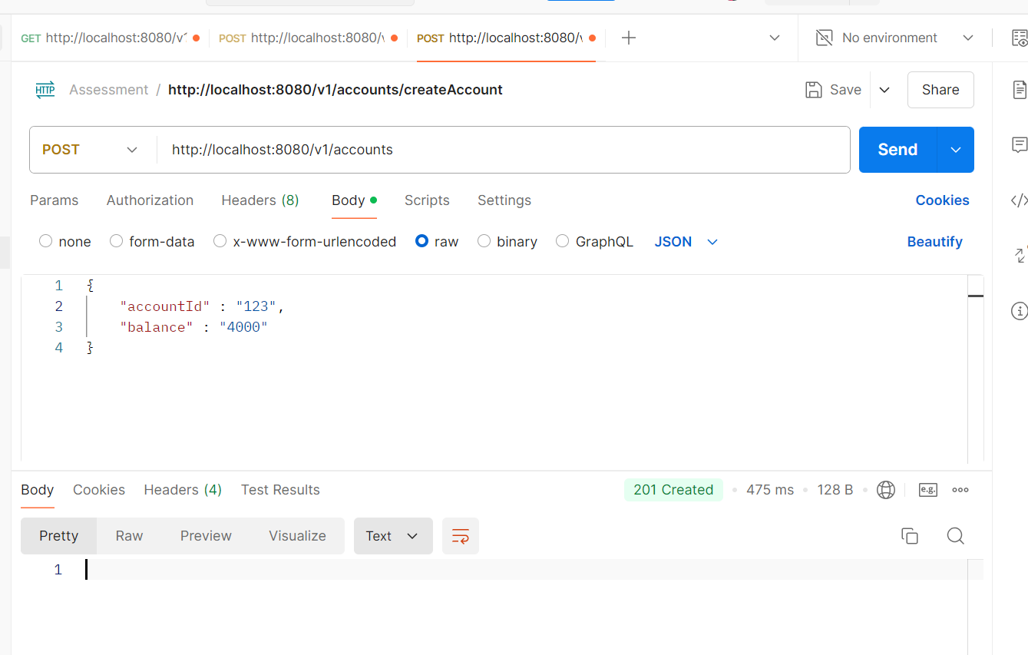
2. Created another account with id 456 and balance 6000:

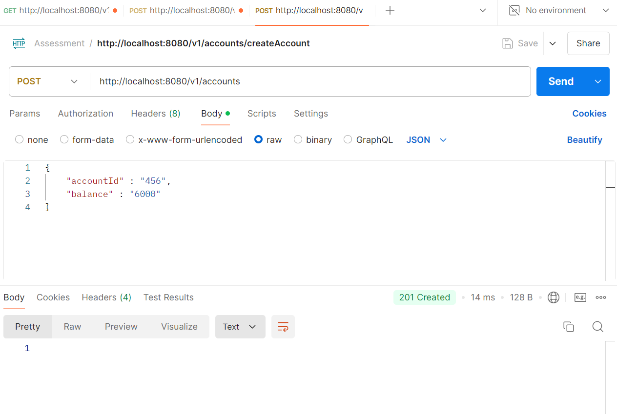

1. Get endpoint called to check both account details:

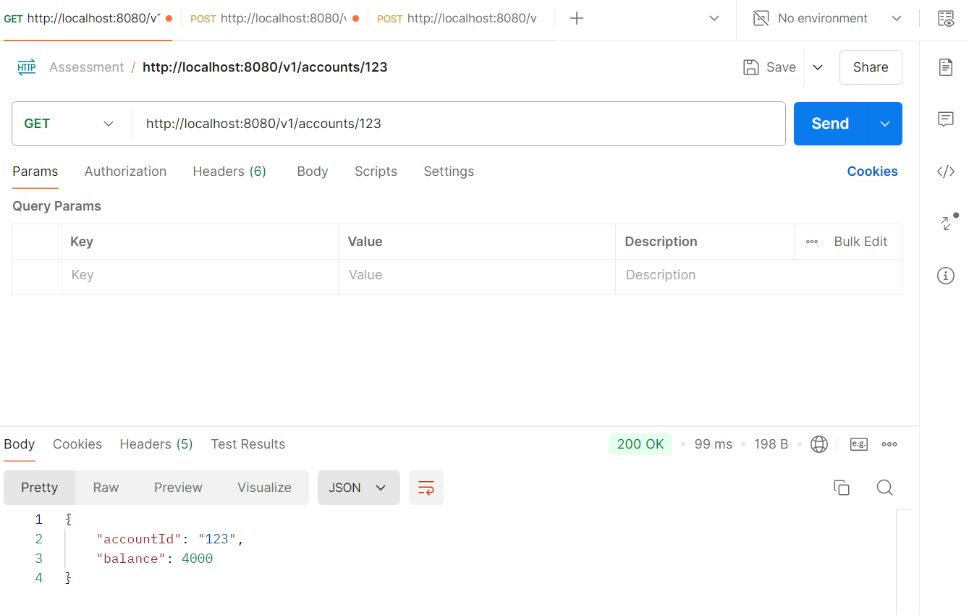

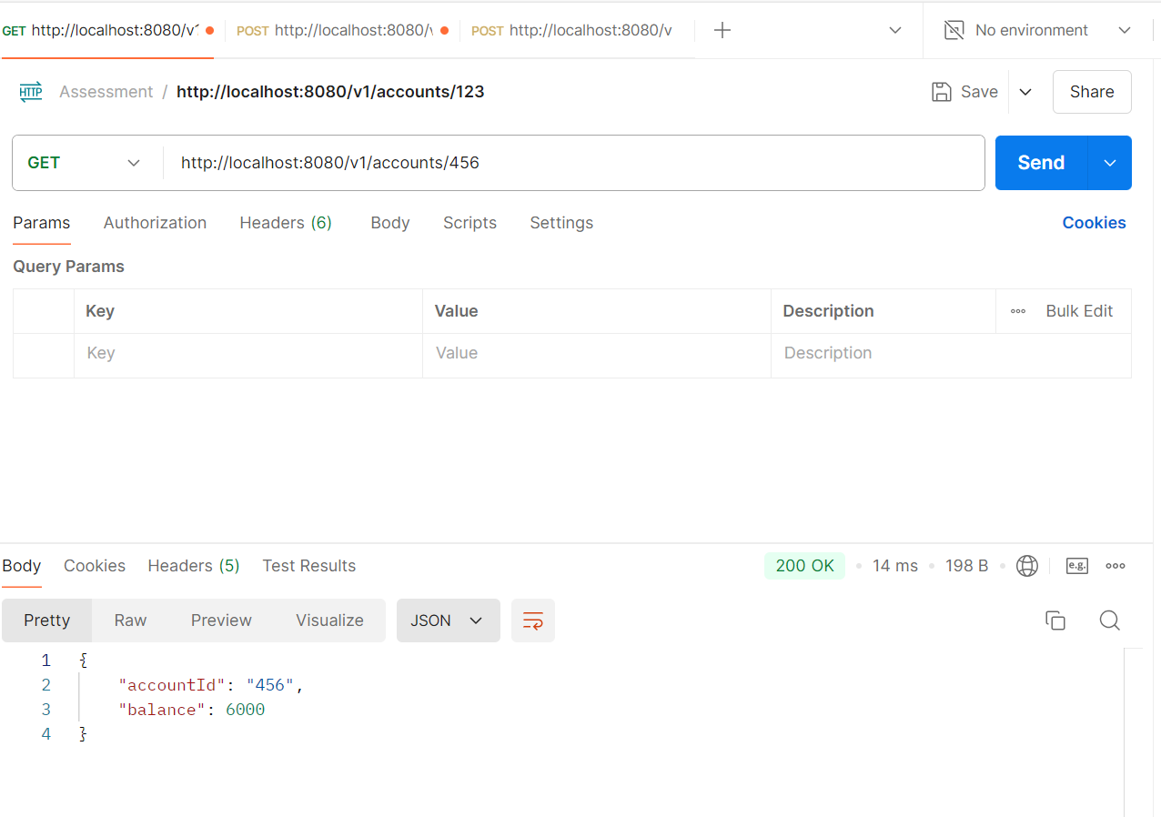

1. Transfer amount from account to another:

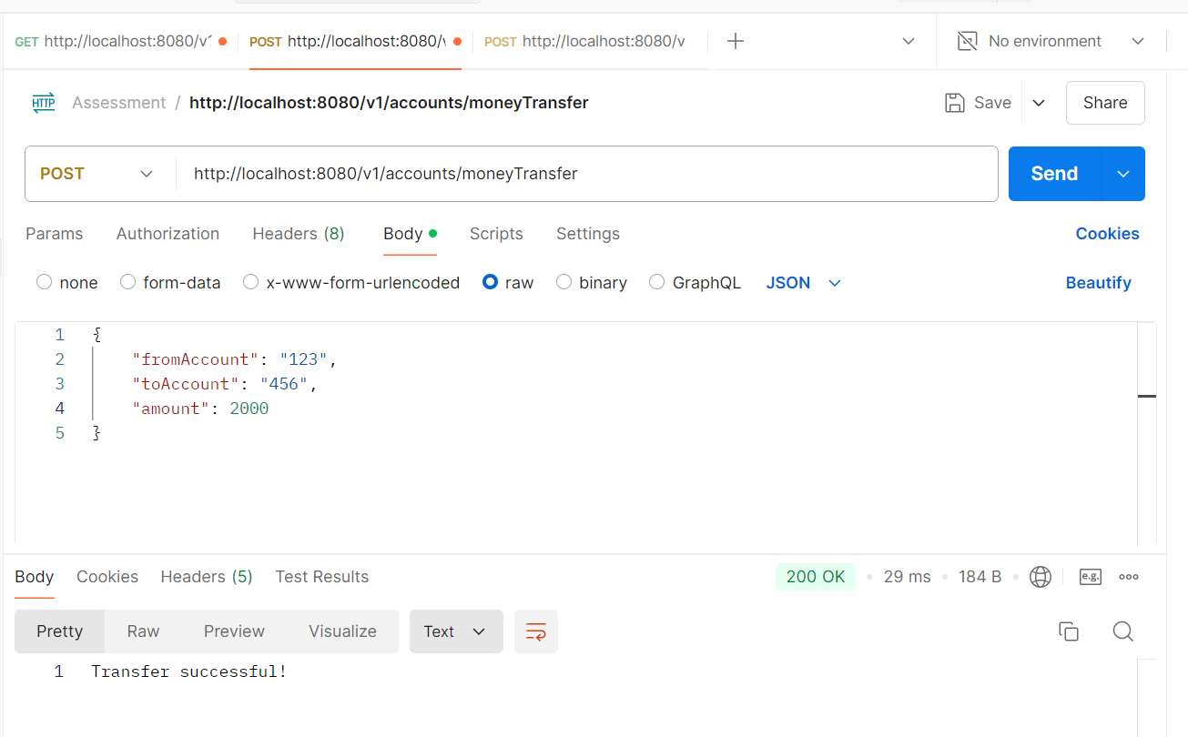

1. Give error for insufficient balance:

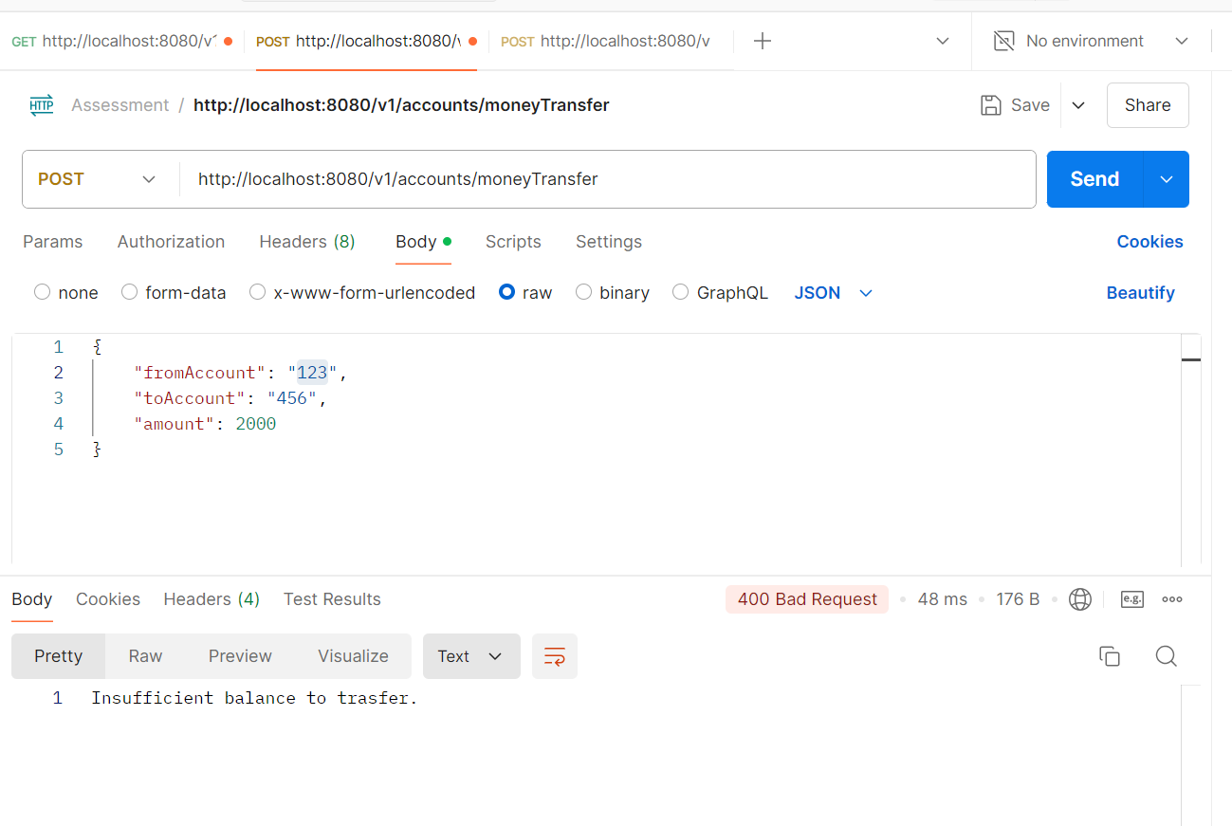

1. Give error when account is invalid

