**Ideation Phase**

**Brainstorm & Idea Prioritization Template**

|  |  |
| --- | --- |
| Date | 24 June 2025 |
| Team ID | LTVIP2025TMID35452 |
| Project Name | Smart Sorting: Identifying Rotten Fruits and Vegetables Using Transfer Learning |
| Maximum Marks | 4 Marks |

**Brainstorm & Idea Prioritization Template:**

**Step-1: Team Gathering, Collaboration and Select the Problem Statement**



**Step-2: Brainstorm, Idea Listing and Gro**

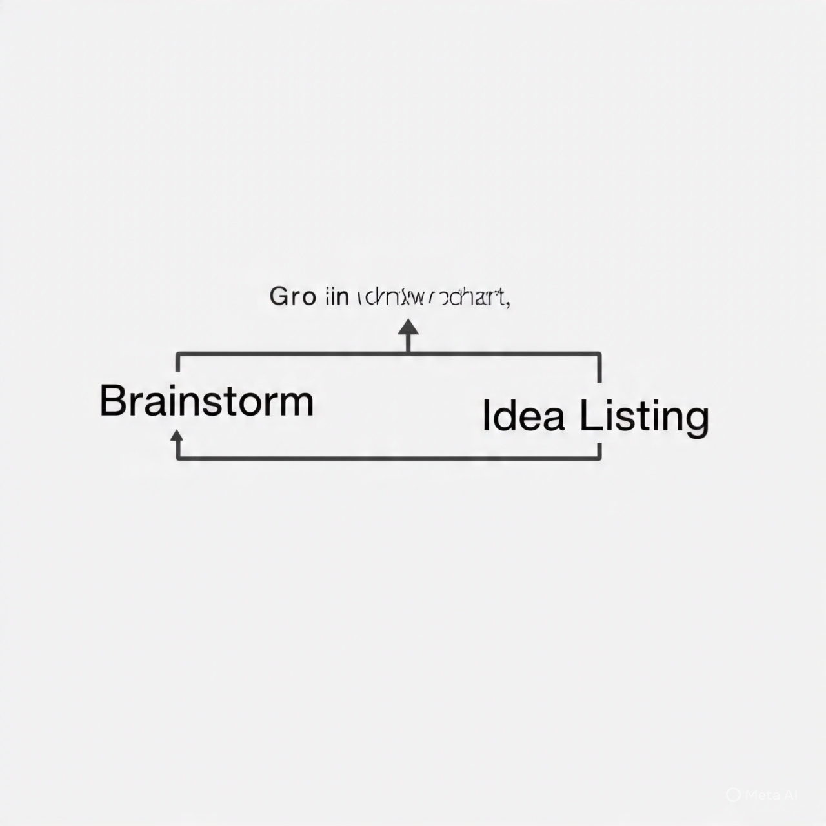

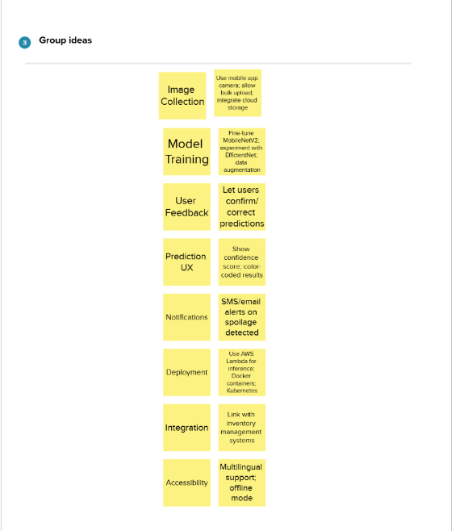

**Step-3: Idea Prioritization**

