Qn.20.

1. **console.log();**

This method allows to write a message to the console

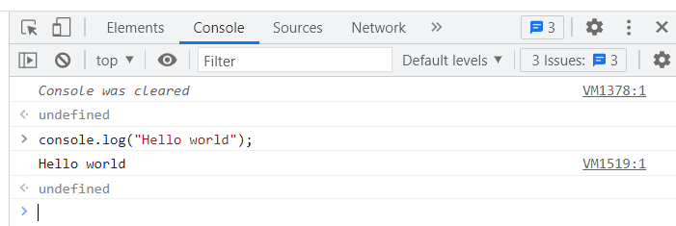

1. **console.dir();**

This method allows to write the message directly on the console.

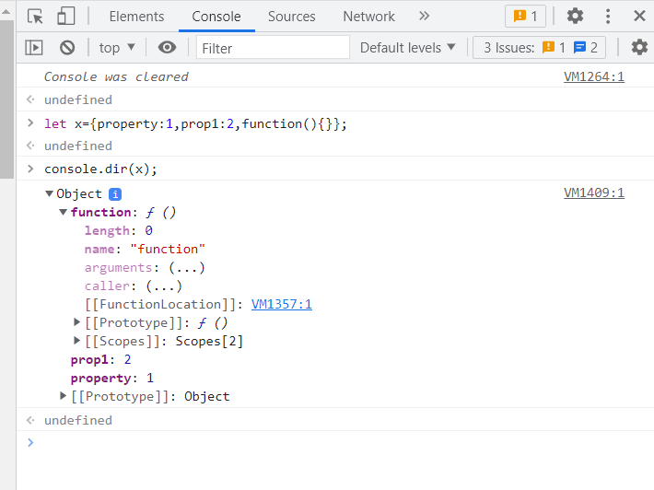

1. **console.count();**

The count() method counts the number of times console.count() is called.

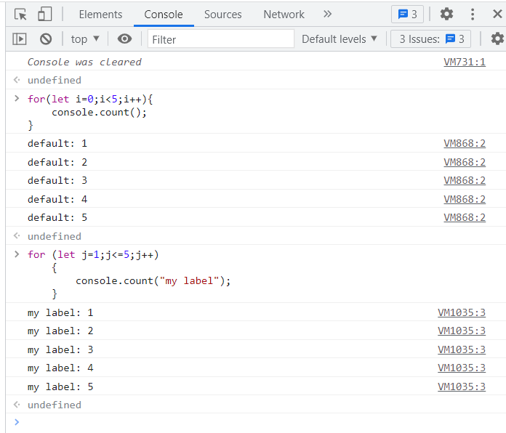

1. **console.table();**

This method is used to display the content of Array, objects in a tabular form.

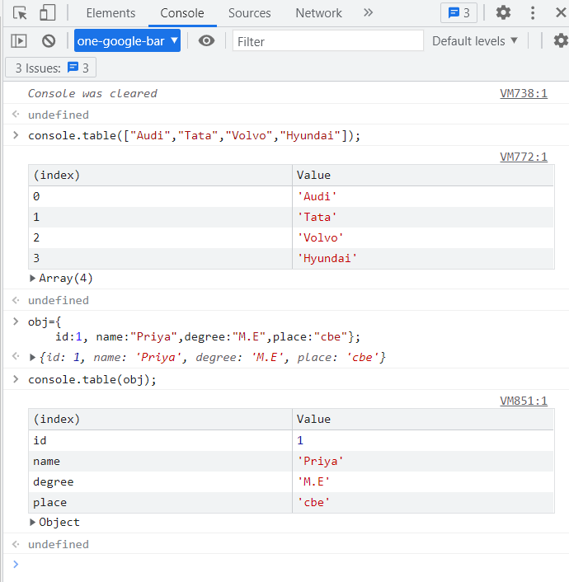

1. **console.time/timeLog/timeEnd**

console.time()- to start the timer

console.timeLog()- this displays the current value of a timer that was previously started by console.time().

console.timeEnd()- this method ends a timer.

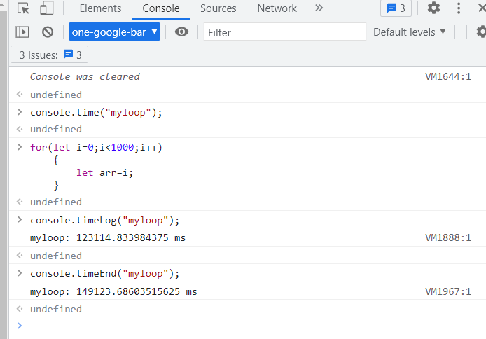

1. **console.trace();**

This method outputs a stack tree to the web console.

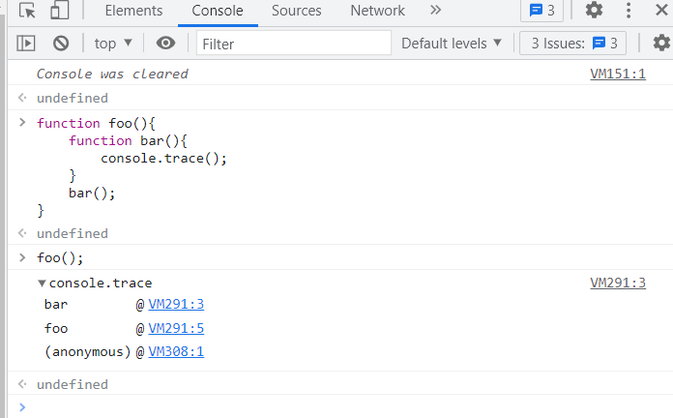

1. **console.group/groupEnd**

console.group()-this method starts the group. All the messages will be written inside the group.and it is ended with the console.groupEnd() method.

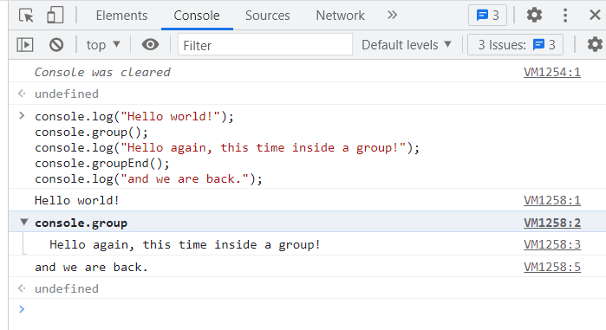

1. **console.assert()**

This method writes a message to the console if an expression evaluates to false.

