**TypeScript**

**What is a TypeScript?**

TypeScript is an object-oriented programming language first developed by Microsoft in 2012. It is an open-source language developed as a superset of JavaScript and is compiled into a plain JavaScript. TypeScript addresses the shortcomings of Javascript.

JavaScript is a simple scripting language for browsers. It is also known as ECMAScript. It is used for dynamic compilation.

TypeScript:

TypeScript is a static type checker. Detecting errors in code without running it is referred to as static checking. TypeScript checks a program for errors before execution and does so based on the kinds of values. It can be considered JavaScript with additional features like strong static typing, compilation and object-oriented programming.

TypeScript is an open source object-oriented programming language and a superset of Javascript. TypeScript cannot be executed by the browser. So, TypeScript is compiled into JavaScript using TypeScript compiler tool. Using this errors can be resolved before they are run.

Benefits of TypeScript:

* Static typing- in a static typing the variables are known at the compile time. If a variable is declared as number and assigned a value to it and it cannot be reassigned with another data type namely it will not accept string or boolean values.
* Code completion
* Refactoring
* Shorthand notations.

Drawbacks:

* Compilation- Typescript code is not directly executed by the browser. So it has to be compiled using a typescript compiler and translated into JavaScript before execution. This is called transpilation.
* Discipline in coding- (medium to large projects typescript is most preferred)

For Example,

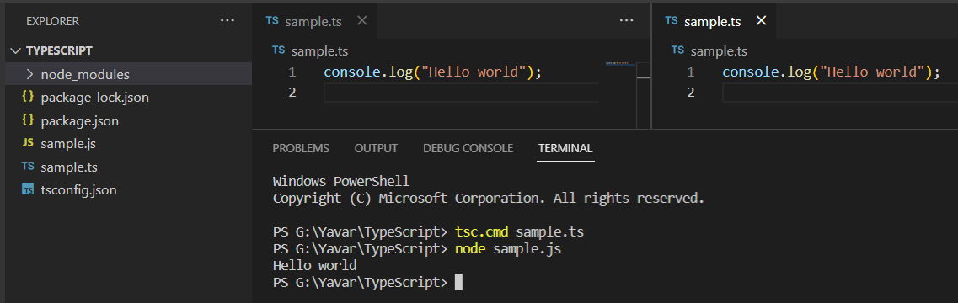

In the ts file after compilation js file is created. The transpilation process has taken place. After running the js file, the content is executed.

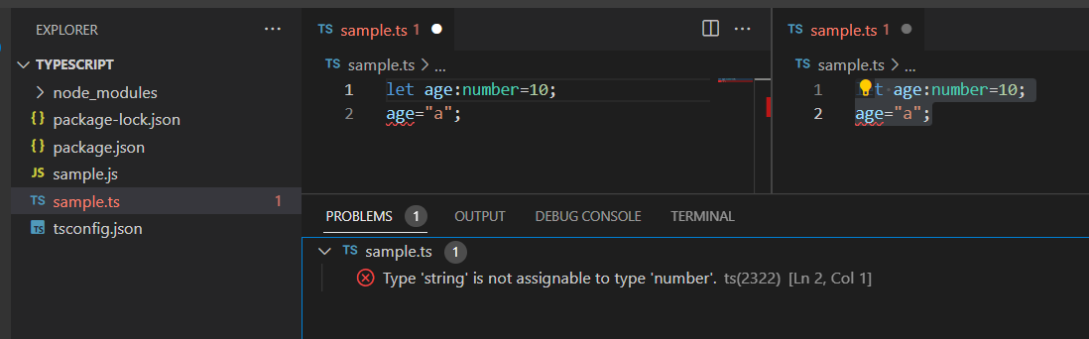

In the above example, the variable age is declared using let keyword and annotated as number and assigned a value 10 to it. Later the same variable is assigned the value a which is a string. Here it throws an error in typescript. But in case of javascript reassignment can be done.

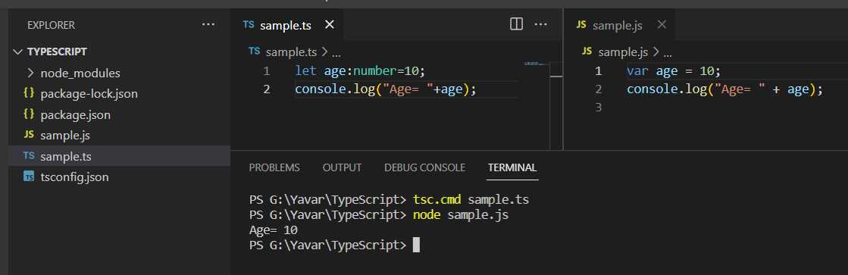

In the above example, the variable age is declared using let keyword in typescript but after compilation in javascript it is changed into var keyword which is the older version of ECMA script.

The datatypes used in javascript and typescript namely:

| JavaScript | TypeScript |
| --- | --- |
| * number | * any |
| * string | * unknown |
| * boolean | * never |
| * null | * enum |
| * undefined | * tuple |
| * object |  |

For example,

let a=10; // a is a number

let b=”a”; // b is a string

let c=true; // c is a boolean

let d; // d is any. So d can be assigned any value such as 20, string, boolean.

Arrays:

let a=[1,2,3]; // array a will be considered as numbers.

let b=[]; // array b will be considered as any.

let arr:any[]=[1,”hi”,true]; // when it is given as any then any type of data can be given.

Tuples:

let user:[number, string]=[1,”Hi”];

Enum:

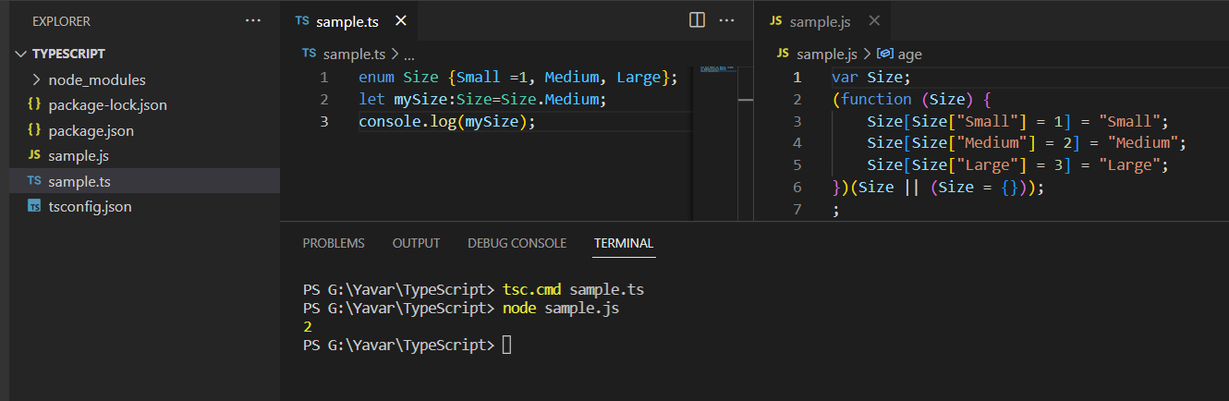

Functions:

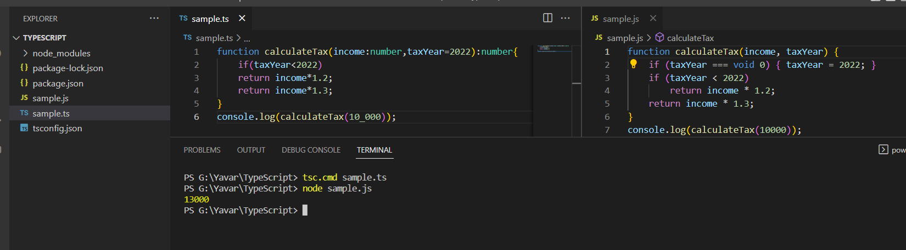

Objects:

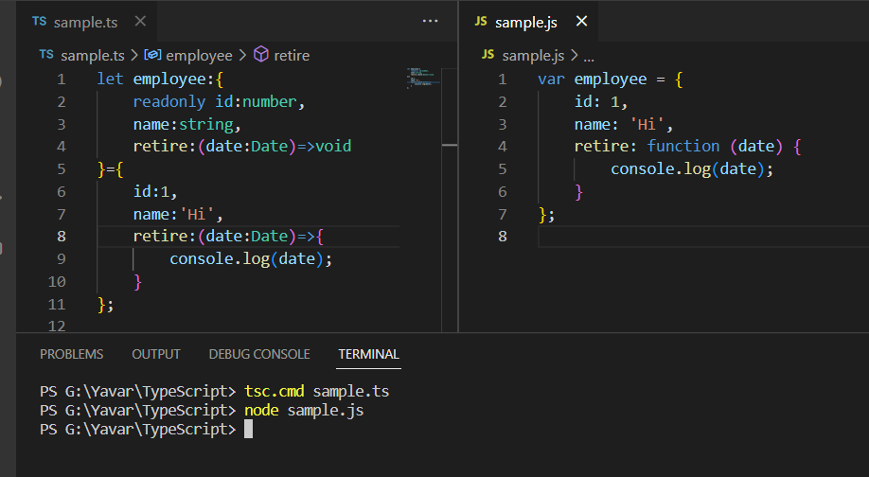

In the above example, there are three problems namely

If we want to create another employee object we have to repeat this structure, second problem is other employee object may have different properties and the last problem is readability. To overcome this type aliases is used. Using type alias custom type is used.

Type alias:

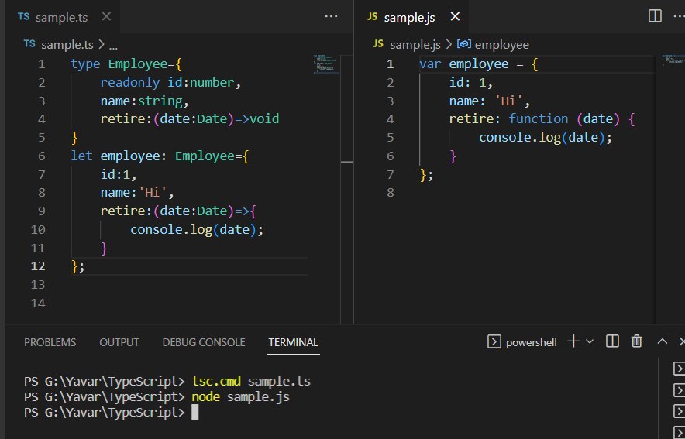

Using type alias the code can be used inmultiple places.

Union types:

With this we can give more than one type to a variable.

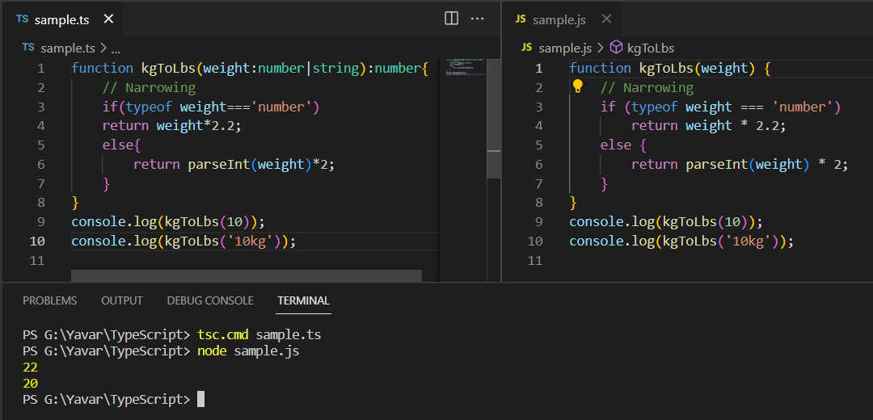

Intersection types:

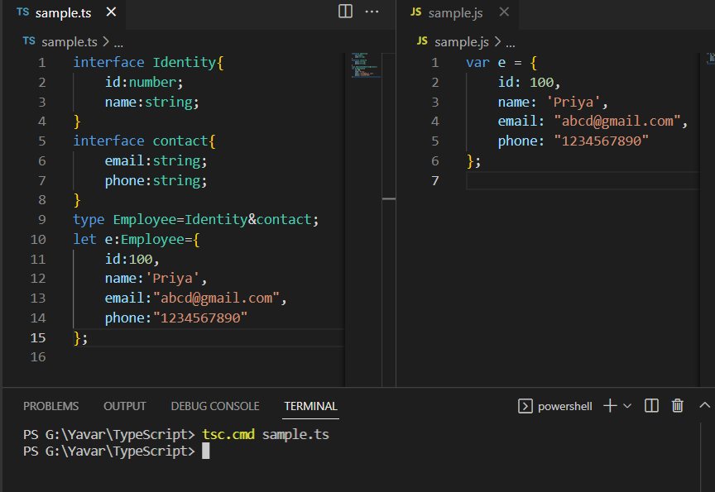

Literal types:

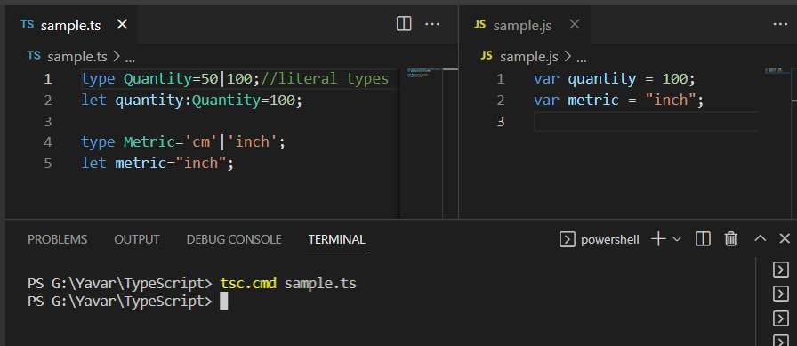

Nullable types:

TypeScript has two special types: null and undefined.

