**REPORT: Analysis Of ZOMATO Data…**

**-Priyanka**

**Bharshankar-**

**36**

**-Prathmesh Satpute-32**

**-Prathmesh Dalve-33**

**-Priya Talele-35**

**-Pratik satham-34**

**Step_1 🡪** I have imported all these libraries for data handling

import pandas as pd

import NumPy as np

import matplotlib.pyplot as plt

import seaborn as sns

**Step_2🡪** Following command use for data read

df=pd.read_csv("zomato.csv")

**Step_3 🡪** I used this following command for checking the dimension of data, data types, no. of columns and no of rows in dataset.

df.head(10)

df.shape

df.columns

df.describe()

df.dtypes

**Step_4 🡪** Here we are checking the null Values from our dataset.

df.isnull().sum()

print("******************************************************")

**Step_5 🡪** Here we are checking the duplicates and correlation in features.

df.duplicated().sum()

df.corr()

**Step_6 🡪** From the step 4 we known that a lot of missing value is there to see it visually we are plotted the Heatmap.

plt.figure(figsize=(25,25))

sns.heatmap(df.isnull())

**Step_7🡪** from the above heatmap we seen that two three features have a lot missing values to the percentage of that missing values:

df.isnull().mean()*100

**Step_8🡪** so dish_liked feature has more than 50% null values so we decided to drop that column.

df = df.drop(columns='dish_liked')

And also the column url and phone also not much Important feature In the analysis. So we drop that also.

df1=df.drop(['url','phone'],axis=1)

**Step_9🡪**Here we changing the column for better understanding:-

df1.columns

df2 = df1.rename(columns={'approx_cost(for two people)':'cost','listed_in(type)':'type',

'listed_in(city)':'city'})

**Step_10🡪**here we complete some transformations.

df2.info()

df2.head()

**Step_11🡪** In the rating column there are some \, new and nan present so we deal with that:

def handlerate(value):

if(value=='NEW' or value=='-'):

return np.nan

else:

value = str(value).split('/')

value = value[0]

return float(value)

df2['rate'] = df2['rate'].apply(handlerate)

df2['rate'].head()

**Step_12🡪** Filling Null Values in Rate Column with Mean

df2['rate'].fillna(df2['rate'].mean(), inplace = True)

df2['rate'].isnull().sum()

**Step_13🡪** Droping all null Values:

df2.dropna(inplace = True)

df2.head()

**Step_14🡪** Checking the unique values of location and city column

df2['location'].unique()

df2['city'].unique()

**conclusion: city and location both are same so drop the city column**

df2 = df2.drop(['city'], axis = 1)

**Step_15🡪** Trasformation on cost column removing the , from price.

def handlecomma(value):

value = str(value)

if ',' in value:

value = value.replace(',', '')

return float(value)

else:

return float(value)

df2['cost'] = df2['cost'].apply(handlecomma)

df2['cost'].unique()

**Step_16🡪** Cleaning the Column. The count of restaurant less than 300 in particular location will be adding in the other column.

location = df2['location'].value_counts(ascending = False)

location_lessthan300 = location[location<300]

def handle_location(value):

if(value in location_lessthan300):

return 'others'

else:

return value

df2['location'] = df2['location'].apply(handle_location)

df2['location'].value_counts()

**Step_17🡪**Cleaning Cuisines Column:

cuisines = df2['cuisines'].value_counts(ascending = False)

cuisines_lessthan100 = cuisines[cuisines<100]

def handle_cuisines(value):

if(value in cuisines_lessthan100):

return 'others'

else:

return value

df2['cuisines'] = df2['cuisines'].apply(handle_cuisines)

df2['cuisines'].value_counts()

**Step_18🡪**Checking the final time null values.

df2.isnull().sum()

**Data is cleaned**

**visualization**

**Step_19🡪**

Visualizing the location column by countplot—countplot() method is used **to Show the counts of observations in each categorical bin using bars**. And shows the frequency of the category.

plt.figure(figsize = (16,10))

ax = sns.countplot(df['location'])

plt.xticks(rotation=90)

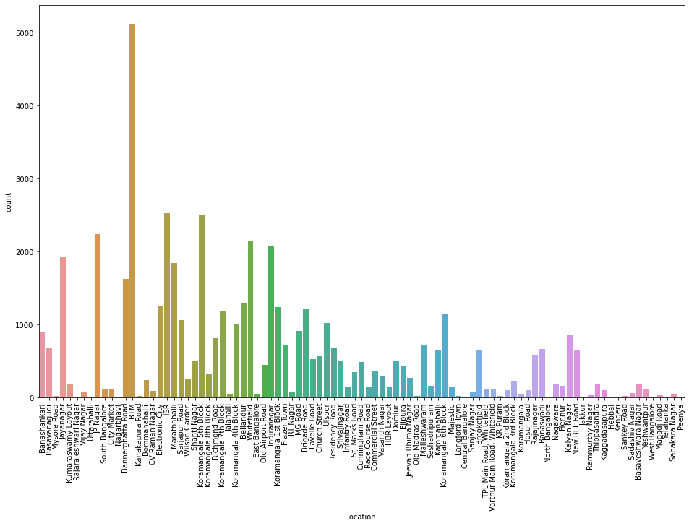

**Conclusion: From above graph we analyzed count of locations in which food is popular.The BTM location has the highest number of counts. Hence it is most popular.**

**Step_20🡪**Visualizing Online Order:

plt.figure(figsize = (6,6))

sns.countplot(df2['online_order'], palette = 'inferno')

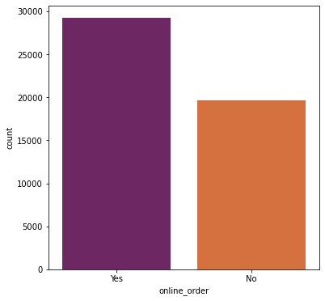

**Conclusion:From above graph we analyzed count of online orders are greater than offline orders. count of online delivery is approx. near 30000 which is greater than offline orders.**

**Step_21🡪** Visualizing Book Table:

plt.figure(figsize = (6,6))

sns.countplot(df['book_table'], palette = 'rainbow')

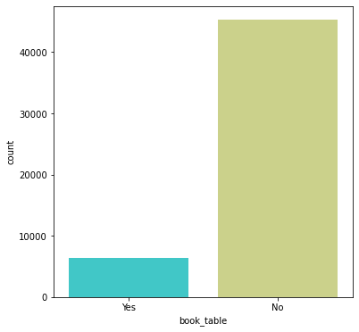

**Conclusion:From above graph we analyzed that people are less attracted towards booking a table due to online delievaries**.

**Step_22🡪 Which are the top restaurant chains in Bangalore ?**

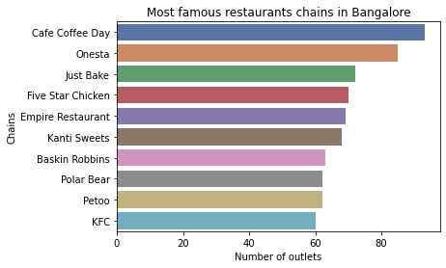

**Conclusion:We understand that café coffee day has highest number of outlets and KFC has minimum outlets.**

# Step_23🡪What areas are the prime locations for the foodies ?

# 

# Conclusion: from graph, it is clear that btm and others this two are the main prime locations for foodies. In others we have the locations counts less than 300.

**Step_2****4🡪Most common restaurant types in the city.**

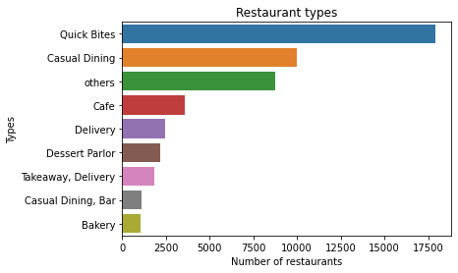

**Conclusion: From graph we understand that Quick bytes has most common restaurant types in india.**

**Step_25🡪 Common Cusines in the restaurants**

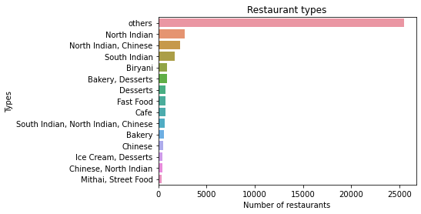

**Conlusion: North Indian are famous in the restaurants.**

**Step_26🡪Visualizing Types of Restaurents vs Rate.**

What kind of a food is more popular in a locality.

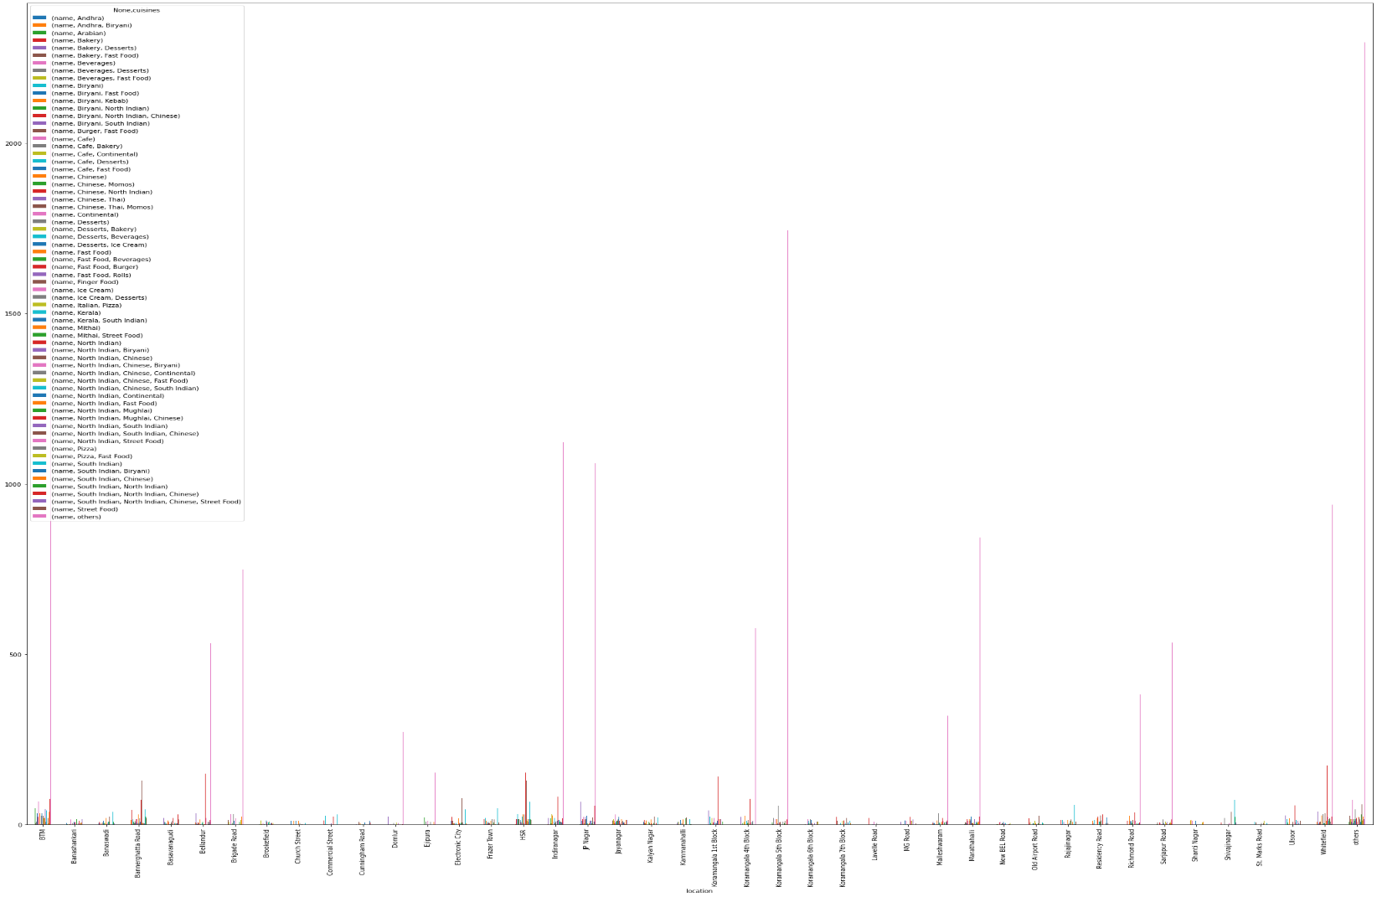

**Conclusion: From this graph we get to know location Koramangala 5th Block has desserts and fast food are most famous in locality. .**

**Step_27🡪Analysis of restaurants has online ordering facility in each location**

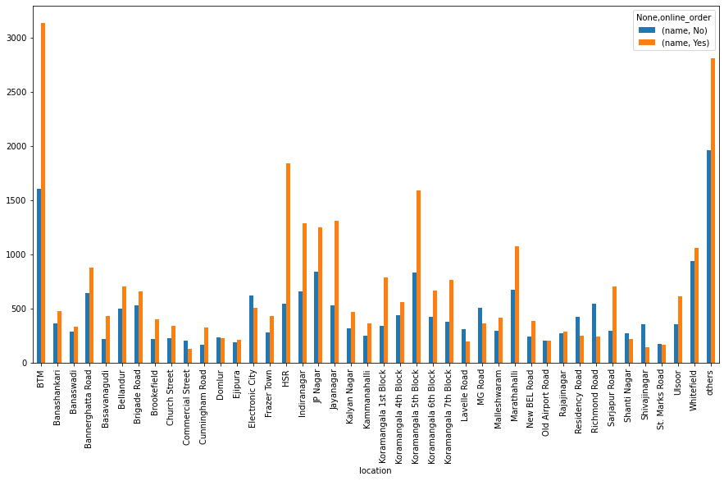

**Conclusion: BTM has the highest number of online orders and location commercial street has lowest number of online orders.**

**Step_28🡪** **Do the entire locality loves vegetarian food. If yes then is that locality populated by a particular sect of people:**

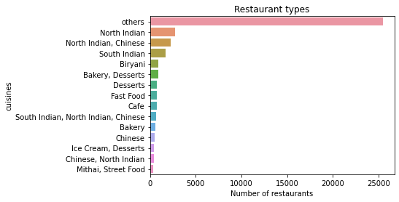

**Conclusion: we conclude that the most of the entire locality loves vageterian food like Jain, Marwaris, Gujaratis who are mostly vegetarian. These kind of analysis we done by using the data and by studying the factors such as location of the restaurant and name of the food.**

**Step_29🡪** **Analysis on cost**

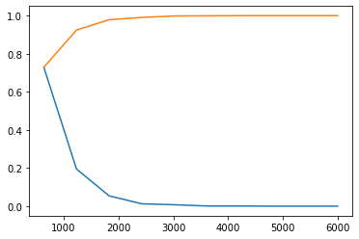

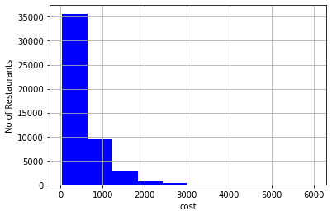

**Conclusion- Majority of restaurants in bangalore has average cost for 2 person is 500 . It concludes that there are all sorts of food at different prices are available in bangalore.**

**CONCLUSION:**

from all this we finally conclude that

* we analyzed count of locations in which food is popular. The BTM location has the highest number of counts. Hence it is most popular , count of online orders are greater than offline orders,count of online delivery is approx. near 30000 which is greater than offline orders we analyzed that people are less attracted towards booking a table due to online delievaries.
* also the café coffee day has highest number of outlets and KFC has minimum outlets.it is clear that btm and others this two are the main prime locations for foodies.
* In others we have the locations counts less than 300.we understand that Quick bytes has most common restaurant types in india.And also North Indian are famous in the restaurants.
* we get to know location Koramangala 5th Block has desserts and fast food are most famous in locality
* BTM has the highest number of online orders and location commercial street has lowest number of online orders.
* we conclude that the most of the entire locality loves vageterian food like Jain, Marwaris, Gujaratis who are mostly vegetarian. These kind of analysis we done by using the data and by studying the factors such as location of the restaurant and name of the food.
* Majority of restaurants in bangalore has average cost for 2 person is 500 . It concludes that there are all sorts of food at different prices are available in bangalore.