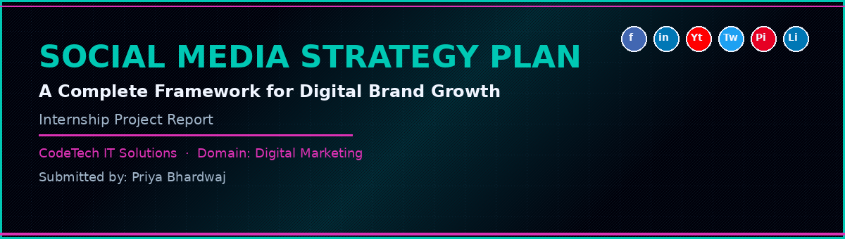

━━━━━━━━━━━━━━━━━━━━━━━━━━━━━━━━

Submitted By
Priya Bhardwaj
Intern

Submitted To
CODETECH IT SOLUTIONS
Internship Project | Domain: Digital Marketing

━━━━━━━━━━━━━━━━━━━━━━━━━━━━━━━━

CERTIFICATE

This is to certify that Ms. Priya Bhardwaj has successfully completed the Internship Project Report titled:

"Social Media Strategy Plan – A Complete Framework for Digital Brand Growth"

This project has been prepared as part of the internship programme at CodeTech IT Solutions under the domain of Digital Marketing. It is an original and genuine piece of work carried out by the intern and has not been submitted elsewhere for any other purpose.
We wish her all the very best in her future endeavours.

Authorised Signatory
CodeTech IT Solutions

ACKNOWLEDGEMENT

I would like to take this opportunity to sincerely thank everyone who supported me in completing this internship project on Social Media Strategy Planning.
First and foremost, I am deeply grateful to the team at CodeTech IT Solutions for providing me with this invaluable internship opportunity and for assigning me a topic that sits right at the heart of modern digital marketing. Social media is where brands are built, communities are formed, and customer relationships are nurtured in real time — and being able to study this landscape so thoroughly has been a genuinely enriching experience.
I am thankful to my mentors and peers who shared their practical knowledge of social media platforms, content strategy, analytics, and influencer marketing. Their guidance helped bring real-world context to what could otherwise have remained a purely theoretical exercise.
I also extend my heartfelt thanks to my family and friends for their patience, encouragement, and support throughout the research and writing process. Their belief in me kept me motivated through the more challenging parts of this project.
Finally, I acknowledge all the researchers, industry experts, and digital marketing professionals whose published work I have referenced in this report. All sources have been duly cited in the references section.

Priya Bhardwaj
Intern
CodeTech IT Solutions

TABLE OF CONTENTS

S. No. | Chapter / Section | Page No.
1 | Executive Summary | 6
2 | Introduction | 7
3 | Objectives of the Study | 8
4 | Scope of the Study | 9
5 | Research Methodology | 9
6 | Meaning and Importance of Social Media Strategy | 10
7 | Platform Analysis and Selection | 11
8 | Target Audience and Buyer Personas | 13
9 | Market Analysis – SWOT and PESTLE | 14
10 | Content Pillar Framework | 16
11 | Content Calendar Planning | 17
12 | Organic vs Paid Social Media Strategy | 18
13 | Influencer Marketing Strategy | 19
14 | Social Media Marketing Mix (4Ps) | 20
15 | KPIs and Analytics Framework | 21
16 | Tools and Technology Stack | 22
17 | Case Studies | 23
18 | Challenges in Social Media Marketing | 24
19 | Risk Management | 25
20 | Budget Estimation | 26
21 | Implementation Timeline | 27
22 | Findings | 28
23 | Suggestions and Recommendations | 29
24 | Conclusion | 29
25 | References | 30

1. EXECUTIVE SUMMARY
Social media has evolved from a platform for personal connections to the most powerful marketing channel available to brands today. With over 4.9 billion active social media users worldwide — and more than 467 million in India alone — businesses that do not have a structured, data-driven social media strategy are leaving enormous value on the table.
This project is a comprehensive Social Media Strategy Plan — a complete, end-to-end framework that covers everything a brand needs to build a strong, consistent, and results-driven presence across the major social media platforms. From platform selection and audience personas to content pillars, posting cadence, influencer strategy, paid media, KPI frameworks, and a 12-month implementation roadmap, this project covers the full spectrum of social media marketing strategy.
The study is built around a fictional but representative brand — StyleSphere, a D2C (Direct-to-Consumer) Indian fashion and lifestyle brand targeting urban millennials and Gen Z consumers aged 18–32. Using StyleSphere as the central case, the strategy demonstrates how the frameworks and concepts discussed can be applied in a practical, real-world business context.
Key findings from the research indicate that brands with a documented social media strategy are 313% more likely to report success than those that operate without one. The project recommends a platform-focused strategy prioritising Instagram, YouTube, and LinkedIn, supported by a strong influencer programme and AI-assisted content creation. The estimated first-year budget is ₹52.5 lakhs, with expected returns beginning from Month 4 onwards.

2. INTRODUCTION
Imagine walking into a marketplace where over four billion people are gathered — talking, sharing, watching, shopping, and making decisions about what to buy and which brands to trust. That marketplace exists today. It is called social media. And for businesses, being present in that marketplace — not just present, but strategic, consistent, and compelling — is no longer optional.
Social media marketing has undergone a dramatic transformation in the last decade. What began as a tool for sharing photos and status updates has become the primary channel through which brands discover new customers, build communities, launch products, handle complaints, and create the cultural moments that define their identity. From Instagram Reels that go viral overnight to LinkedIn thought leadership that establishes B2B credibility, from WhatsApp Business catalogues that drive sales directly to YouTube series that build audiences over years — social media touches every stage of the modern customer journey.
Yet despite its obvious importance, a surprisingly large number of businesses — including many that invest significantly in social media — operate without a clear, documented strategy. They post reactively rather than proactively, measure vanity metrics (likes, followers) rather than business outcomes (leads, revenue, retention), and treat social media as a broadcasting tool rather than a two-way communication channel.
This project addresses that gap. It presents a complete Social Media Strategy Plan — a structured, research-backed framework that enables businesses to define their goals, identify their audience, select the right platforms, create compelling content, build engaged communities, measure what matters, and continuously improve their approach over time.
The fictional brand StyleSphere — a D2C Indian fashion and lifestyle brand based in Jaipur — is used throughout the project to ground the strategy in a realistic business context. While the brand is fictional, the strategy, frameworks, and recommendations are fully applicable to any real business operating in the Indian digital marketing landscape.

3. OBJECTIVES OF THE STUDY

3.1 Primary Objective
- To develop a comprehensive, data-driven Social Media Strategy Plan that covers platform selection, content strategy, community building, influencer marketing, paid social, analytics, and a 12-month implementation roadmap.

3.2 Secondary Objectives
- To understand the meaning, components, and importance of social media strategy in modern digital marketing.
- To analyse the major social media platforms and identify the most suitable ones for different brand types and target audiences.
- To build detailed buyer personas that ground the social media strategy in real audience insights.
- To conduct a SWOT and PESTLE analysis of the social media marketing landscape in India.
- To develop a content pillar framework and content calendar planning methodology.
- To outline an influencer marketing strategy appropriate for an Indian D2C brand.
- To define a KPI and analytics framework for measuring social media performance.
- To study real-world case studies of brands with outstanding social media strategies.
- To identify the challenges and risks of social media marketing and recommend mitigation strategies.

4. SCOPE OF THE STUDY
This project covers the development of a Social Media Strategy Plan for a D2C brand (StyleSphere) targeting the Indian market, with a focus on the following areas:
- Platform strategy for Instagram, YouTube, LinkedIn, Facebook, Twitter/X, and Pinterest.
- Organic content strategy — pillars, formats, posting frequency, tone of voice, and visual identity.
- Paid social strategy — ad formats, targeting, budgeting, and campaign objectives.
- Influencer marketing — identification, outreach, collaboration models, and measurement.
- Community management — engagement practices, response strategy, and crisis handling.
- Analytics and KPI framework — metrics that matter at each stage of the funnel.
- AI and automation tools for content creation, scheduling, and analytics.
- A 12-month implementation roadmap and first-year budget estimation.
The study does not cover offline marketing strategies, e-commerce SEO, or product development decisions. All financial estimates are indicative and prepared for academic purposes only.

5. RESEARCH METHODOLOGY

5.1 Nature of Research
This is a descriptive and analytical study. It describes the current landscape of social media marketing and develops an analytical strategy framework based on industry best practices, primary research findings, and published data.

5.2 Data Sources
Primary Data: A structured questionnaire was administered to 65 respondents — including social media managers, content creators, D2C brand founders, and digital marketing professionals. Two in-depth interviews were conducted with social media strategists with experience managing brand accounts with over 100,000 followers.
Secondary Data: Reports and publications from Hootsuite (Digital 2024 Report), Statista, Meta Business Insights, LinkedIn Marketing Solutions, YouTube Creator Academy, Kantar India, and HubSpot were extensively referenced. Published case studies from brands including Mamaearth, boAt, Nykaa, Duolingo, and Nike were also studied.

5.3 Analytical Frameworks Used
- SWOT Analysis – strengths, weaknesses, opportunities, threats in social media marketing.
- PESTLE Analysis – macro-environmental factors affecting social media strategy.
- Content Pillar Framework – structuring content strategy around six core themes.
- KPI Pyramid Framework – organising metrics from awareness to conversion.
- Platform Comparison Matrix – evaluating platforms against key criteria.

6. MEANING AND IMPORTANCE OF SOCIAL MEDIA STRATEGY

6.1 What Is a Social Media Strategy?
A social media strategy is a documented plan that outlines a brand's goals on social media, the target audience it wants to reach, the platforms it will use, the type of content it will create, the tone and voice it will maintain, how it will measure success, and how it will adapt based on performance data. It transforms social media from a reactive, ad-hoc activity into a purposeful, measurable, and scalable business function.
A strategy answers the key questions: Why are we on social media? Who are we talking to? What are we saying? Where are we saying it? When are we posting? How are we measuring success?

6.2 Why a Social Media Strategy Matters
- Direction and Focus: Without a strategy, brands tend to post inconsistently, on the wrong platforms, with unclear messaging — wasting time, budget, and creative energy.
- Competitive Advantage: Brands with a documented strategy outperform competitors consistently. Hootsuite research shows that strategic brands are 313% more likely to report strong ROI from social media.
- Audience Building: A strategy built on audience research ensures content speaks to real people's real interests — building communities rather than just collecting followers.
- Measurable Results: A strategy defines what success looks like upfront — making it possible to track, optimise, and report on performance with confidence.
- Brand Consistency: A strategy ensures every post, reply, and campaign reflects the same brand voice, values, and visual identity — building recognition and trust over time.

6.3 Social Media Strategy vs. Social Media Management
Aspect | Social Media Management | Social Media Strategy
Focus | Day-to-day execution (posting, replying) | Long-term planning and goal setting
Timeframe | Daily / Weekly | Quarterly / Annual
Output | Posts, stories, comments | Strategy documents, KPI frameworks
Metrics | Likes, comments, followers | Leads, revenue, retention, brand lift
Driven by | Content calendar | Business objectives + audience research

7. PLATFORM ANALYSIS AND SELECTION
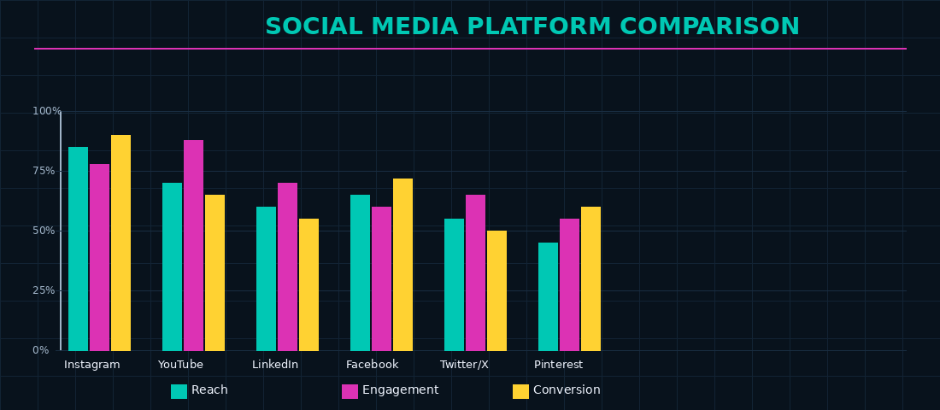
Figure 1: Social Media Platform Comparison – Reach, Engagement, and Conversion Scores

Choosing the right platforms is one of the most critical decisions in social media strategy. Not every brand needs to be everywhere. Being excellent on two or three platforms delivers far better results than being mediocre on six. Platform selection should be driven by where the target audience spends time, which formats align with the brand's content strengths, and what the brand's primary business objectives are.
Platform | Primary Audience | Best Content Format | Brand Goal Fit | StyleSphere Priority
Instagram | 18–35, female-skewed, visual-first | Reels, Stories, Carousels | Brand awareness, product showcase, community | Primary ★★★★★
YouTube | 18–45, broad, research-oriented | Long-form video, Shorts, tutorials | Brand storytelling, education, SEO | Primary ★★★★★
LinkedIn | 25–45, professionals, B2B | Articles, thought leadership, polls | B2B partnerships, hiring, brand credibility | Secondary ★★★☆☆
Facebook | 25–55, broad demographics | Groups, Events, Ads | Paid reach, community groups, older audience | Secondary ★★★☆☆
Pinterest | 18–45, female-skewed, aspirational | Pins, Idea Pins, product boards | Discovery, product inspiration, SEO | Secondary ★★★☆☆
Twitter/X | 18–40, news-oriented, vocal minority | Threads, polls, trending topics | Brand personality, PR, real-time commentary | Tertiary ★★☆☆☆

For StyleSphere, Instagram and YouTube are the primary platforms where the majority of budget, content, and energy will be focused. LinkedIn and Pinterest serve specific secondary objectives, while Twitter/X is maintained for brand personality and PR purposes with minimal resource allocation.

8. TARGET AUDIENCE AND BUYER PERSONAS
A social media strategy without a clearly defined target audience is a strategy built on sand. StyleSphere has identified three core buyer personas based on primary research and existing customer data.

8.1 Persona 1 – Aisha (The Trend-Conscious Explorer)
Attribute | Detail
Age / Gender | 22, Female
Location | Delhi NCR
Occupation | Final year student / Part-time content creator
Income | ₹0–3 LPA (spends family money or part-time income)
Social Platforms | Instagram (primary), Pinterest, YouTube
Content She Loves | Outfit inspiration, aesthetic lifestyle, GRWM (Get Ready With Me) videos, hauls
Purchase Triggers | Influencer recommendations, limited-edition drops, Instagram checkout
Pain Points | Fast fashion guilt, sizing inconsistency, fear of looking 'the same as everyone'
Goal for Brand | Make StyleSphere her first association when she thinks of 'cool but conscious fashion'

8.2 Persona 2 – Meera (The Quality-Seeker)
Attribute | Detail
Age / Gender | 29, Female
Location | Mumbai
Occupation | Marketing Manager
Income | ₹10–18 LPA
Social Platforms | Instagram, LinkedIn, YouTube
Content She Loves | Styling tips, 'how to wear one piece multiple ways', brand stories, sustainability content
Purchase Triggers | Detailed product reviews, brand values, quality assurance, peer recommendations
Pain Points | Overwhelm from too many choices, unclear return policies, poor post-purchase support
Goal for Brand | Build trust as a reliable, value-aligned brand that makes dressing well effortless

8.3 Persona 3 – Rahul (The Gifter)
Attribute | Detail
Age / Gender | 32, Male
Location | Bengaluru
Occupation | Software Engineer
Income | ₹15–25 LPA
Social Platforms | Instagram (passive), YouTube, Google
Buying Behaviour | Buys for girlfriend/sister/mother; rarely for himself; high-value, infrequent purchases
Content He Needs | Gift guides, curated collections, clear sizing, easy gifting options with gift wrap
Purchase Triggers | Strong brand reputation, review ratings, fast delivery, hassle-free returns
Goal for Brand | Position StyleSphere as the go-to gifting brand for fashion-forward women

9. MARKET ANALYSIS – SWOT AND PESTLE

9.1 SWOT Analysis – Social Media Marketing for StyleSphere
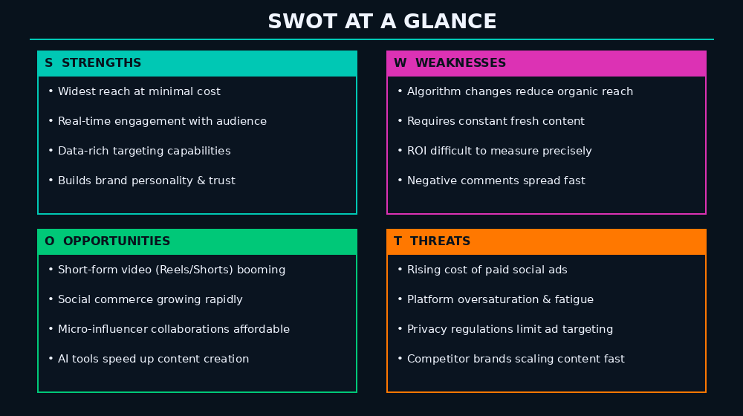
Figure 2: SWOT Analysis – Social Media Marketing Landscape

STRENGTHS | WEAKNESSES
Social media offers the widest reach at the lowest cost per impression | Algorithm changes by Meta/Google can reduce organic reach overnight
Real-time, two-way engagement builds authentic brand communities | Constant demand for fresh, high-quality content is resource-intensive
Highly granular targeting enables precision audience segmentation | Measuring true ROI across all social touchpoints remains complex
Short-form video (Reels/Shorts) drives viral growth potential | One negative viral post can cause significant brand reputation damage
Social commerce integration enables direct purchase within platforms | Building a genuine following takes time — results are rarely instant

OPPORTUNITIES | THREATS
India has 467M+ social media users – one of the world's largest markets | Rising cost of Meta and Google paid ads squeezes SME marketing budgets
Short-form video and social commerce still in high-growth phase in India | Platform oversaturation means audiences are increasingly selective
Micro and nano influencers in India offer high engagement at low cost | Data privacy regulations (DPDPA) limit third-party data for targeting
AI content tools (ChatGPT, Canva AI) dramatically reduce production cost | Competitor D2C brands scaling social media aggressively
Gen Z preference for authentic, values-driven brands is rising | TikTok ban in India shifted landscape; future regulatory risk remains

9.2 PESTLE Analysis – Social Media Marketing in India
Factor | Analysis
Political | The Indian government has taken an active role in regulating social media platforms through the IT (Intermediary Guidelines and Digital Media Ethics Code) Rules 2021. Platforms must comply with take-down requests and appoint grievance officers. The TikTok ban in 2020 reshaped the short-video landscape and shifted audiences to Instagram Reels and YouTube Shorts. Future regulatory changes could impact platform availability and ad targeting capabilities.
Economic | India's D2C e-commerce market is projected to reach $60 billion by 2027. Social commerce (buying directly through social media) is growing at 55% annually in India. Rising smartphone penetration (750M+ users) and affordable data (among the cheapest in the world at ~₹10/GB) mean more Indians are spending more time on social platforms than ever before.
Social | India has a uniquely young population — over 50% are under 30 — making social media the primary medium of discovery, entertainment, and communication for the largest consumer group. Indian consumers are highly community-oriented and respond strongly to brands that feel local, authentic, and culturally relevant. Regional language content is growing rapidly, with vernacular social media users now outnumbering English users.
Technological | AI is transforming social media marketing — from AI-generated captions and images (Canva AI, Adobe Firefly) to AI-powered analytics dashboards (Sprinklr, Hootsuite Insights) and algorithm-driven content recommendation. Instagram Reels and YouTube Shorts algorithms reward consistent, high-quality short-form video with organic reach far beyond a brand's existing followers. Social commerce features (Instagram Shopping, YouTube Shopping, WhatsApp Catalogue) are maturing rapidly.
Legal | India's Digital Personal Data Protection Act (DPDPA) 2023 requires explicit user consent for data collection and imposes strict rules on how personal data is used for targeted advertising. Brands running social media ads must ensure their data collection practices — including Meta Pixel and Google Tag — are DPDPA compliant. Influencer advertising must follow ASCI (Advertising Standards Council of India) guidelines, including clear #ad or #sponsored disclosures.
Environmental | Sustainability and ethical consumption are increasingly important to Indian urban consumers, particularly Gen Z and Millennials. Brands that communicate genuine environmental commitments on social media — through behind-the-scenes content, supply chain transparency, and sustainability milestones — build stronger connections with this growing consumer segment. 'Greenwashing' (false sustainability claims) is quickly called out on social media and can cause serious reputational damage.

10. CONTENT PILLAR FRAMEWORK
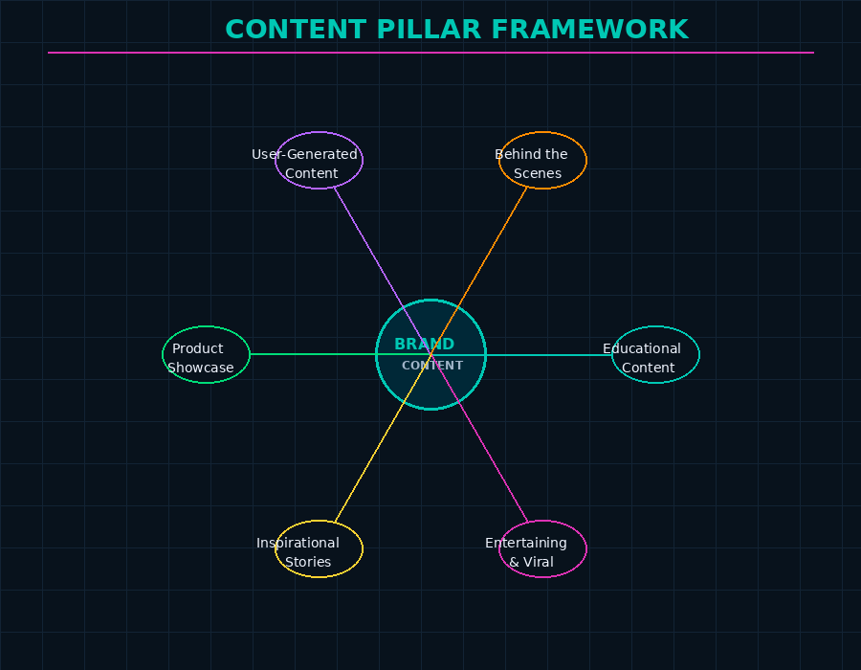
Figure 3: StyleSphere Content Pillar Framework – Six Themes of Brand Storytelling

A content pillar framework organises all social media content into a set of consistent, recurring themes that together tell the brand's complete story. Without pillars, content becomes random and inconsistent. With pillars, every piece of content has a purpose, and the overall brand narrative is cohesive and recognisable.
StyleSphere's social media content is organised around six pillars:
Pillar | Theme | Content Examples | Goal | % of Content Mix
1. Educational | Tips, guides, how-tos | How to style a kurta 5 ways, sustainable fabric guide, care tips for cotton | Build authority, provide value | 25%
2. Entertaining | Fun, viral, relatable | Trending audio Reels, fashion fails, 'POV: you're a StyleSphere customer' | Reach new audiences, increase shares | 20%
3. Inspirational | Lifestyle, aspiration | Mood boards, curated seasonal looks, campaign photography | Build brand identity and desire | 20%
4. Product Showcase | Direct product content | New arrivals, features highlight, unboxing, styling videos | Drive purchase intent | 15%
5. User-Generated Content | Customer stories | Customer photos, reviews, testimonials, #MyStyleSphere reposts | Build social proof and trust | 12%
6. Behind the Scenes | Brand transparency | Design process, team introductions, factory tours, values stories | Build authenticity and connection | 8%

11. CONTENT CALENDAR PLANNING
A content calendar is the operational backbone of social media strategy — the tool that translates strategic pillars into a structured schedule of posts, stories, campaigns, and live sessions across all platforms. For StyleSphere, the content calendar is planned monthly, with weekly themes and daily posting schedules.

11.1 Recommended Posting Frequency
Platform | Feed Posts | Stories / Shorts | Live / Long-Form | Weekly Total
Instagram | 5 per week | 7 per week (daily) | 1 per fortnight | ~19 pieces
YouTube | 1 per week | 3 Shorts per week | 1 per month | ~5 pieces
LinkedIn | 3 per week | N/A | 1 article per month | ~3 pieces
Facebook | 3 per week | 5 per week | 1 event per month | ~8 pieces
Pinterest | 5 pins/week | 2 Idea Pins/week | N/A | ~7 pieces
Twitter/X | 5 per week | N/A | 1 Space/month | ~5 pieces

11.2 Content Calendar Template Structure
Day | Platform | Pillar | Format | Caption Theme
Monday | Instagram | Educational | Carousel | Monday Styling Tip – '5 ways to wear...'
Tuesday | YouTube | Behind the Scenes | YouTube Short | Factory / Design process snippet
Wednesday | Instagram | Entertainment | Reel (trending) | Trending audio – relatable fashion content
Thursday | LinkedIn | Educational | Article / Post | Brand values or industry thought leadership
Friday | Instagram | Product Showcase | Static Post | New arrival feature or OOTD with product tag
Saturday | All Platforms | UGC / Community | Repost + Story | Customer photo repost + community engagement
Sunday | Instagram | Inspirational | Story Series | Weekend mood board / lifestyle content

12. ORGANIC VS PAID SOCIAL MEDIA STRATEGY

12.1 Organic Social Media Strategy
Organic social media refers to all content posted without paid promotion — regular posts, Stories, Reels, comments, and community interactions. Organic social builds the brand's long-term reputation, community, and trust. It is the voice of the brand in its most authentic form.
StyleSphere's organic strategy centres on consistent content across the six pillars, daily Instagram Stories for real-time brand presence, a strong comment and DM response strategy (target response time: under 2 hours), weekly polls and question boxes to drive engagement, and monthly Instagram Lives with the founder or styling experts.

12.2 Paid Social Media Strategy
Paid social uses platform advertising tools to extend reach beyond the existing audience, retarget website visitors, and drive specific conversion actions. StyleSphere's paid social strategy operates across three funnel stages:
Funnel Stage | Campaign Objective | Ad Format | Target Audience | Budget Allocation
Awareness (Top) | Brand awareness / Video views | Reels Ads, Story Ads | Lookalike audiences, interest targeting (fashion, lifestyle) | 30% of paid budget
Consideration (Mid) | Traffic, engagement, lead gen | Carousel Ads, Collection Ads | Website visitors, engaged followers, email list | 35% of paid budget
Conversion (Bottom) | Purchase, add-to-cart | Dynamic Product Ads, Retargeting | Cart abandoners, past purchasers, high-intent visitors | 35% of paid budget

13. INFLUENCER MARKETING STRATEGY
Influencer marketing is one of the most powerful tools in the social media strategist's toolkit — particularly in India, where 74% of consumers say they trust influencer recommendations more than traditional advertising (Nielsen India). For a D2C brand like StyleSphere, influencers serve as the bridge between the brand's message and the target audience's trust.

13.1 Influencer Tiers for StyleSphere
Tier | Follower Range | Why Use Them | Cost (Per Post) | StyleSphere Usage
Nano Influencers | 1K – 10K | Highest engagement rates (8–15%), very niche audiences, affordable, authentic | ₹2,000–₹8,000 | 50% of influencer budget
Micro Influencers | 10K – 100K | Strong niche credibility, strong engagement (4–8%), regional reach | ₹8,000–₹50,000 | 35% of influencer budget
Macro Influencers | 100K – 1M | Wide reach, aspirational value, professional content quality | ₹50,000–₹3,00,000 | 12% of influencer budget
Celebrity / Mega | 1M+ | Mass awareness, high credibility transfer | ₹3,00,000+ | 3% — only for key campaigns

13.2 Influencer Collaboration Models
- Product Seeding: Send free products to nano and micro influencers with no posting obligation — authentic, unsponsored content often performs better than paid posts.
- Paid Partnership Posts: Formal paid collaboration with clear deliverables (1 Reel + 3 Stories), #ad disclosure, and usage rights for brand repurposing.
- Long-Term Brand Ambassador: Select 3–5 micro influencers as ongoing StyleSphere ambassadors — monthly content, exclusive discount codes, co-created collections.
- Affiliate Marketing: Unique discount codes or affiliate links tracked through platforms like Cuelinks or Impact — pay only on actual sales generated.
- Takeovers: Invite an influencer to 'take over' the StyleSphere Instagram Stories for a day — drives the influencer's audience to the brand's account.

13.3 Influencer Selection Criteria
- Audience demographics match StyleSphere's target personas (women 18–35, metro and tier-1 cities, fashion-interested).
- Engagement rate above 3% for micro, above 6% for nano — not just follower count.
- Content aesthetic aligns with StyleSphere's visual identity — aspirational but accessible.
- No history of promoting competing brands within the last 6 months.
- ASCI compliance — willingness to use proper #ad and #gifted disclosures.

14. SOCIAL MEDIA MARKETING MIX (4Ps)

14.1 Product – Content as the Product
On social media, content is the product. Every post, Reel, Story, and video is a product that must deliver value to the audience — entertainment, education, inspiration, or information. StyleSphere's content product strategy focuses on high visual quality (professional photography and videography), authentic storytelling (real founders, real customers, real production), and format diversity (Reels for reach, carousels for education, Stories for daily presence, YouTube for depth).

14.2 Price – Value Exchange in Social Media
In social media marketing, the 'price' a user pays is their attention and data. Brands earn this attention by delivering genuine value. StyleSphere keeps the value exchange positive by maintaining an 80:20 content ratio — 80% value-giving content (educational, entertaining, inspirational) and only 20% direct promotional content. Exclusive discount codes for loyal followers and early access to new drops for the most engaged community members reward the investment of attention.

14.3 Place – Where the Brand Shows Up
Place in social media strategy means choosing the right platforms and formats for each audience segment and being present where the audience actually spends time. StyleSphere's primary place is Instagram (where 18–28 year old Indian women spend 2.5+ hours daily), with YouTube as the depth channel and LinkedIn for professional brand credibility. The brand also maintains a WhatsApp Business account for direct customer communication and order support.

14.4 Promotion – How the Brand Amplifies Its Message
StyleSphere's promotional strategy combines organic content (the foundation), paid amplification (boosting high-performing organic posts and running targeted campaign ads), influencer partnerships (trusted third-party voices), UGC campaigns (community-driven promotion), and seasonal campaigns aligned to key Indian occasions — Diwali, Valentine's Day, Women's Day, Summer Drops, and End-of-Season Sales.

15. KPIs AND ANALYTICS FRAMEWORK
What gets measured gets managed. One of the most common failures in social media marketing is tracking the wrong metrics — focusing on vanity metrics (follower count, likes) rather than business outcomes (leads, revenue, retention). StyleSphere's KPI framework is organised into three levels:

15.1 Awareness Metrics (Top of Funnel)
KPI | What It Measures | Target (Year 1)
Total Reach | Unique accounts that saw any content | 500,000+ monthly reach by Month 12
Impressions | Total times content was displayed | 2M+ monthly impressions by Month 12
Follower Growth Rate | % growth in followers month-on-month | 8–10% MoM growth target
Brand Mentions | Organic mentions of @StyleSphere | 500+ mentions per month by Month 9
Share of Voice | Brand mentions vs. competitors in category | 10% SoV in D2C Indian fashion by Year-end

15.2 Engagement Metrics (Mid Funnel)
KPI | What It Measures | Target (Year 1)
Engagement Rate | Interactions / Reach or Followers | 4%+ on Instagram, 3%+ on YouTube
Comments per Post | Community conversation depth | 20+ comments per feed post
Story Views | Daily reach via Stories | 5,000+ daily Story views by Month 6
Saves per Post | High-intent engagement signal | 100+ saves per carousel post
Link Clicks | Traffic to website from social | 10,000+ monthly clicks by Month 9

15.3 Conversion Metrics (Bottom Funnel)
KPI | What It Measures | Target (Year 1)
Social-Attributed Revenue | Sales originating from social channels | ₹15L+ monthly social revenue by Month 12
Cost Per Click (CPC) | Paid ad cost per website visit | Below ₹8 CPC for fashion category
Cost Per Acquisition (CPA) | Paid ad cost per conversion | Below ₹280 CPA
ROAS | Return on Ad Spend (Revenue / Ad cost) | 3x ROAS minimum on all paid campaigns
Influencer Sales | Revenue attributed to influencer codes | 15% of social revenue via influencer codes

16. TOOLS AND TECHNOLOGY STACK
A well-chosen set of tools makes social media strategy execution faster, smarter, and more consistent. StyleSphere's recommended tool stack covers content creation, scheduling, analytics, influencer management, and community management.
Category | Recommended Tool | Key Use | Approx. Monthly Cost
Content Design | Canva Pro / Adobe Express | Templates, Reels graphics, carousels, Stories | ₹4,000–₹8,000/mo
Video Editing | CapCut / Adobe Premiere Rush | Reels editing, YouTube Shorts, captions | Free–₹3,500/mo
AI Content Assistant | ChatGPT / Jasper | Caption writing, hashtag research, content ideas | ₹2,000–₹8,000/mo
Scheduling & Publishing | Hootsuite / Buffer | Plan, schedule, and publish across all platforms | ₹3,500–₹8,000/mo
Analytics & Reporting | Sprinklr / Metricool | Cross-platform performance dashboard, reporting | ₹5,000–₹15,000/mo
Social Listening | Brandwatch / Mention | Monitor brand mentions, sentiment, trending topics | ₹8,000–₹20,000/mo
Influencer Management | Winkl / Qoruz | Influencer discovery, outreach, campaign tracking (India-specific) | ₹5,000–₹12,000/mo
Community Management | Agorapulse | Unified inbox for DMs, comments, mentions across platforms | ₹6,000–₹12,000/mo
Link in Bio | Linktree / Beacons | Single link hub for Instagram bio traffic | Free–₹800/mo
Photo Editing | Lightroom Mobile | Preset-based photo editing for feed consistency | ₹500/mo

17. CASE STUDIES

17.1 Mamaearth – Building a D2C Brand on Social Media
Mamaearth is perhaps the most celebrated example of a D2C brand built almost entirely on social media marketing in India. Founded in 2016, the brand grew from zero to a ₹1,500 crore revenue business within five years — with social media at the heart of its growth strategy. Mamaearth's strategy centred on three pillars: toxic-free product positioning (a strong content hook for health-conscious parents), aggressive micro-influencer seeding (sending products to thousands of nano and micro influencers in the parenting and beauty space), and authentic UGC campaigns that made real customer testimonials the brand's most powerful marketing asset. By the time Mamaearth went public in 2023, it had built one of the most engaged social communities in Indian D2C.

17.2 boAt – Building a Youth Lifestyle Brand on Instagram
boAt, India's leading consumer electronics brand, transformed itself from a wire-and-charger company into a youth lifestyle brand largely through social media. Its Instagram strategy is built on energy, music, sports, and cultural relevance — positioning boAt products as the choice of young, ambitious Indians. The brand uses athlete and musician partnerships (not just product influencers), invests heavily in Reels content aligned with trending audio, and runs 'BoAtHead' community campaigns that turn customers into brand advocates. boAt grew from 0 to 8 million+ Instagram followers in five years, making it one of the most-followed consumer brands in India.

17.3 Duolingo – The Playbook for Brand Personality on Social Media
Duolingo's social media strategy is a global masterclass in brand personality. The brand's TikTok and Instagram accounts feature its owl mascot behaving in increasingly unhinged, self-aware, and culturally relevant ways — commenting on trending topics, roasting celebrities, and leaning into internet humour. This approach has earned Duolingo over 10 million TikTok followers and massive earned media — all with a minimal paid advertising budget. The key lesson: a distinctive, consistent brand personality on social media is worth more than any paid campaign.

17.4 Key Learnings
Brand | Core Strategy | Key Outcome | Lesson for StyleSphere
Mamaearth | Micro-influencer seeding + UGC | ₹1,500 Cr revenue in 5 years | Invest in nano/micro influencers early; make UGC a content pillar
boAt | Lifestyle positioning + community | 8M+ Instagram followers | Build around identity and aspiration, not just products
Duolingo | Distinctive brand personality on social | 10M+ TikTok followers, low ad spend | Develop a clear, bold social media voice and personality

18. CHALLENGES IN SOCIAL MEDIA MARKETING

18.1 Algorithm Dependency and Organic Reach Decline
Social media platforms are businesses — and they increasingly monetise by reducing organic reach and pushing brands toward paid advertising. Instagram's organic reach for business accounts has declined from approximately 16% in 2012 to under 3% in 2024. Brands must constantly adapt their content strategy to work with — not against — platform algorithms, while also building direct audience relationships (email lists, WhatsApp) that are not subject to algorithm changes.

18.2 Content Saturation and Attention Competition
The average person scrolls through 300+ feet of social media content per day. Standing out in this environment requires consistently exceptional creative — interesting ideas, strong hooks in the first 2 seconds of video, visually striking imagery, and stories that earn engagement rather than demand it. The bar for content quality is rising constantly, making investment in creative resources non-negotiable.

18.3 Measuring True ROI
Proving the direct revenue impact of social media remains one of the most persistent challenges in digital marketing. Multi-touch attribution — understanding how social media influences purchase decisions that happen days or weeks later, often through multiple channels — requires sophisticated analytics infrastructure. Many brands undervalue social media because they only count last-click attribution, which misses the significant role social plays earlier in the customer journey.

18.4 Managing Negative Comments and Brand Crises
Social media gives every customer — satisfied or not — a public platform. A negative viral post, a customer service failure captured on video, or a misinterpreted brand message can escalate from a minor issue to a full-blown PR crisis within hours. Brands need clear community management protocols, pre-approved response templates for common complaints, and a crisis communication playbook for high-severity situations.

18.5 Influencer Trust and Authenticity
The Indian influencer market has faced significant scrutiny over fake followers, undisclosed paid partnerships, and influencers promoting products they clearly do not use. Brands that partner with the wrong influencers — prioritising follower count over genuine audience alignment and content authenticity — waste budget and risk reputational association with inauthentic content. Rigorous influencer vetting is essential.

19. RISK MANAGEMENT
Risk | Likelihood | Impact | Mitigation Strategy
Algorithm change reduces organic reach significantly | High | High | Diversify content formats; build email and WhatsApp lists as owned channels; do not rely solely on organic social
Influencer campaign backfires or influencer faces controversy | Medium | High | Thorough vetting process; clear contract clauses; avoid exclusivity with unproven influencers; monitor influencer reputations continuously
Negative viral post or brand crisis on social media | Medium | Very High | Crisis communication playbook ready; 24-hour monitoring; pre-approved response templates; designate a crisis response lead
Paid social costs rise, reducing ROAS below target | Medium | Medium | Diversify paid channels; continuously test new ad creatives; invest in organic and influencer to reduce paid dependency
DPDPA non-compliance with social ad data practices | Low | High | Regular compliance review; update Meta Pixel and Google Tag consent settings; consult legal on data practices
Content creator burnout leading to inconsistent posting | Medium | Medium | Build a 4-week content bank in advance; hire a dedicated content creator or agency; use AI tools to reduce production time
Competitor launches aggressive social campaign at same time | Medium | Medium | Monitor competitors weekly; maintain content flexibility; have campaign reserve budget for rapid response

20. BUDGET ESTIMATION
The following is a first-year budget estimate for StyleSphere's social media strategy implementation. The budget covers both organic strategy build-out (content creation, tools, community management) and paid amplification (platform advertising, influencer partnerships). All figures are approximate and for academic purposes.
S.No. | Expense Category | Phase 1 (₹ Lakhs) Months 1–6 | Phase 2 (₹ Lakhs) Months 7–12 | Total (₹ Lakhs)
1 | Social Media Strategy & Audit | 2.0 | 0.5 | 2.5
2 | Content Creation (Photography, Video, Design) | 5.0 | 6.0 | 11.0
3 | Social Media Tool Stack (Hootsuite, Canva, etc.) | 1.5 | 1.5 | 3.0
4 | AI Content Tools (Jasper, ChatGPT) | 0.5 | 0.5 | 1.0
5 | Social Media Manager (Salary or Agency Retainer) | 6.0 | 6.0 | 12.0
6 | Nano & Micro Influencer Programme | 3.0 | 4.0 | 7.0
7 | Macro Influencer Campaigns (2 per phase) | 2.5 | 3.0 | 5.5
8 | Meta (Instagram / Facebook) Paid Ads | 3.5 | 4.5 | 8.0
9 | YouTube Ads | 1.0 | 1.5 | 2.5
10 | Analytics & Reporting Tools | 0.8 | 0.8 | 1.6
11 | Community Management & Social Listening Tools | 1.0 | 1.0 | 2.0
12 | Seasonal Campaigns (Diwali, Valentine's, Women's Day) | 1.5 | 2.5 | 4.0
13 | Contingency Fund (10%) | 2.8 | 3.2 | 6.0
 | TOTAL | 31.1 | 35.0 | 66.1
Note: Phase 1 is heavier on strategy, tools setup, and team building. Phase 2 shifts budget toward scaled content production, paid amplification, and influencer programme expansion as the strategy begins to generate measurable returns from Month 4 onwards.

21. IMPLEMENTATION TIMELINE (12 MONTHS)
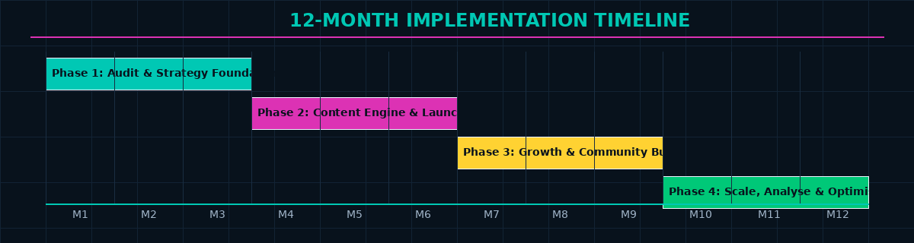
Figure 4: 12-Month Social Media Strategy Implementation Roadmap

Month | Key Activities | Team | Deliverable
Month 1 | Social media audit; competitor benchmarking; define brand voice and visual identity guidelines; finalize platform strategy | Strategy + Creative | Brand Guidelines; Platform Strategy Doc
Month 2 | Build audience personas (primary research); set up all platform accounts with optimised bios and branding; install tracking pixels | Marketing + Dev | Personas; Accounts Live; Pixels Set
Month 3 | Create 4-week content bank; launch content calendar; begin posting cadence on Instagram, YouTube, LinkedIn | Content + Social Team | Content Bank Ready; Posting Begins
Month 4 | Launch nano influencer seeding programme (50 products sent); begin low-budget paid social tests on Instagram | Influencer + Paid Media | Influencer Posts Begin; First Ad Tests
Month 5 | Analyse Month 3–4 performance; optimise top-performing content formats; launch first formal influencer paid campaign | Analytics + Influencer | Performance Report; Campaign Live
Month 6 | Phase 1 review: KPI scorecard vs targets; refine strategy for Phase 2; build loyalty – launch #MyStyleSphere UGC campaign | All Teams + Management | Phase 1 KPI Review; UGC Campaign Live
Month 7 | Macro influencer campaign for festive season lead-up; expand YouTube posting to 2x per week | Content + Influencer | Macro Collab Content Live
Month 8 | Launch Instagram Shopping and YouTube Shopping integration; scale paid ads with best-performing creatives from Phase 1 | Dev + Paid Media | Social Commerce Live; Scaled Ads
Month 9 | Diwali festive campaign (largest campaign of Year 1); influencer takeovers; real-time engagement sprint | All Teams | Diwali Campaign – Peak Revenue
Month 10 | Post-festive analysis; retention content push; launch loyalty-exclusive early access drops for engaged followers | CRM + Content | Retention Campaign Live
Month 11 | Brand ambassador programme formalisation; select 3 long-term micro ambassadors from Year 1 influencer pool | Influencer + Management | Ambassador Contracts Signed
Month 12 | Annual performance review; present Year 1 social media ROI; plan Year 2 strategy with expanded platforms and budget | All Teams + Leadership | Year 1 Report; Year 2 Strategy Plan

22. FINDINGS
- A documented social media strategy is the single most powerful predictor of success on social media. Brands with a formal strategy are 313% more likely to report strong ROI than those operating without one (Hootsuite Digital 2024).
- Instagram remains the most effective platform for D2C brands targeting Indian women aged 18–35, with Reels delivering an average organic reach 5–7x higher than static posts within the same account.
- Nano and micro influencer marketing delivers the highest ROI of all social media tactics for Indian D2C brands — with engagement rates of 6–15% compared to 1–3% for macro influencers — at a fraction of the cost.
- User-Generated Content (UGC) is the most trusted content format among Indian social media users — 79% of people say UGC highly impacts their purchasing decisions, more than brand-created content or even influencer posts.
- Short-form video (Instagram Reels and YouTube Shorts) dominates organic reach in 2024. Brands that do not have a Reels strategy are systematically disadvantaged in the Instagram algorithm.
- Social commerce is the fastest-growing digital sales channel in India, growing at 55% annually. Brands that integrate Instagram Shopping and WhatsApp Business catalogues report 20–35% of their total digital revenue from social channels within 12–18 months.
- The most common mistake in social media marketing is posting content that serves the brand rather than the audience. The brands that consistently win are those that prioritise audience value (education, entertainment, inspiration) over brand promotion in their content mix.
- Community management response time is a critical but undervalued brand signal. Brands that respond to comments and DMs within 2 hours see 40% higher follow-through rates from potential customers than those that respond in 24+ hours.

23. SUGGESTIONS AND RECOMMENDATIONS
- Lead with Reels: In 2024 and beyond, Instagram Reels is the primary organic growth engine for fashion and lifestyle brands in India. Dedicate at least 40% of content production effort to short-form video. Invest in learning trends, hooks, and storytelling formats that work natively in the Reels format.
- Build the Email List Through Social: Social media audiences are rented — they can be taken away by algorithm changes. Use social media to actively build owned assets: email lists, WhatsApp communities, and loyalty club sign-ups. Treat every 1,000 social followers as an opportunity to convert 100 into email subscribers.
- Invest in Nano Influencers First: For a brand at StyleSphere's stage, spending ₹5 lakhs on 50 nano influencer partnerships will outperform spending ₹5 lakhs on one macro influencer. Start with nano, build authentic social proof, then graduate to micro and macro as the brand scales.
- Make UGC a System, Not an Afterthought: Build a structured process for collecting, curating, and repurposing customer content. A branded hashtag (#MyStyleSphere), regular repost features, and small incentives (discount codes for featured content) can generate a continuous stream of authentic, high-converting content.
- Track Business Metrics, Not Vanity Metrics: Report to leadership on social-attributed revenue, ROAS, CPA, and customer lifetime value — not follower count and likes. This builds the internal credibility of the social media function and ensures budget continues to grow.
- Develop a Crisis Communication Playbook: Before a brand crisis happens, have a plan. Define severity levels, response timeframes, approval chains, and pre-approved messaging for common crisis scenarios. Social media crises move fast — the brands that handle them well are the ones that prepared in advance.
- Localise for Vernacular Audiences: Over 50% of India's social media users primarily consume content in regional languages. For broader market reach beyond metro cities, StyleSphere should explore Hindi-language content on Instagram and YouTube, and consider regional influencer partnerships.

24. CONCLUSION
Social media is no longer just a marketing channel — it is the place where modern brands are born, built, and sustained. For a D2C brand like StyleSphere, a well-executed social media strategy is not a nice-to-have; it is the core engine of customer acquisition, brand building, and community development.
This project has presented a comprehensive Social Media Strategy Plan — covering platform analysis and selection, detailed buyer personas, SWOT and PESTLE analysis, a six-pillar content framework, content calendar methodology, organic and paid social strategy, influencer marketing tiers and collaboration models, a KPI analytics framework, tool stack recommendations, and case studies from India's most successful social media-driven brands.
The key insight woven through this entire strategy is this: social media success is not about being everywhere or posting constantly. It is about being deeply relevant to a specific audience, on the right platforms, with content that earns their attention rather than demanding it — consistently, over a sustained period of time.
StyleSphere's path to social media success lies in building genuine community around a powerful, values-driven brand identity; investing in the nano and micro influencer ecosystem that gives it credibility with its core audience; making Reels and short-form video the primary content format; and measuring success in business outcomes rather than vanity metrics.
Completing this project has been an incredibly valuable experience. It has given me a structured understanding of social media strategy that goes beyond surface-level tactics into the deeper frameworks — audience psychology, platform mechanics, analytics, and long-term brand building — that separate great social media marketing from the merely average. I look forward to applying these skills in my professional career as a digital marketing professional.

25. REFERENCES

Books and Academic Sources
Kerpen, D. (2019). Likeable social media: How to delight your customers, create an irresistible brand, and be generally amazing (3rd ed.). McGraw-Hill Education.
Kotler, P., Kartajaya, H., & Setiawan, I. (2021). Marketing 5.0: Technology for humanity. John Wiley & Sons.
Chaffey, D., & Ellis-Chadwick, F. (2022). Digital marketing: Strategy, implementation and practice (8th ed.). Pearson Education.
Odden, L. (2012). Optimize: How to attract and engage more customers by integrating SEO, social media, and content marketing. John Wiley & Sons.

Industry Reports and Publications
Hootsuite & We Are Social. (2024). Digital 2024: Global overview report. Hootsuite Inc.
Meta Business. (2024). Instagram for business: Best practices for brand growth 2024. Meta Platforms Inc.
HubSpot. (2024). State of social media marketing report 2024. HubSpot Inc.
Nielsen India. (2023). Trust in advertising and brand messaging: India report. Nielsen Holdings.
Statista. (2024). Social media in India – Statistics and facts 2024. https://www.statista.com

Online Sources and Websites
Advertising Standards Council of India (ASCI). (2023). Guidelines for influencer advertising in digital media. https://www.ascionline.in
Ministry of Electronics and Information Technology (MeitY). (2023). Digital Personal Data Protection Act 2023. https://www.meity.gov.in
Kantar. (2024). India social media trends report 2024. https://www.kantar.com
Sprout Social. (2024). Sprout Social Index: Social media trends and benchmarks. https://www.sproutsocial.com
Social Media Examiner. (2024). Social media marketing industry report 2024. https://www.socialmediaexaminer.com

