<https://www.analyticsvidhya.com/blog/2019/10/detailed-guide-powerful-sift-technique-image-matching-python/>

<https://kushalvyas.github.io/BOV.html>

<https://machinelearningknowledge.ai/image-classification-using-bag-of-visual-words-model/>

<https://towardsdatascience.com/sift-scale-invariant-feature-transform-c7233dc60f37>

<https://ianlondon.github.io/blog/how-to-sift-opencv/>

https://ianlondon.github.io/blog/visual-bag-of-words/

 One can say that a feauture is any discernable, and a significant point/group of points in an image.

In general, SIFT algorithm can be decomposed into four steps:

* **Constructing a Scale Space:** To make sure that features are scale-independent
* **Keypoint Localisation:** Identifying the suitable features or keypoints
* **Orientation Assignment:** Ensure the keypoints are rotation invariant
* **Keypoint Descriptor:** Assign a unique fingerprint to each keypoint

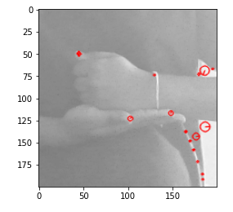

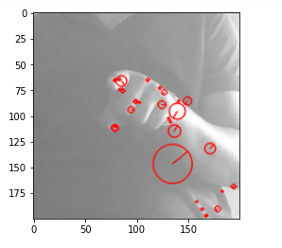

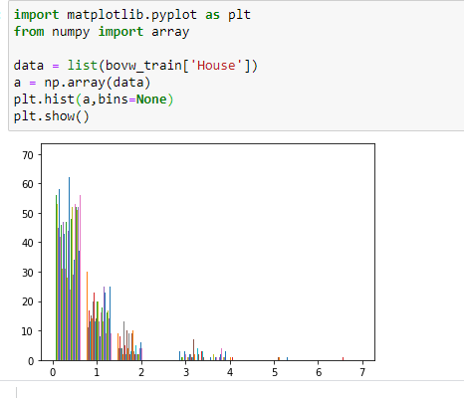

|  |
| --- |
| * Each cluster denotes a particular visual word |
|  | Every image can be represeted as a combination of multiple |
|  | visual words. The best method is to generate a sparse histogram |
|  | that contains the frequency of occurence of each visual word |
|  |  |
|  | Thus the vocabulary comprises of a set of histograms of encompassing |
|  | all descriptions for all images |

K-Means groups the data points into K groups and will return the center of each group(see image below).Each cluster center(centroid) acts as a visual word.