**Task – core-php**

* **Write a PHP program to enter marks of five subjects Physics, Chemistry, Biology, Mathematics and Computer, calculate percentage and grade by if else.**
* <?php

$physics = 90;

$chemistry = 80;

$biology = 70;

$mathematics = 60;

$computer = 50;

$percentage = NULL;

$grade = NULL;

$total = $physics + $chemistry + $biology + $mathematics + $computer;

$percentage = ($total / 500.0) * 100;

if ($percentage >= 90)

$grade = "A";

elseif ($percentage >= 80 && $percentage < 90)

$grade = "B";

elseif ($percentage >= 70 && $percentage < 80)

$grade = "C";

elseif ($percentage >= 60 && $percentage < 70)

$grade = "D";

elseif ($percentage >= 50 && $percentage < 60)

$grade = "E";

else

$grade = "F";

echo "The Percentage = " . $percentage . "%\n";

echo "The Grade = '" . $grade . "'\n";

?>

**Output:**

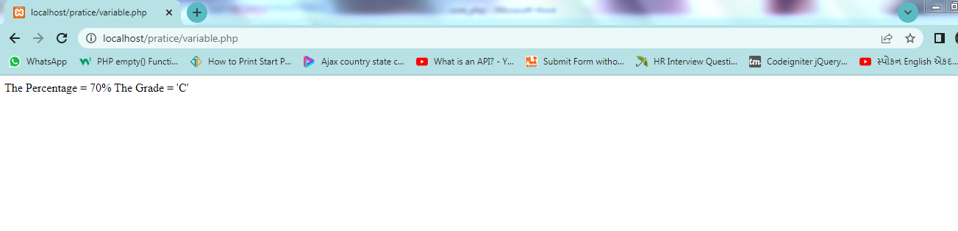

* **Write a PHP program for find „Thursday‟ in week using switch Function.**
* <?php

$day = "4";

switch ($day) {

case 1:

echo "Its a Monday!<br>";

break;

case 2:

echo "Its a Tuesday!<br>";

break;

case 3:

echo "Its a Wednesday!<br>";

break;

case 4:

echo "Its a Thursday!<br>";

break;

case 5:

echo "Its a Friday!<br>";

break;

case 6:

echo "Its a Saturday!<br>";

break;

case 7:

echo "Its a Sunday!!<br>";

break;

default: echo "Invalid number!";

}

?>

**Output:**

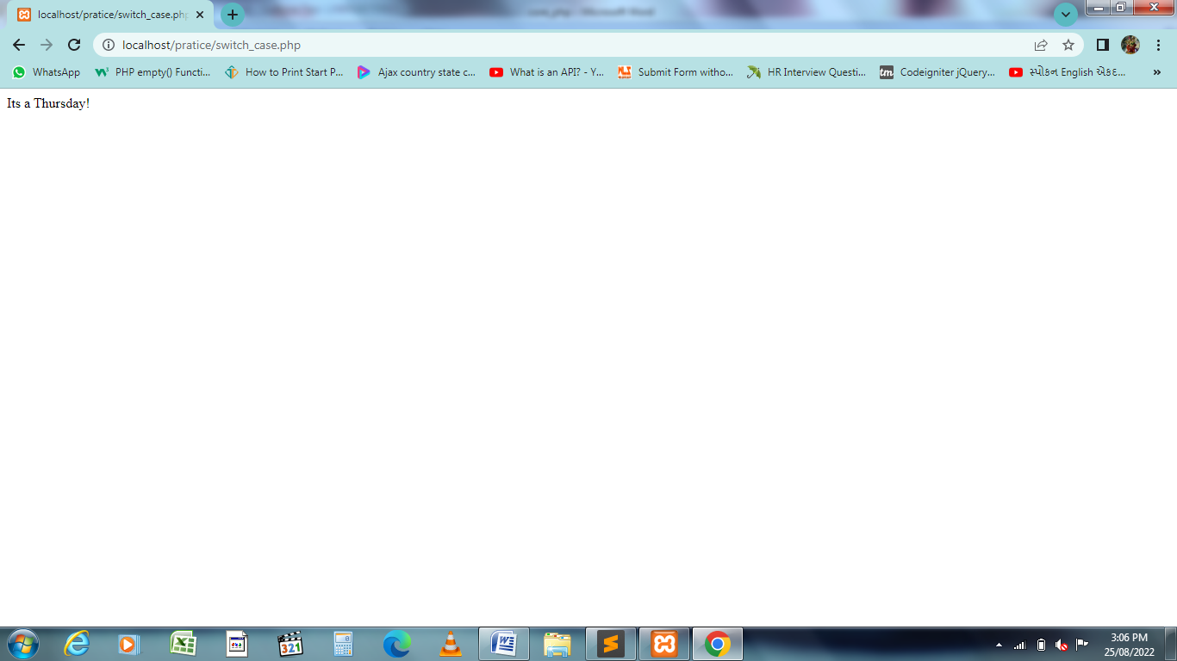

* **Write a PHP program to check Leap years between 1901 to 2016 Using nested if.**
* <?php

for($year=1901; $year<=2016; $year++)

{

if ($year%4==0) {

echo "$year : LEAP YEAR<br>";

}

else

{

echo "$year : Not leap year";

}

}

?>

**Output:**

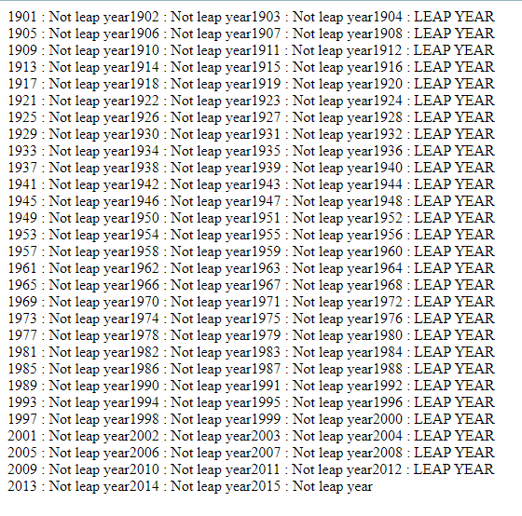

* **Write a PHP program to find the largest of three numbers using ternary Operator.**
* <?php

$x = 220;

$y = 50;

$z = 20;

$max = ($x > $y)? (($x > $z)? $x : $z) : (($y > $z)? $y : $z);

echo "Largest number among $x, $y and $z is:". " " .$max;

?>

**Output:**

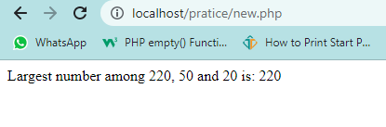

* **Write a program in PHP to print Fibonacci series. 0, 1, 1, 2, 3, 5, 8, 13, 21, 34**
* <?php

$num = 0;

$n1 = 0;

$n2 = 1;

echo "Fibonacci series for first 10 numbers: ";

echo $n1.' '.$n2.' ';

while ($num < 8 )

{

$n3 = $n2 + $n1;

echo $n3.' ';

$n1 = $n2;

$n2 = $n3;

$num = $num + 1;

}

?>

**Output:**

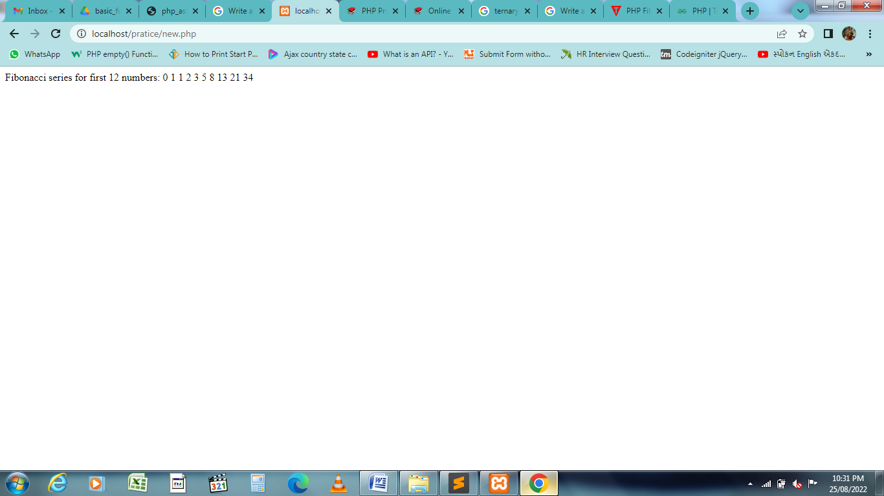

* **Write a program to find whether a number is Armstrong or not**
* <?php

$a=$i=1634;

$p=strlen($i);

$sum=0;

while($i>0)

{

$b=$i%10;

$sum=$sum + pow($b,$p);

$i=$i/10;

}

if($sum==$b){

echo "$a is an Armstrong number <br>";

}

else

{

echo "$a is not an Armstrong number <br>";

}

?>

**Output:**



* **Write a program to print the below format :**

5 9

2610

3711

4812

* <?php

for($i=1; $i<=4; $i++)

{

$a = $i;

for($j=0; $j<=2; $j++){

echo $a;

$a = $a + 4;

}

echo "<br>";

}

?>

**Output:**

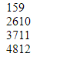

* **Write a program for this Pattern:**

*****

*

*

*

*****

* <?php

for ($i=0; $i<=4;$i++)

{

for ($j=0; $j<=5;$j++)

{

if ($j == 1 or ($i == 0 and $j > 1 and $j < 6) or ($i == 4 and $j > 1 and $j < 6))

echo "*";

}

echo "<br>";

}

?>

**Output:**

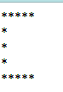

* **What will be the values of $a and $b after the code below is executed? Explain your answer.**
* $a = '1';
* $b = &$a;
* $b = "2$b";
* $a = '1'; // $a is a variable type of string with the value '1';

$b = &$a; // $b is the reference of the $a variable.

$b = "2$b"; // $b & $a have for value the string '2' concatenate with the value of the variable $a (string '1').

So the **output** of value a and b is 21.

* **How can you tell if a number is even or odd without using any Condition or loop?**
* <?php

$arr=array("0"=>"Even","1"=>"Odd");

$check=13;

echo "Your number is: ".$arr[$check%2];

?>

**Output:**



* **Write program to remove duplicate values from array**
* array_ unique function. This function will remove the duplicate values from the array.

**Syntax:**

array array_unique($array, $sort_flags)

<?php

$a = array("red", "green", "pink", "blue","green");

print_r(array_unique($a));

?>

**Output:**

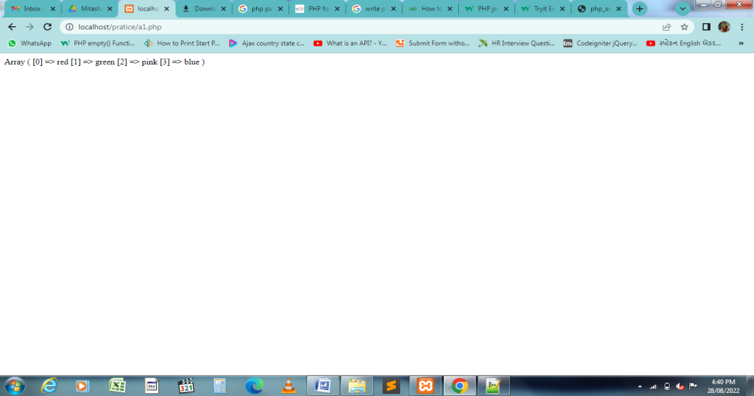

* **Get random values from array**
* There are two functions to get random value out of an array in PHP. The shuffle() and array_rand() function is used to get random value out of an array.

Php array_rand: The array_rand() function is an inbuilt function in PHP which is used to fetch a random number of elements from an array. The element is a key and can return one or more than one key.

**Syntax:** array_rand( $array, $num )

This function accepts two parameters $array and $num. The $array variable store the array elements and $num parameter holds the number of elements need to fetch. By default value of this parameter is 1.

<?php

$arr = array( "a"=>"21", "b"=>"31", "c"=>"7", "d"=>"20" );

$key = array_rand($arr);

echo $arr[$key];

?>

**Output:**



* **Use a for loop to total the contents of an integer array called numbers which has five elements. Store the result in an integer called total.**
* <?php

$arr =array(12, 3, 4, 15, 10);

$n = sizeof($arr);

$sum=0;

for ($i = 0; $i < $n; $i++)

{

$sum = $sum + $arr[$i];

}

echo "Sum of given array is " . $sum;

?>

**Output:**



* **Declare a Multi Dimensioned array of floats called balances having Three rows and five columns.**
* <?php

$cars = array (

"Ankit" => array(

"C" => 9.5,

"DCO" => 8.5,

"FOL" => 7.4,

"rom" => 3.3,

"D" => 2.9

)

);

foreach($cars as $car) {

echo "<p><b>row 1 </b></p>";

echo $car['C']. " ".$car['DCO']." ".$car['FOL']." ".$car['rom']." ".$car['D']."<br>";

echo "<p><b>row 2 </b></p>";

echo $car['C']. " ".$car['DCO']." ".$car['FOL']." ".$car['rom']." ".$car['D']."<br>";

echo "<p><b>row 3 </b></p>";

echo "<p><b>colum number</b></p>";

echo $car['C']. " ".$car['DCO']." ".$car['FOL']." ".$car['rom']." ".$car['D']."<br>";

}

?>

**Output:**

