**Topic – SQL Task -1**

1. **Get First Name from employee table using alias name “Employee Name”.**

* SELECT first_name AS EmployeeName FROM employee;

**Output:**

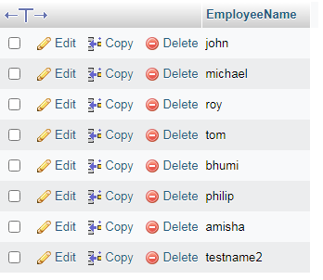

**b) Get FIRST_NAME, Joining year, Joining Month and Joining Date from**

**employee table.**

* SELECT first_name,joining_year,joining_month,joining_date FROM employee;

**Output:**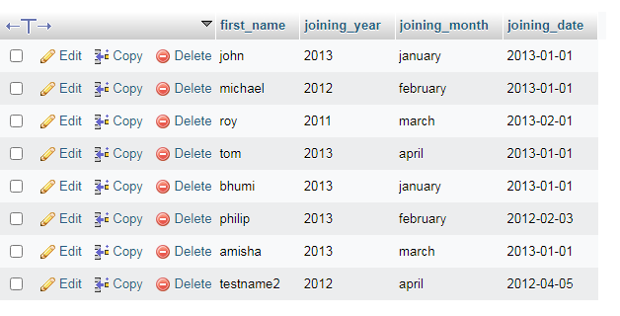

**c) Get all employee details from the employee table order by First Name Ascending And Salary descending?**

* SELECT * FROM `employee` ORDER BY first_name ASC , salary DESC;

**Output:**

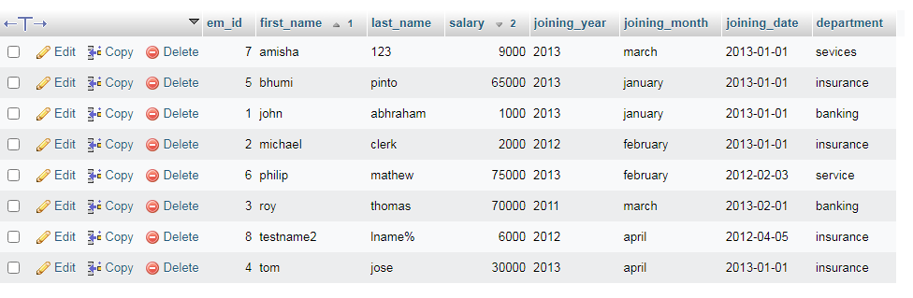

**d) Get employee details from employee table whose first name contains „o‟.**

* SELECT * FROM `employee` WHERE first_name LIKE 'o%';

**Output:**

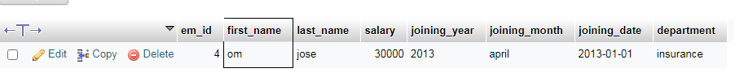

**e) Get employee details from employee table whose joining month is “January”.**

* SELECT * FROM employee WHERE joining_month = january;

**Output:**

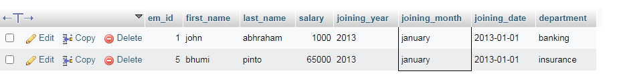

**f) Get department, total salary with respect to a department from employee table order By total salary descending.**

* SELECT * FROM employee ORDER BY department, salary DESC;

**Output:** 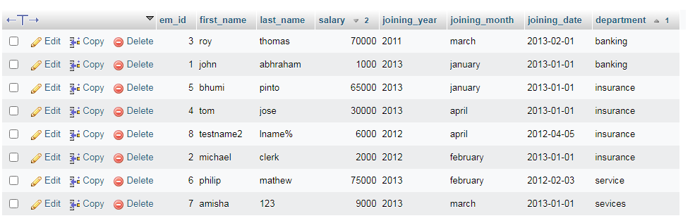

**g) Get department wise maximum salary from employee table order by salary Ascending.**

* SELECT department, MAX(salary) MAX salary FROM employee GROUP BY department ORDER BY MAX salary ASC;

**Output:**

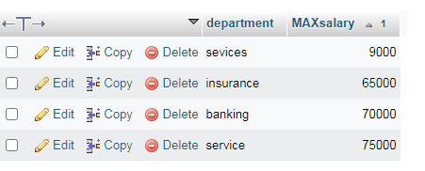

**h) Select first_name, incentive amount from employee and incentives table for those employees who have incentives and incentive amount greater than 3000**

* SELECT incentives. Incentive_amt, employee.first_name FROM incentives INNER JOIN employee ON incentives.em_id = employee.em_id WHERE Incentive_amt > 3000;

**Output:**

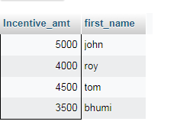

**i) Select 2nd Highest salary from employee table.**

* select salary from employee order by salary desc limit 1,1;

**Output:**

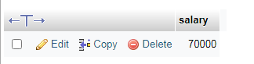

**j) Select first_name, incentive amount from employee and incentives table for all Employees who got incentives using left join.**

* SELECT incentives.Incentive_amt, employee.first_name FROM incentives LEFT JOIN employee ON incentives.em_id = employee.em_id;

**Output:**

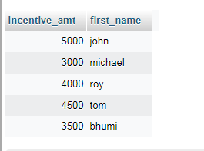

**k) Create View OF Employee table in which store first name ,last name and salary only.**

* CREATE VIEW employee_view as SELECT first_name, last_name,salary FROM employee;

**Output:**

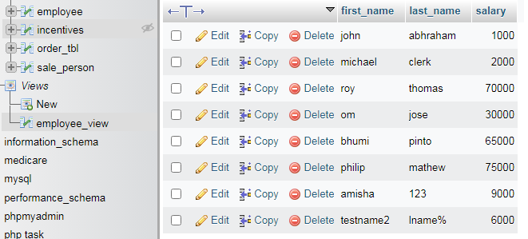

**l) Create Procedure to find out department wise highest salary.**

* CREATE PROCEDURE sell_emp()

BEGIN

SELECT department ,MAX(salary) FROM employee GROUP BY department;

END

Call sell_emp();

**Output:**

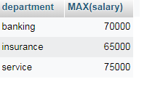

**m) Create After Insert trigger on Employee table which insert records in view table.**

* create table emp_log( em_id int, first_name varchar(255), last_name varchar(255),salary varchar(255),joining_year varchar(255),joining_month varchar(255),joining_date varchar(255), department varchar(255), entry_date_time datetime);
* CREATE TRIGGER insert_emp After INSERT ON employee FOR EACH ROW

BEGIN

insert into emp_log(em_id,first_name,last_name,salary,joining_year,joining_month,joining_date, department ,Entry_date_time) values (new.em_id,new.first_name,new.last_name,new.salary,new.joining_year,new.joining_month,new.joining_date, department ,now());

END

**Output:**

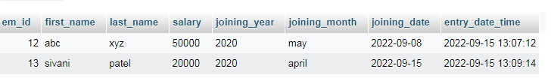

**Task – 2**

1. **All orders for more than $1000.**

* select * from orde_tbl WHERE amt > 1000;

**Output:**

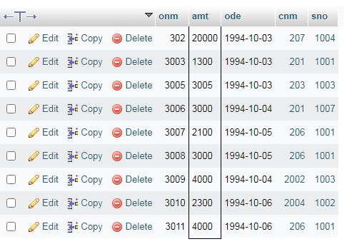

1. **Names and cities of all salespeople in London with commission above 0.10.**

* Select sname, city from sale_person where comm > 0.10 and city = 'london';

**Output:**

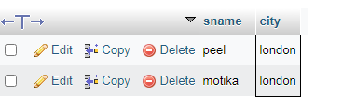

1. **All salespeople either in Barcelona or in London.**

* SELECT * from sale_person WHERE city='barcelona' OR city='london';

**Output:**

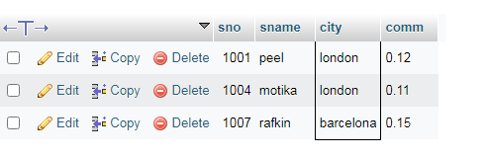

1. **All salespeople with commission between 0.10 and 0.12. (Boundary values should be excluded).**

* SELECT * from sale_person WHERE comm BETWEEN 0.10 AND 0.12;

**Output:**

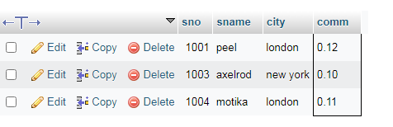

1. **All customers with NULL values in city column.**

* Select * from customer where city is null;

**Output:**

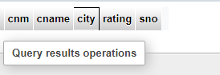

1. **All orders taken on Oct 3Rd and Oct 4th 1994.**

* Select * from order_tbl WHERE ode IN ('1994-10-03','1994-10-04');

**Output:**

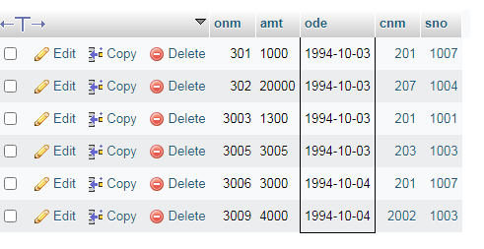

1. **All customers serviced by peel or Motika.**

* SELECT sale_person.sname FROM customer INNER JOIN sale_person ON customer.sno = sale_person.sno WHERE sname = 'peel' or 'motika'

**Output:**

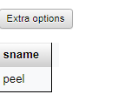

1. **All customers whose names begin with a letter from A to B**

* Select cname from customer WHERE cname like 'a%' or cname like 'b%';

**Output:**

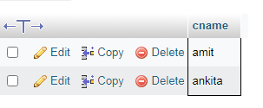

1. **All customers excluding those with rating <= 100 unless they are located in Rome.**

* Select * from customer WHERE rating <= 100 or city = 'rome';

**Output:**

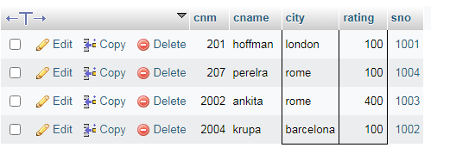

1. **All orders except those with 0 or NULL value in amt field.**

* Select * from order_tbl WHERE amt != 0 or amt is not null;
* **Output:**

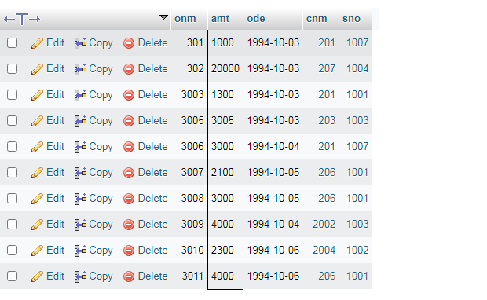

1. **Count the number of salespeople currently listing orders in the order table.**

* Select count(DISTINCT sno) from order_tbl;

**Output:**

