**SQL Task -1**

1. Get First Name from employee table using alias name “Employee Name”.

**SELECT first_name AS EmployeeName FROM employee;**

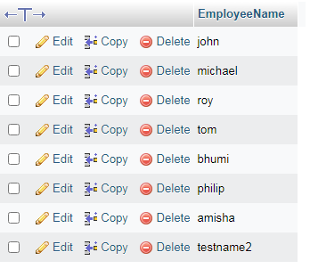

b) Get FIRST_NAME, Joining year, Joining Month and Joining Date from employee table.

**SELECT first_name,joining_year,joining_month,joining_date FROM employee;** 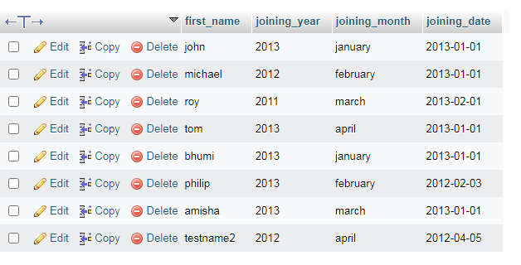c) Get all employee details from the employee table order by First Name Ascending And Salary descending?

**SELECT * FROM `employee` ORDER BY first_name ASC , salary DESC;**

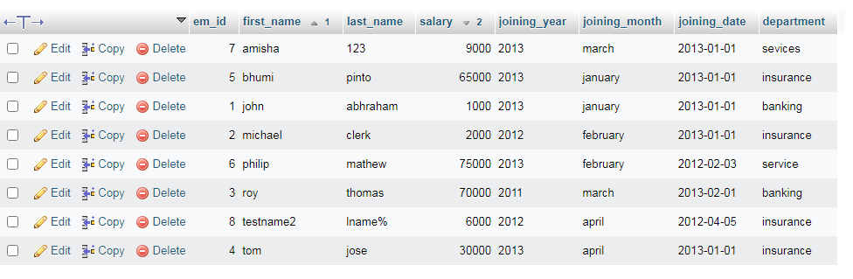

d) Get employee details from employee table whose first name contains „o‟.

**SELECT * FROM `employee` WHERE first_name LIKE 'o%';**

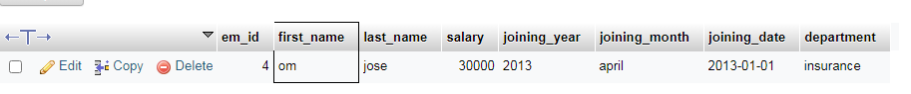

e) Get employee details from employee table whose joining month is “January”.

**SELECT * FROM employee WHERE joining_month = 'january';**

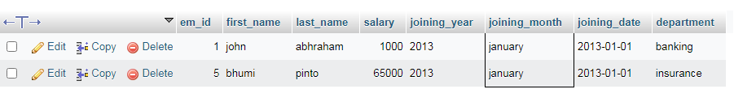

f) Get department, total salary with respect to a department from employee table order By total salary descending.

**SELECT * FROM employee ORDER BY department, salary DESC;**

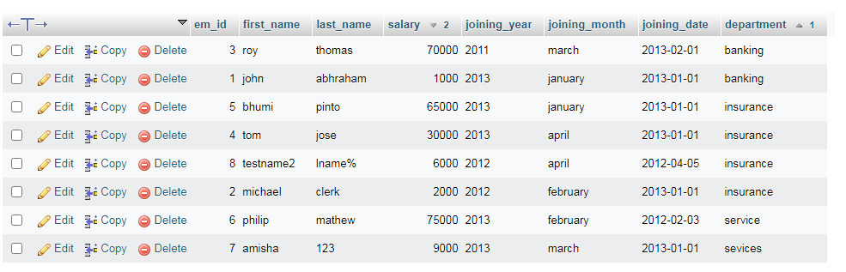

g) Get department wise maximum salary from employee table order by salary

Ascending.

**SELECT department, MAX(salary) MAXsalary FROM employee GROUP BY department ORDER BY MAXsalary ASC;**

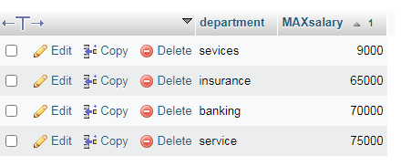

h) Select first_name, incentive amount from employee and incentives table for those employees who have incentives and incentive amount greater than 3000

**SELECT incentives.Incentive_amt, employee.first_name FROM incentives INNER JOIN employee ON incentives.em_id = employee.em_id WHERE Incentive_amt > 3000;**

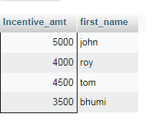

i) Select 2nd Highest salary from employee table.

**select salary from employee order by salary desc limit 1,1;**

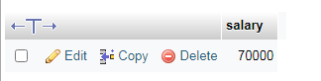

j) Select first_name, incentive amount from employee and incentives table for all Employees who got incentives using left join.

**SELECT incentives.Incentive_amt, employee.first_name FROM incentives LEFT JOIN employee ON incentives.em_id = employee.em_id;**

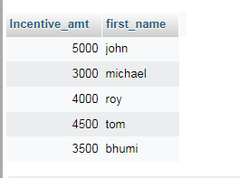

k) Create View OF Employee table in which store first name ,last name and salary only.

[**CREATE**](http://localhost/phpmyadmin/url.php?url=https://dev.mysql.com/doc/refman/8.0/en/create-view.html)[**VIEW**](http://localhost/phpmyadmin/url.php?url=https://dev.mysql.com/doc/refman/8.0/en/create-view.html) **employee_view as** [**SELECT**](http://localhost/phpmyadmin/url.php?url=https://dev.mysql.com/doc/refman/8.0/en/select.html) **first_name,last_name,salary FROM employee;**

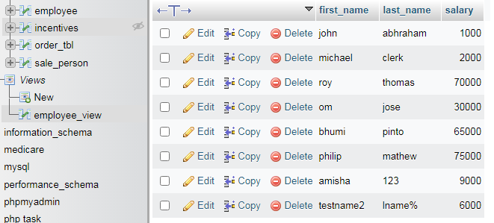

l) Create Procedure to find out department wise highest salary.

**Create procedure sel_emp()**

**BEGIN**

**select department,max(salary) from employee GROUP BY department;**

**END**

**Call sel_emp()**

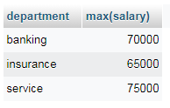

m) Create After Insert trigger on Employee table which insert records in view table.

**create table emp_log(em_id int(100), first_name varchar(100), last_name varchar(100), salary varchar(100), joining_year varchar(100), joining_month varchar(100), joining_date varchar(100), department varchar(100), entry_date_time datetime);**

**CREATE TRIGGER insert_trigger_reg BEFORE INSERT ON reg FOR EACH ROW**

**BEGIN**

**insert into emp_log(em_id,first_name,last_name,salary,joining_year,joining_month,joining_date,department,Entry_date_time) values (new.em_id,new.first_name,new.last_name,new.salary,new.joining_year,new.joining_month,new.joining_date,new.department,now());**

**END**

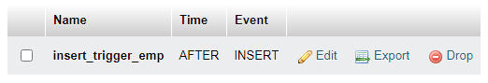

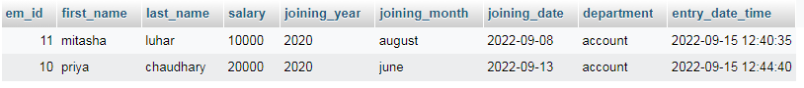

**Task – 2**

1. All orders for more than $1000.

**select * from orde_tbl WHERE amt > 1000;**

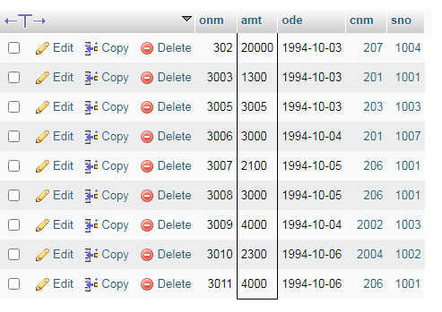

1. Names and cities of all salespeople in London with commission above 0.10.

**Select sname, city from sale_person where comm > 0.10 and city = 'london';**

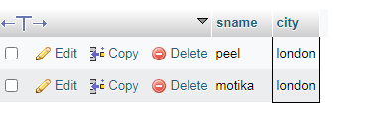

c) All salespeople either in Barcelona or in London.

-> SELECT * from sale_person WHERE city='barcelona' OR city='london';

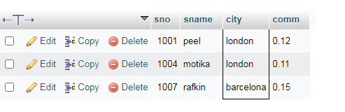

1. All salespeople with commission between 0.10 and 0.12. (Boundary values should be excluded).

**SELECT * from sale_person WHERE comm BETWEEN 0.10 AND 0.12;**

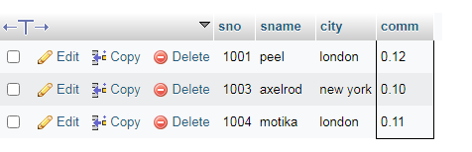

1. All customers with NULL values in city column.

**Select * from customer where city is null;**

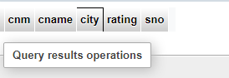

1. All orders taken on Oct 3Rd and Oct 4th 1994.

**Select * from order_tbl WHERE ode IN ('1994-10-03','1994-10-04');**

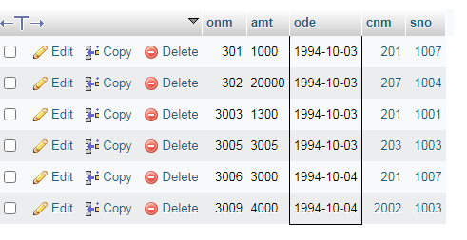

1. All customers serviced by peel or Motika.

**SELECT sale_person.sname FROM customer INNER JOIN sale_person ON customer.sno = sale_person.sno WHERE sname = 'peel' or 'motika';**

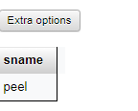

1. All customers whose names begin with a letter from A to B

**Select cname from customer WHERE cname like 'a%' or cname like 'b%';**

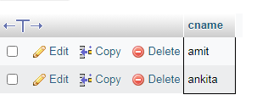

1. All customers excluding those with rating <= 100 unless they are located in Rome.

**Select * from customer WHERE rating <= 100 or city = 'rome';**

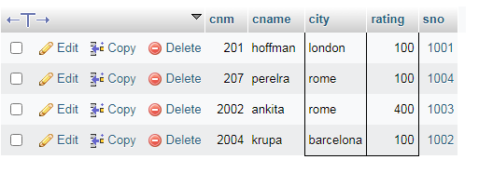

1. All orders except those with 0 or NULL value in amt field.

**Select * from order_tbl WHERE amt != 0 or amt is not null;**

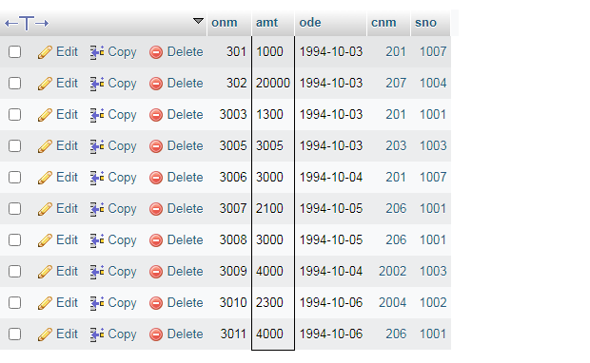

1. Count the number of salespeople currently listing orders in the order table.

**Select count(DISTINCT sno) from order_tbl;**

