Trust Bank – Lending Modernization

MKT 6364.501 - Artificial Intelligence in Marketing - S25

**By “AI Trespassers”**

Priyadarshan Parida

Silvia Rojas Menjivar

Sunayana Jana

Vaishnavi Suresh Iyer

Table of Contents

Introduction 2

Business Problem 3

Company Analysis 3

SWOT Analysis 3

The VRIO Framework analysis 4

The business case for AI in Creditworthiness 5

Lending Decisions at Trust Bank – The Current Landscape 6

Proposed Solution: AI-Based Credit Risk Assessment 8

Proposed Target State: Digital Lending with AI 9

Proposed Solution: Technical Approach 10

Recommendations & Next Steps 11

ROI Considerations 13

Challenges 14

Assumptions and Constraints 15

Avoiding Bias and Ensuring Fairness 15

Conclusion 16

References 16

Appendix 17

# Introduction

Trust Bank is a small-scale community bank that serves local customers. With a steady customer base and a reputation for responsible lending, the bank has traditionally processed loan applications manually. The bank focuses on relationship-based lending and involves manual review rather than performing any automated risk assessment. Owing to its scale of operation and limited customer base, the bank has been operating with limited technological infrastructure.

# Business Problem

The recent closure of a competing bank has led to an unprecedented surge in applications, nearly tripling the usual volume. The sudden increase in applications has placed significant pressure on the underwriting team, given that Trust bank’s traditional manual process is slow, inefficient and error prone. This increases the risk of delays and suboptimal lending decisions, thus may lead to potential revenue loss and customer dissatisfaction. A systematic, AI-driven approach is required to efficiently evaluate applications while maintaining regulatory compliance and minimizing default risk.

# Company Analysis

### SWOT Analysis

Strength: The bank has built a strong reputation for trust and reliability within the local community, which gives it a competitive advantage over impersonal financial institutions. Its deep understanding of the local market allows for more personalized financial services and tailored lending decisions.

Weakness: The bank currently follows manual review process, which is slow and inefficient. Due to limited tech adoption, there is low scalability, making it harder to quickly adopt advance technology and involves higher operational costs.

Opportunity: The competitor’s closure is an opportunity for Trust bank to attract new customers and increase its customer base. By integrating AI-driven creditworthiness assessment, the bank can offer faster approvals and more competitive loan products. This technological shift can also position the bank as an innovator in the local market, appealing to a younger, tech-savvy demographic.

Threat: Owing to the manual review process that is slow, inefficient and error-prone, there is a risk of losing prospects to competitors.

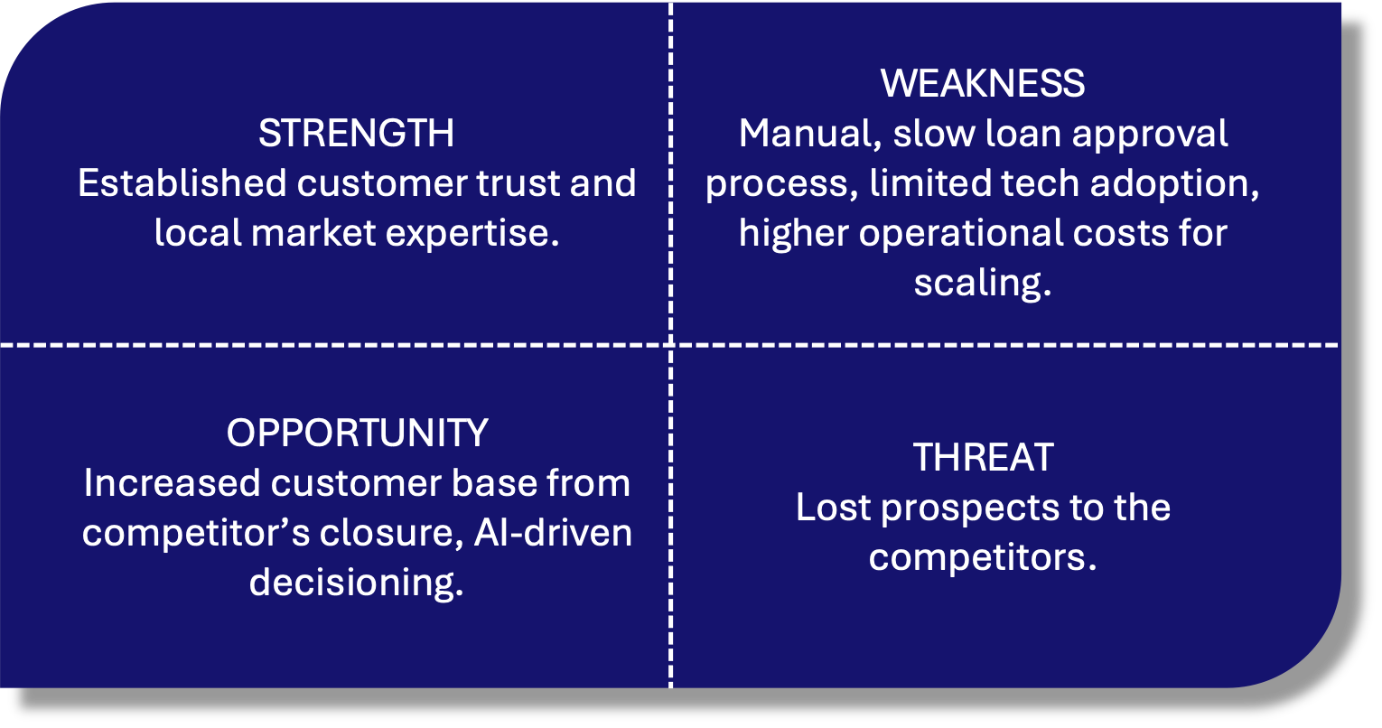

**Fig 1**: SWOT Analysis

### The VRIO Framework analysis

Value: AI-driven assessment of creditworthiness enhances operational efficiency by automating data analysis and decision-making, reducing manual effort, human error, and processing times. It helps reduce lending risks by leveraging predictive analytics to assess borrower reliability with greater accuracy. Additionally, it improves the customer experience by enabling faster loan approvals and personalized financial recommendations.

Rarity: While large financial institutions have adopted AI, there aren’t many community banks that have incorporated such an advanced technology, making it a relatively rare capability in the sector. This can help differentiate the bank and strengthen its market position, leading to higher customer trust and a stronger competitive advantage.

Inimitable: Machine learning models built on proprietary data can provide unique insights into customer creditworthiness. Customized models trained on historical first-party data are difficult for competitors to replicate. Continuous learning and model refinement can help further reinforce this inimitability, enhancing accuracy and decision-making capabilities.

Organized: Adoption of the AI-based solution requires investment in digital infrastructure to make data available and deploy AI models. Additionally, organizational change management is critical, requiring leadership buy-in, process realignment, and staff training to ensure effective AI adoption.

**Fig 2**: The VRIO Framework

# The Business Case for AI in Creditworthiness

Creditworthiness of a customer is their ability and willingness to repay borrowed money. In lending decision-making, creditworthiness is assessed through factors like credit history, income, and assets, ultimately determining the lender's risk and the terms of a loan.

Creditworthiness assessment is not just a financial or risk-management concern; it is a critical marketing factor that directly influences customer acquisition, retention, and brand perception. Slow and offline loan approvals create significant friction in the customer experience, leading to high dropout rates as potential borrowers seek faster, more convenient alternatives. In a competitive financial landscape, a bank’s ability to offer seamless and timely credit decisions can enhance its reputation, attract new customers, and improve overall satisfaction. AI-driven lending solutions address this challenge by leveraging predictive analytics to assess vast amounts of historical data, improving the accuracy of credit decisions while automating risk assessment. This eliminates manual touchpoints, reducing delays and making the lending process more efficient and customer-friendly.

From a marketing perspective, an optimized creditworthiness assessment system directly impacts key performance indicators (KPIs) such as conversion rates. In AI-based, data-driven lending decisions, conversion rate is a leading indicator of success, as higher approval rates for qualified applicants, coupled with a frictionless application process, result in greater loan uptake. This, in turn, contributes to increased revenue, which serves as a lagging indicator of the effectiveness of AI-driven lending strategies. Furthermore, ensuring fairness and transparency in AI-based credit assessments strengthens the bank’s brand image, fostering trust and long-term customer relationships. By integrating AI into lending decisions, the bank not only improves risk management but also gains a competitive edge in customer acquisition and retention, reinforcing its position in the market.

Here are a few facts and figures emphasizing the need of AI in creditworthiness:

* **15.1%** of net revenue in provisions for loan losses at the community banks ([S&P Global](https://www.spglobal.com/market-intelligence/en/news-insights/research/community-bank-earnings-will-recover-despite-weaker-credit-sticky-deposit-costs)).
* **Digital-first lenders** leveraging AI are gaining market share, while many community banks anticipate **declining credit quality** in key lending areas ([CSBS](https://www.csbs.org/node/510346)).
* **Manual Underwriting Inefficiencies** in traditional credit evaluation slows approvals, increases operational costs, and limits scalability, especially as noncurrent loans rise ([Dallas Fed](https://www.dallasfed.org/research/swe/2024/swe2418)).
* An average annual loss of **$15 million** in the banking sector due to poor data quality and management ([datachecks](https://www.datachecks.io/post/financial-impact-of-poor-data-quality-on-banking-operations)).

# Lending Decisions at Trust Bank – The Current Landscape

On average, the end-to-end lending decisions at Trust Bank takes 1-2 weeks (excluding the closing and disbursement). The current lending process at Trust Bank is outlined below.

Step 1: Loan Origination

The current lending process at Trust Bank starts when a customer contacts a banker to submit a loan application through an in-person visit, call, or email. While most banks offer application submission as a self-service offering, Trust bank requires a banker to be contacted by a potential customer. This also requires the banker to spend time discussing with the customer, which they could have rather spent on other more important activities that really require human involvement. This is a time-consuming and inefficient process for both the customer and the bank.

Step 2: Loan Processing

Once a potential borrower submits an application, it is manually reviewed by a loan officer to ensure completeness. Since the application process is manual, there can be errors which can be easily avoided through an online application form with built-in validation logic. Incomplete or incorrect applications require quite a lot of going back and forth between the bank and the customer, only adding to the delay in the overall process.

Step 3: Underwriting

An underwriter or loan officer manually assesses a customer's credit risk by reviewing financial statements, income sources, credit history, and debt obligations to determine their ability to repay a loan. This process is time-consuming, prone to human bias, and can lead to inconsistencies in decision-making. Additionally, the reliance on manual evaluation slows down loan approvals, creating delays that frustrate customers and increase the likelihood of applicants dropping out in favor of faster, tech-driven alternatives.

Step 4: Decisioning

A senior underwriter manually reviews all the documents, including the credit risk assessed in the previous step, and arrives at the decision to approve or disapprove the application. This step adds another layer of delay, as it requires thorough document verification and subjective judgment, increasing processing time. The manual nature of this decision-making process can lead to inconsistencies, potential biases, and inefficiencies, further prolonging loan approvals and negatively impacting customer experience.

Step 5: Closing, Disbursement, Servicing

Once a loan is approved, the closing process involves finalizing agreements, verifying compliance, and obtaining necessary signatures before disbursement. Manual handling of these tasks can introduce delays due to paperwork, coordination issues, and human errors. Even after disbursement, loan servicing such as payment tracking, account management, and customer support requires ongoing manual intervention, making the process inefficient and resource-intensive, ultimately affecting customer satisfaction and operational scalability.

**Fig 3**: The current manual process at Trust Bank

# Proposed Solution: AI-Based Credit Risk Assessment

The current engagement scope only focusses on the part of the underwriting process that assesses credit risk. The proposed solution is to adopt an AI-based data-driven approach to determine the creditworthiness of the applicant. Using Alteryx, we will develop a machine-learning evaluation system that will:

* Analyze historical loan application data to identify patterns in successful approvals. Training data available is listed in the Appendix section.
* Automate credit scoring using key financial indicators and applicant history.
* Prioritize and shortlist creditworthy applicants for manual underwriting.
* Minimize risk by detecting potential defaulters based on predictive modeling.

This timely improvement can substantially alleviate the congestion caused by the surge in the inflow of loan applications.

With the AI-based data-driven credit risk assessment, the average end-to-end lending decision timeline can reach 3-5 business days, i.e., down by 50%.

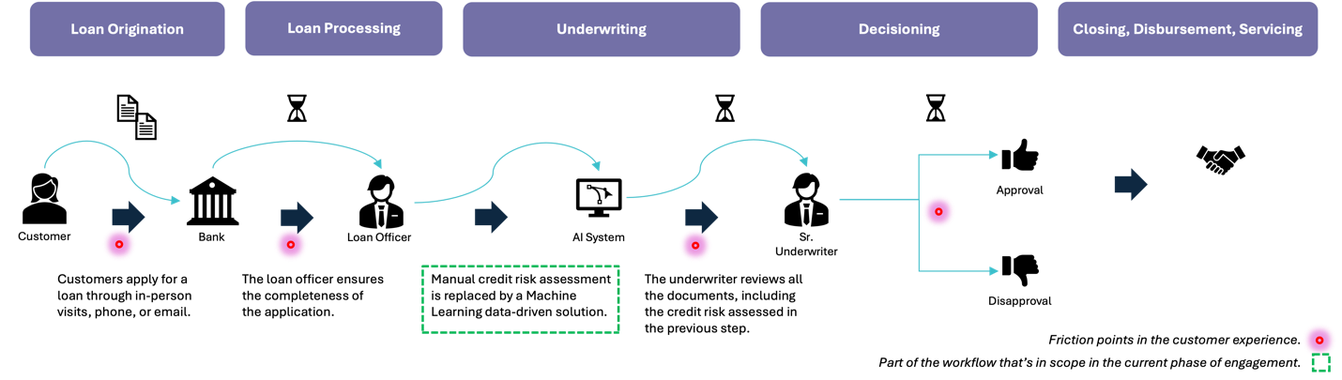

**Fig 4**: Proposed Solution: AI - Based Credit Risk Assessment

# Proposed Target State: Digital Lending with AI

While the current scope of engagement is limited to the credit risk assessment, the proposed target state is a digital lending application that can process loan applications end-to-end. The idea is to provide lending decisions to the customer in real-time or near real-time.

In the proposed AI-driven digital lending model, the loan origination process begins with customers applying for loans through digital channels such as mobile apps or online banking portals. This eliminates the need for in-person visits and paper-based submissions, making the process more accessible and convenient. By leveraging digital applications, the bank can enhance customer experience, reduce application time, and increase engagement with borrowers.

Once an application is submitted, an end-to-end AI-powered lending decision system processes the request. The AI system integrates with the front-end application, instantly analyzing financial data, credit history, and risk factors using predictive analytics and machine learning algorithms. This automation not only accelerates the decision-making process but also ensures accuracy and consistency in credit risk assessments. By eliminating manual touchpoints, the bank can significantly reduce loan approval times, improving conversion rates and overall efficiency.

An optional Review/Override step is included for cases where an underwriter’s intervention may be necessary. If an application falls within a predefined threshold for risk or requires additional evaluation, a loan officer can review or override the AI-generated decision. This hybrid approach balances automation with human expertise, ensuring regulatory compliance and maintaining fairness in lending decisions.

The final step, Closing, Disbursement, and Servicing, is also streamlined through automation. AI-driven workflows handle document verification, electronic agreements, and compliance checks, reducing the chances of errors and delays. Loan disbursements occur swiftly through digital payment systems, while AI-powered servicing tools manage customer interactions, payment tracking, and proactive risk monitoring. By automating these processes, the bank reduces costs, improves operational efficiency, and enhances customer satisfaction, making lending faster, smarter, and more scalable.

The solution is highly scalable but does require significant upfront investment. However, the ROI is promising.

**Fig 5**: Proposed Target State: Digital Lending with AI

# Proposed Solution: Technical Approach

The proposed AI-based solution follows a structured technical approach for leveraging machine learning techniques to assess creditworthiness.

**Fig 6**: Proposed Technical Approach

Data Ingestion & Storage: This phase involves collecting structured and unstructured data from various sources, such as customer applications, credit bureaus, and transaction histories, and storing it securely in a scalable database for further processing. Effective data governance and compliance measures are crucial at this stage to ensure data integrity and security.

Data Pre-processing, Feature Engineering & Exploratory Data Analysis (EDA): Once the raw data is collected, it undergoes preprocessing in Alteryx to clean, normalize, and structure it to handle missing values and inconsistencies to prepare for analysis. Feature engineering techniques are applied to select key variables that influence creditworthiness and can be used to enhance the predictive power of the model. Exploratory Data Analysis (EDA) is conducted to uncover trends, correlations, and anomalies, ensuring that the model is built on a robust and well-understood dataset.

Model Development & Validation: Using Alteryx, machine learning models are developed to predict creditworthiness with high accuracy. Various algorithms, like logistic regression, decision trees, random forest (ensemble), and boosted classification algorithms, are tested to determine the best-performing model based on accuracy. The model is validated through cross-validation techniques to minimize overfitting and ensure generalizability across different borrower profiles.

Model Testing: The AI model undergoes rigorous testing in Alteryx to evaluate its predictive performance against historical lending data. Key metrics are analyzed to assess accuracy and how well the model differentiates between creditworthy and high-risk borrowers. Bias and fairness assessments are also performed to ensure ethical and regulatory compliance in AI-driven credit decisions.

Model Deployment & Integration: Once validated, the AI model is integrated into the bank’s lending platform, enabling real-time credit risk assessment within digital loan applications.

Monitoring and Reinforcement: Continuous monitoring ensures the AI model remains accurate and fair over time, with periodic retraining based on new lending data and evolving market conditions.

The current phase of engagement focuses on data preprocessing, feature engineering, model development, validation, and testing, using **Alteryx** as the primary tool for automation and efficiency. While data ingestion & storage, model deployment & integration, and ongoing monitoring & reinforcement learning are critical to the long-term success of the AI-based lending solution, they fall outside the scope of the current engagement

# Recommendations & Next Steps

**Fig 7**: The “ELEVATE” Framework

AI Trespassers has created the “ELEVATE” framework that applies to companies of the size and nature of Trust bank that are planning to go digital and scale as needed.

* The foundation of this framework is to align with business goals, provide cost-effective solution, optimize speed, and enhance customer experience.
* The immediate goal is to solve the problem at hand by implementing a quick, AI-driven solution to address immediate bottlenecks. Hence, this is termed as the Phase 1 of the solution.
* In order to leverage proprietary data and seamlessly adopt AI technology, the company must consolidate the data silos into a data lake and convert analog data infrastructure into digital format. It must adopt digital technologies to enhance or transform business processes.
* Change management and upskilling is another key requirement for any transformation projects. The company must ensure smooth AI adoption by training employees and driving organizational readiness.
* As the company adopts the AI-based solution and attracts more customers, it should prepare to scale. It must navigate formal institutions by adhering to regulations and mitigating risks, and the informal institutions by aligning with public expectations. The recommendation is to build an on-premise digital lending application that can process loan applications end-to-end. This would be the Phase 2 of the project.
* As the customer base grows and there is a need to scale, it must consider transitioning to cloud and SaaS based solution, to enable long-term scalability and agility. They may also explore custom-built application if there are regulatory concerns.
* The company must always remain compliant with regulatory requirements and practice responsible AI. They must work closely with regulators to ensure AI adoption aligns with lending laws and ethical standards. As part of continuous monitoring and optimization, it must regularly audit AI decisions, retrain models, and refine risk parameters to improve accuracy and fairness over time.

# ROI Considerations

Considerations for the expected return on investment are categorized as Financial, Operational, and Customer-centric. Although the proposed target-state architecture requires a significant upfront investment, the ROI outlook is promising.

From a financial perspective, the AI system is expected to drive **increased revenue** by enabling faster loan approvals, leading to higher conversion rates. Additionally, improved risk assessment **reduces credit losses** **and loan defaults** by ensuring more accurate creditworthiness predictions. Over time, these benefits enhance the bank’s profitability and strengthen its competitive positioning.

On the operational front, AI-driven lending **improves efficiency** by automating credit assessments and eliminating manual bottlenecks. **Faster and more accurate processing** leads to lower operational costs, as fewer resources are required for underwriting and decision-making. By streamlining workflows, the bank can scale its lending operations without a proportional increase in staffing costs.

The customer-centric impact of AI-powered lending is equally significant. A seamless digital experience, reduced approval times, and transparent decision-making contribute to **higher customer satisfaction and engagement**. Borrowers benefit from a more efficient and predictable loan application process, strengthening trust and loyalty toward the bank. In turn, positive customer experiences drive referrals and long-term retention, further contributing to sustainable growth.

By aligning financial gains, operational efficiency, and enhanced customer experiences, the proposed AI lending solution delivers strong and measurable ROI, making it a strategic investment for the bank’s future.

# Challenges

Regulatory Concerns: Compliance with legal and financial regulations to ensure AI-driven lending decisions are fair, transparent, and non-discriminatory.

* Compliance with fair lending laws (e.g., Equal Credit Opportunity Act, Fair Housing Act) and data privacy laws.
* Risk of AI bias and discrimination leading to regulatory scrutiny.
* Need for explainability and transparency in AI-driven decisions.

Ethical Considerations: Addressing biases, data privacy, and the responsible use of AI to ensure fair and accountable credit decision-making.

* Ensuring fair and unbiased credit assessments across all demographics.
* Ensuring borrowers understand how their data is used and decisions are made in the lending process.
* Balancing automation with human oversight to maintain trust and address perceived unfairness.

# Assumptions and Constraints

Assumptions:

* The available historical data is accurate, complete, and representative of current lending trends.
* The AI model can be trained effectively with the given dataset and will generalize well to new applications.
* Trust Bank has the necessary infrastructure to support the deployment of an Alteryx-based AI solution.
* The underwriting team will continue to review and validate AI-driven recommendations before final approvals.
* Regulatory requirements will remain stable during the implementation period.

Constraints:

* Data quality issues such as missing or inconsistent records may affect model performance.
* Compliance with financial regulations and ethical lending practices may limit certain AI-driven decisions.
* The AI model requires continuous monitoring and periodic retraining to maintain accuracy.
* Integration with existing banking systems may pose technical challenges and require additional IT support.

# Avoiding Bias and Ensuring Fairness

To ensure fairness and accuracy, we will use a supervised machine learning approach, training models on historical loan data. The AI system will be regularly monitored and tested to avoid biases related to race, gender, or socio-economic status. Strategies to mitigate bias include:

* Balanced Training Data: Ensuring diversity in historical data to prevent discrimination.
* Feature Selection Scrutiny: Removing attributes that could indirectly introduce bias.
* Fairness Audits: Periodically evaluating model outputs for potential discriminatory patterns.
* Human Oversight: Final lending decisions will include human review to validate AI recommendations.

# Conclusion

In conclusion, the adoption of an AI-powered lending decision system will provide Trust Bank with a scalable solution to meet the increased loan application volume resulting from the recent closure of a competitor. By leveraging Alteryx and machine learning, Trust Bank can automate the evaluation of creditworthiness, ensuring timely and accurate decisions while minimizing manual effort and human error. This digital transformation journey will allow Trust Bank to process loans more efficiently, reduce default risks, and improve operational cost-effectiveness. Furthermore, implementing AI in lending decisions will help maintain compliance with regulatory standards and enhance customer satisfaction by reducing wait times for loan approvals. As Trust Bank continues to expand, this AI-powered system will serve as a critical foundation for supporting growth and maintaining its reputation as a reliable and forward-thinking financial institution.

# References

* https://www.spglobal.com/market-intelligence/en/news-insights/research/community-bank-earnings-will-recover-despite-weaker-credit-sticky-deposit-costs
* https://www.csbs.org/node/510346
* https://www.dallasfed.org/research/swe/2024/swe2418
* https://www.universalclass.com/articles/business/finance/loan-processing-step-by-step.htm
* https://www.communitybankingconnections.org/articles/2015/q1/development-and-maintenance-of-an-effective-loan-policy
* https://www.datachecks.io/post/financial-impact-of-poor-data-quality-on-banking-operations
* https://www.kaggle.com/datasets/thuranaing411/creditworthiness?select=customers-to-score.xlsx

# Appendix

