Generative Ai And Ai Platform Engineering
Name:- K. Priyadarshini
Roll no:- 2520030067
Section no:- 3
WEEK-1
Step 1:-
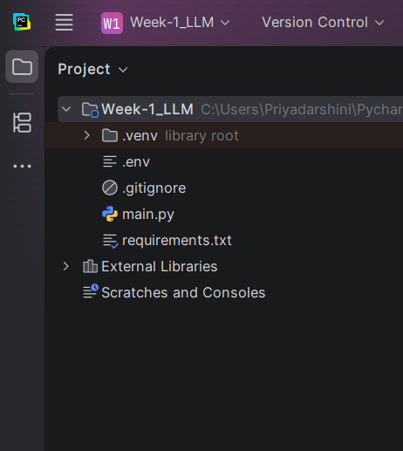
Step 2:-
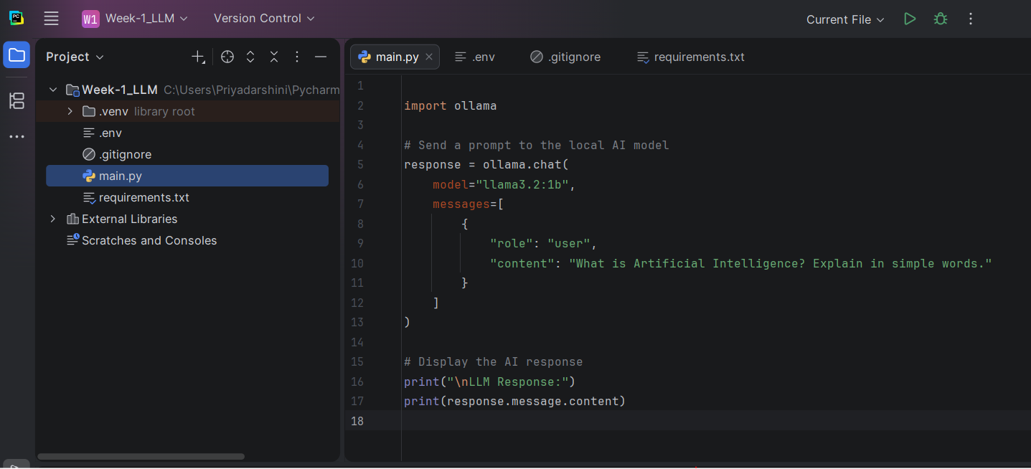
Step 3:-
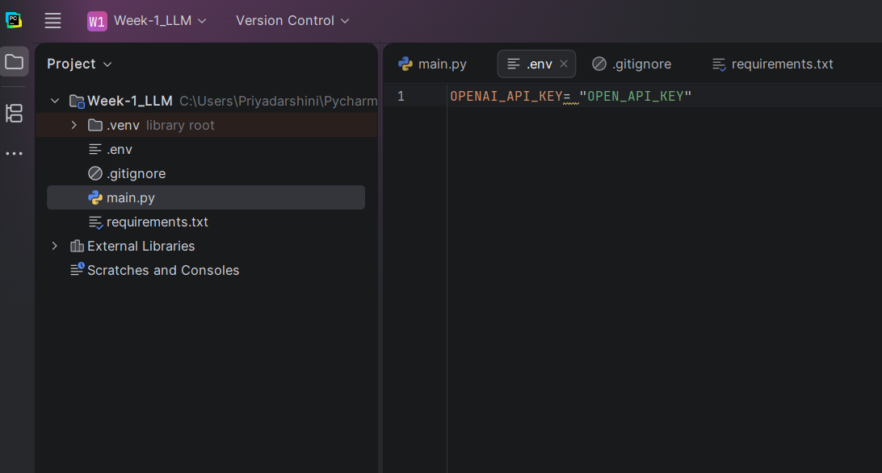
Step 4:-
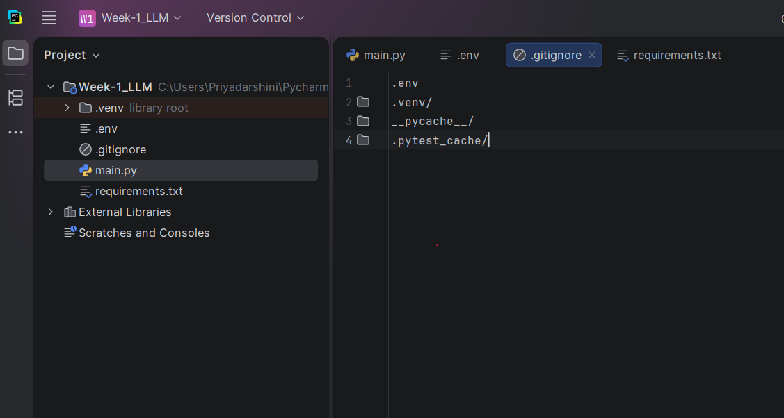

Step 5:-
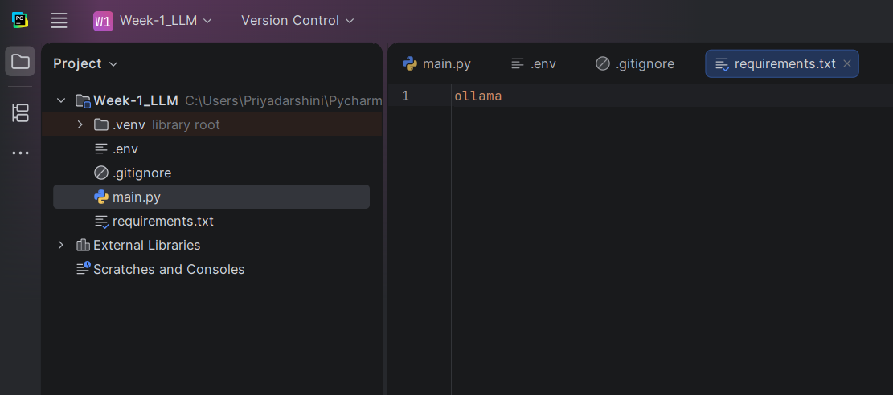

OUTPUT:-


