CARE TRANSITION EFFICIENCY &
PLACEMENT OUTCOME ANALYTICS

HHS Unaccompanied Alien Children Program

Research Paper
Unified Mentor Project

Prepared as an analytical study of care-transition efficiency,
pipeline movement, bottlenecks, and outcome stability.

Submitted by
Priyadarshini Mohapatra

Abstract
This study analyzes care-transition activity within the Unaccompanied Alien Children (UAC) Program using daily operational data covering 720 reporting days. The analysis models the movement of children from apprehension and CBP custody through transfer to HHS care and eventual discharge/placement. Exploratory data analysis, transition ratios, backlog indicators, temporal comparisons, bottleneck detection, and outcome stability analysis were used to identify process patterns. The observed dataset contains 67,337 apprehensions, 92,641 transfers, and 124,853 discharges. The project-defined Transfer Efficiency Ratio was 75.03%, Discharge Effectiveness Index was 2.86%, and Pipeline Throughput Rate was 185.42%. In addition, 17.78% of reporting days showed higher inflow than outflow, while the Outcome Stability Score was 27.51/100 based on discharge variability. The analysis identified 128 bottleneck days and 11 sustained imbalance periods of at least three consecutive days, with the longest lasting five days. The results demonstrate the usefulness of dashboard-based monitoring for detecting operational pressure, supporting case-management prioritization, and improving visibility into care-transition performance.
Keywords
Care transition, UAC Program, HHS care, CBP custody, discharge, bottleneck analysis, backlog, pipeline throughput, outcome stability, Streamlit dashboard

1. Introduction
The Unaccompanied Alien Children (UAC) Program involves a multi-stage care and reunification pipeline. Children may first be apprehended and placed in U.S. Customs and Border Protection (CBP) custody, then transferred to the U.S. Department of Health and Human Services (HHS) for care, case management, and related services, before being discharged to vetted sponsors or through another appropriate placement outcome.
Aggregate counts can describe the scale of program activity, but they do not by themselves explain how efficiently cases move through the pipeline. This project therefore focuses on transition efficiency, discharge activity, backlog pressure, temporal patterns, and consistency of outcomes. A combination of Python-based exploratory data analysis and an interactive Streamlit dashboard was developed to make these patterns easier to monitor.
2. Problem Statement
The primary analytical problem is the lack of simple, consistent process-efficiency measures derived from aggregate care-transition counts. Without transition ratios, backlog indicators, and stability measures, it is difficult to identify periods when inflow is exceeding successful exits, when transfers or discharges are changing sharply, or when operational performance becomes inconsistent.
3. Objectives
- Measure the efficiency of transitions from CBP custody to HHS care.
- Evaluate discharge activity and placement-related outcomes using the available discharge measure.
- Identify days and periods showing potential process bottlenecks or sustained inflow-outflow imbalance.
- Analyze temporal patterns, including monthly trends and weekday-versus-weekend activity.
- Assess the consistency of discharge outcomes using a variability-based stability score.
- Develop an interactive Streamlit dashboard for date filtering, KPI monitoring, ratio-based analysis, and threshold alerts.
- Provide data-driven recommendations that can support case-management and process-improvement decisions.

4. Dataset and Variables
The dataset used for the project contains 1,170 original rows and six core variables. After removing empty rows, 720 valid daily records remained. Dates were converted to datetime format and the records were sorted chronologically before time-based analysis.
Variable | Description
Date | Reporting date for the observation.
Children apprehended and placed in CBP custody* | Daily inflow measure used for pipeline entry analysis.
Children in CBP custody | Number of children reported in CBP custody.
Children transferred out of CBP custody | Daily movement from CBP custody toward HHS care.
Children in HHS Care | Children reported as being in HHS care.
Children discharged from HHS Care | Daily outflow measure used for discharge and exit analysis.
5. Methodology
The analysis followed a structured workflow: data cleaning, exploratory visualization, KPI computation, backlog and bottleneck analysis, temporal analysis, stability analysis, and dashboard development.

5.1 Data Preparation
Empty rows were removed, dates were converted to datetime values, numeric fields were cleaned, and the dataset was sorted in chronological order. Cleaned and analytical versions of the dataset were saved as CSV outputs for reproducibility.

5.2 Care Pipeline Model
The process was modeled as a sequence of apprehension/entry, CBP custody, transfer, HHS care, and discharge/placement. Daily movements were compared to identify periods where inflow exceeded outflow.

5.3 Project-Defined KPIs
KPI | Formula | Result
Transfer Efficiency Ratio | Total transfers ÷ Total children in CBP custody × 100 | 75.03%
Discharge Effectiveness Index | Total discharges ÷ Total children in HHS care × 100 | 2.86%
Pipeline Throughput Rate | Total discharges ÷ Total apprehensions × 100 | 185.42%
Backlog Accumulation Rate | Days where inflow > outflow ÷ total reporting days × 100 | 17.78%
Outcome Stability Score | max(0, 100 − discharge coefficient of variation %) | 27.51 / 100
Important interpretation note: the project-defined formulas are ratio-based monitoring indicators rather than conventional case-level success rates. In particular, Pipeline Throughput can exceed 100% because discharges during the reporting period may relate to children who entered the pipeline earlier. Similarly, the Discharge Effectiveness Index follows the project specification and should not be interpreted as the percentage of individual cases successfully discharged.
The Backlog Accumulation Rate is defined here as the percentage of reporting days on which daily inflow exceeded daily discharge outflow. It is therefore an operational pressure indicator, not a direct count of unresolved cases. The Outcome Stability Score is a variability-based analytical score derived from the coefficient of variation of daily discharges.

5.4 Bottleneck and Sustained Imbalance Analysis
Daily inflow was defined as children apprehended and placed in CBP custody, while daily outflow was defined as children discharged from HHS care. Backlog Change was calculated as inflow minus outflow. A bottleneck day was a day with positive Backlog Change. For sustained imbalance analysis, periods of at least three consecutive positive Backlog Change days were identified. A prolonged stagnation period was defined for this project as at least seven consecutive days.

5.5 Temporal Analysis
Monthly discharge trends were examined to identify changes over time. Average transfer and discharge activity was also compared between weekdays and weekends.

6. Exploratory Data Analysis
The dataset contains 720 valid daily observations after cleaning. The analysis generated time-series plots, a combined trend chart, a correlation heatmap, distribution plots, boxplots, a monthly-average chart, and a pairplot.
Measure | Observed value
Total apprehended | 67,337
Total transferred | 92,641
Total discharged | 124,853
Average daily apprehensions | 93.52
Average daily transfers | 128.67
Average daily discharges | 173.41
Average HHS population | 6,061.28
Peak HHS population | 11,516
Peak daily apprehensions | 333
Peak daily transfers | 440
Peak daily discharges | 505

6.1 Recommended Figures from the Analysis
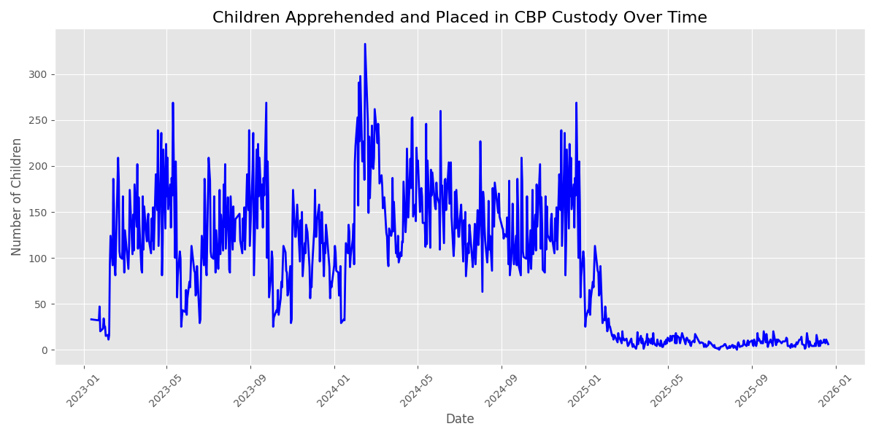
Figure 1. Children apprehended and placed in CBP custody over time.
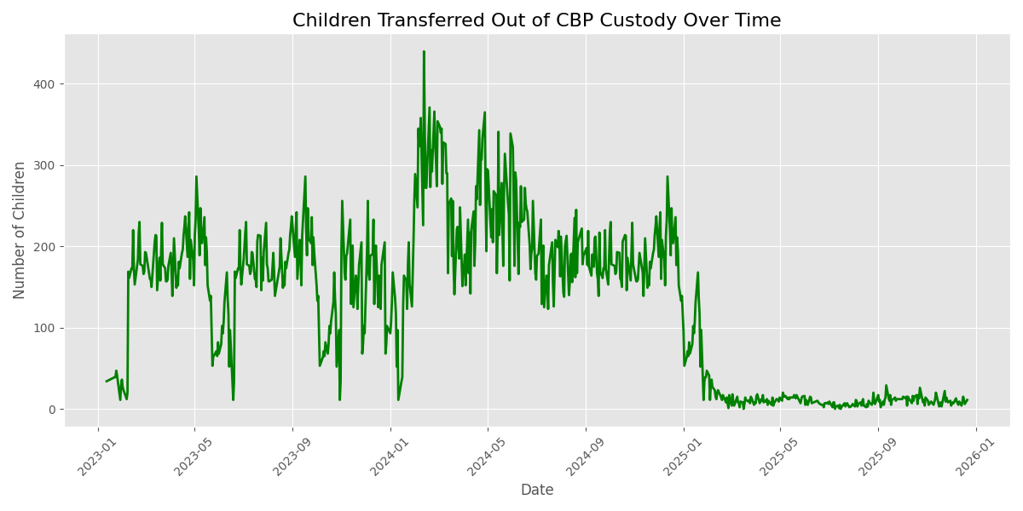
Figure 2. Children transferred out of CBP custody over time.
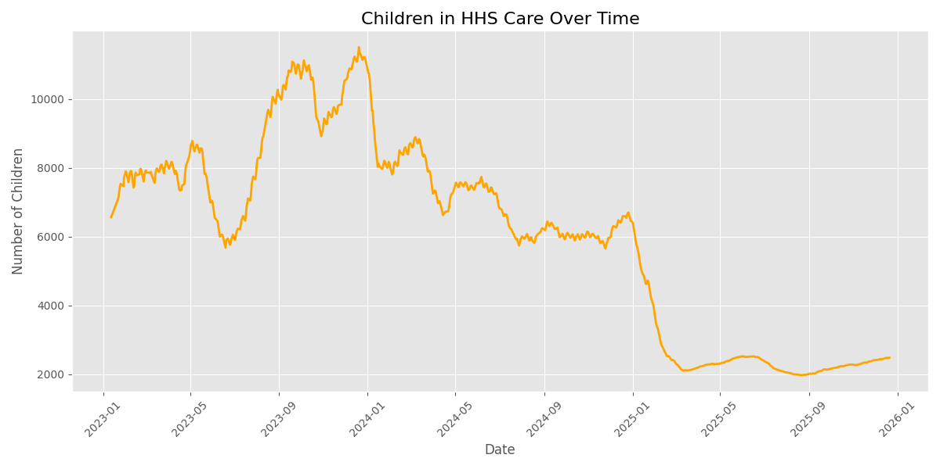
Figure 3. Children in HHS care over time.
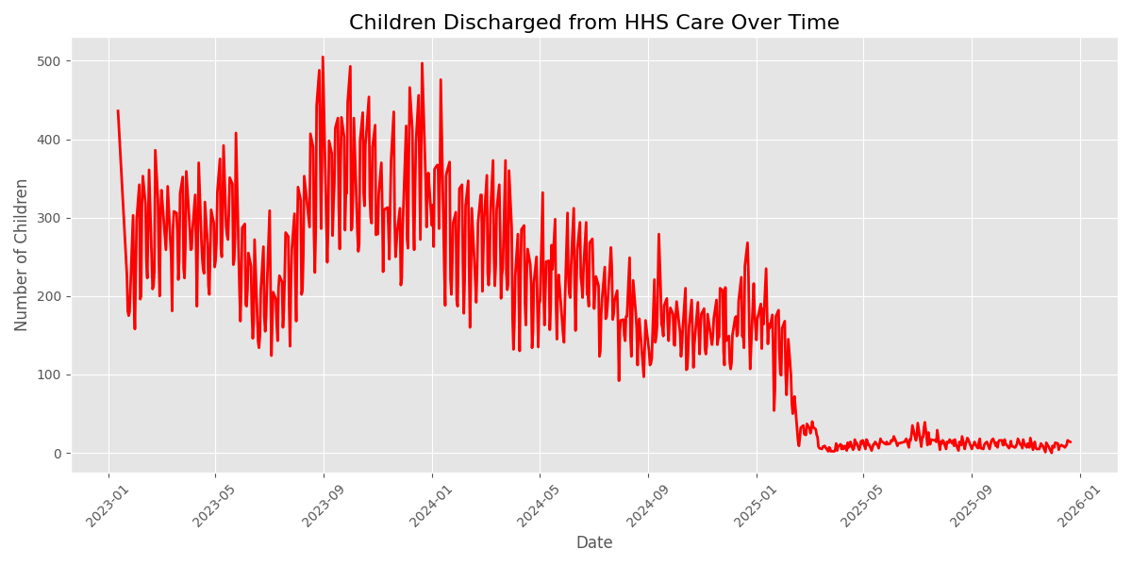
Figure 4. Children are discharged from HHS care over time.
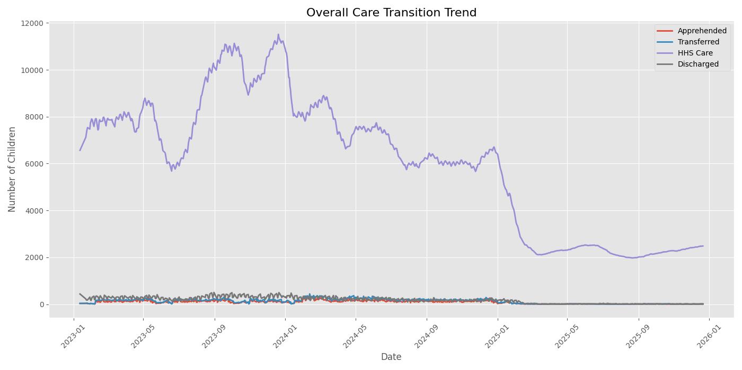
Figure 5. Overall care-transition trend.
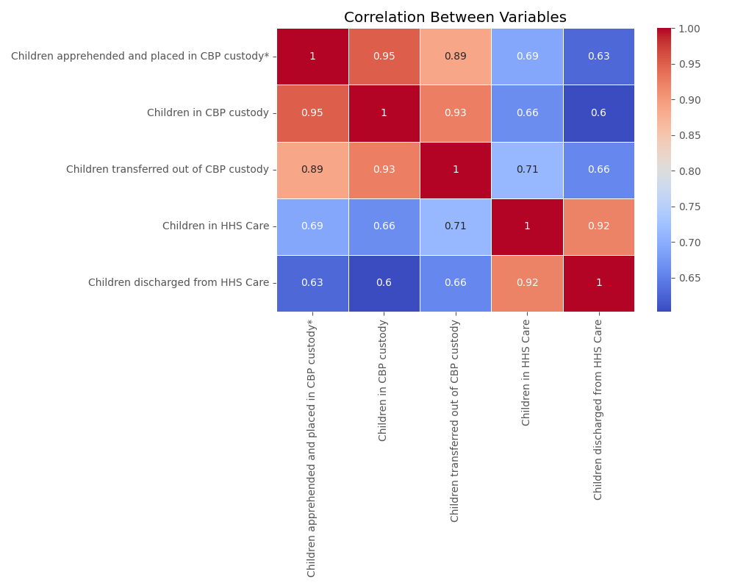
Figure 6. Correlation between numerical pipeline variables.
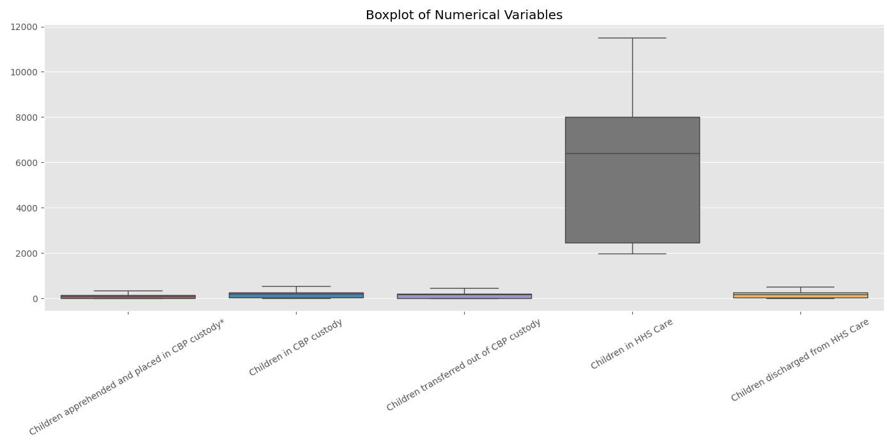
Figure 7. Distribution and variability of numerical variables.
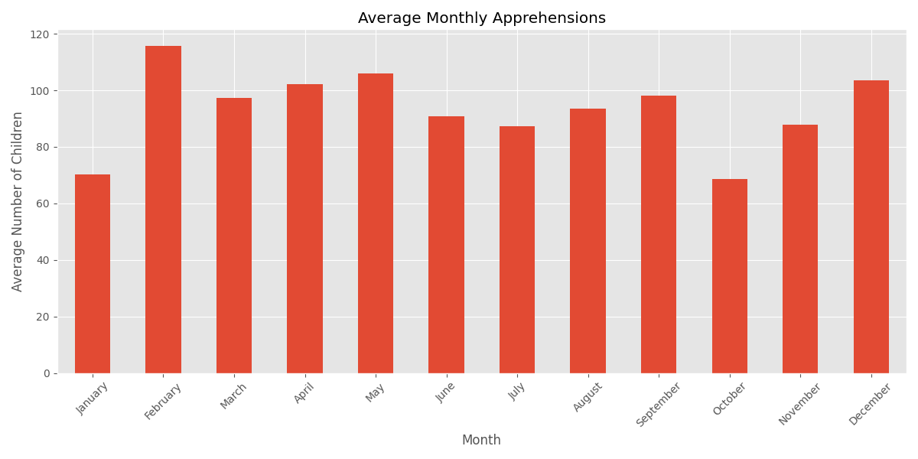
Figure 8. Average monthly apprehensions.
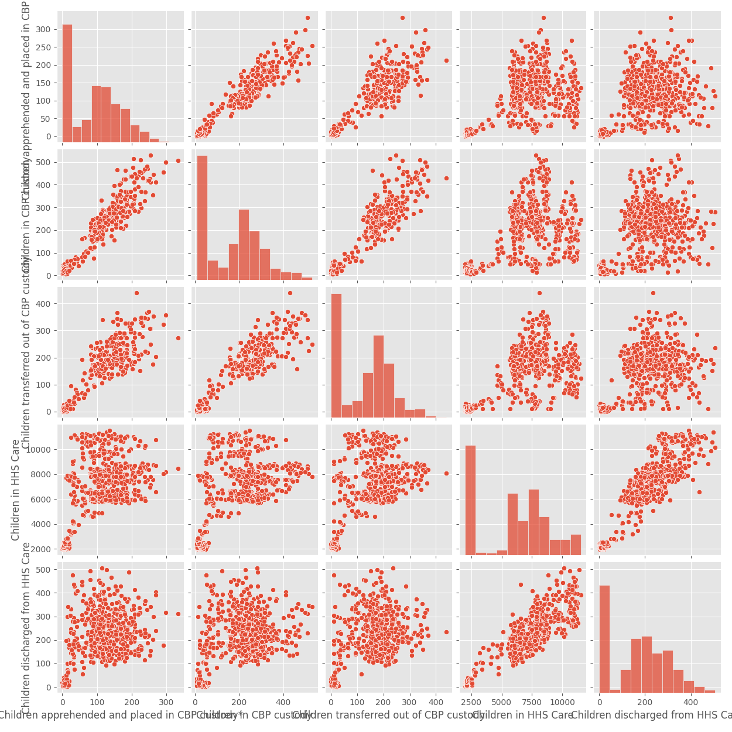
Figure 9. Pairwise relationships among numerical variables.
7. Key Findings
- The dataset shows substantial daily variation in apprehension, transfer, and discharge activity, with peak daily values of 333, 440, and 505 respectively.
- Average daily transfers (128.67) were higher than average daily apprehensions (93.52), indicating that transfers during the period were not limited to same-day entrants and likely included children entering CBP custody earlier.
- Average daily discharges (173.41) were also higher than average daily apprehensions, consistent with the fact that discharges can represent cases that entered the pipeline before the current reporting day.
- The Transfer Efficiency Ratio of 75.03% indicates that the aggregate number of transfers was substantially relative to the reported CBP custody denominator under the project formula.
- The Discharge Effectiveness Index of 2.86% is comparatively low under the specified formula and indicates that discharge volume is small relative to the summed HHS-care denominator used in the calculation.
- The Pipeline Throughput Rate of 185.42% demonstrates that the simple exit-to-entry ratio can exceed 100% in a multi-period pipeline because exits may correspond to earlier entrants.
- There were 128 days on which daily inflow exceeded daily discharge outflow, producing a Backlog Accumulation Rate of 17.78%.
- The largest single-day positive backlog change occurred on 2 December 2024, when inflow exceeded discharge outflow by 121 children.
- Eleven sustained imbalance periods of at least three consecutive days were detected. The longest lasted five days, from 30 March 2025 to 3 April 2025.
- No prolonged stagnation period meeting the seven-day analytical threshold was detected.
- Weekday average transfers were 128.36 compared with 130.06 on weekends, while average discharges were 166.19 on weekdays compared with 206.14 on weekends.
- The discharge coefficient of variation was 72.49%, resulting in an Outcome Stability Score of 27.51/100 and indicating considerable variability in daily discharge activity.
8. Recommendations
Monitor inflow-outflow imbalance daily: Use the dashboard's backlog-change view to flag days when new entries exceed successful exits.
Prioritize sustained imbalance periods: Review consecutive positive-imbalance periods rather than relying only on single-day spikes.
Use threshold-based alerts: Configure operational thresholds for discharge effectiveness or other selected indicators so that unusually weak performance receives attention earlier.
Track transfer and discharge trends together: A combined view can help distinguish upstream transfer pressure from downstream discharge constraints.
Review high-variability discharge periods: The low stability score indicates that discharge activity varies substantially. Periods of unusually low or high discharge volume should be investigated for operational causes.
Use temporal comparisons for planning: The observed weekday/weekend differences suggest that staffing and case-management capacity can be reviewed against daily operating patterns.
Improve case-level measurement where possible: Future datasets should include case identifiers or cohort-level entry and exit information so that true processing times, individual backlog, and cohort-specific outcomes can be measured directly.
9. Streamlit Dashboard
An interactive Streamlit dashboard was developed to convert the analytical results into a monitoring interface. The dashboard provides date-range filtering, KPI cards, a care pipeline view, ratio-based metric selection, transfer and discharge efficiency panels, bottleneck detection, sustained-imbalance detection, monthly discharge trends, weekday-versus-weekend analysis, and threshold-based alerts.
The dashboard is intended to support rapid operational review rather than replace case-management systems. Its indicators should therefore be interpreted as aggregate signals that can guide further investigation.
10. Limitations
- The analysis is based on aggregate daily counts and does not contain case-level identifiers.
- The available variables do not directly provide individual processing times or exact time spent in CBP custody or HHS care.
- Sponsor placement and discharge are represented through the available discharge field; the dataset does not provide detailed placement-outcome categories.
- The project-defined ratio formulas are not conventional individual-level success measures.
- Backlog Accumulation Rate is a daily imbalance indicator and should not be interpreted as the number of unresolved cases.
- The three-day sustained imbalance and seven-day prolonged-stagnation thresholds were analytical definitions introduced for this project.
- Historical aggregate patterns cannot by themselves establish the operational cause of a bottleneck.
11. Conclusion
The Care Transition Efficiency & Placement Outcome Analytics project demonstrates how daily administrative data can be transformed into practical process-monitoring indicators. Across 720 valid reporting days, the analysis identified measurable transfer activity, substantial discharge volume, recurring daily inflow-outflow imbalances, and high variability in discharge outcomes. The 17.78% backlog-accumulation indicator and 11 sustained imbalance periods highlight the value of monitoring not only totals but also the timing and persistence of operational pressure.
The resulting Streamlit dashboard provides an accessible interface for examining these patterns by date range and KPI. For future improvement, richer case-level or cohort-level data would enable more precise measures of processing time, actual backlog, placement duration, and outcome success. Nevertheless, the current analysis provides a structured foundation for identifying periods requiring operational review and for communicating care-transition performance to stakeholders.
12. Tools and Technologies
- Python
- Pandas for data cleaning, transformation, aggregation, and KPI computation
- Matplotlib and Seaborn for exploratory visualization
- Streamlit for interactive dashboard development
- Microsoft Word for research paper documentation
- CSV files for clean and analytical outputs
13. References
1. Unified Mentor, project instructions for “Care Transition Efficiency & Placement Outcome Analytics” (project brief supplied for this internship).
2. Project dataset: HHS Unaccompanied Alien Children Program CSV used for the analysis.
3. Project-generated analytical outputs and Streamlit dashboard developed as part of this study.

