PRODUCT LINE PROFITABILITY &
MARGIN PERFORMANCE ANALYSIS

Nassau Candy Distributor

Research Paper / Internship Project

Prepared as an analytical study of product profitability,
margin performance, cost efficiency, and profit concentration.

Submitted by
Priyadarshini Mohapatra

Abstract
This study analyzes product line profitability and margin performance for Nassau Candy Distributor using 10,194 sales records and 18 variables. The analysis evaluates revenue, cost, gross profit, gross margin, units sold, product contribution, division performance, cost pressure, profit concentration, and margin volatility. Python was used for data cleaning, validation, transformation, metric calculation, product-level analysis, division-level analysis, risk classification, and Pareto analysis. An interactive Streamlit dashboard was developed to present the results through key performance indicators, charts, filters, tables, and downloadable outputs.
The dataset contained no missing values, duplicate rows, invalid sales or unit values, negative costs or gross profits, and no mismatch between reported gross profit and Sales minus Cost. Total sales were 141,783.63, total gross profit was 93,442.80, and total cost was 48,340.83, producing an overall gross margin of 65.91%. The Chocolate division was the dominant contributor, accounting for approximately 92.88% of revenue and 95.06% of gross profit. Product analysis identified major high-profit/high-margin products and one important high-sales/low-margin risk, Kazookles, with a 7.69% gross margin.
Pareto analysis showed that approximately five products contributed around 80% of both revenue and gross profit, indicating concentration within the product portfolio. The findings support practical actions including protecting high-performing products, reviewing low-performing products, and repricing or renegotiating cost-heavy products.
Keywords: Nassau Candy, profitability analysis, gross margin, product performance, cost analysis, Pareto analysis, Python, Streamlit dashboard

1. Introduction
In a product-based business, sales volume alone does not provide a complete picture of business performance. A product may generate high sales but contribute relatively little profit because of high costs or weak margins. Conversely, a product with lower sales may provide a stronger contribution to profitability.
This study focuses on Nassau Candy Distributor and evaluates product and division performance using revenue, cost, gross profit, gross margin, units sold, contribution measures, and volatility indicators. The project combines Python-based data analysis with an interactive Streamlit dashboard to convert raw transaction data into actionable business insights.
2. Problem Statement
The primary analytical problem is that revenue and sales volume alone may not reveal the true profitability of a product portfolio. Products with strong sales can have weak margins, while products with lower sales can have attractive profitability. A structured profitability analysis is therefore required to identify high-performing products, margin risks, division-level imbalances, concentration risks, and potential pricing or cost-efficiency opportunities.
3. Objectives
- Clean and validate the Nassau Candy Distributor dataset.
- Calculate key profitability and margin performance indicators.
- Rank products by gross profit, gross margin, and profit per unit.
- Identify high-profit/high-margin and high-sales/low-margin products.
- Compare revenue, cost, gross profit, and margin performance across divisions.
- Diagnose cost pressure and margin-risk products.
- Measure revenue and profit concentration using Pareto analysis.
- Assess product margin volatility over time.
- Develop business action categories for product-level decisions.
- Develop an interactive Streamlit dashboard for decision support.

4. Dataset and Variables
The dataset contains 10,194 records and 18 variables, covering order, customer, geographic, product, sales, cost, unit, and gross-profit information.
Variable | Description
Row ID | Record identifier.
Order ID | Unique order identifier.
Order Date | Date of the order.
Ship Date | Date of shipment.
Division | Product division.
Region | Business region.
Product ID | Product identifier.
Product Name | Name of the product.
Sales | Revenue generated.
Units | Quantity sold.
Gross Profit | Profit after product cost.
Cost | Product cost.
5. Methodology
The analysis followed a structured workflow consisting of data preparation, validation, profitability metric calculation, product analysis, division analysis, cost diagnostics, concentration analysis, volatility analysis, and dashboard development.

5.1 Data Preparation
The dataset was loaded into Python using pandas. Data types and quality conditions were inspected, records were validated, and analytical outputs were saved as CSV files. No records were removed because all 10,194 records passed the specified validation checks.

5.2 Profitability Metrics
Metric | Formula / Interpretation
Gross Margin % | (Gross Profit / Sales) × 100
Profit per Unit | Gross Profit / Units
Revenue Contribution % | Product/division sales ÷ total sales × 100
Profit Contribution % | Product/division gross profit ÷ total gross profit × 100
Margin Volatility | Variation in product-level monthly gross margins.

5.3 Product-Level Analysis
Products were ranked by gross profit, gross margin, sales, and profit per unit. Products were also classified into performance and action categories.

5.4 Division Analysis
Revenue, cost, gross profit, units, product count, gross margin, revenue contribution, and profit contribution were compared across Chocolate, Other, and Sugar.

5.5 Cost Diagnostics
Cost-versus-sales analysis was used to identify products where sales were not translating efficiently into gross profit.

5.6 Pareto Analysis
Pareto analysis was used to determine the number and percentage of products contributing approximately 80% of total revenue and total gross profit.

5.7 Margin Volatility
Monthly product margins were evaluated to identify changes in profitability over time.

5.8 Dashboard Development
A Streamlit dashboard was developed with interactive date, division, gross-margin, and product-search controls. Plotly visualizations were used for charts and pandas for analytical processing.
6. Data Cleaning and Validation
The dataset was checked for missing values, duplicate rows, invalid sales and unit values, negative costs, negative gross profits, and consistency between reported gross profit and Sales minus Cost.
Validation Check | Result
Original Records | 10,194
Clean Records | 10,194
Removed Records | 0
Missing Values | 0
Duplicate Rows | 0
Sales ≤ 0 | 0
Units ≤ 0 | 0
Negative Cost | 0
Negative Gross Profit | 0
Gross Profit Mismatch | 0
Maximum Calculation Difference | 0.0

7. Overall Profitability Results
Metric | Value
Total Sales | 141,783.63
Total Gross Profit | 93,442.80
Total Cost | 48,340.83
Total Units | 38,654
Overall Gross Margin | 65.91%
Total Records | 10,194
The overall gross margin of 65.91% provides the portfolio benchmark for evaluating individual products and divisions.
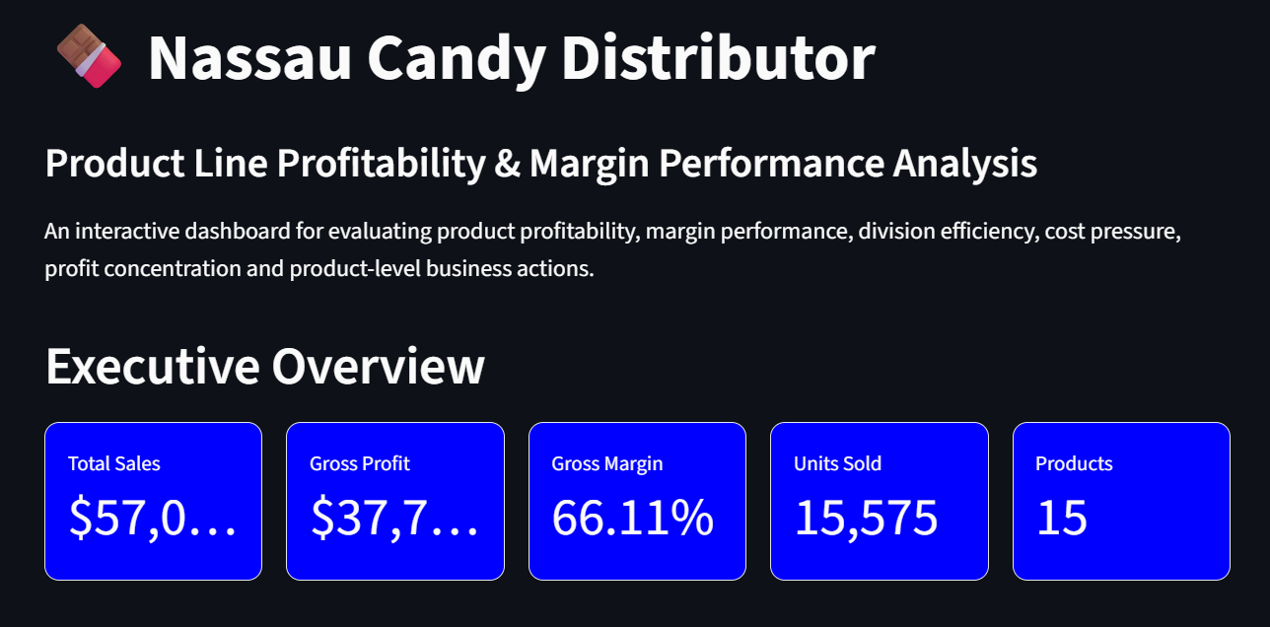

Figure 1. Executive Overview of Nassau Candy Profitability Dashboard
8. Product Profitability Analysis
Product-level analysis showed a strong concentration of profitability among the major Chocolate products. The leading products by gross profit were Wonka Bar - Scrumdiddlyumptious, Wonka Bar - Triple Dazzle Caramel, Wonka Bar - Milk Chocolate, Wonka Bar - Nutty Crunch Surprise, and Wonka Bar - Fudge Mallows.
Product | Division | Sales | Gross Profit | Gross Margin
Wonka Bar - Scrumdiddlyumptious | Chocolate | 27,874.80 | 19,357.50 | 69.44%
Wonka Bar - Triple Dazzle Caramel | Chocolate | 28,485.00 | 18,610.20 | 65.33%
Wonka Bar - Milk Chocolate | Chocolate | 26,867.75 | 17,443.37 | 64.92%
Wonka Bar - Nutty Crunch Surprise | Chocolate | 23,574.95 | 16,819.95 | 71.35%
Wonka Bar - Fudge Mallows | Chocolate | 24,890.40 | 16,593.60 | 66.67%

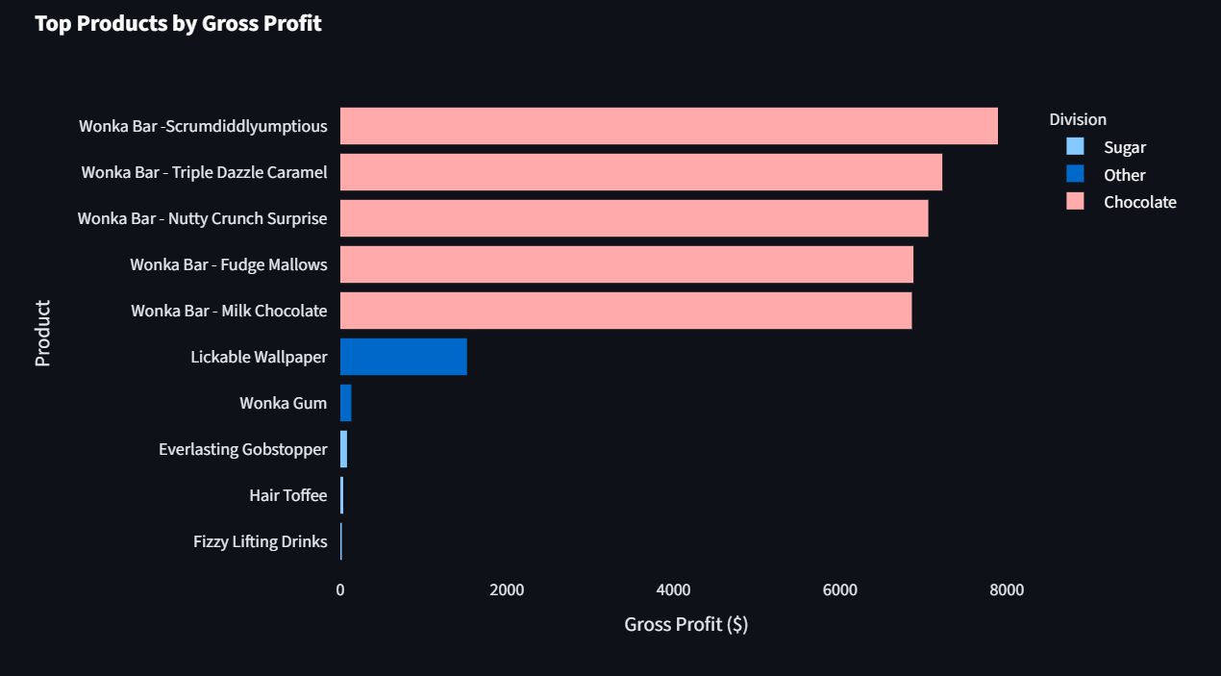
Everlasting Gobstopper recorded an 80.00% gross margin, while Hair Toffee recorded approximately 77.78%. Wonka Bar - Nutty Crunch Surprise recorded approximately 71.35%.

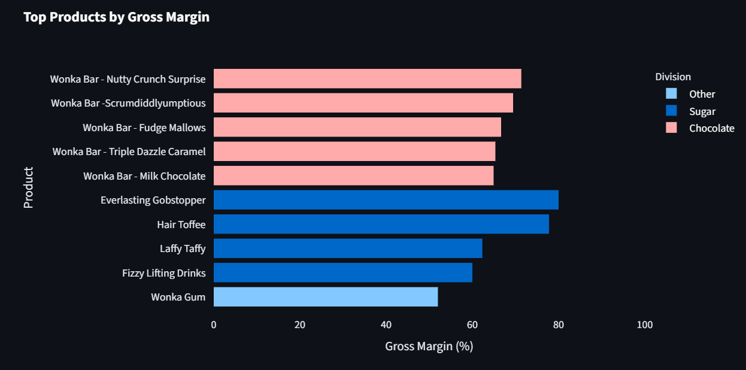
Figure 2. Product-Level Gross Profit and Margin Analysis

9. Division Performance Analysis
Division | Sales | Gross Profit | Cost | Units | Gross Margin
Chocolate | 131,692.90 | 88,824.62 | 42,868.28 | 37,275 | 67.45%
Other | 9,663.25 | 4,333.45 | 5,329.80 | 1,242 | 44.84%
Sugar | 427.48 | 284.73 | 142.75 | 137 | 66.61%

Chocolate was the dominant division, generating 131,692.90 in sales, 88,824.62 in gross profit, and a 67.45% gross margin. It accounted for approximately 92.88% of revenue and 95.06% of gross profit.
The Other division generated 9,663.25 in sales and 4,333.45 in gross profit, with a gross margin of 44.84%. Its lower margin suggests a need for further cost and pricing review.
The Sugar division had a healthy 66.61% gross margin but contributed only approximately 0.30% of revenue and gross profit.
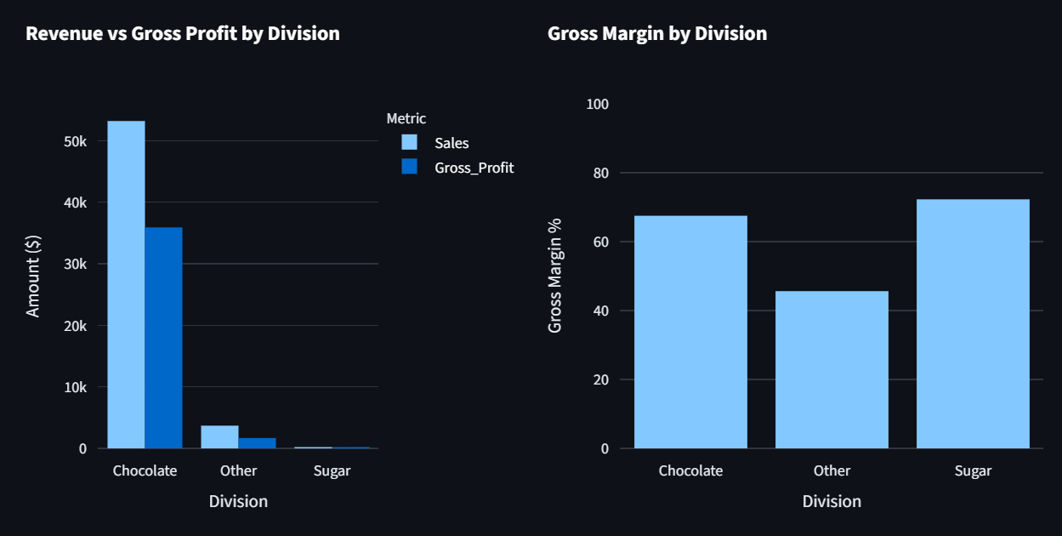
Figure 3. Division-Level Revenue, Gross Profit and Margin Performance

10. Cost vs. Margin Diagnostics
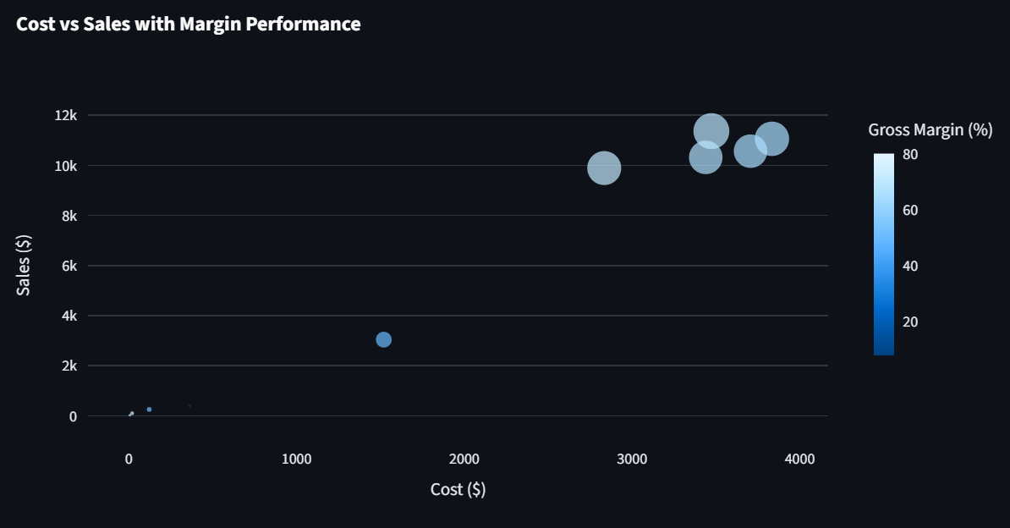
The main high-sales/low-margin risk identified was Kazookles. It generated sales of 1,205.75 and gross profit of 92.75, resulting in a gross margin of only 7.69%, substantially below the overall portfolio margin of 65.91%. The product should be reviewed for pricing, supplier cost, cost reduction, or potential rationalization.
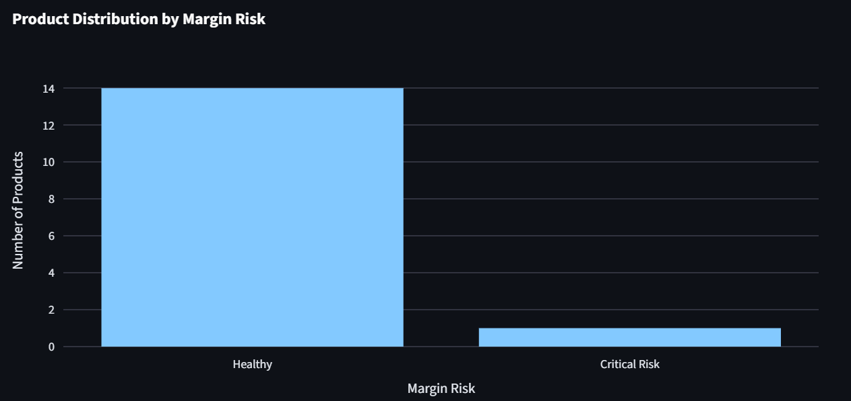
Figure 4. Cost vs. Sales and Margin Risk Analysis

11. Profit and Revenue Concentration Analysis
Approximately five products were required to reach 80% of total revenue. These five products represent approximately 33.33% of the product portfolio.
Approximately five products also contributed 80% of total gross profit, representing approximately 33.33% of the portfolio. This indicates that a relatively small group of products drives a large share of business performance.
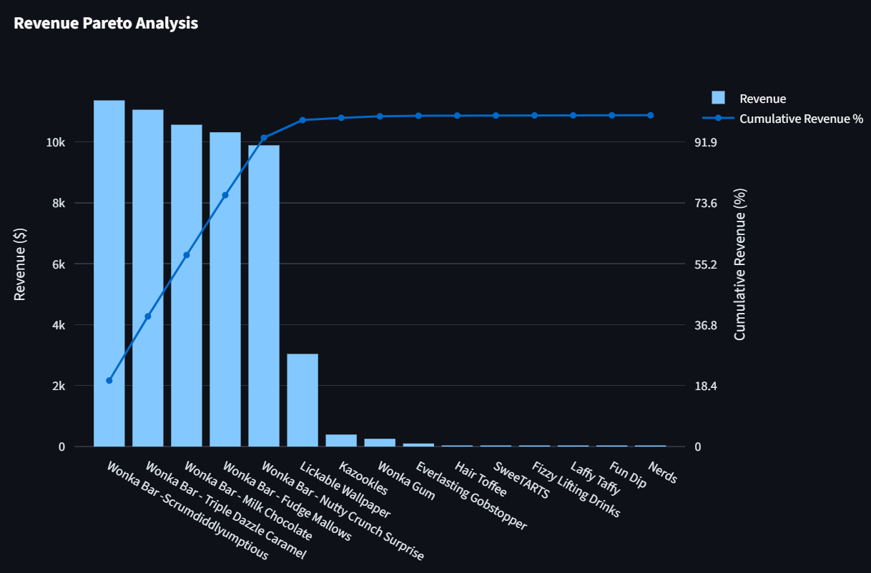
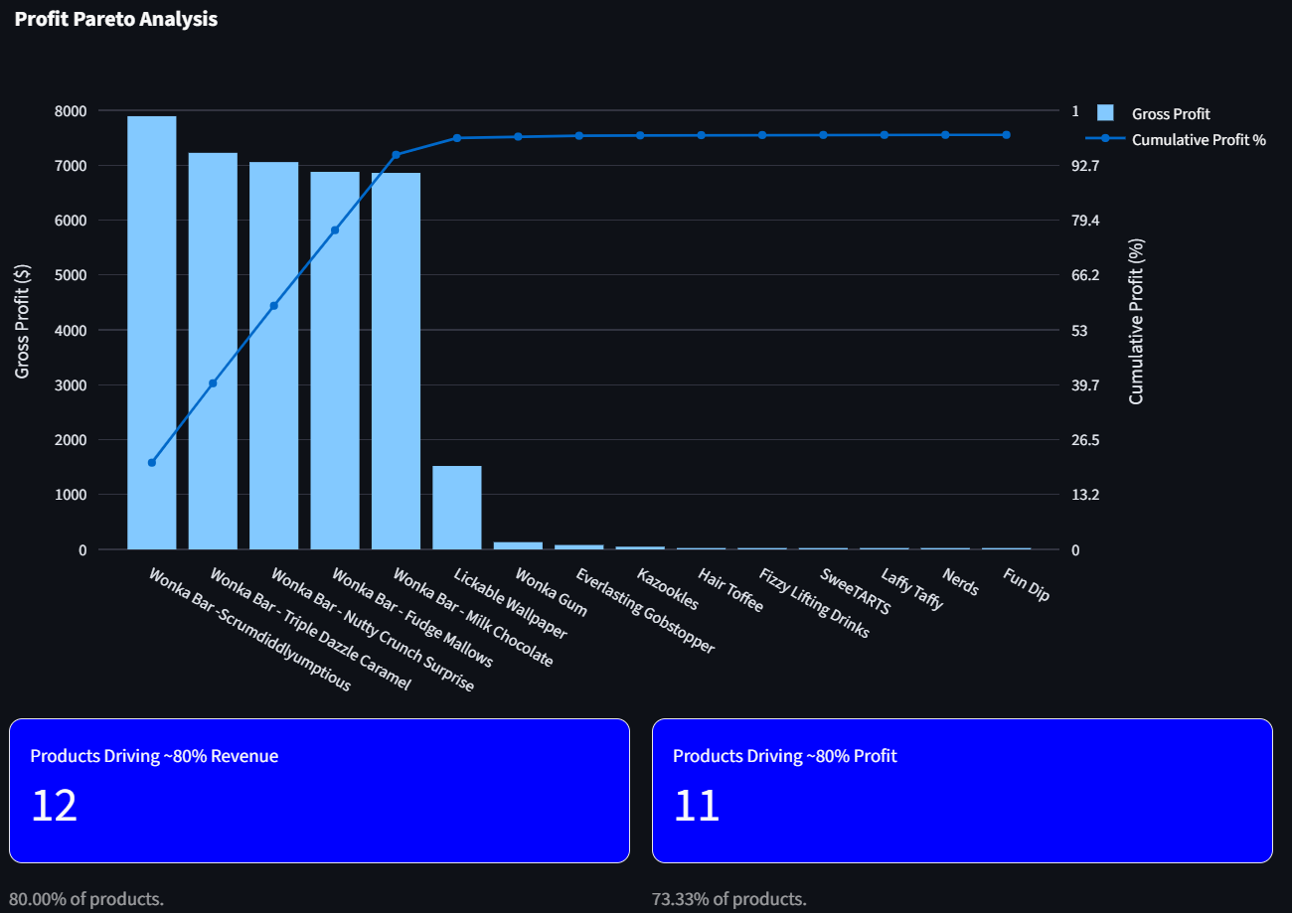

Figure 5. Revenue and Profit Concentration Using Pareto Analysis
12. Margin Volatility Analysis
Monthly product margins were evaluated to identify changes in profitability over time. Margin volatility can reflect changes in product cost, pricing, product mix, or other factors affecting gross profitability. The dashboard provides a monthly gross-margin trend and a product-level margin-volatility table.
13. Low-Sales / Low-Profit Products
Products with relatively low sales and low gross profit were identified for further review. Such products should not automatically be discontinued; instead, they should be evaluated using strategic importance, customer demand, margin potential, operational cost, product differentiation, and growth potential.

14. Business Recommendations

14.1 Protect and Expand High-Performing Products
Major high-profit/high-margin products should receive priority in availability, inventory planning, pricing decisions, and growth planning.

14.2 Review Kazookles
Possible actions include repricing, supplier cost negotiation, cost reduction, product repositioning, or rationalization if improvement is not achievable.

14.3 Monitor the Other Division
The Other division has a 44.84% gross margin, well below the overall 65.91% portfolio margin. Its cost structure and pricing strategy should be examined.

14.4 Manage Product Concentration
Approximately five products contribute around 80% of both revenue and gross profit. These products should be protected while the business develops additional profitable products.

14.5 Review of Low-Performing Products
Low-sales/low-profit products should be evaluated for rationalization, repositioning, cost reduction, or product improvement.

14.6 Continue Margin Monitoring
Monthly margin trends should be monitored regularly so emerging profitability risks can be identified early.
15. Streamlit Dashboard
An interactive Streamlit dashboard was developed as the final analytical interface. It presents executive KPIs, product profitability, division performance, cost diagnostics, profit and revenue concentration, margin volatility, low-sales/low-profit products, and business action recommendations.
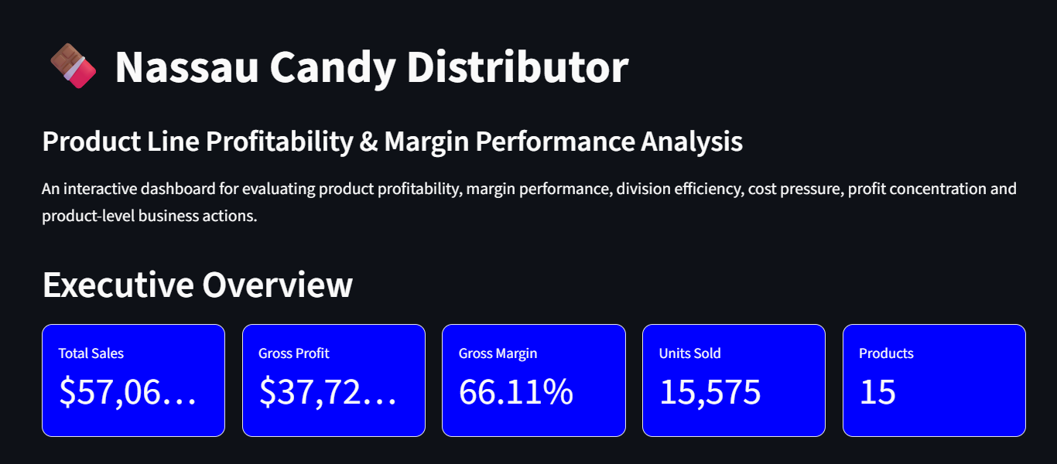
Figure 6. Interactive Streamlit Dashboard for Product Profitability Analysis
16. Interactive Features
- Date range selector.
- Division filter.
- Minimum gross-margin slider.
- Product search.
- Interactive Plotly charts.
- Downloadable analytical tables and CSV outputs.
17. Key Results and Findings
- 10,194 records were analyzed and all passed validation.
- Total sales were 141,783.63 and total gross profit was 93,442.80.
- Overall gross margin was 65.91%.
- Chocolate generated approximately 92.88% of revenue and 95.06% of gross profit.
- Major Wonka Bar products were the strongest contributors to gross profit.
- Everlasting Gobstopper recorded an 80.00% gross margin.
- Kazookles was the major high-sales/low-margin risk at 7.69% margin.
- Approximately five products contributed around 80% of revenue.
- Approximately five products contributed around 80% of gross profit.
- The Other division had the weakest division-level margin at approximately 44.84%.
18. Limitations
- The analysis is based on the available Nassau Candy dataset.
- Product profitability uses the available sales, cost, unit, and gross-profit measures.
- Margin volatility uses the available monthly observations.
- Detailed supplier-level pricing and procurement information was not available.
- External market conditions, competitor pricing, and customer-level profitability were outside the scope of the available data.
19. Conclusion
This study demonstrates that product profitability analysis provides a more useful view of business performance than sales volume alone. By combining sales, cost, units, gross profit, gross margin, contribution, concentration, and volatility measures, the analysis identifies both strong-performing products and potential margin risks.
The results show a highly concentrated business structure, with Chocolate products contributing the majority of revenue and profit. Approximately five products account for around 80% of both revenue and gross profit, indicating that these products are particularly important to overall business performance. Kazookles represents an important margin-risk case because of its low gross margin relative to sales.
The combination of Python-based analysis and an interactive Streamlit dashboard provides a practical framework for monitoring product profitability and supporting pricing, sourcing, and product-portfolio decisions.
20. Future Scope
- Product-level sales and profit forecasting.
- Customer profitability analysis.
- Regional profitability analysis.
- Supplier-level cost analysis.
- Price elasticity analysis.
- Machine-learning models for predicting margin risk.
- Automated alerts for falling product margins.
- Price-change scenario analysis.
- Automated periodic profitability reports.
- Predictive and prescriptive decision-support systems.
21. Tools and Technologies
Tool / Technology | Purpose
Python | Core data analysis and processing.
Pandas | Data cleaning, transformation, grouping, and analysis.
NumPy | Numerical calculations.
Matplotlib | Data visualization.
Seaborn | Statistical visualization.
Plotly | Interactive dashboard charts.
Streamlit | Interactive dashboard development.
OpenPyXL | Spreadsheet-related data handling.
Scikit-learn | Machine-learning toolkit for future extensions.
Microsoft Word | Research-paper documentation.
22. References
- Python Software Foundation. Python Documentation.
- Pandas Documentation. Data Analysis and Manipulation in Python.
- NumPy Documentation. Scientific Computing with Python.
- Plotly Documentation. Interactive Data Visualization.
- Streamlit Documentation. Building Data Applications with Streamlit.
- scikit-learn Documentation. Machine Learning Tools for Python.
- Nassau Candy Distributor dataset provided for the project analysis.

