Quality Monitoring Framework for Government ITIs running under Public-Private Partnership (PPP)

Group Members –

1) Saransh Srivastava - BITS Pilani (Pilani campus)

2) Subh Priyadarshi - BITS Pilani (Hyderabad campus)

3) Jay Sharma - BITS Pilani (Pilani campus)

Skill Set Requirements: Web Development (through PHP version 8 – MySQL)

Mentors

* Mr. Bappaditya Haldar, DIT
* Mr. Siddhartha Bose, Addl. DIT as Nodal Officer
* Mr. Ramesh Venkatraman as BITS Faculty Mentor

Project Guidance

* Mr. Nilanjan Kundu, ADIT
* Mr. Arindam Acharyya, Principal, Govt. ITI, Haldia
* Mr. Arnab Acharyya, ITI Specialist, SPIU

SPECIAL ACKNOWLEDGEMENTS

* Mr. Saibal Sengupta, JDIT
* Mr. Narayan Chandra Mandal, DDIT
* Mr. Sanjib Mondal, DDIT
* Mr. Angsujit Das, DDIT
* Mr. Prasenjit Bose, ADIT

INTRODUCTION

* DGT: DGT is the apex organisation in Ministry of Skill Development and Entrepreneurship for development and coordination at National level for the programmes relating to vocational training.
* NCVT: The National Council for Vocational Training, an advisory body, was set up by the Government of India in 1956.
* DIT: DIT imparts craftsmen & training to a substantial number of youths in different trades for supply of skilled manpower to different industries.
* ITI: Industrial Training Institutes, also known as ITIs, have been established with an aim to provide industrial training to students.
* PPP Mode:  A public–private partnership is a cooperative arrangement between two or more public and private sectors, typically of a long-term nature.

BACKGROUND STUDY

**After going through details, we thought that following parameters may be monitored centrally for better training:**

* Attendance Monitoring.
* Curriculum Progress Monitoring.
* Quality monitoring through weekly/monthly Assessment.
* Student rating & review of a teacher based on communication, teaching, and discipline.
* Teacher’s approval of adequate material and technical support from ITI’s.
* Average earnings of graduates in their profession compared to the nationwide average for the trade
* Student feedback

Problem Definition

The objective of this project is to develop an IT/software-based solution to the problem of creating an effective framework for monitoring the quality of Government Industrial Training Institutes (ITIs) operating under the Public-Private Partnership mode.

The software solution can be delivered through a Desktop Application, Web Application or Mobile Application.

However, Web Applications are most widely used, and the Web is the most ubiquitous platform across all electronic devices, so it has been decided to develop a Web application, so the monitoring system is most widely and conveniently accessible to anyone who requires it.

SOFTWARE DEVELOPMENT LIFE CYCLE

The process of software development, summarized in a few brief steps.

PHASES OF SOFTWARE DEVELOPMENT  
LIFE CYCLE –

1. Problem Definition
2. Feasibility Study
3. Requirement Analysis & Specification
4. Designing
   1. Front End – HTML, CSS, JS, PHP
   2. Database – Tables to store data (using ER diagram)
   3. Functional – defining users and their requirements, access level, and other functions
5. Coding (PHP version 8-MySQL) – to implement Designing phase
6. Testing
7. Documentation

FEASIBILITY STUDY OF THE MODULEs

**What is a feasibility study?**

**Feasibility** is the measure of how beneficial or practical the development of an information

system will be to an organization

**Types of feasibility**

* **Technical:** This assessment focuses on the technical resources available to the organization and whether the technical team can convert the ideas into working systems.
* **Economic:** This assessment typically involves a cost/ benefits analysis of the project, helping organizations determine the viability, cost, and benefits associated with a project before financial resources are allocated
* **Time:** A time feasibility study will consider the period in which the project is going to take up to its completion. A project will fail if it takes too long to be completed before it is useful.

ATTENDANCE MONITORING

**INITIAL PROPOSALS**

* Can be done for trainees
* It can also be done for Instructors.
* Frequency of monitoring can be daily, weekly or monthly.
* Monitoring will be done Trade-wise and subject-wise (TT, TP, WCS, ED, ES)

**Changes AFTER Feasibility Study**

* Due to time feasibility only trainees taken under condition.
* Frequency of monitoring is done monthly due to time constraint.

CURRICULUM PROGRESS MONITORING

**INITIAL PROPOSALS**

* Monitoring done for an ITI Trade.
* It can also be done for Instructors.
* Frequency of monitoring can be daily, weekly or monthly.
* Monitoring will be done Trade-wise and subject-wise (TT, TP, WCS, ED, ES)

**Changes AFTER Feasibility Study**

* Frequency of monitoring – weekly (four entries a month) due to time feasibility.

QUALITY MONITORING THROUGH ASSESSMENT

**INITIAL PROPOSALS**

* Evaluation done through uploaded marks.
* Monthly assessment will be conducted by ITIs for their trainees
* Frequency of monitoring – component-wise, monthly (once a month) as per monthly assessment
* Monitoring will be done Trade-wise and subject-wise (TT, TP, WCS, ED, ES)

**AFTER**

* Frequency of monitoring – monthly (once a month) as per monthly assessment

TEACHING AIDS MONITORING

**INITIAL PROPOSALS**

* Monitoring will be done for various modern teaching aids
* Data will be updated through YES/NO entries indicating availability of each teaching aid
* Frequency of monitoring –monthly, half-yearly & annually.
* Monitoring will be done ITI wise, since most classrooms use similar teaching aids

**Changes AFTER Feasibility Study**

* Frequency of monitoring – monthly (once a month).
* To maintain the uniformity of the report submission, the frequency is set to monthly submission.

PLACEMENT MONITORING

**INITIAL PROPOSALS**

* Data from the last 3 years to be monitored for
  1. Average percentage of placement among graduates
  2. Average salary among graduates
* Frequency of monitoring – monthly, half-yarly & annually (once a year).
* Monitoring will be done Trade-wise and subject-wise (TT, TP, WCS, ED, ES)

**Changes AFTER Feasibility Study**

* All the module requirements are feasible.
* To maintain the uniformity of the report submission, the frequency is set to monthly submission.

STUDENT FEEDBACK

**INITIAL PROPOSALS**

* As the name suggests, feedback will be taken from students about the instructors and institutes
* Frequency of monitoring – monthly (once a month)
* Monitoring will be done ITI wise, with individual data input from each student
* This module is currently placed on halt due to time constraints

**Changes AFTER Feasibility Study**

* Feedback requires a new user namely student.
* Requires a new interface.
* Ruled out due to time feasibility.

Feasibility Study

* Out of several parameters for monitoring that were originally considered, five were determined to be objective enough to design data gathering modules for: Attendance Monitoring, Curriculum Progress Monitoring, Quality Monitoring via Assessment, Teaching/Learning Aids Monitoring, and Placement Monitoring.
* A student feedback module was considered but is currently placed on halt due to time constraints. It may be implemented time permitting, but it is not being slated for development right now.
* Finally for all the modules the frequency of monitoring is decided as monthly (once a month).

REQUIREMENT ANALYSIS & SPECIFICATION

1. Data Requirements

2. Functional Requirements

3. Entity-Relationship Diagram

4. Data Control Flow

DATA REQUIREMENTS

* Attendance Monitoring
  + - Institute's NCVT MIS code
    - Year of admission
    - Trade
    - Month for which attendance data is being updated
    - Year for which attendance data is being updated
    - Trainee's name
    - Total hours delivered for Trade Theory
    - Number of hours attended in Trade Theory
    - Total hours delivered for Trade Practical
    - Hours attended in Trade Practical
    - Total hours delivered for Workshop Calculation and Science
    - Hours attended in Workshop  Calculation and Science
    - Total hours delivered for Engineering Drawing
    - Hours attended in Engineering Drawing
    - Total hours delivered for Employability Skills
    - Hours attended in Employability Skills

CURRICULUM Progress Monitoring

Institute's NCVT MIS code

Year of admission

Trade

Month for which attendance data is being updated

Week for which attendance data is being updated

Year for which attendance data is being updated

* + - Progress made in Trade Theory
    - Progress made in Trade Practical
    - Progress made in Workshop Calculation and Science
    - Progress made in Engineering Drawing
    - Progress made in Employability Skills

QUALITY Monitoring THROUGH ASSESSMENT

Institute's NCVT MIS code

Year of admission

Trade

Month for which attendance data is being updated

Year for which attendance data is being updated

Trainee's name

* + - Marks obtained in Trade Theory
    - Total marks in Trade Theory
    - Marks obtained in Trade Practical
    - Total marks in Trade Practical
    - Marks obtained in Workshop Calculation and Science
    - Total marks in Workshop Calculation and Science
    - Marks obtained in Engineering Drawing
    - Total marks in Engineering Drawing
    - Marks obtained in Employability Skills
    - Total marks in Employability Skills

Teaching Aids MONITORING

* + - Institute's NCVT MIS code
    - Calendar year for which data is being entered
    - Calendar month for which data is being entered
    - Availability of PROJECTOR(Y/N)
    - Availability of DIGITAL WHITEBOARD(Y/N)
    - Availability of AUDIO_SYSTEM_WITH_MICROPHONE(Y/N)
    - Availability of E-LEARNING / E-CONTENTS (Y/N)

PlacementMonitoring

* + - Institute's NCVT MIS code
    - Trade
    - Current placement year
    - Placement % for the current year
    - Average salary for the current year
    - Placement % for the previous year
    - Average salary for the previous year
    - Placement % for the 2nd previous year
    - Average salary for the 2nd previous year

**ENTITY RELATIONSHIP DIAGRAM**

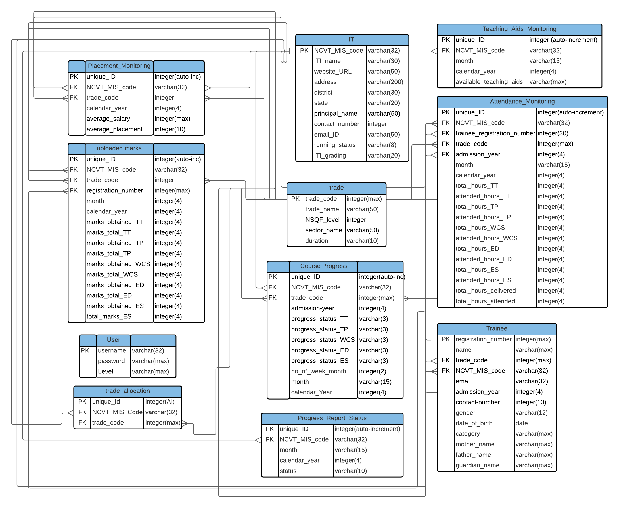

DATA CONTROL FLOW

The pathway data takes through the system

ATTENDANCE MONITORING

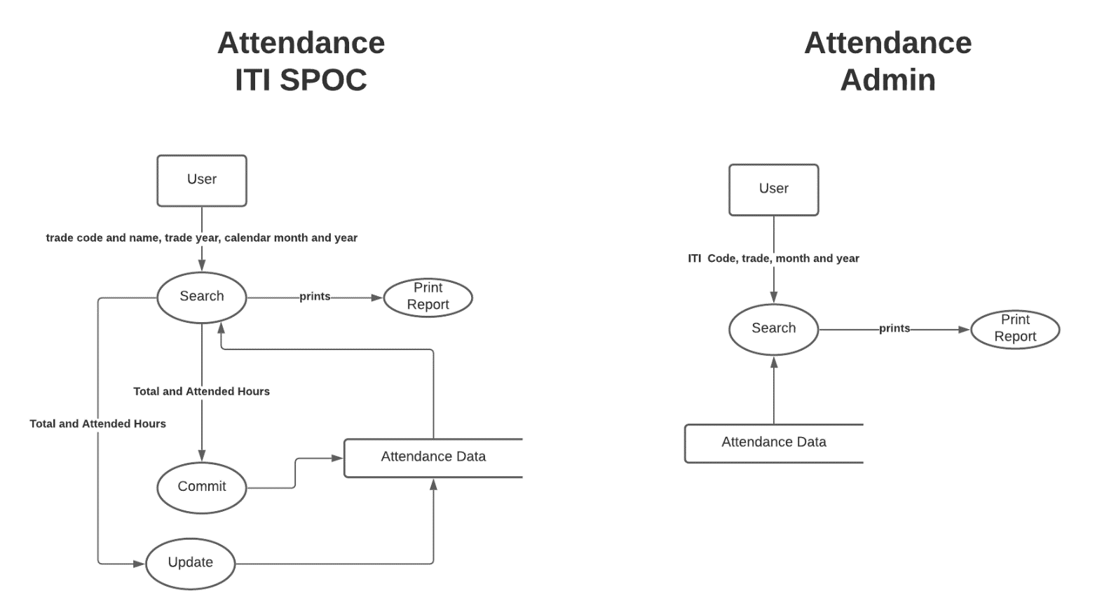

CURRICULUM PROGRESS MONITORING

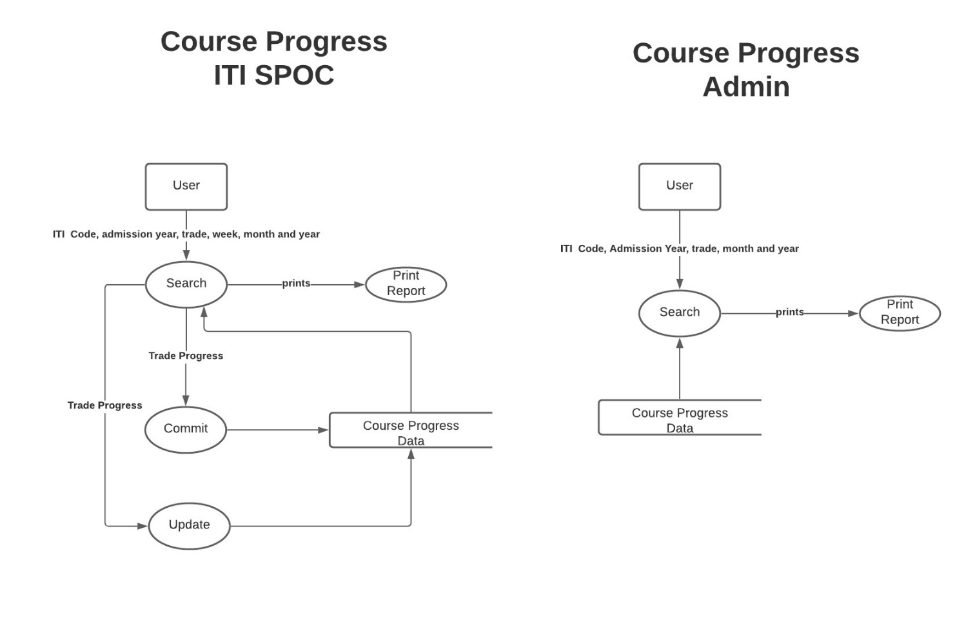

QUALITY MONITORING THROUGH ASSESSMENT

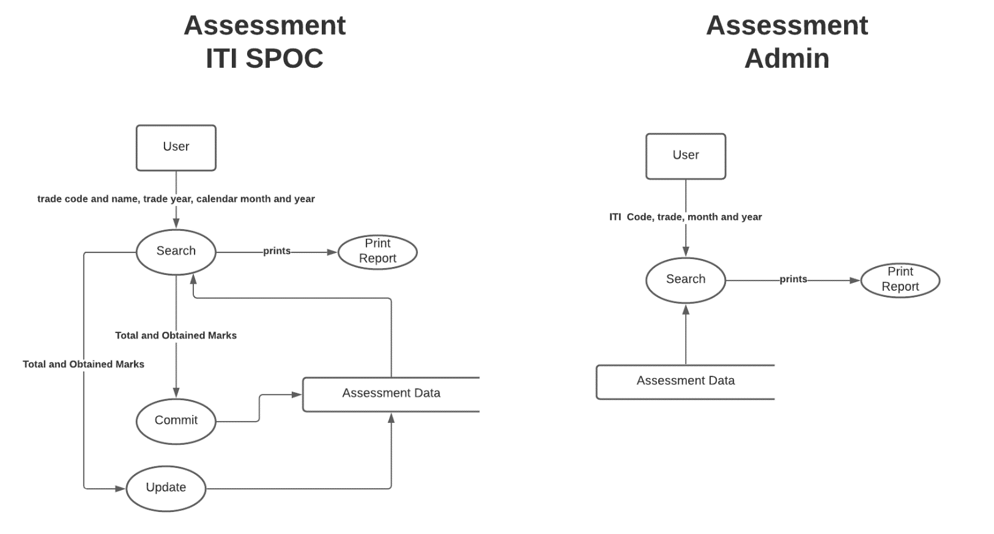

TEACHING AID MONITORING

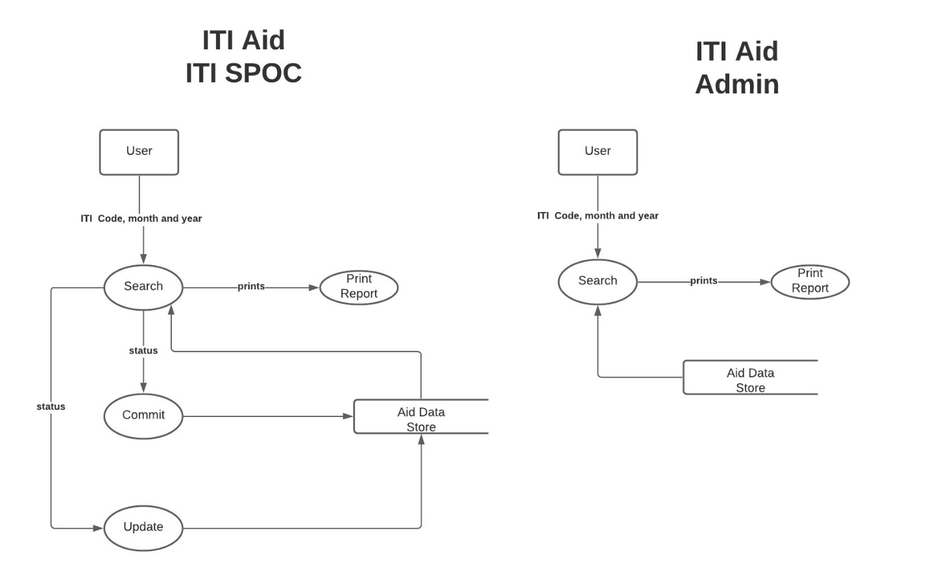

PLACEMENT MONITORING

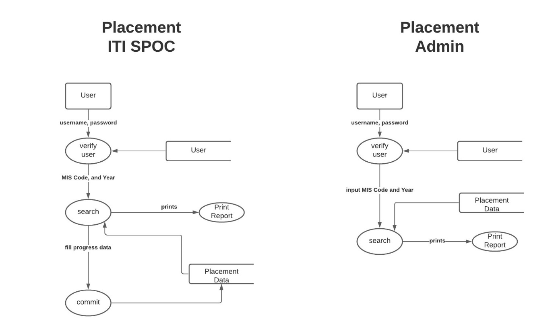

WEB VIEWS

What the graphical interface for each module will look like when opened on the web.

Website-link - <http://localhost/php/index.html>

