COVID-19 World Vaccination Progress - Project Proposal

1. Project Definition
This project analyses how COVID-19 vaccination rolled out across countries, using Python to clean the public Kaggle dataset, visualise the trends and report what they show.
Problem statement. Countries began vaccinating at different times and at very different speeds. Raw daily records are messy and hard to compare, so it is unclear which countries led, which lagged and which vaccines dominated.
Objectives
1. Clean the raw data: handle missing values, duplicates, wrong data types and outliers.
2. Explore vaccination progress by country, over time and by vaccine type.
3. Build at least 6 clear visualisations that answer specific questions.
4. Write a short insights report summarising what the data shows.
5. Publish the code, notebook and documentation in a GitHub repository with commits from both team members.
Scope. The analysis is descriptive and exploratory (no prediction models). It covers all countries and dates present in the Kaggle dataset.

2. Dataset and Use Case
The project uses the public Kaggle dataset COVID-19 World Vaccination Progress, which records daily vaccination counts per country.
Dataset: https://www.kaggle.com/datasets/gpreda/covid-world-vaccination-progress
Kaggle search: https://www.kaggle.com/search?q=COVID-19%20World%20Vaccination%20Progress
Main columns (to be confirmed when the file is downloaded)
Column | Meaning
country, iso_code | Country name and its 3-letter code
date | Date of the record
total_vaccinations | Cumulative doses given
people_vaccinated | People with at least one dose
people_fully_vaccinated | People with the full course
daily_vaccinations | Doses given per day (smoothed)
total_vaccinations_per_hundred | Doses per 100 people
vaccines | Vaccine brands used in the country
source_name, source_website | Where the figures came from

Note on data source. The graphs in this proposal were made from the Our World in Data file the Kaggle set is built from, because Kaggle could not be downloaded here. That file uses location instead of country, adds a few booster columns and has no vaccines column, so plot 4 uses its vaccinations-by-manufacturer file. The final project will repeat the work on the Kaggle download.
Use cases
- Compare vaccination speed and coverage between countries and regions.
- Track how fast each country moved from the first dose to full vaccination.
- Show which vaccines were most widely used.
- Give a practice dataset for real-world data cleaning, since it has gaps, repeated records and uneven reporting.

3. Data Cleaning Plan
Cleaning follows four steps, each logged in the notebook with before and after counts.
Step | Problem to check | Planned method
Missing values | Blank cumulative and daily figures for some countries and dates | Count nulls per column with isnull().sum(); sort by country and date, then forward-fill cumulative columns within each country; fill missing daily figures from the day-to-day difference; drop rows with no usable vaccination figure
Duplicates | Repeated country and date rows | Check with duplicated(subset=["country", "date"]) and keep one record per pair
Data types | date read as text; counts stored as floats | Convert date with pd.to_datetime; cast counts to integers after filling gaps; keep country and iso_code as categories
Outliers | Negative daily values, sudden spikes, or cumulative totals that drop | Detect with the IQR rule and box plots; correct clear reporting errors, and keep real mass-vaccination peaks

Preliminary results. 196,246 rows and 235 locations were loaded. 18 of the locations are aggregates (continents, income groups and the world) and were separated from the 217 countries. No duplicate country-date rows and no negative daily values were found. About 56% of total_vaccinations values were blank before forward-filling. The IQR rule flagged many high daily rates, but these are genuine mass-vaccination peaks and were kept.
Output. A cleaned file, vaccination_clean.csv, saved in the repository together with a short summary of how many rows were changed or removed at each step.

4. Visualizations and Outcomes
Eight plots were produced from a preliminary run on the Our World in Data vaccination file (the source the Kaggle dataset is built from), two more than the required 6. Each plot is followed by the outcome it shows. Code and PNG files go in the repository's visuals/ folder.
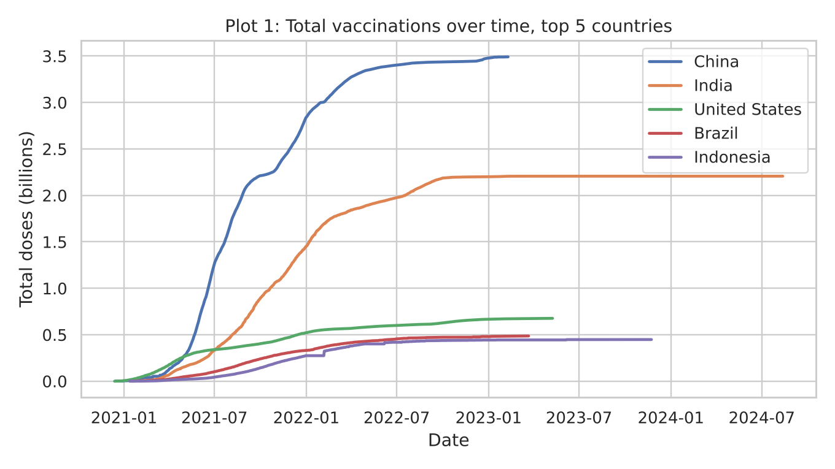
Plot 1 - Line chart of total doses over time, top 5 countries.
Outcome: China leads with about 3.49 billion doses, then India (2.21 billion), the United States (0.68 billion), Brazil (0.49 billion) and Indonesia (0.45 billion). The size of the top two countries comes mostly from population.
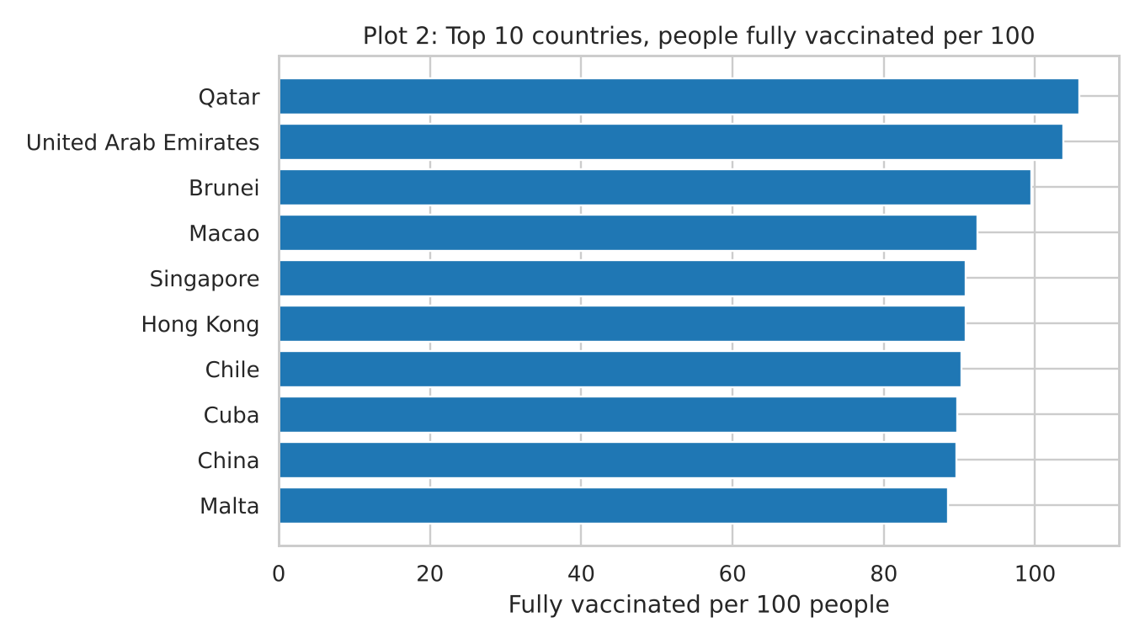
Plot 2 - Bar chart of the top 10 countries by people fully vaccinated per 100 (countries with over 1 million doses).
Outcome: Qatar (about 106 per 100), the United Arab Emirates (about 104) and Brunei (about 100) are highest. Values near or above 100 are possible because of how populations are counted.
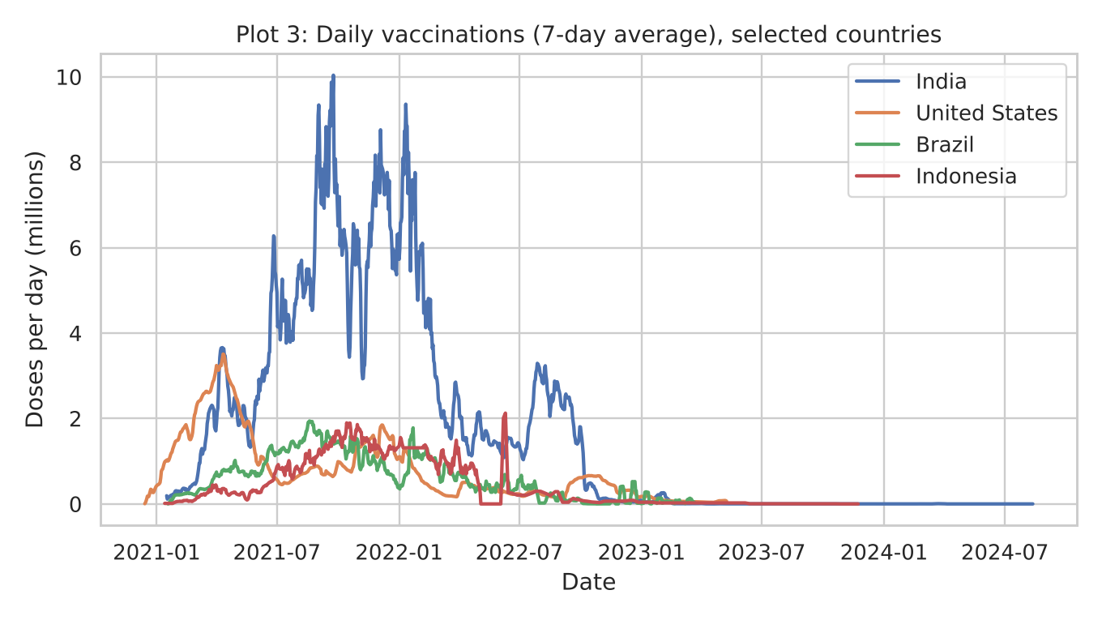
Plot 3 - Line chart of daily vaccinations (7-day average), India, United States, Brazil and Indonesia.
Outcome: The United States peaked early (about 3.5 million a day in April 2021), India peaked highest (about 10 million a day in September 2021), and all four fell close to zero by 2023. Indonesia's sudden spike in mid-2022 follows a reporting gap, so it is a data-quality case to check.
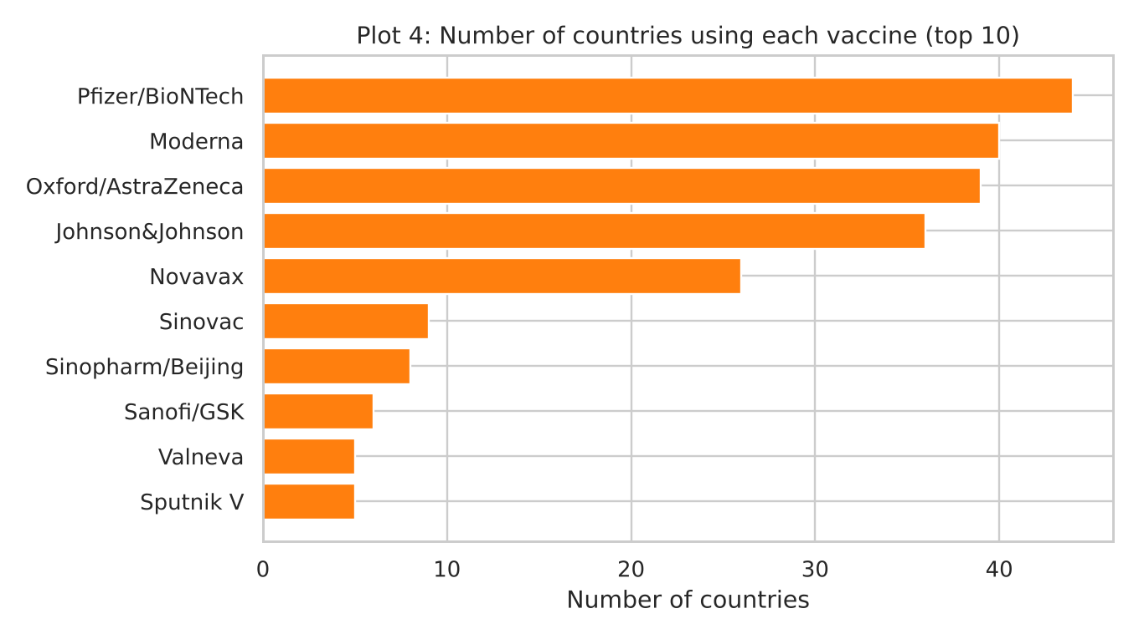
Plot 4 - Bar chart of the number of countries using each vaccine (top 10, countries that report by manufacturer).
Outcome: Pfizer/BioNTech is used in the most countries (44), followed by Moderna (40), Oxford/AstraZeneca (39) and Johnson&Johnson (36).
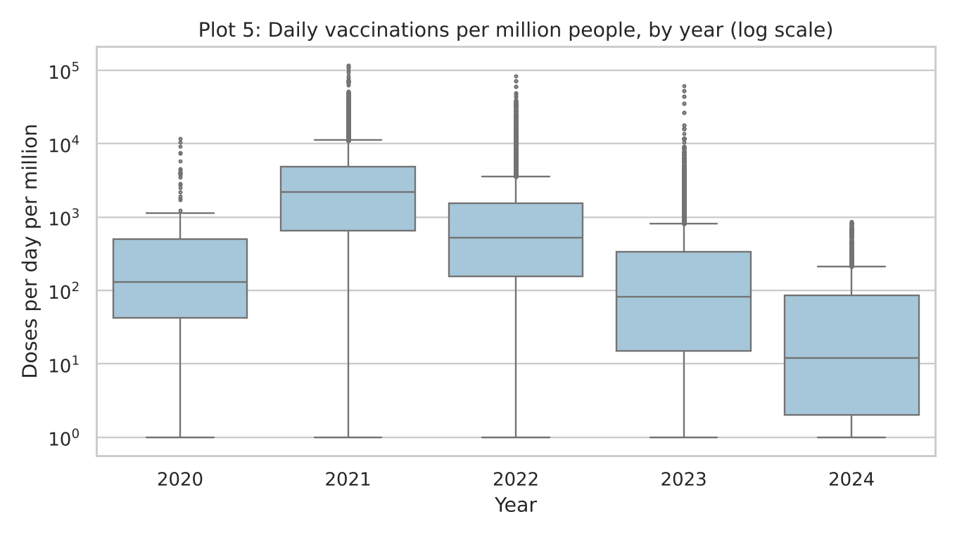
Plot 5 - Box plot of daily vaccinations per million people by year (log scale).
Outcome: The median rate was highest in 2021 (about 2,200 doses per million per day), then fell to about 520 in 2022, 82 in 2023 and 12 in 2024. The many points above each box are real mass-vaccination peaks, so they are kept.
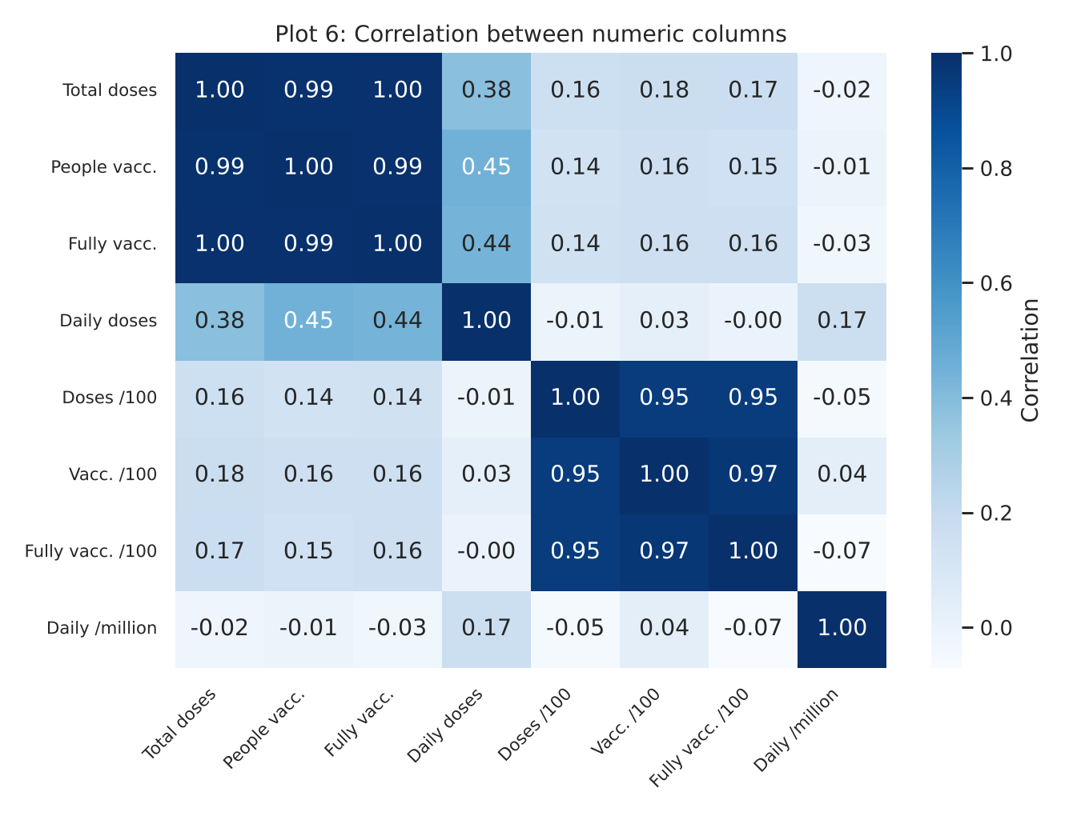
Plot 6 - Correlation heatmap of the numeric columns.
Outcome: Total doses, people vaccinated and people fully vaccinated move almost together (0.99 to 1.00). Absolute counts have only a weak link (about 0.16) with the per-100 figures, so countries must be compared per capita.
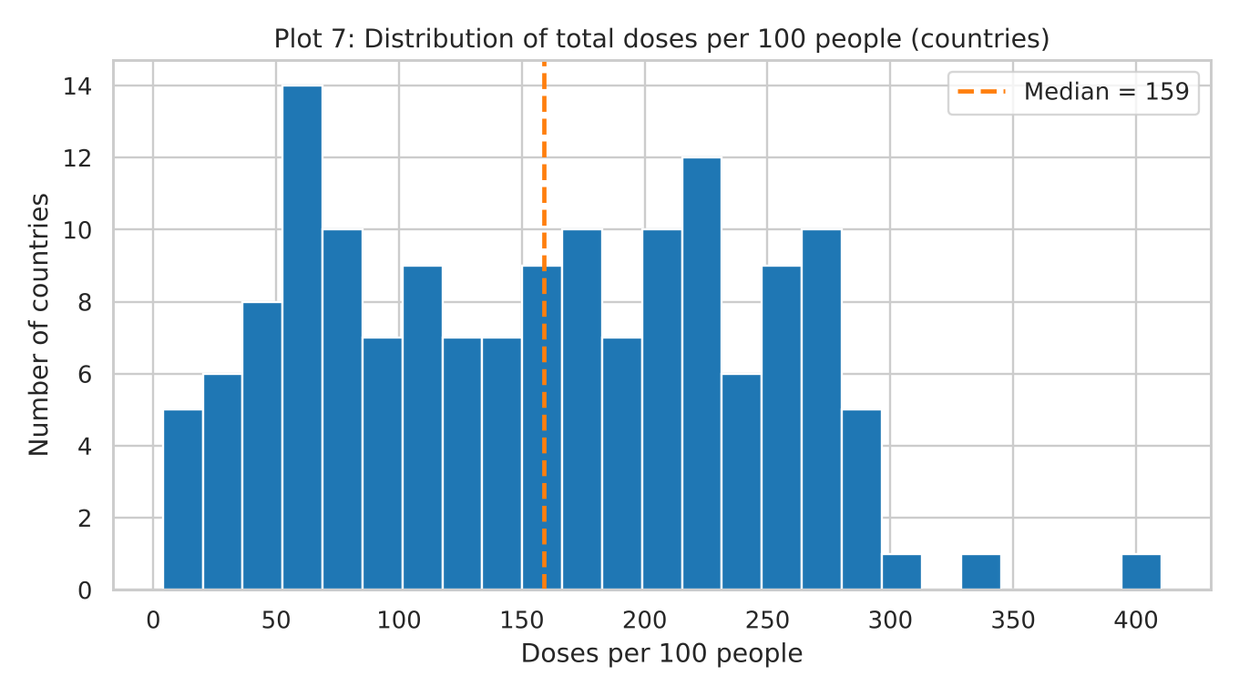
Plot 7 - Histogram of total doses per 100 people across countries.
Outcome: Coverage is very uneven: the median country gave about 159 doses per 100 people, but the range runs from about 4 to about 410.
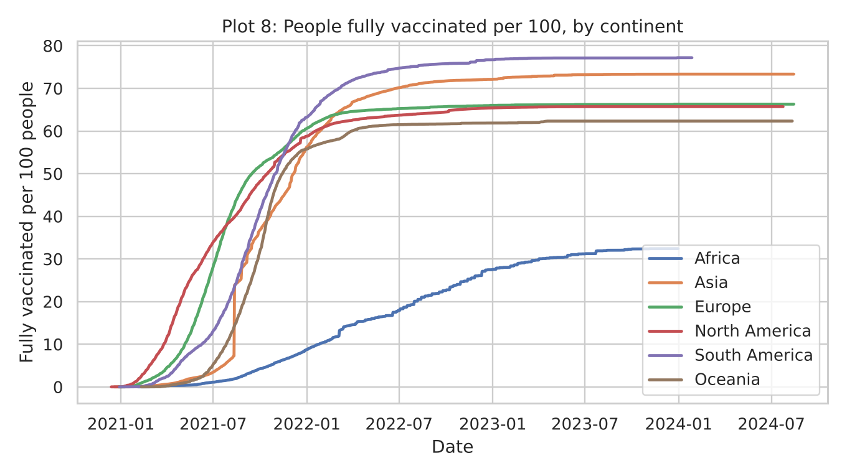
Plot 8 - Line chart of people fully vaccinated per 100, by continent.
Outcome: South America (about 77 per 100) and Asia (about 73) ended highest, Europe, North America and Oceania sit in the low to mid 60s, and Africa is far behind at about 32.

5. Short Insights Report
These insights come from the preliminary run and will be re-checked on the final cleaned Kaggle file.
1. Rollout was fast but short: daily vaccinations peaked in 2021 in most countries and were close to zero by 2023.
2. Absolute totals mainly reflect population size (China and India lead), so per-capita figures are needed for fair comparison.
3. Coverage gaps are large: some countries reached about 100 doses per 100 people, while the median country is near 159 doses per 100 and Africa lags other continents by about 30 to 45 points of full vaccination.
4. Pfizer/BioNTech, Moderna and Oxford/AstraZeneca were the most widely used vaccines among reporting countries.
5. Data quality needs care: more than half of the total_vaccinations values are blank before filling, aggregate rows (continents, income groups) are mixed with countries, and reporting gaps create false spikes.

6. Python Libraries and Tools
Tool | Used for
Python 3 | Main programming language
Pandas | Loading, cleaning and grouping the data
NumPy | Numeric operations and outlier calculations
Matplotlib | Line, bar, histogram and box plots
Seaborn | Heatmap and styled statistical plots
Plotly (optional) | Interactive charts and a world map
Jupyter Notebook | Running and documenting the analysis step by step
Kaggle website or kagglehub | Downloading the dataset
Git and GitHub | Version control, collaboration and hosting the project
Google Docs or Word | Writing the proposal and final report

7. GitHub Repository and Documentation
Repository link: https://github.com/priyadave57/covid19-vaccination-progress.git
Planned structure
covid19-vaccination-progress/
README.md project overview, setup and how to run
data/ raw and cleaned CSV files
notebooks/ cleaning and analysis notebook
visuals/ saved plots (PNG)
reports/ short insights report
requirements.txt list of Python libraries
README will include: project title and goal, dataset link, installation steps, how to run the notebook, a list of the plots with screenshots, key insights.
8. Timeline and Team Responsibilities
The work is planned in five phases, in this order:
1. Setup: create the GitHub repository, download the dataset and write the first README.
2. Cleaning: handle missing values, duplicates, data types and outliers, and save the cleaned file.
3. Visualisation: build the 8 plots and save them to the visuals/ folder.
4. Reporting: write the short insights report and finish the README.
5. Review: check that both members have commits, test the notebook from top to bottom and submit.
9. Conclusion
This proposal sets out a complete plan to study how COVID-19 vaccination progressed across countries. The dataset is suited to the task, the cleaning steps handle its main problems (blank values, mixed aggregate rows, text dates and reporting gaps), and the 8 planned visualizations answer clear questions about speed, coverage and vaccine use.
The preliminary run already shows the expected pattern: a rollout that peaked in 2021, very uneven coverage between countries and continents, and Pfizer/BioNTech, Moderna and Oxford/AstraZeneca as the most widely used vaccines. The next step is to repeat the full analysis on the Kaggle file, finish the README and commit the work to the GitHub repository.

