2. REQUIREMENT ANALYSIS PHASE
EduGenie: Google Gemini Powered Learning Assistant
Requirement analysis converts the EduGenie idea into functional, technical, and interface requirements. The uploaded project document specifies Python 3.10+, FastAPI, HTML/CSS, a Google Gemini API key, Uvicorn, and Jinja2 as prerequisites.
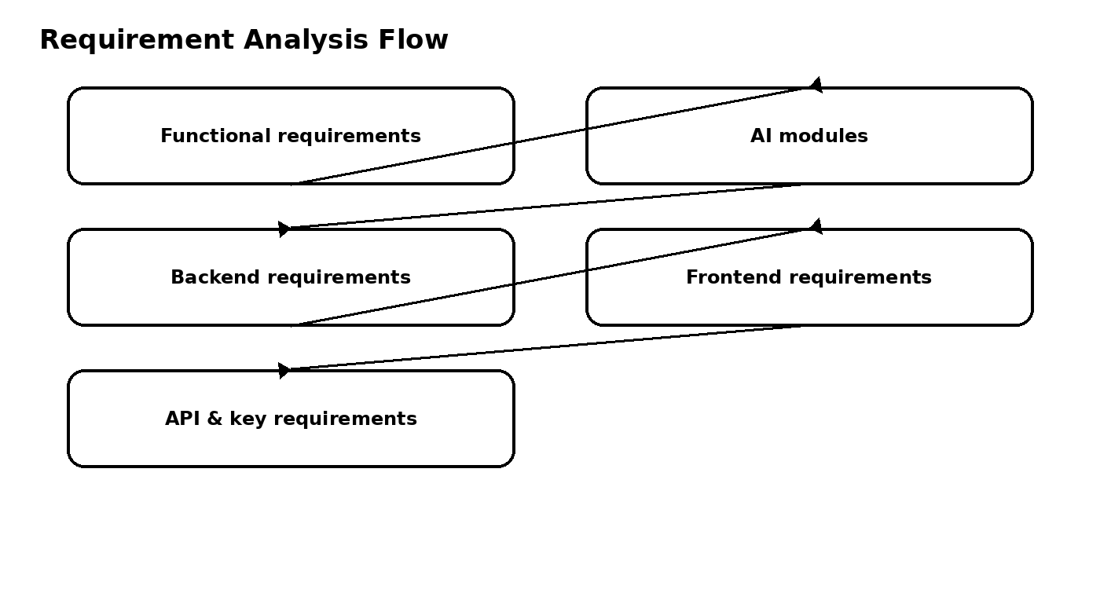

2.1 Functional Requirements
- Question answering through the /qa endpoint.
- Concept explanation through the /explain endpoint.
- Quiz generation through the /quiz endpoint.
- Text summarization through the /summarize endpoint.
- Personalized learning recommendations through /learn/recommendations.

2.2 AI Requirements
- Gemini 1.5 Pro via API for Q&A, summarization, quiz generation, and learning paths.
- LaMini-Flan-T5-783M local model for concept explanation.
- Gemini API key created and stored securely.

2.3 Software Requirements
- Python 3.10+
- FastAPI framework
- HTML & CSS
- Uvicorn ASGI server
- Jinja2 HTML templating engine

2.4 Interface Requirements
- Task dropdown with Explain, QnA, Quiz, Summary, and Recommend Path.
- Text area for learner input.
- Submit button.
- Responsive design and a result container.

2.5 Requirement Analysis Result
The requirements define a lightweight educational web application with modular AI functions, RESTful backend endpoints, and a simple responsive frontend.

