3. PROJECT DESIGN PHASE
EduGenie: Google Gemini Powered Learning Assistant
The design phase defines how the frontend, FastAPI backend, AI modules, and model services work together. The project uses modular files so each educational feature can be developed and maintained separately.
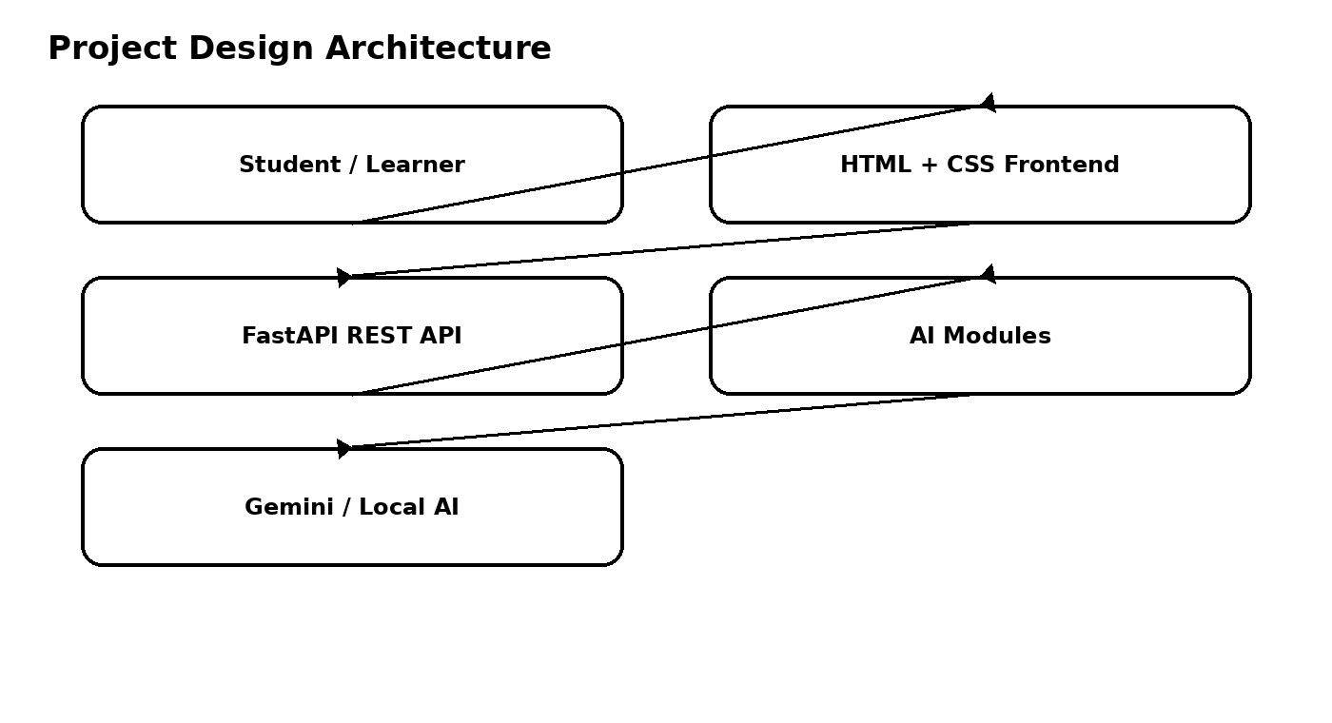

3.1 System Architecture
- Frontend: templates/index.html and static/style.css.
- Backend: main.py using FastAPI.
- Explanation logic: explanation_module.py.
- Question answering: qna.py.
- Quiz generation: quiz_module.py.
- Summarization: summary_module.py.
- Learning recommendations: learning_path.py.

3.2 AI Model Design
- Gemini 1.5 Pro is used through the API for Q&A, summarization, quiz generation, and learning paths.
- LaMini-Flan-T5-783M is used locally for concept explanation.

3.3 Folder Architecture
Project Folder Structure
EduGenie/
├── main.py
├── explanation_module.py
├── qna.py
├── quiz_module.py
├── summary_module.py
├── learning_path.py
├── templates/
│ └── index.html
├── static/
│ └── style.css
└── requirements.txt

3.4 API Design
- /qa
- /explain
- /quiz
- /summarize
- /learn/recommendations
