4. PROJECT PLANNING PHASE
EduGenie: Google Gemini Powered Learning Assistant
Project planning organizes EduGenie development into milestones and activities. The source project describes four major milestones: model selection and architecture, core functionality development, frontend development, and deployment.
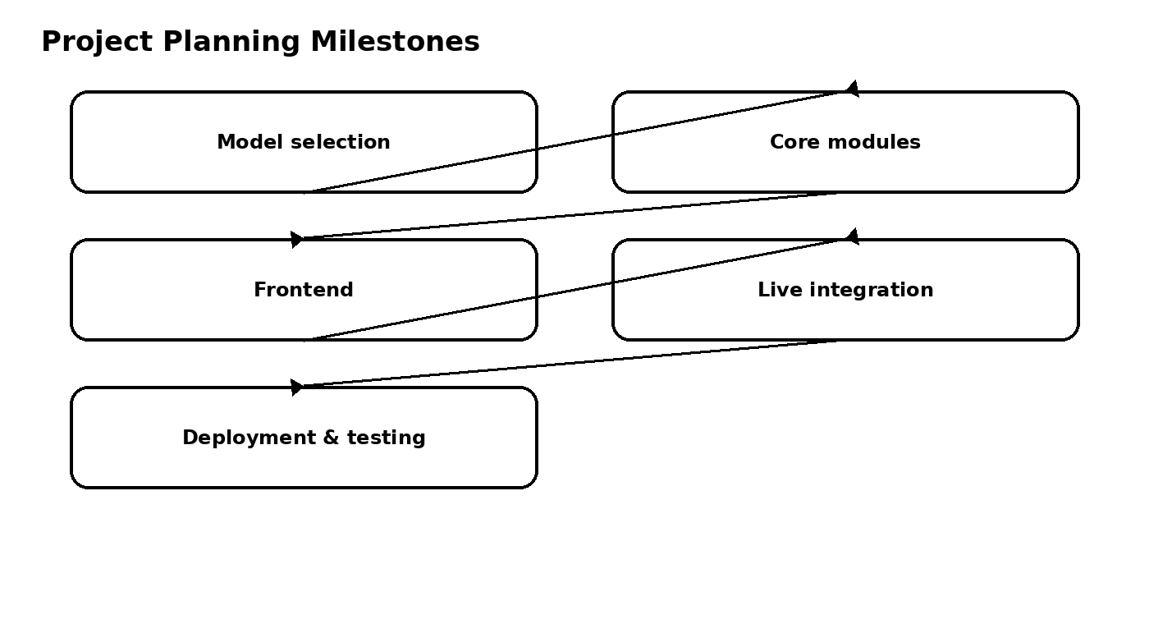

4.1 Milestone 1 – Model Selection and Architecture
- Select Gemini 1.5 Pro for Q&A, summarization, quiz generation, and learning paths.
- Select LaMini-Flan-T5-783M for lightweight concept explanation.
- Create the project folder architecture.

4.2 Milestone 2 – Core Functionalities Development
- Implement explanation module.
- Implement QnA module.
- Implement quiz module.
- Implement summary module.
- Implement learning path module.
- Create FastAPI endpoints for each module.

4.3 Milestone 3 – Frontend Development
- Build the HTML form.
- Add task dropdown and text input area.
- Add submit button and result container.
- Apply responsive CSS styling.
- Integrate frontend requests with FastAPI.

4.4 Milestone 4 – Deployment
- Run the application locally using Uvicorn.
- Open the application at http://127.0.0.1:8000.
- Perform functional testing of each major feature.
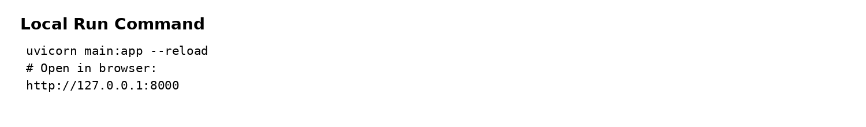

4.5 Planning Deliverable
The output of this phase is a milestone-based development plan that connects model selection, module implementation, frontend integration, deployment, and testing.

